Project Document

Fid’Lin

Version 1.2

3/7/19

CPSC 4910 SP19

Prepared by:
Team 2
Jakob Beckleheimer, Dylan Brownell, Tanner Groll, Derek Pendleton, and Phil Snider

<Fiddle Player Practice App>
SECTION 1 - INTRODUCTION #
1.1 PURPOSE #
1.2 SCOPE #
1.3 TERMINOLOGY #
1.4 REFERENCES #
SECTION 2 – MANAGEMENT #
2.1 GENERAL DESCRIPTION #
2.2 SOFTWARE VALIDATION #
2.3 CONFIGURATION MANAGEMENT PLAN #
2.4 PROJECT SCHEDULE #
SECTION 3 - REQUIREMENTS #
3.1 FUNCTIONAL REQUIREMENTS #
3.1.1 Functional Capabilities #
3.1.1 System Inputs #
3.1.2 System Outputs #
3.2 NONFUNCTIONAL REQUIREMENTS #
3.2.1 Performance Considerations #
3.2.2 User Interface #
3.2.3 Language #
3.2.8 Operating Environment #
SECTION 4 – DESIGN #
4.1 Configuration Design #
4.2 Technical Design #
4.3 SYSTEMS ARCHITECTURE #
SECTION 5 - IMPLEMENTATION STRATEGY #
SECTION 6 - USER DOCUMENTATION #
6.1 INSTALLATION GUIDE #
6.2 USER'S GUIDE #
SECTION 7 - TEST AND VALIDATION #

SECTION 1 - INTRODUCTION
Fid’Lin, the fiddle / violin player practice app, is an application intended to aid fiddle or violin players learn how to play and practice their instrument. The app shall assist with tuning, intonation, scales, tempo, etc. (Stakeholders: Russ Hare)
  - PURPOSE
To aid those who wish to learn or better their skills on the fiddle or violin.
1.2 SCOPE
The App will be available for Androids.
1.3 TERMINOLOGY
Intonation - accuracy of pitch in playing of an instrument.
Metronome - a device that marks time at a selected rate by giving a regular tick.
Pitch – how high or low a note is.
Scale – any set of musical notes ordered by fundamental frequency or pitch.
Tempo - the speed at which a passage of music is or should be played.
1.4 REFERENCES
List any sources of information
SECTION 2 – MANAGEMENT
- Jakob Beckleheimer – Application Architect
- Dylan Brownell – QA Manager
- Tanner Groll – SA Manager
- Derek Pendleton – Development Manager
- Phil Snider – Project Manager
2.1 GENERAL DESCRIPTION
A functioning mobile app in which its purpose is to assist the user in various ways for the fiddle or violin. It allows the user to create a profile and keep up with progression on learning their instrument. It additionally helps the player tune their instrument by recording the pitch of the instrument and notifying the user to tune the instrument to a higher or lower pitch. This app also helps the user learn basic scales and keeps up with tempo using a metronome.
2.2 SOFTWARE VALIDATION
2.3 CONFIGURATION MANAGEMENT PLAN
How are you going to handle configuration management? It needs to be thought about early and upfront.
2.4 PROJECT SCHEDULE
This should be a part of each and every report, not only iterations. You need to decide by Iteration I how you are going to track your project.
SECTION 3 - REQUIREMENTS
CPSC 4900
3.1 BUSINESS REQUIREMENT SPECIFICATION (BRS)
- Assist tuning violin to at least open strings in standard tuning, preferably alternate tunings as well
-Assist playing scales by playing tone for correct note and displaying finger position and name of correct note
-Include all major, minor, chromatic, and pentatonic scales
-Adjustable metronome that counts at user entered tempo
-Metronome should have visible display in addition to audio
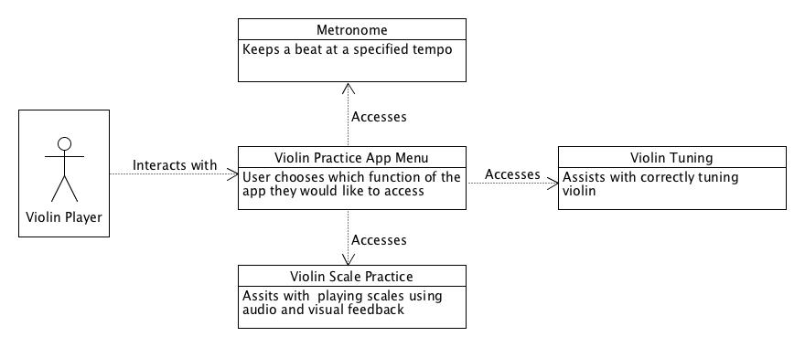
-Checks intonation by listening to played notes and determines if fingers are in correct position (assuming standard tuning)

3.2 FUNCTIONAL REQUIREMENT SPECIFICATION (FRS)
(System Requirements)
3.2.1 Functional Capabilities
3.2.2 System Inputs
3.2.3 System Outputs
3.3 NONFUNCTIONAL REQUIREMENTS
3.3.1 Performance Considerations
3.3.2 User Interface
3.3.3 Language
3.3.8 Operating Environment
SECTION 4 – DESIGN

SYSTEM CONTEXT
This context diagram shows how the app will be structured and accessed by a user.

CPSC 4900 Iteration I and maybe Iteration II but no later than II. You should include UML diagrams in this section. You may need to go back and review add to and delete from as the semester progresses.

4.1 SYSTEMS ARCHITECTURE
4.2 Configuration Design
4.3 Technical Design
SECTION 5 - IMPLEMENTATION STRATEGY
CPSC 4900 No later than Iteration II. You may need to go back and review add to and delete from as the semester progresses. I expect a detailed explanation on how to you plan to implement your project. How do you plan to meet the requirements?
SECTION 6 - USER DOCUMENTATION
This section is a necessity for each project and can be completed last, prior to delivery.
6.1 INSTALLATION GUIDE
6.2 USER'S GUIDE
6.3 Administrator Guide (Possibly)
SECTION 7 - TEST AND VALIDATION
I want to see a test plan no later than iteration II. As you decide how you are going to implement your project you should define this. It may change somewhat as the project progresses but thought on the front end needs to be given. The earlier the better. Include a test plan, test cases, and validation of the software. You may need to go back and review add to and delete from as the semester progresses.

