|  |
| --- |
| PRODUCT SALES ANALYSIS |
|  |

PHASE 5: Project Documentation & Submission

SUBMMITTED BY

NAME: THATHIREDDY JYOTHIREDDY

NM ID: au723921244050

MAIL ID: [jyothireddythathireddy@gmail.com](mailto:jyothireddythathireddy@gmail.com)

**DOCUMENTATION**

**1)Outline the project's objective, design thinking process, and development phases.**

**Project Objective:**

The objective of this project is to analyze product sales data in order to gain insights into sales trends, customer behavior, and product performance. The ultimate goal is to make data-driven decisions that will optimize sales strategies and increase revenue.

**Design Thinking Process:**

**Empathize:**

* Understand the stakeholders' needs and expectations regarding the sales analysis.
* Conduct interviews with sales teams, managers, and other relevant parties to gather insights into their pain points and requirements.

**Define:**

* Synthesize the information gathered during the empathize phase to define the core objectives and key performance indicators (KPIs) for the sales analysis.
* Establish clear metrics such as revenue, units sold, customer acquisition cost, etc.

**Ideate:**

* Generate ideas for the types of analyses and visualizations that will provide meaningful insights.
* Consider different approaches for segmenting data (e.g., by product category, customer demographics, time periods).

**Prototype:**

* Create mockups or wireframes of potential dashboards and reports that will display the sales analysis.
* Determine the data sources and tools that will be used for data visualization and analysis.

**Test:**

* Gather feedback from stakeholders on the prototypes to ensure that the proposed visualizations meet their needs.
* Iterate on the designs based on the feedback received.

**Development Phases:**

**Data Collection and Preparation:**

* Identify and gather relevant sales data from various sources (e.g., CRM systems, POS systems, online sales platforms).
* Clean, validate, and transform the data to ensure its accuracy and consistency.

**Data Analysis and Modeling:**

* Apply statistical and analytical techniques to uncover patterns, trends, and correlations in the sales data.
* Utilize machine learning models if applicable (e.g., predictive sales forecasting).

**Dashboard and Report Development:**

* Design and develop interactive dashboards and reports to visualize the sales analysis.
* Ensure that the dashboards are user-friendly and provide easy navigation for exploring different aspects of the data.

**Integration with Data Sources:**

* Establish connections and integrations with the data sources to enable real-time or automated updates to the sales analysis.

**Testing and Validation:**

* Conduct thorough testing to verify the accuracy and reliability of the sales analysis tools and reports.
* Validate that the insights derived align with stakeholders' expectations and objectives.

**Deployment and Training:**

* Deploy the sales analysis tools and provide training to relevant stakeholders on how to use them effectively.

**Feedback and Iteration:**

**Gather feedback from users and stakeholders after the deployment.**

**Make any necessary adjustments or improvements based on the feedback received.**

**Maintenance and Support:**

* Provide ongoing support for the sales analysis tools, addressing any issues or updates that may arise.
* Monitor data integrity and system performance.

**Documentation and Knowledge Sharing:**

* Document the processes, methodologies, and tools used for the sales analysis.
* Share knowledge and best practices with the team for future reference.

**2)Describe the analysis objectives, data collection process, data visualization using IBM Cognos, and derived actionable insights.**

**Analysis Objectives:**

The primary objectives of the product sales analysis are:

* **Sales Performance Assessment:** Evaluate the performance of products in terms of revenue generated, units sold, and profitability.
* **Customer Segmentation:** Identify key customer segments based on purchasing behavior, demographics, and other relevant factors.
* **Market Trends and Seasonality:** Analyze sales trends over time to identify seasonal patterns and market trends that may impact sales strategies.
* **Product Mix Optimization:** Determine which products are driving the majority of sales and which may need adjustments in marketing or pricing strategies.
* **Sales Channel Effectiveness:** Evaluate the effectiveness of different sales channels (e.g., online, offline, partnerships) in driving sales.

**Data Collection Process:**

**Data Sources:**

* Gather sales data from various sources, including CRM systems, POS systems, e-commerce platforms, and any other relevant databases.

**Data Extraction and Transformation:**

* Extract relevant data from the sources and perform data cleaning and transformation to ensure consistency and accuracy.

**Data Integration:**

* Integrate the cleaned and transformed data from different sources into a unified dataset for analysis.

**Data Quality Assurance:**

* Validate the data to ensure that it is complete, accurate, and free from errors or duplicates.

**Data Visualization using IBM Cognos:**

* IBM Cognos is a powerful business intelligence and analytics tool that provides a range of features for data visualization and reporting. Here's how it can be used for product sales analysis:

**Dashboard Creation:**

* Design interactive dashboards that display key metrics and visualizations related to sales performance, customer segmentation, and market trends.

**Report Generation:**

* Generate detailed reports that provide deeper insights into specific aspects of the sales data, such as product performance by category or region.

**Drill-Down Capabilities:**

* Enable users to drill down into specific data points to gain more granular insights and understand the underlying trends.

**Data Exploration and Ad-Hoc Analysis:**

* Provide tools for users to perform ad-hoc analysis, allowing them to explore the data and create custom visualizations as needed.

**Derived Actionable Insights:**

Based on the analysis conducted using IBM Cognos, the following actionable insights can be derived:

**Promotion Effectiveness:**

* Identify which promotional campaigns or discounts have the highest impact on sales and adjust marketing strategies accordingly.

**Customer Segmentation Strategies:**

* Tailor marketing efforts and product offerings to specific customer segments based on their preferences and purchasing behavior.

**Optimize Product Mix:**

* Focus resources on promoting and optimizing the performance of high-margin and high-demand products.

**Seasonal Inventory Management:**

* Plan inventory levels and marketing efforts around seasonal trends to maximize sales during peak periods.

**Sales Channel Investment:**

* Allocate resources based on the effectiveness of different sales channels, potentially reallocating budget to channels with higher returns.

**Forecasting and Planning:**

* Use historical data and trends to create accurate sales forecasts for future planning and resource allocation.

**3)Explain how the insights from the analysis can guide inventory management and marketing strategies.**

**Inventory Management:**

**Demand Forecasting:**

* By analyzing historical sales data, businesses can forecast future demand for specific products. This helps in ensuring that the right amount of inventory is maintained to meet customer demand without excess or shortages.

**Seasonal Trends and Inventory Planning:**

* Understanding seasonal sales patterns allows businesses to adjust their inventory levels accordingly. They can stock up on popular items in anticipation of high demand periods and reduce inventory during slower seasons.

**Product Mix Optimization:**

* Analysis can identify which products are top performers and which may need adjustments. This helps in prioritizing inventory allocation to high-demand, high-margin items.

**Safety Stock Levels:**

* Insights from sales data can help determine the appropriate safety stock levels to guard against unexpected spikes in demand or supply chain disruptions.

**Slow-Moving and Dead Stock Management:**

* Identifying slow-moving or obsolete inventory enables businesses to take proactive measures, such as markdowns or targeted promotions, to clear out excess stock.

**Supplier Relationship Management:**

* With a clear understanding of sales trends, businesses can negotiate better terms with suppliers, including lead times and order quantities, to optimize inventory levels.

**Marketing Strategies:**

**Targeted Marketing Campaigns:**

* Insights into customer segments and preferences allow for more targeted and effective marketing campaigns. Businesses can tailor messages and offers to resonate with specific customer groups.

**Promotion Optimization:**

* Analysis helps in identifying which promotions or discounts drive the highest sales. This information enables businesses to focus resources on the most effective promotional strategies.

**Product Positioning and Pricing:**

* Understanding which products are the best sellers and which have lower demand informs decisions about pricing and product placement. It helps in maximizing revenue and profit margins.

**Customer Retention Strategies:**

* Knowing which products have high repeat purchase rates allows businesses to implement strategies to retain and upsell existing customers, potentially through loyalty programs or personalized offers.

**Market Expansion and New Product Introductions:**

* Insights can guide decisions about expanding into new markets or introducing new products. Understanding customer preferences and market trends helps in making informed expansion strategies.

**Optimizing Marketing Channels:**

* By analyzing which sales channels (e.g., online, in-store, partnerships) are most effective, businesses can allocate resources to the highest-performing channels for maximum ROI.

In summary, insights derived from product sales analysis provide valuable information that enables businesses to make informed decisions about inventory management and marketing strategies. This leads to improved operational efficiency, better customer satisfaction, and ultimately, increased profitability. It's important to regularly review and update strategies based on ongoing sales analysis to adapt to changing market conditions and customer preferences.

**SUBMISSION**

**GitHub repository link :** [**https://github.com/chaithanya572003/product-sale-analysis.git**](https://github.com/chaithanya572003/product-sale-analysis.git)

**Example outputs of the visualizations and derived insights.**

**1)Revenue Trends:**

* Line chart showing monthly revenue trends over the past year. Insights derived:
* Identify peak sales months for better inventory planning.
* Recognize any seasonal patterns that may affect marketing strategies.

**Python program:**

# Monthly distrubution of revenue

sns.relplot(x="month",y="S-P1",data=df,kind="line",height=10,color="red")

plt.xticks(rotation=90);

sns.relplot(x="month",y="S-P2",data=df,kind="line",height=10,color="blue")

plt.xticks(rotation=90);

sns.relplot(x="month",y="S-P3",data=df,kind="line",height=10,color="green")

plt.xticks(rotation=90);

sns.relplot(x="month",y="S-P4",data=df,kind="line",height=10,color="purple")

plt.xticks(rotation=90);

**output:**

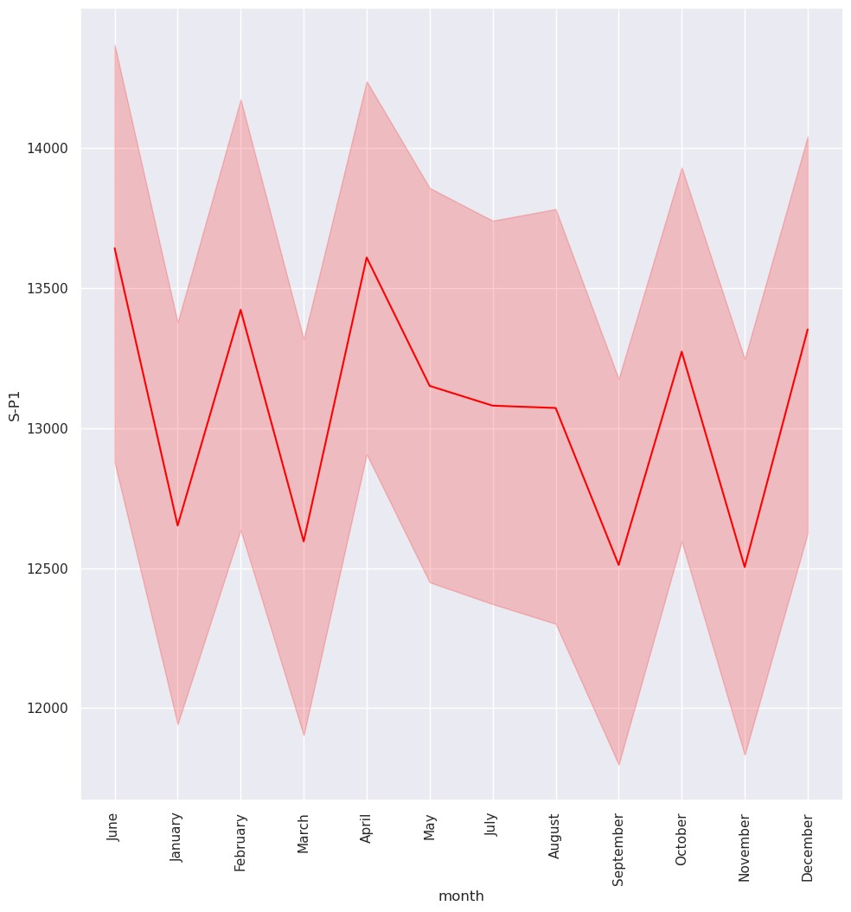

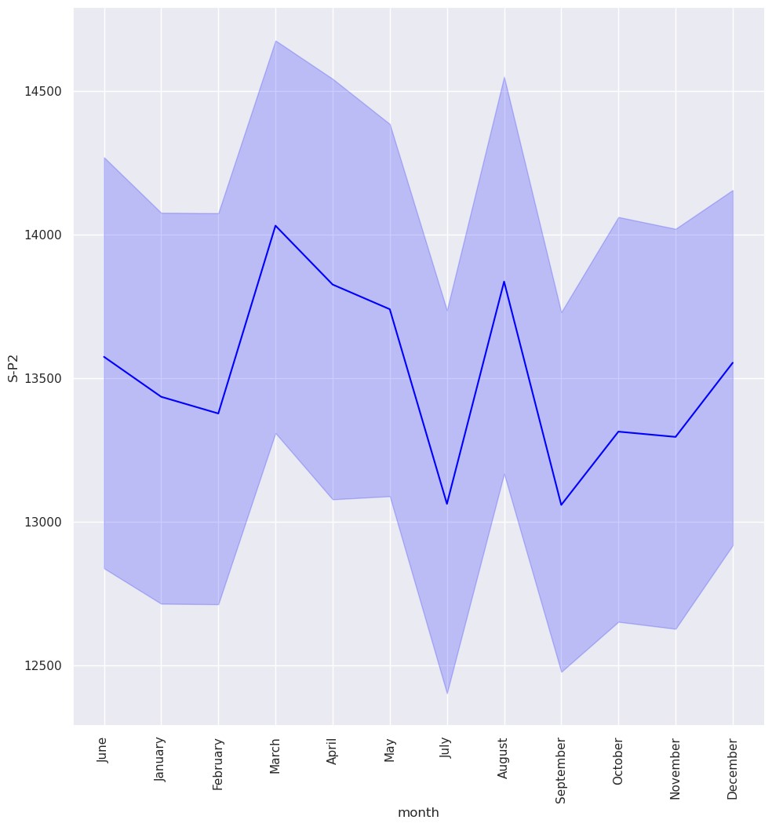

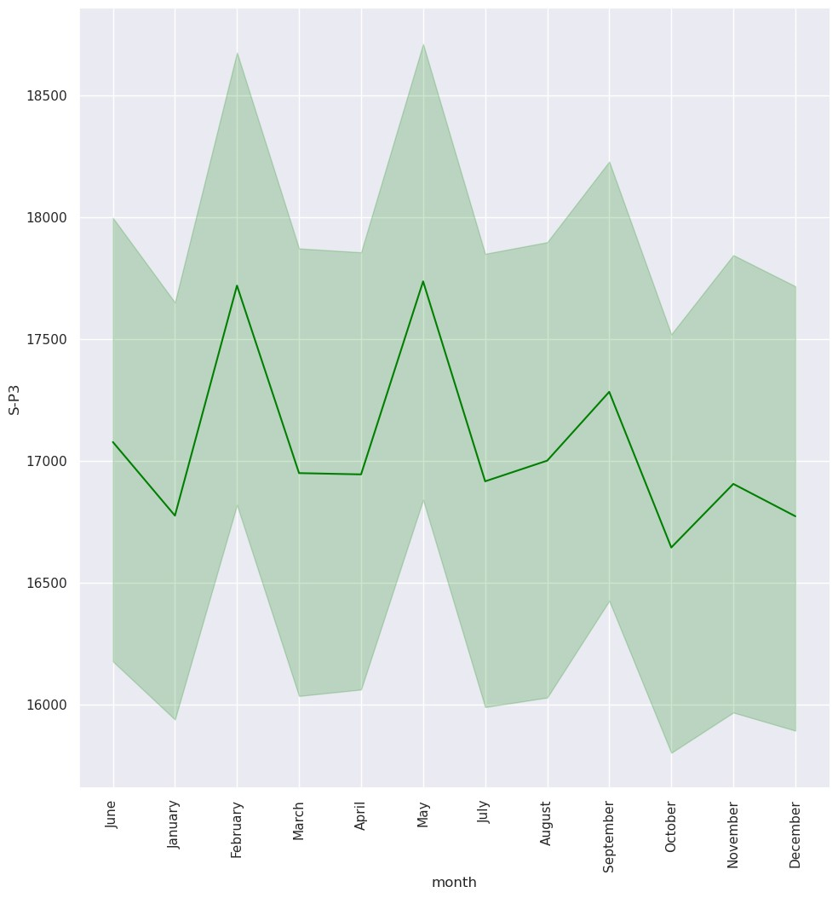

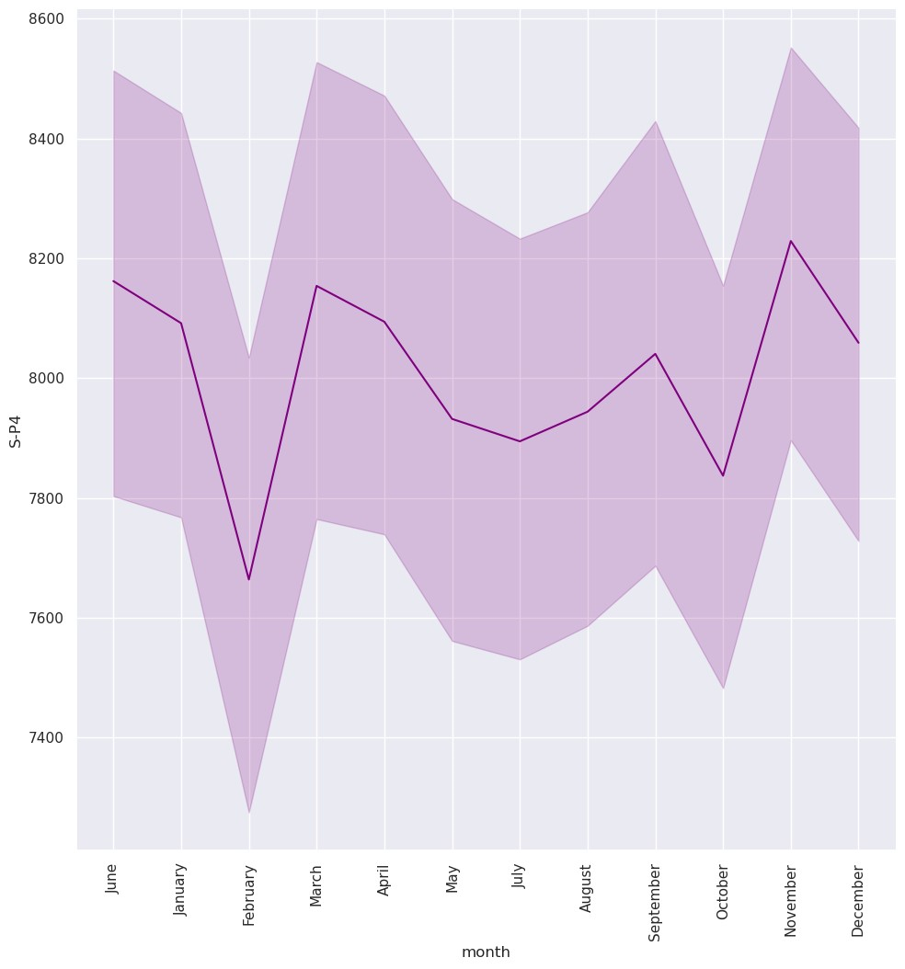

**Pie chart:**

Pie chart showing the distribution of customers by demographics (e.g., age groups). Insights derived:

* Target marketing efforts towards the most profitable customer segments.
* Customize product offerings based on demographic preferences.

**Python program:**

import matplotlib.pyplot as plt

# Sample customer segmentation data (replace with your actual data)

customer_segments = {

'Segment A': 150,

'Segment B': 200,

'Segment C': 180,

'Segment D': 120,

}

# Extract labels and sizes

labels = list(customer_segments.keys())

sizes = list(customer_segments.values())

# Create the pie chart

plt.figure(figsize=(8, 8))

plt.pie(sizes, labels=labels, autopct='%1.1f%%', startangle=140, colors=plt.cm.Paired(range(len(labels))))

# Equal aspect ratio ensures that pie is drawn as a circle.

plt.axis('equal')

plt.title('Customer Segmentation Distribution')

plt.show()# Equal aspect ratio ensures that pie is drawn as a circle.

plt.axis('equal')

plt.title('Customer Demographics Distribution')

plt.show()

**output:**

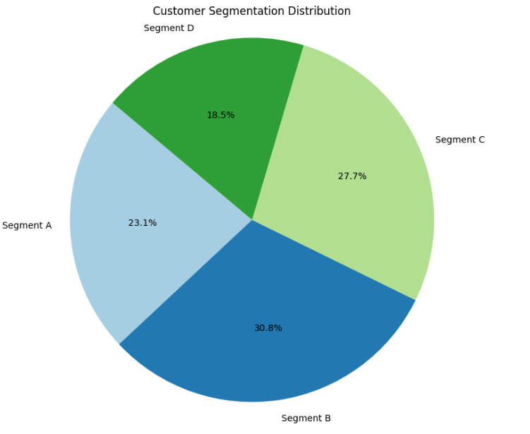

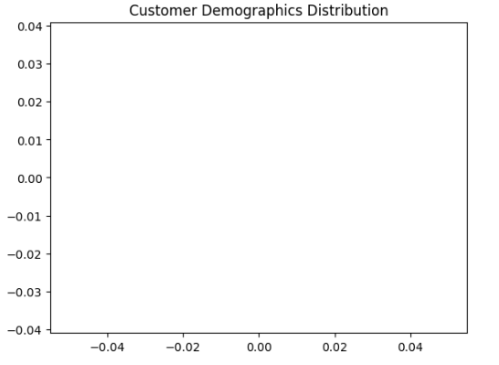

**Python code:**

## In which month unit sales were more in Product 1, Product 2, Product 3, Product 4

df.groupby ("month")[["Q-P1","Q-P2","Q-P3","Q-P4"]].sum()

plt.figure(figsize=(15,15),dpi=100)

plt.subplot(2,2,1)

sns.barplot(x="month",y="Q-P1",data=df,edgecolor="black",estimator=sum)

plt.xticks(rotation=90);

plt.subplot(2,2,2)

sns.barplot(x="month",y="Q-P2",data=df,edgecolor="black",estimator=sum)

plt.xticks(rotation=90);

plt.subplot(2,2,3)

sns.barplot(x="month",y="Q-P3",data=df,edgecolor="black",estimator=sum)

plt.xticks(rotation=90);

plt.subplot(2,2,4)

sns.barplot(x="month",y="Q-P4",data=df,edgecolor="black",estimator=sum)

plt.xticks(rotation=90)

plt.subplots_adjust(hspace=0.3);

**output:**

