|  |
| --- |
| PRODUCT SALES ANALYSIS |
| **PHASE4:**  **Development Part 2** |

SUBMMITTED BY

NAME: Thathireddy Jyothireddy

NM ID: au723921244050

MAIL ID: [jyothireddythathireddy@gmail.com](mailto:jyothireddythathireddy@gmail.com)

# **Product Sales Analysis**

# **Phase-4 Document Submission**

## **Project: Product Sales Analysis**

**Phase 3: Development Part 2**

**Topic: The Development Part 2, is a crucial stage in your project where you Continue building the analysis by creating visualizations using IBM Cognos and generating actionable insights**  **from the visualizations, such as identifying products with the highest sales, peak sales periods, and customer preferences for specific products.**

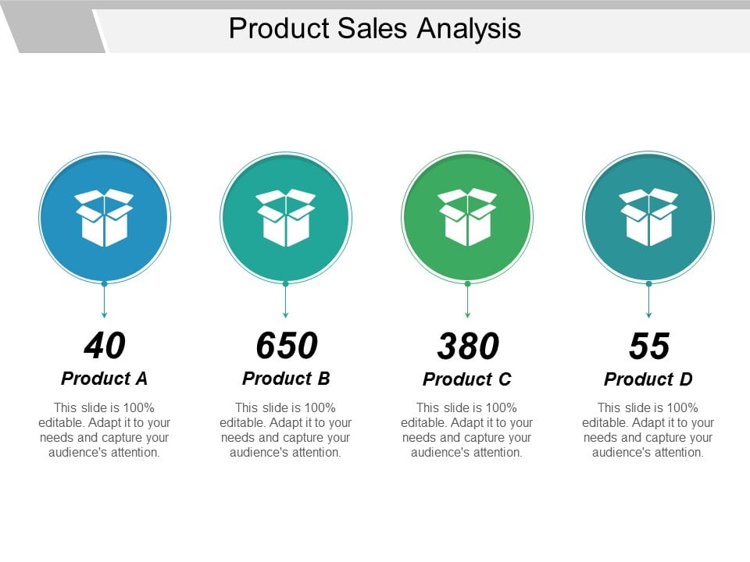

**Introduction:**

In an ever-evolving business landscape, understanding sales patterns, consumer behavior, and product performance is paramount to the sustained growth and success of a company. Product sales analysis is the critical tool that equips organizations with the insights needed to navigate this landscape.

**Given dataset:**

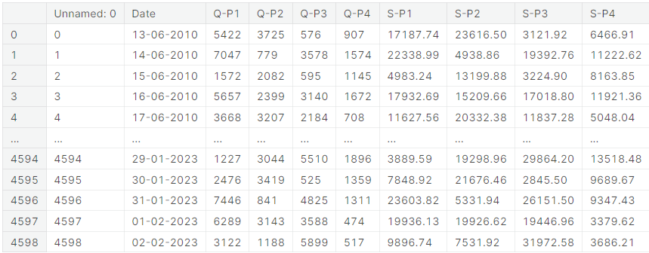

**Building the analysis by creating visualizations using IBM Cognos and generating actionable insights.**

**Connect to Data Sources:**

Launch IBM Cognos and connect it to your data sources containing product sales data.

**Create a Data Module:**

Define a data module to organize and prepare your data for analysis. Select relevant tables, join data, and create calculated fields if necessary.

**Design Visualizations:**

Create visualizations that address specific aspects of product sales analysis:

* **Top-Selling Products:** Create a bar chart or a list that displays the top-selling products based on sales revenue.
* **Sales Trends:** Develop a line chart or area chart to visualize sales trends over time. Break it down by month, quarter, or year.
* **Customer Preferences:** Use filters to allow users to select customer preferences (e.g., region, product category) and link them to relevant visualizations.

**Interactive Dashboards:**

Design a dashboard and add the visualizations you created. Arrange them logically for easy consumption.

**Add Interactivity:**

Implement interactive elements like drop-down menus, sliders, and date pickers to enable users to dynamically explore the data.

**Apply Contextual Filters:**

Apply filters that allow users to refine the data displayed in real-time. For example, let users select a specific time frame or product category.

**Incorporate Drill-Downs:**

Enable users to drill down into specific data points for more detailed insights. For instance, from a regional view to a country-level view.

**Utilize Conditional Formatting:**

Apply color coding and formatting to highlight important information and trends in the visualizations.

**Add Tooltips and Labels:**

Provide additional context by adding tooltips and labels to your visualizations. This helps users understand the data points.

**Set Up Alerts:**

Configure alerts to notify users when specific thresholds or conditions are met (e.g., sales exceeding a target).

**Apply Statistical Analysis:**

Incorporate statistical functions to identify significant trends, correlations, or outliers in the data.

**Generate Reports:**

Create detailed reports for stakeholders who may prefer a more structured view of the data.

**Schedule and Distribute Reports:**

Set up schedules to automatically generate and distribute reports to relevant stakeholders via email or a shared platform.

**Monitor and Analyze Usage:**

Keep track of how users interact with the dashboards and reports. Use this feedback to make improvements or updates.

**Derive Actionable Insights:**

Analyze the visualizations and reports to draw conclusions and recommendations. Identify areas for improvement, marketing strategies, and product development opportunities.

Remember to engage with end-users or stakeholders to gather feedback and refine the analysis and dashboards over time. This iterative process ensures that the insights provided are relevant and valuable for decision-making.

**Total unit sales Product 1, Product 2, Product 3, Product 4**

*# Total unit sales Product 1, Product 2, Product 3, Product 4*

q = df[["Q-P1","Q-P2","Q-P3","Q-P4"]].sum()

print(q)

plt.figure(figsize=(8,8))

plt.pie(q,labels=df[["Q-P1","Q-P2","Q-P3","Q-P4"]].sum().index,shadow=True,autopct="**%0.01f%%**",textprops={"fontsize":20},wedgeprops={'width': 0.8},explode=[0,0,0,0.3])

plt.legend(loc='center right', bbox_to_anchor=(1.2, 0.8));

Q-P1 18960506

Q-P2 9799295

Q-P3 14470404

Q-P4 5168100

dtype: int64

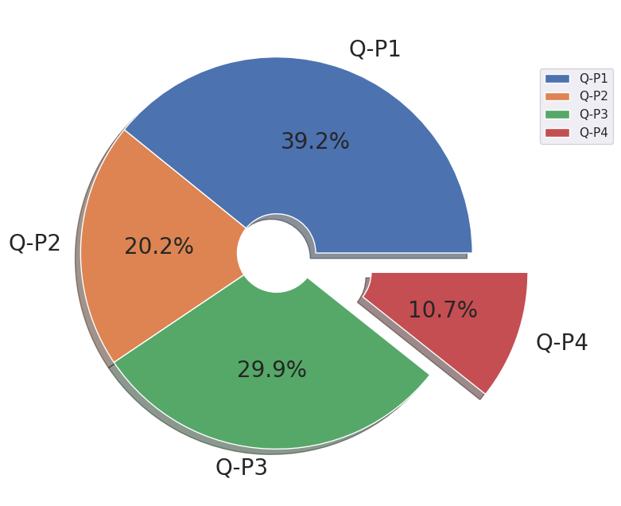

**Total Revenue percent from sales from Product 1, Product 2, Product 3, Product 4**

*# Total Revenue percent from sales from Product 1, Product 2, Product 3, Product 4*

s=df[["S-P1","S-P2","S-P3","S-P4"]].sum()

print(s)

plt.figure(figsize=(8,8))

plt.pie(s,labels=df[["S-P1","S-P2","S-P3","S-P4"]].sum().index,shadow=True,autopct="**%0.01f%%**",textprops={"fontsize":20},wedgeprops={'width': 0.8},explode=[0,0,0,0.3])

plt.legend(loc='center right', bbox_to_anchor=(1.2, 0.8))

S-P1 60104804.02

S-P2 62127530.30

S-P3 78429589.68

S-P4 36848553.00

dtype: float64

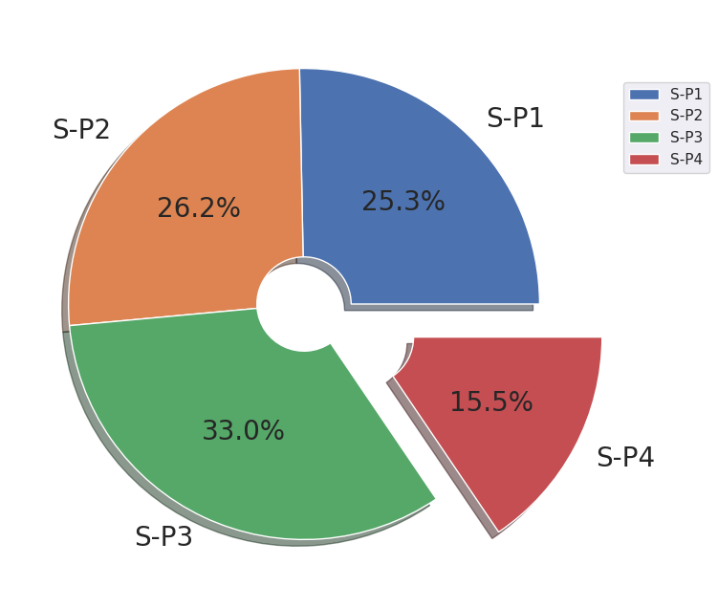

**Most sales occuring month :**

# which is the most occuring month

print(df["month"].value_counts())

plt.figure(figsize=(10,10))

sns.countplot(x="month",data=df,edgecolor="black")

plt.xticks(rotation=90);

October 411

January 399

July 398

June 385

August 385

September 385

November 385

December 385

March 380

May 379

April 367

February 341

Name: month, dtype: int64

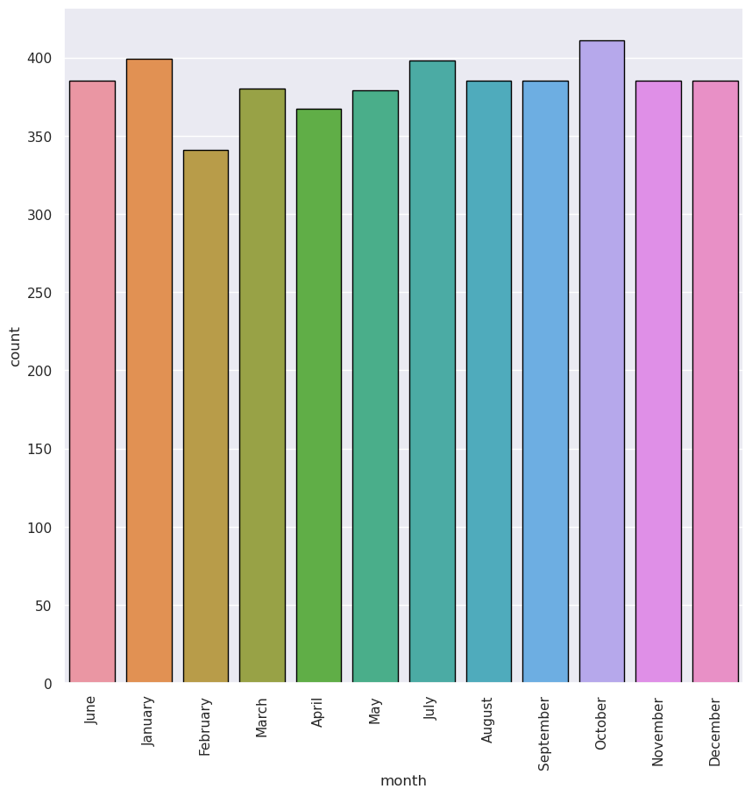 **Most sales occuring Day**

*# which is the most occuring Day*

print(df["day"].value_counts())

plt.figure(figsize=(10,10))

sns.countplot(x="day",data=df,edgecolor="black")

plt.xticks(rotation=90);

Friday 680

Wednesday 655

Sunday 654

Thursday 654

Tuesday 653

Monday 652

Saturday 652

Name: day, dtype: int64

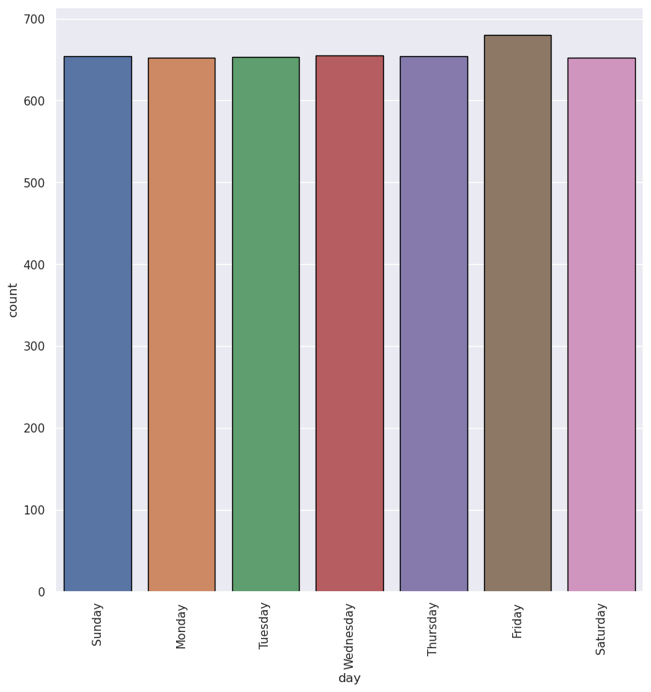

**Most sales occuring year:**

*# which is the most occuring year*

print(df["year"].value_counts())

plt.figure(figsize=(10,10))

sns.countplot(x="year",data=df,edgecolor="black")

plt.xticks(rotation=90);

2016 387

2011 362

2013 362

2014 362

2015 362

2017 362

2018 362

2019 362

2021 362

2022 362

2012 361

2020 361

2010 199

2023 34

Name: year, dtype: int64

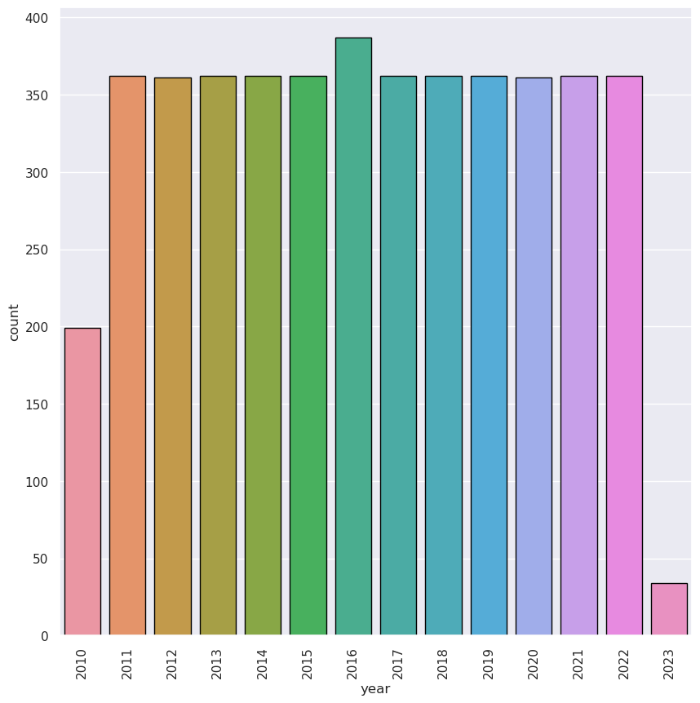

**Peak sales in a month:**

*# In which month revenue was it peak*

df.groupby("month")[["S-P1","S-P2","S-P3","S-P4"]].sum()

plt.figure(figsize=(15,15),dpi=100)

plt.subplot(2,2,1)

sns.barplot(x="month",y="S-P1",data=df,edgecolor="black",estimator=sum)

plt.xticks(rotation=90);

plt.subplot(2,2,2)

sns.barplot(x="month",y="S-P2",data=df,edgecolor="black",estimator=sum)

plt.xticks(rotation=90);

plt.subplot(2,2,3)

sns.barplot(x="month",y="S-P3",data=df,edgecolor="black",estimator=sum)

plt.xticks(rotation=90);

plt.subplot(2,2,4)

sns.barplot(x="month",y="S-P4",data=df,edgecolor="black",estimator=sum)

plt.xticks(rotation=90)

plt.subplots_adjust(hspace=0.3);

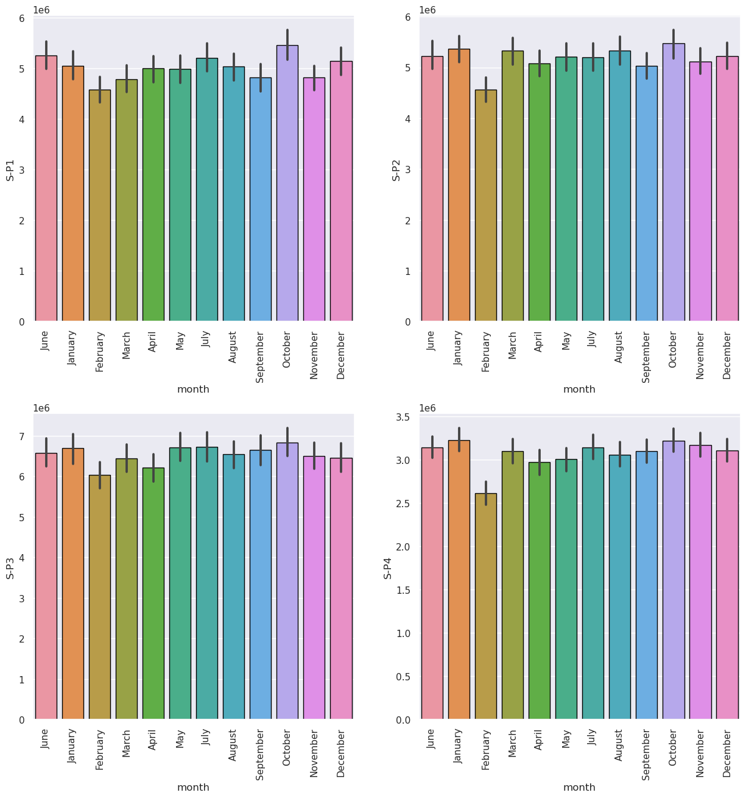

**Sales per week:**

week_t=df[df["dayoftheweek"]<5]

weekend_t=df[df["dayoftheweek"]>=5]

print(week_t.groupby("day")[["S-P1","S-P2","S-P3","S-P4"]].sum())

S-P1 S-P2 S-P3 S-P4

day

Friday 8913637.41 9267831.02 11428877.58 5463169.99

Monday 8636791.80 8864347.08 11064892.06 5292577.61

Thursday 8577981.96 8909481.54 10951554.44 5043013.35

Tuesday 8433525.06 8738326.90 11156338.30 5384854.07

Wednesday 8693537.97 8908067.72 11017830.20 5086827.20

plt.figure(figsize=(10,10),dpi=100)

plt.subplot(2,2,1)

sns.barplot(x="day",y="S-P1",data=week_t,edgecolor="black",estimator=sum)

plt.xticks(rotation=45);

plt.subplot(2,2,2)

sns.barplot(x="day",y="S-P2",data=week_t,edgecolor="black",estimator=sum)

plt.xticks(rotation=45);

plt.subplot(2,2,3)

sns.barplot(x="day",y="S-P3",data=week_t,edgecolor="black",estimator=sum)

plt.xticks(rotation=45);

plt.subplot(2,2,4)

sns.barplot(x="day",y="S-P4",data=week_t,edgecolor="black",estimator=sum)

plt.xticks(rotation=45)

plt.subplots_adjust(hspace=0.5);

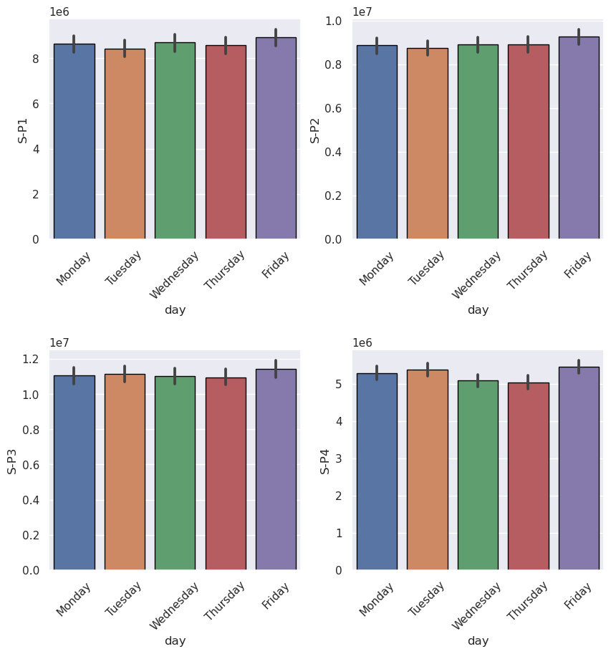

**Sales at Weekend:**

print(weekend_t.groupby("day")[["S-P1","S-P2","S-P3","S-P4"]].sum())

S-P1 S-P2 S-P3 S-P4

day

Saturday 8409578.88 8853201.36 11796375.26 5339977.85

Sunday 8439750.94 8586274.68 11013721.84 5238132.93

plt.figure(figsize=(10,10),dpi=100)

plt.subplot(2,2,1)

sns.barplot(x="day",y="S-P1",data=weekend_t,edgecolor="black",estimator=sum)

plt.xticks(rotation=45);

plt.subplot(2,2,2)

sns.barplot(x="day",y="S-P2",data=weekend_t,edgecolor="black",estimator=sum)

plt.xticks(rotation=45);

plt.subplot(2,2,3)

sns.barplot(x="day",y="S-P3",data=weekend_t,edgecolor="black",estimator=sum)

plt.xticks(rotation=45);

plt.subplot(2,2,4)

sns.barplot(x="day",y="S-P4",data=weekend_t,edgecolor="black",estimator=sum)

plt.xticks(rotation=45)

plt.subplots_adjust(hspace=0.5);

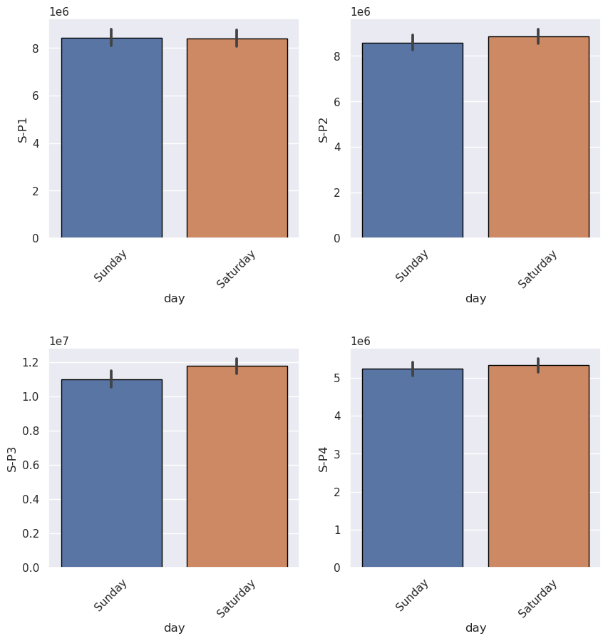

**Conclusion:**

The product sales analysis has yielded valuable insights into our business's performance and customer behavior. Through a detailed examination of sales data, we have uncovered several key findings such as Top-Selling Products,Sales Trends,Customer Preferences,Profitability Analysis and so on....