**Creating Python Programs**

Mr. Damon Townsend

Colorado State University Global

Course Code: CSC500-1

Instructor: Dr. Lori Farr

Due Date: April 20, 2025

# Pseudocode

## Part 1 – Add and Subtract

1. Ask the user to input the first number  
2. Ask the user to input the second number  
3. Add the two numbers  
4. Subtract the second number from the first  
5. Display the results

## Part 2 – Multiply and Divide

1. Ask the user to input two numbers  
2. Multiply the numbers  
3. Divide the first number by the second (if not zero)  
4. Display the results

# Source Code

## Part 1 – Addition and Subtraction

# Part 1: Addition and Subtraction  
  
# Ask the user to enter two numbers  
num1 = float(input("Enter the first number: "))  
num2 = float(input("Enter the second number: "))  
  
# Perform the calculations  
sum_result = num1 + num2  
difference = num1 - num2  
  
# Display the results  
print("The sum is:", sum_result)  
print("The difference is:", difference)

## Part 2 – Multiplication and Division

# Part 2: Multiplication and Division  
  
# Ask the user to enter two numbers  
num1 = float(input("Enter the first number: "))  
num2 = float(input("Enter the second number: "))  
  
# Perform the calculations  
product = num1 * num2  
  
# Check for division by zero  
if num2 != 0:  
 quotient = num1 / num2  
 print("The product is:", product)  
 print("The quotient is:", quotient)  
else:  
 print("The product is:", product)  
 print("Cannot divide by zero.")

# Screenshots of Code Execution

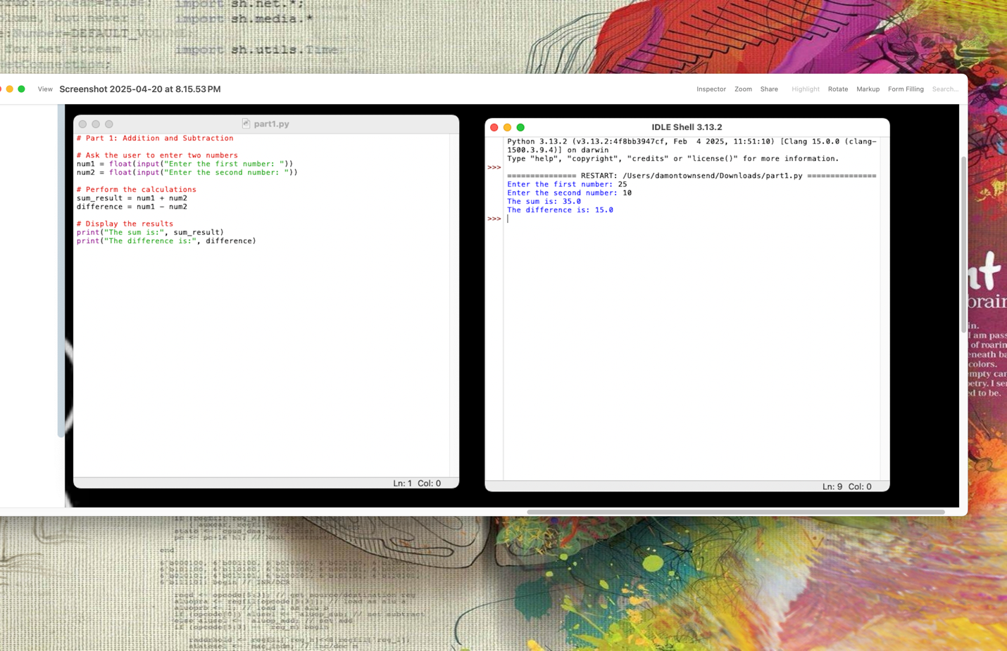

# 

# GitHub Repository

https://github.com/Thatlilguy/python-math-assignment