Dithare Car Wash Network Technical Report
CMPG 325 Final Project Submission
Individual Semester Project
Project ID CMPG325-2026-138
Client ID CLI-138
Student SITHOLE, TJ | 51636654
Client Dithare Car Wash & Detailing Group, Potchefstroom
Technical challenge NAT inside/outside translation
Final verification 16 October 2026

Executive Summary
This report presents the final design, Packet Tracer implementation, and verification of the Dithare Car Wash & Detailing Group network. The design uses three /27 VLANs for Office, CCTV, and IoT/Operations traffic, with router-on-a-stick routing, inbound ACLs on each VLAN gateway, and PAT for Office traffic only.
The final Packet Tracer checks confirmed the switch VLANs and trunk, R1 interface and route state, Office access to the simulated external host through NAT, CCTV communication between the NVR and Camera1, and the tested restrictions between Office, CCTV, IoT, and the external network. A temporary VLAN 30 test PC reached its gateway and was then removed after the isolation tests.
The evidence supports the required network behavior. It does not establish application-level sensor telemetry between the wireless IoT sensors and the controller; that service-level exchange was not part of the live verification recorded for this report.

Project Information
Item | Project detail
Module | CMPG 325 Computer Networks
Student | SITHOLE, TJ (51636654)
Organisation | Dithare Car Wash & Detailing Group, Potchefstroom
Internal address block | 192.168.59.0/24
Design constraint | CCTV traffic segmented from Office data traffic
Change request | CR12: IoT sensors in Operations need an isolated segment
Assigned challenge | NAT inside/outside address translation
Simulation platform | Cisco Packet Tracer 9.0.1.0858

1 Project Scope and Requirements
The project builds a site network for office administration, CCTV coverage, and operational IoT sensors. It uses the assigned 192.168.59.0/24 block and a simulated external network so that Office access and NAT can be demonstrated.
Requirement | Design response | Verification status
Office connectivity and simulated external access | VLAN 10, gateway 192.168.59.1; PAT through R1 G0/0. | Verified: PC1 reached External-PC with 4/4 replies on repeat; NAT translation present.
CCTV segmented from Office | VLAN 20; ACL 100 blocks Office-to-CCTV; ACL 110 blocks CCTV-to-Office. | Verified: both directions blocked; NVR-to-camera passed.
CR12 IoT isolated segment | VLAN 30; ACL 120 blocks IoT to Office, CCTV, and external destinations. | Verified with temporary VLAN 30 host; ACL 120 counters increased.
Assigned NAT challenge | ACL 10 selects Office subnet; PAT overload uses R1 outside address. | Verified: 192.168.59.2 translated to 203.0.113.2.
Working, testable Packet Tracer implementation | Router-on-a-stick, access switch, endpoint devices, simulated ISP and external host. | Interface, routing, trunk, and ping checks completed.
Clear evidence and troubleshooting record | Portfolio includes diagrams, CLI screenshots, testing, and troubleshooting notes. | Existing evidence reviewed; fresh results are recorded in this report.

The scope follows the assigned client scenario and does not add a management VLAN or unrelated network services.

2 Network Design
The site uses one edge router (R1) and one access switch (SW1). R1 connects to SW1 over a single 802.1Q trunk and routes the three VLANs through subinterfaces. R1 G0/0 connects to the simulated ISP and serves as the NAT outside interface.
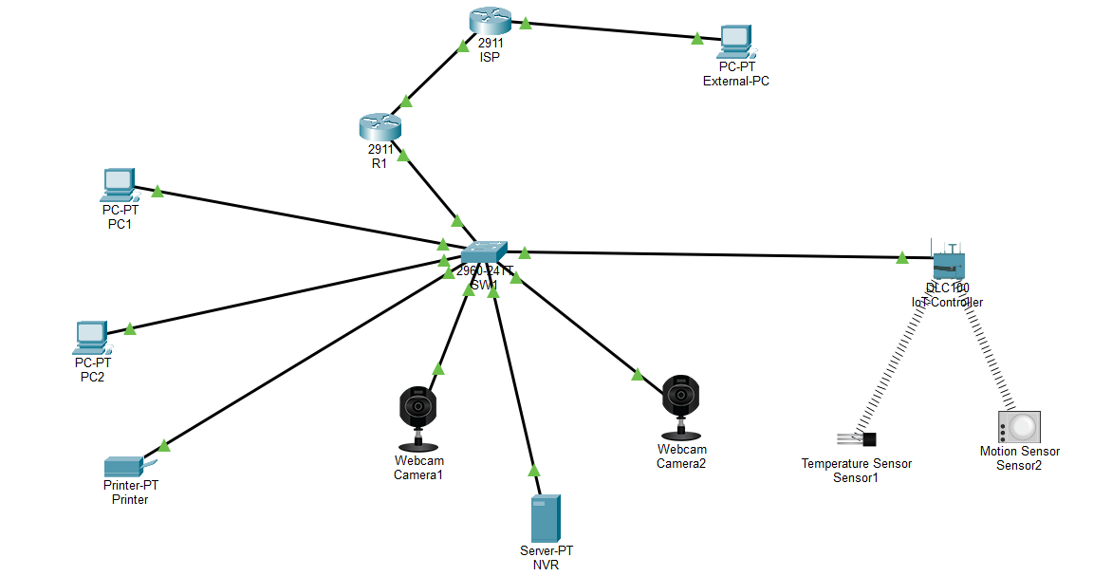
Figure 1. Packet Tracer topology showing R1, SW1, the three user segments, the IoT controller and sensors, and the simulated external network.
The approved logical design separates Office, CCTV, and IoT/Operations into distinct broadcast domains. ACLs on the router subinterfaces then control routed traffic between those domains. VLAN assignment alone would not prevent R1 from routing between directly connected subnets.
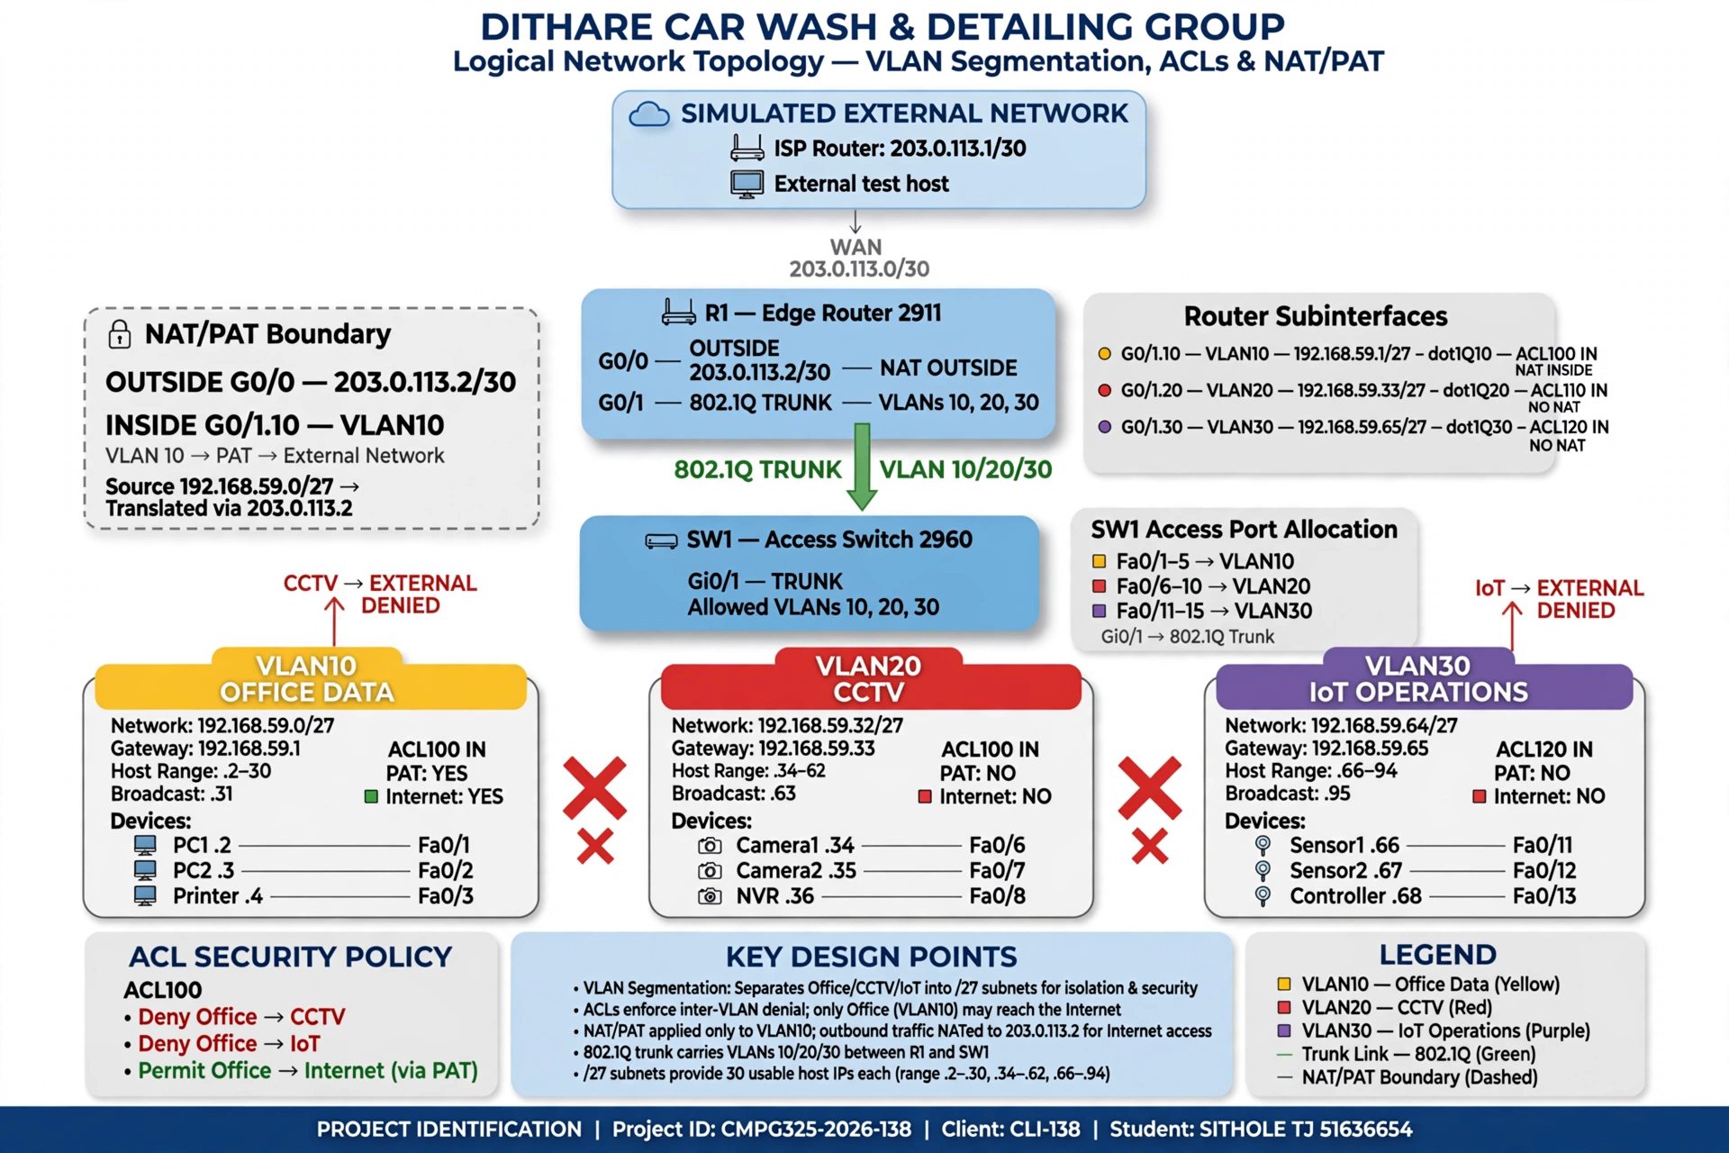
Figure 2. Logical topology showing the VLAN subnets, gateway subinterfaces, NAT boundary, and ACL policy.

2.1 Design Decisions
Decision | Reason
One router and one access switch | A small single-site network can be implemented without adding unnecessary infrastructure.
Three equal /27 subnets | The address plan is straightforward to administer and leaves five /27 blocks available in the /24.
Router-on-a-stick | One trunk carries VLANs 10, 20, and 30 to R1, where each VLAN has a gateway subinterface.
Inbound ACL per VLAN | Each source segment has a defined Layer 3 control point for the required restrictions.
Office-only PAT | Office hosts need external access; CCTV and IoT do not. ACL 10 matches only the Office /27.

3 Addressing and Device Inventory
VLAN | Purpose | Network / mask | Gateway | Assigned hosts
10 | Office_Data | 192.168.59.0/27 | 192.168.59.1 | PC1 .2; PC2 .3; Printer .4
20 | CCTV | 192.168.59.32/27 | 192.168.59.33 | Camera1 .34; Camera2 .35; NVR .36
30 | IoT_Operations | 192.168.59.64/27 | 192.168.59.65 | Sensor1 .66; Sensor2 .67; IoT-Controller .68

Each subnet uses mask 255.255.255.224 and provides 30 usable host addresses. The simulated WAN links use 203.0.113.0/30 between R1 and ISP, then 203.0.113.4/30 between ISP and External-PC.
Device | Model or type | Address / role | Connection
R1 | Cisco 2911 | G0/0 203.0.113.2/30; VLAN gateways .1, .33, .65 | G0/0 to ISP; G0/1 trunk to SW1
SW1 | Catalyst 2960-24TT | Access switch; VLANs 10, 20, 30 | Gi0/1 trunk to R1
ISP | Cisco 2911 | 203.0.113.1/30 and 203.0.113.5/30 | Upstream simulation
External-PC | PC-PT | 203.0.113.6/30; gateway .5 | ISP G0/1
Office hosts | PCs and printer | 192.168.59.2-.4 | SW1 Fa0/1-Fa0/3
CCTV hosts | Webcams and Server-PT NVR | 192.168.59.34-.36 | SW1 Fa0/6-Fa0/8
IoT endpoints | Temperature and motion sensors | 192.168.59.66-.67; SSID IoT-Net | Wireless to IoT-Controller
IoT-Controller | DLC100 HomeGateway | LAN address 192.168.59.68 | SW1 Fa0/13; wireless IoT network

4 Packet Tracer Implementation

4.1 Switch VLANs and trunk
SW1 has VLAN 10 Office_Data, VLAN 20 CCTV, and VLAN 30 IoT_Operations. Fa0/1-Fa0/5 are access ports in VLAN 10; Fa0/6-Fa0/10 are in VLAN 20; Fa0/11-Fa0/15 are in VLAN 30. Gi0/1 is an 802.1Q trunk that allows VLANs 10, 20, and 30.

4.2 Router gateways and routing
R1 interface | Address | Tag and policy
G0/0 | 203.0.113.2/30 | NAT outside
G0/1.10 | 192.168.59.1/27 | dot1Q 10; NAT inside; ACL 100 inbound
G0/1.20 | 192.168.59.33/27 | dot1Q 20; ACL 110 inbound
G0/1.30 | 192.168.59.65/27 | dot1Q 30; ACL 120 inbound

The physical LAN interface G0/1 is unnumbered and carries the VLAN tags. R1's static default route is 0.0.0.0/0 via 203.0.113.1.

4.3 NAT/PAT
R1 uses access list 10 to select Office traffic and overloads the G0/0 address for translations. The inside interface is G0/1.10; the outside interface is G0/0. The CCTV and IoT subinterfaces are not configured as NAT inside interfaces.
access-list 10 permit 192.168.59.0 0.0.0.31
ip nat inside source list 10 interface GigabitEthernet0/0 overload

4.4 Traffic policy
ACL | Applied inbound on | Permitted and denied traffic
100 | R1 G0/1.10 (Office) | Denies Office to CCTV and IoT; permits Office to other destinations.
110 | R1 G0/1.20 (CCTV) | Permits the CCTV subnet to itself; denies CCTV to Office, IoT, and all other destinations.
120 | R1 G0/1.30 (IoT) | Permits the IoT subnet to itself; denies IoT to Office, CCTV, and all other destinations.

Same-VLAN traffic is switched by SW1 and does not pass through the router ACL. The same-subnet permit entries in ACLs 110 and 120 apply only to traffic that reaches R1.

5 Verification Method and Results
The final verification checks were performed in Packet Tracer on 16 October 2026. Testing was performed in a Save As copy so the original project remained untouched. A temporary test PC was connected to SW1 Fa0/14 in VLAN 30 with address 192.168.59.70/27 and gateway 192.168.59.65. It was removed after the tests.
Check | Expected | Observed result
SW1 show vlan brief | VLANs 10, 20, 30 active with planned access ports | Pass. All three active with Fa0/1-5, Fa0/6-10, Fa0/11-15.
SW1 show interfaces trunk | Gi0/1 trunking; VLANs 10, 20, 30 forwarding | Pass. 802.1Q trunk up; allowed, active, and forwarding VLANs 10, 20, 30.
R1 show ip interface brief | WAN and all VLAN gateway interfaces up/up | Pass. G0/0 and G0/1.10, .20, .30 up/up with expected IPs.
R1 show ip route | Connected /27s and default route to ISP | Pass. Three LAN routes connected; default route via 203.0.113.1.
PC1 to External-PC | Office access through PAT | Pass on repeat: 4 sent, 4 received, 0% loss. Initial attempt was 2/4.
R1 NAT translations after ping | Office local address translated to R1 outside address | Pass. Four ICMP entries showed 192.168.59.2 translated to 203.0.113.2 for 203.0.113.6.
PC1 to Camera1 | Blocked by ACL 100 | Pass. 0/4; R1 192.168.59.1 returned destination unreachable.
PC1 to Sensor1 | Blocked by ACL 100 | Pass. 0/4; R1 192.168.59.1 returned destination unreachable.
NVR to Camera1 | Allowed within CCTV | Pass. 4/4 replies; 0% loss.
NVR to PC1 | Blocked by ACL 110 | Pass. 0/4; R1 192.168.59.33 returned destination unreachable.
NVR to External-PC | Blocked by ACL 110 | Pass. 0/4; R1 192.168.59.33 returned destination unreachable.
Temporary VLAN 30 PC to gateway | Allowed to R1 VLAN 30 gateway | Pass. 4/4 replies; 0% loss.
Temporary VLAN 30 PC to Office, CCTV, and external host | Blocked by ACL 120 | Pass. Each target 0/4; R1 192.168.59.65 returned destination unreachable.

5.1 ACL Counters
After the tests, show access-lists reported four matches on each ACL 100 Office deny rule. ACL 110 showed four matches on its CCTV-to-Office deny. ACL 120 showed four matches each for deny-to-Office, deny-to-CCTV, and deny-to-any; its same-subnet permit had four matches for the successful gateway ping. The counters support that the failed cross-segment pings were denied by the intended ACLs.

5.2 NAT Evidence
The translation table after PC1's successful external ping showed ICMP entries with inside-local 192.168.59.2, inside-global 203.0.113.2, and outside host 203.0.113.6. The portfolio's Milestone 2 NAT statistics screenshot records G0/1.10 as inside and G0/0 as outside. Dynamic entries may expire after traffic stops, so fresh traffic should be generated before demonstrating the table.
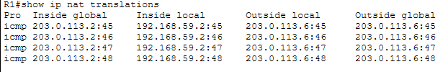
Figure 3. Existing portfolio evidence of dynamic NAT translations for Office traffic.
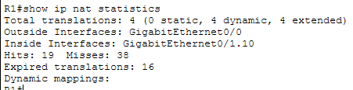
Figure 4. Existing portfolio evidence showing the NAT inside and outside interfaces.

6 Troubleshooting and Operational Notes
Issue or observation | Action | Outcome
Camera2 did not initially operate on the intended CCTV connection. | Removed its conflicting wireless configuration and set 192.168.59.35/27 on its wired interface with gateway 192.168.59.33. | The NVR later reached Camera2 in the Milestone 2 test record.
Initial external ping had packet loss. | Repeated PC1-to-External-PC ping and checked the NAT translation table. | The repeat test returned 4/4 replies and translations were present.
NAT table can appear empty after waiting. | Generated fresh Office traffic before inspecting the table. | Dynamic ICMP translations appeared.
ACL 120 needed a real VLAN 30 source for verification. | Used a temporary host on SW1 Fa0/14, tested gateway and denied destinations, then removed it. | Gateway passed; Office, CCTV, and external pings were denied; ACL counters increased.

Testing was based on IPv4 ICMP reachability and IOS counters. The results confirm the tested path and policy behavior; they do not test every application protocol.
The IoT controller is assigned 192.168.59.68/27 and the sensors use the IoT-Net wireless profile in the saved design. The live ACL test used a temporary VLAN 30 PC at 192.168.59.70. It verified gateway reachability and the listed ACL restrictions, but did not verify sensor registration or application-level sensor data exchange with the controller.

7 Conclusion
The implemented network meets the requirements covered by the recorded tests. The VLANs and trunk are operational, R1 routes the assigned LAN subnets and forwards default traffic to the ISP, and Office traffic reaches the simulated external host using PAT. ACLs 100, 110, and 120 enforce the tested Office, CCTV, and IoT restrictions. Office and CCTV internal connectivity was demonstrated, and the temporary VLAN 30 host reached its gateway before ACL 120 blocked its tested traffic to other segments and the external host.
The final Packet Tracer project, GitHub portfolio, this technical report, and the individual inset-webcam video form the final submission package. The video should demonstrate the same configuration and outcomes described here.

8 Project Reflection
This project showed why network segmentation needs both VLAN configuration and Layer 3 policy. VLANs separated the broadcast domains, while the inbound ACLs controlled traffic routed between them. NAT testing also required generating traffic and inspecting the translations, because a dynamic table is not permanent.
The troubleshooting work helped isolate specific causes. Camera2's interface configuration was corrected, the first external ping was repeated before drawing a conclusion, and a temporary VLAN 30 host provided a real source for testing ACL 120. The test host was removed after verification so it would not become part of the submitted topology.
A useful next improvement would be to record the IoT sensor-to-controller association and a sensor-data exchange test, then capture clear screenshots of those results. Before submission, I will review this reflection and adjust it to match my own experience and understanding.

Appendix A Command Reference
The following commands were used to verify the submitted Packet Tracer implementation:
SW1# show vlan brief
SW1# show interfaces trunk
R1# show ip interface brief
R1# show ip route
R1# show access-lists
R1# show ip nat translations
R1# show ip nat statistics

Endpoint tests used Packet Tracer Desktop Command Prompt. The principal targets were PC2 192.168.59.3, Camera1 192.168.59.34, Sensor1 192.168.59.66, R1 gateways 192.168.59.1/.33/.65, and External-PC 203.0.113.6.

