CMPG 325 — Computer Networks
Milestone 1 — Client Design Review
Dithare Car Wash & Detailing Group (Potchefstroom)
Project ID | CMPG325-2026-138 | Client ID | CLI-138
Student | SITHOLE, TJ (51636654) | Industry | Automotive
Assigned Feature | NAT (inside/outside translation) | Addressing Block | 192.168.59.0/24

1. Client Requirements
Dithare Car Wash & Detailing Group operates a single-site car wash and detailing facility in Potchefstroom. The site requires a network supporting office operations, a CCTV security system, and newly introduced IoT operational equipment (CR12), with appropriate segmentation between the three traffic types.
- Office / front-of-house — staff PCs and a printer supporting bookings and administration.
- Security (CCTV) — cameras covering the wash bays, yard and reception, recording to a local NVR.
- Operations — IoT sensors and a controller monitoring equipment, water usage and bay occupancy (CR12).

1.1 Functional Requirements
- R1 — Office devices must have LAN connectivity and access to the simulated external network.
- R2 — CCTV traffic must be segmented from office data traffic (design constraint).
- R3 — IoT sensors in the operations area must be placed on their own isolated segment (CR12).
- R4 — Internal private addresses must be translated to an outside address for traffic leaving the network (assigned NAT challenge).
- R5 — The network must be built and demonstrated in Cisco Packet Tracer using 192.168.59.0/24.
- R6 — The design must be testable end-to-end with appropriate evidence captured.

1.2 Design Constraint
CCTV traffic must be segmented from office data traffic. VLAN 20 (CCTV) is a dedicated VLAN and subnet, with no NAT/internet access. Because R1 would otherwise route directly between connected VLANs, an access control list (ACL) is applied on each router subinterface to enforce the required denial of inter-VLAN traffic — VLANs alone provide Layer 2 separation but not Layer 3 enforcement.

1.3 Change Request — CR12
IoT sensors added to the operations area need an isolated segment. VLAN 30 (IoT/Operations) is a dedicated VLAN and subnet, separate from Office and CCTV, enforced the same way via ACL120 on its router subinterface, with no external access.

1.4 Assigned Networking Challenge — NAT
Edge router R1 is configured with NAT overload (PAT) so Office devices (VLAN 10 only) share R1's outside interface address when reaching the simulated external network. CCTV and IoT/Operations are deliberately excluded from the NAT inside source list, since neither has a business requirement for external access — reinforcing the segmentation constraint and CR12 while satisfying the assigned NAT challenge.
A separate ACL (ACL 10) matches only the Office subnet for NAT translation, kept numerically distinct from the segmentation ACLs (ACL100/110/120) to avoid configuration ambiguity:
access-list 10 permit 192.168.59.0 0.0.0.31
ip nat inside source list 10 interface GigabitEthernet0/0 overload

2. Physical Topology
The physical design uses a single on-site comms point: one edge router (R1) and one access switch (SW1), appropriate for a single small automotive site. R1's G0/1 connects to SW1's Gi0/1 as a single 802.1Q trunk carrying VLANs 10, 20 and 30; R1's G0/0 connects to the simulated ISP as the NAT outside boundary. Standardised access-port ranges (Fa0/1–5 Office, Fa0/6–10 CCTV, Fa0/11–15 IoT) keep documentation, troubleshooting and the Packet Tracer build consistent, with several ports per segment reserved for future devices.
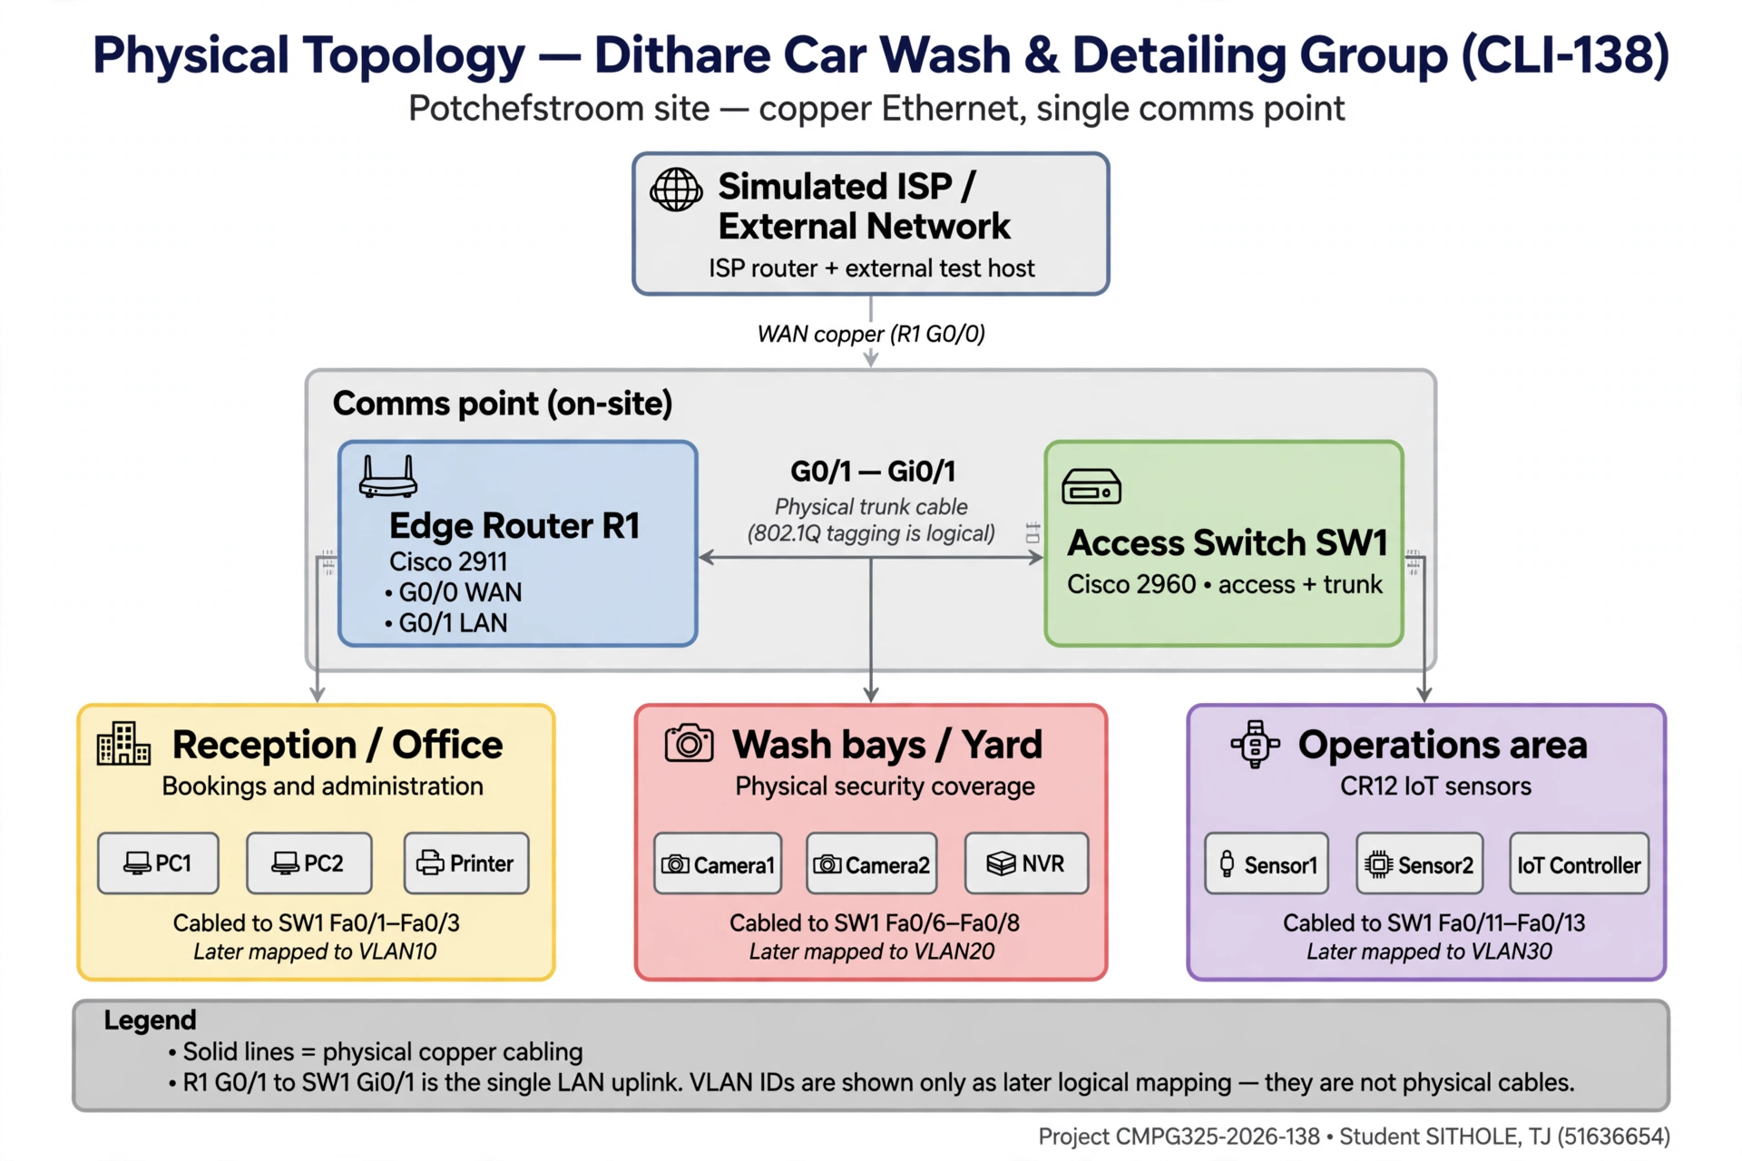
Figure 1 — Physical topology: single router + single access switch

2.1 Device List
Device | Model (Packet Tracer) | Role
R1 | Cisco 2911 | Edge router: router-on-a-stick inter-VLAN routing, NAT/PAT (Office only), ACL enforcement
SW1 | Cisco 2960 | Single access switch; VLANs 10/20/30; Gi0/1 802.1Q trunk to R1
Office (Fa0/1–5) | PC ×2, Printer | PC1 .2, PC2 .3, Printer .4 — bookings/administration; Fa0/4–5 reserved
CCTV (Fa0/6–10) | IP Camera ×2, Server-PT as NVR | Camera1 .34, Camera2 .35, NVR .36 — wash bay/yard/reception coverage; Fa0/9–10 reserved
IoT/Ops (Fa0/11–15) | IoT-PT sensors ×2, IoT server/SBC | Sensor1 .66, Sensor2 .67, IoT Controller .68 — CR12 segment; Fa0/14–15 reserved
ISP router + test host | Cisco 2911 / generic | Simulated external network for NAT outside testing

3. Logical Topology
R1 uses router-on-a-stick sub-interfaces (G0/1.10, G0/1.20, G0/1.30) for inter-VLAN routing, with an inbound ACL on each subinterface enforcing segmentation, and NAT/PAT applied only on the Office path. No dynamic routing protocol is required since all internal networks are directly connected to R1.
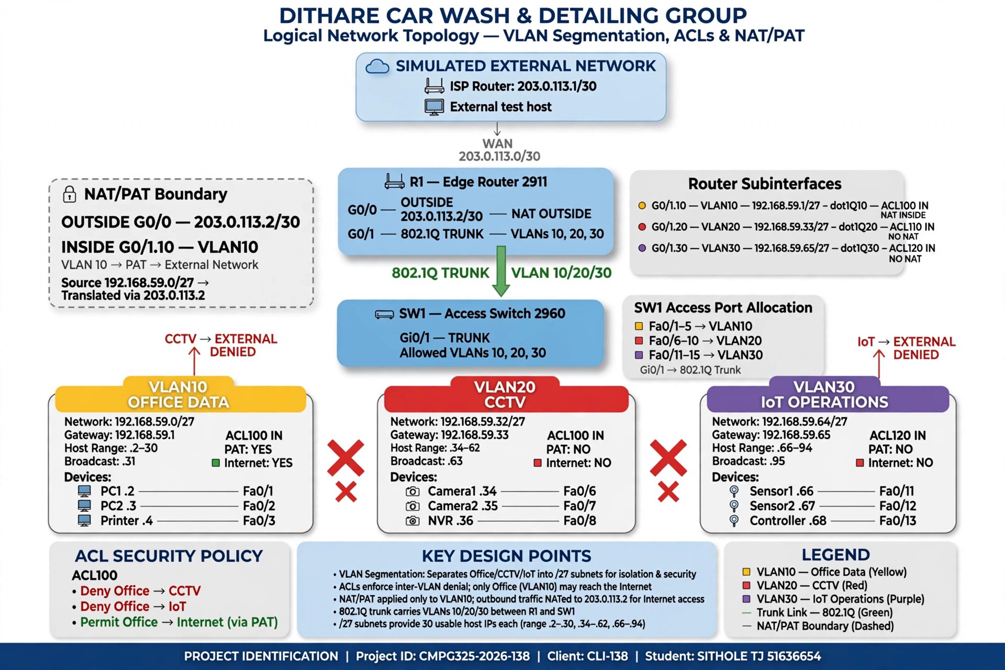
Figure 2 — Logical topology: VLANs, subnets, ACLs and NAT/PAT boundary

3.1 Traffic Segmentation Policy
- Office → Internet: ALLOW (via NAT/PAT). Office → CCTV: DENY. Office → IoT/Operations: DENY.
- CCTV → Office, IoT/Operations, Internet: DENY. Same-VLAN CCTV traffic: ALLOW (camera ↔ NVR).
- IoT/Operations → Office, CCTV, Internet: DENY. Same-VLAN IoT traffic: ALLOW (sensors ↔ controller).
- Enforcement: ACL100 inbound on G0/1.10, ACL110 inbound on G0/1.20, ACL120 inbound on G0/1.30 — a source-side control point on every VLAN, not only on CCTV/IoT.

4. IP Addressing Plan
The assigned block 192.168.59.0/24 is divided into equal /27 subnets (30 usable hosts each) — sufficient for the representative device set on each segment while keeping the scheme simple to verify, with five /27 blocks left unallocated for future growth (e.g. a management or guest segment) without renumbering the live subnets.

VLAN | Purpose | Network / Mask | Gateway | Usable Range | Hosts
10 | Office Data — PC1, PC2, Printer | 192.168.59.0/27 | 192.168.59.1 | .2 - .30 | 30
20 | CCTV — Camera1, Camera2, NVR (segmented, no internet) | 192.168.59.32/27 | 192.168.59.33 | .34 - .62 | 30
30 | IoT / Operations — Sensor1, Sensor2, IoT Controller (CR12, isolated) | 192.168.59.64/27 | 192.168.59.65 | .66 - .94 | 30
— | Reserved (5 × /27) for future growth | 192.168.59.96/27 – .224/27 | — | — | 150

4.1 WAN / NAT Outside Addressing
Link | Address | Notes
R1 G0/0 (outside) | 203.0.113.2/30 | NAT outside; documentation prefix TEST-NET-3, outside the assigned /24.
ISP router (G0/0) | 203.0.113.1/30 | Simulated upstream gateway; R1 default route points here.

Default route on R1: ip route 0.0.0.0 0.0.0.0 203.0.113.1. NAT will be verified in Milestone 2 with show ip nat translations and show ip nat statistics — Office traffic should produce translations; CCTV and IoT/Operations traffic should not, since neither is a NAT inside source.

5. Initial GitHub Repository
An individual GitHub repository holds the Milestone 1 portfolio of evidence, structured as follows:
- README.md — project overview, design-at-a-glance, milestone table and timeline.
- 01_Client_Requirements/ — requirements, constraints, design decisions and traceability (Markdown).
- 02_Physical_Topology/ — physical_topology.md, .png and .svg (source).
- 03_Logical_Topology/ — logical_topology.md, .png and .svg (source).
- 04_IP_Addressing/ — IP_Addressing_Plan.md, the addressing source of truth.
- 05_Packet_Tracer/, 06_Configuration/, 07_Testing/ — reserved for Milestone 2 (.pkt file, device configs, test evidence).
- 08_Screenshots/, 09_Troubleshooting/, 10_Reflection/ — reserved for later milestones and final submission.
Each document carries its own version history (document control table), with Milestone 1 content locked at v2.0 (physical) and v1.5 (logical) after corrections to NAT wording, port allocation and ACL numbering were resolved through iterative commits.

6. Design Decisions — Summary Justification
- One router + one switch: appropriate for a single small automotive site; avoids unnecessary hardware and stays within the brief's scope (no extra VLANs or a management VLAN introduced).
- Equal /27 subnetting: simpler to document and troubleshoot than VLSM here, since Office, CCTV and IoT are similar in scale for this simulation, while still leaving five /27s free for growth.
- ACL-based segmentation on all three subinterfaces: VLANs alone only provide Layer 2 separation; router-on-a-stick would otherwise route freely between them, so ACL100/110/120 give an explicit, verifiable source-side enforcement point per VLAN.
- Office-only NAT/PAT with a dedicated NAT-matching ACL (ACL10), numerically separate from the segmentation ACLs, avoiding configuration ambiguity between address translation and traffic-segmentation policy.

7. GitHub Repository Link
https://github.com/Thato-J4/CMPG325-2026-138_Dithare-Network-Design/tree/main/CMPG325-2026-138_SITHOLE-TJ

