CMPG 325 — Computer Networks
Milestone 2 — Client Implementation Review
Dithare Car Wash & Detailing Group (Potchefstroom)
Project ID | CMPG325-2026-138
Client ID | CLI-138
Student | SITHOLE, TJ (51636654)
Organisation | Dithare Car Wash & Detailing Group (Potchefstroom)
Industry | Automotive
Addressing block | 192.168.59.0/24
Assigned challenge | NAT (inside/outside address translation)
Design constraint | CCTV traffic segmented from office data traffic
Change request | CR12 — IoT sensors need an isolated segment
Submission date | 2 October 2026

1. Milestone 2 Objective
Milestone 1 delivered the client requirements, the physical and logical topologies and the IP addressing plan. Milestone 2 turns that approved design into a working Cisco Packet Tracer network. This document shows that the network has been built as designed, that the assigned NAT challenge is implemented, and that connectivity, segmentation and NAT behave as required, backed by testing evidence.
Items submitted for this milestone:
- The working Packet Tracer file: CMPG325-2026-138_Dithare-Network-Final.pkt
- This document, covering the implementation, the NAT feature, testing evidence and troubleshooting
- The updated GitHub portfolio (link in Section 8)

2. Implemented Network

2.1 Topology and devices
The network uses one edge router (R1, Cisco 2911) and one access switch (SW1, Cisco 2960). R1 connects to a simulated ISP (a second 2911) that leads to an External-PC used to test traffic leaving the site. R1 and SW1 are joined by a single 802.1Q trunk, and R1 performs inter-VLAN routing with router-on-a-stick sub-interfaces. The VLAN, addressing and routing design follows Milestone 1. The IoT sensor connectivity is implemented wirelessly in Packet Tracer as described in Section 6.
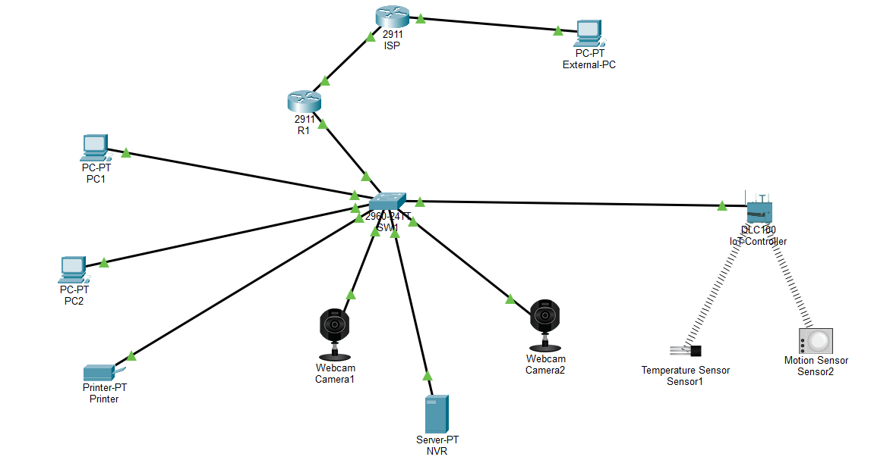
Figure 1: Final Packet Tracer topology

2.2 VLANs and addressing
VLAN | Purpose | Subnet | Gateway (R1) | Devices
10 | Office Data | 192.168.59.0/27 | 192.168.59.1 | PC1 .2, PC2 .3, Printer .4
20 | CCTV | 192.168.59.32/27 | 192.168.59.33 | Camera1 .34, Camera2 .35, NVR .36
30 | IoT / Operations (CR12) | 192.168.59.64/27 | 192.168.59.65 | Sensor1 .66, Sensor2 .67, IoT Controller .68

WAN link | Device / interface | Address
R1 — ISP | R1 G0/0 (NAT outside) | 203.0.113.2/30
R1 — ISP | ISP G0/0 | 203.0.113.1/30
ISP — External-PC | ISP G0/1 | 203.0.113.5/30
ISP — External-PC | External-PC (gateway 203.0.113.5) | 203.0.113.6/30

SW1 ports are allocated as Fa0/1–5 for VLAN 10, Fa0/6–10 for VLAN 20 and Fa0/11–15 for VLAN 30, with Gi0/1 as the trunk to R1. The next two screenshots show the VLAN table and the trunk, which carries VLANs 10, 20 and 30 only.
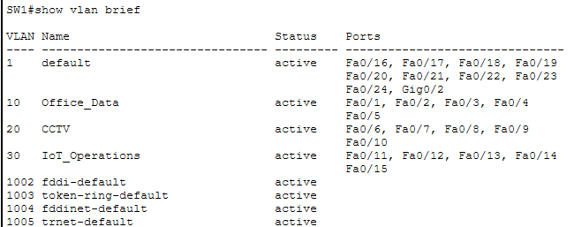
Figure 2: SW1 show vlan brief
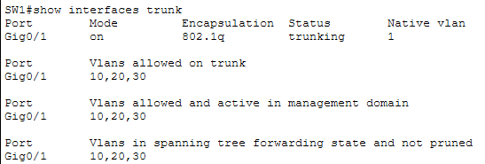
Figure 3: SW1 show interfaces trunk (Gi0/1, 802.1Q, VLANs 10, 20, 30)

2.3 Router interfaces and routing
R1 has no IP address on its physical LAN port. Each VLAN gateway is a subinterface (G0/1.10, G0/1.20, G0/1.30) with the matching dot1Q tag. R1 learns the three internal subnets and the WAN subnet as connected routes, and a static default route points to the ISP. Output from the final network:
R1#show ip interface brief
GigabitEthernet0/0 203.0.113.2 YES manual up up
GigabitEthernet0/1 unassigned YES unset up up
GigabitEthernet0/1.10 192.168.59.1 YES manual up up
GigabitEthernet0/1.20 192.168.59.33 YES manual up up
GigabitEthernet0/1.30 192.168.59.65 YES manual up up

R1#show ip route (extract)
C 192.168.59.0/27 is directly connected, GigabitEthernet0/1.10
C 192.168.59.32/27 is directly connected, GigabitEthernet0/1.20
C 192.168.59.64/27 is directly connected, GigabitEthernet0/1.30
C 203.0.113.0/30 is directly connected, GigabitEthernet0/0
S* 0.0.0.0/0 [1/0] via 203.0.113.1

3. Assigned Challenge — NAT / PAT

3.1 What was configured and why
The assigned challenge is NAT (inside/outside address translation). R1 is configured with PAT (NAT overload), so Office devices share R1's single outside address, 203.0.113.2, when they reach the simulated external network. This suits the client because the Office subnet uses private addresses that cannot be routed on the external side, and one public-facing address is enough for the whole Office VLAN.
NAT is deliberately limited to the Office VLAN. CCTV and IoT/Operations have no business need for external access, so they are not NAT inside sources. This supports the design constraint and CR12 and keeps those segments off the external network.

3.2 Configuration
interface GigabitEthernet0/0
ip address 203.0.113.2 255.255.255.252
ip nat outside
!
interface GigabitEthernet0/1.10
encapsulation dot1Q 10
ip address 192.168.59.1 255.255.255.224
ip nat inside
ip access-group 100 in
!
access-list 10 permit 192.168.59.0 0.0.0.31
ip nat inside source list 10 interface GigabitEthernet0/0 overload
ip route 0.0.0.0 0.0.0.0 203.0.113.1

G0/0 is the only NAT outside interface and G0/1.10 is the only NAT inside interface. ACL 10 is a separate, NAT-only ACL that matches the Office subnet; it is kept apart from the segmentation ACLs (100, 110, 120) so that translation and security policy are never confused.

3.3 Verification
Verification used a ping from PC1 (192.168.59.2) to External-PC (203.0.113.6), followed immediately by the NAT tables on R1. The translation table shows PC1's inside local address 192.168.59.2 translated to the inside global address 203.0.113.2, with 203.0.113.6 as the outside host. The statistics confirm G0/0 as outside, G0/1.10 as inside, and dynamic extended (PAT) entries.
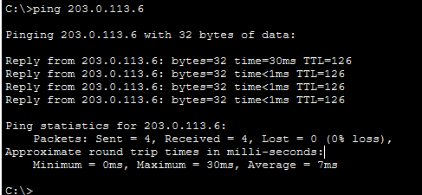
Figure 4: PC1 ping to External-PC (203.0.113.6), 4 of 4 replies
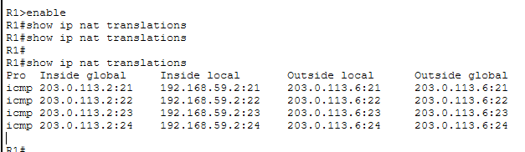
Figure 5: R1 show ip nat translations — PC1 (192.168.59.2) translated to 203.0.113.2
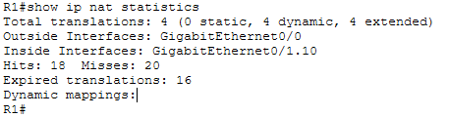
Figure 6: R1 show ip nat statistics — inside G0/1.10, outside G0/0, dynamic extended translations
NAT entries age out when traffic stops, so an empty table after a pause is normal. Fresh traffic was generated before each capture.

4. Network Segmentation
VLANs separate the three traffic types at Layer 2, but R1 would still route between them. Each subinterface therefore has an inbound ACL as a source-side control point.
ACL | Applied inbound on | Behaviour | Purpose
100 | G0/1.10 (Office) | Deny Office to CCTV; deny Office to IoT; permit Office to everything else | Office reaches the Internet via PAT only
110 | G0/1.20 (CCTV) | Permit own subnet; deny CCTV to Office, IoT and any other destination | Design constraint: CCTV isolated
120 | G0/1.30 (IoT) | Permit own subnet; deny IoT to Office, CCTV and any other destination | CR12: IoT isolated

Traffic within a VLAN, for example camera to NVR or sensor to controller, is switched by SW1 and never reaches R1, so it is unaffected by the ACLs. The permit line at the top of ACLs 110 and 120 allows traffic whose destination is within the same VLAN subnet. Traffic destined for the other internal segments or external networks is subsequently denied:
access-list 100 deny ip 192.168.59.0 0.0.0.31 192.168.59.32 0.0.0.31
access-list 100 deny ip 192.168.59.0 0.0.0.31 192.168.59.64 0.0.0.31
access-list 100 permit ip 192.168.59.0 0.0.0.31 any
access-list 110 permit ip 192.168.59.32 0.0.0.31 192.168.59.32 0.0.0.31
access-list 110 deny ip 192.168.59.32 0.0.0.31 192.168.59.0 0.0.0.31
access-list 110 deny ip 192.168.59.32 0.0.0.31 192.168.59.64 0.0.0.31
access-list 110 deny ip 192.168.59.32 0.0.0.31 any
access-list 120 permit ip 192.168.59.64 0.0.0.31 192.168.59.64 0.0.0.31
access-list 120 deny ip 192.168.59.64 0.0.0.31 192.168.59.0 0.0.0.31
access-list 120 deny ip 192.168.59.64 0.0.0.31 192.168.59.32 0.0.0.31
access-list 120 deny ip 192.168.59.64 0.0.0.31 any

interface GigabitEthernet0/1.10 : ip access-group 100 in
interface GigabitEthernet0/1.20 : ip access-group 110 in
interface GigabitEthernet0/1.30 : ip access-group 120 in

5. Testing and Verification
Each test below has an expected result. A blocked test is a pass only when the ACL counters show that the deny rule matched the traffic, which rules out a wrong address or a disconnected cable.

5.1 Connectivity inside each segment
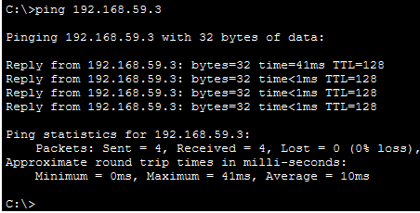
Figure 7: Office: PC1 to PC2 (192.168.59.3), 4 of 4 replies
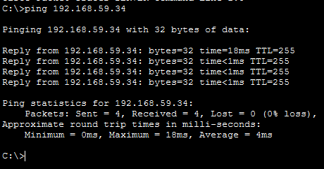
Figure 8: CCTV: NVR to Camera1 (192.168.59.34), same VLAN, 4 of 4 replies
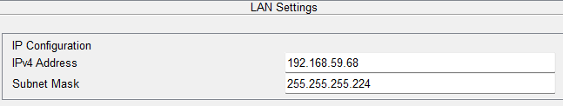
Figure 9: IoT Controller LAN settings: 192.168.59.68 / 255.255.255.224, inside the VLAN 30 subnet
The IoT Controller is configured with address 192.168.59.68/27, placing it inside the VLAN 30 IoT/Operations subnet. The sensors connect to the controller wirelessly, as described in the deviation note in Section 6.

5.2 Traffic that must be blocked
Office to CCTV and Office to IoT were tested from PC1. R1 answers "Destination host unreachable" from the Office gateway 192.168.59.1, which is the ACL 100 deny in action. The CCTV test in Figure 12 shows the same behaviour from the CCTV side, with the reply coming from the CCTV gateway 192.168.59.33.
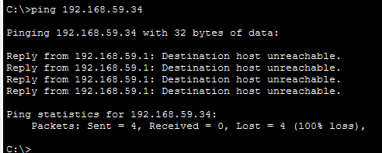
Figure 10: Office to CCTV: PC1 to 192.168.59.34 blocked (ACL 100)
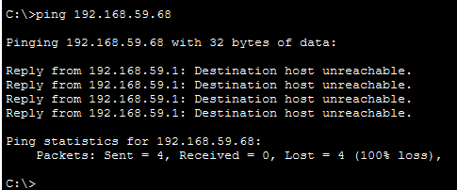
Figure 11: Office to IoT: PC1 to 192.168.59.68 blocked (ACL 100)
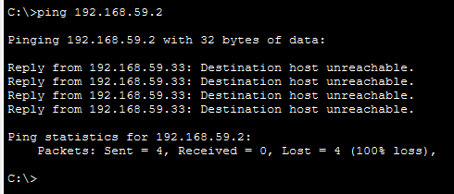
Figure 12: CCTV isolation: ping to 192.168.59.2 blocked (ACL 110)
IoT isolation was tested from a temporary host on SW1 Fa0/14 in VLAN 30 (192.168.59.69, gateway 192.168.59.65), removed after testing. All three replies come from the IoT gateway 192.168.59.65, which is the ACL 120 deny.
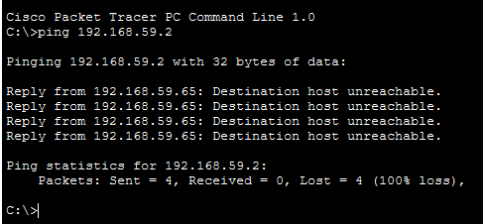
Figure 13a: VLAN 30 test host to Office (PC1, 192.168.59.2): blocked
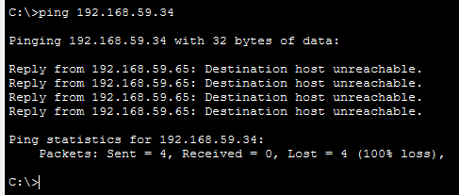
Figure 13b: VLAN 30 test host to CCTV (Camera1, 192.168.59.34): blocked
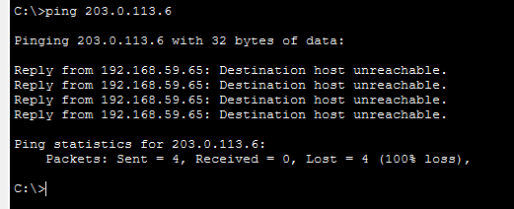
Figure 13c: VLAN 30 test host to External-PC (203.0.113.6): blocked

5.3 ACL counters
The ACL counters on R1 show the deny rules matching the test traffic. This rules out a wrong address or a disconnected cable as the cause of the failed pings.
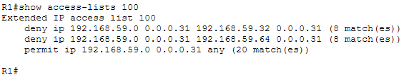
Figure 14a: ACL 100: 8 matches on Office-to-CCTV deny, 8 on Office-to-IoT deny, 20 on the permit (Office to External-PC)
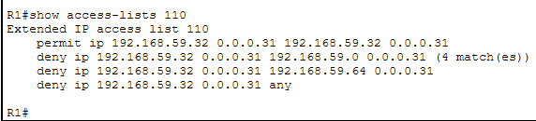
Figure 14b: ACL 110: deny CCTV-to-Office matched 4 times after the CCTV isolation test
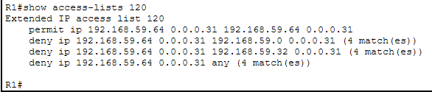
Figure 14c: ACL 120: 4 matches each on the deny to Office, CCTV and any other destination

5.4 Test results summary
Test | Expected | Result | Evidence
PC1 to PC2 | Allowed | Pass (4/4) | Figure 7
NVR to Camera1 | Allowed | Pass (4/4) | Figure 8
NVR to Camera2 | Allowed | Pass (4/4) | Testing log
R1 to IoT Controller | Allowed | Pass (5/5 on repeat) | Testing log
IoT Controller in VLAN 30 subnet | Required | Configured | Figure 9
PC1 to External-PC | Allowed via PAT | Pass (4/4) | Figures 4, 5
PC1 to Camera1 | Blocked | Pass (0/4) | Figure 10, 14a
PC1 to IoT Controller | Blocked | Pass (0/4) | Figure 11, 14a
CCTV to Office | Blocked | Pass (0/4) | Figures 12, 14b
VLAN 30 host to Office, CCTV, External-PC | Blocked | Pass (0/4 each) | Figures 13a-c, 14c
NAT translation for PC1 | Required | Pass | Figures 5, 6
NAT inside / outside interfaces | G0/1.10 / G0/0 | Verified | Figure 6

Full test logs, including the NVR and temporary-host results, are in 07_Testing of the GitHub portfolio.

6. Troubleshooting and Implementation Notes
Issue | Action | Result
Camera2 would not work on the CCTV network | Found a conflicting wireless configuration; cleared it and set 192.168.59.35 on the wired interface | NVR to Camera2 4 of 4
First ping to a host sometimes lost a packet | Normal ARP resolution on the first packet; repeated the test | 5 of 5 and 4 of 4 on repeat
NAT table empty after a pause | NAT entries expire when traffic stops; generated fresh traffic first | Translations appeared
ACL 120 needed a real VLAN 30 source | Added a temporary host on Fa0/14 (192.168.59.69), tested, then removed it | Isolation confirmed; host not in the final topology

Deviation from Milestone 1: the Milestone 1 plan listed the sensors and controller on separate switch ports. In Packet Tracer the IoT sensors connect wirelessly to the IoT Controller, and only the controller is cabled to SW1 (Fa0/13, VLAN 30). The addressing and VLAN design are unchanged. Two further notes: there is no dedicated management VLAN, as stated in Milestone 1, and a CCTV test that succeeds (NVR to Camera1) is internal to VLAN 20 and not an Office to CCTV path.

7. Results Summary
- R1, SW1, the ISP and all end devices are implemented with the VLAN, addressing and trunk design from Milestone 1.
- PAT works for the Office VLAN only: PC1 is translated to 203.0.113.2 and reaches External-PC.
- CCTV is segmented from office data, and ACLs 100, 110 and 120 enforce the configured isolation between the Office, CCTV and IoT segments. CR12 is met by VLAN 30 (192.168.59.64/27) with ACL 120 and no external access.

8. GitHub Portfolio
The portfolio holds the requirements, topologies, IP plan, final .pkt, configuration, testing, troubleshooting and evidence screenshots, with commits that show development over time.
https://github.com/Thato-J4/CMPG325-2026-138_Dithare-Network-Design/tree/main/CMPG325-2026-138_SITHOLE-TJ

9. Conclusion
The Milestone 1 network design has been implemented in Cisco Packet Tracer with the required VLAN structure, addressing plan, router-on-a-stick configuration and simulated external network. The assigned NAT challenge has been implemented using PAT/NAT overload, with PC1 successfully translated from 192.168.59.2 to R1's outside address 203.0.113.2 when communicating with External-PC. The testing evidence also demonstrates the intended Office-to-CCTV and Office-to-IoT restrictions, as well as the isolation policies applied to the CCTV and IoT segments. CR12 is addressed through the isolated IoT/Operations VLAN 30. The Packet Tracer implementation, testing evidence, troubleshooting record and updated GitHub portfolio provide the required Milestone 2 implementation record.

