Mocha functions:

it: Run a test and make an assertion

describe: Groups together, ‘it’ functions

beforeEach: Execute some general setup code

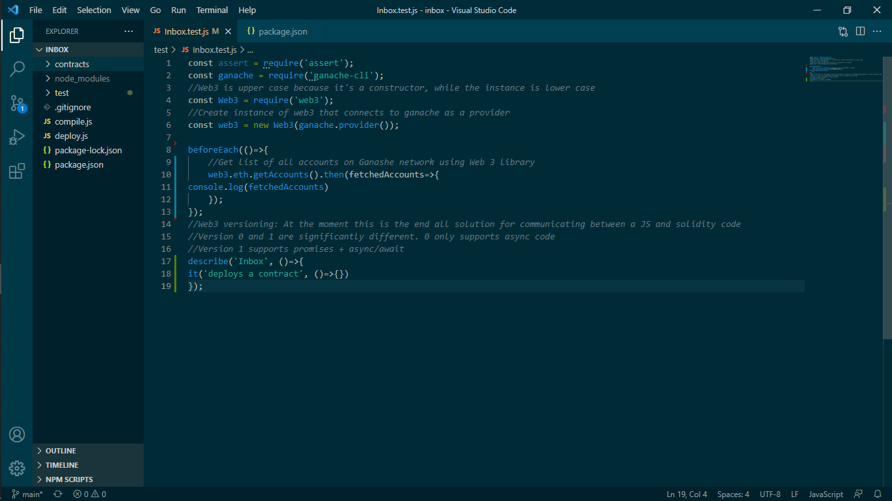

Access accounts on Ganache network and console.log them using PROMISES (.then)