CS414.A3 Assignment 3

Richard Humphrey, rjh2h

September 29, 2014

**Domain Model:**

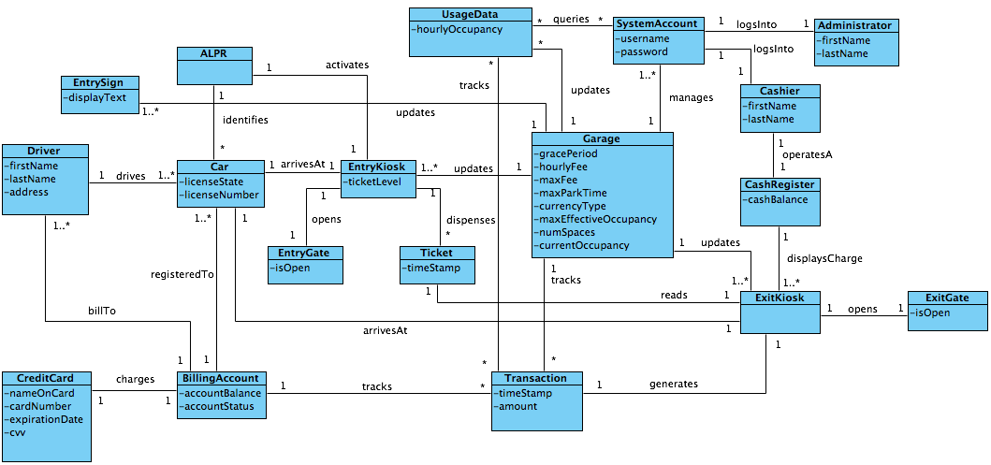

**Glossary:**

|  |  |  |
| --- | --- | --- |
| **Term** | **Definition and Information** | **Initial Value / Range** |
|  |  |  |
| accountStatus | Status of the customer’s billing account. | Enum, current, overdue, delinquent |
| Administrator | A high level garage administrator who has permissions to change garage parameters and view reports. |  |
| ALPR System | Automatic License Plate Recognition System, consists of camera at entry and exit; includes ocr software as part of the system. |  |
| Billing Account | System can track drivers by license plate number, allows for monthly billing. | License plate, driver name, address, optional credit card,  account balance, account status |
| Cashier | Cashier may be a physical person at the garage, some cashier tasks may be automated by the system (ie credit card reader vs entering credit card; ticket reader) |  |
| currencyType | Local currency at the garage location. | US Dollar ($), configurable |
| currentOccupancy | The number of cars inside the garage at any point in time. | Variable, calculated |
| Driver / Customer | The driver of the car is the primary customer. As such, quality customer service should be observed. |  |
| gracePeriod | Minimum period of time where the driver incurs no charges. | 1 hour (first hour free), configurable, open (garage is temporarily free) |
| hourlyFee | Cost to park in currency, per hour | $2.00 per hour, configurable, min $0, max $50.00 / hour |
| licenseState | The US State (Colorado) of the license plate. Can be modified for international use (beyond scope). |  |
| maxEffective  Occupancy | The desired maximum number of cars in the garage at one time. Once max is reached, the full sign is lit. Ex, for a 300 car parking garage, max at 90% is 270 spaces. | Expressed as a percentage of total, 90% of all spaces: 270, configurable. |
| maxFee | Amount charged, per day, for a lost ticket, if entry time is not determined. | 24 * hourly fee,  calculated |
| maxParkTime | The maximum time a car is allowed to park at the garage. Beyond this time, cars may be ticketed or towed. System may generate report showing current cars in garage over max time. | 48 hours, configurable |
| numSpaces | The total number of parking spaces within the garage. | For this garage, 300. |
| System Account | Used by cashier and garage administrator, allows login to the system and tracks user privileges. |  |
| ticketLevel | The amount of tickets left in an entry kiosk. | Calculated, percentage of total. |
| UsageData | Tracks transactions and hourly occupancy. |  |

**Actor Goals for Garage Parking System:**

|  |  |  |
| --- | --- | --- |
| **Actor** | **Goal** | **Use Case** |
| Driver | Park a car in less than 3 minutes | Enter Garage (UC1) |
| Driver | Leave garage, pay and leave within 5 minutes | Exit Garage (UC2) |
| Driver | Manage System Account | Outside scope of project |
| Cashier | Process sale | Exit Garage (UC2) |
| Cashier | Create System Account | Manage Accounts (UC3) |
| Cashier | Update System Account | Manage Accounts (UC3) |
| Garage Administrator | Manage System | Manage System (UC4) |
| Garage Administrator | View Usage | Show Usage (UC5) |
| Garage Administrator | Increase Revenue | Manage System (UC4) |

**Use Case Diagram:**

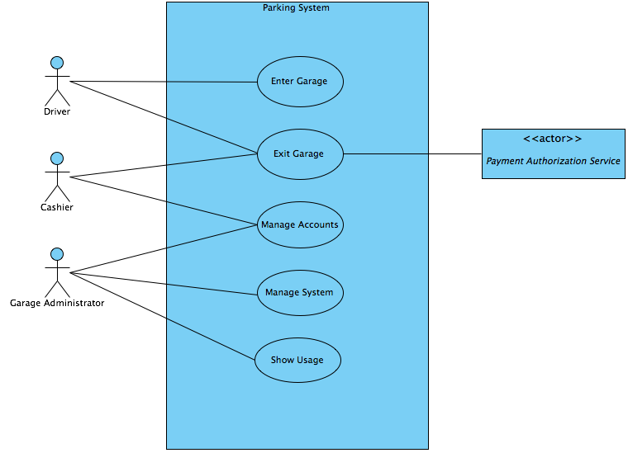

**Fully Dressed Use Cases:**

**Use Case Name:**

Enter Garage (UC1)

**Scope:**

Parking System

**Level:**

User goal

**Primary Actor:**

Driver / Customer

**Stakeholders and Interests:**

Garage Administrator

Payment Authorization Service

**Preconditions:**

System has power.

System is connected to a server.

**Success Guarantee:**

Driver is given a ticket.

Entry is logged.

System tracks garage occupancy.

Entry gate is closed.

**Main Success Scenario:**

1. Driver arrives at the parking garage and views entry sign.

2. Driver drives to the entry gate.

3. Driver indicates presence to entry kiosk (presses button).

4. ALPR System logs license plate and time.

5. Entry kiosk prints ticket with time stamp.

6. Driver takes the ticket.

7. System opens Entry Gate.

8. System increments garage occupancy

9. System updates entry sign.

9. Driver drives through the gate.

10. System closes Entry Gate.

**Extensions:**

1a. Garage sign indicates full

1. Driver leaves.

1b. Driver sees price.

1. Driver leaves.

2a. Another car is at the entry gate.

1. Driver waits.

4a. ALPR is unable to determine plate number

1. Nothing is logged.

5a. Ticket dispenser is jammed or unoperational.

1. Driver presses a “call” button to contact garage administrator.

2. Driver explains problem to administrator.

3a. Administrator fixes the jam.

3b. Administrator marks the time on an informal ticket.

6a. System detects kiosk is out of tickets.

1. System contacts the garage administrator to refill.

**Special Requirements:**

Call button that will initiate contact with the garage administrator.

Phone line and speaker system.

Dispense ticket button.

Ticket dispenser system.

Access to correct system time.

Automatic License Plate Recognition System (ALPR).

**Technology and Data Variations List:**

**Frequency of Occurrence:**

Intermittent to continuous.

**Open Issues:**

If the user is in the system and is recognized by the ALPR the gate could automatically open and there would be no need for the driver to take a ticket. This is saved for a later iteration.

**Use Case Name:**

Exit Garage (UC2)

**Scope:**

Parking System

**Level:**

User Goal

**Primary Actor:**

Driver / Customer

**Stakeholders and Interests:**

Cashier

Garage Administrator

**Preconditions:**

All systems have power.

System is connected to central server.

Driver is a valid driver with a current license.

**Success Guarantee:**

Transaction is logged and saved.

System tracks garage occupancy.

Exit gate is closed.

**Main Success Scenario:**

1. Driver arrives at exit gate.

2. Driver shows ticket to cashier or ticket reader.

3. Cashier enters arrival time.

4. System presents total due.

5. Cashier tells Driver the cost and requests payment.

6. Driver pays.

7. System logs completed sale.

8. System opens the Exit Gate.

9. Driver drives through the Exit Gate.

10. System updates the garage occupancy.

11. System updates entry sign.

12. System closes Exit Gate.

**Extensions:**

2a. Driver has lost the ticket.

1. Cashier checks ALPR system to determine entry time.

1a. Entry time is undetermined by the ALPR.

1. Cashier charges the Maximum Fee.

2. Cashier charges the correct fee based upon entry.

6a. Driver pays cash.

1. Cashier enters the cash amount tendered.

2. System presents balance due and opens cash drawer.

3. Cashier deposits cash and returns balance in cash to Driver.

6b. Driver pays by credit card.

1. Driver shows credit card.

2. System displays payment for verification.

3. Driver confirms.

4. System sends payment authorization request to external payment authorization system.

4a. System detects failure to collaborate with external system

1. System signals error to cashier.

2. Cashier asks driver for alternate payment.

5. System receives payment approval.

5a. System receives payment denial.

1. System signals denial to cashier.

2. Cashier asks customer for alternate payment.

5b. Timeout waiting for response.

1. System signals timeout to cashier.

2. Cashier asks customer for alternate payment.

6c. Driver pays by System Account.

1. ALPR System acknowledges that the driver has a System Account

1a. No account found.

1. Cashier asks driver if they want to open an account.

1a. Driver declines

1. Cashier asks for alternate payment.

2. Cashier asks driver for drivers license.

3. Cashier creates an account for the driver.

2a. ALPR System fails to recognize license plate.

1. Cashier manually enters license plate.

1a. No account found.

1. Cashier asks driver if they want to open an account.

1a. Driver declines

1. Cashier asks for alternate payment.

2. Cashier asks driver for drivers license.

3. Cashier creates an account for the driver.

2. System applies charges to System Account.

6d. Driver has no payment.

1. Cashier requests drivers license.

2. Cashier creates a System Account for the driver.

**Special Requirements:**

ALPR system installed and connected.

Cashier has a cash register and drawer.

Cashier has access to the system.

**Technology and Data Variations List:**

6b. Credit card information can be entered by card reader or keyboard.

**Frequency of Occurrence:**

Intermittent to continuous.

**Open Issues:**

**Use Case Name:**

Manage Accounts (UC3)

**Scope:**

Parking System

**Level:**

Subfunction

**Primary Actor:**

User: Cashier, Garage Administrator

**Stakeholders and Interests:**

Driver

**Preconditions:**

User has access to system UI.

User is logged in and verified.

**Success Guarantee:**

System is updated with current information

**Main Success Scenario:**

1. User logs into system.

2. User executes request.

3. System is updated.

**Extensions:**

2a. User requests to add account.

1. User enters name, address, license plate number.

1a. User enters credit card information.

1. System verifies credit card.

2. System creates a System Account.

2b. User requests to delete account.

1. User identifies account by license plate or name.

2. User confirms desire to delete account.

3. System deletes account.

2c. User requests to update account.

1. User identifies account by license plate or name.

2. User confirms desire to update account.

3. System displays current information.

4. User updates changed information.

3. System updates account.

**Special Requirements:**

**Technology and Data Variations List:**

System user interface.

**Frequency of Occurrence:**

Intermittent

**Open Issues:**

**Use Case Name:**

Manage System (UC4)

**Scope:**

Parking System

**Level:**

Subfunction

**Primary Actor:**

Garage Administrator

**Stakeholders and Interests:**

Driver

Cashier

**Preconditions:**

Admin has access to the system UI.

Admin permissions are verified.

**Success Guarantee:**

All system parameters are up to date.

**Main Success Scenario:**

1. Admin logs into system.

2. System shows all current configurable parameters.

3. Admin selects the parameter to update.

4. Admin enters an updated value.

5. System checks input for validity.

6. System updates the parameter.

**Extensions:**

1a. User does not have permissions to access parameters.

1. System does not offer UI to change parameters.

*a. Input value is out of range.

1. System displays an out of range error.

2a. Admin updates Hourly Fee price parameter.

1. System changes parameter in system.

2. System notes change time in system.

3. Parking sign is updated.

4. Customers arriving after change time are charged new price.

2b. Admin updates the Maximum Effective Occupancy

1. System changes the parameter in system

2. System updates the garage sign if needed.

2c. Admin updates the Grace Period.

1. System changes the parameter in system.

2. System notes change time.

3. Customers arriving after change time are allowed new grace period.

2d. Admin updates Maximum Park Time.

1. System changes the parameter in system.

2. System updates the garage sign.

**Special Requirements:**

**Technology and Data Variations List:**

System user interface.

**Frequency of Occurrence:**

Occasional

**Open Issues:**

**Use Case Name:**

Show Usage (UC5)

**Scope:**

Parking System

**Level:**

Subfunction

**Primary Actor:**

Garage Administrator

**Stakeholders and Interests:**

Driver

Cashier

**Preconditions:**

Administrator is logged in and has adequate permissions.

**Success Guarantee:**

Administrator is able to view the data requested.

**Main Success Scenario:**

1. Administrator requests data.

2. System displays occupancy and revenue data.

**Extensions:**

1a. Admin requests hourly occupancy data.

1. Admin requests start time, end time.

2. System returns hourly data.

1b. Admin requests daily occupancy data.

1. Admin requests start day, end day.

2. System returns daily aggregated data.

1c. Admin requests weekly occupancy data.

1. Admin requests start day, end day.

2. System returns weekly aggregated data.

1d. Admin requests monthly occupancy data.

1. Admin requests start month, end month.

2. System returns monthly aggregated data.

2a. Admin request to drill down into aggregations.

1. System shows next level averages with max and min highlighted.

**Special Requirements:**

**Technology and Data Variations List:**

System aggregates average occupancy by hour.

Data is returned as a table or a graph that admin can select parts of to drill down to next level.

**Frequency of Occurrence:**

Occasional

**Open Issues:**