PROJECT TITLE
IMPLEMENT CLIENT SCRIPT & UI POLICY
(INCIDENT)

Team Members
1. K. Thavachselvi
2. B. Mohanapriya 3.
3. K. Thamaraiselvi
4. R. Sivarajani
5. S.Thasmeem

Project Submitted By
B.Sc. Information Technology
Dr. Umayal Ramanathan College for Women
Academic Year: 2026–2027

2. Requirement Analysis Phase

2.1 Introduction
The Requirement Analysis Phase is an important stage of the project “Implement Client Script & UI Policy (Incident)”. In this phase, the team identifies and analyzes the requirements needed to implement Client Script and UI Policy in the ServiceNow Incident module.
The main purpose of this phase is to understand the existing Incident form, identify the fields that require dynamic control or validation, and determine how Client Script and UI Policy can be used to improve the form.
The team studied the Incident form and analyzed the behavior of different fields. Based on the project objectives, the functional and technical requirements were identified.

2.2 Existing System Analysis
The existing ServiceNow Incident form contains several fields used to record incident information.
Some of the commonly used fields include:
- Caller
- Short Description
- Description
- Category
- Subcategory
- Impact
- Urgency
- Priority
- Assignment Group
- Assigned To
- State
- Contact Type
The team analyzed these fields to understand their purpose and existing behavior.
During the analysis, it was identified that some fields may require additional control depending on the values entered by the user. For example, a field may need to become mandatory when a particular condition is satisfied, or a field may need to become read-only or hidden based on the selected value.
Therefore, Client Script and UI Policy were considered suitable features for implementing these requirements.

2.3 Functional Requirements
Functional requirements describe what the system should do.
The identified functional requirements are:

1. Client-side Validation
The system should validate appropriate information entered by the user on the Incident form.
Client Script can be used to perform validation without requiring the form to be submitted first.

2. Dynamic Field Behaviour
The Incident form should be able to change field behaviour according to specified conditions.
For example:
- A field can become mandatory.
- A field can become read-only.
- A field can be displayed or hidden.

3. Condition-Based Actions
The system should perform an action when a particular condition is satisfied.
The condition may depend on the value selected in an Incident field.

4. User-Friendly Incident Form
The implemented functionality should make the Incident form easier for users to complete correctly.

5. Data Accuracy
The system should help prevent incomplete or incorrect information from being entered into important fields.

2.4 Client Script Requirements
The following requirements were identified for Client Script:
- Client Script should be created for the Incident table.
- It should work on the Incident form.
- Appropriate client-side logic should be defined.
- The script should respond to the required form event.
- It should validate or control information according to the project requirement.
- It should provide the expected result when the specified condition occurs.
Client Scripts can be associated with different form events such as:
- onLoad
- onChange
- onSubmit
- onCellEdit
For this project, the required event will be selected according to the specific functionality being implemented.

2.5 UI Policy Requirements
The following requirements were identified for UI Policy:
- UI Policy should be created for the Incident table.
- A suitable condition should be defined.
- The UI Policy should control the required Incident fields.
- Fields should change their properties according to the condition.
- The required UI Policy Actions should be configured.

The properties that can be controlled include:
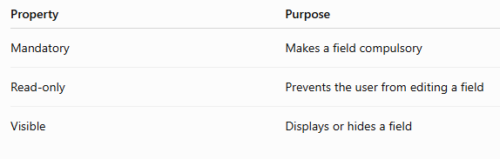
UI Policy is mainly used to control the appearance and behaviour of fields on the Incident form without writing scripting code for these basic field-property changes.

2.6 Non-Functional Requirements
Non-functional requirements describe how the system should perform.
The main non-functional requirements are:

1. Usability
The Incident form should be simple and easy for users to understand.

2. Reliability
The Client Script and UI Policy should work consistently when the defined conditions are satisfied.

3. Performance
The implemented functionality should not unnecessarily slow down the Incident form.

4. Maintainability
The configuration should be easy to understand and modify in the future.

5. Accuracy
The implementation should help maintain accurate and complete Incident information.

2.7 Technical Requirements
The project requires the following technical components:
- ServiceNow platform
- Incident Management module
- Incident table
- Client Script
- UI Policy
- UI Policy Actions
- Incident form
- Appropriate user access/permissions
The project is implemented within the ServiceNow environment using the available configuration and scripting features.

2.8 Hardware and Software Requirements

Hardware Requirements
- Computer or laptop
- Stable Internet connection
- Sufficient memory and processing capability to access the ServiceNow platform

Software Requirements
- Operating System such as Windows
- Web browser such as Google Chrome or Microsoft Edge
- ServiceNow instance
- ServiceNow Incident Management module

2.9 Input Requirements
The Incident form receives information from the user through different fields.
Examples include:
- Caller
- Category
- Impact
- Urgency
- Short Description
- Description
- Assignment Group
- Assigned To
- State
The entered or selected values are used to determine whether the defined Client Script or UI Policy conditions should be triggered.

2.10 Expected Output Requirements
After implementing the requirements, the Incident form should provide the expected behaviour.

Depending on the defined condition:
- Required fields should become mandatory.
- Certain fields should become read-only.
- Certain fields should be displayed or hidden.
- Client-side validation should occur where required.
- Users should receive the expected response when incorrect or incomplete information is entered.
The final output should improve the usability and data quality of the Incident form.

2.11 Requirement Summary
The requirements identified for the project can be summarized as follows:

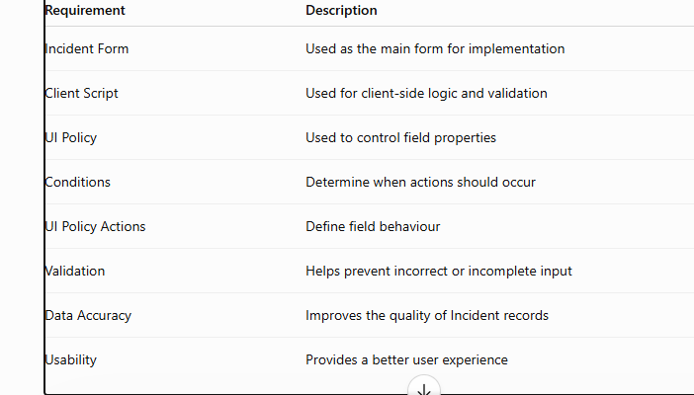

2.12 Finalized Requirements
After analyzing the existing Incident form and discussing the project objectives, the following requirements were finalized:

- Implement Client Script on the Incident form.
- Define the required Client Script condition and action.
- Implement UI Policy on the Incident form.
- Define the required UI Policy condition.
- Configure UI Policy Actions for the selected fields.
- Test the field behaviour under different conditions.
- Ensure that the implemented functionality works as expected.
- Improve the accuracy and usability of Incident data entry.
These requirements provide the foundation for the Project Design Phase, where the actual design and implementation approach will be planned.

