PROJECT TITLE
IMPLEMENT CLIENT SCRIPT &UI POLICY (INCIDENT)

Team Members
1. K. Thavachselvi
2. B. Mohanapriya
3. K. Thamaraiselvi
4. R. Sivarajani
5. S.Thasmeem

Project Submitted By
B.Sc. Information Technology
Dr. Umayal Ramanathan College For Women
Academic Year: 2026–2027

5. Project Development Phase

5.1 Introduction
The Project Development Phase is the fifth phase of the project “Implement Client Script & UI Policy (Incident)”. In this phase, the requirements and design identified in the previous phases are converted into an actual working implementation in the ServiceNow platform.
The main purpose of this phase is to configure and implement Client Script and UI Policy in the ServiceNow Incident module. The required fields, conditions, and actions identified during the design phase are configured according to the project requirements.
The development process is performed systematically to ensure that the Incident form behaves as expected.

5.2 Development Environment
The project is developed using the ServiceNow platform and its Incident Management module.
The main components used during development are:
- ServiceNow platform
- Incident Management module
- Incident table
- Incident form
- Client Script
- UI Policy
- UI Policy Actions
- Web browser
- Internet connection
The development is carried out within the ServiceNow instance using the available configuration and scripting features.

5.3 Development Process
The development process is carried out through the following steps:
- Access the ServiceNow instance.
- Open the Incident module.
- Open the required Incident form.
- Identify the fields involved in the project.
- Create the Client Script.
- Configure the Client Script properties.
- Add the required client-side logic.
- Create the UI Policy.
- Define the UI Policy condition.
10.Configure the UI Policy Actions.
11.Save the configurations.
12.Open the Incident form and verify the behaviour.
13.Correct any configuration or scripting issues.
14.Prepare the implementation for testing.

5.4 Incident Module Configuration
The first step in development is to access the Incident module in ServiceNow.
The Incident module is used because the project focuses on controlling and improving the behaviour of the Incident form.
The team opens the Incident list and selects an appropriate Incident record to verify the fields and functionality.
The relevant Incident fields identified during the Requirement Analysis and Design phases are used for the implementation.

5.5 Client Script Implementation
A Client Script is created to implement the required client-side functionality on the Incident form.
The Client Script is configured according to the requirement identified during the design phase.
The main configuration includes:
- Name
- Table
- UI Type
- Type
- Field, where applicable
- Script
- Active status
The appropriate Client Script type is selected based on the required functionality.

Client Script Types
The commonly available Client Script types include:

1. onLoad
The script executes when the Incident form is loaded.

2. onChange
The script executes when the value of a selected field changes.

3. onSubmit
The script executes when the user submits the Incident form.

4. onCellEdit
The script executes when a value is edited directly from a list.
The appropriate type is selected according to the project's actual requirement.

5.6 Client Script Logic
The Client Script contains the JavaScript logic required for the project.
The script is designed to:
- Detect the required condition.
- Read the relevant field value.
- Perform the required client-side action.
- Validate information where necessary.
- Provide the expected response to the user.
The logic is tested after configuration to ensure that it does not produce unwanted behaviour on the Incident form.
The script is kept specific to the project requirement so that it does not unnecessarily affect other Incident form functionality.

5.7 UI Policy Implementation
After configuring the Client Script, the required UI Policy is created for the Incident table.
UI Policy is used to control the behaviour and properties of fields on the Incident form.
The UI Policy is configured with:
- Name
- Table
- Conditions
- Active status
- Other applicable settings
The condition is defined according to the requirement identified during the design phase.
When the condition is satisfied, the UI Policy applies the configured field behaviour.

5.8 UI Policy Condition
The UI Policy condition determines when the policy should be applied.
The condition is based on the selected Incident field and its value.
For example:
Field value changes
↓
Condition is checked
↓
Condition is satisfied
↓
UI Policy Action is applied
The actual condition used in the project should match the condition finalized during the Design Phase.

5.9 UI Policy Actions
UI Policy Actions determine how the selected field behaves when the UI Policy condition is satisfied.
The available field properties include:
Property | Purpose
Mandatory | Makes the field compulsory
Read-only | Prevents the user from modifying the field
Visible | Displays the field
Hidden | Hides the field
The required UI Policy Actions are configured according to the project requirements.
For example, if the requirement states that a particular field must be compulsory under a specific condition, the field is configured as Mandatory through the UI Policy Action.

5.10 Integration of Client Script and UI Policy
Client Script and UI Policy are implemented together to achieve the required Incident form behaviour.
Client Script is used for client-side logic and validation, while UI Policy is used for controlling field properties.
The combination allows the Incident form to respond dynamically to user input.
The implementation is designed so that both features work according to their respective requirements without creating unnecessary conflicts.

5.11 Development Workflow
The development workflow can be summarized as:
Open ServiceNow
↓
Open Incident Module
↓
Identify Required Fields
↓
Create Client Script
↓
Configure Client Script
↓
Add Required Logic
↓
Create UI Policy
↓
Define Condition
↓
Configure UI Policy Actions
↓
Save and Verify
↓
Proceed to Testing
This workflow provides a systematic approach to the development process.

5.12 Error Handling and Corrections
During development, configuration or scripting errors may occur.
The team checks the implementation if the expected behaviour does not occur.
Possible issues include:
- Incorrect field selected.
- Incorrect Client Script type.
- Incorrect condition.
- Incorrect JavaScript logic.
- UI Policy not activated.
- Incorrect UI Policy Action.
- Field behaviour not changing as expected.
These issues are reviewed and corrected before moving to the final testing stage.

5.13 Development Verification
After configuring the Client Script and UI Policy, the implementation is verified on the Incident form.
The team checks:
- Whether the Client Script is active.
- Whether the correct Incident table is selected.
- Whether the Client Script executes under the required condition.
- Whether the UI Policy is active.
- Whether the condition is correct.
- Whether the UI Policy Action affects the intended field.
- Whether the Incident form behaves according to the requirement.
The implementation is then prepared for detailed testing in the Project Testing Phase.

5.14 Development Outcome
At the end of the development phase, the required Client Script and UI Policy are configured in the ServiceNow Incident module.
The development phase produces:
- Configured Client Script
- Required client-side logic
- Configured UI Policy
- Defined UI Policy condition
- Configured UI Policy Actions
- Updated Incident form behaviour
The completed implementation is then taken to the Testing Phase for verification.

5.15 Screenshots for Project Development Phase

Screenshot 1 — Client Script Configuration
Show the Client Script configuration page containing details
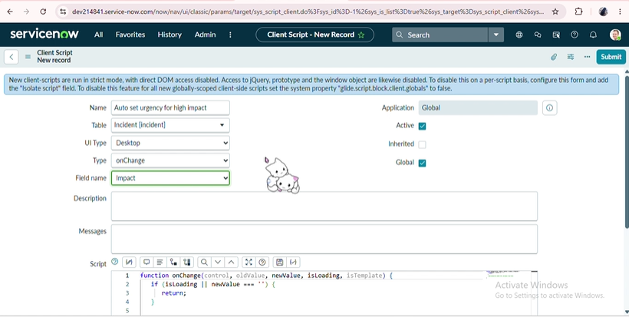

Screenshot 2 — Client Script Code
Show the actual JavaScript written inside the Client Script.

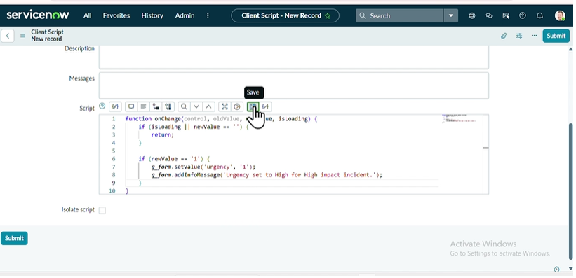

Screenshot 3 — UI Policy Configuration
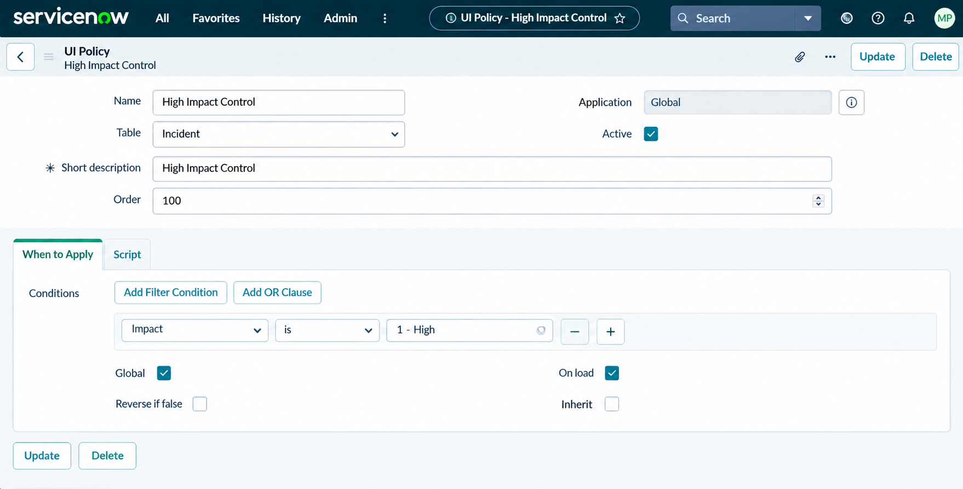

Screenshot 4 — UI Policy Action Show the UI Policy

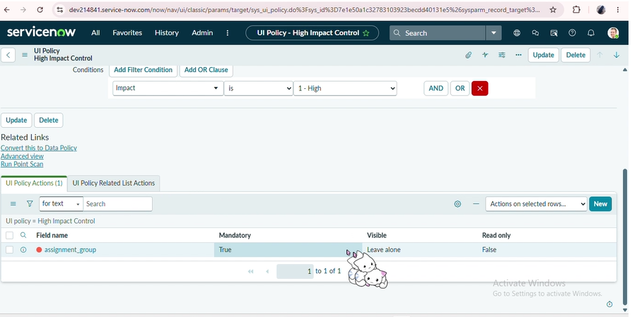

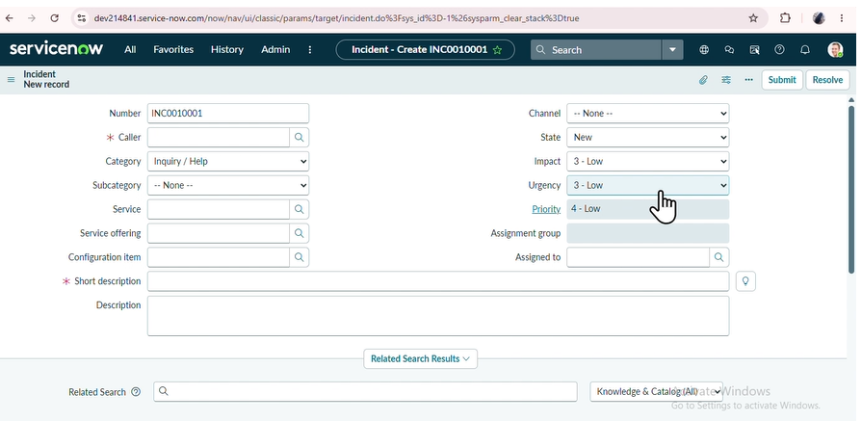
Screenshot 5 — Developed Incident Form

