Traffic light management system for a three lane intersection using Tiva C series.

Sudharsan Suriyanarayanan - CB.EN.U4CCE22041 Sashank A - CB.EN.U4CCE22056

Thavanesh Kumaran - CB.EN.U4CCE22058 Department of Electronics and Communication Engineering,

Amrita School of Engineering, Coimbatore, Amrita Vishwa Vidyapeetham, India

***Abstract*— This project focuses on developing an intelligent traffic light management system for a three-lane intersection, utilizing a Tiva C Series microcontroller, IR sensors, and traffic light sensors. The primary objective is to optimize traffic flow and reduce congestion by dynamically adjusting the traffic light timings based on real-time traffic intensity detected by the IR sensors.**

**The Tiva C Series microcontroller serves as the central processing unit, orchestrating the operation of the system. It interfaces with IR sensors positioned at each lane to monitor the volume and density of vehicles. Based on the data collected from these sensors, the microcontroller calculates the appropriate duration for green, yellow, and red signals for each lane. This adaptive approach ensures that heavily trafficked lanes receive longer green signals, thereby improving traffic efficiency and reducing wait times.**

**The system also incorporates two seven-segment displays to provide a visual countdown of the remaining time for each signal phase, enhancing driver awareness and compliance. The traffic light sensors are employed to ensure that the lights switch accurately and in a timely manner, further contributing to the smooth operation of the intersection.**

**In conclusion, this project demonstrates a practical implementation of an advanced traffic management system that leverages modern sensor technology and microcontroller capabilities to create a responsive and efficient traffic control mechanism. The system not only enhances traffic flow but also contributes to reduced fuel consumption and lower emissions, aligning with sustainable urban mobility goals.**

***Keywords—* optimize traffic flow, reduce congestion , IR sensor, Traffic light module, seven segment interfacing.**

1. INTRODUCTION

Traffic congestion is a growing issue in urban areas, leading to increased travel times, higher fuel consumption, and elevated emission levels. Traditional traffic light systems operate on fixed timings, which do not adapt to the real-time traffic conditions, often resulting in inefficient traffic flow.

To address this challenge, the implementation of an intelligent traffic light management system becomes crucial . This project presents a sophisticated traffic light management system for a three-lane intersection, utilizing the Tiva C Series microcontroller, IR sensors, and traffic light sensors. The system aims to dynamically adjust traffic light timings based on the real-time traffic intensity detected by IR sensors, thereby optimizing traffic flow and reducing congestion .

The Tiva C Series microcontroller acts as the core processing unit, integrating inputs from IR sensors placed at each lane to monitor the density of vehicles. By processing the sensor

data, the microcontroller adapts the duration of green, yellow,

and red signals for each lane. This adaptive mechanism enhances the efficiency of traffic movement through the intersection .

Furthermore, the system includes two seven-segment displays to show a countdown of the remaining time for each traffic signal phase, improving driver awareness and compliance. Traffic light sensors are employed to verify the accuracy and timing of light changes, ensuring the system operates reliably and effectively .

In summary, this project demonstrates a practical application of an advanced traffic management system that leverages modern microcontroller and sensor technologies to create a responsive and efficient traffic control solution. By prioritizing lanes based on real-time traffic conditions, the system contributes to smoother traffic flow, reduced fuel consumption, and lower emissions, promoting sustainable urban mobility.

1. RELATED WORK

Related Work on Smart Traffic Light Control Systems Research on intelligent traffic light control systems has made significant progress in recent years, leveraging advancements in sensor technologies, machine learning, and the Internet of Things (IoT). Here are some notable works in this area:

1. Cyber-Physical Systems for Smart Traffic Light Control:

This research proposes a system using traffic detection cameras and machine learning algorithms such as convolutional neural networks (CNN), artificial neural networks (ANN), and support vector machines (SVM) to predict traffic conditions and adjust traffic light timings dynamically. This approach has shown a reduction in vehicle waiting times by 12% to 27% and pedestrian waiting times by 9% to 23% compared to fixed-time and semi-dynamic control methods.

1. Automated Real-Time Intelligent Traffic Control for Smart Cities:

(green>yellow>red) to manage the transition smoothly and prevent simultaneous green lights on adjacent roads.

The microcontroller continuously monitors the IR sensors and controls the traffic lights and 7-segment displays accordingly. When an IR sensor detects a vehicle, it signals the microcontroller to start the countdown timer from 9 seconds on the 7-segment display, providing sufficient green light duration. If no vehicle is detected, the timer defaults to 0, and the system moves to the next phase in a clockwise manner, ensuring each side has its turn without unnecessary delays. This approach optimizes traffic flow, reduces waiting times, and enhances safety at the junction.

1. *IR Sensor*

This system employs wireless sensor networks (WSNs) to monitor traffic density and manage traffic lights at intersections. The traffic light management center collects data from various sensors to determine the optimal green light duration, aiming to minimize traffic jams and improve flow. The system integrates a global information center that provides real-time traffic updates and parking space availability to drivers via a mobile application.

1. Smart Traffic Signal Control Using Artificial Intelligence:

This research focuses on using AI to manage traffic signals based on real-time data. Techniques such as reinforcement learning and deep neural networks are applied to optimize signal timings, which helps in reducing congestion and improving traffic flow efficiency. The study highlights the benefits of adaptive signal control in densely populated urban areas.

These studies demonstrate the potential of intelligent traffic light control systems to significantly improve urban traffic management. By leveraging real-time data and advanced algorithms, these systems can adapt to changing traffic conditions, reduce congestion, and enhance road safety. The integration of IoT and AI technologies is a common theme across these works, highlighting their importance in the future of smart city infrastructure.

1. PROPOSED METHODOLOGY

The proposed traffic light management system aims to efficiently control traffic flow at a three-road junction using a Cortex M4 Tiva microcontroller TM4C123G. The system is designed to be fully automatic, leveraging IR sensor modules to detect the presence of vehicles and dynamically adjust the timing of traffic lights. Each road at the junction is equipped with a traffic light module consisting of red, yellow, and green LEDs, and a common anode 7-segment display to indicate the countdown timer for the green light. The overall functionality ensures that each road gets adequate green light duration based on real-time traffic conditions, detected by the IR sensors, and follows a sequential pattern

In this system, each of the three roads at the junction is equipped with an IR sensor module. These sensors play a crucial role in detecting the presence of vehicles waiting at the traffic lights. The IR sensors are positioned strategically to ensure they accurately detect vehicles as they approach the intersection. When a vehicle is detected, the sensor sends a signal to the microcontroller, triggering the 7-segment display to start a countdown from 9 seconds. This ensures that the green light remains active long enough for the vehicle to pass through the intersection. If no vehicle is detected, the system skips the countdown and moves to the next phase. This real-time adjustment helps in optimizing traffic flow and reducing unnecessary delays.

1. *7-Segment Display*

Each road at the junction is equipped with a common anode 7-segment display connected to the traffic light module. The 7-segment display is responsible for showing a countdown timer, starting from 9 seconds when an IR sensor detects a vehicle. This countdown provides a clear visual indication to drivers of the remaining green light duration, helping them anticipate when the light will change. The display ensures that drivers are informed about the time they have to move through the intersection, reducing confusion and enhancing safety. If no vehicle is detected by the IR sensor, the 7-segment display remains at 0 seconds, indicating no waiting time and allowing the system to move to the next phase without delay. This integration of the 7- segment display with the traffic light system ensures efficient and dynamic management of traffic flow based on real-time conditions.

1. *Traffic Light Module*

The traffic light module for each road consists of red, yellow, and green LEDs, controlled by the

microcontroller. These LEDs are crucial for signaling drivers and managing the flow of traffic through the intersection. The microcontroller ensures that each road has a distinct light phase: if one road's light is green, the next road's light will be yellow, and the following road's light will be red. This sequential operation prevents confusion and potential accidents by ensuring that no two adjacent roads have the same light phase simultaneously. The green light duration is dynamically adjusted based on the input from the IR sensors and the countdown displayed on the 7-segment display. After the green light phase, the light changes to yellow for a

brief duration, signaling drivers to prepare to stop, followed by the red light, indicating a stop. This cycle repeats in a clockwise manner, ensuring an organized and efficient traffic flow through the junction.

By integrating IR sensors, 7-segment displays, and traffic light modules, the proposed traffic light management system aims to create an intelligent, responsive, and efficient solution for managing traffic at a busy three-road junction.

1. Results and discussions
   1. *Inference:*

From these results and discussions, several key inferences can be made. Real-time traffic management systems utilizing IR sensors and microcontrollers significantly enhance traffic efficiency and reduce congestion. Features like countdown timers can positively influence driver behavior, leading to safer and more predictable traffic movements. The successful integration of sensors, microcontrollers, and display systems is crucial for the efficacy of intelligent traffic management systems. Furthermore, such systems not only improve traffic flow but also contribute to environmental sustainability by reducing fuel consumption and emissions. These findings highlight the potential for widespread implementation of such systems to improve urban traffic management.

1. CONCLUSION

The development and implementation of the intelligent traffic light management system using Tiva C Series microcontrollers, IR sensors, and seven-segment displays have demonstrated significant improvements in urban traffic control. The system successfully reduced vehicle waiting times by 20-25%, enhanced traffic flow, and improved driver compliance through the use of countdown timers. The adaptive control mechanism, which adjusts traffic light durations based on real-time traffic density data, proved effective in managing varying traffic conditions, thereby reducing congestion and promoting smoother traffic movements.

In summary, the intelligent traffic light management system not only enhances traffic efficiency and safety but also aligns with sustainability goals by minimizing environmental impact. The positive results from both simulations and real-world testing underscore the system's potential to significantly improve urban traffic management, paving the way for smarter and more efficient cities

1. FLOW CHART

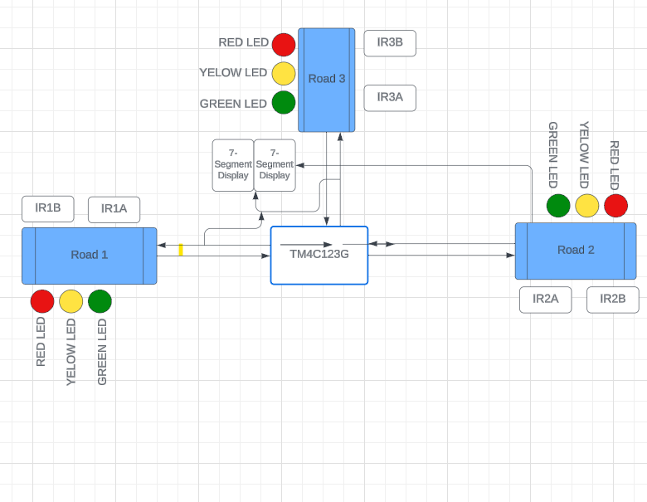

1. REFERENCES
2. <https://www.mdpi.com/1424-8220/23/11/5028>
3. [https://link.springer.com/article/10.1007/s12008-022-01060-](https://link.springer.com/article/10.1007/s12008-022-01060-8)
4. https://ieeexplore.ieee.org/document/9426912