EXP 4  Date:5\04/25 | Create a web form that accepts a user’s name  and age and to write a servlet to process the form date and display it back on the browser.

Aim:
To create a web form that accepts a user’s name and age and to write a servlet to process the form date and display it back on the browser.
PROGRAM:
<!DOCTYPE html>
<html>
<head>
<meta charset="ISO-8859-1">
<title>Insert title here</title>
</head>
<body>
<form action ="/Sree/DisplayUser" method="get" >
<p>
<label for="username">Username:</label>
<input type="text" id="username" name="username">
</p>
<p>
<label for="age">Age:</label>
<input type="number" id="age" name="age">
</p>
<input type="submit" value="Accept" name="submit">
</form>
</body>
</html>

SERVLET
package com.sandhya.servlet;
import java.io.IOException;
import java.io.PrintWriter;
import javax.servlet.ServletException;
import javax.servlet.annotation.WebServlet;
import javax.servlet.http.HttpServlet;
import javax.servlet.http.HttpServletRequest;
import javax.servlet.http.HttpServletResponse;
/**
* Servlet implementation class DisplayUser
*/
@WebServlet("/DisplayUser")
public class DisplayUser extends HttpServlet {
private static final long serialVersionUID = 1L;
/**
* @see HttpServlet#HttpServlet()
*/
public DisplayUser() {
super();
// TODO Auto-generated constructor stub
}
/**
* @see HttpServlet#doGet(HttpServletRequest request, HttpServletResponse response)
*/
protected void doGet(HttpServletRequest request, HttpServletResponse response) throws ServletException, IOException {
String a= request.getParameter("username");
int b= Integer .parseInt(request.getParameter("age"));
PrintWriter p=response.getWriter();
if(b<=0) {
p.println("Login failed");
}
else {
p.println(a);
p.println(b);
}
}
/**
* @see HttpServlet#doPost(HttpServletRequest request, HttpServletResponse response)
*/
protected void doPost(HttpServletRequest request, HttpServletResponse response) throws ServletException, IOException {
// TODO Auto-generated method stub
doGet(request, response);
}
}
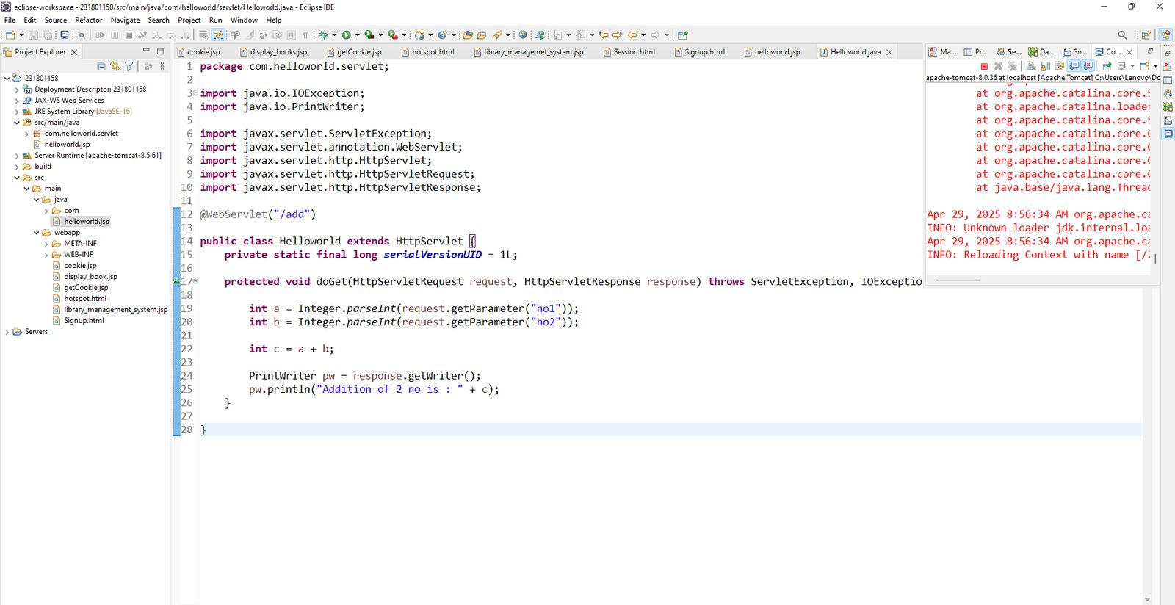
OUTPUT:

