EXP 5  05/04/25 | HTTP Using GET and POST

AIM:
To write a servlet to demonstrate the difference between HTTP GET and POST methods by creating a form and hadling requests accordingly
PROGRAM:
HTML
<!DOCTYPE html>
<html>
<head>
<meta charset="ISO-8859-1">
<title>Insert title here</title>
</head>
<body>
<form action="/Sree/Signup" method="get">
<label for="firstName">First Name:</label>
<input type="text" id="firstName" name="firstName" required><br><br>

<label for="lastName">Last Name:</label>
<input type="text" id="lastName" name="lastName" required><br><br>

<label for="dob">Date of Birth:</label>
<input type="date" id="dob" name="dob" required><br><br>

<label>Gender:</label>
<input type="radio" id="male" name="gender" value="Male" required>
<label for="male">Male</label>
<input type="radio" id="female" name="gender" value="Female" required>
<label for="female">Female</label><br><br>

<label for="address">Address:</label><br>
<textarea id="address" name="address" rows="4" cols="50" required></textarea><br><br>

<input type="submit" value="Submit">
</form>
</body>
</html>
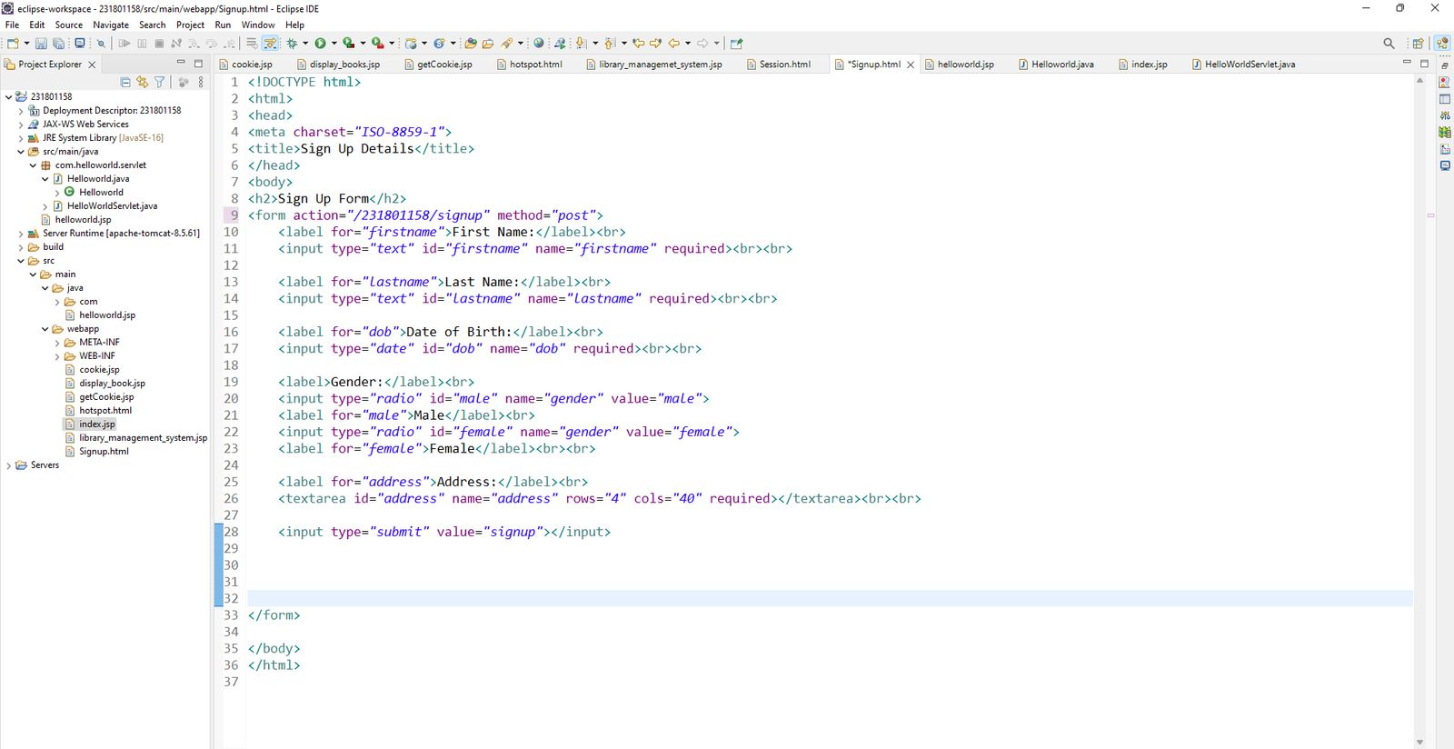
SERVLET
package com.sandhya.servlet;
import java.io.IOException;
import java.io.PrintWriter;
import javax.servlet.ServletException;
import javax.servlet.annotation.WebServlet;
import javax.servlet.http.HttpServlet;
import javax.servlet.http.HttpServletRequest;
import javax.servlet.http.HttpServletResponse;
/**
* Servlet implementation class Signup
*/
@WebServlet("/Signup")
public class Signup extends HttpServlet {
private static final long serialVersionUID = 1L;
/**
* @see HttpServlet#HttpServlet()
*/
public Signup() {
super();
// TODO Auto-generated constructor stub
}

/**
* @see HttpServlet#doGet(HttpServletRequest request, HttpServletResponse response)
*/
protected void doGet(HttpServletRequest request, HttpServletResponse response) throws ServletException, IOException {
String a=request.getParameter("firstName");
String b=request.getParameter("lastName");
String c=request.getParameter("dob");
String d=request.getParameter("gender");
String e=request.getParameter("address");

PrintWriter p=response.getWriter();
p.println(a);
p.println(b);
p.println(c);
p.println(d);
p.println(e);
}

/**
* @see HttpServlet#doPost(HttpServletRequest request, HttpServletResponse response)
*/
protected void doPost(HttpServletRequest request, HttpServletResponse response) throws ServletException, IOException {
String a=request.getParameter("firstName");
String b=request.getParameter("lastName");
String c=request.getParameter("dob");
String d=request.getParameter("gender");
String e=request.getParameter("address");

PrintWriter p=response.getWriter();
p.println(a);
p.println(b);
p.println(c);
p.println(d);
p.println(e); }

}

OUTPUT:
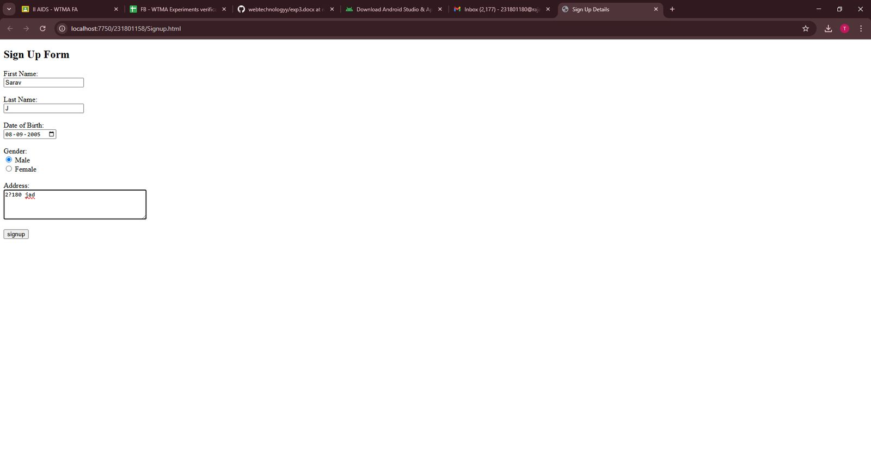

RESULT:
Thus the program was executed succesfully

