EXP 6  Date:07/04/25 | Implementation of HTTP session

AIM:
To Write a Servlet to demonstrate session tracking using HTTP Session.Implement a simple login system where the user's session is tracked.

PROGRAM:
<!DOCTYPE html>
<html>
<head>
<meta charset="ISO-8859-1">
<title>Insert title here</title>
</head>
<body>
<h1>Form Handle By HTTP Session</h1>
<form action="/Sree/Httpsession" method="POST" style="margin-left: 50px">
<label>Username: </label><input type="text" name="username"/><br><br>
<label>Password: </label><input type="password" name="password"/><br><br>
<input type="submit" value="Login" style="margin-left: 130px"/>
</form>
</body>
</html>

package com.saravanan.servlet;

import java.io.IOException;
import java.io.PrintWriter;

import javax.servlet.ServletException;
import javax.servlet.annotation.WebServlet;
import javax.servlet.http.HttpServlet;
import javax.servlet.http.HttpServletRequest;
import javax.servlet.http.HttpServletResponse;
import javax.servlet.http.HttpSession;

/**
* Servlet implementation class HttpSessionHandle
*/
@WebServlet("/Httpsession")
public class Httpsession extends HttpServlet {
private static final long serialVersionUID = 1L;

@SuppressWarnings("deprecation")
protected void doPost(HttpServletRequest request, HttpServletResponse response) throws ServletException, IOException {
String username = "WTMA";
String password = "WTMA";

PrintWriter p = response.getWriter();
String user = request.getParameter("username");
String pass = request.getParameter("password");

if(user.equals(username) && pass.equals(password))
{
HttpSession session = request.getSession(true);
session.putValue("username", user);

response.sendRedirect(request.getContextPath() + "/Httpsessionhandlingdisplay");
}

else
{
p.println("fail");
}
}

}
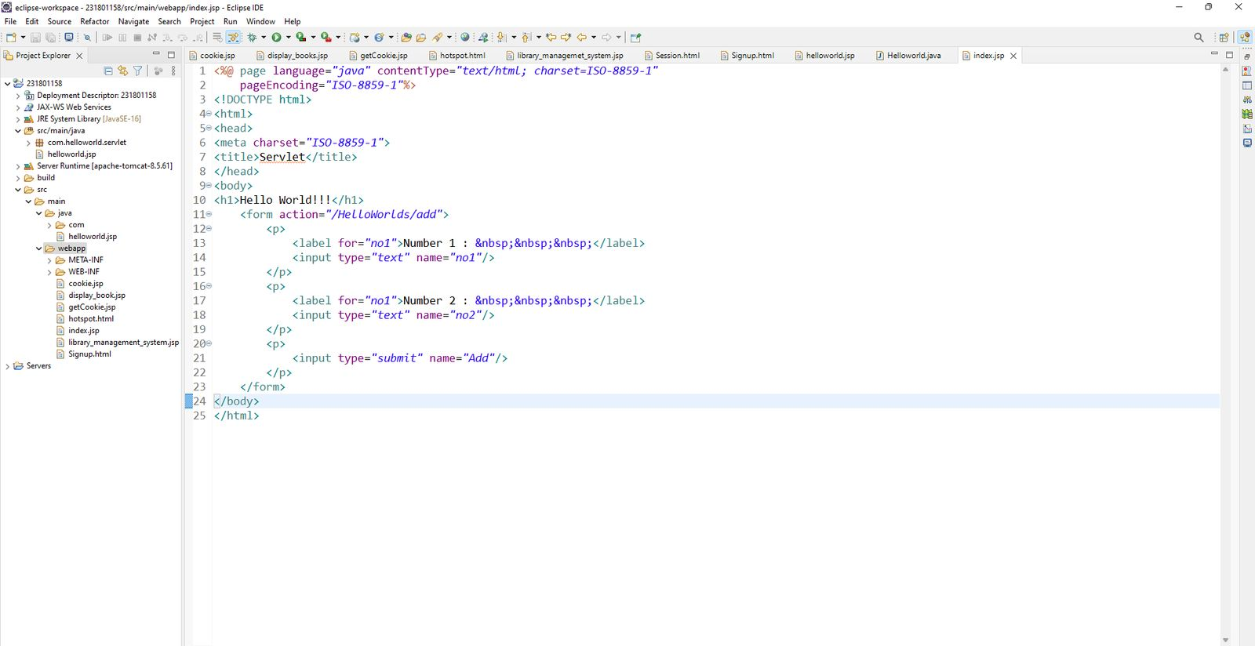
package com.saravanan.servlet;

import java.io.IOException;
import java.io.PrintWriter;

import javax.servlet.ServletException;
import javax.servlet.annotation.WebServlet;
import javax.servlet.http.HttpServlet;
import javax.servlet.http.HttpServletRequest;
import javax.servlet.http.HttpServletResponse;
import javax.servlet.http.HttpSession;

/**
* Servlet implementation class HttpSessionHandleDisplay
*/
@WebServlet("/Httpsessionhandlingdisplay")
public class Httpsessionhandlingdisplay extends HttpServlet {
private static final long serialVersionUID = 1L;

/**
* @see HttpServlet#doGet(HttpServletRequest request, HttpServletResponse response)
*/
protected void doGet(HttpServletRequest request, HttpServletResponse response) throws ServletException, IOException {
PrintWriter p = response.getWriter();
HttpSession session = request.getSession(true);

@SuppressWarnings("deprecation")
String user_name = (String)session.getValue("username");
p.println("Usernmae is " + user_name);
}

}
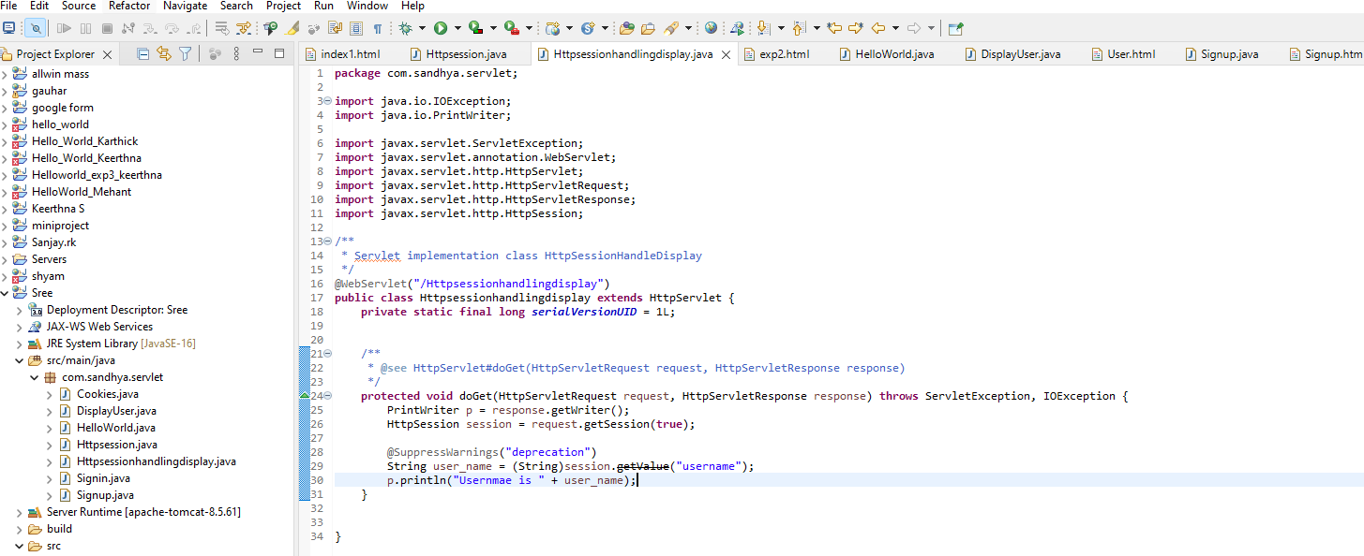

OUTPUT:

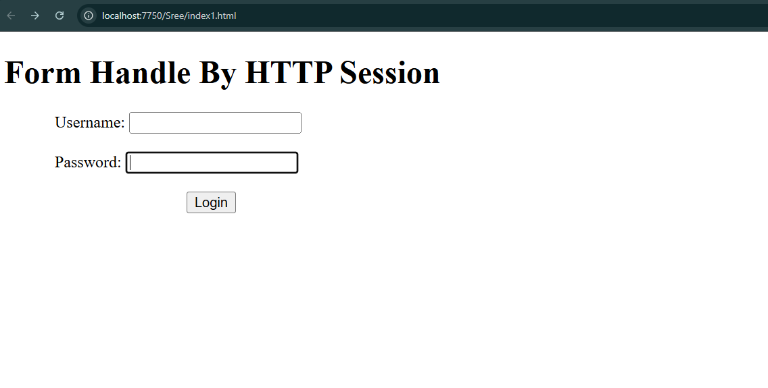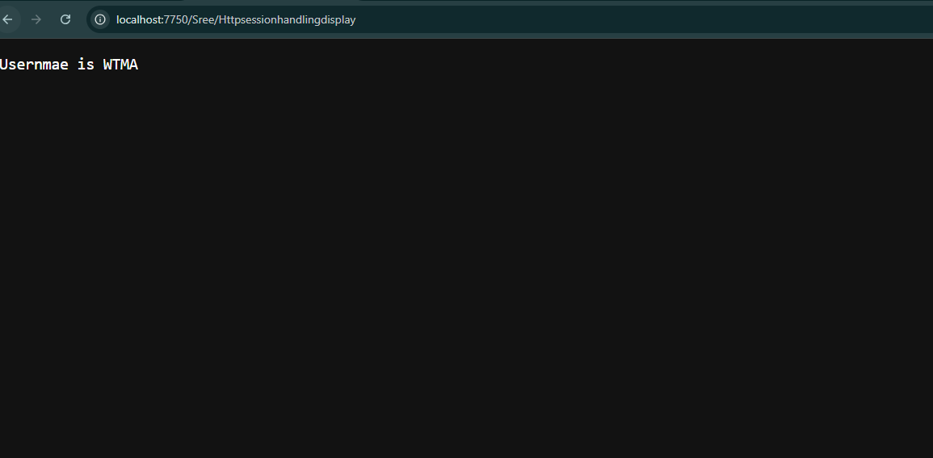

RESULT:
Thus the program to demonstrate session tracking using HTTP Session.Implement a simple login system where the user's session is tracked.

