Exp :9 Create layout using android studio

AIM:
To create a layout usind android application with textview and buttons

PROGRAM:

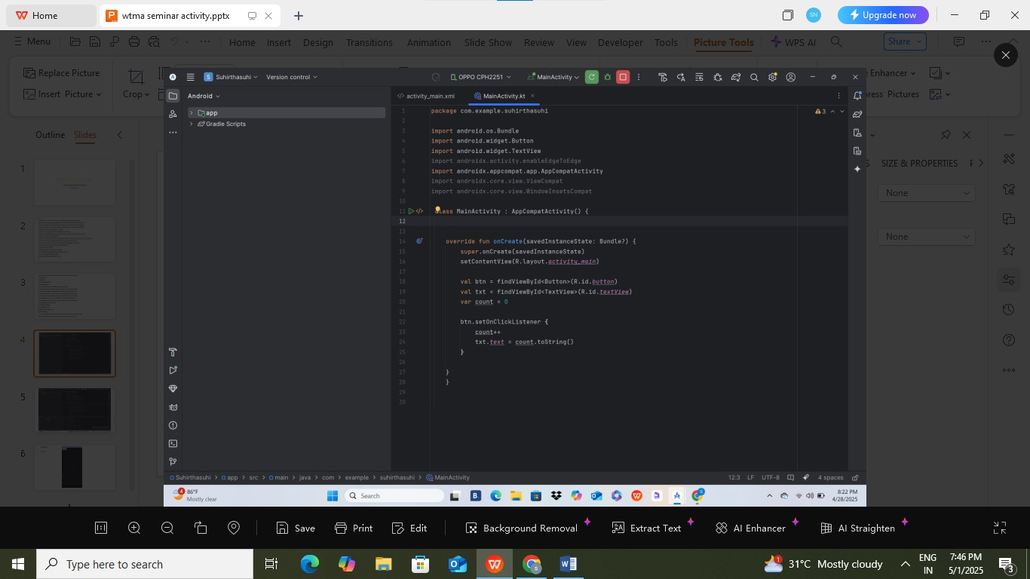
OUTPUT:
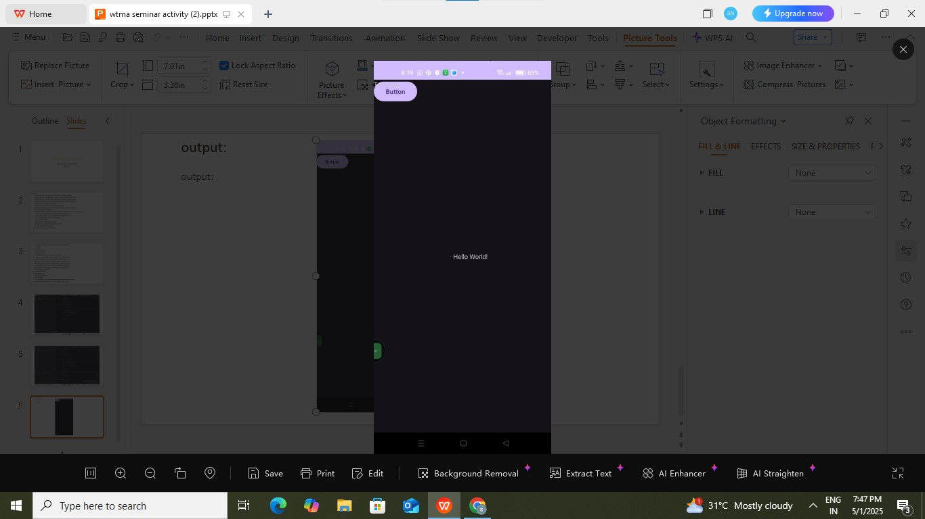

RESULT:
Thus the program was executes succesfully

