**Informatics Institute of Technology**

**Department of Computing**

**Coursework 01**

**Name**

W. Thaveesha Dheerasekera

**UoW ID**

17613697/1

**IIT ID**

2019483

**Degree Program**

BEng (Hons) Software Engineering

**Module**

6COSC022C Advanced Server-side Web Development

**Module Leader**

Mr. Sriyan Fernando

**Date**

03/11/2022

TABLE OF CONTENT

QUESTION 1 3

**Topic** 3

**Reason** 3

QUESTION 2 3

QUESTION 3 4

**Database Schema** 4

**Class Diagram** 5

**Screen Mockups** 5

QUESTION 4 8

REFERENCE 10

# **QUESTION 1**

## **Topic**

A technical question and answer website, where people can pose questions on technical issues or problems and other people can help answer them.

## **Reason**

Most professional developers, when asked, explain that one of the most difficult things about their work is dealing with technical questions, as it can take hours or days to find an answer to a problem that could be solved in minutes if another person had experience with the issue at hand. Therein, inter-developer relations and networking options are of large importance to not just the growth of developers and individuals but also the development of the community as a whole. As such, I chose to develop an informational question and answer website, where people can pose questions and descriptions on technical issues or problems, and other peers and community members can help answer, resolve and provide prescriptions for them. My vision is to create a website that can reduce the amount of time developers spend on mundane tasks such as troubleshooting and answering basic questions about relevant projects and avenues. I hope to improve their productivity and ultimately their bottom line through this venture.

# **QUESTION 2**

|  |  |  |
| --- | --- | --- |
| **Requirement** | | **Priority Level** |
| **R001** | User must be able to create an account | Essential |
| **R002** | User must be able to login using username and password | Essential |
| **R003** | User must be able to log out | Essential |
| **R004** | User must be able to pose a question | Essential |
| **R005** | User must be able see all questions | Essential |
| **R006** | User must be able to select a question and answer that question | Essential |
| **R007** | User must be able to upvote or downvote and answer | Essential |
| **R008** | User must be able to see all answers | Essential |
| **R009** | User must be able to search questions | Essential |
| **R010** | User shall be able to add tags with the question | Desirable |
| **R011** | User shall be able to upvote or downvote a question | Desirable |
| **R012** | User shall be able to search questions with tags | Desirable |
| **R013** | User shall be able to edit the answer | Desirable |
| **R014** | User shall be able to change the vote | Desirable |
| e.g., change the vote from upvote to downvote |
| **R015** | User (question owner) shall be able to mark the answer which worked for him | Desirable |

# **QUESTION 3**

## **Database Schema**

## **Class Diagram**

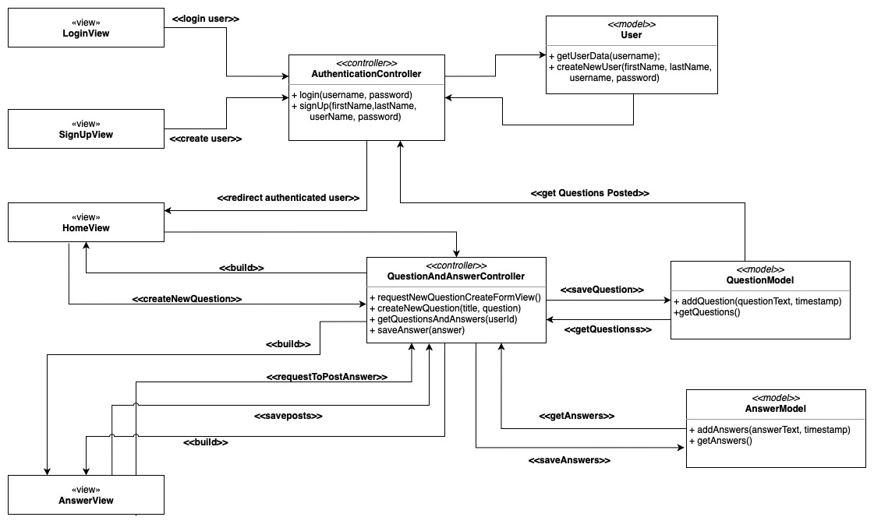

## **Screen Mockups**

Login Page

Sign Up Page

Home Page

Create Question Pop Up

Question Page

Add Answer Pop Up

# **QUESTION 4**

Back-end development, often known as server-side web development, is a sort of development that involves using server-based software. Because it forms the foundation of the entire online application, backend development is crucial. Although server-side, or more often known as backend, applications perform a significant amount of work, the end user would only be able to see the stunning frontend. As a result, this type of development is not visible. Common responsibilities carried out by a server-side application include connecting to databases, ensuring that the frontend obtains necessary data, monitoring system security, and many more.

The languages used for server-side programming are numerous. programming languages like Python, PHP, Node.js, and Java. Each of these languages has advantages and disadvantages. Therefore, what characteristics make a server-side programming language appropriate for server-side development Well, in order to properly understand the need in order to answer that question, we must first understand what it is. Never pick a language just because one developer is an expert in it. It seems to be a problem that many new, young developers face. In any setting, individuals have a tendency to speak or think in the most familiar language or framework. Returning to the question of how to choose the best server-side language, there are numerous variables to take into account when selecting a server-side programming language, including external and technical variables. Technical considerations are therefore entirely tied to the language itself. Among many others, speed, security, and scalability. On the other hand, there are many other external elements that need to be taken into account if you work for an organization, such as if there are adequate resources there who are fluent in the language. Because it would take a long time to fix a problem if no one was familiar with it. Next is the cost; this needs to be taken into account because certain tools are open-source and free to use, while others are not. The cost to the developers should also be taken into account. because hiring a programmer with exceptional skill would be more expensive. The size and complexity of the project that will be created using the programming language is the next and one of the most crucial variables. If you choose a language without doing your homework and without considering the big picture, simply based on what the developer is comfortable with, what happens is that you may need to scale up in the future, and because of the language choice, it's impossible you would regret the choice that was made. This is why this is one of the most important things to consider.The worst part of this is that you'll need to completely rewrite the system in order to make it scalable, and this will get more expensive over time. Therefore, choosing a programming language is a very essential decision that must be made at the appropriate time. This is true for both backend programming and other types of development.

(Lei et al., 2014; Purer, n.d.)

In order to better understand this, let's look at PHP, a server-side programming language created in 1994 by Rasmus Lerdorf. PHP is a suitable option for online applications because it was created for the web and gets along well with frontend technology like HTML and CSS. The versatility of PHP is another factor in its popularity. Facebook is a well-known application that makes use of PHP. Both basic landing sites and complex systems like Facebook can be built using it. (Purer, n.d.)

Python, a high-level, object-oriented general-purpose programming language, is another illustration of a well-known web development language. Python is mostly used in the scientific community and is frequently taught in colleges due to its tight and clear syntax, simplicity in learning, and many other advantages. Python is used by many large organizations, including NASA, Google, Netflix, and Django, one of its most well-liked frameworks. (Purer, n.d.)

As was stated earlier, we should always take into account the needs, the scope of the project, and the cost before selecting a programming language. One thing to remember is that not all languages are created equal. Some may be incredibly quick, some may be sluggish but trustworthy, and some may even be very secure. Therefore, you should consider conducting a good research study on all available languages and should have a good understanding of what's about what you are going to build before choosing a language for not only server-side development, also known as backend development, but other types of development. (“8 Reasons Why PHP Is Still So Important for Web Development,” n.d.; Anna, 2020)

What about PHP as a server-side web development language? Yes, to answer briefly. Let's now explore the reasons PHP is unpopular or, more accurately, why PHP is despised by developers. Back then, thanks to the timely appearance of frameworks, programming languages like Ruby, Python, and Java were a crucial component of web development. The Ruby on Rails framework debuted for Ruby. All of these web-oriented frameworks, including the Django framework for Python and the Spring framework for Java, first debuted. (“8 Reasons Why PHP Is Still So Important for Web Development,” n.d.; Anna, 2020)

# **REFERENCE**

8 Reasons Why PHP Is Still So Important for Web Development [WWW Document], n.d. URL https://jobsity.com/blog/8-reasons-why-php-is-still-so-important-for-web-development (accessed 11.2.22).

Anna, 2020. Is PHP Worthy of Developers Hate? Altamira Softworks. URL https://www.altamira.ai/blog/is-php-worthy-of-developers-hate/ (accessed 11.2.22).

Lei, K., Ma, Y., Tan, Z., 2014. Performance Comparison and Evaluation of Web Development Technologies in PHP, Python, and Node.js, in: 2014 IEEE 17th International Conference on Computational Science and Engineering. Presented at the 2014 IEEE 17th International Conference on Computational Science and Engineering (CSE), IEEE, Chengdu, China, pp. 661–668. https://doi.org/10.1109/CSE.2014.142

Purer, K., n.d. PHP vs. Python vs. Ruby – The web scripting language shootout 16.