|  |  |
| --- | --- |
| **Project Title**  **Name**  **Student ID**  **Institution**  **Course**  **Department**  **Date** | **: Sale Management Report**  **: Thaw Zin Htike**  **: 2430210021**  **: Artificial Intelligence**  **: Knowledge Management Principles and Business Intelligence**  **: Computer Engineering, Beykoz University**  **: 9.1.2024** |

1. **Executive Summary**

This project focuses on comprehensive sales analysis for Sample Sale Company from Microsoft access database, utilizing Power BI to generate insightful reports that facilitate data-driven decision-making. The analysis encompasses various dimensions of sales performance, providing stakeholders with the necessary tools to understand sales dynamics and effectiveness across diverse metrics.

1. **Introduction**

When a sales company operates without a Business Intelligence (BI) dashboard, it may face several challenges and limitations in its operations and decision-making processes.

Data Collection: Without a BI dashboard, data collection may be fragmented and manual.

Reporting: Companies without BI tools can be time-consuming and may not provide real-time insights.

**Decision-Making**:Decision-making can be slow and reactive rather than proactive and data-driven.

**Performance Monitoring**:Sales representatives may not receive timely feedback on their performance, motivation and productivity.

1. **Goal**

The main goal of a Sales Business Intelligence (BI) project is to enhance decision-making and improve sales performance through effective data analysis and visualization.

The goal of a Sales BI project is to transform data into actionable insights, empowering sales teams to make smarter, faster decisions and ultimately drive better business outcomes.

1. **Tools and Techniques**
2. Powerbi,
3. Data Analysis Expressions (DAX) Formula
4. Data set from the sample sale company
5. **Detail of Report**

|  |  |
| --- | --- |
| -Shapping Data | :Remove columns and rows that are not needed  :Rename columns using an obious naming convention  :Ensure columns have the correct data types  :Use date and time functions to create new column  :Add columns and indexes useful for appending data  :Apply a sort order or use an index to guarantee order |
| -Formatting Data | :Query editor provides many options for creating columns, formatting text, and numbers:  :All formatting uses a query that you can view in the formula bar or in advanced editor |
| -Transforming Data | :Table Group  :Any Column Group  :Text Column Group |

**Manage Table Relationship**

-Linked the primary key and foreign key with one to many relationship or one to one relationship.

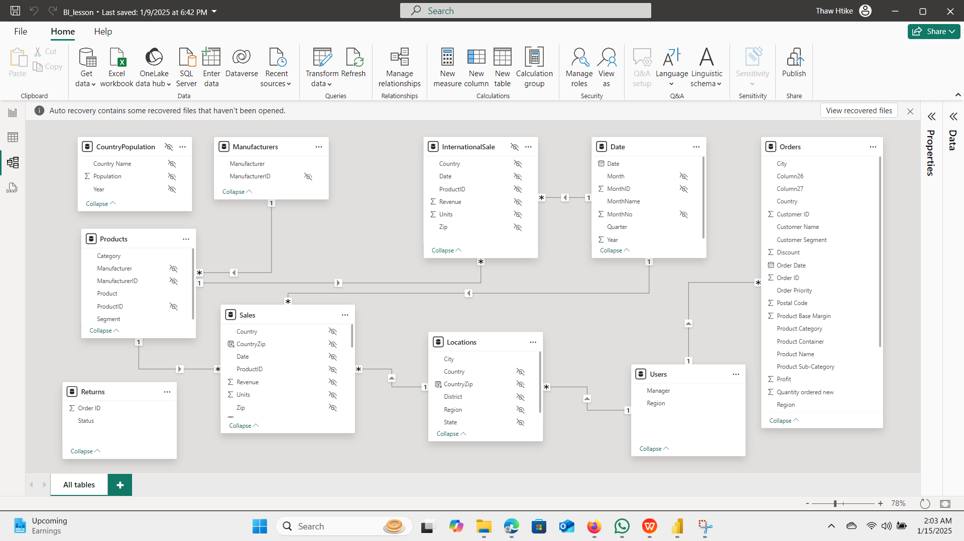

**Using the aggregate funciton**

1. Sum 2) Min 3) Max 4) Avg 5) Count

**Using DAX Formula**

* Total Units
* Total Units Variance
* Total Unit Variance %
* Year to Date Total Units
* Year to Date Total Units Variance
* Year to Date Total Units Variance %

**Detail of Report**

1. **Yearly Sale Amount Report:**

- Using Card Chart visualization with (sum, min, max, avg, count function)

**Note:** Each card can display a specific metric.

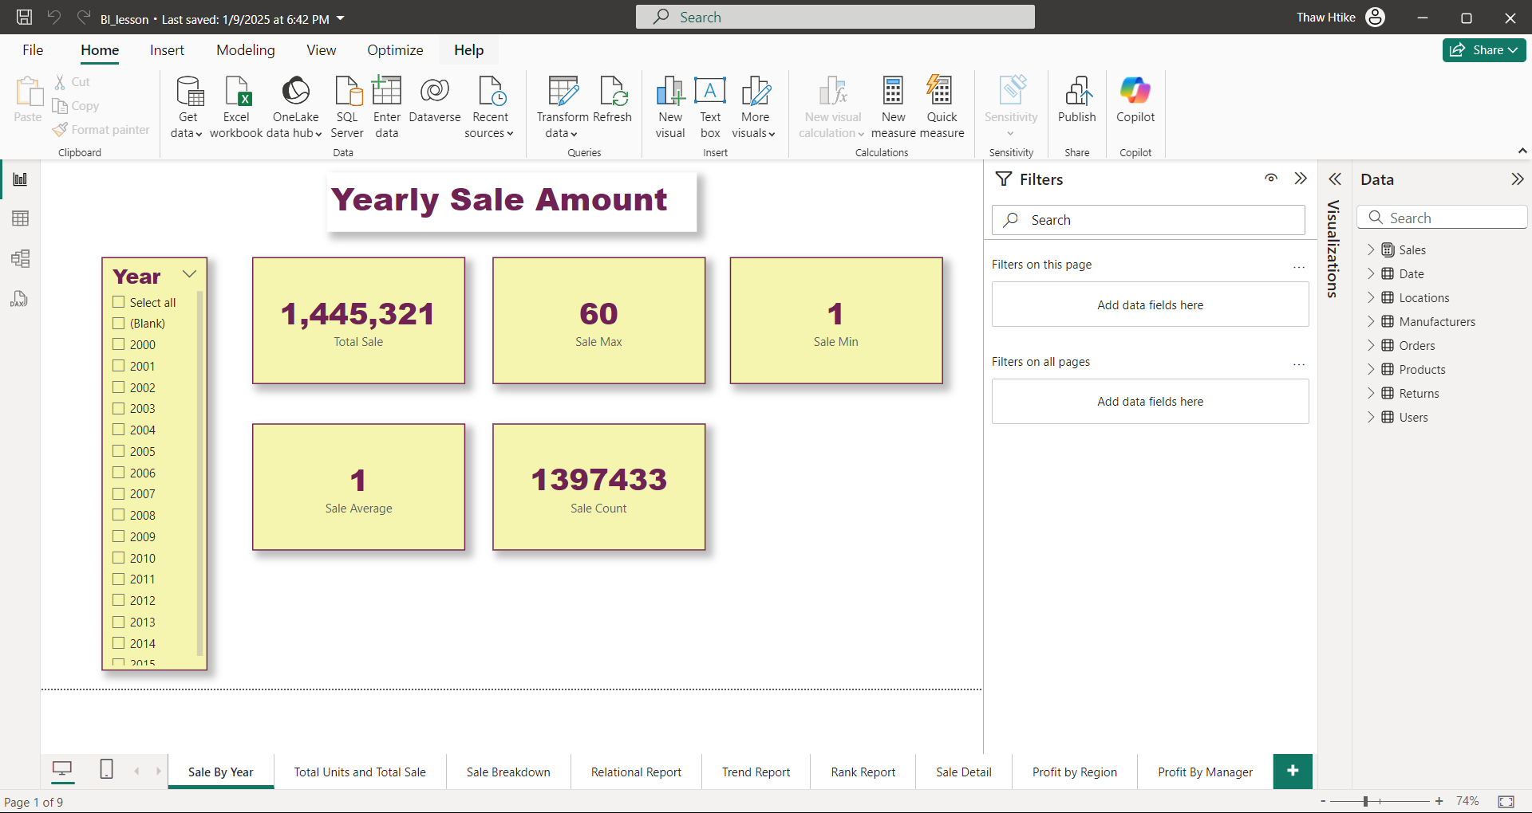

1. **Total Units and Total Sale Report:**

- Using Matrix Chart Visualization (Row: Month Name, Column: Year, Values : Total Units)

**Note:** Both are used to present data in tabular format. However, Matrix (right) has more features. It lets you pivot data by one or more columns so you can create crosstab reports. Matrix also automatically aggregates your data and enables you to drill down.

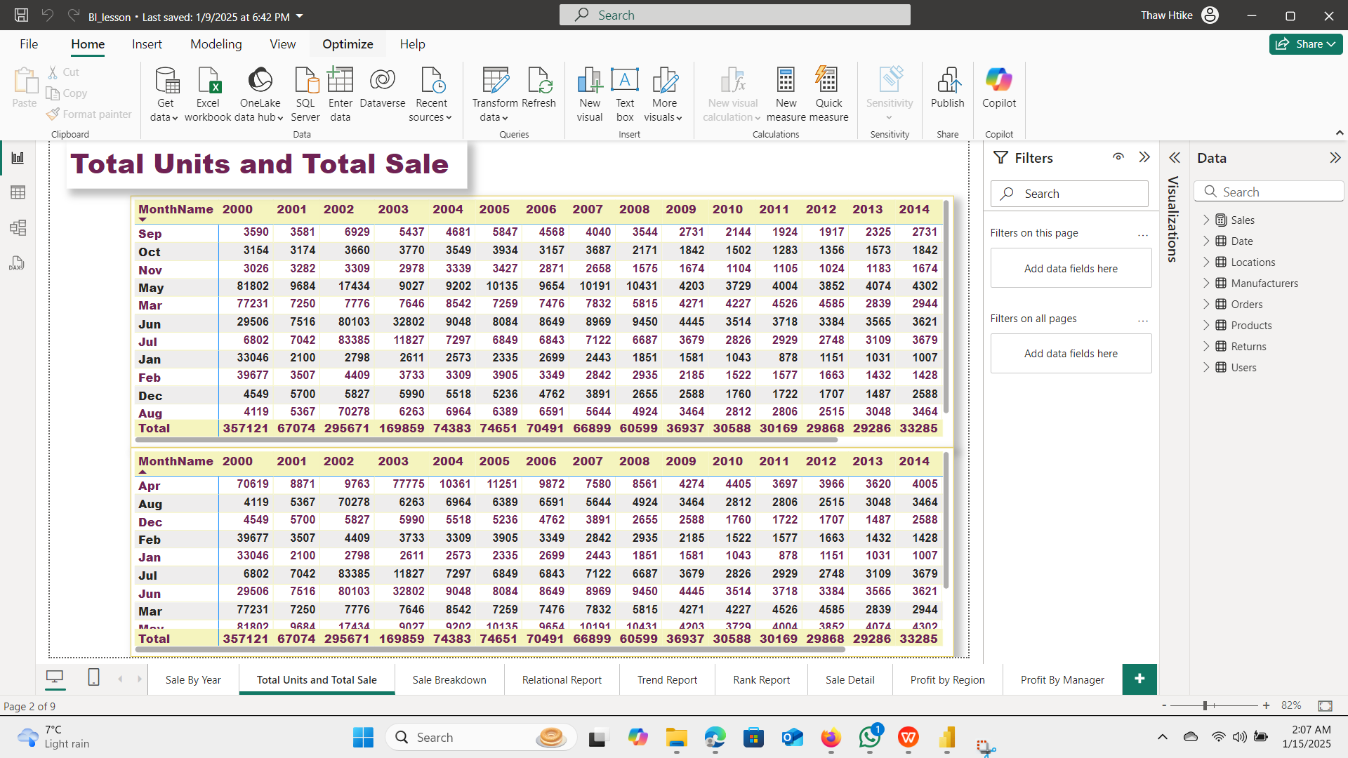

1. **Sale Breakdown Report:**

- Using Line and Stacked Column Chart (Y-axis:Category, X-axis: total Sale, Legend: Segment)

**Note:** If the aim is to compare individual category values, the Line and Clustered Column Chart is more appropriate.

- Using Treemap Chart (Category : Manufacturer, Values: Total Sale)

**Note:**  Tree Maps are primarily used to display data that is grouped and nested in a hierarchical (or tree-based) structure. Treemaps are often used to visualize very large data sets, with hundreds or thousands of items.

- Using the Slicer (year, month)

**Note:**  To get columns after filtering unwanted fields.

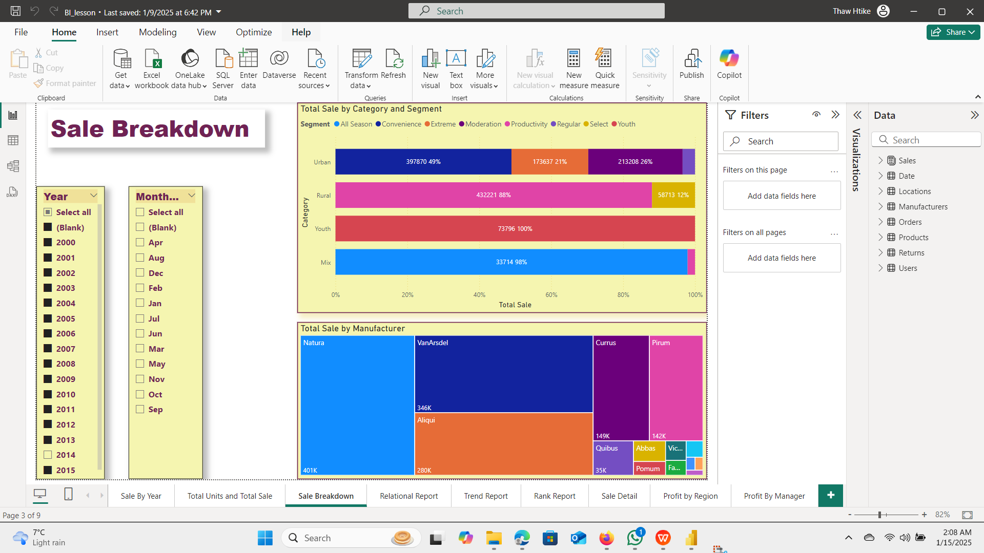

1. **Relational Report**

- Using the Scatter Chart Visualization(Values : Category, X-Axis : Total Sale, Y-axis: Total Units, Legend: Segment, Size : YTD Total Units, Play Axis: Year)

Note: The most common use of the scatter plot is to display the relationship between two variables and observe the nature of the relationship. The relationships observed can either be positive or negative, non-linear or linear, and/or, strong or weak.

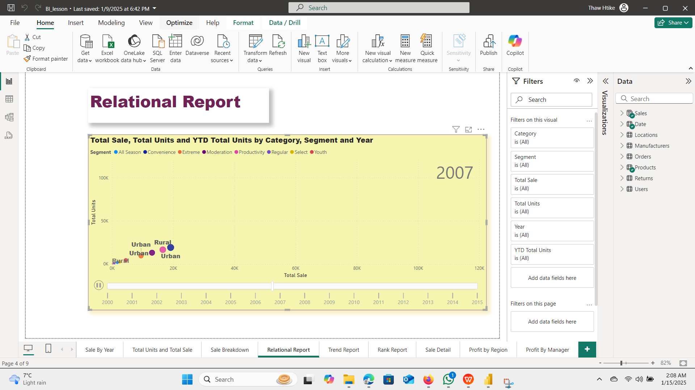

1. **Yearly Trend Report**

- Using the Line and Stacked Column Chart Visualization (x-axis : Year, column y-axis : Total Sale, Line y-axis: Total Units)

**Note:**  The Line and Stacked Column Chart is a combo charts that combines the Line chart and Column chart together in one visual. By combining these two visuals together, you can make a very quick comparison between two sets of measures.

- Using the Waterfall Chart Visualization (Category: year, Y-axis : Total Unit Var)

- Using the Waterfall Chart Visualization (Category: Year, Y-axis: Total Unit)

**Note:** There is a need to graphically display change from a starting to a final value.

The data has positive and negative values.

The data can be categorical, such as revenue and expense types, or it can show movement of a variable over time, such as share price.

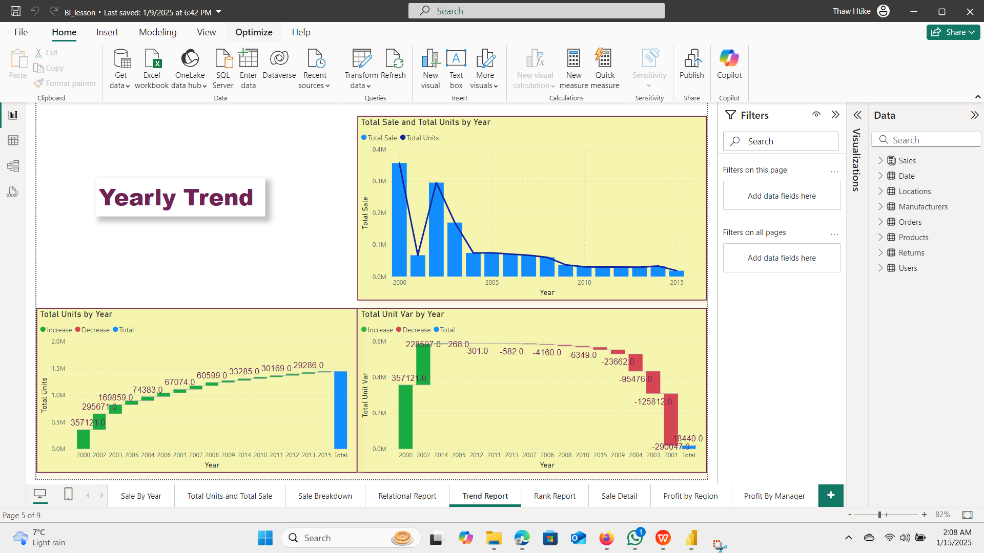

1. **Top Product Report/ Rank Report**

- Using the Stacked Bar chart (Y-axis: Product, X-axis : total Units)

**Note:** Use 100% Stacked Bar charts when required to compare a large number of categories and sub-categories.

- Using the date Slicer (Year)

**Note:**  To get columns after filtering unwanted fields.

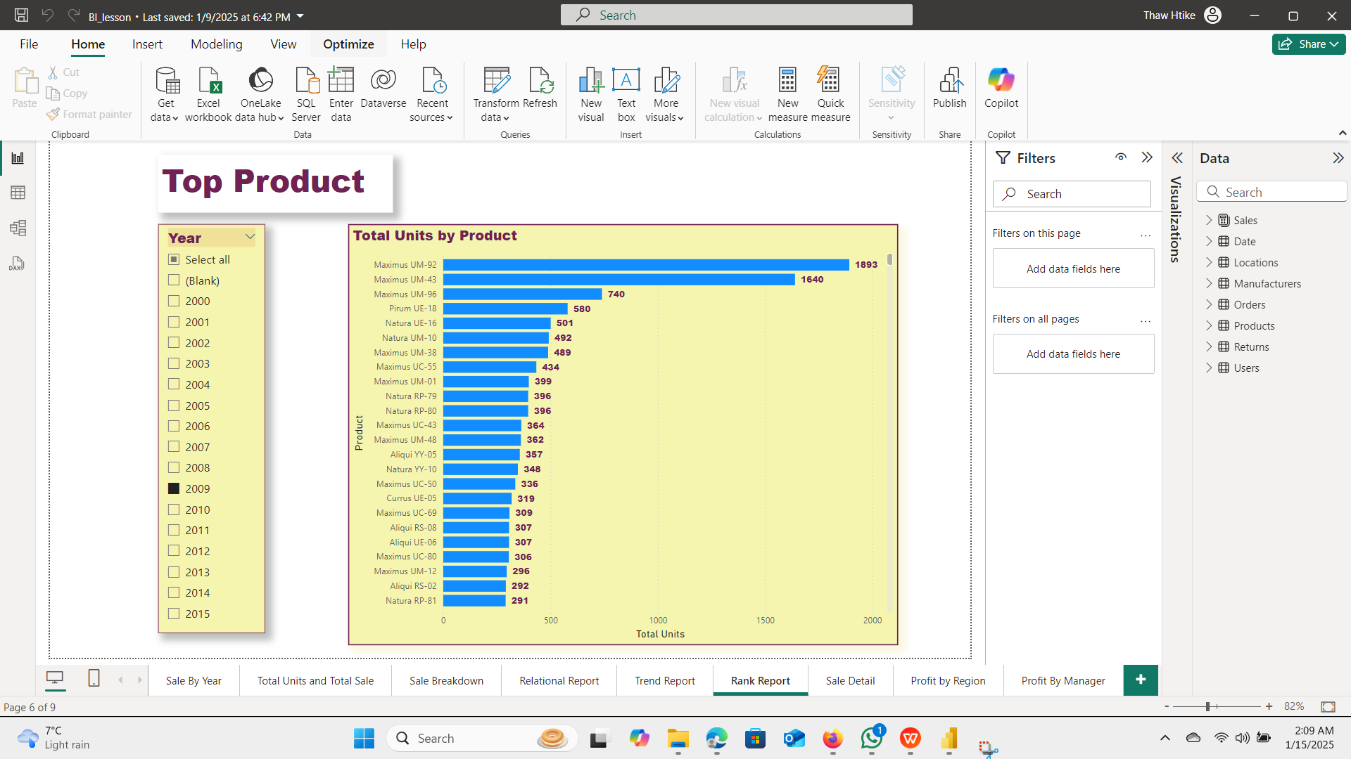

1. **Sale Detail Report**

- Using the table chart (columns: city, Order date, sum of quantity, sum of sales, sum of profit)

**Note:** A table is an effective method for presenting data when the precise values matter, whereas figures are better at illustrating general trends. Still, tables must be designed effectively.

- Using the slicer (profit ) , style : between

**Note:** Each card can display a specific metric.

- Using the slicer (order date), style : between

**Note:**  To get columns after filtering unwanted fields.

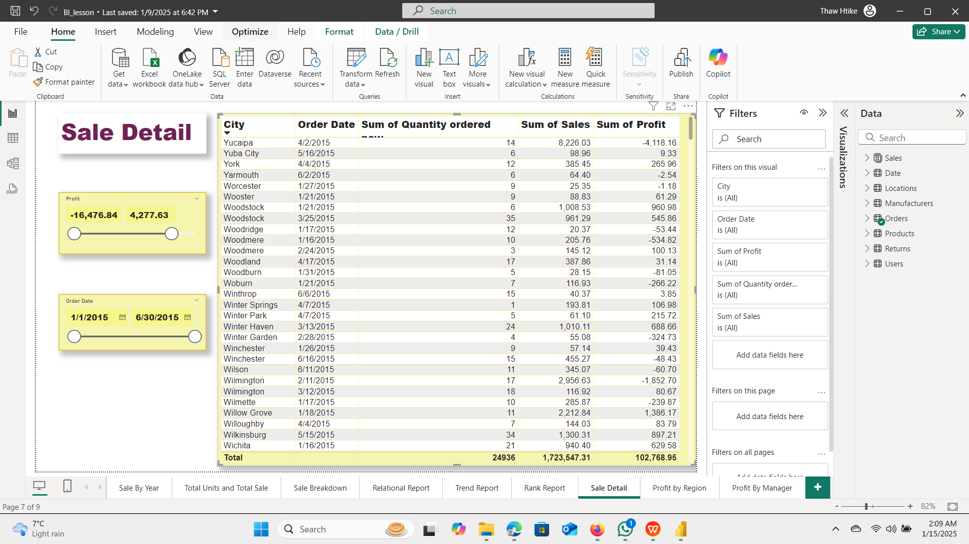

1. **Profit by Region Report**

- Using the Pie chart (Legend : Region, Values : Sum of Profit)

**Note:** Pie charts are best to use when you are trying to compare parts of a whole.

- Using the Treemap chart ( Category: product Category, Values (Sum of Sales)

**Note:**  Tree Maps are primarily used to display data that is grouped and nested in a hierarchical (or tree-based) structure. Treemaps are often used to visualize very large data sets, with hundreds or thousands of items.

- Using the Stacked Bar Chart (Y-Axis: Customer Segment, X-axis: Sum of Quantity ordered)

**Note:** Use 100% Stacked Bar charts when required to compare a large number of categories and sub-categories.

- Using the slicer chart ( Year, month name)

**Note:** To get columns after filtering unwanted fields.

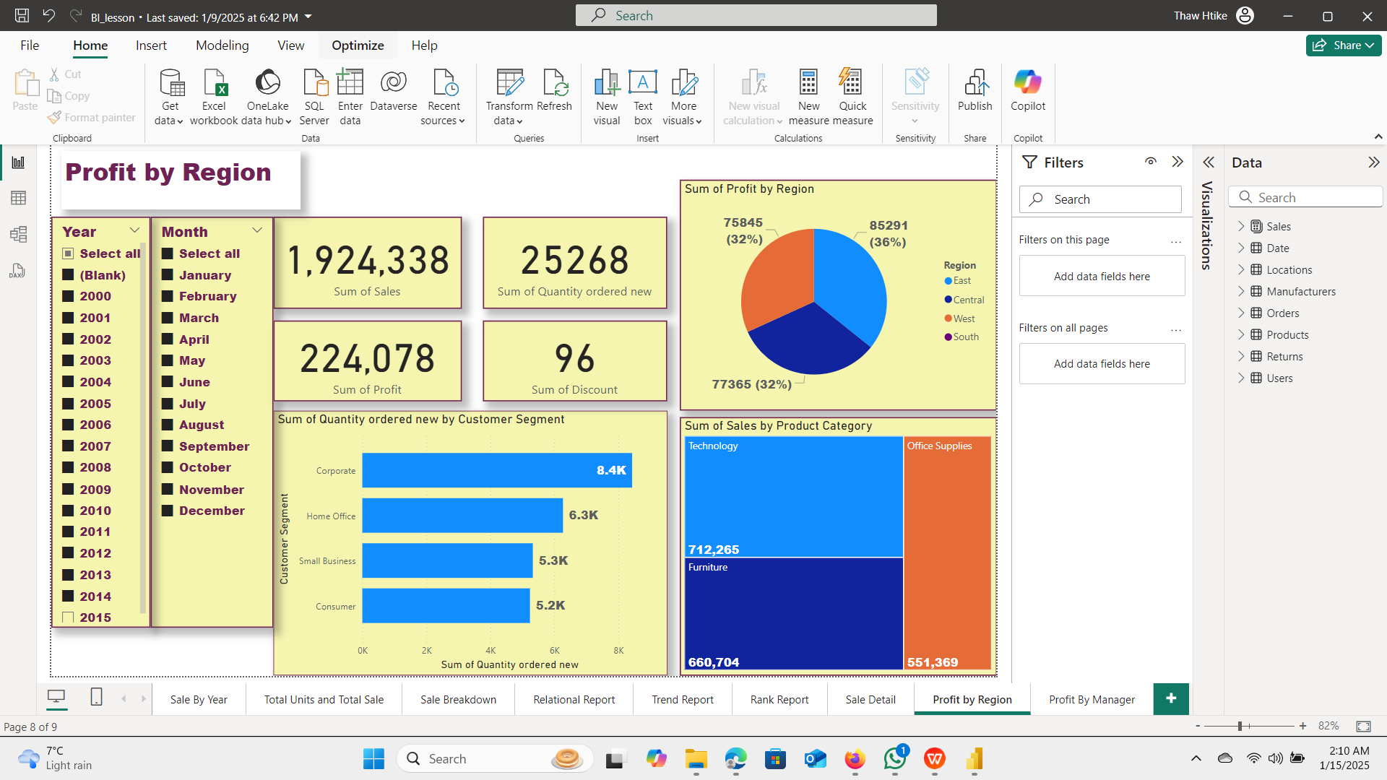

1. **Profit by Manager Report**

- Using the Line and Stacked Column Chart (X-axis: Manager, Column Y-axis: Sum of Sales, Line y-axis : Sum of Profit)

**Note:** If the aim is to compare individual category values, the Line and Clustered Column Chart is more appropriate.

- Using the Card chart (total Sale, Sum of quantity ordered new, sum of profit, sum of discount)

**Note:** Each card can display a specific metric.

- Using the slicer (Month)

**Note:** To get columns after filtering unwanted fields.

