**OFFLINE APP SYNC (CODETHON @ ITECH 2018,ITC INFOTECH)**

1. Challenge Name : OFFLINE APP SYNC

1. Solution Overview:

2.1 Project-name: **Sync-Assist**

2.2 Project-overview:-

**Sync-Assist** is a two-way synchronisation tool , which can be used by the companies like product distribution companies, departmental stores having multiple branches, etc,. who needs to maintain data such as managing their billing information from their branches precisely in centralised manner.

Usually the companies maintain their data by processing their information in excel sheets, In-order to reduce the sales representative’s work load, we were planned to reduce their difficulties by entering the information offline.

These offline data is further synced with cloud storage and in this way multiple sales representatives can share their billing information remotely.

The application can run offline and when sync is triggered, it should be able to perform the update while taking data conflict into account.

1. Solution Approach:

Functionality diagram

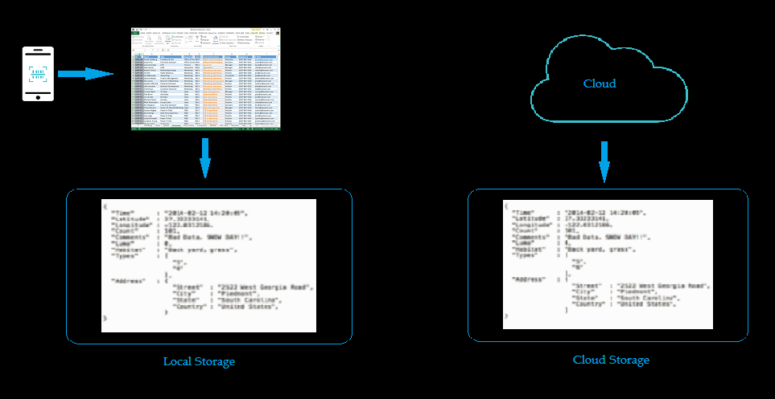

Functional Overview:

For Sync-Assist we planned to build up the backend Rest-API which performs CRUD operartion specified data using node.js framework with express.js.

For online storage bucket we will be using mlab which is the storage client for NO-SQL MongoDB.

For Android and IOS front-end applications we planned to use React-Native frame work, it is an javascript framework which is developed by facebook used to develop native mobile apps for both Android and IOS with single code base.

And additionally we planned to implement a desktop application using electron.js framework or may be a web-application using Angular – framework .

The thought of choosing the desktop or web application in added with native application is because of maintaining and monitoring enormous amount of data needs massive user interface, so it is better to develop a desktop or web application for maintaing such amount of data as in the form of timeline, bar charts and pie charts etc,

It is also used to calculate the GST calculation for companies using the corresponding GST calculation APIs.

1. High Level Architecture :-

Sync-Assist High Level Architecture

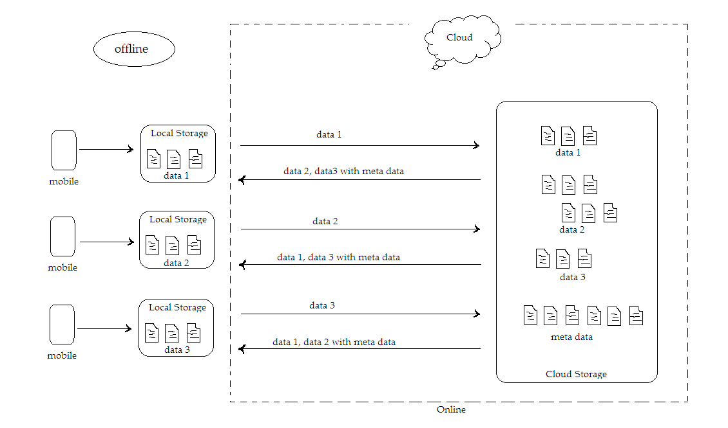

1. Technology Stack :-
   1. Front-end scripting:- (native application Android/IOS)
      1. React Native
      2. React Components
      3. React-native-local-mongodb
      4. React-native node bridge adapter
      5. Electron/Angular framework (optional)

5.2 Back-end Scripting:-(server-Rest-API)

5.2.1 Node.js framework

5.2.2 Express framework

5.2.3 Cross Origin Access control framework (CORS)

5.2.4 JWT Token based Authentication

5.3 Database:- :-(storage)

5.3.1 MongDB (NO-SQL database)

5.4 Hosting:-

5.4.1 Heroku (Cloud instance provider)

5.4.1 mlab (MongoDB instance provider)