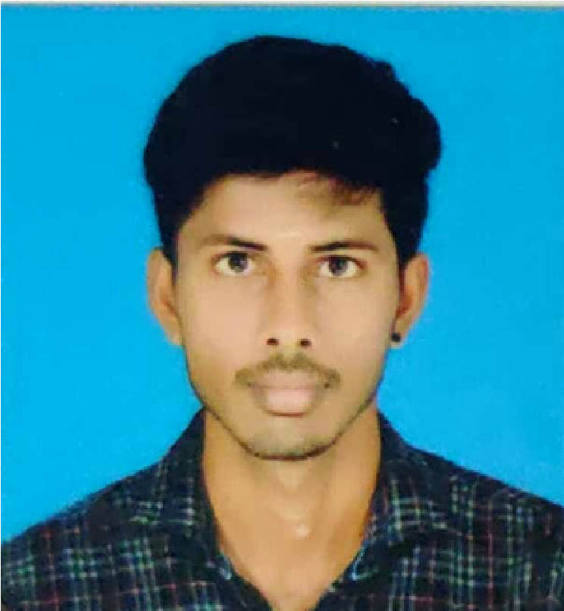

**CAREER OBJECTIVE**

**WORK EXPERIENCE**

**EDUCATION**

**CONTACT**

**SKILLS**

+919543325825

HTML

CSS

JAVASCRIPT

thayamt15@gmail.com

/170, Neasavalar Colony,

4

Savakkattupalayam,

Avinashi, Tiruppur.

**LANGUAGE SKILLS**

Tamil

THAYANITHI V

English

Kannada

**Date of Birth**

28-04-1997

To work in a challenging environment that would provide me with numerous opportunities to utilize and develop my skills and knowledge. This would help me improve my career and contribute to the company to my full potential.

**CERTIFICATE**

• BSc. CHEMISTRY, Bharathiyar University

Gobichettipalayam. | 2014–2017

• HSC, Kumutha Matriculation Higher Secondary School Nambiyu.r | 2012–2014

• SSLC, Govt. Higher Secondary School Savakkattupalayam. | 2012

Process Associate, I-Cons Technologies

Coimbatore | 2020 August–2022 September

• Experienced working on data verification and data generation.

• And by Using client applications like street bees, slintel

**Data Verification**

An application called street bees is mainly used to take the survey from clients who mostly used products in pandemic situations. Understand and track brand performance from consumers. And how consumers are engaging with media and entertainment, in and out of home, across all the platforms.

**Data Generation**

An application called slintel we used to collect the information about the b2b marketing. Analyses factors such as buyer journeys, and technology adoption patterns. And having access to collect customers buying patterns and contact information in all countries.

MICROSOFT EXCEL

• Medical Coding and Training, Thought Flows Medical Coding Academy, Coimbatore.

• Junior Type Writing, Valarmathi Institute, Nambiyur.

• Programming Foundations with JavaScript, HTML and CSS. Coursera.org.