1. Write a C program to simulate a Deterministic Finite Automata (DFA) for the given language.

Program :

#include<stdio.h>

#include<string.h>

#define max 20

int main()

{

int trans_table[4][2]={{1,3},{1,2},{1,2},{3,3}};

int final_state=2,i;

int present_state=0;

int next_state=0;

int invalid=0;

char input_string[max];

printf("Enter a string:");

scanf("%s",input_string);

int l=strlen(input_string);

for(i=0;i<l;i++)

{

if(input_string[i]=='a')

next_state=trans_table[present_state][0];

else if(input_string[i]=='b')

next_state=trans_table[present_state][1];

else

invalid=l;

present_state=next_state;

}

if(invalid==l)

{

printf("Invalid input");

}

else if(present_state==final_state)

printf("Accept\n");

else

printf("Don't Accept\n");

}

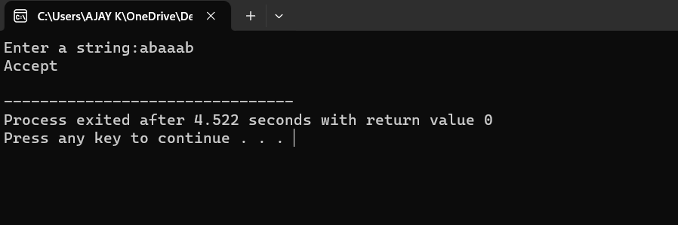

2.Write a C program to simulate a Non-Deterministic Finite Automata (NFA) for the given language.

Program :

#include<stdio.h>

#include<string.h>

int main()

{

int i,j,k,l,m,next_state[20],n,mat[10][10][10],flag,p;

int num_states,final_state[5],num_symbols,num_final;

int present_state[20],prev_trans,new_trans;

char ch,input[20];

int symbol[5],inp,inp1;

printf("How many states in the NFA : ");

scanf("%d",&num_states);

printf("How many symbols in the input alphabet : ");

scanf("%d",&num_symbols);

for(i=0;i<num_symbols;i++)

{

printf("Enter the input symbol %d : ",i+1);

scanf("%d",&symbol[i]);

}

printf("How many final states : ");

scanf("%d",&num_final);

for(i=0;i<num_final;i++)

{

printf("Enter the final state %d : ",i+1);

scanf("%d",&final_state[i]);

}

for(i=0;i<10;i++)

{

for(j=0;j<10;j++)

{

for(k=0;k<10;k++)

{

mat[i][j][k]=-1;

}

}

}

for(i=0;i<num_states;i++)

{

for(j=0;j<num_symbols;j++)

{

printf("How many transitions from state %d for the input %d : ",i,symbol[j]);

scanf("%d",&n); for(k=0;k<n;k++)

{

printf("Enter the transition %d from state %d for the input %d : ",k+1,i,symbol[j]);

scanf("%d",&mat[i][j][k]);

}

}

}

printf("The transitions are stored as shown below\n");

for(i=0;i<10;i++)

{

for(j=0;j<10;j++)

{

for(k=0;k<10;k++)

{

if(mat[i][j][k]!=-1)

printf("mat[%d][%d][%d] = %d\n",i,j,k,mat[i][j][k]);

}

}

}

while(1)

{

printf("Enter the input string : ");

scanf("%s",input);

present_state[0]=0;

prev_trans=1;

l=strlen(input);

for(i=0;i<l;i++)

{

if(input[i]=='0')

inp1=0;

else if(input[i]=='1')

inp1=1;

else

{

printf("Invalid input\n");

}

for(m=0;m<num_symbols;m++)

{

if(inp1==symbol[m])

{

inp=m;

break;

}

}

new_trans=0;

for(j=0;j<prev_trans;j++)

{

k=0;

p=present_state[j];

while(mat[p][inp][k]!=-1)

{

next_state[new_trans++]=mat[p][inp][k];

k++;

}

}

for(j=0;j<new_trans;j++)

{

present_state[j]=next_state[j];

}

prev_trans=new_trans;

}

flag=0;

for(i=0;i<prev_trans;i++)

{

for(j=0;j<num_final;j++)

{

if(present_state[i]==final_state[j])

{

flag=1;

break;

}

}

}

if(flag==1)

printf("Acepted\n");

else

printf("Not accepted\n");

printf("Try with another input\n");

}

}

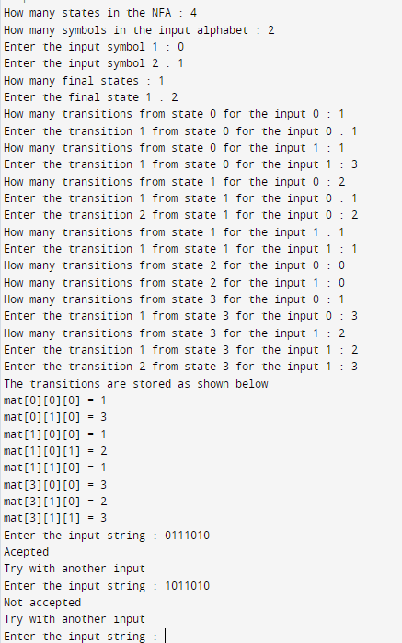

3.Write a C program to find ε-closure for all the states in a NonDeterministic Finite Automata (NFA) with ε -moves.

Program:

#include<stdio.h>

#include<string.h>

int trans_table[10][5][3];

char symbol[5],a;

int e_closure[10][10],ptr,state;

void find_e_closure(int x);

int main()

{

int i,j,k,n,num_states,num_symbols;

for(i=0;i<10;i++)

{

for(j=0;j<5;j++)

{

for(k=0;k<3;k++)

{

trans_table[i][j][k]=-1;

}

}

}

printf("How may states in the NFA with e-moves:");

scanf("%d",&num_states);

printf("How many symbols in the input alphabet including e :");

scanf("%d",&num_symbols);

printf("Enter the symbols without space. Give 'e' first:");

scanf("%s",symbol);

for(i=0;i<num_states;i++)

{

for(j=0;j<num_symbols;j++)

{

printf("How many transitions from state %d for the input %c:",i,symbol[j]);

scanf("%d",&n);

for(k=0;k<n;k++)

{

printf("Enter the transitions %d from state %d for the input %c :", k+1,i,symbol[j]);

scanf("%d",&trans_table[i][j][k]);

}

}

}

for(i=0;i<10;i++)

{

for(j=0;j<10;j++)

{

e_closure[i][j]=-1;

}

}

for(i=0;i<num_states;i++) e_closure[i][0]=i;

for(i=0;i<num_states;i++)

{

if(trans_table[i][0][0]==-1)

continue; else

{

state=i; ptr=1;

find_e_closure(i);

}

}

for(i=0;i<num_states;i++)

{

printf("e-closure(%d)= {",i);

for(j=0;j<num_states;j++)

{

if(e_closure[i][j]!=-1)

{

printf("%d, ",e_closure[i][j]);

}

}

printf("}\n");

}

}

void find_e_closure(int x)

{

int i,j,y[10],num_trans;

i=0;

while(trans_table[x][0][i]!=-1)

{

y[i]=trans_table[x][0][i];

i=i+1;

}

num_trans=i;

for(j=0;j<num_trans;j++)

{

e_closure[state][ptr]=y[j];

ptr++;

find_e_closure(y[j]);

}

}

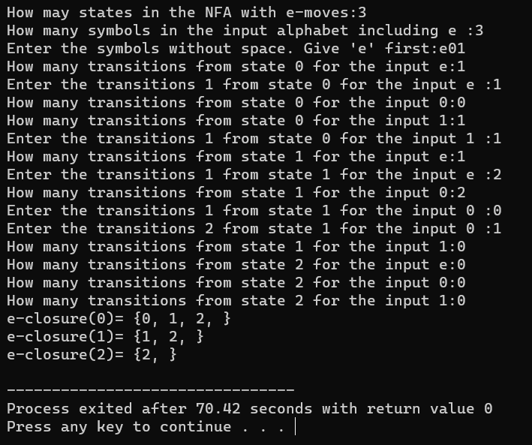

4.Write a C program to check whether a given string belongs to the language defined by a Context Free Grammar (CFG)

Program:

#include<stdio.h>

#include<string.h>

int main(){

char s[100];

int i,flag;

int l;

printf("enter a string to check:");

scanf("%s",s);

l=strlen(s);

flag=1;

for(i=0;i<l;i++)

{

if(s[i]!='0' && s[i]!='1')

{

flag=0;

}

} if(flag!=1)

printf("string is Not Valid\n");

if(flag==1)

{

if (s[0]=='0'&&s[l-1]=='1')

printf("string is accepted\n");

else

printf("string is Not accepted\n");

}

}

