  Agricultural Learning Platform | Group Members: Cele Mmeli - 22355803 Mangwedi Boitumelo- 22404965 Qwabe Thobekisiwe - 21505137

Table of Contents
2.1 Problem statement 2
Proposed Solution 2
How the Solution Stands out and adds Real Value 3
2.2 System Requirement Specification (SRS) 4
Functional 4-5
Non- Functional 5-6
2.3 Use Cases 7-13
2.4 Product Backlog 14-21
2.5 User Stories and Acceptance Criteria 22-25
2.6 Use Case Diagrams 26-28
2.7 Work breakdown structure (WBS) 29-30
2.8 Security Planning 31-36
2.9 Feasibility Study 37-42
2.10 Stakeholder Analysis 43-46

Project Proposal draft
Project Theme: Agricultural learning platforms
2.1 Problem statement
The problem addressed in this study is that small-scale farmers in South Africa remain excluded from formal agricultural markets due to limited access to practical, localized agricultural knowledge and market information (NAMC, 2024; FAO, 2022). As a result, most smallholder farmers rely on informal markets because of inadequate extension services, technical support, and market readiness (Agholor, Ogujiuba & Shongwe, 2023). Although digital agricultural platforms are available, many are fragmented, internet-dependent, overly technical, and poorly suited to rural environments, limiting their practical application (Bontsa et al., 2023; Nxumalo & Chauke, 2025). This knowledge-to-practice gap contributes to low productivity, post-harvest losses, unstable incomes, and continued economic exclusion (World Bank, 2020). Therefore, there is a need to develop an accessible, practice-oriented digital agricultural learning platform that provides localized content, offline and low-data access, step-by-step guidance, and market-readiness support to enable meaningful participation in formal agricultural markets.
Proposed Solution
The proposed solution is a digital agricultural learning platform that provides the following:
- Simple, localized farming education for small farmers.
- The platform also includes a basic marketplace feature that allows farmers to connect with larger markets and retailers to sell their products. This integrated approach supports improved farming practices, income growth, and market participation.
- To address language barriers commonly faced by rural users, the system will integrate AI-assisted translation services. This allows learning content and system messages to be presented in multiple languages, supporting inclusivity and accessibility

How the Solution Stands out and adds Real Value
Although similar agricultural platforms exist, many fail to address the specific needs of small and beginner farmers. The proposed system differentiates itself by offering localized, beginner-friendly agricultural learning combined with direct market access on a single platform. By focusing on practical content tailored to local conditions, low data usage, and simplified user interfaces, the solution provides real value to underserved farming communities while supporting economic empowerment through improved market participation.
The learning platform will be designed to support multiple languages, helping rural users who may struggle to understand English to access and benefit from the content.

Justification for Using the Agile SDLC Model
The Agile Software Development Life Cycle (SDLC) model is selected for the development of the agricultural learning and market access platform due to its:
- Flexibility
- Adaptability
- User-focused approach
The project requirements may evolve as feedback is gathered from potential users such as small-scale farmers. Agile supports continuous improvement by allowing changes to be incorporated throughout the development process rather than only at the end.
Agile promotes incremental development through short development cycles known as sprints. This allows the project team to deliver core features early, such as learning modules and basic marketplace functionality, and then enhance the system over time. Early delivery reduces project risk and ensures that the most important features are prioritized.
Additionally, Agile encourages frequent testing and stakeholder feedback, which helps identify usability issues and technical challenges early in the project. This is especially important for ensuring that the system remains simple, accessible, and suitable for beginner users. For a student-led project with limited time and resources, Agile provides better control over scope, improves collaboration within the team, and increases the likelihood of delivering a functional and high-quality system.

2.2 System Requirement Specification (SRS)

Requirement | Type | Priority (MoSCoW)
The system shall allow users (farmers, retailers, buyers) to register and create an account | Functional | Must
The system allows users to log in and log out securely | Functional | Must
The system should support different user roles (farmer, buyer, retailer) | Functional | Must
The system shall provide structured agricultural learning content | Functional | Must
Farmers shall be able to create product listings with product details | Functional | Must
Farmers shall be able to update or remove product listings | Functional | Must
Buyers shall be able to browse and view available products | Functional | Must
Buyers shall be able to contact farmers through the platform | Functional | Must
The system shall allow users to update and manage their profiles | Functional | Should
The system shall allow users to reset or recover forgotten password | Functional | Should
The system shall allow users to search for specific farming topics | Functional | Should
The system shall categorize learning content by crop type or farming topic | Functional | Should
Buyers shall be able to search for or filter products | Functional | Should
The system should have clear navigation and organized sections | Functional | Should
The system allows users to view multimedia learning materials (images/video) | Functional | Could
The system shall allow users to bookmark or save learning resources | Functional | Could
Farmers shall receive notifications when buyers show interest | Functional | Could
The system shall have a simple and user-friendly interface | Non-Functional | Must
The system shall be accessible on different devices | Non-Functional | Must
The system shall load pages within 3–5 seconds | Non-Functional | Must
The system shall securely store user data | Non-Functional | Must
The system shall require authentication for sensitive feature | Non-Functional | Must
The system shall protect against unauthorized access | Non-Functional | Must
The system shall store passwords using hashing and encryption | Non-Functional | Must
The system will maintain data integrity | Non-Functional | Must
The system will be accessible through modern web browsers | Non-Functional | Must
The system will have clear navigation and organized sections | Non-Functional | Should
The system will support multiple users simultaneously | Non-Functional | Should
The system will minimize crashes and ensure stable operation | Non-Functional | Should
The system will provide error handling and user feedback | Non-Functional | Should

2.3 Use Cases
UC-01: Register as Farmer
Actor: Unregistered User (Farmer)
Secondary Actor: Authentication System (OTP Service)
Pre-condition:
User has a smartphone with internet access.
Main Flow:
- User opens the application
- User selects Register
- User enters mobile number
- System sends OTP
- User enters OTP
- User sets password
- System creates farmer profile
Alternate Flow A:
A1. Invalid mobile number → system displays validation error → user re-enters number
Exception Flow E1:
E1. OTP not received after 60 seconds - system displays Resend OTP option
Post-condition:
Farmer account created; user redirected to dashboard.

UC-02: Login to System
Actor: Registered User (Farmer / Admin)
Secondary Actor: Authentication System
Pre-condition:
User is registered and account is active.
Main Flow:
- User opens application
- User enters mobile number and password
- System validates credentials
- System grants access to dashboard
Alternate Flow A:
A1. User selects Forgot Password → system initiates password reset
Exception Flow E1:
E1. Invalid credentials - system displays error message and denies access
Post-condition:
User logged in and session started.

UC-03: Manage Profile and Language Preferences
Actor: Farmer
Secondary Actor: User Profile Service
Pre-condition:
User is logged in.
Main Flow:
- User selects Profile Settings
- User updates personal details and preferred language
- System saves changes
- System updates content language preference
Alternate Flow A:
A1. Selected language unavailable → system falls back to default language
Exception Flow E1:
E1. Invalid data entered → system displays validation error
Post-condition:
Profile and preferences successfully updated.

UC-04: Browse Learning Content
Actor: Farmer
Secondary Actor: Content Management System
Pre-condition:
User is logged in.
Main Flow:
- User selects Learning Modules
- System displays available categories
- User selects a category
- System displays relevant learning content
Alternate Flow A:
A1. No content available → system suggests related categories
Exception Flow E1:
E1. Content service unavailable → system displays error message
Post-condition:
Learning content list displayed.

UC-05: View Learning Module
Actor: Farmer
Secondary Actor: Content Delivery System
Pre-condition:
User is logged in and learning content exists.
Main Flow:
- User selects a learning module
- System displays module content
- System tracks learning progress
Alternate Flow A:
A1. User bookmarks module for later viewing
Exception Flow E1:
E1. Module fails to load → system displays retry option
Post-condition:
Module viewed and progress recorded.

UC-06: Download Learning Content for Offline Use
Actor: Farmer
Secondary Actor: Storage System
Pre-condition:
User is logged in and has available device storage.
Main Flow:
- User selects Download for Offline Use
- System checks storage availability
- System downloads learning content
- System confirms offline availability
Alternate Flow A:
A1. User selects low-data version → system downloads compressed content
Exception Flow E1:
E1. Insufficient storage → system displays warning
Post-condition:
Content stored locally for offline access.

UC-07: Create Product Listing
Actor: Farmer
Secondary Actor: Marketplace System
Pre-condition:
Farmer is logged in and profile is complete.
Main Flow:
- Farmer selects Create Listing
- Farmer enters product details (type, price, quantity)
- Farmer uploads product image
- System publishes listing
Alternate Flow A:
A1. Farmer saves listing as draft
Exception Flow E1:
E1. Missing mandatory fields → system highlights required inputs
Post-condition:
Product listing published in marketplace.

UC-08: Contact Seller / Request Supply
Actor: Buyer / Retailer
Secondary Actor: Messaging System
Pre-condition:
Buyer is logged in and product listing exists.
Main Flow:
- Buyer selects a product listing
- Buyer clicks Contact Seller
- Buyer sends request message
- System notifies seller
Alternate Flow A:
A1. Buyer sends bulk request to multiple sellers
Exception Flow E1:
E1. Seller unavailable → system suggests alternative sellers
Post-condition:
Request sent and conversation initiated.

UC-09: Manage Platform Operations
Actor: Administrator
Secondary Actor: Audit & Security System
Pre-condition:
Administrator is logged in.
Main Flow:
- Admin accesses admin dashboard
- Admin manages user accounts
- Admin updates or removes content
- Admin monitors marketplace activity
- System logs all actions
Alternate Flow A:
A1. Admin exports audit report
Exception Flow E1:
E1. Unauthorized action attempted → system blocks and logs incident
Post-condition:
Platform operations updated and logged.

UC10: AI Translation & Language Support
Actor
- Farmer
Secondary Actors
- AI Translation Service (Azure Cognitive Services – Translator)
- On-device Translation Engine (Google ML Kit – offline mode)
Pre-Conditions
- User is registered and logged into the system
- Learning content or chatbot interaction exists
- AI translation service or offline translation model is available
Post-Conditions
- Learning content, chatbot responses, and supported UI text are displayed in the selected language
- User language preference is saved for future sessions
Main Flow:
- User selects a preferred language from the system settings (e.g., isiZulu).
- System records the user’s language preference.
- System sends learning content, chatbot responses, and basic UI text to the AI translation service.
- AI translation service returns translated content.
- System displays the translated content to the user.
- User continues interacting with the platform in the selected language.

Alternate Flow A - Partial Language Support
1. User selects a language that is partially supported.
2. System translates all available content using the AI service.
3. Unsupported text is displayed in the default language (English).
4. System notifies the user that some content is unavailable in the selected language.

Alternate Flow B- Offline Translation Mode
1. User accesses previously downloaded learning content in low-connectivity or offline mode.
2. System uses on-device translation via Google ML Kit where available.
3. Translated content is displayed without requiring an internet connection.

Exception Flow E1 – Translation Service Unavailable
- Translation service is unavailable or fails to respond.
- System displays content in the default language.
- System logs the incident for administrative review.

2.4 Product Backlog

ID | User Story | Acceptance Criteria | MoSCoW Priority | Story Points | Status
PB-01 | As an Admin, I want to log in securely so that I can manage platform operations safely. | Given I am an admin  when I enter valid credentials then I access the admin dashboard and invalid attempts show a safe error (no user enumeration) and account locks after X failed attempts  and sessions expire after inactivity | Must | 8 | Backlog
PB-02 | As a Farmer, I want to register an account so that I can access learning content and marketplace features. | Given I am new  when I submit required details then my account is created in “Pending approval” status  And I receive a confirmation message  And validation prevents missing/invalid fields | Must | 5 | Backlog
PB-03 | As an Admin, I want to approve or reject registrations so that only legitimate users access the system. | Given there are pending registrations  When I approve/reject with a reason  Then the user status updates accordingly  And the user is notified of the outcome  And actions are logged for audit | Must | 5 | Backlog
PB-04 | As a Farmer, I want to log in so that I can access my personalized learning and marketplace tools. | Given my account is approved  When I enter correct credentials  Then I am signed in and redirected to my home screen  And failed logins show a generic error | Must | 5 | Backlog
PB-05 | As a Farmer, I want to browse learning modules so that I can find relevant topics (crop/livestock). | Given modules exist  When I open Learning Content  Then I can view categories and module lists  And modules show title, level, language, last updated | Must | 8 | Backlog
PB-06 | As a Farmer, I want to view a learning module so that I can learn step-by-step practical content. | Given I selected a module  When I open it  Then I can read/watch the content  And media loads with adaptive quality option (low data)  And I can resume where I left off | Must | 8 | Backlog
PB-07 | As an Admin, I want to upload learning content so that farmers receive accurate and relevant information. | Given I am logged in as admin  When I upload content (text/video/pdf)  Then it is saved with metadata (topic, language, level)  And it appears in the learning catalogue | Must | 8 | Backlog
PB-08 | As an Admin, I want to update or remove learning content so that outdated or incorrect info is not shown. | Given content exists  When I edit or delete it  Then users see the latest version, or it disappears  And changes are versioned or logged | Must | 5 | Backlog
PB-09 | As a Farmer, I want to create a marketplace listing so that I can sell produce to buyers/retailers. | Given I am logged in  When I enter product, price, quantity, location, photos (optional)  Then the listing is created in “Pending review” or “Active” (per rules)  And required fields are validated | Must | 8 | Backlog
PB-10 | As a Buyer/Retailer, I want to browse marketplace listings so that I can find products to purchase. | Given listings exist  When I browse the marketplace  Then I can view listings with key details  And filter by category/location/price | Must | 8 | Backlog
PB-11 | As an Admin, I want to monitor marketplace activity and moderate listings so that inappropriate/incorrect content is handled. | Given listings are submitted  When I approve/reject/remove listings  Then the marketplace reflects my decision  And I can record a reason  And actions are audit-logged | Must | 8 | Backlog
PB-12 | As an Admin, I want to manage user roles and accounts so that access is controlled (approve roles, disable accounts). | Given users exist  When I change role or disable a user  Then permissions update immediately  And disabled users cannot sign in  And updates are logged | Must | 8 | Backlog
PB-13 | As a User, I want to give consent for personal data processing so that the platform complies with POPIA. | Given I register or first sign in  When I accept the privacy notice/consent  Then consent is stored with timestamp/version  And I can view the privacy notice anytime | Must | 5 | Backlog
PB-14 | As a Security Admin, I want encryption in transit so that data is protected between app and server. | Given network requests occur  When data is transmitted  Then TLS is enforced  And insecure requests are rejected | Must | 3 | Backlog
PB-15 | As a Security Admin, I want to audit logs for admin actions so that we can investigate incidents and prove compliance. | Given an admin changes users/content/listings  When the action occurs  Then logs capture who/what/when/before-after (where applicable)  And logs are tamper-resistant (restricted access) | Must | 5 | Backlog
PB-16 | As a Farmer, I want to search learning content so that I can quickly find topics I need. | Search by keyword + filters (topic/level/language)  Returns relevant results | Should | 5 | Backlog
PB-17 | As a Farmer, I want to bookmark modules so that I can revisit important lessons | Bookmark/unbookmark works  Saved list appears in “My Learning”  Bookmarks persist across devices | Should | 3 | Backlog
PB-18 | As a Farmer, I want quizzes after modules so that I can confirm understanding. | Quiz created per module  Score shown after completion  Minimum pass criteria configurable | Should | 8 | Backlog

PB-19 | As a User, I want multi-language support so that I can learn in my preferred language. | Language selector available  UI labels translated  Content filtered by available language | Should | 8 | Backlog
PB-20 | As a Buyer/Retailer, I want to contact a seller so that I can negotiate and arrange collection/delivery. | In-app messaging or contact method shown per privacy rules  Spam prevention (rate limits/reporting)  Conversation history saved | Should | 8 | Backlog
PB-21 | As a Farmer, I want low-data mode so that I can use the platform in rural/limited connectivity areas. | Toggle low-data mode  Images compressed; video defaults to low quality  Page sizes reduced; lazy-loading enabled | Should | 8 | Backlog
PB-22 | As an Admin, I want content versioning so that updates can be tracked and rolled back if needed. | Each edit creates a version entry  Admin can restore previous version  Version history is visible | Should | 5 | Backlog
PB-23 | As a Security Admin, I want role-based access control (RBAC) so that users only access permitted features. | Farmer/Buyer/Admin roles defined  Endpoints protected server-side  Unauthorized actions blocked + logged | Should | 8 | Backlog
PB-24 | As a Security Admin, I want encryption at rest so that stored personal data is protected. | Sensitive fields encrypted in storage  Keys managed securely  Backups encrypted | Should | 5 | Backlog
PB-25 | As an Ops Admin, I want backup and restore so that we can recover after failures. | Automated daily backups  Restore procedure tested successfully  Recovery objectives documented | Should | 5 | Backlog
PB-26 | As a Farmer, I want offline access to saved modules so that I can learn without internet. | Download allowed for marked modules  Offline reader works  Auto-sync progress when online | Could | 13 | Backlog
PB-27 | As a User, I want push notifications so that I know when new content or listing updates occur. | Notifications configurable  Opt-in/out supported  No sensitive info in notification previews | Could | 5 | Backlog
PB-28 | As a Farmer, I want to rate learning modules so that the best content is easy to identify. | 1–5 rating + optional comment  Moderation rules applied  Average rating displayed | Could | 3 | Backlog
PB-29 | As an Admin, I want analytics dashboards so that I can track usage and improvement areas. | Track active users, top modules, completion rates  Data anonymized where required  Export to CSV | Could | 8 | Backlog
PB-30 | As a User, I want accessibility support so that the platform is usable for everyone. | WCAG-aligned basics: contrast, font scaling, screen reader labels  Keyboard navigation supported on web | Could | 8 | Backlog
PB-31 | As a Buyer, I want in-app payments so that I can pay directly on the platform. | Payment gateway integrated, receipts issued, dispute flow | Won’t (Now) | 13 | Backlog
PB-32 | As a User, I want live video training sessions so that I can attend real-time classes. | Live streaming, scheduling, moderation, recording | Won’t (Now | 13 | Backlog

2.5 User Stories and Acceptance Criteria
User Stories
US-01 Register Account
Story
As a new user (farmer or buyer), I want to create an account, so that I can access the learning platform and marketplace features.
Acceptance Criteria
AC-1: Given a user enters valid registration details, when they submit the form, then the system creates a new account successfully.
AC-2: Given a user enters an email already registered, when they attempt to register, then the system displays an error message “Email already exists”.
AC-3: Given required fields are empty, when the user submits the form, then the system prevents registration and highlights missing fields.
AC-4: Given registration is successful, when the process is completed, then the user is redirected to the login page.

US-02 Login to System
Story
As a registered user, I want to log into the system, so that I can access my dashboard and features relevant to my role.
Acceptance Criteria
AC-1: Given a user enters correct login credentials, when they click login, then the system grants access to the dashboard.
AC-2: Given incorrect login credentials are entered, when the user attempts to log in, then the system displays an “Invalid credentials” error.
AC-3: Given that a user fails to log in 5 times consecutively, when another attempt is made, then the system temporarily locks the account.

US-03 Access Learning Content
Story
As a farmer, I want to view structured agricultural learning content, so that I can improve my farming knowledge and skills.
Acceptance Criteria
AC-1: Given a user selects the learning section, when the page loads, then the system displays categorized farming topics.
AC-2: Given a user selects a learning topic, when they open the content, then the system displays the full learning guide.
AC-3: Given a topic contains multimedia resources, when the user views the topic, then images or videos are displayed correctly.

US-04 Search for Farming Topics
Story
As a farmer, I want to search for farming topics, so that I can quickly find information related to specific farming problems.
Acceptance Criteria
AC-1: Given a user enters a keyword in the search bar, when they submit the search, then the system returns relevant topics.
AC-2: Given no results match the search term, when the search completes, then the system displays “No results found”.
AC-3: Given that the user clears the search field, when the page refreshes, then the full topic list is displayed again.

US-05 Create Product Listing
Story
As a farmer, I want to create a product listing, so that buyers can view and purchase my agricultural products.
Acceptance Criteria
AC-1: Given a farmer enters valid product details, when they submit the form, then the product listing is saved successfully.
AC-2: Given required product details are missing, when the farmer submits the listing, then the system prevents submission.
AC-3: Given a listing is successfully created, when the process is completed, then the product appears in the marketplace.

US-06 Browse Marketplace Products
Story
As a buyer or retailer, I want to browse available agricultural products, so that I can find produce to purchase from farmers.
Acceptance Criteria
AC-1: Given the buyer opens the marketplace, when the page loads, then all available products are displayed.
AC-2: Given products exist in the database, when the page loads, then each product displays name, price, and quantity.
AC-3: Given there are no products listed, when the buyer accesses the marketplace, then the system displays “No products available”.

US-07 Contact Farmer
Story
As a buyer, I want to contact a farmer regarding a product, so that I can arrange a purchase or ask questions about the product.
Acceptance Criteria
AC-1: Given a buyer selects a product, when they click “Contact Farmer”, then the system displays the farmer’s contact option.
AC-2: Given that a buyer sends a message, when the message is submitted, then the system delivers the message successfully.
AC-3: Given the system fails to send a message, when the buyer attempts to send it, then the system displays an error message.

US-08 Update Profile
Story
As a registered user, I want to update my profile information, so that my account details remain accurate.
Acceptance Criteria
AC-1: Given a user edits their profile information, when they save the changes, then the system updates the information.
AC-2: Given invalid information is entered, when the user attempts to save, then the system displays validation errors.
AC-3: Given the update is successful, when the process is completed, then the updated profile is displayed.

US-9: Select Preferred Language
Story
As a farmer, I want to select my preferred language, so that I can use the platform in a language I understand.
Acceptance Criteria
- AC-1: Given I am logged in, when I select a language from the language settings, then the system saves my language preference.
- AC-2: Given a language is selected, when I navigate to another screen, then the selected language remains active.
- AC-3: Given I log out and log in again, when my session starts, then my previously selected language is automatically applied.

2.6 Use Case Diagrams

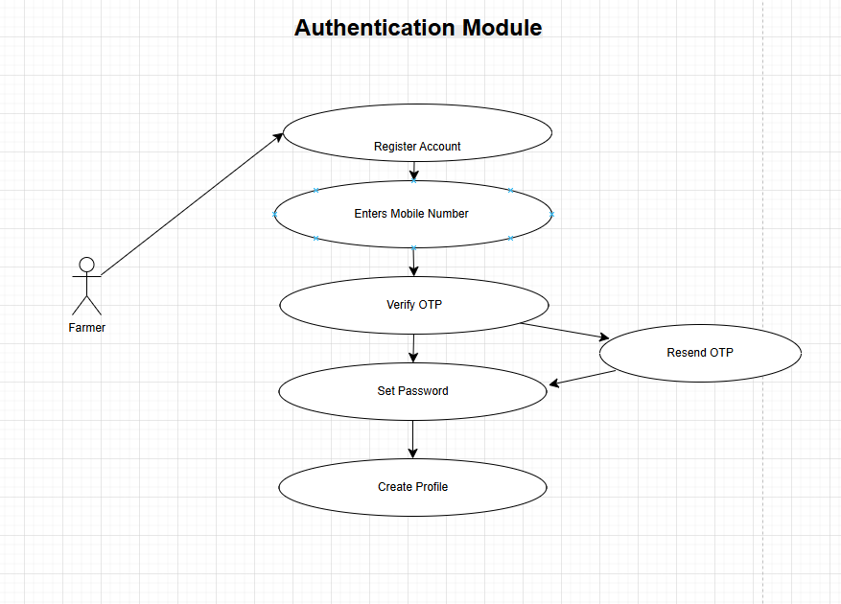

Core features

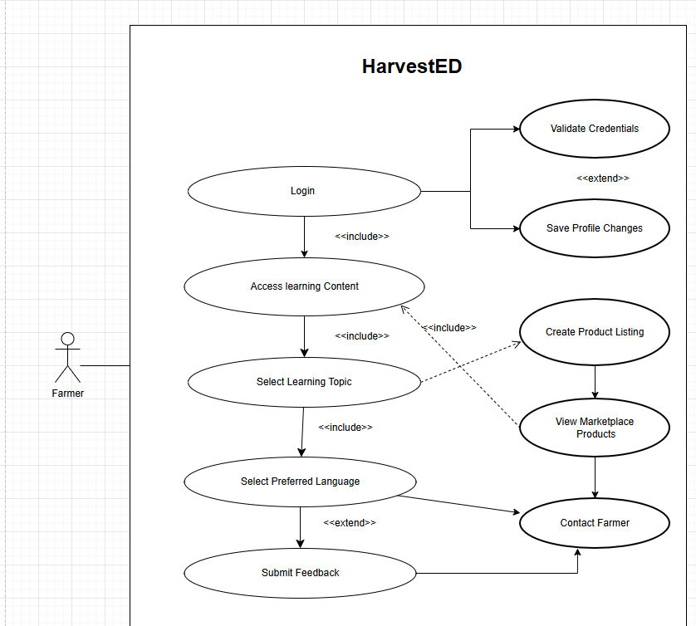

Admin Functions
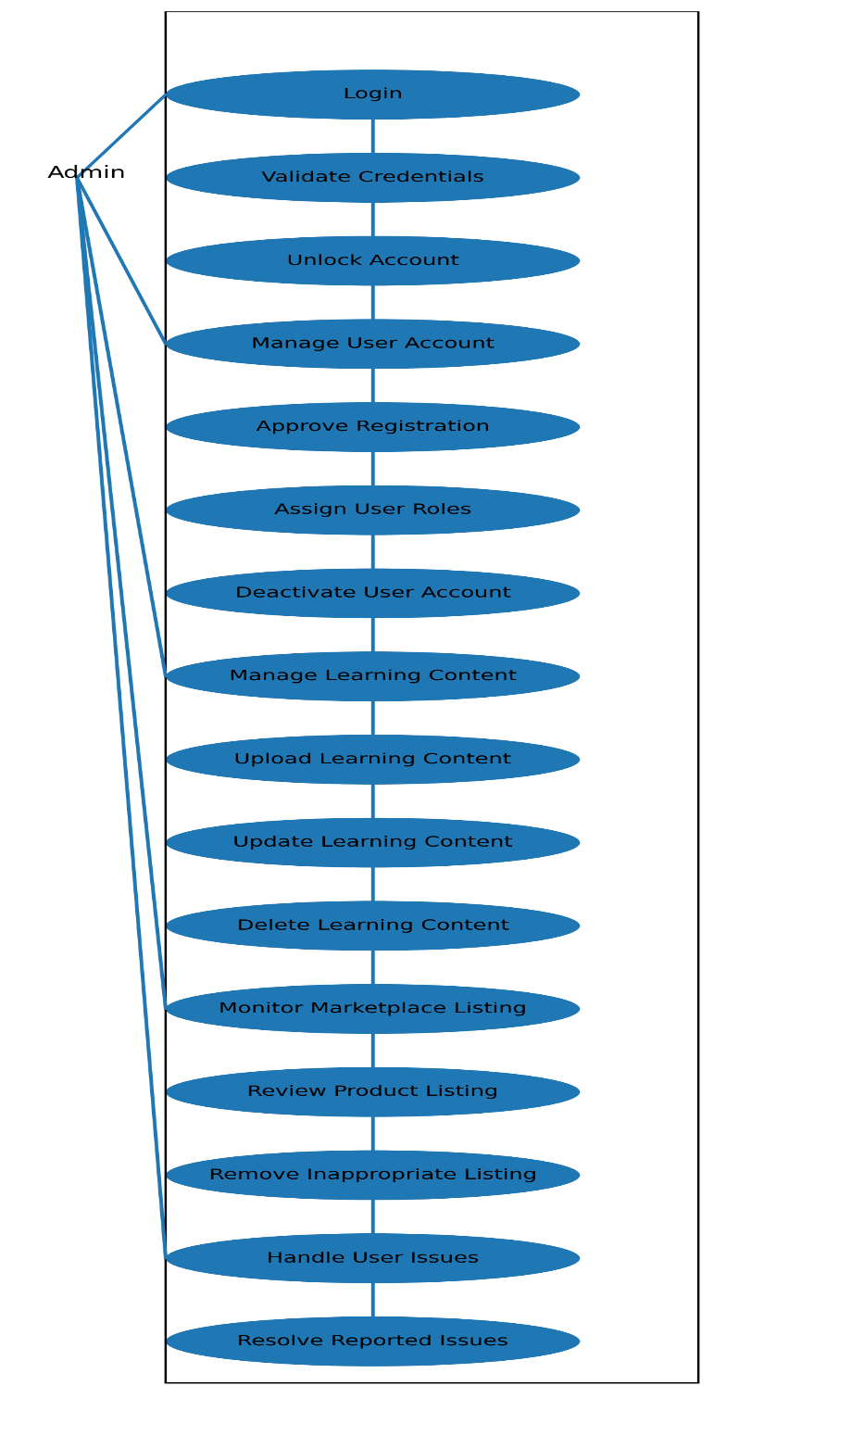

2.7 Work breakdown structure (WBS)
The Work Breakdown Structure (WBS) decomposes the Agricultural Learning and Marketplace System into sprint-sized tasks to demonstrate scope clarity, realistic effort estimation, and feasibility. The WBS is structured to three levels (Feature → User Story → Task), with each task having a clear deliverable, owner, sprint allocation, and effort estimate.
Team & Sprint Assumptions
- Team size: 3 members
- Sprint duration: 2 weeks
- Sprint velocity: ±120 hours per sprint (3 × 40 hrs)

WBS Summary (3 Levels)
Feature 1: User Authentication (Owner: MMeli Cele)
- US1: Register Account → UI, Supabase Auth, validation
- US2: Login & Logout → Login UI, JWT handling, account lockout
Feature 2: Learning Content (Owner: Thobekisiwe Qwabe)
- US3: View Learning Content → Categories, content retrieval, multilingual support
- US4: Search Topics → Search UI, keyword filtering
Feature 3: Marketplace (Owner: Boitumelo Mangwedi)
- US5: Create Product Listing → Listing form, DB storage, image upload
- US6: Browse Products → Marketplace UI, filters
- US7: Contact Farmer → Messaging interface
Feature 4: Admin & Security (Owner: all members)
- US8: Manage Users → Admin dashboard, RBAC
- US9: Manage Content → CRUD learning materials
- US10: Security & POPIA → Encryption, audit logs
(All tasks are 1–3 days in duration.)
Sprint Allocation & Effort
Sprint | Scope | Effort
Sprint 1 | Authentication & planning | 110 hrs
Sprint 2 | Learning content | 120 hrs
Sprint 3 | Marketplace | 125 hrs
Sprint 4 | Admin & security | 105 hrs
Sprint 5 | Testing & documentation | 90 hrs
Total Estimated Effort: 550 hours
Feasibility & Risk Mitigation
The WBS demonstrates that the project scope is achievable within a semester, with work distributed across a three-person team and prioritised using MoSCoW. Core features are delivered first, with non-critical features deferrable.
Key risks: learning curve, time constraints, security complexity.
Mitigation: early prototyping, sprint prioritisation, use of Supabase built-in security.

Gantt Chart (Sprint-Level)
Activity | S1 | S2 | S3 | S4 | S5
Planning & Design | ████
Authentication | ████
Learning Module |  | ████
Marketplace |  |  | ████
Admin & Security |  |  |  | ████
Testing & Docs

2.8 Security Planning
Security is a critical component of the Agricultural Learning and Marketplace System because the platform stores personal information and facilitates communication between farmers and buyers. The system must ensure that user data is protected, access is controlled, and the platform complies with South Africa’s Protection of Personal Information Act (POPIA).
1. CIA Triad Application
The security of the system will be guided by the Confidentiality, Integrity, and Availability (CIA) model.
1.1 Confidentiality
Confidentiality ensures that sensitive user information is only accessible to authorized users.
Potential Threats
- Unauthorized users accessing personal profiles of farmers or buyers.
- Attackers intercepting login credentials during transmission.
Countermeasures
- All communication between the client and server will be encrypted using TLS 1.3.
- User passwords will be stored using bcrypt hashing.
- Role-Based Access Control (RBAC) will ensure that users can only access features related to their role (farmer, buyer, retailer).
- Sensitive user data will be stored securely in the database with restricted access.

1.2 Integrity
Integrity ensures that data stored in the system remains accurate and cannot be altered without authorization.
Potential Threats
- Unauthorized modification of product listings or user information.
- Injection attacks attempt to manipulate the database.
Countermeasures
- Input validation will be applied to all user inputs to prevent SQL injection and malicious data entry.
- Database transactions will ensure correct data updates.
- Audit logs will record important system activities such as product updates and profile changes.
- Access permissions will restrict users from modifying data that does not belong to them.
1.3 Availability
Availability ensures that the system remains accessible and operational for users.
Potential Threats
- Server overload caused by high traffic.
- Denial-of-Service (DoS) attacks.
- System crashes or database failures.
Countermeasures
- The system will use efficient backend architecture to support multiple users.
- Regular database backups will be implemented.
- Error handling mechanisms will prevent system crashes.
- Hosting services will implement rate limiting and firewall protection.

2. Authentication Plan
The system will implement a secure authentication mechanism to protect user accounts and restrict unauthorized access.
Registration Flow
- User selects Register.
- User enters required information (name, email/phone, password, role).
- System validates the data.
- Password is hashed using bcrypt before storage.
- User account is created.
Login Process
- User enters login credentials.
- System verifies the credentials.
- Upon successful login, the system generates a JWT Access Token.
- The token is used for secure communication between the client and server.
Token Security
- Access Token: Short-lived token used for authentication.
- Refresh Token: Used to obtain a new access token without requiring login again.
Password Security
- Passwords will be hashed using bcrypt with a cost factor of 10–12.
- Password complexity requirements will be enforced.
Account Protection
- After 5 failed login attempts, the account will be temporarily locked.
- Users can reset their passwords using a password recovery feature.
Role-Based Access Control (RBAC)
The system will support multiple roles:
Role | Permissions
Farmer | Create and manage product listings
Buyer/Retailer | Browse products and contact farmers
RBAC ensures users only access features relevant to their role.

3. POPIA Compliance
The system will comply with the Protection of Personal Information Act (POPIA) to ensure responsible handling of personal data.
3.1 Data Collected
The system collects the following personal information:
- Name
- Email address
- Phone number
- User role
- Product listing information (for farmers)
3.2 Legal Basis for Processing
User data will only be collected with the user’s consent during registration.
3.3 Data Retention Policy
- User data will be stored only while the account is active.
- Users may delete their accounts at any time.
3.4 User Consent
A privacy notice will be displayed during registration explaining:
- What data is collected
- Why it is collected
- How it will be used
Users must accept the privacy policy before registering.
3.5 Data Subject Rights
Users will have the ability to:
- View their personal information
- Update their profile information
- Request deletion of their account
3.6 Breach Notification Plan
If a data breach occurs:
- The development team will investigate the breach.
- Affected users will be notified.
- Necessary corrective actions will be implemented.

4. Data Protection Strategy
The system will implement layered security mechanisms to protect sensitive data.
Encryption in Transit
All communication between users and the server will use TLS 1.3 encryption to protect data during transmission.
Encryption at Rest
Sensitive data stored in the database will be protected using AES-256 encryption.
Password Protection
Passwords will be stored using bcrypt hashing, ensuring that even if the database is compromised, passwords remain secure.
Secure Environment Variables
Sensitive credentials such as database passwords and API keys will be stored in environment variables, not in the application code.
Access Control
- Only authorized system components will access the database.
- Administrative access will be restricted.
Secure Development Practices
The system will include:
- Input validation
- Error handling
- Secure session management
These measures reduce the risk of injection attacks, data leaks, and unauthorized access.
Summary
The security plan ensures that the Agricultural Learning and Marketplace System protects user data and complies with legal requirements. By applying the CIA triad, implementing secure authentication with JWT and bcrypt, complying with POPIA regulations, and using layered encryption and access control, the system will provide a secure environment for farmers and buyers.

2.9 Feasibility Study
This feasibility study evaluates the technologies selected for the Agricultural Learning and Marketplace System. The goal is to ensure that the chosen tools are technically suitable, scalable, and realistic for the development team to implement within the project timeline.
The system will use the following main technologies:
- Frontend: React Native with Expo
- Backend / API: Supabase
- Database: PostgreSQL (Supabase)
- Authentication: Supabase Auth with JWT
- Hosting / Infrastructure: Supabase Cloud
Each technology was selected after comparing alternatives based on:
- Learning curve
- Community support
- Security features
- Scalability
- Suitability for mobile-first applications

1. Technology Comparison
1.1 Frontend Layer
Layer | React Native (Expo) | Flutter | Recommended | Reason
Frontend | Uses JavaScript and React ecosystem; large developer community; reusable components; Expo simplifies development and deployment | Uses Dart language; high performance; strong UI framework but smaller community compared to React | React Native (Expo) | The development team already has experience with JavaScript, making React Native easier to adapt. Expo simplifies development by eliminating complex native setups and allows rapid prototyping. React Native also has a large community and many third-party libraries which support long-term scalability.

Why React Native with Expo is Suitable
React Native is particularly suitable for this project because:
- It enables cross-platform mobile development, meaning the app can run on both Android and iOS.
- Most small-scale farmers primarily use Android smartphones, making a mobile-first approach ideal.
- Expo simplifies development by handling device configurations, APIs, and testing.
- It allows fast development cycles, which is important for a university project timeline.

1.2 Backend / API Layer
Layer | Supabase | Firebase | Recommended | Reason
Backend | Open-source Backend-as-a-Service with PostgreSQL database, built-in authentication, APIs, and real-time capabilities | NoSQL Firestore database; strong integration with Google services; highly scalable but less relational structure | Supabase | The application requires structured relational data such as users, products, and learning content. PostgreSQL provides strong relational integrity, making Supabase more suitable than Firebase’s NoSQL model.
Why Supabase is Suitable
Supabase provides several advantages:
- Built-in authentication system
- Automatic REST APIs
- Secure Row Level Security (RLS)
- Real-time database updates
- Easy integration with React Native
Using Supabase reduces the need to build a backend from scratch, allowing the team to focus on core features.

1.3 Database Layer
Layer | PostgreSQL | MongoDB | Recommended | Reason
Database | Relational database with strong ACID compliance; supports structured relationships and constraints | NoSQL document-based database; flexible schema but weaker relational integrity | PostgreSQL | The application includes structured data such as user accounts, product listings, and learning modules which require strong relationships and consistency. PostgreSQL ensures data integrity and supports complex queries.
Why PostgreSQL is Suitable
The system needs structured relationships between:
- Users
- Product listings
- Learning content
- Marketplace interactions
PostgreSQL ensures:
- ACID-compliant transactions
- Data integrity
- Scalability
- Advanced security features
These characteristics are important when managing user data and marketplace listings.

1.4 Authentication Layer
Layer | Supabase Auth | Custom JWT Authentication | Recommended | Reason
Authentication | Built-in authentication system supporting JWT, OAuth, and secure password storage | Requires building and managing authentication logic manually | Supabase Auth | Supabase provides secure authentication with built-in JWT token management, reducing development time and improving security reliability.
Why Supabase Authentication is Suitable
Supabase Auth includes:
- Secure JWT authentication
- Password hashing
- Session management
- Email authentication support
This allows secure user login and protects sensitive features such as product listings and profile management.

2. Technology Justification
The selected technology stack (React Native + Expo + Supabase + PostgreSQL) is appropriate for the Agricultural Learning and Marketplace System because it supports the main system requirements:
Requirement | Technology Support
Mobile accessibility | React Native allows mobile-first development
User authentication | Supabase Auth provides secure login
Data management | PostgreSQL ensures structured relational data
Marketplace functionality | Supabase APIs handle product listing storage
Scalability | Supabase cloud infrastructure supports growing user base
This stack also reduces development complexity while maintaining strong security and performance capabilities.

3. Risk Assessment
A risk register was created to identify potential project risks and mitigation strategies.
Risk | Probability | Impact | Mitigation Strategy | Contingency Plan
Limited experience with React Native | Medium | Medium | Use online documentation and tutorials; start with simple prototypes | Seek help from community forums or adjust features to manageable scope
Supabase service outage | Low | High | Use reliable cloud infrastructure and monitor uptime | Export database backups regularly
Data security vulnerabilities | Medium | High | Implement secure authentication, encryption, and access control | Conduct security testing and patch vulnerabilities
Performance issues with many users | Low | Medium | Optimize queries and use efficient data fetching | Scale backend resources
Project timeline constraints | Medium | High | Use Agile development and prioritize core features | Reduce non-critical features

Risk Probability–Impact Matrix
Impact ↓ / Probability → | Low | Medium | High
High Impact | Supabase outage | Security vulnerability | —
Medium Impact | Performance issues | Learning curve | —
Low Impact | Minor UI bugs | — | —
This matrix helps prioritize risks that require immediate attention.

Conclusion
The feasibility study confirms that the selected technologies are suitable for building the Agricultural Learning and Marketplace System. React Native with Expo enables efficient cross-platform mobile development, while Supabase and PostgreSQL provide a secure, scalable backend infrastructure with strong relational data management. The chosen stack reduces development complexity while supporting the system’s functional and security requirements. Identified risks have been documented along with mitigation strategies to ensure successful project implementation.

2.10 Stakeholder Analysis
The Agricultural Learning and Marketplace System involves multiple stakeholders who benefit from the platform in different ways. These stakeholders include primary users such as farmers and buyers, as well as secondary stakeholders such as system administrators, educational institutions, and agricultural support organizations.
The system is designed to address the challenges faced by these stakeholders by improving access to agricultural knowledge, facilitating market connections, and providing a structured digital environment for learning and trade.

Stakeholder Analysis Matrix
Stakeholder | Role | Current Pain Point | Goal | How the App Helps | Influence | Interest
Smallholder Farmers | Primary User | Limited access to structured agricultural knowledge and difficulty connecting with larger markets | Improve crop productivity and sell produce to more buyers | Provides step-by-step farming guides and a marketplace to list and sell agricultural products directly to buyers | High | High
Local Buyers / Retailers | Primary User | Difficulty finding reliable local farmers and available products | Easily locate fresh produce from farmers | Marketplace allows buyers to browse available products and contact farmers directly | Medium | High
System Administrator | Technical Stakeholder | Difficulty managing users, monitoring system performance, and maintaining platform security | Ensure the platform operates efficiently and securely | Admin tools allow monitoring of user activity, managing listings, and maintaining system security | High | High
Agricultural Extension Officers | Secondary Stakeholder | Limited reach to rural farmers due to limited physical extension services | Provide farming knowledge and support to more farmers | The system allows extension officers to share agricultural knowledge digitally with a larger audience | Medium | Medium
Government Agricultural Departments | External Stakeholder | Difficulty supporting and monitoring small-scale farming communities | Improve agricultural productivity and rural economic development | The platform encourages digital agricultural learning and improves farmer access to markets | High | Medium
NGOs Supporting Rural Development | External Stakeholder | Lack of effective digital platforms to distribute agricultural knowledge | Support farmer education and economic empowerment | NGOs can use the platform to distribute educational resources and support small farmers | Medium | Medium

Stakeholder Influence and Interest Matrix
Stakeholders can also be analyzed based on their power (influence) and interest in the system.
High Influence – High Interest (Key Players)
These stakeholders must be closely engaged because they directly affect the success of the system.
- Smallholder Farmers
- System Administrator
- Government Agricultural Departments
Engagement Strategy:
- Regular feedback collection
- Continuous system improvements
- Training or onboarding support

High Influence – Medium Interest (Keep Satisfied)
- Government Agricultural Departments
- Agricultural Extension Officers
Engagement Strategy:
- Provide reports on platform usage
- Ensure system supports agricultural development initiatives
- Supports multi-language requirement
Medium Influence – High Interest (Keep Informed)
- Local Buyers / Retailers
Engagement Strategy:
- Provide regular updates about new features
- Maintain an easy-to-use platform
Medium Influence – Medium Interest (Monitor)
- NGOs supporting rural communities
Engagement Strategy:
- Allow collaboration opportunities
- Share learning resources and impact statistics

Summary
The stakeholder analysis demonstrates that the Agricultural Learning and Marketplace System serves a wide range of users, including farmers, buyers, and supporting organizations. By addressing the specific needs and challenges of each stakeholder group, the platform promotes knowledge sharing, improves access to markets, and supports sustainable agricultural development. Proper stakeholder engagement ensures that the system remains useful, scalable, and aligned with the needs of rural agricultural communities.

