COVID-19 DATA ANALYSIS
PROJECT REPORT

Prepared By: Abhay Chudasama
Tools Used: Python, Pandas, NumPy, Matplotlib, Seaborn and Google Colab

CERTIFICATE

This is to certify that the project titled “COVID-19 Data Analysis” is a data analysis project completed using Python and data visualization techniques. The project focuses on confirmed cases, recoveries, deaths, active cases, testing activity, vaccination rate, mortality rate, recovery rate and positivity rate.

ACKNOWLEDGEMENT

I would like to thank my mentors and instructors for providing guidance and support during this project. This project helped me understand the complete data analysis workflow, including data cleaning, feature engineering, numerical analysis, exploratory data analysis, visualization and interpretation.

ABSTRACT

The COVID-19 Data Analysis project examines COVID-19 statistics across countries and states/regions. The dataset contains confirmed cases, recovered cases, deaths, active cases, tests conducted and vaccination rate. Derived measures such as mortality rate, recovery rate, positivity rate, testing efficiency and risk level are used to understand the dataset more clearly.
The analysis compares countries, studies month-over-month changes in confirmed cases, identifies the highest active-case healthcare load, evaluates testing efficiency and measures the correlation between vaccination rate and test positivity rate. The project demonstrates how Python-based data analysis can convert raw health statistics into clear and useful insights.
TABLE OF CONTENTS
1. Introduction
2. Project Objectives
3. Dataset Overview
4. Tools and Libraries Used
5. Project Workflow
6. Data Cleaning & Feature Engineering
7. Exploratory Data Analysis
7.1 Total Confirmed Cases by Country
7.2 Mortality Risk Distribution
7.3 Average Recovery Rate by Country
7.4 State/Region with Highest Mortality Rate
7.5 Testing Efficiency by Country
7.6 Month-over-Month Confirmed Case Change
7.7 Cumulative Active Case Healthcare Load
7.8 Vaccination Rate vs. Test Positivite
8. Overall Findings
9. Final Conclusion
10. Future Improvements

1. INTRODUCTION

Customer churn is a major business challenge because losing customers can reduce recurring revenue and increase the cost of acquiring replacements. Customer-level data can be analyzed to identify which service offerings, price levels and lifecycle stages are associated with higher churn.
In this project, customer information is analyzed using Python. The main focus is to clean the dataset, engineer useful features, perform Exploratory Data Analysis (EDA), answer business questions and present the results through clear visualizations.

2. PROJECT OBJECTIVES

• Understand the structure and information available in the COVID-19 dataset.
• Clean the dataset and prepare it for analysis.
• Calculate mortality, recovery and positivity rates.
• Compare confirmed COVID-19 cases across countries.
• Identify the state/region with the highest average mortality rate.
• Compare testing efficiency across countries.
• Analyze month-over-month changes in confirmed cases.
• Identify the country with the highest cumulative active-case healthcare load.
• Measure the correlation between vaccination rate and test positivity rate.
• Use charts and simple conclusions to communicate the findings.

3. DATASET OVERVIEW

The notebook uses a 200-row COVID-19 dataset containing 10 original fields. The executed inspection shows 200 non-null observations for every field. The dataset covers five countries: Brazil, India, Japan, UK and USA, with state/region information and dates.

The descriptive statistics show an average of 246,900.925 confirmed cases per record, an average of 210,518.205 recovered cases, an average of 3,766.56 deaths and an average of 32,852.28 active cases. The mean vaccination rate is 57.955%.

4. TOOLS AND LIBRARIES USED

- Python – Main programming language.
- Pandas – Data cleaning, transformation and aggregation.
- NumPy – Numerical calculations, percentiles and vectorized operations.
- Matplotlib - Chart creation and figure formatting.
- Seaborn – Statistical and business visualizations.
- Google Colab – Environment used to write and execute Python code.

5. PROJECT WORKFLOW

- Chart creation and figure formatting.
- Inspect dataset structure, data types and summary statistics.
- Convert the Date column to datetime format.
- Rename the vaccination column for easier coding.
- Remove the redundant Record_ID column from the cleaned DataFrame.
- Check and remove duplicate records.
- Create mortality, recovery and positivity rate features.
- Aggregate COVID-19 indicators by country.
- Use NumPy for mean, standard deviation, median, Z-score and conditional risk categorization.
- Perform EDA using bar plots and box plots.

6. DATA CLEANING & FEATURE ENGINEERING

Data preparation was performed before analysis so that calculations and visualizations used consistent fields. The Date column was converted to datetime format and the original vaccination-rate column was renamed from Vaccination_Rate_% to Vaccination_Rate.
- Dataset inspection showed 200 rows and 10 columns.
- All 200 records were non-null in the executed df.info() output.
- Record_ID was dropped from the cleaned analysis DataFrame because it is an identifier rather than an analytical feature.
- Duplicate rows were checked and removed using drop_duplicates().
- Mortality_Rate = Deaths / Confirmed × 100.
- Recovery_Rate = Recovered / Confirmed × 100.
- Positivity_Rate = Confirmed / Tests_Conducted × 100.
- Tests_per_Case = Tests_Conducted / Confirmed.
- Risk_Level was created using mortality thresholds: below 1% = Low Risk, 1% to 2.5% = Moderate Risk, above 2.5% = High Risk.

7. EXPLORATORY DATA ANALYSIS:

7.1 Q1. Which country has the highest total number of confirmed COVID-19 cases?

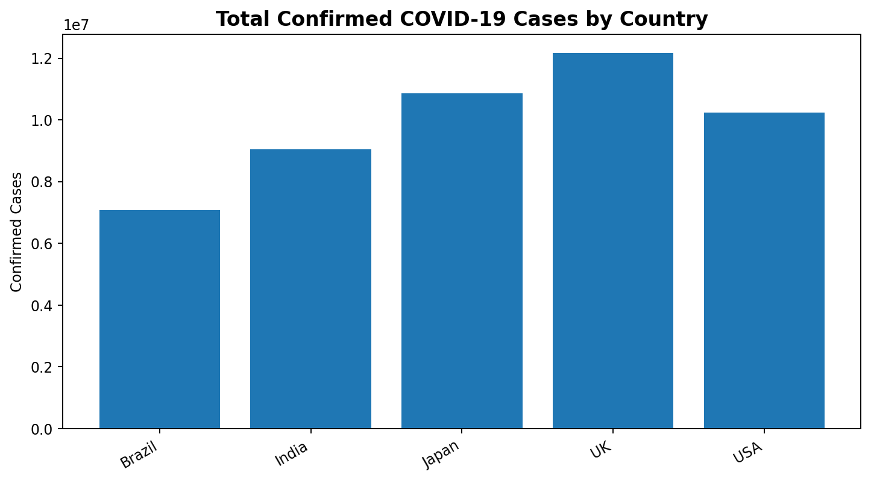
Conclusion: The UK has the highest cumulative confirmed cases in this dataset at 12,167,547, followed by the USA, Japan, India and Brazil. This indicates that the UK carries the largest confirmed-case burden among the five countries represented.

7.2 Q2. Which state/region exhibits the highest average case mortality rate?
The notebook groups mortality rate by Country and State and identifies the state/region with the maximum average mortality rate.
Result: USA – California, with an average mortality rate of 1.76%.
This result indicates that California has the highest average mortality rate among the state/region groups in the dataset. The finding can help prioritize deeper investigation into healthcare capacity, case severity and regional response conditions.
Conclusion: California in the USA has the highest average mortality rate at 1.76% in this dataset. A suitable policy response would be to examine the factors associated with mortality and strengthen monitoring and healthcare preparedness in higher-risk regions.

7.3 Q3. What does the mortality-risk distribution show?
The notebook creates three risk categories from mortality rate: Low Risk (<1%), Moderate Risk (1%–2.5%) and High Risk (>2.5%). A box plot is used to compare the mortality-rate distribution across these categories.
Conclusion: The risk categorization provides a simple way to segment observations according to mortality rate and makes it easier to focus further analysis on records with comparatively higher mortality.

7.4 Q4. How does testing efficiency vary across countries?
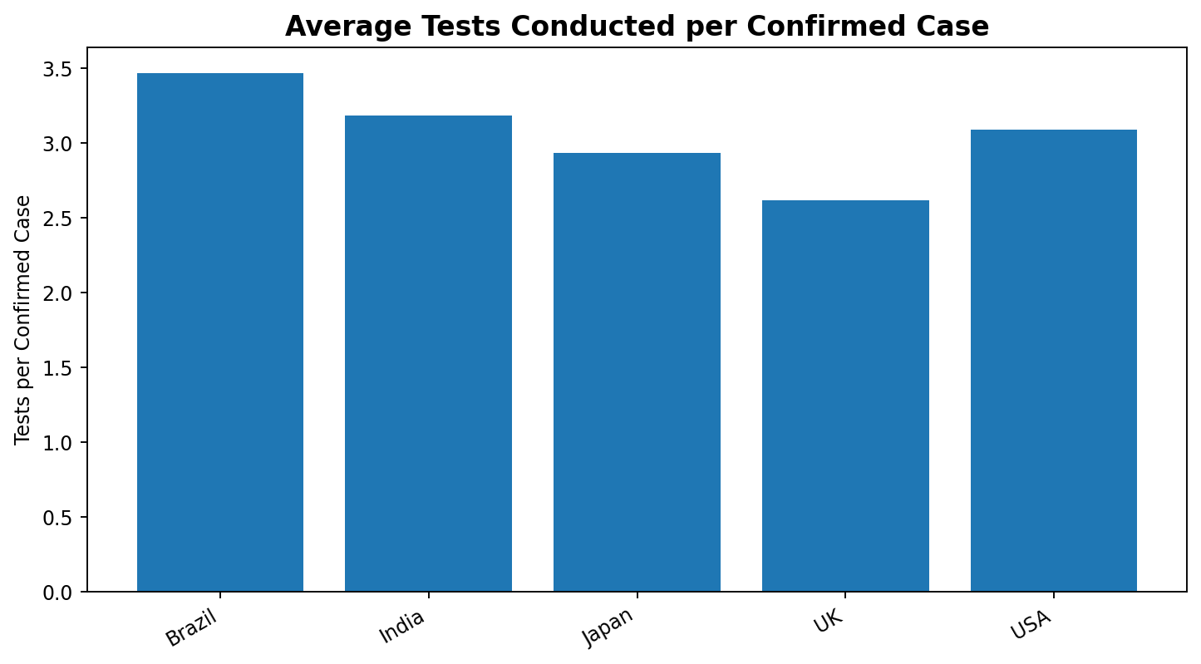
Brazil: 3.469 tests per confirmed case.
India: 3.183 tests per confirmed case.
Japan: 2.933 tests per confirmed case.
UK: 2.618 tests per confirmed case.
USA: 3.089 tests per confirmed case.
Conclusion: Brazil has the highest average testing efficiency at about 3.47 tests per confirmed case, while the UK has the lowest at about 2.62. The comparison suggests differences in testing intensity relative to confirmed cases across countries.

7.5 Q5. What is the Month-over-Month percentage change in total confirmed cases?
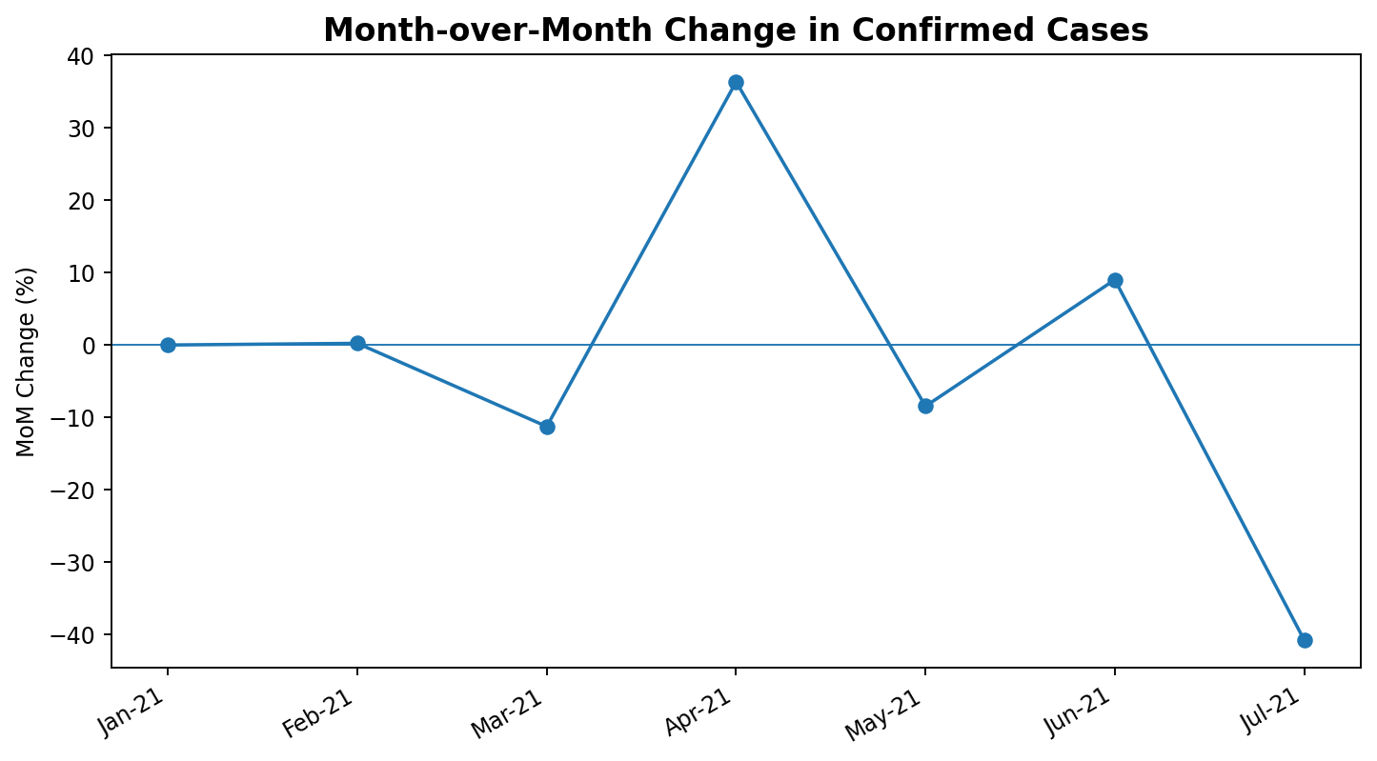
The notebook calculates monthly confirmed cases and then applies pct_change() to measure month-over-month growth. January 2021 is the starting month, so its percentage change is not defined.
Feb-21: 0.23%
Mar-21: -11.26%
Apr-21: 36.34%
May-21: -8.45%
Jun-21: 9.01%
Jul-21: -40.74%
Conclusion: The largest increase occurred in April 2021 at 36.34%, while the largest decrease occurred in July 2021 at -40.74%. The monthly pattern shows that confirmed-case totals changed substantially from month to month.

7.6 Q6. Which country bears the highest cumulative active-case healthcare load?
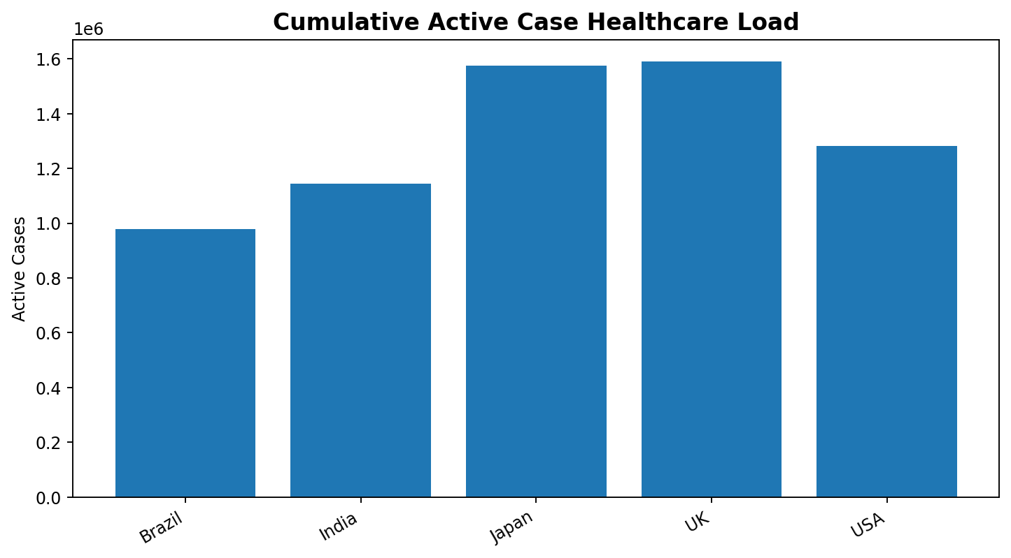
UK: 1,590,754 cumulative active cases.
Japan: 1,575,117 cumulative active cases.
USA: 1,282,188 cumulative active cases.
India: 1,144,493 cumulative active cases.
Brazil: 977,904 cumulative active cases.
Conclusion: The UK has the highest cumulative active-case healthcare load at 1,590,754, closely followed by Japan at 1,575,117. This makes the UK the highest-priority country for active-case healthcare-load monitoring in this dataset.

7.7 Q7. What is the statistical correlation between vaccination rate and test positivity rate?
The notebook calculates Test Positivity Rate as Confirmed / Tests_Conducted × 100 and then measures the Pearson correlation between Vaccination_Rate and Positivity_Rate.
Correlation result: 0.07985 (approximately 0.08).
A correlation close to zero indicates a very weak positive linear relationship between vaccination rate and positivity rate across the records in this dataset. This result should be interpreted as an association within the available observations, not as evidence that vaccination causes or prevents a particular positivity level.
Conclusion: The correlation of approximately 0.08 is very weak and positive. In this dataset, vaccination rate and test positivity rate do not show a strong linear relationship.

7.8 Q8. What does the country-level COVID-19 summary show?
The notebook aggregates Confirmed, Deaths, Recovered and Tests_Conducted by Country. The results are:
Country | Confirmed | Deaths | Recovered | Tests
Brazil | 7,073,638 | 103,779 | 5,991,955 | 24,072,403
India | 9,042,374 | 135,168 | 7,769,020 | 28,838,049
Japan | 10,853,319 | 153,422 | 9,130,537 | 30,119,600
UK | 12,167,547 | 189,923 | 10,415,496 | 31,115,813
USA | 10,243,307 | 171,020 | 8,796,633 | 32,167,423
The notebook also visualizes average recovery rate by country and a mortality-rate box plot by risk level. These visualizations complement the country totals by showing recovery performance and mortality-risk distribution.
Conclusion: Country-level aggregation makes it easier to compare the overall scale of the pandemic indicators and identify countries that require closer attention for specific measures such as confirmed cases, deaths, recoveries or testing.

8. OVERALL FINDINGS

- The dataset contains 200 observations across five countries and state/region fields.
- The executed inspection shows 200 non-null values for all 10 original columns.
- The average confirmed cases per record are 246,900.925.
- No confirmed-case outliers were detected using the Z-score threshold |Z| > 3.
- The UK has the highest total confirmed cases in the country aggregation: 12,167,547.
- California, USA has the highest average state/region mortality rate at 1.76%.
- Brazil has the highest average testing efficiency at approximately 3.47 tests per confirmed case.
- The UK has the highest cumulative active-case healthcare load at 1,590,754.
- April 2021 recorded the highest MoM increase in confirmed cases at 36.34%.
- July 2021 recorded the largest MoM decrease at -40.74%.
- The correlation between vaccination rate and positivity rate is approximately 0.08, indicating a very weak positive relationship.

9. FINAL CONCLUSION

This project analyzed COVID-19 statistics using a complete data analysis workflow: data inspection, cleaning, feature engineering, numerical analysis, exploratory analysis, visualization and interpretation. The analysis demonstrates how Pandas and NumPy can be used to transform raw COVID-19 statistics into meaningful indicators such as mortality rate, recovery rate, positivity rate and testing efficiency.
The country-level analysis shows that the UK has the highest confirmed-case total and the highest cumulative active-case healthcare load among the five countries in the dataset. Brazil records the highest average tests-per-confirmed-case measure. The state/region analysis identifies California as having the highest average mortality rate, while the vaccination-versus-positivity correlation is very weak.
Overall, the project shows that COVID-19 data should be examined from multiple perspectives rather than using confirmed cases alone. Combining case burden, deaths, recoveries, active cases, testing and vaccination-related indicators provides a broader view of the dataset and supports clearer analytical interpretation.

10. FUTURE IMPROVEMENTS

- Add a larger and more consistently sourced time-series dataset for more reliable trend analysis.
- Include population data to calculate cases, deaths and tests per capita.
- Add hospital admissions, ICU occupancy and hospital capacity indicators.
- Study vaccination coverage by date and compare it with later changes in cases and deaths.
- Build an interactive Power BI or Tableau dashboard for country and state/region monitoring.
- Apply statistical tests or regression models to investigate relationships among testing, vaccination and positivity.
- Use rolling averages to reduce short-term fluctuations in daily or monthly observations.
- Develop forecasting models for confirmed and active cases using time-series methods.
- Add demographic and socioeconomic variables where appropriate and ethically available.
- Document data-source dates and definitions to improve reproducibility and interpretation.
The current notebook provides a strong foundation for exploratory analysis. Future work should focus on improving data coverage, adding context variables and using more advanced statistical or predictive techniques.

