GLOBAL E-COMMERCE SALES & PROFITABILITY ANALYSIS
PROJECT REPORT

Prepared By: Abhay Chudasama
Tools Used: Python, Pandas, NumPy, Matplotlib, Seaborn and Google Colab

CERTIFICATE

This is to certify that the project titled “Global E-Commerce Sales & Profitability Analysis” is a data analysis project completed using Python and data visualization techniques. The project focuses on regional sales performance, product profitability, discount-related losses, shipping efficiency, order status, payment methods, customer segments and seasonal business performance. The work presented in this report has been prepared using Python, Pandas, NumPy, Matplotlib, Seaborn and Google Colab.

ACKNOWLEDGEMENT

I would like to thank my mentors and instructors for providing guidance and support during this project. This project helped me understand the complete data analysis workflow, including data cleaning, feature engineering, statistical analysis, exploratory data analysis, visualization and business interpretation. I am also thankful for the Python data-analysis ecosystem, which provided the tools required to transform raw e-commerce transaction data into meaningful business insights.

ABSTRACT

The Global E-Commerce Sales & Profitability Analysis project focuses on understanding sales performance, profitability and operational patterns in a global e-commerce dataset. The analysis uses 10,000 orders and 26 fields covering customers, regions, products, prices, discounts, revenue, costs, profit, shipping and payment information.
Feature engineering was used to create total cost, net profit, order-value segments, shipping-to-revenue ratio and time-based fields. Exploratory analysis then examines regional revenue, category margins, discount losses, shipping costs, cancelled and returned revenue, product performance, payment methods, delivery delays, monthly growth, shipping anomalies and seasonal performance.
The project demonstrates how raw transaction data can be cleaned, transformed and visualized to generate actionable insights for e-commerce sales, pricing, logistics and profitability decisions.
TABLE OF CONTENTS
1. Introduction
2. Project Objectives
3. Dataset Overview
4. Tools and Libraries Used
5. Project Workflow
6. Data Cleaning & Feature Engineering
7. Exploratory Data Analysis
7.1 Regional Revenue
7.2 Profit Margin by Category
7.3 High Discount and Negative Profit
7.4 Shipping Cost to Revenue Ratio
7.5 Cancelled and Returned Revenue
7.6 Top Products by Region
7.7 Average Order Value by Payment Method
7.8 Delivery Delays by Customer Segment
7.9 Monthly Revenue Growth
7.10 Category Revenue and Profit Margin
7.11 Shipping-Day Anomaly
7.12 Seasonal Sales and Profit
8. Overall Findings
9. Final Conclusion
10. Future Improvements

1. INTRODUCTION

Global e-commerce generates large volumes of transactional data that can be used to understand sales performance, customer behavior, profitability and operational efficiency. This project analyzes an e-commerce order dataset to identify the regions, categories, products and customer segments that contribute most to business performance.

The project uses Python to clean the data, engineer analytical features, perform Exploratory Data Analysis (EDA), answer business questions and present the results through clear visualizations.

2. PROJECT OBJECTIVES

- Understand the structure and information available in the e-commerce dataset.
- Clean and prepare the data for analysis.
- Analyze revenue performance across global regions.
- Compare profitability across product categories.
- Identify high-discount orders associated with negative profit.
- Measure shipping cost relative to revenue.
- Quantify revenue associated with cancelled and returned orders.
- Identify top revenue-generating products in each region.
- Compare average order value across payment methods.
- Analyze delayed deliveries across customer segments.
- Study month-over-month revenue growth.
- Compare category revenue with average profit margin.
- Identify shipping-day anomalies using percentile analysis.
- Analyze seasonal unit sales and profitability.

3. DATASET OVERVIEW

The notebook uses a 10,000-order e-commerce dataset containing 26 columns. The fields cover order details, customer information, geography, product details, pricing, discount, revenue, cost, profit, shipping and payment information.

Important fields include Order_ID, Order_Date, Year, Month, Quarter, Season, Customer_ID, Customer_Gender, Customer_Segment, Region, Country, Category, Sub_Category, Product_Name, Unit_Price, Quantity, Discount, Revenue, Cost, Profit, Profit_Margin, Shipping_Cost, Shipping_Method, Shipping_Days, Payment_Method and Order_Status.

No missing values were reported, and duplicate Order_ID values were zero in the executed analysis.

4. TOOLS AND LIBRARIES USED

- Python – Main programming language.
- Pandas – Data cleaning, transformation, grouping and aggregation.
- NumPy – Numerical calculations, percentiles and vectorized operations.
- Matplotlib – Chart creation and visualization.
- Seaborn – Statistical and business visualizations.
- Google Colab – Environment used to write and execute Python code.

5. PROJECT WORKFLOW

- Load the dataset into a Pandas DataFrame.
- Understand the dataset using shape, info and descriptive statistics.
- Check missing values and duplicate records.
- Review and organize column names and data types.
- Convert Order_Date into datetime format.
- Create analytical and business features.
- Perform numerical calculations and percentile analysis using NumPy.
- Perform Exploratory Data Analysis using grouping, sorting and statistical analysis.
- Create charts to understand patterns and relationships.
- Write conclusions based on the results
- Calculated revenue statistics and percentiles using NumPy.
- Created a clipped revenue field using np.clip for robust analysis.

6. DATA CLEANING & FEATURE ENGINEERING

Data preparation was performed before analysis so that calculations and visualizations would
use consistent fields.
- Checked the dataset for missing values: none were reported.
- Checked duplicate Order_ID values: 0 duplicates were reported.
- Renamed Profit_Margin_% to Profit_Margin.
- Converted Order_Date to datetime format.
- Created Total_Cost = Cost + Shipping_Cost.
- Created Net_Profit = Revenue - Total_Cost.
- Created Order_Year_Month and Day_of_Week.
- Created Order_Value_Segment using the 75th percentile of Revenue.

7. EXPLORATORY DATA ANALYSIS:

7.1 Q1. What is the total revenue generated across each region?
Regional revenue was grouped and compared to understand geographic sales performance.
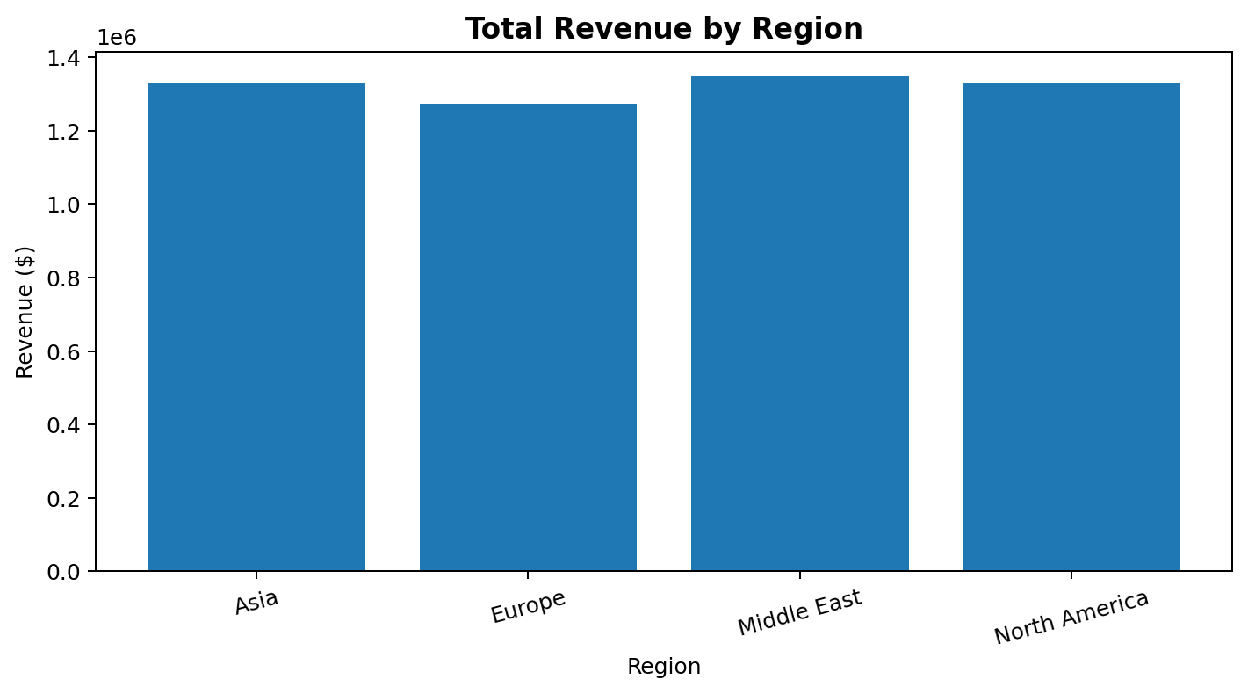
Conclusion: The Middle East generated the highest regional revenue at $1,348,593.22. Asia generated $1,330,007.18, North America $1,331,129.75 and Europe $1,274,657.55.

7.2 Q2. Which product category has the highest average profit margin?
Average Profit_Margin was calculated for each product category and visualized to compare profitability.
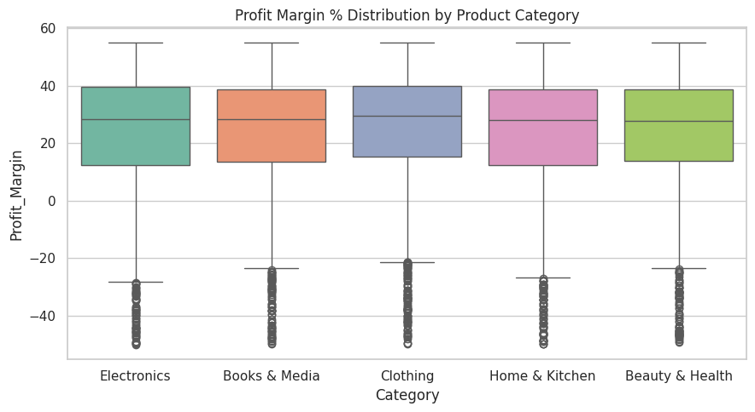
Conclusion: Clothing had the highest average profit margin at 24.803%, while Home & Kitchen had the lowest at 23.019%.

7.3 Q3. How many orders have discounts above 20% and negative profit?
The analysis filtered orders where Discount was greater than 20% and Profit was negative to measure discount-related losses.
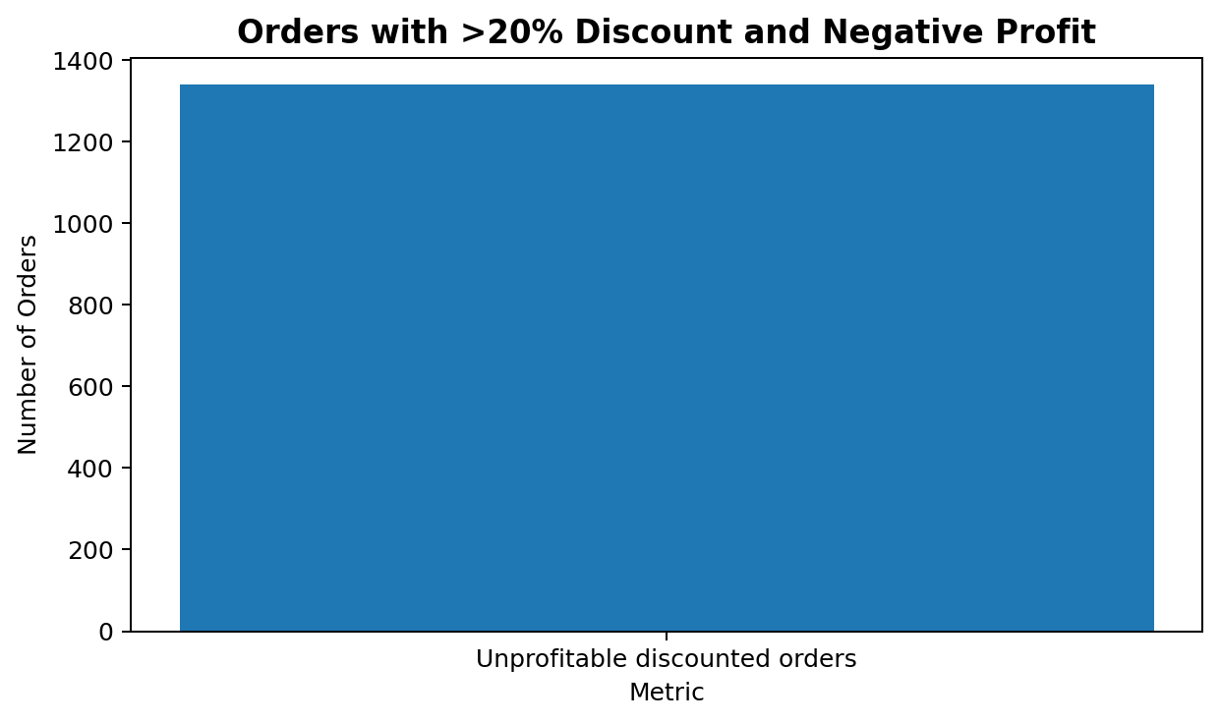
Conclusion: There were 1,338 such orders, with a total loss of $83,495.35.

7.4 Q4. Which category has the highest shipping cost as a percentage of revenue?
Shipping_To_Revenue_Ratio was compared across categories to identify where logistics costs consume a larger share of revenue.
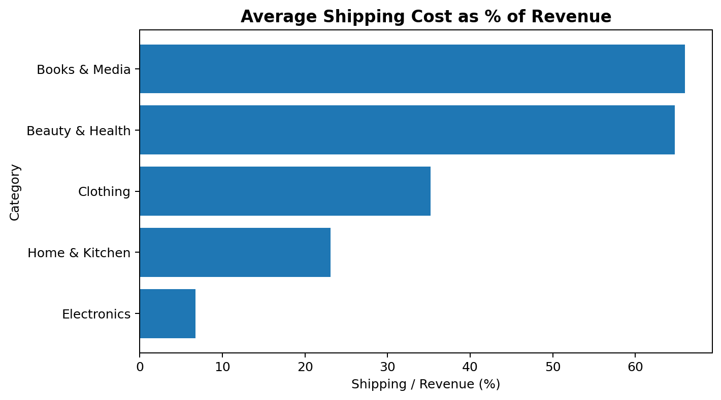
Conclusion: Books & Media had the highest shipping-to-revenue ratio at 66.02%, followed by Beauty & Health at 64.77%.

7.5 Q5. What percentage of total revenue comes from cancelled and returned orders?
Revenue associated with Cancelled and Returned orders was aggregated and compared with gross revenue.
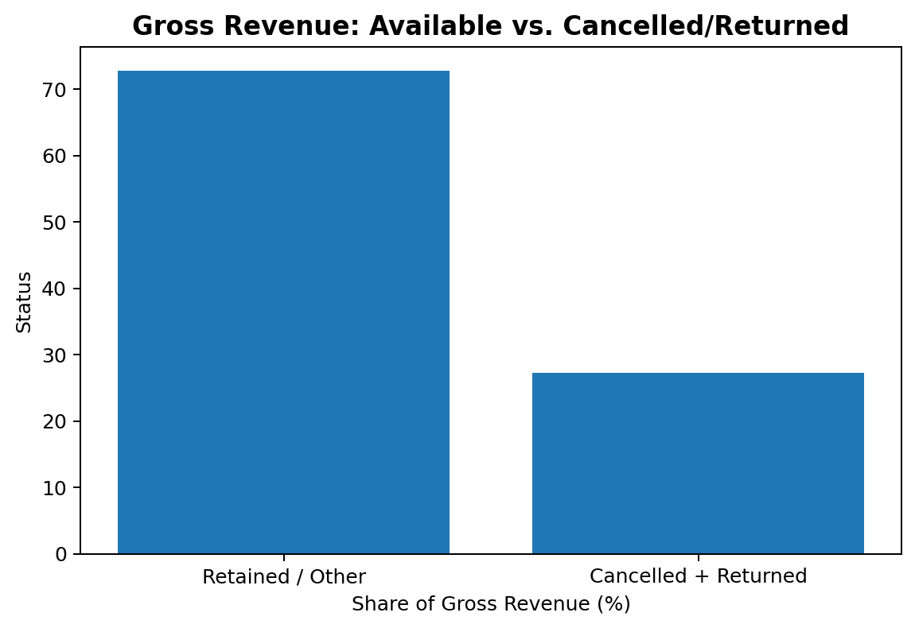
Conclusion: Cancelled and Returned orders were associated with $1,438,776.62 in revenue, equal to 27.23% of gross revenue.

7.6 Q6. What are the top 3 revenue-generating products in each region?
Product-level revenue was grouped within each region and the top three products were identified.
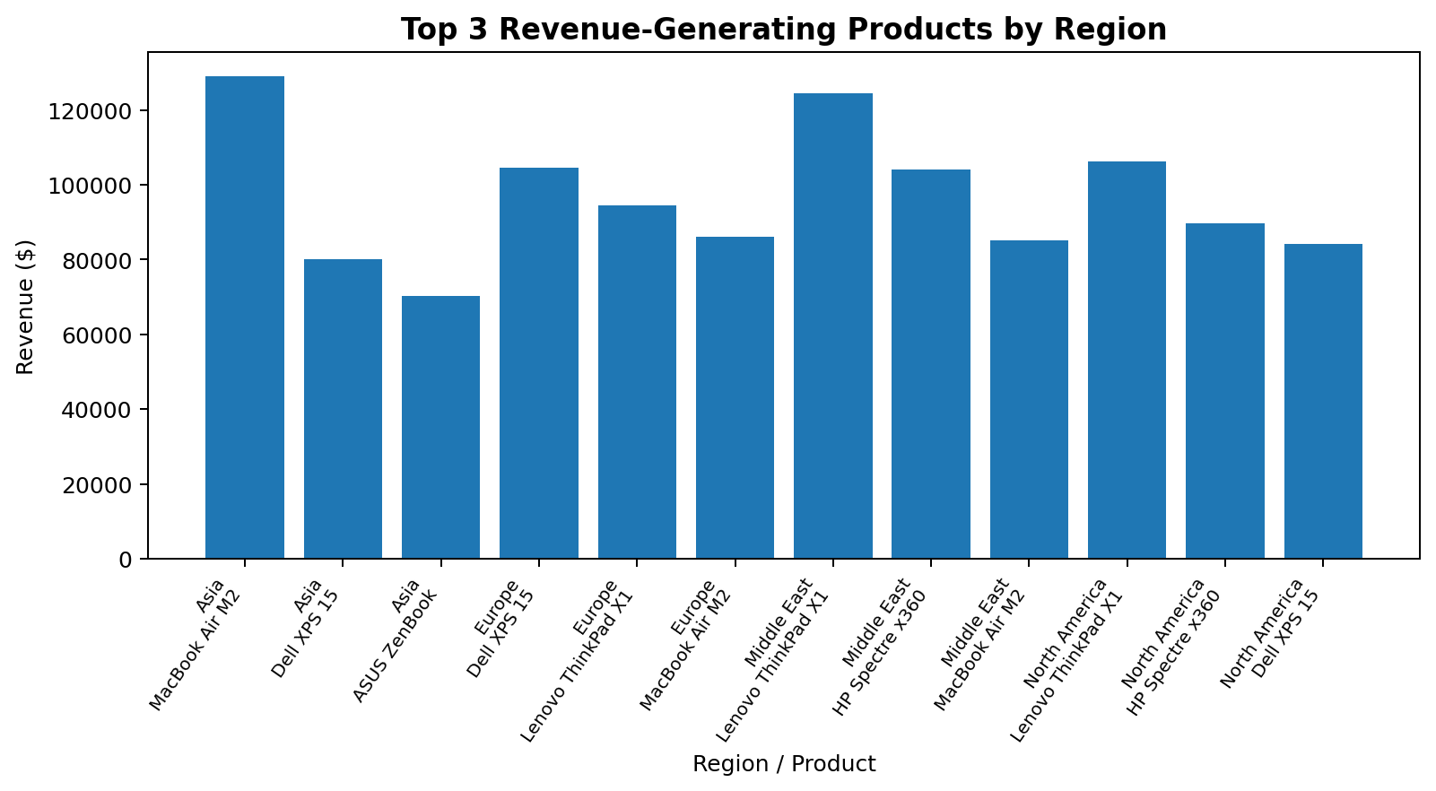
Conclusion: Leading products included MacBook Air M2, Dell XPS 15, Lenovo ThinkPad X1, HP Spectre x360 and ASUS ZenBook, with the exact top three varying by region.

7.7 Q7. Which payment method has the highest average order value?
Average revenue per order was calculated for each payment method to compare order values.
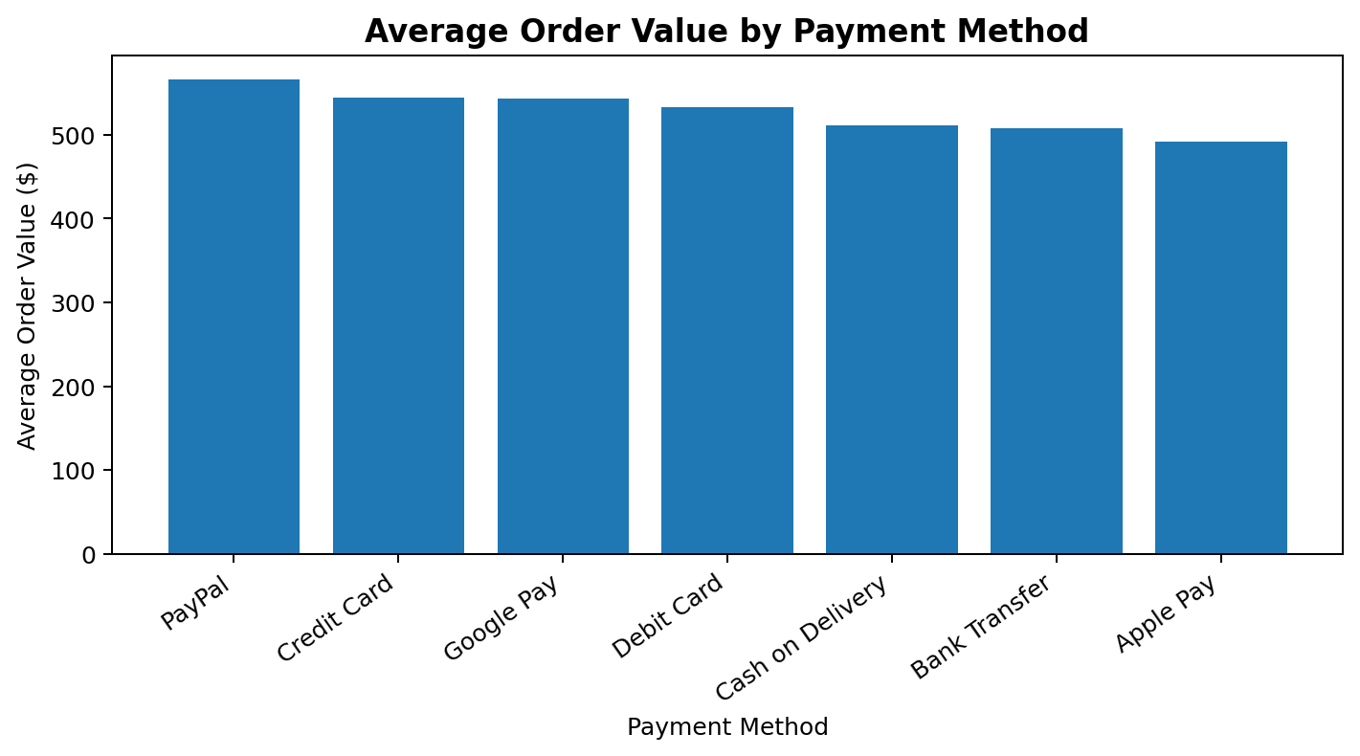
Conclusion: PayPal had the highest average order value at $565.73, while Apple Pay had the lowest at $492.00.

7.8 Q8. Which customer segment has the most orders taking more than 7 shipping days?
Orders with Shipping_Days greater than 7 were grouped by Customer_Segment.
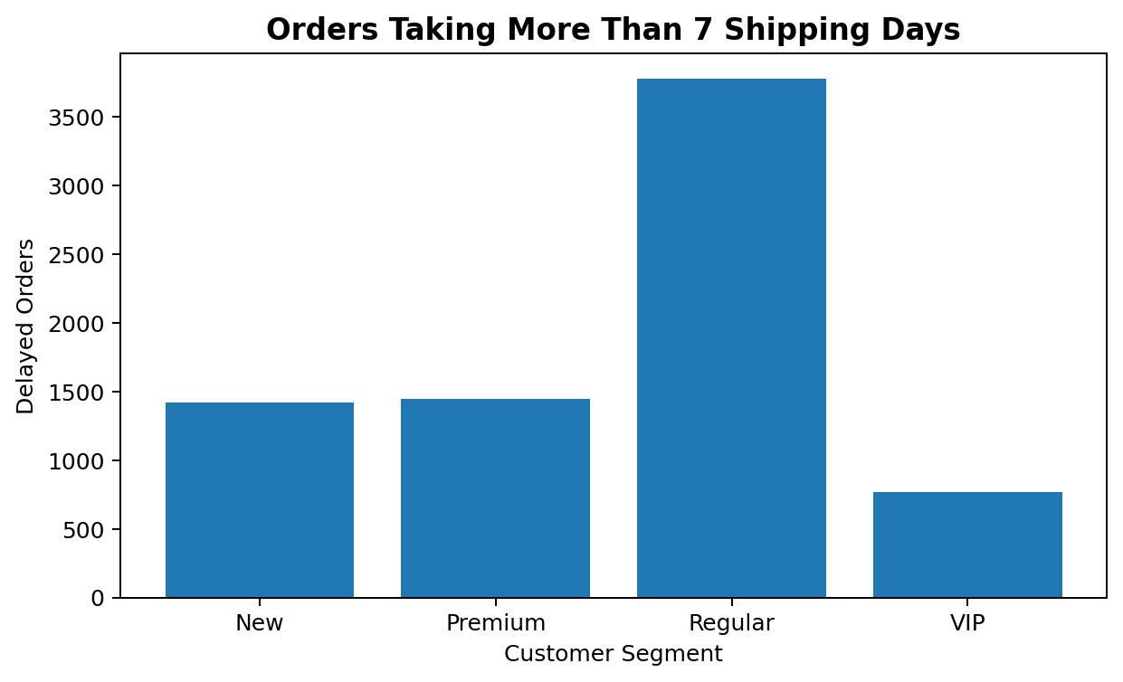
Conclusion: Regular customers had the highest number of delayed orders at 3,777, followed by Premium at 1,449 and New at 1,418.

7.9 Q9. How does monthly revenue change month over month?
Monthly revenue was calculated and month-over-month percentage growth was used to identify major increases and declines.
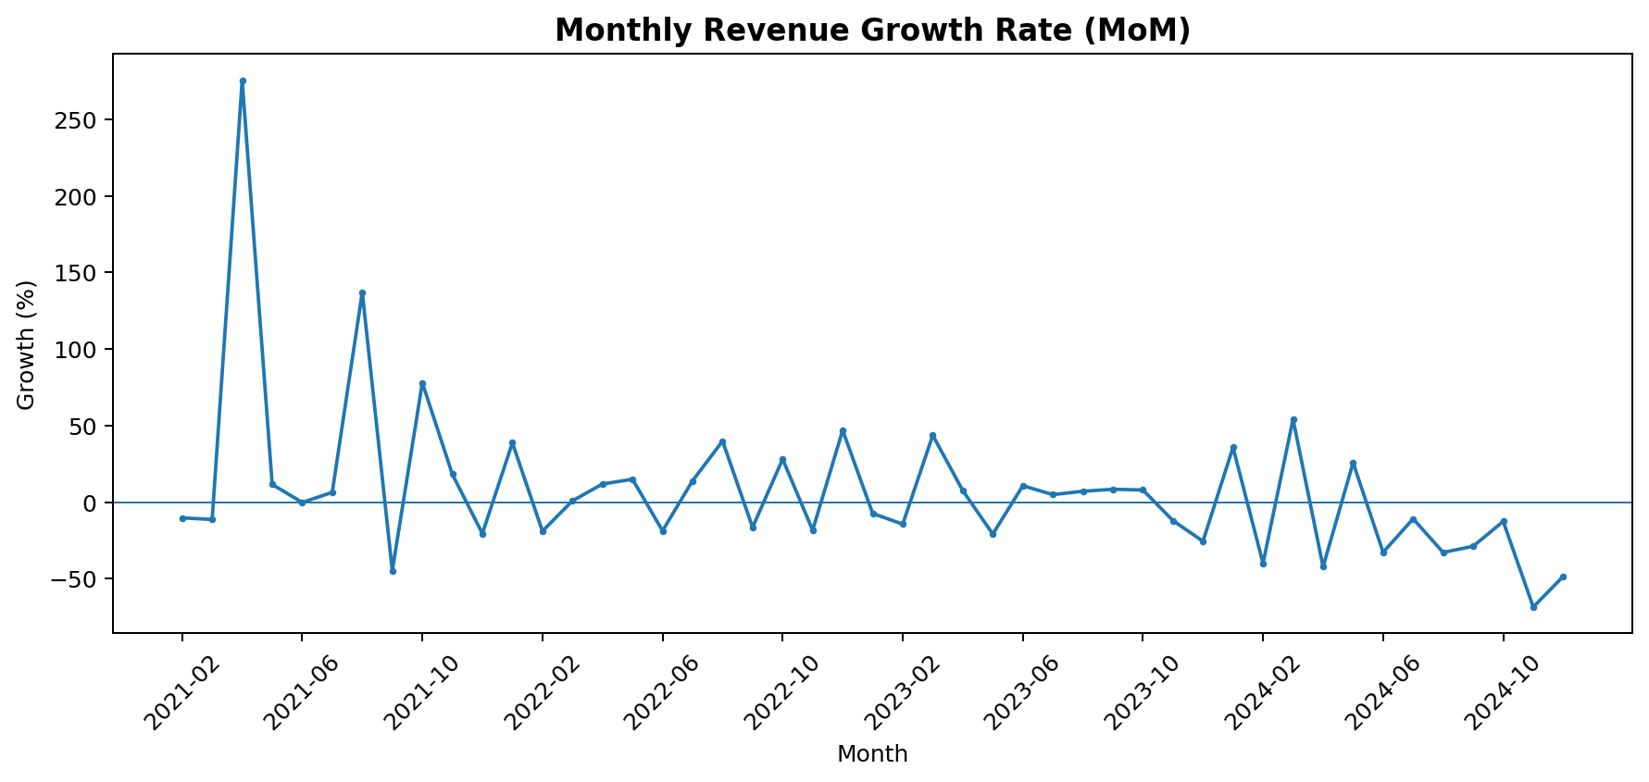
Conclusion: The largest positive growth was in April 2021 at 275.42%, while the largest negative change was in November 2024 at -68.53%.

7.10 Q10. Which categories combine high revenue with strong average profit margin?
Category revenue was compared with average profit margin to evaluate both sales scale and profitability.
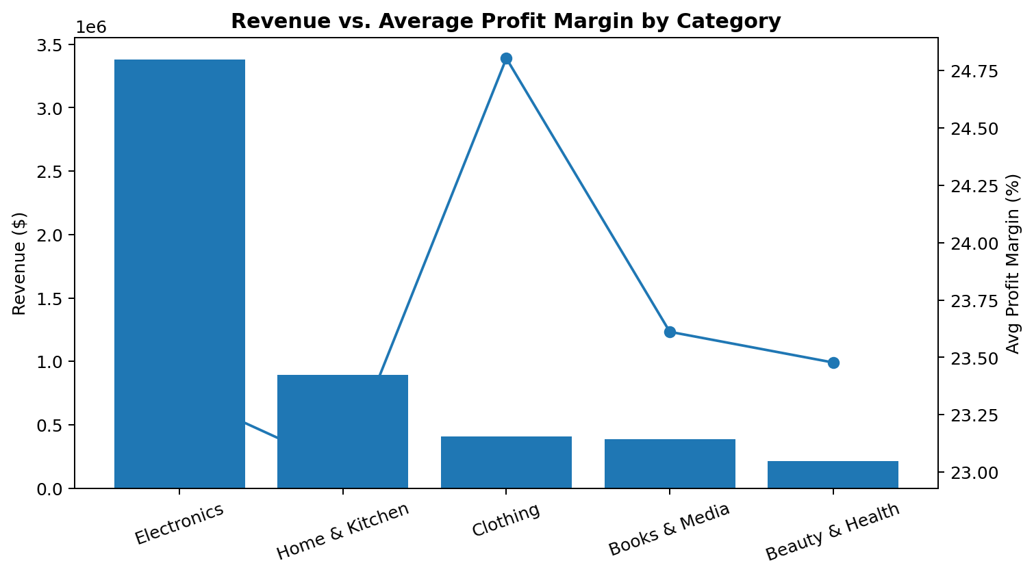
Conclusion: Electronics generated the highest revenue at $3,382,028.46, while Clothing had the strongest average profit margin at 24.803%.

7.11 Q11. Are there shipping-day anomalies above the 99th percentile?
Shipping days were evaluated using NumPy percentile calculations and orders above the calculated 99th percentile were examined.
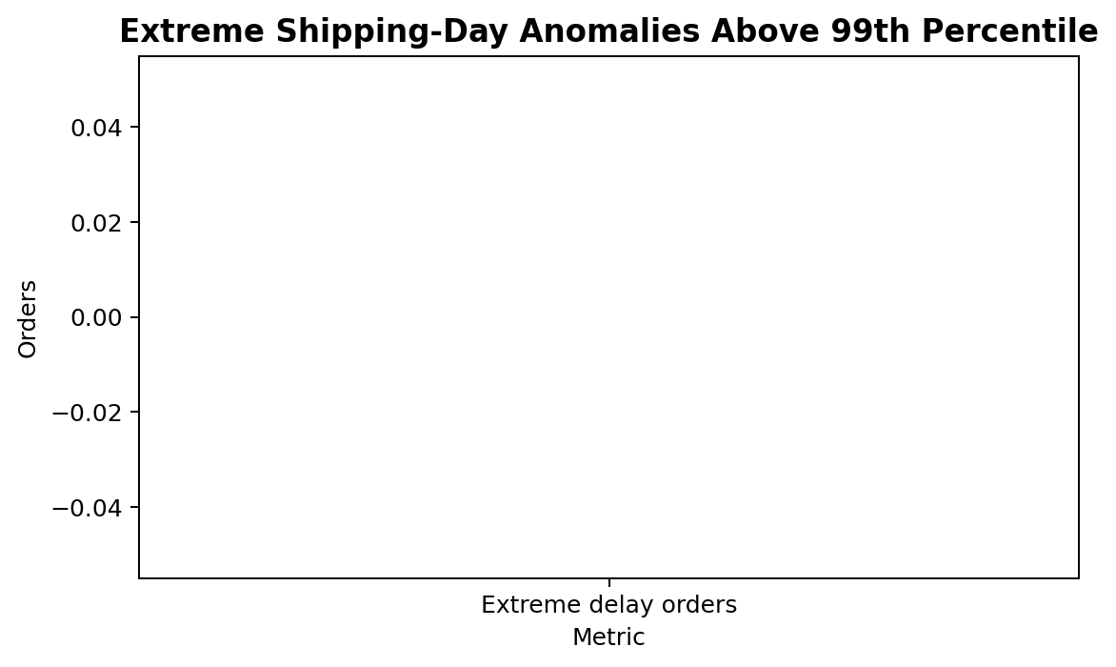
Conclusion: The executed analysis returned zero orders above the calculated 99th percentile, so no extreme shipping-day observations were identified by this rule.

7.12 Q12. Which season has the highest unit sales and which has the highest profit?
Units sold and profit were aggregated by season to identify seasonal differences in sales volume and profitability.
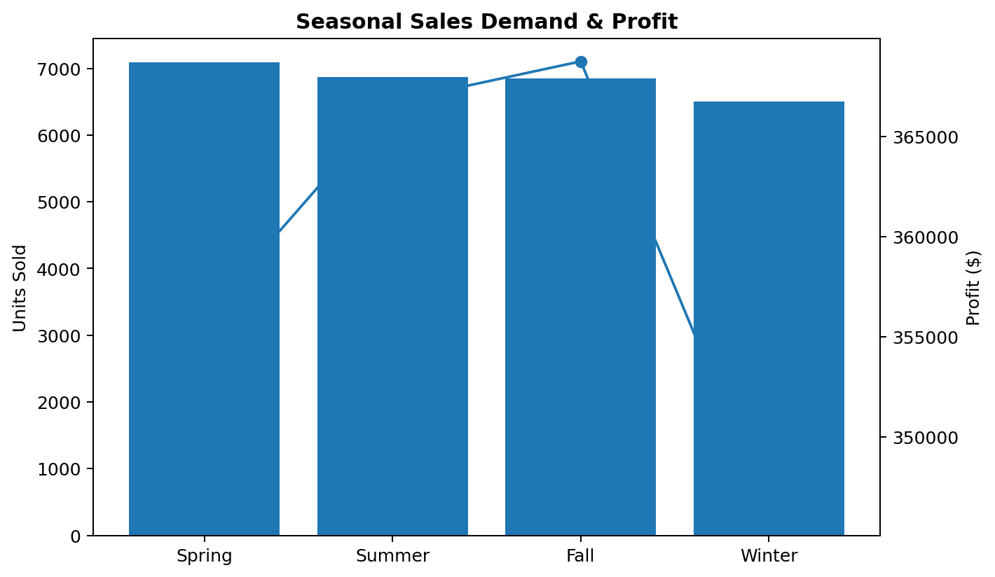
Conclusion: Spring recorded the highest unit sales at 7,089 units, while Fall generated the highest profit at $368,748.60.

8. OVERALL FINDINGS

- Middle East was the highest-revenue region.
- Clothing achieved the highest average profit margin.
- High discounts were associated with 1,338 negative-profit orders and $83,495.35 in total loss.
- Books & Media had the highest shipping cost relative to revenue.
- Cancelled and returned orders represented 27.23% of gross revenue.
- Electronics was the dominant revenue-generating category.
- PayPal had the highest average order value.
- Regular customers accounted for the largest number of orders taking more than seven shipping days.
- Monthly revenue showed considerable volatility across the analyzed period.
- No shipping-day observations exceeded the calculated 99th percentile.
- Spring led in unit sales, while Fall led in profit.

9. FINAL CONCLUSION

This project analyzed customer churn using a complete data analysis workflow: data inspection, cleaning, feature engineering, numerical analysis, EDA, visualization and business interpretation. The results show that churn is not evenly distributed. Mobile customers, high-fee customers and early-tenure customers face substantially higher risk.
The analysis also quantifies the financial consequence of churn through monthly recurring revenue and annualized revenue at risk. These findings can support targeted retention strategies such as stronger onboarding, early-tenure engagement, pricing/value reviews and focused interventions for high-value customers. This project analyzed global e-commerce performance using a complete data analysis workflow: data inspection, cleaning, feature engineering, numerical analysis, EDA, visualization and business interpretation.
The results show that revenue is distributed across several regions, with the Middle East leading. Electronics is the main revenue driver, while Clothing demonstrates the strongest average margin. At the same time, high discounts can create negative-profit orders and certain categories face significant shipping-cost pressure.
The analysis also shows that cancelled and returned orders account for a substantial share of revenue, while Regular customers have the highest number of orders taking more than seven shipping days. Seasonal and monthly analysis further demonstrates that business performance can vary considerably over time.
Overall, the project demonstrates how e-commerce data can be transformed into practical insights for pricing, product strategy, logistics, customer management and profitability improvement.

10. FUTURE IMPROVEMENTS

- Build an interactive Power BI or Tableau dashboard for continuous monitoring.
- Use predictive models to forecast revenue and profitability.
- Develop customer-level lifetime value and retention analysis.
- Investigate the causes of cancellations and returns in greater detail.
- Optimize discounts using profitability-based rules.
- Analyze shipping performance by country, carrier and shipping method.
- Create product-level demand forecasts and inventory recommendations.
- Use anomaly detection to identify unusual orders and operational risks.

