SPM Assignment 02

Project Scope Management

Members (ordered):

Ahmad Tariq

Ahmad Tashfeen

Umer Qureshi

Roll no.s (ordered):

22i-1534

22i-2490

22i-2578

Class:

SE-7C

Submitted to:

Dr. Muhammad Bilal

Task 1: Project Scope Statement
Project Title: Bug Triage AI Agent

1. Project Justification
Software projects receive large volumes of bug reports through issue trackers. Manually reviewing, classifying, and assigning these reports is time-consuming and prone to human error.
The Bug Triage AI Agent addresses this challenge by automating three core functions:
- Classifying bug reports into categories (e.g., UI, Functional, Performance).
- Predicting their priority level (High, Medium, Low).
- Suggesting a suitable assignee or development team based on past data.
This solution improves triage speed, consistency, and team efficiency. The project is designed as an independent, self-contained AI agent, not dependent on any other agents or paid APIs.

2. Product Characteristics and Boundaries
Feature | Description
Automated Classification | Classifies bug reports by analyzing textual data.
Priority Prediction | Suggests an appropriate severity or urgency level.
Assignee Recommendation | Suggests developer/team using pattern recognition.
ML/NLP Pipeline | Preprocessing, feature extraction (TF-IDF or embeddings), and supervised learning.
Integration with UI | Basic integration with a mock bug tracker UI for demonstration only.
Evaluation Metrics | Accuracy, Precision, Recall, and F1-score.
Model Training | Conducted on curated or public dataset of bug reports.
Independence | No dependency on other AI agents, cloud APIs, or external services.

3. Project Deliverables
Milestone | Expected Outputs
M1 – Project Approved (≈ 7 Oct 2025) | Charter, stakeholder analysis, high-level feasibility.
M2 – Plan Baseline Established (≈ 21 Oct 2025) | Scope Statement, WBS, Scope Management Plan, risk/resource/schedule documents, initial dataset prepared.
M3 – Prototype Complete (≈ 18 Nov 2025) | Functional prototype (baseline ML model + mock UI integration), evaluation metrics, review summary.
M4 – Project Closed (≈ 25–30 Nov 2025) | Final documentation, packaging, and presentation slides.

4. Assumptions
- Dataset will contain labeled bug reports available from public repositories (e.g., Bugzilla or curated samples).
- All development will use free or local tools (Python, scikit-learn, Flask).
- Supervisor feedback will be obtained after each milestone.
- Scope and schedule baselines remain fixed unless approved via change request.

5. Constraints
- Time: Must be completed within 8 weeks (no extensions).
- Compute: Local or free cloud (Colab/Kaggle).
- Scope: Limited to approved functionality only.
- Performance: Target ≥ 70% accuracy and macro F1 ≥ 0.65.
- Deliverables: All outputs reviewed and approved by supervisor.

6. Agent Description
Name: Bug Triage AI Agent
Type: Stand-alone predictive classification agent
Input: Bug title, description, metadata (if available)
Processing: NLP preprocessing -> feature extraction -> ML inference
Output: Bug type, priority, assignee, and confidence score
Operation: Independent; no communication with other agents or external systems.
Supervisor Role: Validates deliverables and provides feedback after each milestone.

7. Summary
Deliverable 2 establishes a solid foundation for development by defining a realistic and limited scope, creating the structure for all subsequent milestones, and preventing scope creep. The Bug Triage AI Agent remains self-contained, focused, and measurable in outcomes.

Task 2: Work Breakdown Structure
Hierarchical WBS
1. Bug Triage AI Agent
│
└── 1.1 Project Approval (M1)
|- 1.1.1 Project Charter & Stakeholder Analysis
|- 1.1.2 High-Level Requirements & Feasibility
|- 1.1.3 Supervisor Review & Approval

└── 1.2 Plan Baseline Established (M2)
|- 1.2.1 Scope Statement & WBS (Task 1 & 2)
|- 1.2.2 Schedule, Resource & Risk Planning
|- 1.2.3 Scope Management Plan (Task 3)
|- 1.2.4 Dataset Acquisition & Cleaning

1.3 Prototype Development (M3)
|- 1.3.1 Sprint 1 – Model Design & Initial Training
|- 1.3.2 Sprint 1 – Integration with Mock Bug Tracker UI
|- 1.3.3 Review & Adjust (End of Sprint 1)
|- 1.3.4 Sprint 2 – Model Refinement & Feature Additions
|- 1.3.5 Sprint 2 – Testing & User Feedback

└── 1.4 Project Closure (M4)
|- 1.4.1 Final Testing, Documentation, and Packaging
|- 1.4.2 Final Presentation & Lessons Learned
|- 1.4.3 Supervisor Approval & Submission

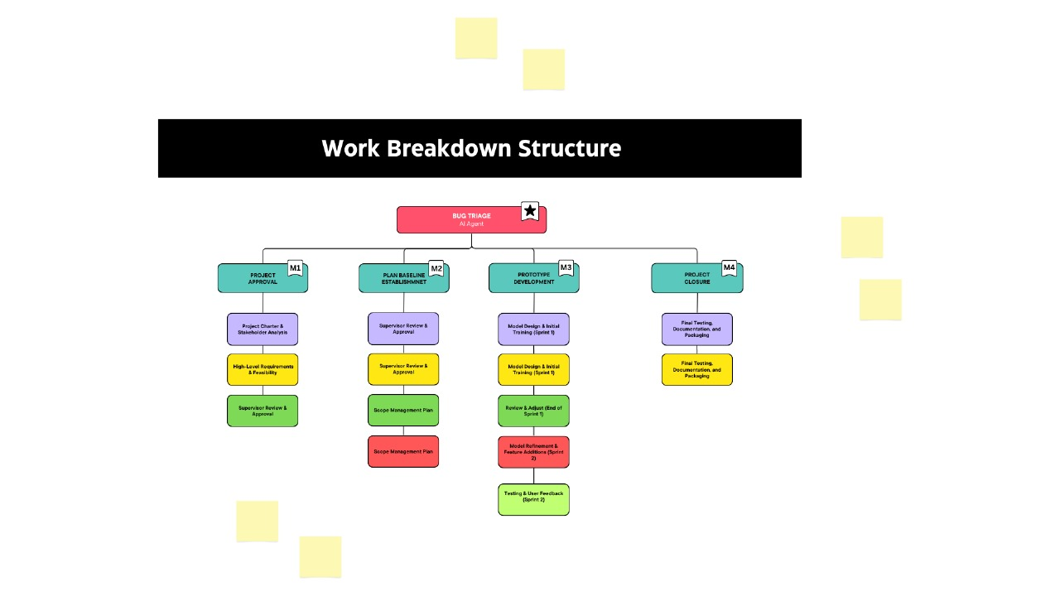

Tabular WBS
WBS ID | Task Name | Description
1.0 | Bug Triage AI Agent | Entire project covering planning to closure.
1.1 | Project Approval (M1) | Define problem, analyze feasibility, and get supervisor approval.
1.1.1 | Project Charter | Define objectives, justification, and boundaries.
1.1.2 | Requirements & Feasibility | Assess technical feasibility and dataset availability.
1.1.3 | Approval | Supervisor confirms project initiation.
1.2 | Plan Baseline Established (M2) | Develop all baseline project planning documents.
1.2.1 | Scope Statement & WBS | Create detailed project scope and breakdown structure.
1.2.2 | Schedule & Risk Planning | Prepare project timeline and identify potential risks.
1.2.3 | Scope Management Plan | Define how scope will be managed and controlled.
1.2.4 | Dataset Acquisition | Collect and clean initial dataset for training.
1.3 | Prototype Development (M3) | Build and test AI agent prototype.
1.3.1 | Model Design & Initial Training | Build baseline ML model using bug dataset.
1.3.2 | Integration with UI | Connect model to mock bug tracker interface for demo.
1.3.3 | Review & Adjust | Test and refine model based on supervisor feedback.
1.3.4 | Model Refinement | Fine-tune parameters and features.
1.3.5 | Testing & User Feedback | Evaluate performance metrics and usability.
1.4 | Project Closure (M4) | Final reporting, packaging, and presentation.
1.4.1 | Final Testing & Documentation | Final model evaluation, prepare documentation.
1.4.2 | Presentation & Lessons Learned | Conduct presentation and compile final reflections.
1.4.3 | Supervisor Sign-off | Final approval and submission.

Task 3: Scope Management Plan
1. Purpose
This plan defines how the project scope will be defined, validated, and controlled to ensure that the Bug Triage AI Agent remains within approved boundaries, prevents scope creep, and aligns with stakeholder expectations at every milestone.

2. Scope Definition
- Defined During M1–M2:
  - Scope Statement, WBS, and Scope Management Plan form the scope baseline.
- Scope Breakdown:
  - Each milestone (M1–M4) corresponds to a set of deliverables and review points.
- Approval:
  - Supervisor validates all deliverables before the next phase begins.

3. Scope Validation
Milestone | Validation Method | Approved By
M1 | Charter & Feasibility Review | Supervisor
M2 | Review of Scope Docs, WBS, Dataset | Supervisor
M3 | Working Prototype Demo | Supervisor
M4 | Final Presentation & Documentation | Supervisor / Section Coordinator
Only supervisor-approved deliverables advance to the next milestone.

4. Scope Control and Change Management
Process:
- Any proposed change (feature, dataset, schedule adjustment) is logged in a Change Request Form (Appendix A).
- PM reviews its impact on time, cost, and quality.
- Supervisor approves or rejects the request.
- Approved changes update the Scope Baseline and Schedule.
Approval Rule:
No change is implemented without written supervisor consent.

5. Scope Creep Prevention
Preventive Action | Description
Fixed Baseline | No modification to deliverables post M2 approval.
Milestone Reviews | Each milestone acts as a scope validation checkpoint.
Restricted Features | No added AI agents or external system integration.
Team Communication | Weekly syncs ensure consistent understanding.
Change Control Log | All change requests documented for transparency.

6. Stakeholder Alignment
- Supervisor: Reviews and approves each milestone.
- Project Manager: Maintains baselines, manages change process.
- Team Members: Execute only approved scope items.
- Section Coordinator: Reviews final deliverables at M4.

7. Summary
The Scope Management Plan ensures the Bug Triage AI Agent remains focused, efficient, and aligned with its approved objectives. By linking scope control directly to milestones (M1–M4), the project will prevent scope creep and ensure timely, validated progress.

Appendix A – Change Request Form Template
Change ID | Date | Requested By | Description of Change
Impact (): Scope/Schedule/Quality/Resources | Justification: | Supervisor Decision: Approve/Reject | Remarks:

Task 4: Gantt Chart
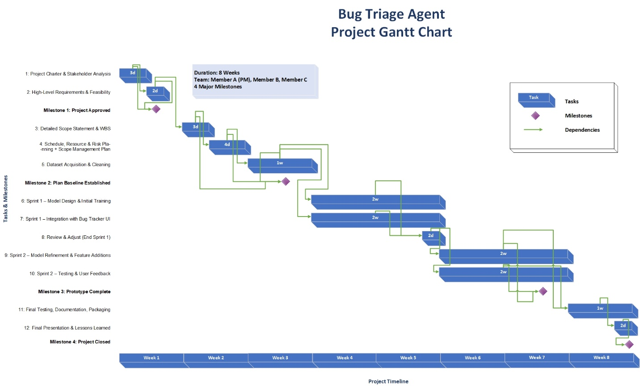

Task 5: Scope Verification and Validation Report

1. Introduction
This following section defines the methods, tools, and criteria used to verify and validate the scope of the Bug Triage AI Agent project. It ensures that all deliverables meet stakeholder expectations, comply with documented requirements, and align with the approved project scope. Scope verification and validation are conducted systematically through milestone reviews, prototype demonstrations, and supervisor evaluations.

2. Objectives
- To ensure all project deliverables conform to the Project Scope Statement and WBS.
- To verify that functional and non-functional requirements are satisfied.
- To formally obtain supervisor and stakeholder acceptance of deliverables.
- To prevent unauthorized scope changes (scope creep).

3. Scope Verification and Validation Approach
The approach follows PMI’s Project Scope Management framework and relates directly to its six core processes.

3.1 Planning Scope
Purpose: Determine how the project’s scope and requirements will be defined, verified, and controlled.
Activities:
- Review and approve the Scope Management Plan during the Plan Baseline Established (M2) milestone.
- Identify acceptance criteria for each major deliverable (e.g., scope statement, WBS, functional prototype).
- Establish a verification schedule aligning with project milestones (M1–M4).
Tools & Techniques:
- Stakeholder review meetings
- Requirements traceability matrix (RTM)
- Supervisor sign-off templates
Outputs:
- Approved Scope Management Plan
- Baseline for scope verification activities

3.2 Collecting Requirements
Purpose: Define and document all necessary functional and non-functional requirements for the Bug Triage AI Agent.
Activities:
- Conduct brainstorming and requirement-gathering sessions with project stakeholders (students, supervisor).
- Document features such as automatic bug classification, prioritization, and integration with mock bug tracker UI.
- Record performance criteria (accuracy, processing time, usability).
Tools & Techniques:
- Requirement documentation forms
- Interviews and feedback sessions
- Use-case diagrams and functional requirement tables
Outputs:
- Requirements Specification Document
- Updated Requirements Traceability Matrix

3.3 Defining Scope
Purpose: Refine the project charter and requirement documents to produce the finalized Project Scope Statement.
Activities:
- Confirm inclusions: AI model design, dataset preparation, and UI integration.
- Confirm exclusions: multi-agent dependency, external API calls, or external dataset integration.
- Identify constraints (time, academic schedule, hardware).
Tools & Techniques:
- Expert judgment (supervisor feedback)
- Document analysis
- Alternatives evaluation
Outputs:
- Finalized Project Scope Statement
- Approved deliverable list

3.4 Creating the WBS
Purpose: Break down the project into smaller, manageable deliverables for scheduling and responsibility assignment.
Activities:
- Develop a hierarchical WBS representing all tasks (M1–M4).
- Assign work packages (Scope Statement, Model Design, Integration, Testing).
- Link WBS elements to corresponding milestones and deliverables.
Tools & Techniques:
- Hierarchical WBS diagram (Mermaid/Graphical PNG)
- WBS dictionary and numbering scheme
Outputs:
- Approved WBS and WBS Dictionary
- Task responsibility matrix

3.5 Validating Scope
Purpose: Formalize acceptance of completed deliverables by verifying that outputs meet defined acceptance criteria.
Activities:
- Conduct milestone-based validation:
  - M1 (Initiation): Approval of Project Charter and Feasibility.
  - M2 (Planning): Acceptance of Scope Statement, WBS, and Scope Management Plan.
  - M3 (Execution): Review of working prototype and performance test results.
  - M4 (Closure): Supervisor approval of final deliverables and lessons learned.
- Perform prototype demonstrations and document acceptance forms.
Tools & Techniques:
- Review meetings and demos
- Inspection checklists
- Supervisor sign-off forms
Acceptance Criteria:
Deliverable | Verification Method | Acceptance Criteria | Acceptance Authority
Project Scope Statement | Supervisor Review | Matches project charter and FYP guidelines | Supervisor
WBS Diagram & Dictionary | Visual inspection | Includes all planned deliverables | Project Team
Prototype (AI Agent) | Functional testing | ≥ 85% classification accuracy, UI integration | Supervisor
Final Report & Presentation | Document review | Completeness, formatting, accuracy | Supervisor
Outputs:
- Approved deliverables per milestone
- Signed acceptance documentation

3.6 Controlling Scope
Purpose: Monitor and manage changes to project scope to prevent deviation from approved boundaries.
Activities:
- Track deliverables against the approved WBS and Gantt chart.
- Evaluate all change requests via Change Control Log before implementation.
- Reject out-of-scope additions (e.g., multi-agent or external dependency integration).
Tools & Techniques:
- Change Request Form
- Scope Baseline tracking
- Regular supervisor review meetings
Outputs:
- Updated scope baseline (if approved)
- Change log and decision records

4. Tools and Templates Summary
Tool | Purpose
Requirements Traceability Matrix (RTM) | Map requirements to deliverables
Supervisor Review Checklist | Verify deliverable completeness
Change Request Log | Record, track, and evaluate proposed changes
Deliverable Acceptance Form | Obtain formal acceptance at each milestone

5. Validation Schedule
Milestone | Deliverables to Validate | Validation Method | Authority
M1 – Project Approved | Charter & Feasibility Docs | Supervisor Review | Supervisor
M2 – Plan Baseline | Scope Docs, WBS, Management Plan | Documentation Review | Supervisor
M3 – Prototype Complete | Trained Model, UI Integration | Functional Testing, Demo | Supervisor
M4 – Project Closed | Final Report, Presentation | Review & Sign-off | Supervisor

6. Conclusion
The Scope Verification and Validation Plan ensures that all project deliverables of the Bug Triage AI Agent are developed, reviewed, and accepted systematically. Formal milestone-based verification and scope control mechanisms guarantee alignment with stakeholder expectations while preventing scope creep and ensuring successful project closure.

Task 6: Assign Tasks & Monitor Team Progress
