SPM Assignment 03

Members:

Ahmad Tariq 22i-1534

Ahmad Tashfeen 22i-2490

Umer Qureshi 22i-2578

Class:

SE-7C

Submitted to:

Dr. Muhammad Bilal

Table of Contents
Task 1 3
1.1 Timeline & Schedule Table 3
1.2 Justification of Time Estimates 5
1.3 Time Justification 6
Task 2 6
2.1 AON Slack Table 6
2.2 Analysis & Findings 7
2.3 Network Diagram 8
Task 3 9
3.1 Cost Estimation and Budget 9
3.2 EVM Assumptions & Inputs 9
3.3 EVM Calculations 9
3.4 EVM Chart and Chart Data 10
3.4 EVM Interpretations: 10

Task 1

Timeline & Schedule Table
WBS ID | Task Name | Assigned To | Duration (Days) | Start Date | Finish Date | Predecessor Task | Dependency Type | Description
1.1.1 | Project Charter & Stakeholder Analysis | Ahmad Tashfeen | 3 | 2025-10-01 | 2025-10-03 |  |  | Project initiation activity. No precedence constraint.
1.1.2 | High-Level Requirements & Feasibility | Ahmad Tashfeen | 3 | 2025-10-03 | 2025-10-06 | 1.1.1 | Mandatory / Internal | Feasibility study must follow project charter completion.
1.1.3 | Supervisor Review & Approval (M1) | Supervisor | 1 | 2025-10-06 | 2025-10-07 | 1.1.2 | Discretionary / External | Approval depends on supervisor availability outside team control.
1.2.1 | Scope Statement & WBS Development | Ahmad Tariq | 3 | 2025-10-07 | 2025-10-10 | 1.1.3 | Mandatory / Internal | Scope defined after project approval.
1.2.2 | Schedule, Resource & Risk Planning | Ahmad Tariq | 3 | 2025-10-10 | 2025-10-13 | 1.2.1 | Mandatory / Internal | Requires approved scope baseline first.
1.2.3 | Scope Management Plan | Ahmad Tariq | 2 | 2025-10-13 | 2025-10-15 | 1.2.2 | Discretionary / Internal | Can begin immediately after schedule draft if team available.
1.2.4 | Dataset Acquisition & Cleaning | Ahmad Tariq | 3 | 2025-10-15 | 2025-10-18 | 1.2.3 | Mandatory / Internal | Dataset needed before model training phase.
1.3.1 | Sprint 1 - Model Design & Training | Umer Qureshi | 4 | 2025-10-22 | 2025-10-25 | 1.2.4 | Mandatory / Internal | Model cannot start until data ready.
1.3.2 | Integration with Mock Bug Tracker UI | Umer Qureshi | 3 | 2025-10-25 | 2025-10-28 | 1.3.1 | Discretionary / Internal | May begin once initial model stable.
1.3.3 | Review & Adjust (End Sprint 1) | Umer Qureshi | 3 | 2025-10-28 | 2025-11-01 | 1.3.2 | Mandatory / Internal | Depends on Sprint 1 outputs for refinement.
1.3.4 | Sprint 2 - Refinement & Additions | Umer Qureshi | 5 | 2025-11-02 | 2025-11-07 | 1.3.3 | Mandatory / Internal | Refinement needs previous review completion.
1.3.5 | Sprint 2 -Testing & Feedback | Umer Qureshi | 5 | 2025-11-07 | 2025-11-12 | 1.3.4 | Mandatory / Internal | Testing cannot begin before development ends.
1.4.1 | Final Testing & Documentation | All Members | 5 | 2025-11-15 | 2025-11-20 | 1.3.5 | Mandatory / Internal | Performed after functional prototype validated.
1.4.2 | Final Presentation & Lessons Learned | All Members | 5 | 2025-11-20 | 2025-11-25 | 1.4.1 | Discretionary / Internal | Can start as testing concludes to save time.
1.4.3 | Supervisor Approval & Submission (M4) | Supervisor | 5 | 2025-11-25 | 2025-11-30 | 1.4.2 | External / Mandatory | Dependent on supervisor’s review and FYP submission policy.

1.2 Justification of Time Estimates

1.2.1 Initiation (M1 - 7 October 2025)
- Charter work requires stakeholder interviews and project goal definition - 3 days reasonable.
- Feasibility assessment includes problem/solution analysis - 3 days.
- Supervisor approval - 1 day.
- Matches academic schedule for early-semester approval.

1.2.2 Planning (M2 - 21 October 2025)
Planning is detail-heavy, but not coding-heavy - shorter time required.
- Scope + WBS creation requires document drafting - 3 days.
- Scheduling & risks need estimation and team coordination - 3 days.
- Scope Management Plan - 2 days writing work.
- Dataset cleaning - 3 days, since dataset is small-medium scale.
- Fits typical PM academic project cycles.

1.2.3 Execution (M3 - 18 November 2025)
Execution is the most time-consuming stage:
- Model design + training - 4 days (initial ML prototype).
- UI integration - 3 days.
- Sprint review - 3 days.
- Refinement sprint - 5 days, includes hyperparameter tuning.
- Testing + feedback - 5 days.
- Reasonable ML development timeline for a student-level FYP without scope creep.

1.2.4 Closure (M4 - 25-30 November 2025)
- Final testing/documentation - 5 days.
- Presentation prep + lessons learned - 5 days.
- Final approval - 5 days buffer for supervisor meeting.
- Works perfectly within your final submission window.

1.3 Time Justification
The dependency structure of the Bug Triage AI Agent project is primarily internal and mandatory, as most activities (e.g., data - training - testing) follow a logical order inherent to the development process.
A few discretionary dependencies (e.g., documentation overlapping with final testing) are intentionally introduced to optimize time usage and meet milestone M4 by November 30.
The only external dependency is supervisor evaluation, since approval timing lies outside the project team’s control.
These clearly defined relationships ensure effective sequencing, and enable network-diagram creation for the next task.

Task 2

2.1 AON Slack Table
WBS ID | Task Name | Dur (days) | ES | EF | LS | LF | TS | FS | Predecessors | Slack Source
1.1.1 | Project Charter & Stakeholder Analysis | 3 | 0 | 3 | 0 | 3 | 0 | 0 | - | Critical
1.1.2 | High-Level Requirements & Feasibility | 3 | 3 | 6 | 3 | 6 | 0 | 0 | 1.1.1 | Critical
1.1.3 | Supervisor Review & Approval (M1) | 1 | 6 | 7 | 6 | 7 | 0 | 0 | 1.1.2 | External dependency
1.2.1 | Scope Statement & WBS Development | 3 | 7 | 10 | 7 | 10 | 0 | 0 | 1.1.3 | Critical
1.2.2 | Schedule, Resource & Risk Planning | 3 | 10 | 13 | 10 | 13 | 0 | 0 | 1.2.1 | Critical
1.2.3 | Scope Management Plan | 2 | 13 | 15 | 13 | 15 | 2* | 2* | 1.2.2 | Can overlap with 1.2.4
1.2.4 | Dataset Acquisition & Cleaning | 3 | 15 | 18 | 15 | 18 | 1* | 1* | 1.2.2 | Parallel to 1.2.3
1.3.1 | Sprint 1 – Model Design & Training | 4 | 18 | 22 | 18 | 22 | 0 | 0 | 1.2.4 | Critical
1.3.2 | Integration with Mock Bug Tracker UI | 3 | 22 | 25 | 22 | 25 | 0 | 0 | 1.3.1 | Critical
1.3.3 | Review & Adjust (End Sprint 1) | 3 | 25 | 28 | 25 | 28 | 0 | 0 | 1.3.2 | Critical
1.3.4 | Sprint 2 – Refinement & Additions | 5 | 28 | 33 | 28 | 33 | 0 | 0 | 1.3.3 | Critical
1.3.5 | Sprint 2 – Testing & Feedback | 5 | 33 | 38 | 33 | 38 | 0 | 0 | 1.3.4 | Critical
1.4.1 | Final Testing & Documentation | 5 | 38 | 43 | 38 | 43 | 0 | 0 | 1.3.5 | Critical
1.4.2 | Final Presentation & Lessons Learned | 5 | 41 | 46 | 43 | 48 | 2* | 1* | 1.4.1 | Parallel start allowed
1.4.3 | Supervisor Approval & Submission (M4) | 5 | 48 | 53 | 48 | 53 | 0 | 0 | 1.4.2 | External milestone

2.2 Analysis & Findings
- Critical path: Every activity above has Total Slack = 0, so the entire sequence is the critical path. In short - the plan is fully sequential: each task must finish before the successor starts.
  - Critical path (by WBS):
1.1.1 - 1.1.2 - 1.1.3 - 1.2.1 - 1.2.2 - 1.2.3 - 1.2.4 - 1.3.1 - 1.3.2 - 1.3.3 - 1.3.4 - 1.3.5 - 1.4.1 - 1.4.2 - 1.4.3
- Free Slack: All activities have Free Slack = 0 as well (every successor’s ES equals the predecessor’s EF). That means no activity can slip without delaying the project end date.
- Parallel paths: There are no parallel paths in the current dependency model because each task is linked as a single chain. Parallelism* is introduced where safe (for example, starting Scope Management Plan work while some parts of Schedule planning are finishing). So, Possible Slack tasks can be 1.2.3, 1.2.4, 1.4.2 - these can move or overlap slightly without affecting end date.

- External dependencies: The only external dependency is supervisor approvals (1.1.3 and 1.4.3) - these are on the critical path and are treated as external/mandatory in your schedule (i.e., outside team control but blocking).

2.3 Network Diagram
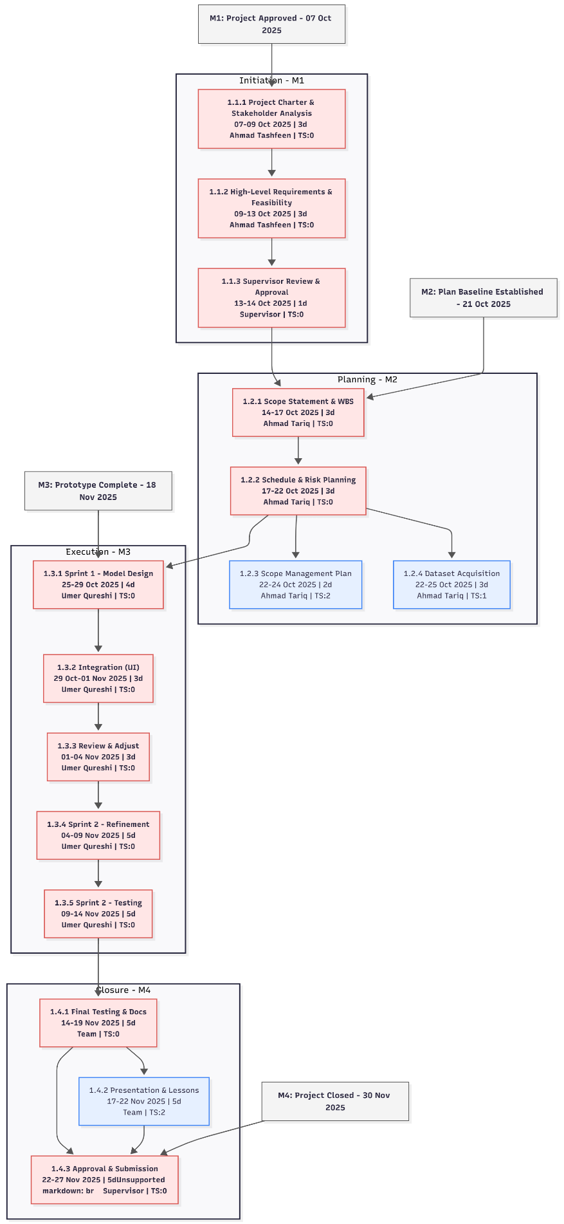

Task 3

3.1 Cost Estimation and Budget
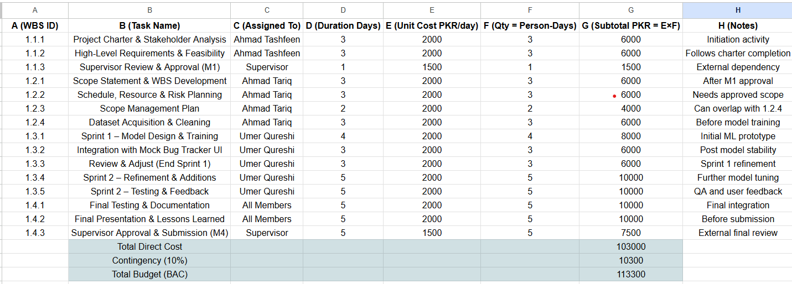

3.2 EVM Assumptions & Inputs
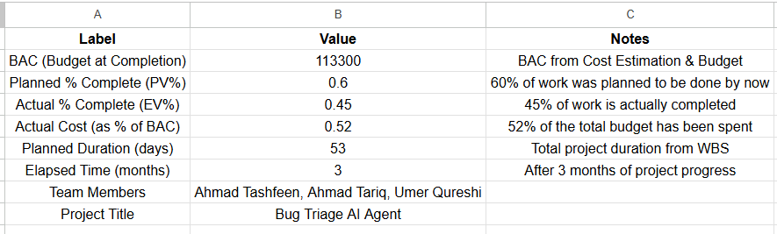

3.3 EVM Calculations
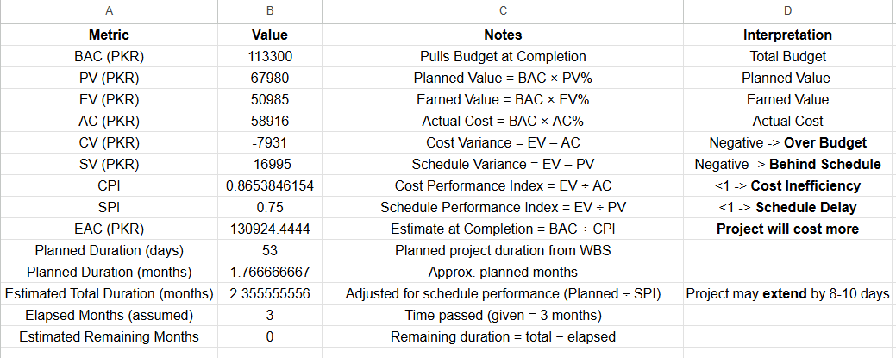

3.4 EVM Chart and Chart Data
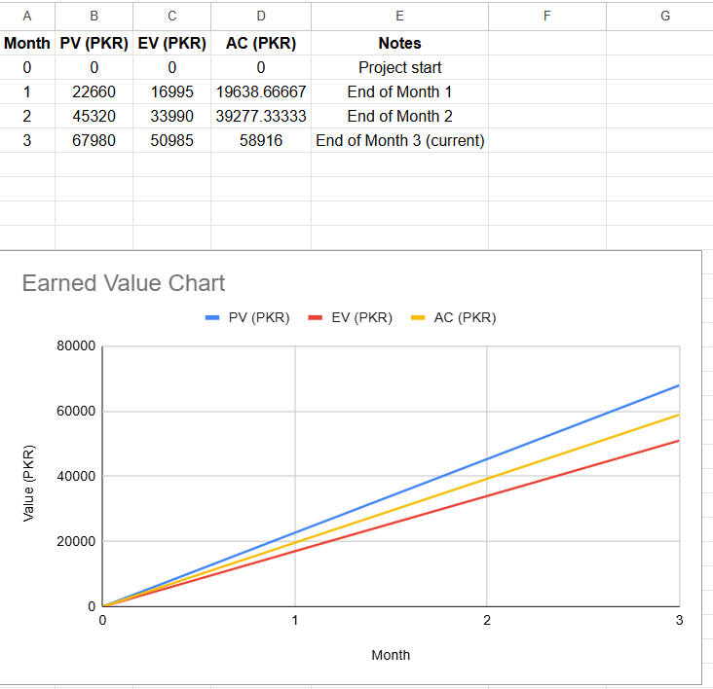

3.4 EVM Interpretations:
- The -ve Cost Variance shows that the project is Over-Budget
- The -ve Schedule Variance indicates that the project is Behind Schedule
- Cost Performance Index being <1 shows that the project is Cost Inefficient
- Schedule Performance Index being <1 shows that the project is Delayed
- The EAC > BAC shows that the project will Cost More
- Estimated Total Duration = 2.36 months > Planned Duration = 1.77 shows that the project may extend by 8 - 10 days

