

See discussions, stats, and author profiles for this publication at: [https://www.researchgate.net/publication/309637872](https://www.researchgate.net/publication/309637872_Chemistry_in_Our_Daily_Life_Preliminary_Information_International_Journal_of_Home_Science?enrichId=rgreq-7d5e9c1938b7b191875372eb0d163792-XXX&enrichSource=Y292ZXJQYWdlOzMwOTYzNzg3MjtBUzo0MzMyODU4MDIyNzA3MjBAMTQ4MDMxNDc5MzEwNQ%3D%3D&el=1_x_2&_esc=publicationCoverPdf)

[Chemistry in Our Daily Life: Preliminary Information. International Journal of Home Science](https://www.researchgate.net/publication/309637872_Chemistry_in_Our_Daily_Life_Preliminary_Information_International_Journal_of_Home_Science?enrichId=rgreq-7d5e9c1938b7b191875372eb0d163792-XXX&enrichSource=Y292ZXJQYWdlOzMwOTYzNzg3MjtBUzo0MzMyODU4MDIyNzA3MjBAMTQ4MDMxNDc5MzEwNQ%3D%3D&el=1_x_3&_esc=publicationCoverPdf)

**Article** · November 2016

CITATIONS

6

READS

345,404

**1 author:**

[Sanjay Roy](https://www.researchgate.net/profile/Sanjay-Roy-2?enrichId=rgreq-7d5e9c1938b7b191875372eb0d163792-XXX&enrichSource=Y292ZXJQYWdlOzMwOTYzNzg3MjtBUzo0MzMyODU4MDIyNzA3MjBAMTQ4MDMxNDc5MzEwNQ%3D%3D&el=1_x_5&_esc=publicationCoverPdf)

[Netaji Subhas Open University](https://www.researchgate.net/institution/Netaji_Subhas_Open_University?enrichId=rgreq-7d5e9c1938b7b191875372eb0d163792-XXX&enrichSource=Y292ZXJQYWdlOzMwOTYzNzg3MjtBUzo0MzMyODU4MDIyNzA3MjBAMTQ4MDMxNDc5MzEwNQ%3D%3D&el=1_x_6&_esc=publicationCoverPdf)

**120** PUBLICATIONS **1,101** CITATIONS

[SEE PROFILE](https://www.researchgate.net/profile/Sanjay-Roy-2?enrichId=rgreq-7d5e9c1938b7b191875372eb0d163792-XXX&enrichSource=Y292ZXJQYWdlOzMwOTYzNzg3MjtBUzo0MzMyODU4MDIyNzA3MjBAMTQ4MDMxNDc5MzEwNQ%3D%3D&el=1_x_7&_esc=publicationCoverPdf)

**Some of the authors of this publication are also working on these related projects:**

Nanomaterials and their performance [View project](https://www.researchgate.net/project/Nanomaterials-and-their-performance?enrichId=rgreq-7d5e9c1938b7b191875372eb0d163792-XXX&enrichSource=Y292ZXJQYWdlOzMwOTYzNzg3MjtBUzo0MzMyODU4MDIyNzA3MjBAMTQ4MDMxNDc5MzEwNQ%3D%3D&el=1_x_9&_esc=publicationCoverPdf)



Solution Chemistry on Amino Acids Solvation [View project](https://www.researchgate.net/project/Solution-Chemistry-on-Amino-Acids-Solvation?enrichId=rgreq-7d5e9c1938b7b191875372eb0d163792-XXX&enrichSource=Y292ZXJQYWdlOzMwOTYzNzg3MjtBUzo0MzMyODU4MDIyNzA3MjBAMTQ4MDMxNDc5MzEwNQ%3D%3D&el=1_x_9&_esc=publicationCoverPdf)

All content following this page was uploaded by [Sanjay Roy](https://www.researchgate.net/profile/Sanjay-Roy-2?enrichId=rgreq-7d5e9c1938b7b191875372eb0d163792-XXX&enrichSource=Y292ZXJQYWdlOzMwOTYzNzg3MjtBUzo0MzMyODU4MDIyNzA3MjBAMTQ4MDMxNDc5MzEwNQ%3D%3D&el=1_x_10&_esc=publicationCoverPdf) on 28 November 2016.

The user has requested enhancement of the downloaded file.

# International Journal of Home Science 2016; 2(3): 361-366

**ISSN:** 2395-7476

IJHS 2016; 2(3): 361-366

© 2016 IJHS

[www.homesciencejournal.com](http://www.homesciencejournal.com/) Received: 15-07-2016

Accepted: 17-08-2016

**Dr. Sanjay Roy** Department of Chemistry Shibpur Dinobundhoo

Institution (College), 412/1, G.T. Road (South), Howrah, Pin.

711102, West Bengal, India

**Chemistry in our daily life: Preliminary information**

**Dr. Sanjay Roy**

**Abstract**

Chemistry is a big part in our everyday life. We start the day with Chemistry. One can find chemistry in daily life in the foods we eat, the air we breathe, cleaning chemicals, our emotions and literally every object we can see or touch. Here's a look at examples of everyday chemistry. Some common chemistry may be obvious, but others might surprise us.

Our body is made up of chemical compounds, which are combinations of elements. The emotions that you feel are a result of chemical messengers, primarily neurotransmitters. Love, jealousy, envy, infatuation and infidelity all share a basis in chemistry.

They sit there, so harmless-looking on the kitchen counter. Yet as soon as we cut an onion, the tears begin to fall. What is it in an onion that makes them burn our eyes? We can be sure everyday chemistry is the guilty party.

Soap is a chemical that mankind has been making for a very long time. You can form a crude soap by mixing ashes and animal fat. How can something so nasty actually make you cleaner? The answer has to do with the way soap interacts with oil-based grease and grime.

The presentation also deals with the chemistry of coffee, drinks, lactose intolerance, smoking and chemistry of sleep.

**Keywords:** Preliminary information**,** everyday chemistry, ashes

# Introduction

**The day we start with: Toothpaste**

Ever wonder where toothpaste and mouthwash came from? What people used for toothpaste before the invention of Colgate, Pepsodent or Aquafresh? Below are some interesting point and recipes that may help satisfy our curiosity!!

Back in the Days of Buddha....

It has been recorded that he would use a "tooth stick" from the God Sakka as part of his personal hygiene regimen.

**Correspondence Dr. Sanjay Roy**

**Department of Chemistry**

So. what's in the toothpaste of the 90s?

**Fig 1**

Shibpur Dinobundhoo Institution (College), 412/1, G.T. Road (South), Howrah, Pin.

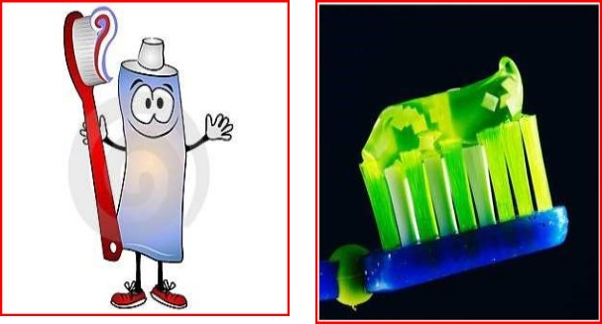

711102, West Bengal, India [Email:sanjayro](mailto:sanjayroyp@gmail.com)[yp@gmail.com](mailto:yp@gmail.com)

Sodium monofluorophosphate color flavoring Fluoride foaming agents (Sodium Lauryl Sulfate).

Herbal toothpastes have gained popularity for people looking for a "natural" toothpaste or for those who don't want fluoride in their dental cleansers. Some herbal toothpastes contain:

Peppermint oil plant extract (strawberry extract) special oils and cleansing agents

The 21st Century....

If the trends of the 20th century continue we should see more toothpaste that whiten and brighten the teeth, and give us the ultimate brushing or rinsing experience.

The more things change, the more they stay the same! Precipitated Chalk- 58.75%,

Glycerin-28.60%, Water-5.60%, Starch-1.10%, Soap- 5%,

Mineral oil- 0.25%,

Saccharin- 0.03%,

Hydrochloride- .0015%,

Thymol- 0.015%,

Menthol- 0.03%,

Oil of eucalyptus- 0.11%, Methyl Salicylate- 0.11%, Oil of Peppermint- 0.40%

# The Chemistry of Soaps/Detergents

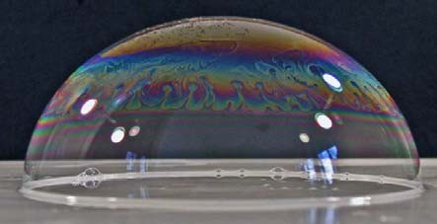

**Fig 2**

“Surfactants allow us to protect a water surface and blow beautiful soap bubbles which delight our children” P.-G. DeGennes. SOFT MATTER, Nobel Lecture, 1991.

There are substances which can be dissolved in water (salt for example), and others that can't (for example oil). Water and oil don't mix together, so if we try to clean an oily stain from a cloth or from the skin, water is not enough. We need soap.

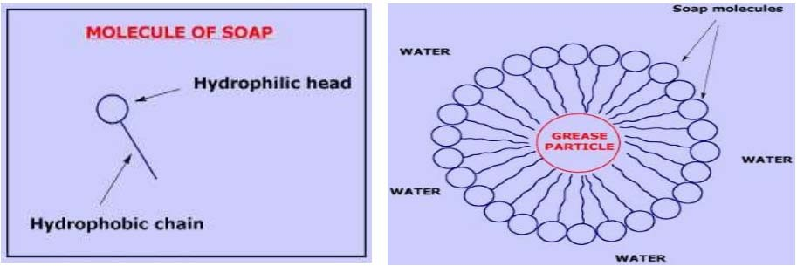

**Fig 4**

Soap cleans by acting as an emulsifier. It allows oil and water to mix so that oily grime can be removed during rinsing.

Soap cleans by acting as an emulsifier. It allows oil and water to mix so that oily grime can be removed during rinsing.

# Chemistry at the breakfast table

We've all used raising agents in cooking and baking but do you know the chemistry involved? There are two raising agents used in most recipes, yeast and baking powder. Yeast (Saccharomyces cerevisiae) is a micro-organism that contains the enzyme zymase that converts the sugars in bread into carbon dioxide and ethanol.

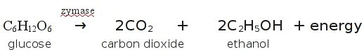

Raising Agents: Gluten in the bread is a fibrous compound that stretches as the bread rises and traps the carbon dioxide in an elastic framework. Yeast grows in a warm environment so the bread is kept warm until it rises. When it is placed in a hot oven the yeast increases production of carbon dioxide initially then dies as the temperature rises. The carbon dioxide trapped in the bread expands and the bread rises even more. The flavour comes partly from the ethanol produced by the yeast.

**Fig 3**

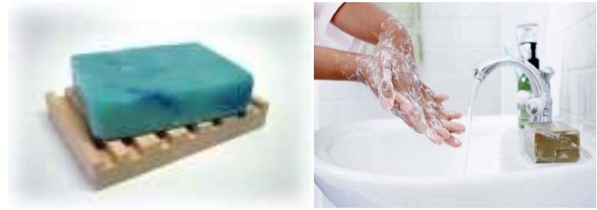

Because of this dualism, soap molecules act like a diplomat, improving the relationship between water and oil. How? When soap is added to the water, the hydrophilic heads of its molecules stay into the water (they like it!), while the long hydrophobic chains join the oil particles and remain inwards (escaping from the water). In that way, they form circular groups named *micelles*, with the oily material absorbed inside and trapped.

**Fig 5**



**Fig 6**



# The taste maker

Glutamic acid is a neurotransmitter that excites our neurons not just in our tongues. This electrical charging of neurons is what makes foods with added free glutamic acid taste so good. Unfortunately, the free glutamic acid can cause problem to our brain. Our brains have many receptors for glutamic acid and some areas, such as the hypothalamus do not have an impermeable blood-brain barrier, so free glutamic acid from food sources can get into the brain, this can injure and sometimes kill the neurons.

# Oranges, pineapples and strawberries are rich in Vitamin C

little to handle more than one or two glasses of milk at a time. When this drop in lactase production falls below certain minimums the intolerance to lactose appears. Without enough lactase in the digestive fluids, the lactose of milk and milk products isn't broken effectively, so lactose passes along the intestinal path to a region where it undergoes fermentation to gases such as carbon dioxide and hydrogen and to acid lactic, a bowel irritant. The combination easily produces gastric distress and diarrhea.

**Fig 11**

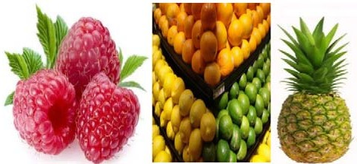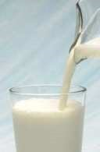

**Fig 7**

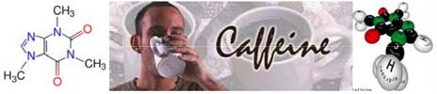

**Fig 12**

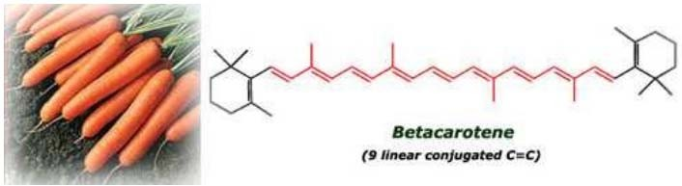

**Fig 8**

# Coffee makes our morning fresh and energetic. The reason? Caffeine...

Caffeine is a central nervous system stimulant. It's one of the most popular drugs in the world, consumed by up to 90% of people in the world in different form.

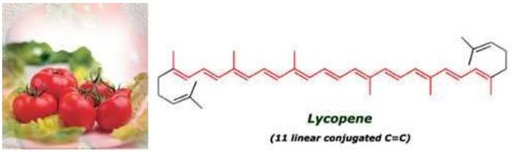

**Fig 9**

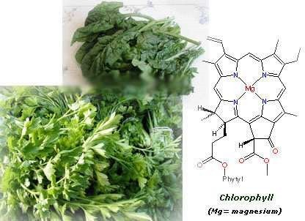

**Fig 10:** World of natural colors

# Lactose intolerance

Normally there's plenty of lactase in the digestive systems of infants and children, but the ability to produce lactase in big amounts decreases as we grow older, generating usually too

**Fig 13:** How does it work?

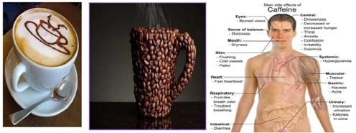

Caffeine is a stimulant of the central nervous system (CNS), the cardiac muscle increases heart rate, and respiratory system

-relaxes air passages permitting improved inhalation, and allows some muscles to contract more easily.

It acts as a diuretic it increases the rate of bodily urine excretion, and delays fatigue having the effect of warding off drowsiness and restoring alertness.

Caffeine absorption occurs in the body very quickly. It enters the bloodstream through the stomach and small intestine, and its effects are felt as soon as 15 minutes after consumption. It is completely absorbed within 45 minutes of intake. Caffeine does not accumulate in the bloodstream nor it is stored in the body, but it does persist but only about ½ is eliminated in the urine within 6 hours.

Caffeine sensitivity refers to the amount of caffeine that will produce negative side effects in a particular person. Regular caffeine consumption reduces sensitivity to caffeine, and a higher intake is needed for the same effects. So caffeine is considered to be an addictive drug.

# Let’s move to the kitchen….. Why do onions make we cry?

Inside the onion cells there are some chemical compounds that contain sulphur. When we cut an onion its cells are broken and those chemical compounds then undergo a reaction that transforms them into more volatile sulfured products, which are released into the air.

These sulfured compounds react with the moisture in our eyes forming sulfenic acid, which produces a burning sensation. The nerve endings in our eyes are very sensitive and so they pick up on this irritation. The brain reacts by telling our tear ducts to produce more water, to dilute the irritating acid.

The chemical reaction is given below:

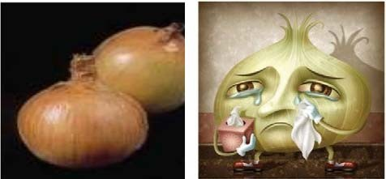

**Fig 14**

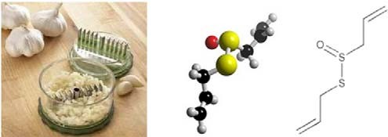

**Fig 16**

**Allicin** being a strongly oxidising compound, it protects garlic from attack by bacteria and insects by disabling the enzymes that are found in the substrate necessary for infections to occur, thus acting as a natural insecticide. It does so by attacking the SH groups found on their active sites.

**We all enjoy cooked food and many of us cook every day but have we ever thought about the chemistry of cooking?** Cooking makes food easier to digest and safer to eat as it kills micro organisms in the food. However it can also destroy some nutrients in food, such as vitamin C, so it's necessary to balance making food easier to digest and taste better without destroying the valuable nutrients that we need.

# Use of herbs/spices

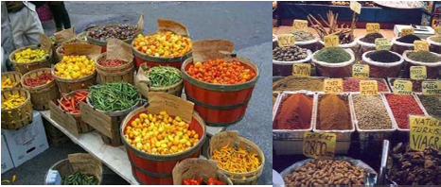

**Fig 17**

Spices contain essential oils with antimicrobial properties. Many of these oils are derived from the organic compound Phenol. This oil is used as an antiseptic and disinfectant also. In Europe, turmeric became known as Indian saffron, since it was widely used as an alternative to the far more expensive saffron spice.

**Fig 15:** So you cry to keep your eyes protected from the acid.

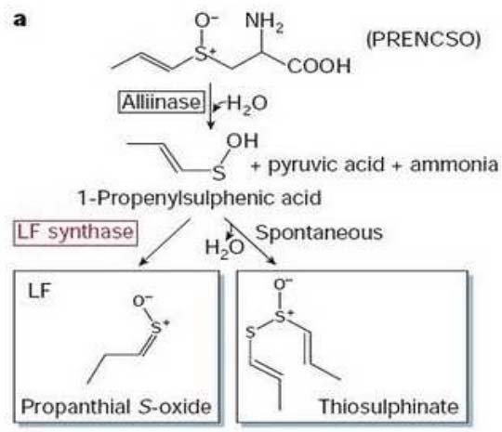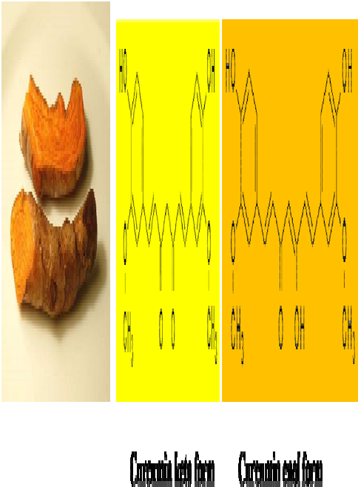

# There are some tricks to make onion-dicing less problematic:

*You can freeze the onion* for 10 minutes before cutting it. The cold temperature of the onion will slow down the chemical reaction which forms the volatile sulfured compounds.

The sulfur-containing compounds also leave a characteristic odor on your fingers. You may be able to remove or reduce some of the smell by wiping your fingers on a stainless steel odor. If the sulfur compounds bind to the steel, then the odor is removed from your fingers.

Chop the onion under cold water. The volatile sulfured compounds will be released but then they react with the water, instead of reaching your eyes.

# How garlic chase parasite away?

The sulphurous compound is called Allicin. Allicin is synthesized from alliin when garlic is crushed or bruised. Allicin is an oily, yellow liquid, which gives garlic its characteristic odour which is due to the –S=O group.

**Fig 18**

It can exist at least in two tautomeric forms, keto and enol. The keto form is preferred in solid phase and the enol form in solution.

# Curcumin is a pH indicator.

In acidic solutions (pH <7.4) it turns yellow, whereas in basic (pH > 8.6) solutions it turns bright red.

# Aroma: Esters

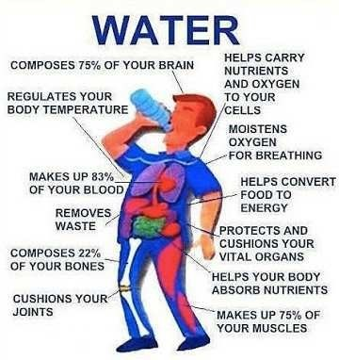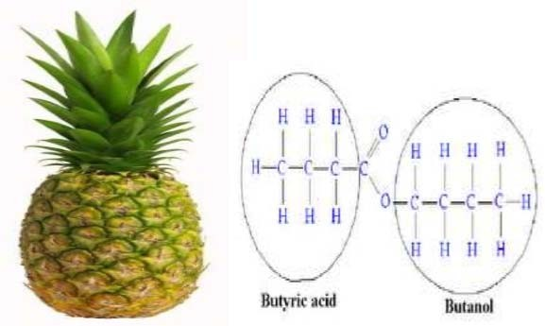

**Fig 19**

**Fig 23**



# Let’s go for a cigarette…..

Smokers don’t think about the chemical in the cigarettes. They only think about how cigarettes help them cope with the stress of daily life, how cigarettes quiet them down when they are angry, help them relax at the end of a long day, comfort them when they were sad or lonely. But do they know that there are harmful chemical in cigarettes???

**Fig 20**

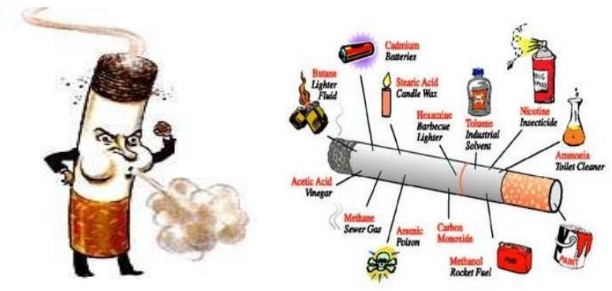

This ester gives a jasmine smell. It can be found naturally in many flowers. It is formed by benzyl alcohol and acetic acid.

**Fig 24**

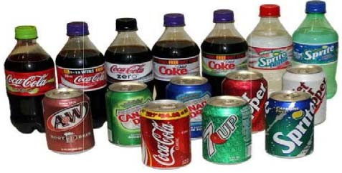

More than 3000 chemicals in the cigarette smoke.

When one smokes, nicotine is absorbed through the skin and mucosal lining of the mouth and nose or by inhalation in the lungs.

**Fig 21**

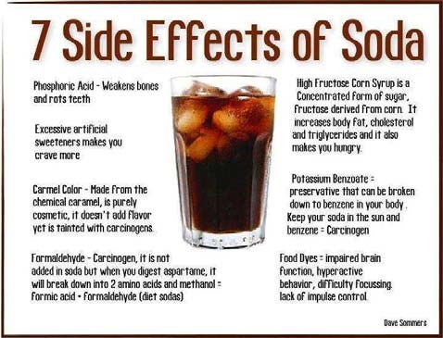

**Fig 22**

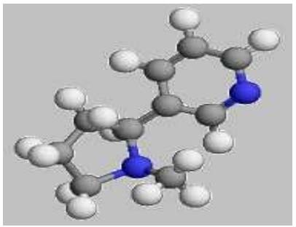

**Fig 25:** Nicotine

In the brain, nicotine increases the level of the neurotransmitter dopamine, which is a chemical in the brain responsible for feelings of pleasure. The acute effects of nicotine subside within minutes, so people continue dosing

themselves frequently throughout the day to maintain the pleasurable effects of nicotine and to prevent withdrawal symptoms.

# Let’s see some drink to celebrate joy or to bypass sorrow:

More than 90% of the ethyl alcohol that enters the body is completely oxidized to acetic acid. This process occurs primarily in the liver. The remainder of the alcohol is not metabolized and is excreted either in the sweat, urine, or given off in one’s breath. There are several routes of metabolism of ethyl alcohol in the body. The major pathways involve the liver and in particular the oxidation of ethyl alcohol by alcohol dehydrogenase (ADH).

# Time to go to the bed: Sleep

**Fig 26**

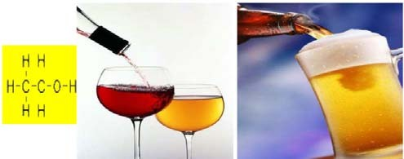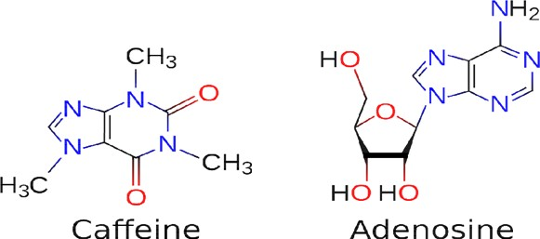

There are 3 types of alcoholic drinks which are beer, wine and spirits.

All this alcoholic drinks contain ethanol, C2H5OH which is one type of alcohol.

**Fig 29**

There is a chemical in our brain called adenosine, that binds to certain receptors and slows down nerve cell activity when we are sleeping.

**Fig 27**

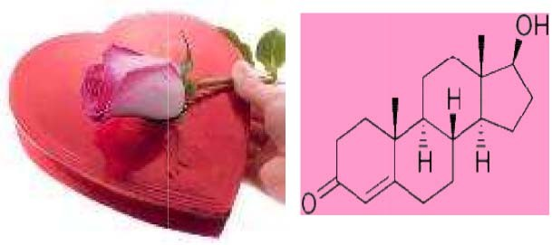

Alcohol’s direct action on the brain is as a depressant. It generally decreases the activity of the nervous system. The alcohol can cause disinhibition, i.e., inhibits cells and circuits in the brain which themselves are normally inhibitory.

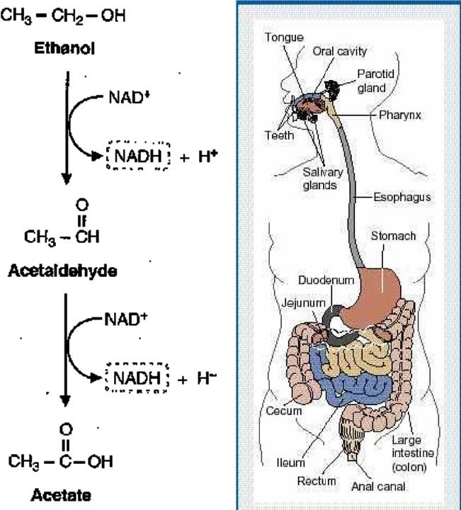

**Fig 28**

**Fig 30:** The Chemistry of love

First, there's attraction. Nonverbal communication plays a big part in initial attraction and some of this communication may involve pheromones, a form of chemical communication. Raw lust is characterized by high levels of testosterone. The sweaty palms and pounding heart of love are caused by higher than normal levels of norepinephrine. Meanwhile, the 'high' of being in love is due to a rush of phenylethylamine and dopamine.

# Conclusion

Therefore one can see that chemistry is on the whole in everyday life. Without chemistry life is not possible. Therefore chemistry is the great way to know the life in better way. If anyone think chemistry before doing something, it would be helpful to anyone. Therefore chemistry may be enjoyable to anyone. But be care about the harmful thing of chemistry.

# Reference

1. <http://chemistry.about.com/>
2. [http://www.rsc.org/learn-chemistry/resource/listing?](http://www.rsc.org/learn-chemistry/resource/listing)
3. <http://www.silviamar.com/chemistry_everyday.htm>
4. <http://wiki.chemprime.chemeddl.org/index.php/Chemistry>

_in_Everyday_Life

1. <http://pubs.acs.org/cen/whatstuff/stuff/paper.html>

~ 366 ~

[View publication stats](https://www.researchgate.net/publication/309637872)