**Li-Fi Using Arduino**

**Components Needed:**

1. Arduino Uno
2. Resistors – 1kΩ, 100Ω
3. KY-022 Receiver Module
4. Infra-Red LED Bulb
5. BC547 NPN Transistor
6. Jumper Wires

**Software Used:**

1. Arduino software

**Library Used:**

No additional libraries used.

**Workshop Skill Break-up:** 45% hardware, 55% software

**Workshop Overview**

The objective of this workshop is to build a Light Fidelity (Li-Fi) communication system between two Arduino’s through the serial monitor. One Arduino will act as the sender and the other as the receiver and will use Infra-Red (IR) Signals to communicate.

The Arduino is a low cost, open-source microcontroller board using the ATMega328 with 32KB of Flash memory storage.

By the end of this workshop, we should be able to set-up a safe wireless communication system between 2 people.

**Workshop Steps**

1. Circuit Connections:

Before we get started, we need to be familiar with the wiring connections of the breadboard and the type of rails we have.

The Blue and Red Rails are connected vertically and are usually used for power. Red is the Voltage Supply (Vcc) and the Blue is usually used for Ground (GND). In the diagram you can see how each rail is connected in green.

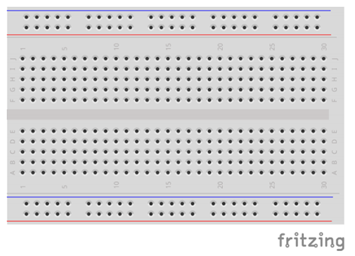

1. Receiver Arduino Wiring:

* Connect the pin on the receiver with the S to Pin 0 (Rx) on the Arduino as in the diagram.
* Connect the pin on the receiver with the – to a GND on the Arduino as in the diagram.
* Connect the middle pin on the receiver to 5V on the Arduino as in the diagram.

1. Sender Arduino Wiring:

* First start by placing the IR Led on the breadboard.
* Connect the negative leg of the led (shorter leg) to the GND rail.
* Next connect the NPN Transistor’s Collector Leg on the positive leg of the LED.
* From the base pin of the NPN transitor, connect a 1kΩ resistor and the other leg of the resistor to Pin 1 (Tx) on the sender Arduino.
* Also, from the Collector leg on the NPN Transistor, Connect a 100Ω resistor in between the LED positive leg and the Transistor’s legs. Connect the other end of the resistor to Pin 9 on the Arduino.
* Finally, Connect the Emitter’s Leg to the GND rail through a jumper wire, and connect the rail to a GND Pin on the Arduino.

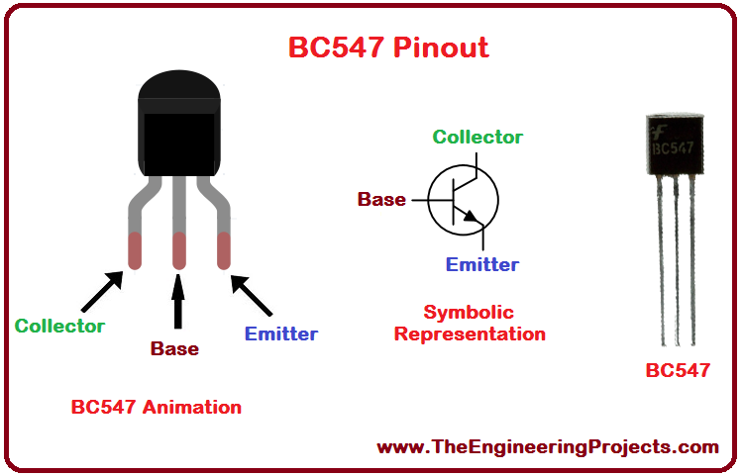

1. Coding the Sender:

* Begin by defining the “cr” pin used for modulation.
* Next, Open the Serial Port at a Baud Rate of 1200.
* Modulate the signal at 38kHz.
* In the loop, Define the message that we’ll be receiving as a string.
* Read the serial port and save the message in the variable “incomingByte”
* Add a conditional statement to keep checking and print only valid results.
* In the Serial Monitor, change the Baud Rate to 1200 before sending.
* Type the message on the Serial Monitor and hit enter.

1. Coding the Receiver

* Begin by defining the Serial port at a Baud Rate of 1200.
* In the loop, define a conditional statement to check if the serial connection is available.
* Before receiving, in the Serial Monitor, change the Baud Rate to 1200.
* If there is a message, “Serial.print(char(Serial.read()))” will display what is being received.

**References and Tutorials**

* <https://www.electronicwings.com/arduino/ir-communication-using-arduino-uno>