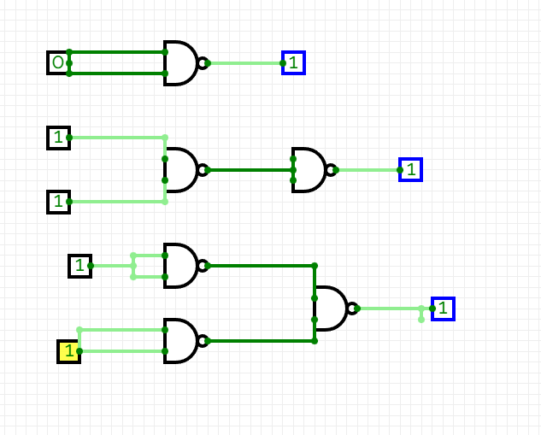
Mission 1:

Mission 2:
a)
Input1(A) | Input 2(B) | Carry bit(C) | Sum bit(S)
0 | 0 | 0 | 0
0 | 1 | 0 | 1
1 | 0 | 0 | 1
1 | 1 | 1 | 0

b)
S=AB’+BA’
C=AB

c)
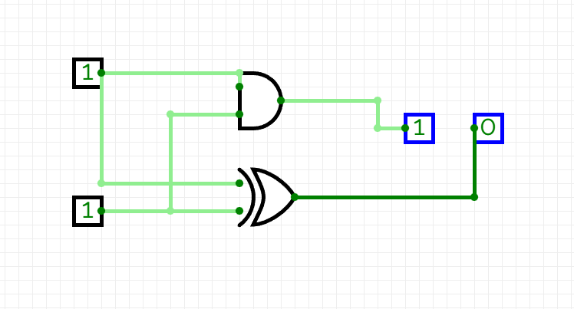

Mission 3:
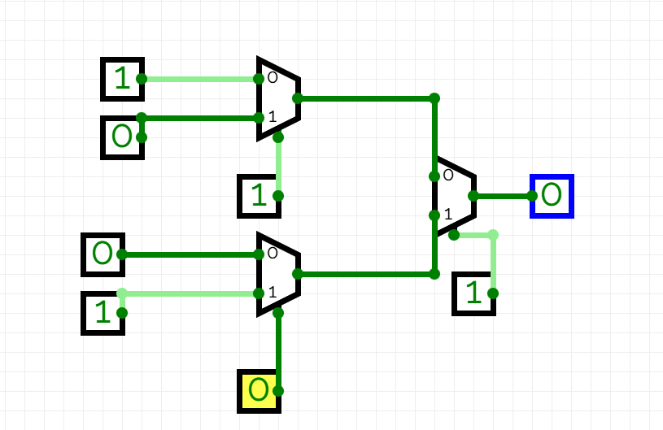
Mission 4:
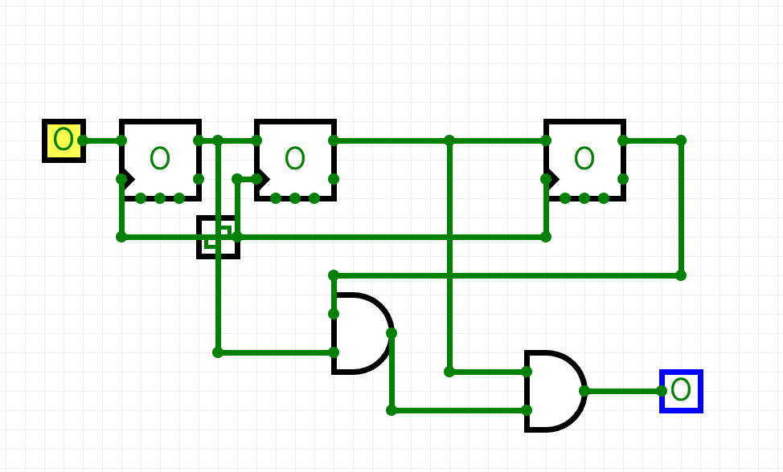
Mission 5:

