Annual Report Content To-Dos

Setup
- Enable notifications for the Annual Report 2022 teams channel
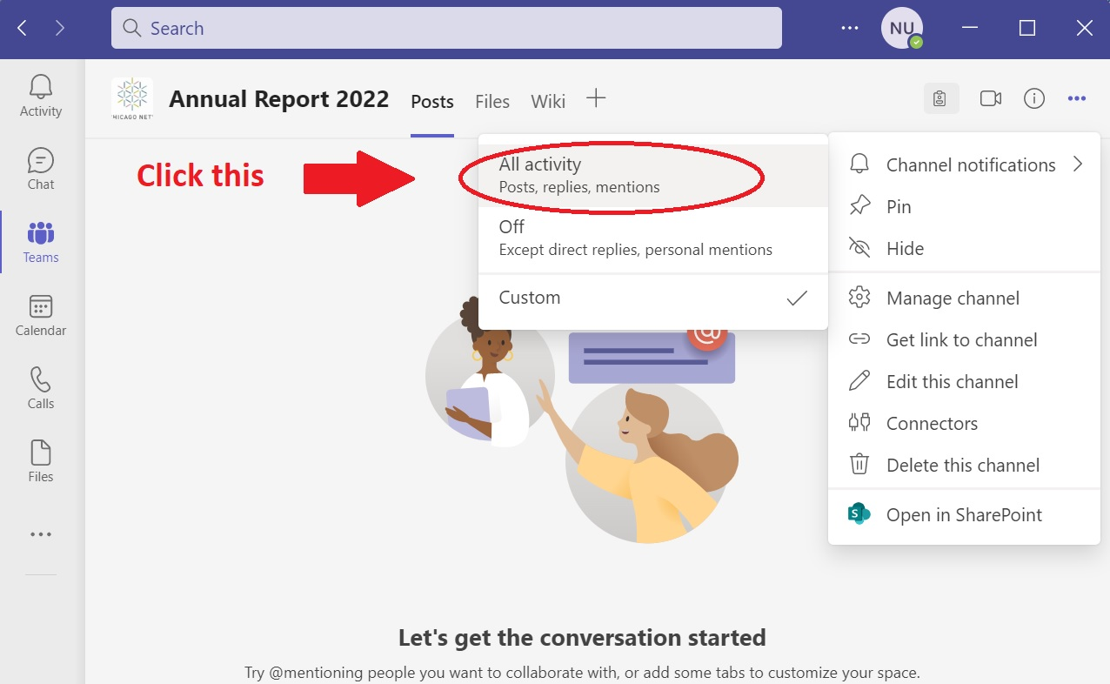
- Locate the following folder and add it to your quick access: Design & Innovation\Annual Report\2022\
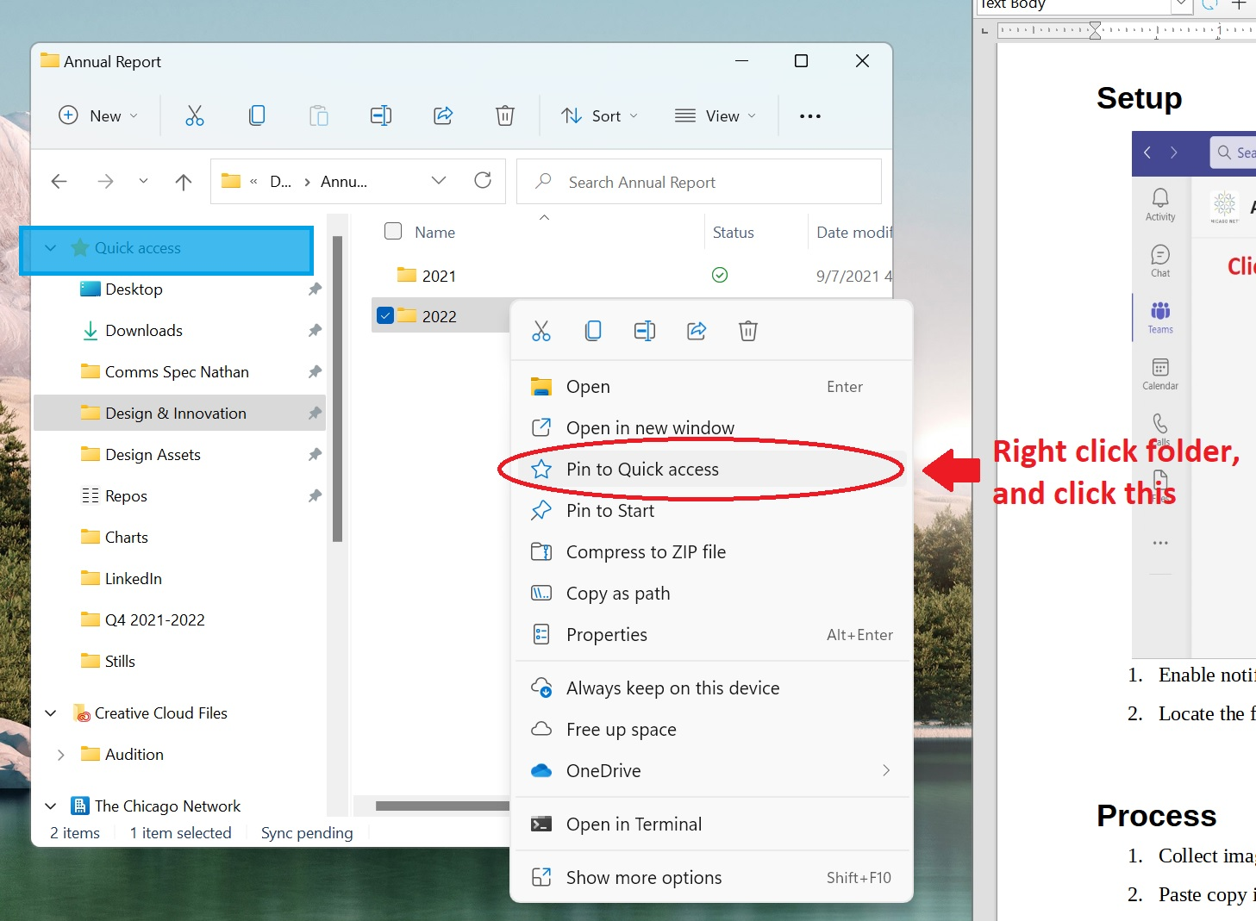

Process
- Collect images, quotes, or draft copy
- Paste copy into ContentSlides.odp
- Paste images into: Design & Innovation\Annual Report\2022\PicturesAndGraphics\RELEVANTFOLDER
- Notify Maria of the content to be approved via the Annual Report 2022 teams channel
- All content approved by 26th

To-Dos

Cathy
- Membership stats

Ellen
- List of new members, including:
  - Their Positions, and their employers
- List of board members, including:
  - Their Position on the board
  - Their Position
  - Their Employer

Lora
- List of all programs in the year (Titles)
- Pictures from Annual Meeting
- WIFL images
- Equity Principles copy
- Annual Meeting copy
- WIFL copy
- Launchpad copy

Maria
- Chair welcome copy
- Approval of all other copy & images

Nathan
- MPVV
- HerStories Podcast Copy
- Equity Principles Logos
- WOB Copy
- Launchpad images

