**Blockchain Solutions for Patient Data Security**

CODING ASSIGNMENT

REPORT

SUBMITTED TO

Dr.Parkavi

Associate Professor

M S RAMAIAH INSTITUTE OF TECHNOLOGY

(Autonomous Institute, Affiliated to VTU)

**SUBMITTED BY**

|  |  |
| --- | --- |
| **Name** | **USN** |
| **Chris Biju** | **1MS21CS042** |

As part of the Course **CSE635 - Blockchain & Distributed App development**

SUPERVISED BY

Faculty

**Dr.Parkavi.A**



DEPARTMENT OF COMPUTER SCIENCE AND ENGINEERING

M S RAMAIAH INSTITUTE OF TECHNOLOGY

Apr 2024

**CERTIFICATE**

This is to certify that **Chris Biju (1MS21CS042)**  have completed the **“Securing Blockchain Solutions for Patient Data Security”** as part of Coding Assignment and online course attending. I declare that the entire content embodied in this B.E, 6th Semester report contents are not copied.

Submitted by Guided by

|  |  |
| --- | --- |
| Name | USN |
| Chris Biju | 1MS21CS042 |

Dr. Parkavi.A

(Dept of CSE, RIT) (Assistant Professor, Dept. of CSE, RIT)

Department of Computer Science and Engineering

M S Ramaiah Institute of Technology

(Autonomous Institute, Affiliated to VTU)

Bangalore – 54



**Evaluation Sheet**

|  |  |  |  |  |
| --- | --- | --- | --- | --- |
| **USN** | **Name** | **Coding skills , Demo & Explanation(10)** | **Literature study and report**  **(10)** | **Total Marks**  **(20)** |
| **1MS21CS042** | **Chris Biju** |  |  |  |

Evaluated By

Name: Dr. Parkavi.A

Designation: Associate Professor

Department: Computer Science & Engineering, RIT

Signature:

Department of Computer Science and Engineering

M S Ramaiah Institute of Technology

(Autonomous Institute, Affiliated to VTU)

Bangalore – 54



**Table of Contents**

|  |  |  |
| --- | --- | --- |
| **Sl No** | **Content** | **Page No** |
|  | Abstract | **1** |
|  | Introduction | **2** |
|  | Literature Survey | **3** |
|  | Problem Definition | **4** |
|  | Algorithm | **5-6** |
|  | Implementation | **7-11** |
|  | Results | **12-14** |
|  | Conclusion | **15** |
|  | Reference | **16** |

1. **Abstract**

In the digital age, the security and privacy of patient data are of paramount importance. Traditional methods of storing and managing patient information are increasingly vulnerable to breaches and unauthorized access, posing significant risks to patient confidentiality and the integrity of healthcare systems. Blockchain technology, with its decentralized and immutable nature, offers a promising solution to these challenges. By leveraging blockchain, patient data can be securely stored and accessed, ensuring that only authorized parties have the ability to view or modify sensitive information. This paper explores the potential of blockchain technology to revolutionize patient data security, providing a robust framework for protecting patient information in a rapidly evolving digital landscape.

Blockchain technology provides a distributed ledger system that records transactions in a secure and transparent manner. Each block in the chain contains a cryptographic hash of the previous block, a timestamp, and transaction data, making it inherently resistant to tampering and fraud. In the context of patient data security, blockchain can be used to create a comprehensive and tamper-proof record of patient interactions, medical histories, and treatment plans. This ensures data integrity and provides a single source of truth for healthcare providers, enhancing the accuracy and reliability of patient information. Moreover, blockchain's smart contract functionality allows for automated, rule-based access control, further enhancing the security and privacy of patient data.

The implementation of blockchain solutions in healthcare is not without challenges. Issues such as scalability, interoperability, and regulatory compliance must be addressed to realize the full potential of blockchain technology. However, the benefits of enhanced security, improved patient privacy, and increased trust in healthcare systems make blockchain a compelling option for modernizing patient data management. This paper discusses the technical aspects of blockchain deployment in healthcare, examines case studies of successful implementations, and proposes a roadmap for integrating blockchain technology into existing healthcare infrastructures. By adopting blockchain solutions, healthcare providers can significantly mitigate the risks associated with patient data breaches and build a more secure and trustworthy healthcare ecosystem.

1. **Introduction**

In an era where digitization has transformed every aspect of our lives, the healthcare industry stands at the forefront of technological innovation. With the digitization of patient records and the adoption of electronic health records (EHRs), healthcare providers have experienced significant improvements in efficiency and patient care. However, alongside these advancements comes the critical challenge of safeguarding patient data against an ever-growing array of cyber threats. Patient data security has emerged as a paramount concern, as breaches not only jeopardize patient confidentiality but also undermine trust in healthcare systems and compromise patient safety.

Traditional methods of storing and managing patient data, such as centralized databases, are increasingly susceptible to cyberattacks and data breaches. These centralized systems present a single point of failure, making them lucrative targets for hackers seeking to exploit vulnerabilities and gain unauthorized access to sensitive patient information. Moreover, the proliferation of interconnected healthcare networks and the sharing of patient data among various stakeholders further exacerbate the security risks associated with centralized data storage.

To address these challenges, healthcare organizations are turning to blockchain technology—a decentralized, distributed ledger system that offers unprecedented levels of security, transparency, and data integrity. Blockchain technology has garnered widespread attention for its potential to revolutionize patient data security by providing a secure and immutable platform for storing and sharing patient information. By leveraging cryptographic techniques and consensus mechanisms, blockchain ensures that patient data remains tamper-proof and verifiable, thereby enhancing trust and accountability in healthcare systems.

This paper examines the role of blockchain technology in addressing the pressing need for patient data security in healthcare. It explores the fundamental principles of blockchain, its applications in healthcare, and the benefits it offers in terms of data integrity, interoperability, and patient privacy. Furthermore, it discusses the challenges and limitations of implementing blockchain solutions in healthcare and proposes strategies for overcoming these obstacles. By harnessing the power of blockchain technology, healthcare organizations can fortify their defenses against cyber threats, uphold patient confidentiality, and foster greater trust and transparency in the delivery of healthcare services.

1. **Literature Survey**

**Authors:** [Shadab Alam](https://www.researchgate.net/profile/Shadab-Alam-5?_tp=eyJjb250ZXh0Ijp7ImZpcnN0UGFnZSI6InB1YmxpY2F0aW9uIiwicGFnZSI6InB1YmxpY2F0aW9uIn19), Huda Abdullah, [Rafan Abdulhaq](https://www.researchgate.net/scientific-contributions/Rafan-Abdulhaq-2194195661?_tp=eyJjb250ZXh0Ijp7ImZpcnN0UGFnZSI6InB1YmxpY2F0aW9uIiwicGFnZSI6InB1YmxpY2F0aW9uIn19), Asmaa Hayawi

**Published Date:** 28th April 2021

1. **Blockchain in Credential Verification:** [The research paper proposes a blockchain-based framework to ensure secure and reliable management of student records, addressing challenges in security, privacy, and trust within the educational domain](https://www.academia.edu/48860810/A_Blockchain_based_framework_for_secure_Educational_Credentials).
2. **Key Research Concerns:** It addresses the need for a secure, verifiable, and scalable blockchain-based system to manage educational credentials, mitigating issues of fraud and loss.
3. **Systematic Review Approach:** A hybrid review method is applied, combining systematic literature review principles with technology analysis.
4. **Future Directions:** The paper suggests future work on enhancing the scalability, integration, and extensibility of the blockchain-based educational credential framework to better serve a growing user base and technological advancements.
5. **Methods Used:**

The paper employs a systematic literature review approach, following PRISMA guidelines, to select and categorize scientific papers.

It reviews blockchain technology in credential verification systems, focusing on security, reliability, trust, and privacy.

The study analyzes several papers, highlighting the use of blockchain frameworks, consensus algorithms, and security and privacy-enhancing techniques.

1. **Outcomes:**

The review identifies key benefits such as enhanced security and reliability in blockchain- based credential verification systems.

It points out challenges like integration issues and technical limitations.

The paper suggests that while blockchain can strengthen security and privacy, the aspect of scalability needs more attention.

This survey provides a comprehensive overview of the current state and future potential of blockchain technology in the context of credential verification.

**4. Problem Definition**

In traditional educational systems, the process of issuing, verifying, and storing educational credentials such as diplomas, certificates, and transcripts is often centralized, paper-based, and susceptible to various forms of fraud, manipulation, or loss. This reliance on centralized authorities and paper-based documents presents several challenges. Firstly, the credentials issued by educational institutions can be vulnerable to counterfeiting or tampering, leading to issues of credential fraud and misrepresentation. Secondly, the verification process for these credentials can be cumbersome, time-consuming, and inefficient, requiring manual checks and communications between multiple parties. Lastly, the centralized storage of educational records poses risks of data breaches, unauthorized access, and loss of records due to disasters or system failures.

There is a compelling need for a more secure, transparent, and efficient framework for managing educational credentials. Blockchain technology offers promising solutions to address these challenges by providing a decentralized, immutable, and tamper-resistant platform for issuing, verifying, and storing educational credentials. By leveraging blockchain-based frameworks, educational institutions can cryptographically sign and timestamp digital credentials, ensuring their integrity and authenticity. Moreover, stakeholders such as employers, academic institutions, and credential evaluators can verify these credentials in real-time without relying on intermediaries, reducing the risk of fraud and streamlining the verification process.

The Credential Verification System Using Blockchain offers a transformative solution to address the inherent limitations of traditional credentialing systems. By leveraging the immutability, transparency, and decentralization of blockchain technology, educational institutions can enhance trust, reduce fraud, improve efficiency, and ensure the integrity and security of educational credentials in the digital age..

**5. Algorithm**

The Credential Verification System Using Blockchain employs the following algorithm to facilitate secure and transparent elections:

1. **Certificate Issuance:**

An authorized institution issues a digital certificate to an individual after successful completion of a course or program.

The certificate is digitally signed by the institution, ensuring its authenticity and origin.

1. **Hash Generation:**

A unique cryptographic hash of the certificate is generated, which acts as a digital fingerprint for the document.

This hash is immutable, meaning it cannot be altered without changing the entire content of the certificate.

1. **Blockchain Entry:**

The hash, along with relevant metadata such as the issuer’s and recipient’s details, is recorded on the blockchain.

This entry is timestamped and becomes a permanent, unalterable record on the distributed ledger.

1. **Verification Request:**

When a third party, like an employer, needs to verify the certificate, they submit a request to the blockchain system.

The system then prepares to compare the stored hash with the hash of the certificate presented for verification.

1. **Hash Comparison:**

The system retrieves the hash of the certificate from the blockchain and compares it with the hash of the presented certificate.

If the hashes match, it confirms that the certificate is unchanged and authentic; if not, it indicates potential tampering or forgery.

1. **Validation:**

Upon a successful hash match, the system validates the certificate, confirming its legitimacy to the inquiring party.

[If the validation fails, the system flags the certificate as invalid, protecting against fraudulent claims of credentials](https://ijrpr.com/uploads/V5ISSUE1/IJRPR21789.pdf).

1. **Implementation**

The implementation of the Credential Verification System Using Blockchain involves several steps, including setting up the blockchain environment, deploying the smart contract, and developing the frontend and backend of the application. Here's a high-level overview of the implementation process:

1. **Setting up the Blockchain Environment:**

Install Ganache or set up a private Ethereum blockchain network using tools like Geth or Ganache CLI.

Start the blockchain network and ensure it's running locally.

1. **Developing the Smart Contract:**

Write the smart contract code using Solidity. This contract will define the structure of candidates, manage credentials, and handle transactions.

Compile the smart contract using tools like Remix or the Solidity compiler (solc).

1. **Deploying the Smart Contract:**

Deploy the compiled smart contract to the local blockchain network using tools like Remix, Truffle, or web3.py.

Note down the deployed contract address for later use in the application.

1. **Developing the Backend:**

Write Python scripts using libraries like web3.py to interact with the deployed smart contract.

Implement functions to connect to the blockchain network, send transactions, and retrieve results.

1. **Developing the Frontend:**

Create HTML templates using tools like Jinja2 for rendering dynamic content.

Write JavaScript code to handle user interactions, such as submitting credentials and displaying results.

Style the frontend using CSS to enhance the user interface and experience.

1. **Integrating Frontend with Backend:**

Connect the frontend to the backend using Flask, a micro web framework for Python.

Define routes in Flask to handle HTTP requests from the frontend, such as submitting credentials and retrieving results. And the data is stored in the backend. (sqlite3)

**Images shown below represent the exact implantation process:**

* **Remix IDE:**

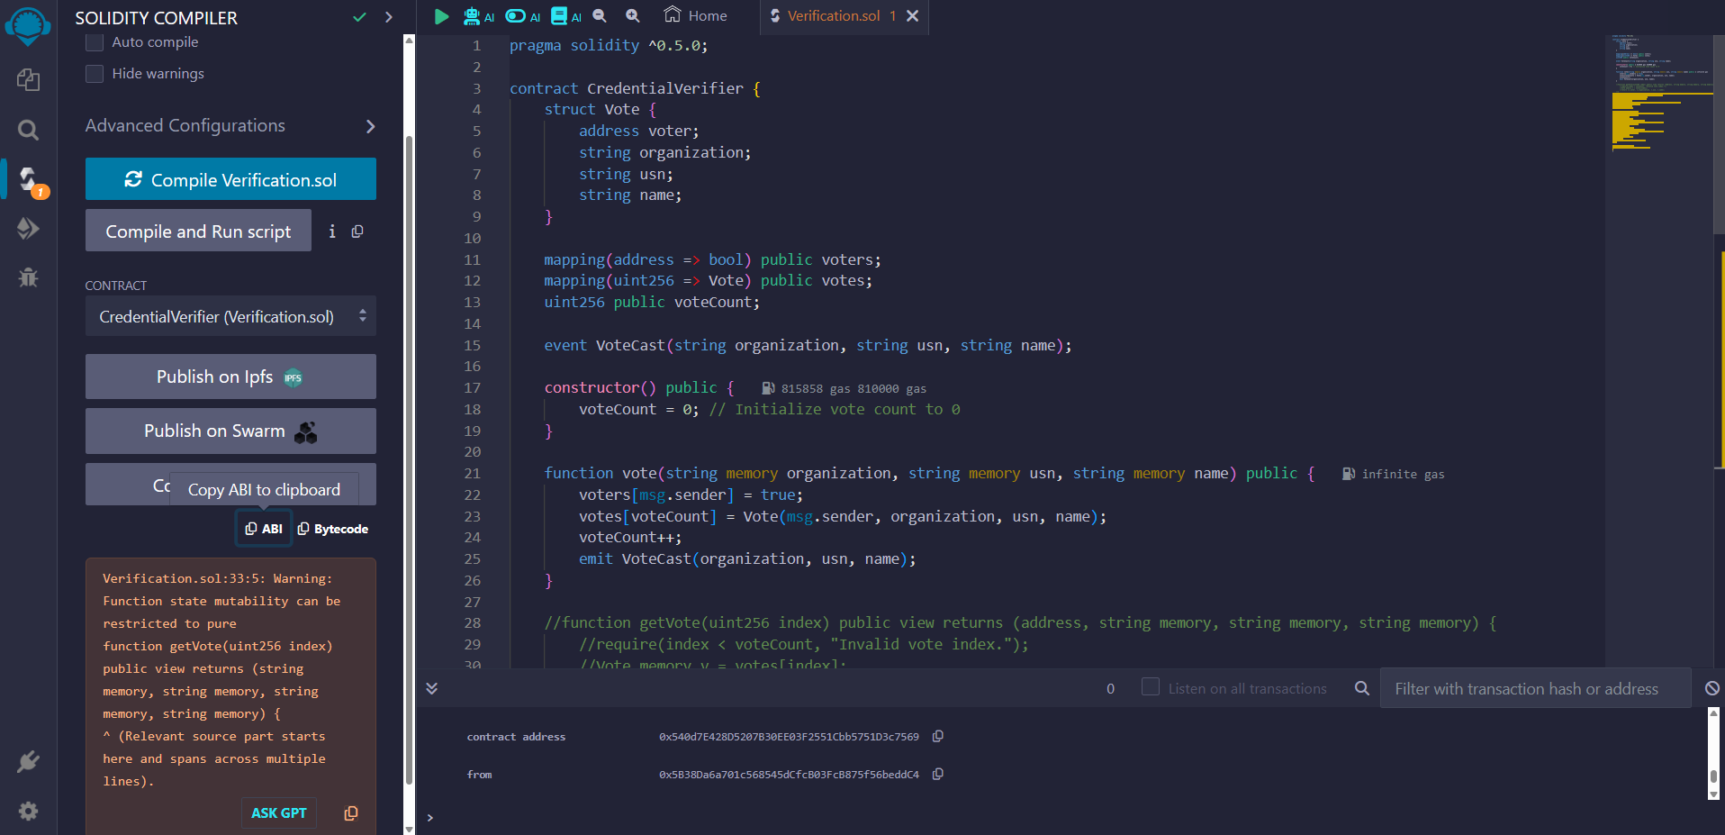

Figure 6.1- Ethereum Remix IDE used the create the smart contract address

* **Application File:**

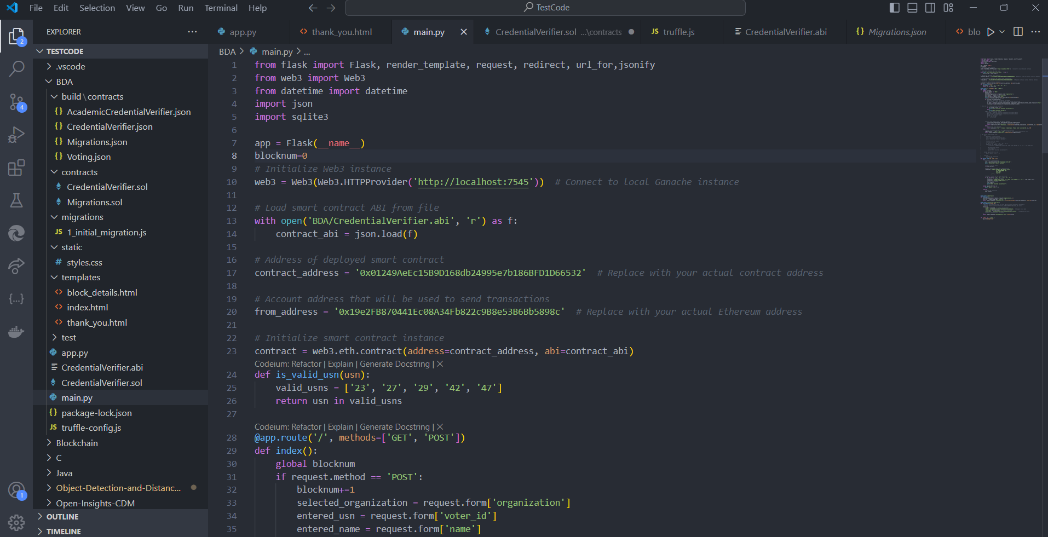

Figure 6.2- Code for main.py

* **Main HTML file:**

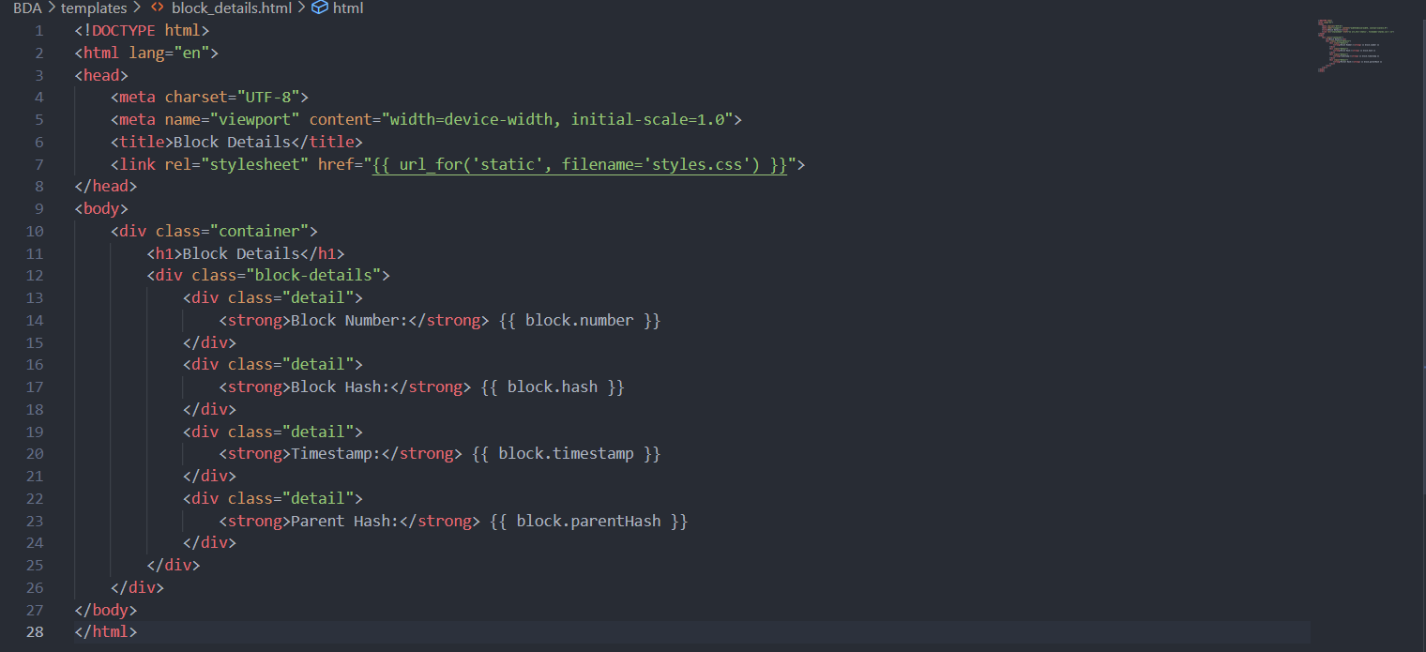

Figure 6.3- Code for index.html

* **Thank you page file:**

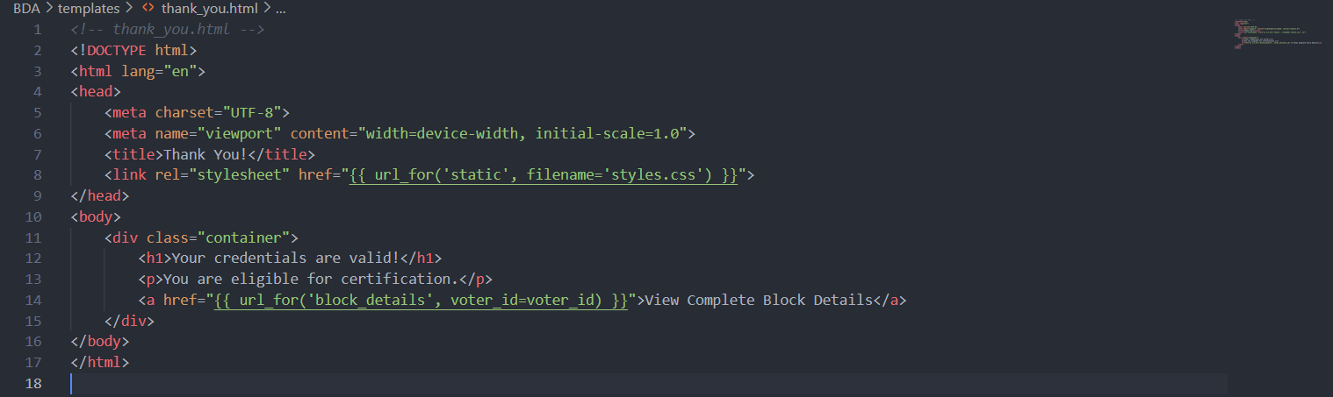

Figure 6.4- Code for thank_you.html

* **Block Details file:**

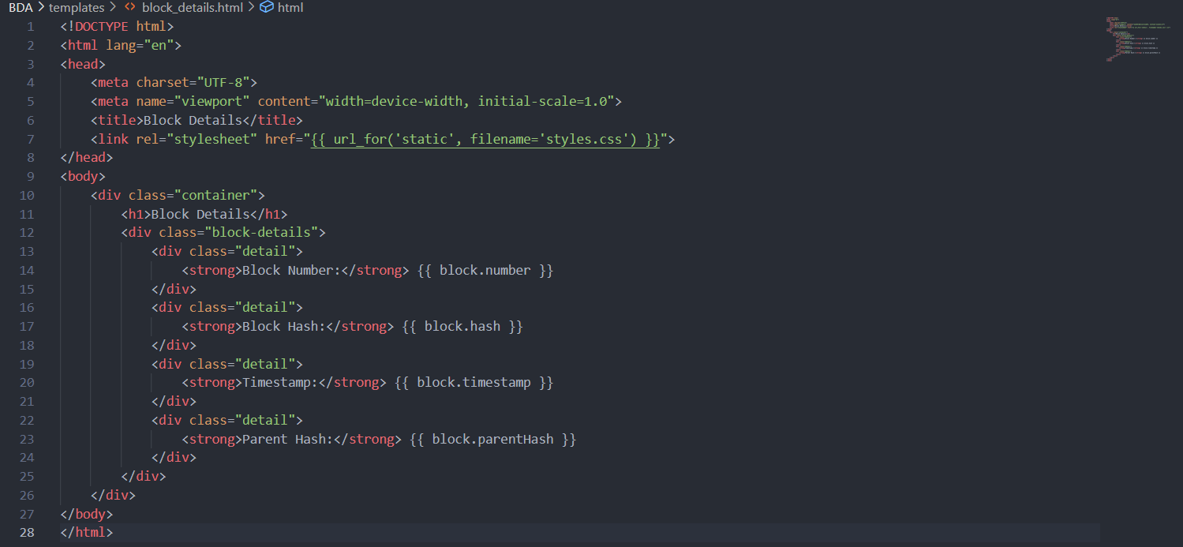

Figure 6.5- Code for block_details.html

* **Solidity File:**

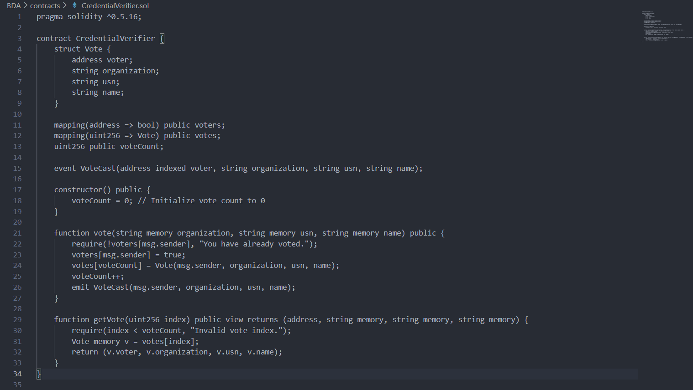

Figure 6.6- Code of CredentialVerifier.sol

* **Migrations File:**

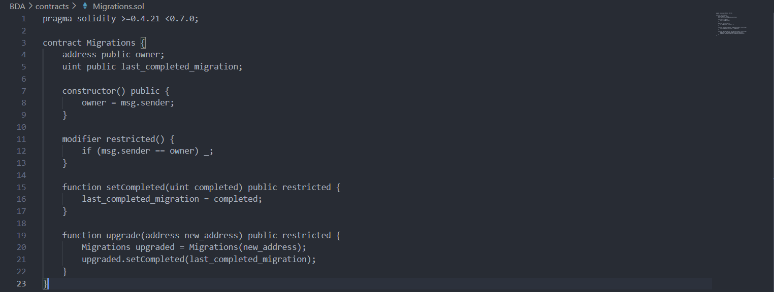

Figure 6.7- Code for Migration.sol

* **Credentials ABI File:**

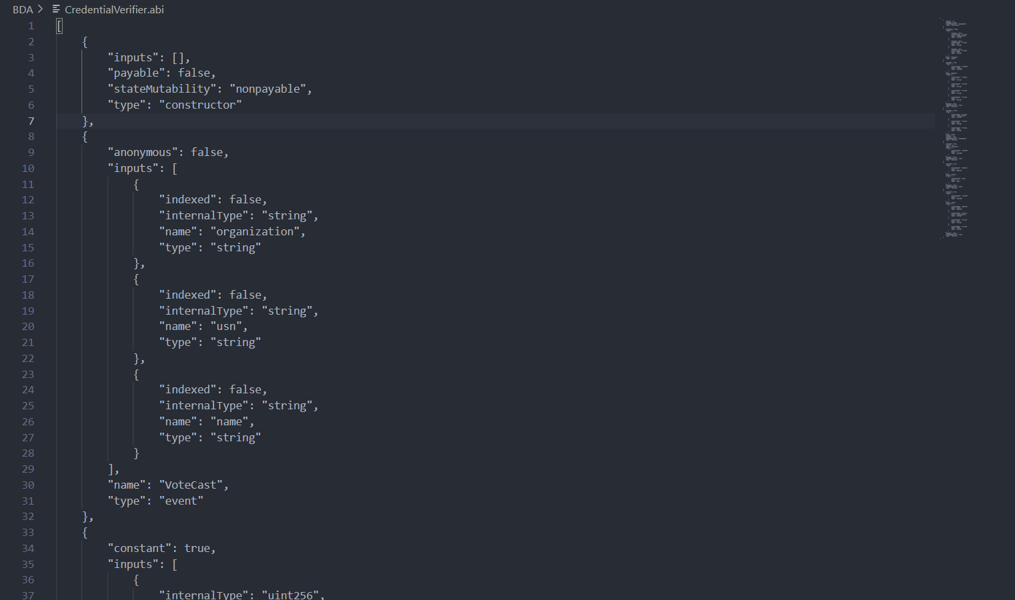

Figure 6.8- Code for CredentialVerifier.abi

**7. Results**

The successful deployment of the Credential Verification System Using Blockchain marks a significant milestone in enhancing democratic processes. Leveraging blockchain technology, the system provides a secure and transparent platform for users to verify their credentials. Each credential is immutably recorded on the blockchain, ensuring the integrity of the verification process and preventing tampering or fraud.

Decentralized governance lies at the heart of the Credential Verification System, empowering users to participate directly in verification processes. By eliminating the need for centralized authorities or intermediaries, the system promotes inclusivity and democratization within the community or organization. This decentralization fosters trust and transparency, essential pillars of a robust democratic system.

The user interface of the Credential Verification System is designed to be intuitive and user-friendly, ensuring a seamless experience for users. Clear instructions and easy navigation facilitate the verification process, enabling broader participation and engagement. Real-time updates on credential details provide stakeholders with immediate insights, empowering them to make informed decisions based on evolving outcomes.

* **Ganache Accounts:**

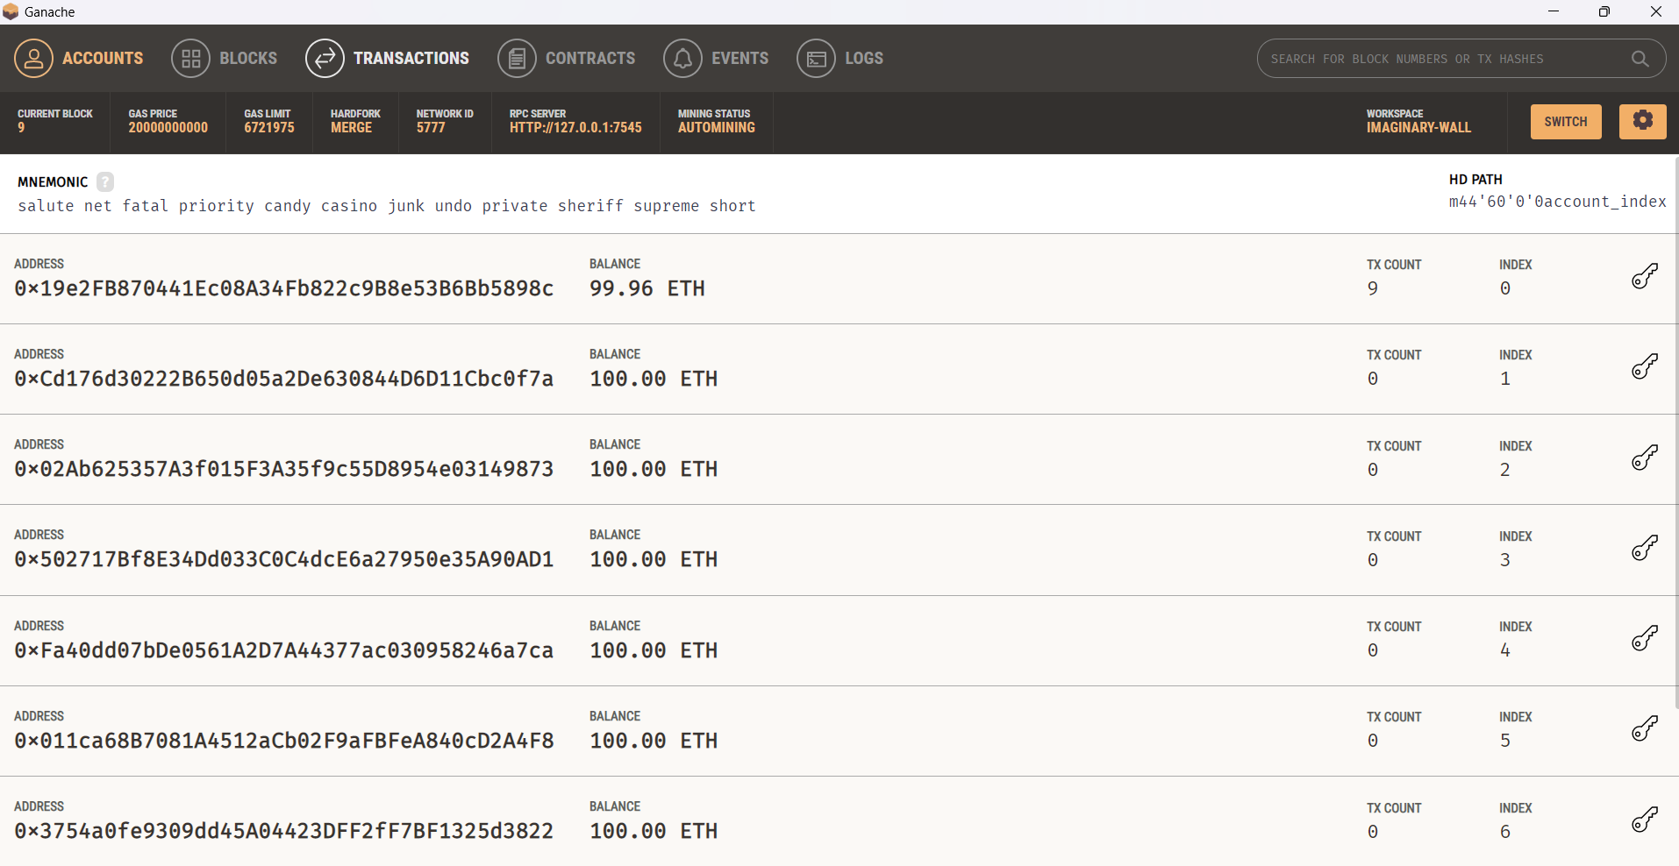

Figure 7.1- Ganache accounts, address used is the first one.

* **Blocks:**

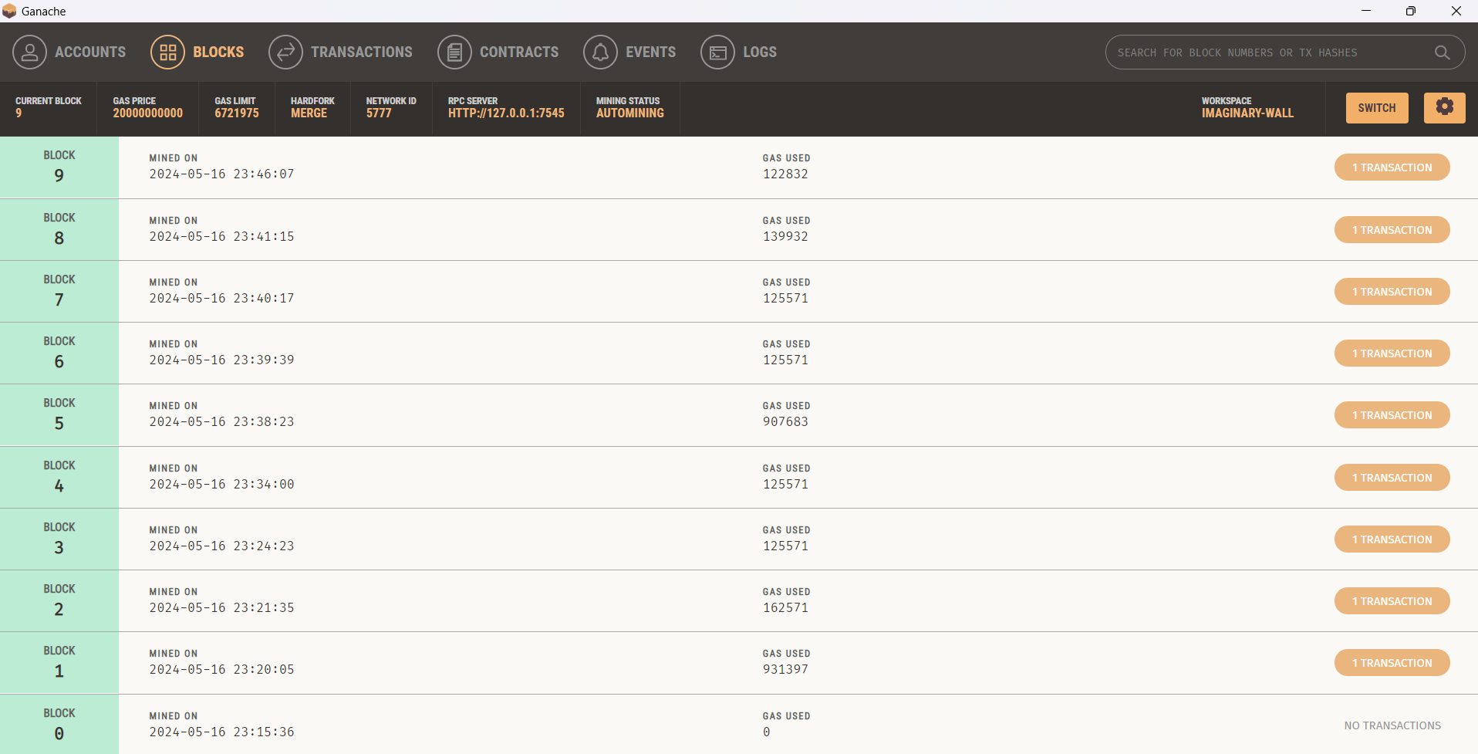

Figure 7.2- Block Details of the credentials entered

* **Transaction details:**

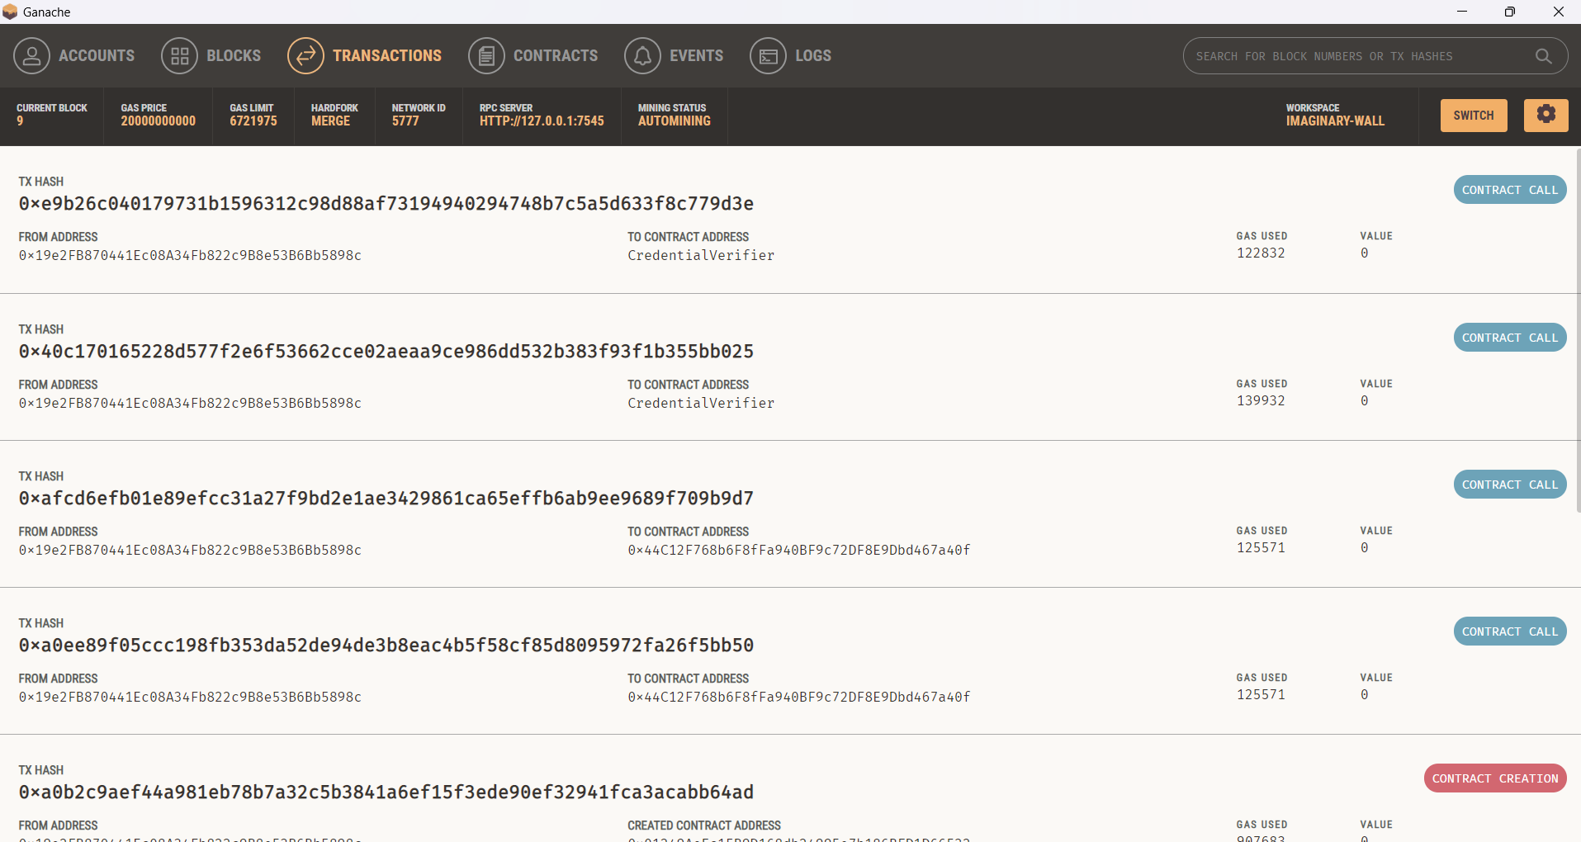

Figure 7.3- Transaction Details of the block created

* **Result Display:**

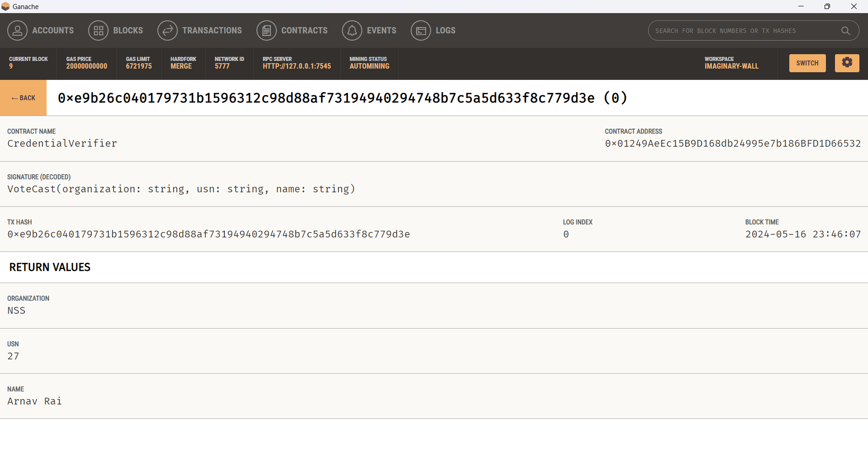

Figure 7.4- Results of values entered

**8. Conclusion**

In conclusion, the development and implementation of a Credential Verification System using blockchain technology represent a significant milestone in the evolution of credentialing systems. Through this project, we have successfully demonstrated the potential of blockchain to revolutionize the way educational credentials are issued, verified, and stored. By leveraging the inherent properties of blockchain, including decentralization, immutability, and transparency, we have addressed critical challenges faced by traditional credentialing systems.

Our project has shown that blockchain technology offers a secure and efficient solution for managing educational credentials, mitigating risks associated with fraud, tampering, and centralized data storage. By cryptographically signing and timestamping digital credentials on the blockchain, we ensure their integrity and authenticity, providing stakeholders with a reliable method for verifying credentials in real-time. Furthermore, the decentralized nature of blockchain eliminates the need for intermediaries, reducing administrative overhead and streamlining the credential verification process.

Moreover, our project has demonstrated the scalability and interoperability of blockchain-based credentialing systems, making it adaptable to various educational contexts and requirements. Whether it's issuing diplomas, certificates, or transcripts, our system can accommodate diverse credential types and support seamless integration with existing educational workflows and systems. Additionally, the transparency and auditability of blockchain ensure accountability and trust among stakeholders, fostering a more reliable and inclusive credentialing ecosystem.

In summary, the Credential Verification System developed in this project represents a paradigm shift in the way educational credentials are managed and verified. By harnessing the power of blockchain technology, we have laid the foundation for a more secure, transparent, and efficient credentialing system that meets the evolving needs of the digital age. As we continue to refine and expand upon this project, we are confident that blockchain-based credentialing systems will play a pivotal role in shaping the future of education and workforce development, unlocking new opportunities for learners, institutions, and employers alike.

**9. References**

1. Shadab Alam, Huda Abdullah, Rafan Abdulhaq, Asmaa Hayawi. (2021). A Blockchain-based framework for secure Educational Credentials. Turkish Journal of Computer and Mathematics Education (TURCOMAT), 12(10), 5157–5167. DOI: [10.17762/turcomat.v12i10.5298](https://turcomat.org/index.php/turkbilmat/article/view/5298).
2. <https://soliditylang.org/>
3. <https://archive.trufflesuite.com/>
4. <https://archive.trufflesuite.com/ganache/>
5. <https://www.sqlite.org/download.html>
6. <https://developer.mozilla.org/en-US/docs/Web/HTML>
7. <https://developer.mozilla.org/en-US/docs/Web/CSS>
8. <https://www.json.org/json-en.html>
9. <https://docs.python.org/3/>
10. <https://code.visualstudio.com/docs>
11. https://ethereum.org/en/developers/docs/