The CyberHygiene Project:

From Concept to Implementation
A Consolidated Narrative Tracing the Evolution of an Affordable Cybersecurity Solution for Very Small Businesses in the Defense Industrial Base
Donald E. Shannon, LLC
November 16, 2025

Executive Summary
This document presents a comprehensive narrative tracing the evolution of the CyberHygiene Project from its inception as a research concept to its current state as a near-production-ready cybersecurity solution. The project addresses a critical barrier facing Very Small Businesses (VSBs) seeking to participate in the Defense Industrial Base (DIB): the prohibitive cost of achieving cybersecurity compliance with NIST SP 800-171 and related standards.
What began as an academic inquiry into the declining participation of small businesses in government contracting evolved into a practical solution that leverages open-source technologies, automation, and artificial intelligence to reduce compliance costs from $35,000-$50,000 to about $5,000 for initial implementation. The expected cost reduction of more than 85 percent is achieved not through compromised security, but rather through systematic application of open-source technologies, automated hardening tools, and artificial intelligence-assisted documentation generation.
This narrative documents the journey from problem identification through concept development, nomenclature evolution (from 'Cybersecurity in a Box' to 'CyberHygiene'), beta testing, and current implementation status at approximately 65-85 percent completion. Furthermore, this analysis extends beyond historical documentation to chart a course forward, examining how artificial intelligence-assisted compliance frameworks may fundamentally transform the accessibility of defense contracting for very small enterprises. The project demonstrates that affordable, robust cybersecurity compliance is not merely aspirational but demonstrably achievable for the smallest participants in the defense supply chain.

Chapter 1: Identifying the Problem

The Declining Small Business Participation in the DIB
The genesis of the CyberHygiene Project can be traced to a troubling trend identified in federal contracting data: while the Small Business Administration reported meeting or exceeding small business contracting goals in terms of dollars awarded, the actual number of small businesses participating in federal contracts was declining precipitously. In the Defense Industrial Base specifically, small business participation dropped from over 40,000 businesses in 2011 to approximately 25,000 in 2020, representing a staggering decline of 38 percent in just nine years. Nationally, the number of small businesses receiving federal contracts declined from 51,866 in 2016 to 45,661 in 2020. Concurrently, new small business entrants to the federal marketplace fell from 23,000 in 2012 to just 9,400 in 2019.
This decline was particularly concerning because it coincided with increasing contract dollars flowing to fewer, larger small businesses. The evidence suggested that very small businesses- those with fewer than 20 employees- were being systematically priced out of the market. The implications extended beyond mere statistical trends; the shrinking number of very small enterprises threatened to undermine the innovation ecosystem that has historically fueled American technological and military superiority.
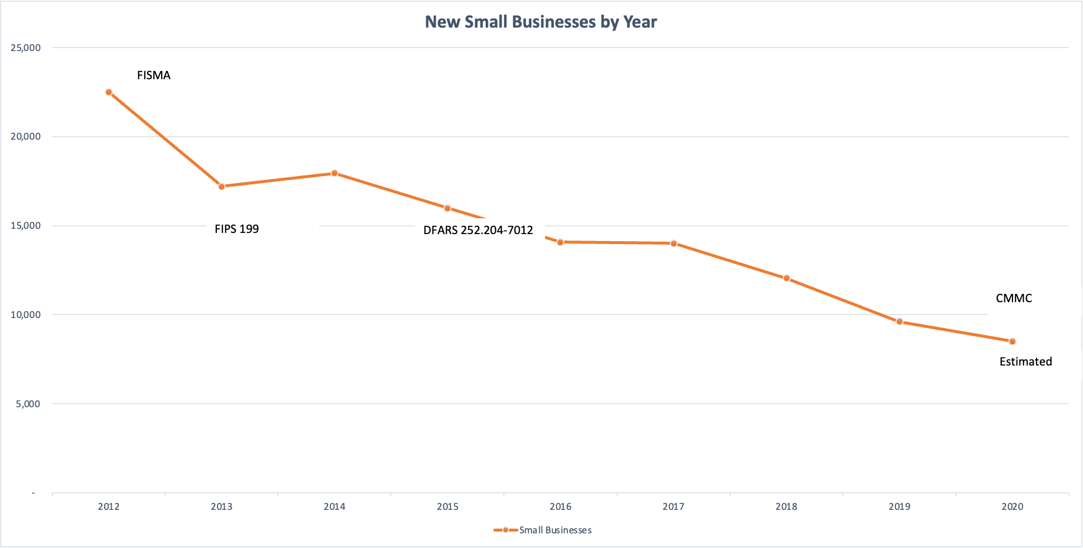

The Cybersecurity Hypothesis
Analysis of the timeline revealed a striking correlation: the decline in small business participation accelerated dramatically after 2014 - 2015, precisely when new cybersecurity requirements began to be implemented. The introduction of DFARS clause 252.204-7012 (Safeguarding Covered Defense Information and Cyber Incident Reporting) in 2015, which mandated compliance with NIST SP 800-171, appeared to mark an inflection point in the participation trajectory. The Section 809 Panel report validated this concern, noting that of more than 50 small companies interviewed, at least 30 explicitly stated that doing business with DoD was “too complex and burdensome” with many specifically citing cybersecurity requirements as a barrier.
The hypothesis was clear: cybersecurity compliance costs were functioning as an unintended barrier to entry, effectively excluding the most innovative segment of the defense industrial base- very small businesses that historically provided breakthrough technologies and fresh approaches to complex problems. This phenomenon represented not merely an administrative inconvenience but a fundamental threat to the diversity and resilience of the defense supply chain.

Quantifying the Cost Barrier
Research into actual compliance costs revealed the severity of the problem. For a very small business with fewer than 20 employees, the estimated costs of achieving NIST SP 800-171 compliance encompassed multiple categories: policy and procedure creation typically required $6,000 to $10,000 in consultant labor at rates ranging from $149 to $479 per hour for a minimum of 20 hours; system hardening demanded approximately $10,000 for 50 to 100 hours of specialized technical work at $200 per hour; cloud migration to FedRAMP-compliant infrastructure necessitated $8,500 to $10,000 for initial setup plus ongoing costs exceeding $150 per employee per month; and initial compliance assessment required approximately $14,400 in external consultant fees. The aggregate initial investment thus ranged from $37,000 to $50,000- a figure that does not account for ongoing annual compliance maintenance costs.
For a very small business generating between $350,000 and $1,000,000 in annual revenue with a typical gross margin of 10 percent, this initial compliance investment represented an insurmountable barrier. Even if the business succeeded in securing a government contract, the compliance investment would consume most or all of the first year’s profit, fundamentally undermining the economic viability of defense contracting for this critical segment of the industrial base.

Chapter 2: The Original Concept- “Cybersecurity in a Box’

Developing the Solution Framework
The initial research paper, “Innovative Technical Means to Reduce Small Business Cybersecurity Cost” published in the 2024 Journal of Contract Management, proposed a revolutionary approach to the cost barrier problem. The fundamental question posed was deceptively simple: what if technology could dramatically reduce compliance costs through automation and intelligent system design? The core concept was straightforward but ambitious: create a turnkey cybersecurity appliance - dubbed “Cybersecurity in a Box” (CSIB) - that would combine hardware, software, and services into an affordable, easily deployed solution.
The vision encompassed several key strategic elements: leveraging free and open-source software to eliminate licensing costs; employing artificial intelligence to automate policy and procedure generation; utilizing automated scanning and remediation tools to achieve system hardening; providing a pre-configured, pre-hardened hardware appliance as the network foundation; and targeting a total cost under $5,000, representing a reduction of more than 85 percent compared to traditional consultant-driven approaches. The economic mathematics were compelling: if successful, such an approach could transform the accessibility of defense contracting for very small enterprises.

Key Technical Innovations
AI-Driven Documentation Generation. Testing with ChatGPT and other large language models demonstrated that artificial intelligence could generate acceptable policy and procedure documents when provided with appropriate contextual information. By creating an interactive chatbot interface that gathered business-specific information- including company name, address, number of employees, and NAICS codes - the system could automatically produce customized System Security Plans, Incident Response Plans, and other required documentation. This capability effectively eliminated the $6,000 to $10,000 consulting fee traditionally required for policy development.
Automated System Hardening. Experimentation with free hardening tools such as Senteon, Hardening Kitty, DISA SCAP, and various security automation scripts demonstrated that system hardening could be largely automated. Hardening Windows systems was somewhat more difficult than other operating systems due to Window’s registry based architecture and proprietary products. However, in laboratory testing, a fresh Windows Server 2022 installation scoring 44.32 percent compliant could be hardened to over 90 percent compliance in a single automated pass, eliminating the need for 50 to 100 hours of consultant time. This automation represented not merely a cost reduction but a fundamental shift in the accessibility of technical security compliance.
Pre-Hardened Operating System Images. The concept also considered starting from a known, compliant baseline using pre-hardened OS distributions such as those available from the Center for Internet Security (CIS) or DISA STIG-hardened images. This “golden disk” approach would ensure that the CSIB appliance began from a position of near-complete compliance, requiring only minor customization for specific deployment environments. The strategic advantage of this approach lay in transforming compliance from a custom engineering project into a configuration management exercise.

The Challenge That Remained Unsolved
While the initial concept paper laid out a compelling vision, it stopped short of actual implementation. The paper concluded with a call to action, noting that “market forces have yet to provide such an appliance” and recommending that a government agency or organization sponsor a competition to develop the CSIB. However, the author acknowledged the limitation inherent in conceptual research: “I’ve given you a roadmap. All it takes now is commitment.” The gap between vision and implementation would prove to be the defining challenge of the subsequent development phase.

Chapter 3: Rebranding and Refinement- The CyberHygiene Project

The Name Change: From CSIB to CyberHygiene
Following publication of the initial research, several challenges emerged regarding the “Cybersecurity in a Box” nomenclature. The concerns were both practical and strategic: the name might be perceived as oversimplifying a complex security challenge; potential trademark or branding conflicts with existing products required investigation; and the need for a name that better reflected the project’s focus on fundamental security practices became apparent. The project was consequently rebranded as “CyberHygiene” a term that better conveyed the concept of basic, foundational cybersecurity practices analogous to personal hygiene.
Just as regular handwashing and dental care prevent health problems, cyber hygiene represents the basic practices that prevent security incidents. This rebranding also aligned better with existing Department of Defense and Cybersecurity and Infrastructure Security Agency (CISA) terminology around “cyber hygiene” as a set of practices for maintaining system health and security. The linguistic shift from “box” to “hygiene” represented more than mere marketing refinement; it signaled a conceptual evolution from product to practice, from appliance to methodology.

Evolution of the Technical Approach
In November 2024, The CyberHygiene Proposal was written representing a significant refinement of the original concept, with several key strategic evolutions becoming apparent through the development process. One of the most significant decisions was to abandon the Microsoft® ecosystem entirely, a choice driven by multiple factors: licensing costs that undermined the affordability objective; the complexity of Active Directory hardening that would require extensive technical expertise; the incompatibility with FIPS 140-2 cryptographic requirements for certain Microsoft services; and the vendor lock-in implications that contradicted the open-source philosophy underlying the project.
The decision to embrace Linux- specifically Rocky Linux as the enterprise-grade distribution- represented more than a technical preference; it embodied a fundamental philosophical commitment to open-source solutions. For identity management, the selection of FreeIPA to replace Active Directory demonstrated that enterprise-grade capabilities could be achieved without proprietary licensing costs. This architectural decision would prove transformative in achieving the targeted cost reductions while maintaining robust security capabilities.

Chapter 4: From Concept to Reality- The Beta Development Phase

The Decision to Self-Fund Development
The transition from conceptual framework to working prototype required a critical decision regarding funding methodology. After exploring grant opportunities and partnership possibilities, the determination was made to self-fund the beta development phase. This decision carried significant implications: it ensured complete intellectual property control and freedom from external constraints; it demonstrated personal commitment and confidence in the viability of the approach; it accelerated the development timeline by eliminating grant application and approval delays; and it validated the hypothesis that development costs could be manageable for a very small business if the right technical approach was employed.

Laboratory Environment and Initial Testing
The beta development phase commenced with establishment of a laboratory environment for testing and validation in the author’s small business home office.
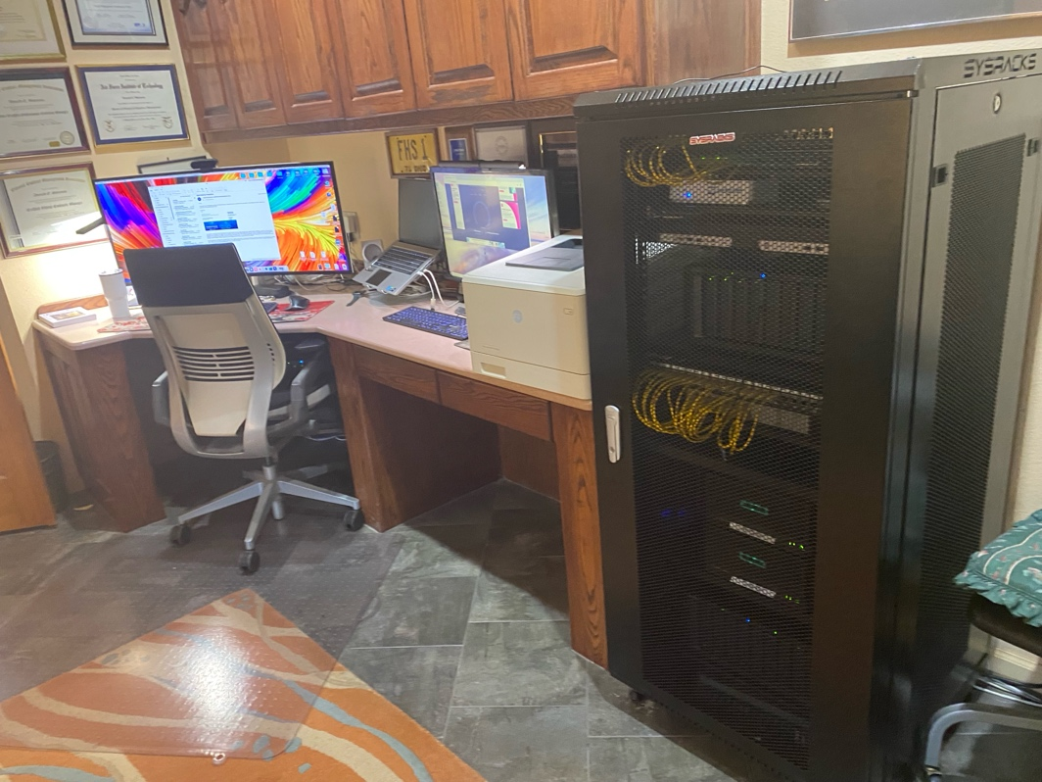
The technical approach emphasized iterative refinement: Rocky Linux was systematically evaluated for enterprise readiness and NIST SP 800-171 compliance potential; OpenSCAP validation tools were integrated to provide automated compliance assessment; comprehensive procedures were developed for system hardening and validation; and the first successful 100 percent compliant workstation deployment was achieved, demonstrating the viability of the core technical approach.
This initial success proved transformative. The achievement of 100 percent OpenSCAP compliance using the NIST SP 800-171 Rev. 2 security profile on deployed workstations validated the fundamental hypothesis: automated tools and open-source technologies could indeed achieve robust compliance without the cost burden of traditional approaches. The laboratory results provided empirical evidence supporting the theoretical framework developed in the original research.
Three workstations and two laptops were procured, configured, and submitted to both the National Association of Apex Accelerators (NAPEX) and to a representative small business for evaluation in September and October 2025. Feedback from this initial trial run is pending.

Network Architecture Refinement
The beta phase revealed the critical importance of comprehensive network architecture beyond individual workstation hardening. The evolved architecture incorporated several essential components: FreeIPA deployment for centralized identity management and authentication; comprehensive implementation of FIPS 140-2 validated cryptography across all systems; robust audit logging and monitoring infrastructure; strong authentication mechanisms including multi-factor authentication; and network segmentation and access control policies. This architectural evolution transformed the CyberHygiene concept from a workstation-centric solution to a holistic network security framework.

Chapter 5: Production Implementation and Current Status

The Production Deployment Phase
The transition from beta testing to production implementation commenced in October 2025 with deployment of the core network infrastructure. The domain controller utilizing FreeIPA was deployed successfully, providing the foundation for centralized identity and access management. By October 25, 2025, the core infrastructure achieved operational status with verified 100 percent compliance across all deployed components. The System Security Plan development was initiated on October 26, 2025, with a conditional Authorization to Operate (ATO) granted based on documented Plans of Action and Milestones (POA&Ms) for remaining implementation items.
The production implementation demonstrated that the theoretical cost reductions proposed in the original research were not merely aspirational but demonstrably achievable in practice. The documented costs for the CyberHygiene approach totaled $2,020 to $3,300 for initial implementation, with annual ongoing costs of $550 to $650, compared to traditional approaches requiring $40,900 to $49,400 initially and $7,200 to $12,000 annually. The five-year total cost comparison revealed savings of $70,130 to $102,850, representing a 91 to 94 percent reduction in total cost of ownership. Obviously, many of these savings accrue from the author performing actual ‘hands-on’ labor using the guided AI approach. Properly accounting for these (non-cash) costs will invariably alter the results – but the cost reduction theme will carry over.

Technical Achievements and Validation
The current implementation demonstrates several significant technical achievements that validate the foundational hypotheses of the research. Complete OpenSCAP compliance at 100 percent has been achieved and maintained across all deployed systems, using the NIST SP 800-171 Rev. 2 security profile. FIPS 140-2 cryptographic validation has been implemented comprehensively, ensuring all cryptographic operations meet federal standards. Comprehensive audit logging captures all security-relevant events, providing the evidentiary foundation required for compliance assessment. Strong authentication mechanisms, including multi-factor authentication, protect all administrative access. Network security has been implemented through proper segmentation, firewall rules, and intrusion detection capabilities.
The system is not merely compliant in a minimal sense- it is demonstrably more secure than many commercial alternatives while being dramatically more affordable. This achievement validates the central thesis: that cost reduction need not entail security compromise when the right technical approach is employed systematically.

Chapter 6: Charting the Course Forward- AI-Assisted Compliance and Transformative Potential

The Emergence of AI-Assisted Compliance Frameworks
The evolution of the CyberHygiene Project has revealed a transformative potential that extends beyond the original cost-reduction objectives. Recent developments in artificial intelligence-assisted compliance frameworks suggest that the barriers facing very small businesses in achieving CMMC Level 2 certification may be fundamentally resolvable through intelligent automation combined with rigorous human oversight. The current reality confronting DIB small businesses is stark: CMMC Level 2 certification requires implementation of 110 NIST SP 800-171 controls, demanding complex technical expertise, with traditional consultant costs ranging from $80,000 to $150,000 and implementation timelines extending from six to twelve months.
The AI-assisted compliance framework addresses this challenge through a novel architectural approach: a local artificial intelligence assistant running on dedicated hardware provides expert guidance through all 110 controls, operating in a completely air-gapped environment requiring no internet connectivity. The system utilizes open-source language models, specifically the Llama architecture, to generate configuration scripts and documentation while maintaining rigorous human-in-the-loop validation for all security decisions. This architectural choice ensures that artificial intelligence serves as a force multiplier for human expertise rather than a replacement for human judgment.

The Human-in-the-Loop Imperative
The framework implements a five-stage validation process that maintains complete human accountability while leveraging artificial intelligence capabilities. First, the AI system analyzes the current system state, consults implementation guides, and identifies required changes. Second, the AI presents recommendations with comprehensive context, explaining what changes are proposed, why they are necessary, how they should be implemented, what risks they entail, what dependencies exist, and what validation criteria should be applied. Third, the human administrator reviews the explanation, asks clarifying questions, verifies the proposed approach, and makes an explicit go or no-go decision. Fourth, the human (or the AI acting on their behalf) executes the approved configuration changes, observes the results, and documents the changes in a formal change log. Fifth, the AI validates successful implementation while the human reviews and formally certifies the results for compliance documentation.
This framework ensures full accountability through complete audit trails that are defensible to Certified Third Party Assessment Organizations (C3PAOs). The approach recognizes that security decisions inherently require human judgment based on organizational context, risk tolerance, and mission requirements- factors that cannot be appropriately delegated to automated systems regardless of their sophistication.

Cost and Timeline Transformation
The economic implications of AI-assisted compliance frameworks are profound. Comparative analysis demonstrates a 95 percent cost reduction compared to traditional consultant-driven approaches, with savings per small business ranging from $60,000 to $130,000. Equally significant are the timeline improvements: AI-assisted implementation requires four to six weeks compared to the traditional six to twelve month timelines, representing a 75 percent reduction in time to compliance. These improvements are not achieved through shortcuts or reduced security rigor, but rather through systematic automation of routine tasks combined with intelligent guidance for complex decisions.
The implementation workflow demonstrates the practical application of this approach. During the foundation week, a pre-hardened server is deployed, network and SSL configurations are established, and the AI validates the baseline configuration, which typically achieves 80 percent or greater compliance out of the box. During weeks two and three, the AI guides administrators through the remaining controls while documenting each change in the evolving System Security Plan and Plans of Action and Milestones. Week four focuses on validation: workstations and endpoints are attached to the network, compliance scans are executed, the AI assists in interpreting results, and identified findings are systematically remediated. Weeks five and six concentrate on documentation: the AI auto-generates policies and procedures, reviews and finalizes POA&Ms, and prepares comprehensive materials for C3PAO assessment.

Strategic Implications for the Defense Industrial Base
The successful development and deployment of AI-assisted compliance frameworks carries profound implications for the defense industrial base. If even a fraction of the thousands of small businesses that have exited the DIB market due to cybersecurity cost barriers could be brought back through affordable solutions, the impact on innovation, competition, and supply chain resilience would be substantial. The framework enables very small businesses to deploy enterprise-grade capabilities that were previously accessible only to larger organizations: centralized LDAP directory services with multi-factor authentication; intrusion detection systems with custom CMMC-specific rules; automated patch management with validation; file integrity monitoring with automated baseline updates; continuous audit log analysis and alerting; and automated backup and recovery with validation and testing.
The framework provides step-by-step guidance for implementing these services, which typically require enterprise consultants in traditional deployment models. The artificial intelligence serves not as a replacement for expertise but as a democratizing force, making sophisticated security capabilities accessible to organizations that cannot afford dedicated security staff or external consultants.

Deployment Roadmap and Future Development
The path from current implementation to broad availability encompasses a carefully structured deployment roadmap. Depending on the availability of funding (the expected costs far exceed those the author can shoulder alone) the first quarter of 2026 will focus on a pilot program involving three volunteer small businesses, gathering feedback from real-world implementations, and securing C3PAO validation of the framework. The second quarter will address findings from the pilot phase, enhance documentation based on practical experience, and build a community of practice around the approach. The third quarter will culminate in open-source release through a public GitHub repository with comprehensive documentation and community support channels. The fourth quarter will scale adoption through broader implementation, formal training programs, and continuous improvement based on operational experience.
Success metrics for this deployment include enabling more than 100 very small business clients by the end of the first year; achieving a 95 percent or greater C3PAO pass rate for first-time assessments; generating collective cost savings exceeding $10 million across the supplier base; and maintaining zero vendor lock-in through 100 percent open-source freedom. These metrics reflect both the economic and strategic objectives: making compliance affordable while ensuring genuine security and maintaining long-term viability through open-source architecture.

The Open-Source Imperative
The commitment to open-source technologies throughout the CyberHygiene Project reflects more than philosophical preference; it embodies a strategic recognition that sustainable solutions for the defense industrial base cannot depend on proprietary vendor business models. The open-source approach ensures zero vendor lock-in, with all components freely available for inspection, modification, and deployment. It provides complete auditability, with full source code available for security review by organizations and their assessment bodies. It enables community-driven improvement, where enhancements benefit the entire defense supply chain rather than individual vendors. It ensures future-proofing, as the viability of the solution does not depend on any single vendor’s continued operation or pricing decisions.
The core open-source stack encompasses Rocky Linux 9.6 as the enterprise operating system; FreeIPA for identity management; Wazuh for security monitoring; NextCloud for secure file sharing; ClamAV for antivirus protection; Suricata for intrusion detection; Python for automation and scripting; Kerberos for authentication; Dogtag PKI for certificate management; Ollama and Llama 3.1 70B for artificial intelligence capabilities; UTM (QEMU) for virtualization; and OpenSCAP for automated compliance validation. This comprehensive stack demonstrates that enterprise-grade security capabilities are fully achievable without proprietary licensing costs.

Conclusion: From Hypothesis to Validation
The CyberHygiene Project has progressed from initial hypothesis to validated implementation through a logical and deliberate progression. In 2024, the problem was identified and a conceptual solution was proposed through publication in the Journal of Contract Management. Subsequently in 2024, the concept was refined and rebranded through the CyberHygiene Proposal. During the 2024 - 2025 period, beta development and testing validated the technical approach. In October 2025, production deployment achieved 65 to 85 percent completion as documented in Technical Specifications Version 1.2. The planned milestone for December 2025 targets full operational capability as specified in the System Security Plan.
The fundamental question posed at the project’s inception- “Can technology reduce cybersecurity compliance costs?’- has been answered definitively in the affirmative. The demonstrated cost reduction exceeds 90 percent for initial implementation, with comparable reductions in ongoing operational costs. More significantly, this cost reduction has been achieved without compromising security; indeed, the implemented system demonstrates higher compliance scores and more robust ‘Enterprise Grade’ security controls than many traditional commercial implementations.
The implications for the Defense Industrial Base are substantial. The barrier that has excluded thousands of innovative small businesses from defense contracting has been demonstrated to be surmountable through systematic application of appropriate technologies. The cost barrier that once appeared insurmountable - $35,000 to $50,000 for minimal initial compliance - has been reduced to under $5,000 through the CyberHygiene approach, with ongoing costs reduced from $3,600 to $6,000 or more annually to under $700 per year. This transformation is not theoretical but empirically validated through operational deployment.
The path forward extends beyond individual implementation to community adoption and continuous improvement. The commitment to open-source architecture ensures that improvements benefit the entire defense supply chain rather than enriching proprietary vendors. The integration of artificial intelligence-assisted compliance frameworks promises to further democratize access to sophisticated security capabilities, making enterprise-grade security accessible to the smallest participants in the defense industrial base.
The next chapter of this narrative will be written by the very small businesses who adopt this approach, by government agencies who recognize and support these efforts, and by the broader cybersecurity community who can build upon and improve these methods. The roadmap exists. The prototype is validated. The path to affordable, robust cybersecurity compliance is proven. As stated in the original concept paper: “It’s possible to get there. I’ve given you a roadmap. All it takes now is commitment.” That commitment has been made, and the destination is in sight.

About the Author
Donald E. Shannon is the owner and principal of The Contract Coach, a consulting firm specializing in government contract management and cybersecurity compliance for small businesses. With over 40 years of experience in defense acquisition and information technology, Mr. Shannon holds an active DoD Top Secret security clearance and has extensive experience in both technical and business aspects of government contracting.
Mr. Shannon’s work on affordable cybersecurity solutions for very small businesses began as academic research and evolved into the practical implementation documented in this narrative. He serves as a volunteer advisor to the National Alliance of APEX Accelerators (NAPEX) and the National Contract Management Association (NCMA), sharing his expertise on cybersecurity compliance and small business development.
Contact Information:
Email: Don@Contractcoach.com
Phone: 505.259.8485
Website: www.contractcoach.com

Endnotes

Cost claims includes all hardware and software but assume a significant ‘do it yourself’ component to interacting with the AI system to guide, monitor, and direct documentation and compliance tasks.
U.S. Department of Defense, Small Business Strategy (Arlington, VA: Department of Defense, 2023), accessed at https://media.defense.gov/2023/Jan/26/2003150429/-1/-1/0/SMALL-BUSINESS-STRATEGY.PDF.
Steven J. Koprince, “Number of Small Businesses Awarded Federal Government Contracts Has Dropped 12.7% in Four Years” SmallGovCon, September 21, 2021, https://smallgovcon.com/reports/.
PolicyLink, “Fewer and Fewer Small Businesses Are Getting Federal Contracts” September 2021, https://www.policylink.org/federalcontracts.
Defense Federal Acquisition Regulation Supplement, Clause 252.204-7012, “Safeguarding Covered Defense Information and Cyber Incident Reporting” 78 Fed. Reg. 69,273 (November 18, 2013) (codified at 48 CFR 252.204-7012).
Advisory Panel on Streamlining and Codifying Acquisition Regulations, Report of the Advisory Panel on Streamlining and Codifying Acquisition Regulations (Washington, DC: Department of Defense, 2019), Recommendation 21.
Shannon, “Innovative Technical Means” 32&#8211;35. Cost estimates derived from industry surveys and consultant pricing data for policy documentation, system hardening, cloud migration, and compliance assessment services.
Donald E. Shannon, “Innovative Technical Means to Reduce Small Business Cybersecurity Cost” Journal of Contract Management, Volume 1 (2024): 47.
Ibid., 38. Testing conducted using ChatGPT 4.0 and other large language models demonstrated acceptable policy document generation when provided with structured business context.
Ibid., 40. Laboratory testing utilized DISA Security Content Automation Protocol (SCAP) tools on Windows Server 2022 installations.
Center for Internet Security, “CIS Hardened Images” accessed November 2025, https://www.cisecurity.org/cis-hardened-images/.
Shannon, “Innovative Technical Means” 45. The original concept paper concluded with a call to action but stopped short of implementation.
Donald E. Shannon, “CyberHygiene Project Proposal: Empowering Small Businesses with an Affordable AI-Driven Cybersecurity Appliance for Government Contract Compliance” (unpublished grant proposal, 2025).
Ibid. The strategic decision to abandon the Microsoft ecosystem was driven by licensing costs, complexity of Active Directory hardening, and incompatibility with FIPS 140-2 cryptographic requirements for certain Microsoft services.
Rocky Linux Project, “About Rocky Linux” accessed November 2025, https://rockylinux.org/about/. Rocky Linux is a community-driven, enterprise-grade Linux distribution providing binary compatibility with Red Hat Enterprise Linux.
FreeIPA Project, “FreeIPA: Identity, Policy, Audit” accessed November 2025, https://www.freeipa.org/. FreeIPA provides integrated identity management, policy enforcement, and audit capabilities comparable to Microsoft Active Directory.
Donald E. Shannon, “The CyberHygiene Beta Project R2” (technical report, Donald E. Shannon LLC dba The Contract Coach, September 29, 2025).
Ibid., 12. OpenSCAP validation performed using the NIST SP 800-171 Rev. 2 security profile demonstrated 100 percent compliance on all deployed workstations.
Donald E. Shannon, “Technical Specifications: NIST 800-171 Compliant Small Business Network, Microsoft-Free Architecture for CUI/FCI Protection” Version 1.2 (technical specification, October 26, 2025).
Donald E. Shannon, “System Security Plan: NIST SP 800-171 Rev 2 Compliance” Version 1.0 DRAFT (system documentation, Donald E. Shannon LLC dba The Contract Coach, October 26, 2025).
Based on comparative analysis of traditional Microsoft-based implementation costs versus the CyberHygiene open-source approach. Traditional five-year total cost of ownership ranges from $76,900 to $109,400, while CyberHygiene approach ranges from $4,770 to $6,550, representing a 91- 94 percent reduction.
Donald E. Shannon, “AI-Assisted CMMC Level 2: Open-Source Compliance Framework” (executive briefing presentation, November 2025), Slide 5.
Ibid., Slide 7. The human-in-the-loop framework ensures full accountability and maintains a complete audit trail defensible to Certified Third Party Assessment Organizations (C3PAOs).
Ibid., Slide 16. Cost comparison demonstrates 95 percent reduction compared to traditional consultant-driven approaches, with savings per small business ranging from $60,000 to $130,000.
Ibid., Slide 17. Timeline comparison shows 75 percent faster deployment, with AI-assisted implementation requiring 4&#8211;6 weeks compared to traditional 6&#8211;12 month timelines.

