CLOSETCUE
Smart Wardrobe and Wear Log

WEB TECHNOLOGY PROJECT REPORT, V SEM. B.Tech
FLEXICORE-3131

SUBMITTED TO
SCHOOL OF COMPUTER ENGINEERING, M.I.T., MANIPAL


By
Muhir Kapoor (Reg. No. 240953576)
B.Tech in Computer and Communication
Aanya Verma (Reg. No. 240911400)
B.Tech in Information Technology

Under the guidance of: Ms Swathi B.P
November 2026



Team Details and Work Split
Sl. | Name | Reg. No. | Modules / Pages designed (2 per student) | Signature
1 | Muhir Kapoor | 240953576 | 1. Home Dashboard  2. Add Garment
2 | Aanya Verma | 240911400 | 1. My Closet  2. Item Details
Muhir Kapoor: B.Tech in Computer and Communication. Aanya Verma: B.Tech in Information Technology. All four modules use the shared visual design, API helpers and relational data model.

1. Project Overview
ClosetCue is a personal wardrobe website that helps users find, combine and reuse clothes they already own. It presents photographs, garment attributes and shelf locations in a catalogue, records each wear, and recommends complementary pieces through explicit category, occasion and colour rules. The completed project has four pages and six API endpoints, with a PHP/MySQL implementation and an independent Python/SQLite demonstration server.
1.1 Purpose of the Website
A physical wardrobe can be difficult to search without disturbing folded clothes. ClosetCue connects a visual record to the exact shelf location so that a chosen item can be retrieved directly. Wear counts and last-worn dates make frequently used and overlooked pieces visible, while outfit suggestions help users select combinations from their existing collection.
1.2 Objectives
The website supports garment uploads with photographs; filtering by occasion, category, fabric and colour family; sorting by recency or wear; shelf-location lookup; persistent wear logging; explainable outfit matching; dashboard summaries; and confirmed deletion with wear-history cleanup.
1.3 Target Users
The target users are students and other people managing a personal wardrobe on a phone or computer. Keyboard users, people using screen readers and people who cannot distinguish some colours are considered through labelled controls, visible focus, descriptive image alternatives and written matching explanations. A captioned guide and transcript provide another way to understand the workflow. [5]
1.4 Site Map
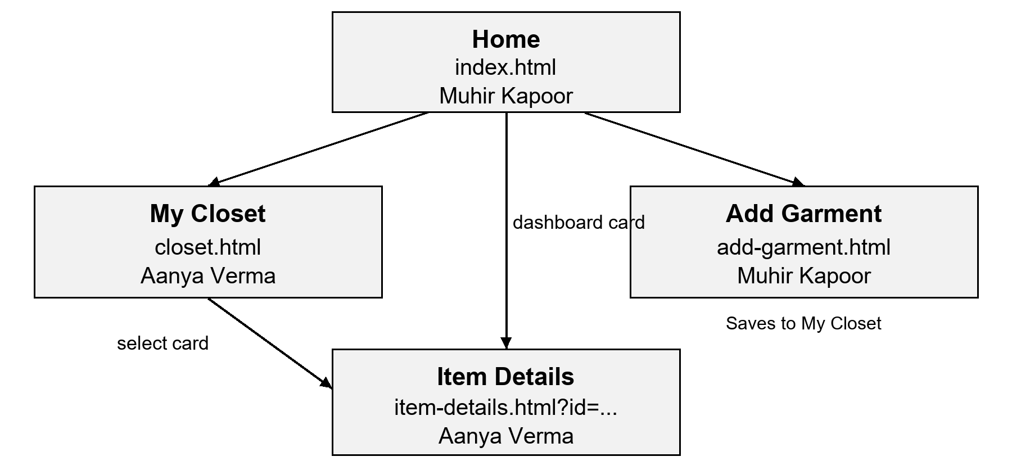
Figure 1. Page links and the two modules assigned to each student.
The shared navigation links Home, My Closet and Add Garment from every page. Garment cards open Item Details with an item ID; recommendation cards open another item. A successful upload or deletion returns the user to My Closet.
1.5 Tools and Technologies
Item | Details
HTML version | HTML5 semantic landmarks, native forms, dialog and video.
CSS framework and version | Bootstrap 5.3.0 CSS with custom responsive grid and retro styling. [2]
JavaScript | Vanilla JavaScript; Fetch API, FormData, URLSearchParams and DOM updates. [1]
Data source | PHP JSON endpoints; MySQL relational data and uploaded image files. Python/SQLite provides an independent local demo.
IDE and environment | Windows development workspace; Apache 2.4.69, PHP 8.3.36 and MySQL 8.4.13 exercised in Docker; Chrome browser.
Accessibility guidelines | WCAG 2.1 A/AA used as a design and automated-testing reference. [5]
Testing tools | Playwright, axe-core, Node assertions, PHP syntax checks and database integration tests. [6]
1.6 Common Design Followed by the Team
All pages share a header, navigation, main content landmark and footer. A skip link moves keyboard focus to the main region. The active navigation link identifies the current section. Product cards, feedback messages, buttons and form fields use the same styles, and the common card renderer escapes user-supplied text before inserting it into HTML.
The visual theme uses gray window surfaces, navy title bars, raised borders, purple controls, a yellow dashboard panel and a teal history section. Host Grotesk is used for display text, IBM Plex Sans for interface text and IBM Plex Mono for labels. Font files, Bootstrap CSS, photographs and the instructional video are stored locally. Layouts adapt to narrow screens without replacing essential controls with colour-only indicators.
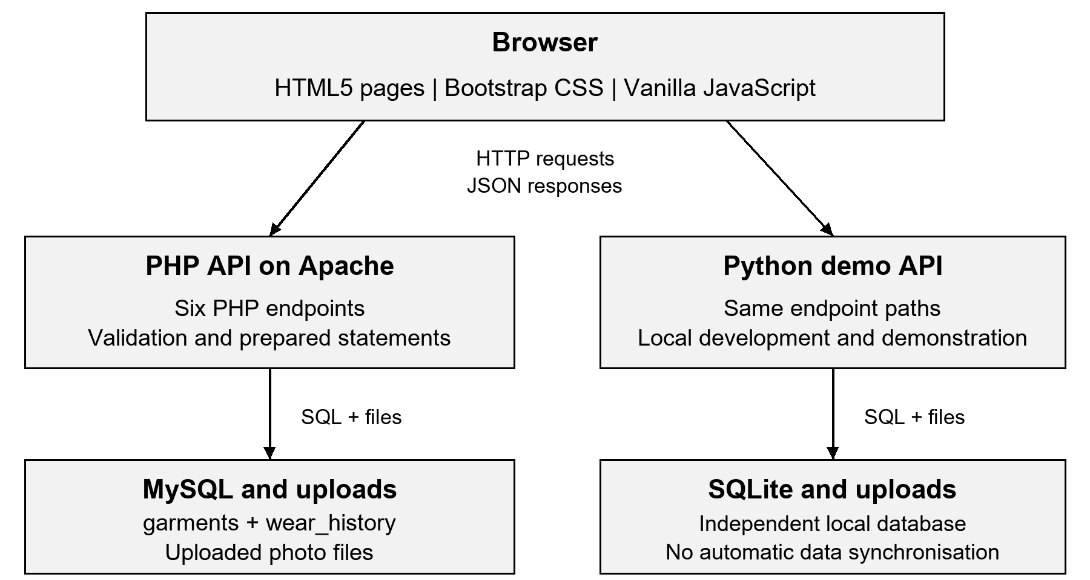
Figure 2. Browser communication and the two independent backend modes.
JavaScript sends GET query parameters or POST form data and reads JSON responses. The PHP implementation performs validation, database queries and file operations. Prepared statements bind user values separately from SQL. The Python server exposes the same route names for demonstration, but its SQLite database is not synchronised with MySQL. [1, 3]
The common API helper checks both the HTTP status and the JSON status. Connection failures display an error instead of simulating a successful write. Loading and empty states are distinct, API responses use no-store caching, and wear dates use Asia/Kolkata in both backends.

2. Student 1: Muhir Kapoor
Registration number: 240953576
Program: B.Tech in Computer and Communication
Modules / Pages: Home Dashboard (index.html) and Add Garment (add-garment.html).
2.1 Module Description

Home Dashboard
The dashboard gives an overview of wardrobe use. It displays the total garments, total wear entries, unworn garments and percentage of items used at least once. Most Loved shows up to four garments with the highest wear counts, while Recently Worn shows up to four items ordered by their latest worn date. Selecting a card opens Item Details. A 28-second instructional video has captions and an expandable text transcript.

Add Garment
The form collects a garment name, category, colour family, colour name, fabric, occasion, shelf location and photo. It previews the chosen file before submission and presents required-field errors in a focused feedback area. It accepts JPG, PNG and WebP files no larger than 5 MB. After the server saves the record and photo, the page redirects to My Closet.
Both pages combine semantic HTML with the shared navigation, responsive containers, cards, labelled form controls and custom feedback panels. The design uses Bootstrap CSS as a base and project-specific styles for the visible window frames and layout. [2]
2.2 Design of the Module
Action and input | Processing and output
Load dashboard  GET analytics and closet data | SQL counts wear rows and finds latest dates. JSON arrays populate cards; the closet list supplies totals and unworn counts.
Select photo  Browser File object | Client validation checks the declared type and byte size. An object URL displays a preview without writing to the database.
Submit garment  Multipart FormData | PHP validates text and image content, stores the file and inserts a row with generated alt text. JSON success leads to My Closet; errors remain on the form.
2.2 Design of the Module continued

Relational Data Model
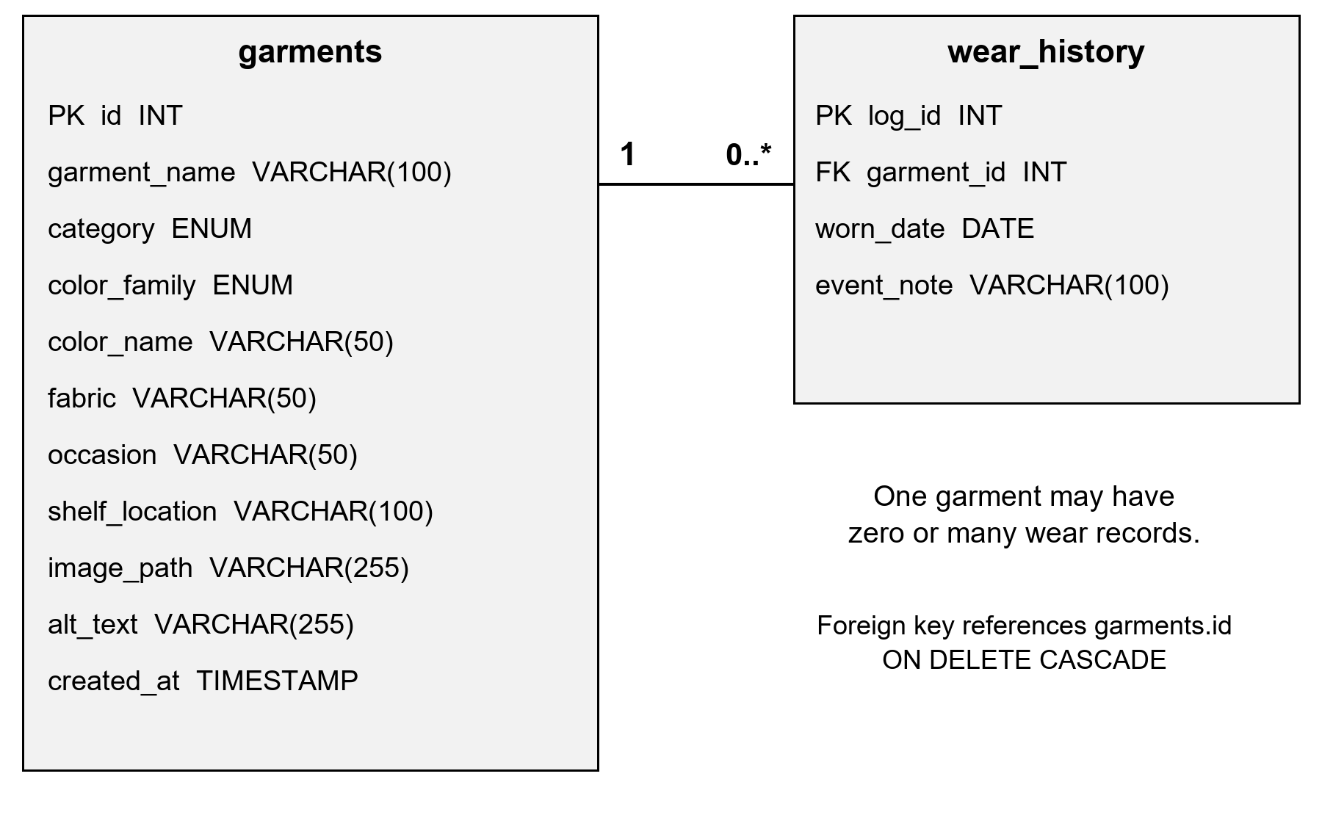
Figure 3. The garments and wear_history tables with their one-to-many relationship.
Each garment stores its descriptive attributes, shelf location and image path. Individual wear events are separate rows so that a garment can be worn repeatedly without duplicating its metadata. COUNT and MAX derive the wear total and most recent date. The MySQL foreign key references garments.id and cascades deletions; the API also removes dependent wear rows explicitly inside its deletion transaction. [4]

Upload Validation and Storage
Client-side validation provides immediate feedback, while PHP repeats validation independently. Garment names and shelf locations allow up to 100 Unicode characters; colour names, fabrics and occasions allow 50. Category and colour family use allowed-value lists. PHP checks the actual MIME type and image dimensions rather than trusting the submitted extension, and enforces the 5 MB limit.
Uploaded names use random bytes and a MIME-derived extension. Generated image descriptions are limited to the database field length. If the database insert fails after the file has moved, the file is removed. PHP deployment settings allow a 5 MB upload and a 6 MB total POST body so the documented limit can be used in practice.
2.3 Development of the Module
The following excerpts come from the implemented source; indentation is adjusted for the report. The first query groups wear records by garment and returns only items that have been worn.

Dashboard aggregation in php/get_analytics.php
SELECT g.*, COUNT(w.log_id) AS total_wears,
MAX(w.worn_date) AS last_worn
FROM garments g
JOIN wear_history w ON g.id = w.garment_id
GROUP BY g.id
ORDER BY total_wears DESC, g.id DESC
LIMIT 4
A separate query orders by last_worn for Recently Worn. The secondary ID ordering makes equal counts or dates deterministic. The frontend loads analytics and the closet list independently, allowing it to report a failed request without inventing data.

Asynchronous dashboard requests in js/analytics.js
const outcomes = await Promise.allSettled([
api('php/get_analytics.php'),
api('php/filter_closet.php')
]);
const [analytics, closet] = outcomes;

Image verification in php/upload_garment.php
$mime = (new finfo(FILEINFO_MIME_TYPE))
->file($file['tmp_name']);
$dimensions = @getimagesize($file['tmp_name']);
if (!isset($extensions[$mime]) || !$dimensions
|| ($dimensions['mime'] ?? '') !== $mime) {
api_error(400,
'Uploaded photo must be a valid JPG, PNG, or WebP image.');
}
The browser sends the file and metadata as multipart FormData. The server responds with status, message, garment_id and redirect fields. The shared Fetch helper turns unsuccessful HTTP or JSON statuses into form feedback. MySQL values are passed through prepared statements. [1, 3]
2.4 Results

Home Dashboard
Figure 4 shows the working dashboard with the seeded demonstration wardrobe. The 10 garments have 18 wear events; three garments have never been worn, so seven of ten garments are in rotation.
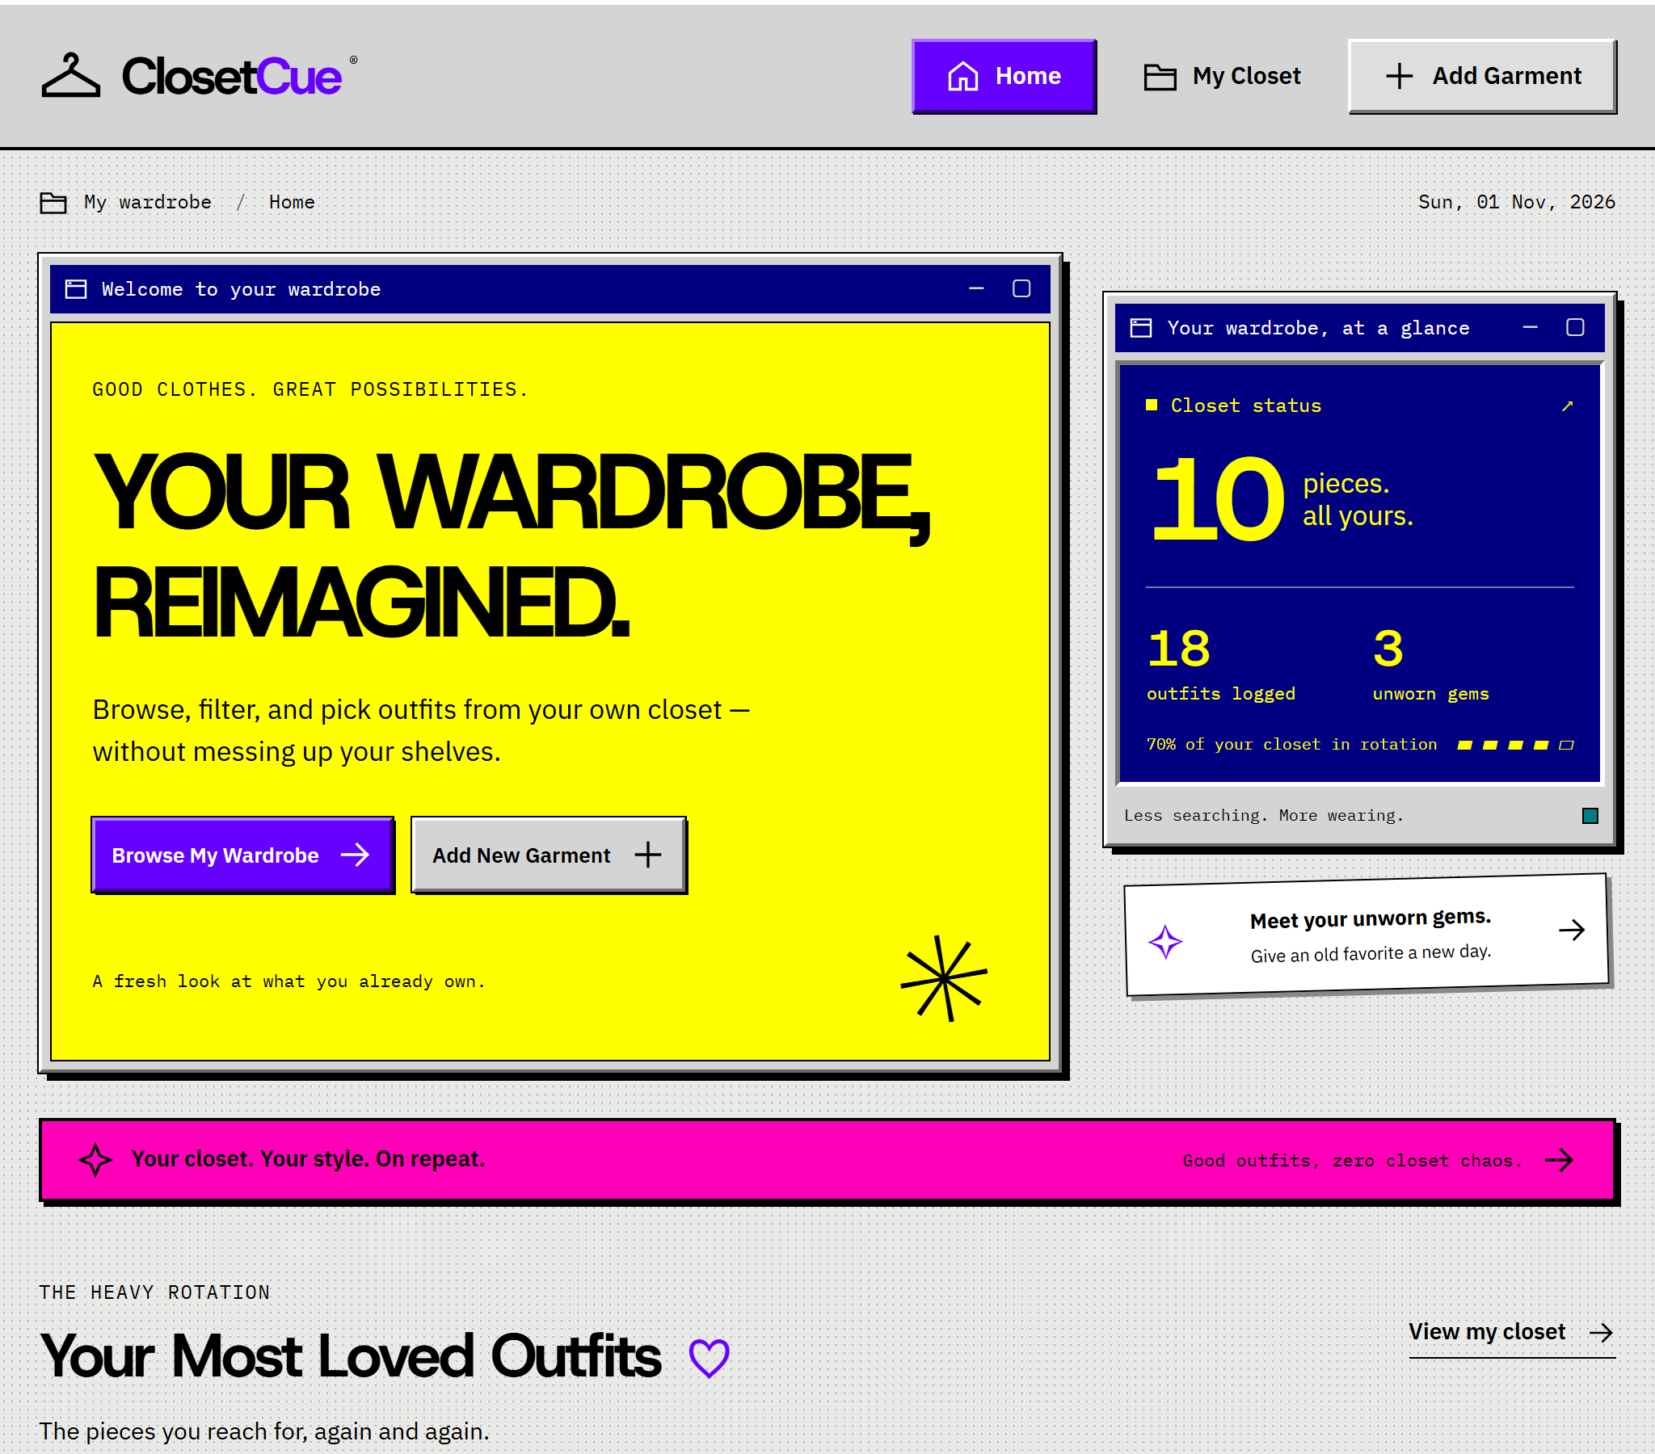
Figure 4. Home Dashboard with live totals and navigation to the wardrobe.
The browser tests verified dashboard totals after an upload, navigation from cards, the caption track, the 28-second media duration and the transcript control. The same frontend flows passed against both PHP/MySQL and Python/SQLite.
Screenshots in this report were captured from the local Python/SQLite demonstration using a disposable copy of the seeded wardrobe. PHP/MySQL behavior is documented separately in the runtime test results. The application was not modified to create the screenshots.
2.4 Results continued

Add Garment
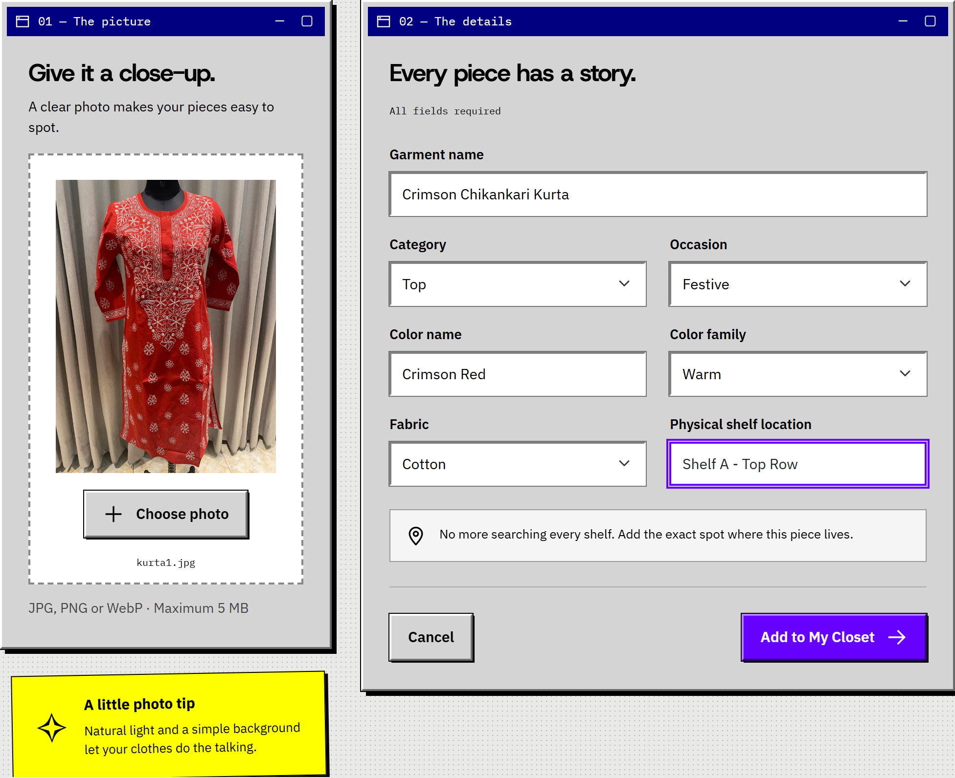
Figure 5. Completed Add Garment form with a real photo preview before submission.
The preview is generated locally as soon as a valid image is selected. The illustrated form was not submitted during screenshot capture. Automated tests separately uploaded real files, verified the saved record and served photo, and confirmed the redirect to My Closet.
Empty required fields, invalid categories, excessive field lengths, non-image content and oversized uploads were rejected. JPG, PNG and WebP uploads, Unicode names and a file exactly at the 5 MB boundary passed the PHP API tests.

3. Student 2: Aanya Verma
Registration number: 240911400
Program: B.Tech in Information Technology
Modules / Pages: My Closet (closet.html) and Item Details (item-details.html).
3.1 Module Description

My Closet
My Closet displays the wardrobe as image cards with garment name, fabric, colour, category and occasion. Four filters narrow the list by occasion, category, colour family and fabric. Sorting supports newest, most worn and least recently worn, with unworn items first in the last mode. The result count changes with the filters, and Clear Filters restores the full list.
Filter values are reflected in the URL so that a filtered view can be reopened. A new request aborts the previous request to avoid displaying stale results after rapid changes. A legitimate empty result has its own message; a server failure uses a distinct error state.

Item Details
The detail view displays the selected photograph, metadata, exact shelf location, wear count and last-worn date. Choose for Today accepts an optional event note and saves a dated wear event. Complete the Look displays compatible items with written matching reasons. Delete Garment opens a confirmation dialog and removes the garment only after confirmation.
3.2 Design of the Module
User action | Request and response
Change a filter or sort | GET filter_closet.php with query parameters. JSON contains count and garments with wear_count and last_worn.
Open an item card | GET item_engine.php?id=... returns the item, its wear statistics and recommendations; missing items return HTTP 404.
Choose for Today | POST log_wear.php with multipart garment_id and event_note. JSON supplies updated wear statistics and shelf feedback.
Confirm deletion | POST delete_garment.php with URL-encoded garment_id. Success returns to My Closet; an error leaves the dialog open.
3.2 Design of the Module continued

Outfit Recommendation Rules
Selected category | Complementary categories
Top | Bottom and Footwear
Bottom | Top and Footwear
One-Piece | Footwear
Footwear | Top, Bottom and One-Piece
For each complementary category, the engine first requires the same occasion and a compatible colour family: neutral, the same family, or any family when the selected garment is neutral. It excludes the selected item and returns up to three matches per target category. Only when no exact matches exist does it relax the occasion condition and return up to two compatible items per category, labelled Versatile Match. This is a rule-based query, not a machine-learning model.
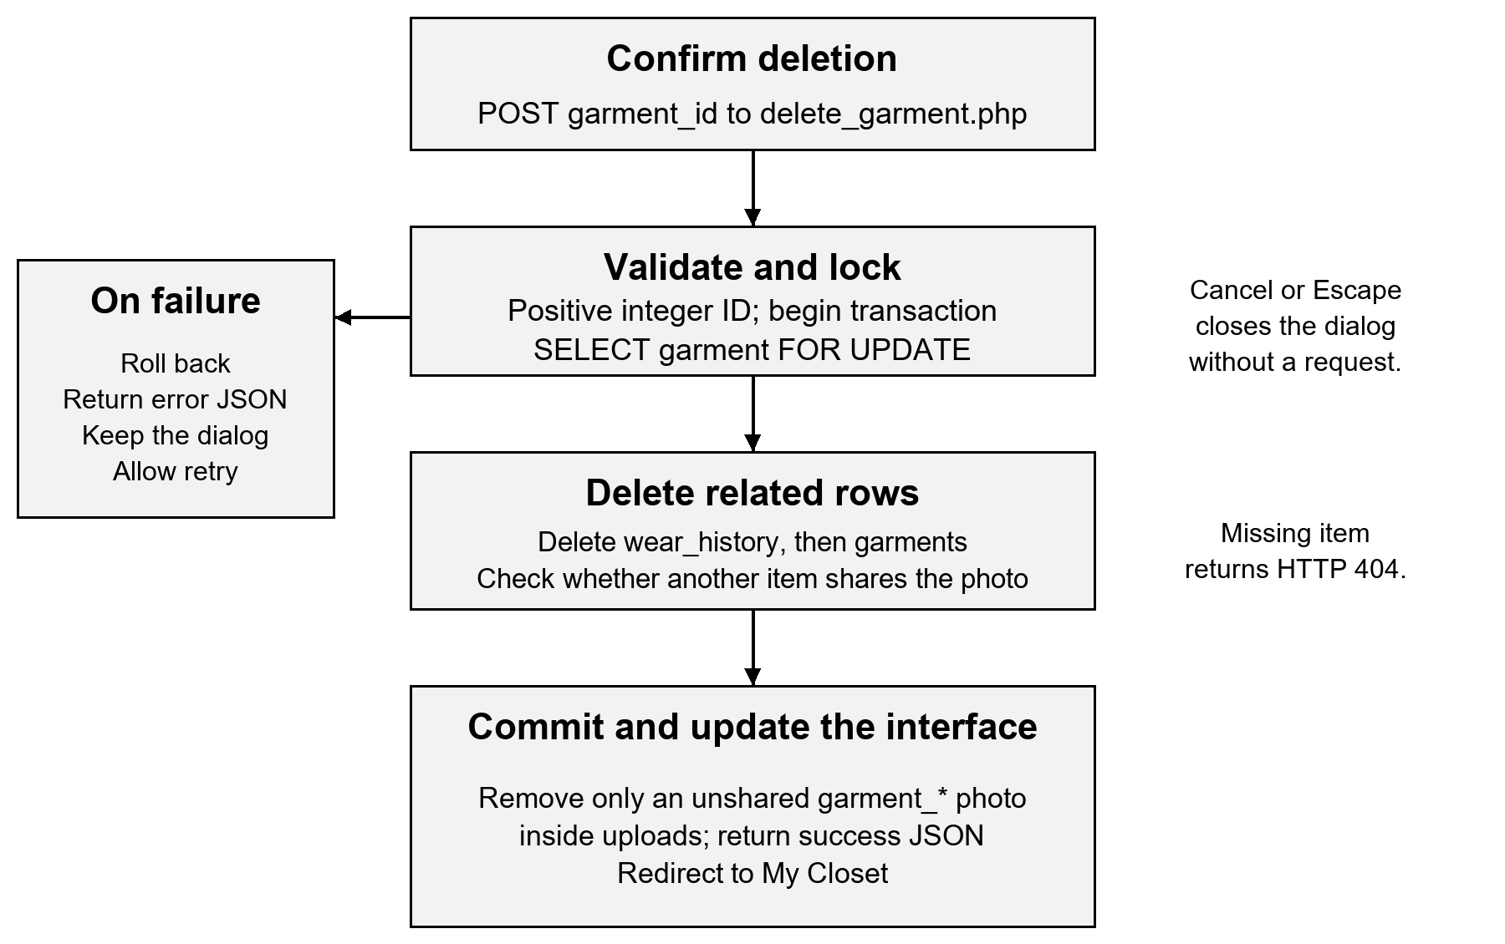
Figure 6. Confirmed deletion, transaction boundaries and failure recovery.
Wear logging locks the same garment row before inserting a wear record. Deletion removes wear events and the garment atomically. After committing, only an unshared user-uploaded photo inside the uploads directory is removed; bundled example photographs remain available.
3.3 Development of the Module

Recommendation query in php/item_engine.php
SELECT * FROM garments
WHERE category = ?
AND occasion = ?
AND (color_family = 'Neutral'
OR color_family = ? OR ? = 'Neutral')
AND id != ?
ORDER BY id DESC LIMIT 3
The prepared query binds the target category, occasion, selected colour family and ID. Each returned recommendation receives a text explanation, so colour matching can be understood without relying solely on the image. [3]

Wear insertion in php/log_wear.php
$stmt = $conn->prepare(
'INSERT INTO wear_history
(garment_id, worn_date, event_note)
VALUES (?, CURDATE(), ?)'
);
$stmt->bind_param('is', $garment_id, $event_note);
$stmt->execute();
$stmt->close();
This insert runs after an ID check and SELECT FOR UPDATE within a transaction. The endpoint returns the updated COUNT and MAX date only after the transaction commits. A failure rolls back and produces an error response.

Deletion request in js/item-details.js
await api('php/delete_garment.php', {
method: 'POST',
body: new URLSearchParams({
garment_id: String(item.id)
})
});
window.location.replace('closet.html?deleted=1');
The dialog initially focuses Keep Garment, supports Escape and contains keyboard focus while open. During deletion both controls are disabled. If the request fails, the buttons are restored and the error is shown; the item is not removed optimistically.
3.4 Results

My Closet
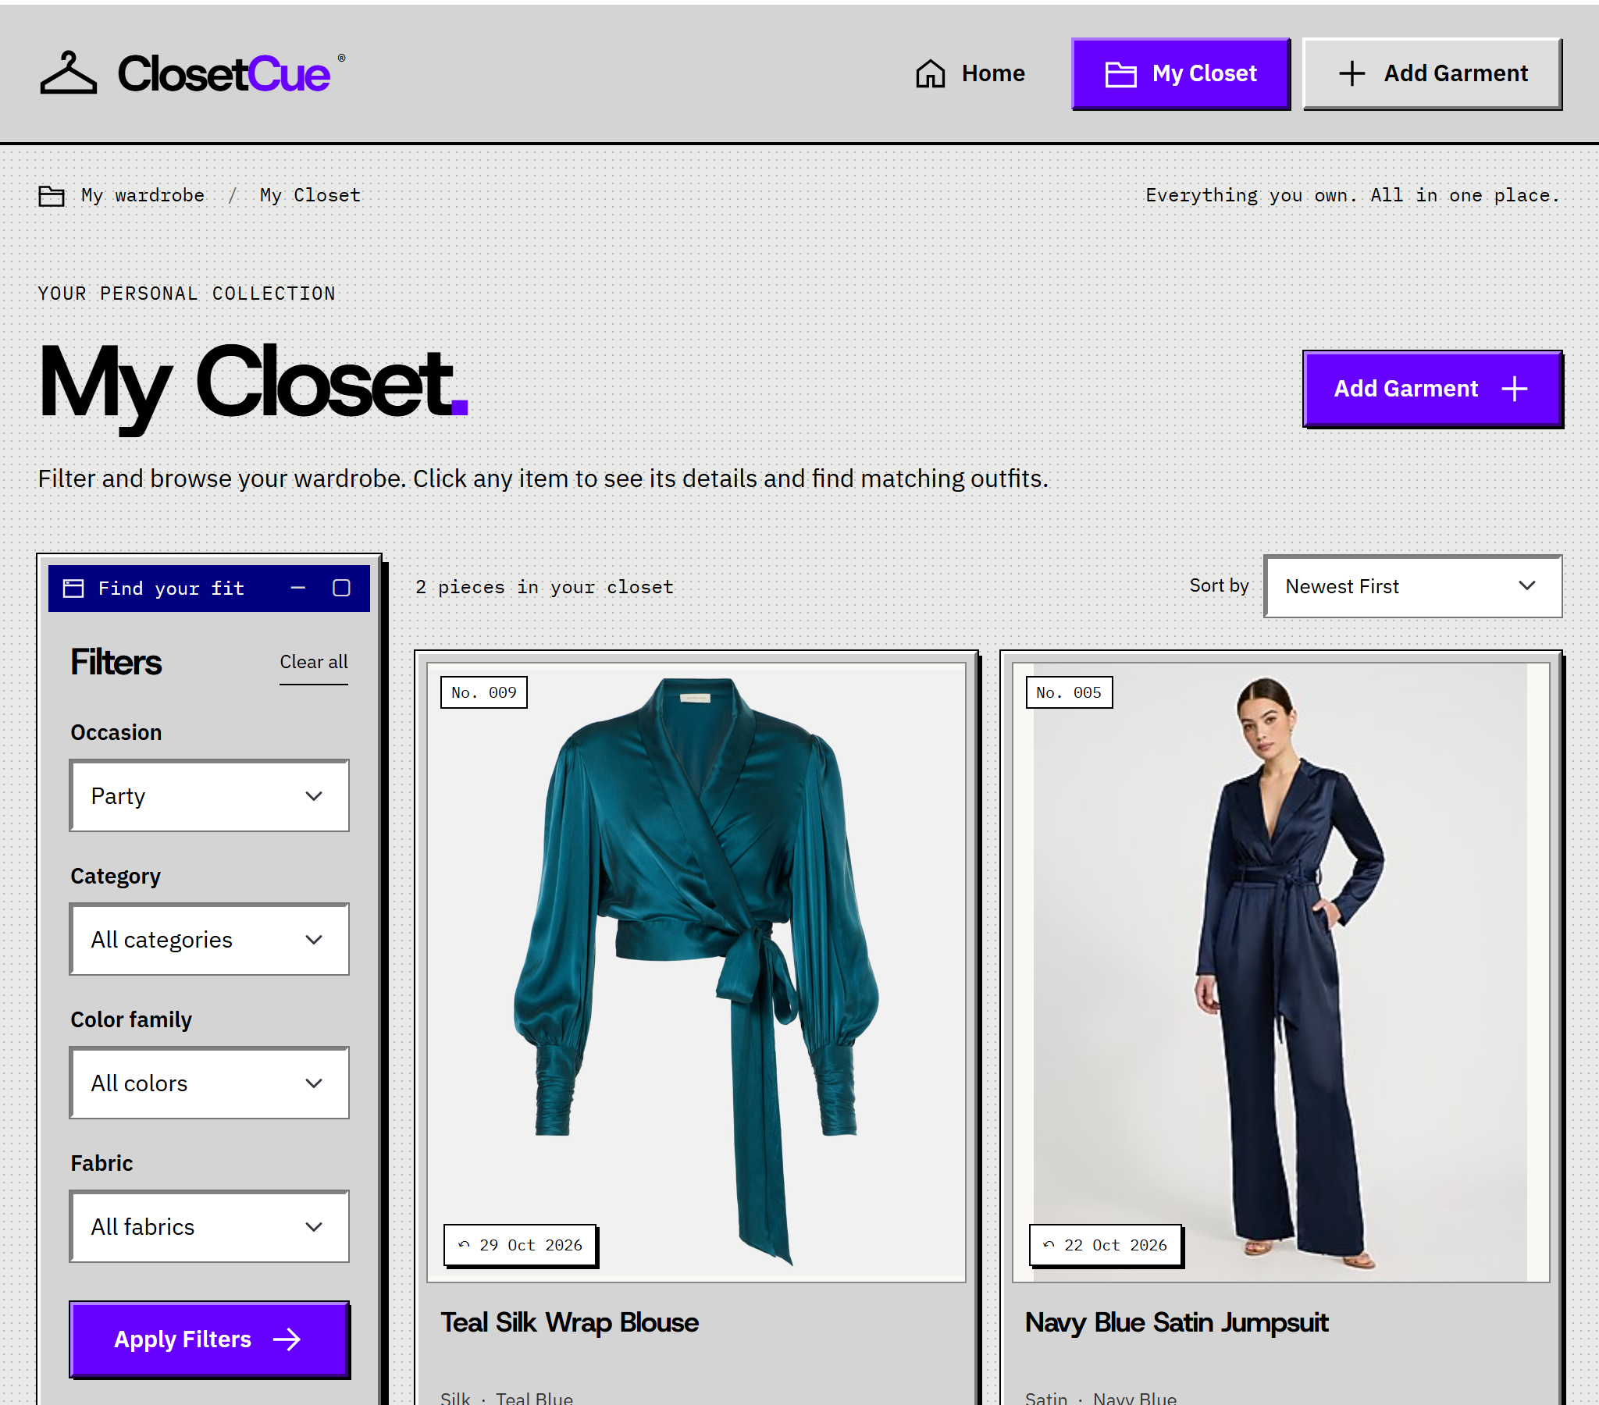
Figure 7. Party occasion filter returns two matching garments from the seeded wardrobe.
The selected occasion is preserved in the URL and the result count agrees with the two displayed cards. Combining Party with Denim produces a valid empty result. The browser suite verified this case, reset behavior and the Most Worn ordering, where Crimson Chikankari Kurta appears first with six seed wear records.
Each card links to the corresponding item ID. Names and other metadata are escaped before rendering; tests verified that text containing markup is displayed as text rather than interpreted as an HTML element.
3.4 Results continued

Item Details and Wear Logging
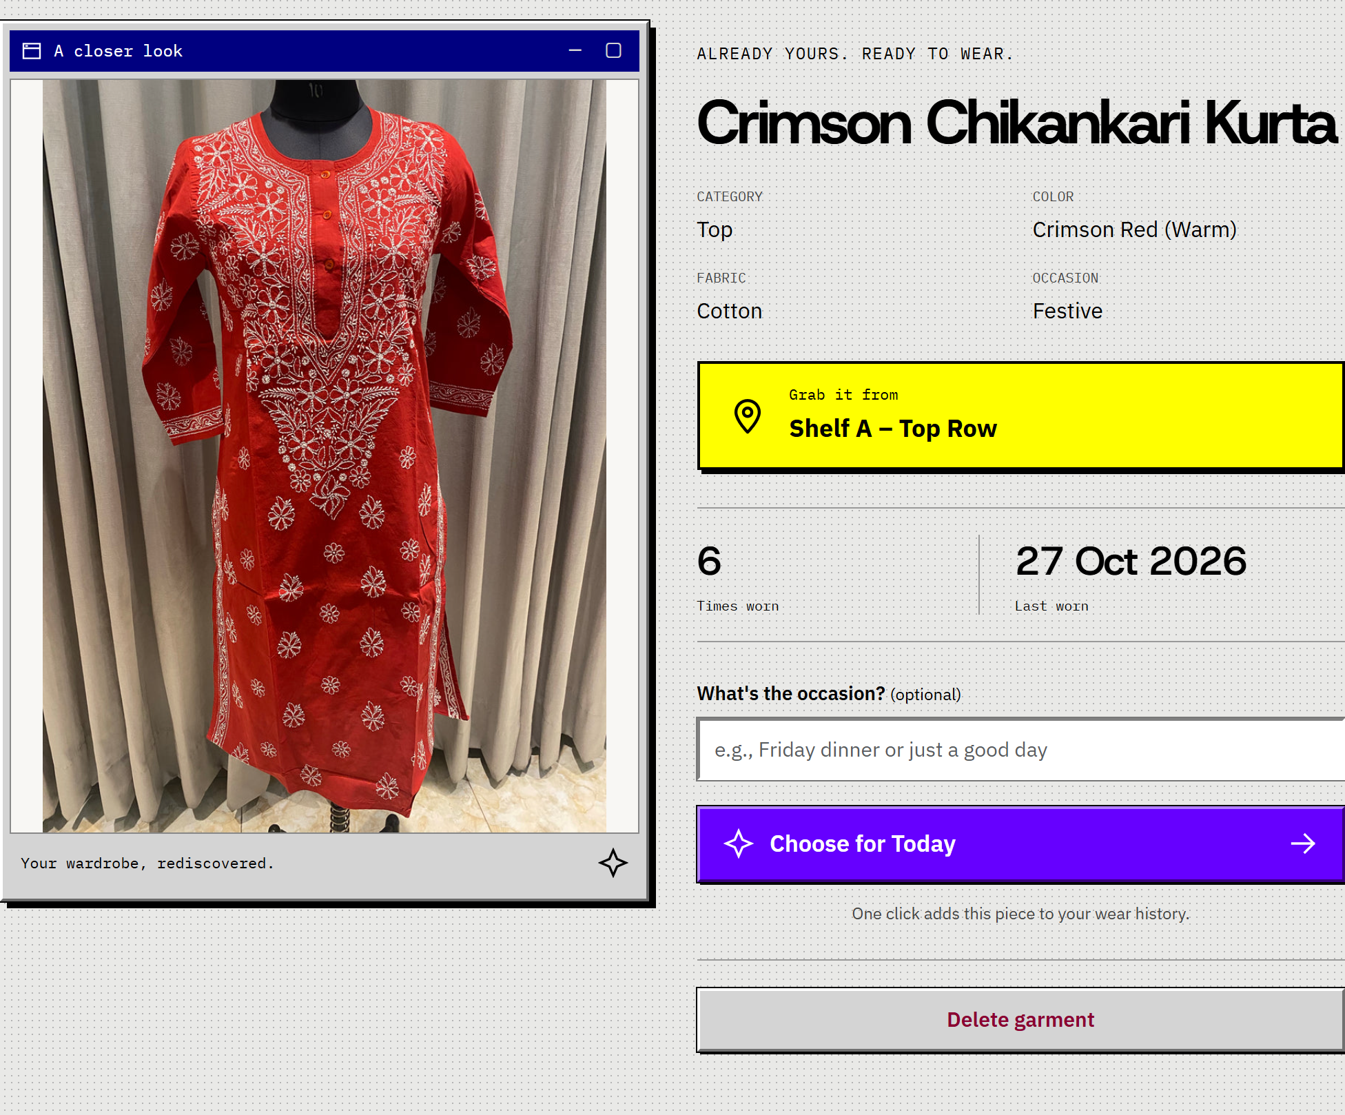
Figure 8. Garment detail view with shelf location, wear history and Choose for Today.
The seed garment has six recorded wears and a last-worn date of 27 October 2026. Choose for Today inserts another event and updates the visible count and date. A browser reload retains the change because the values come from the database.
The tests verified successful logging, persistence after reload and failed requests that do not increase the displayed count. Additional PHP tests exercised eight concurrent wear requests, Unicode event notes, invalid IDs and database rollback.
3.4 Results continued

Recommendations and Deletion
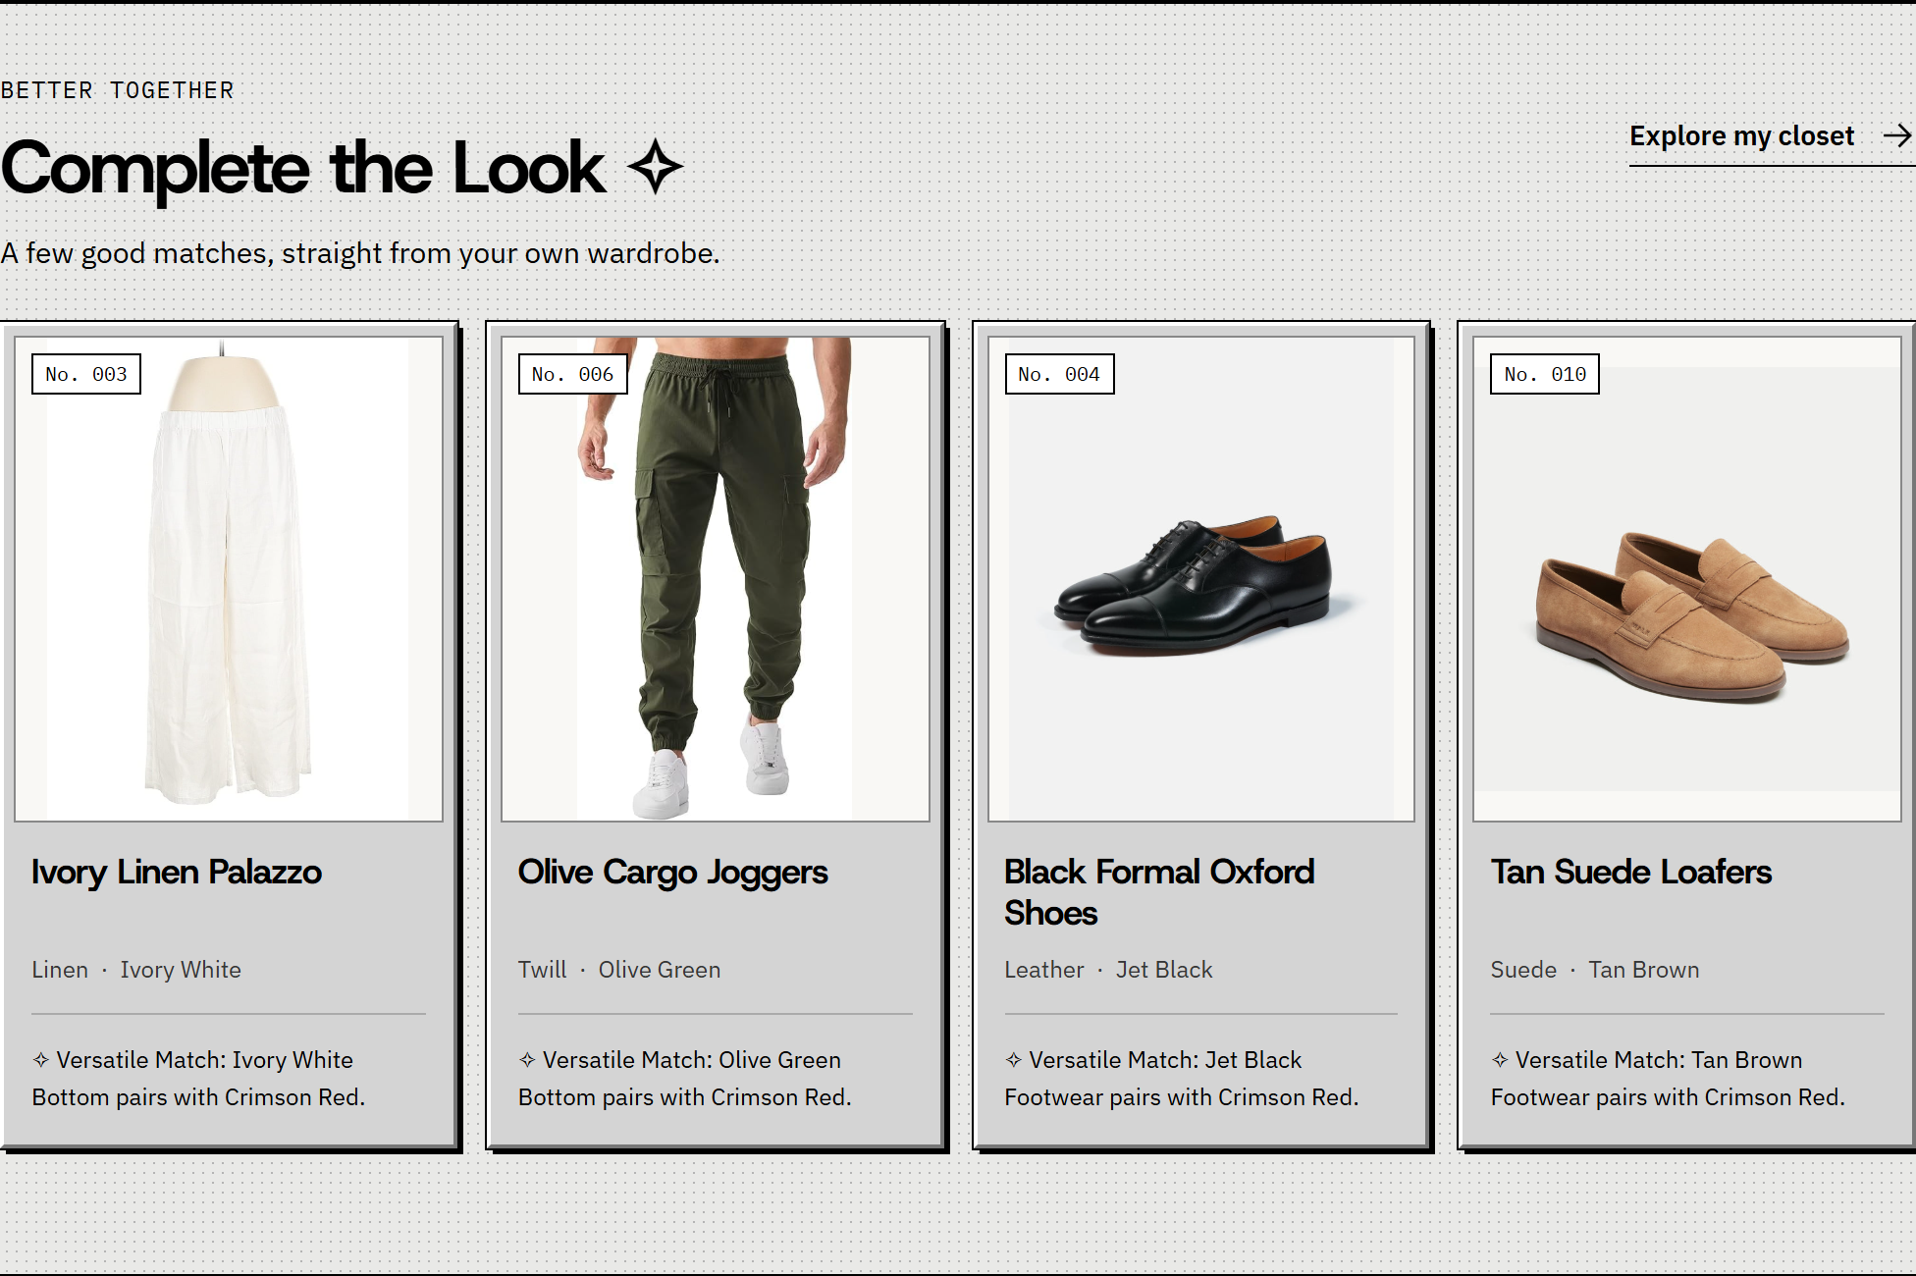
Figure 9. Complete the Look displays compatible wardrobe pieces with written match reasons.
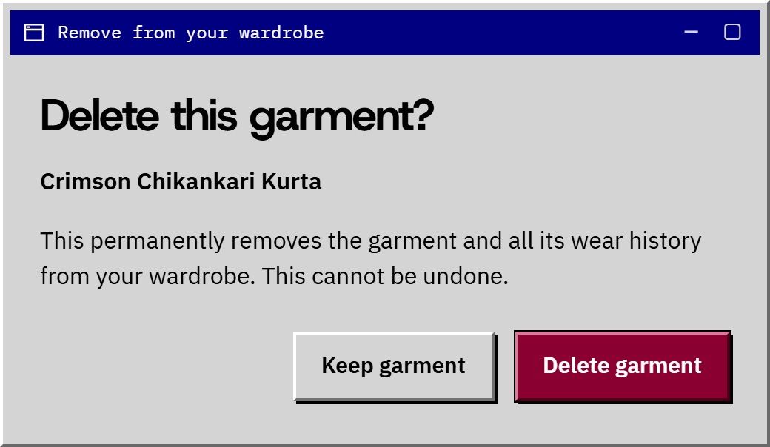
Figure 10. Explicit confirmation protects against accidental deletion.
The pictured recommendation set uses the fallback because the seed wardrobe has no exact Festive match in the complementary categories. Cancellation leaves the garment unchanged. Tested confirmation removes its wear history and updates closet and analytics results; shared photos remain until the final referencing garment is removed.
3.4 Results continued

Integration and Accessibility Verification
Verification was completed on 1 November 2026. The PHP suite used Apache 2.4.69, PHP 8.3.36 and MySQL 8.4.13 with strict SQL mode, including ONLY_FULL_GROUP_BY. It served the application under /project_2nd_try/. The Python suites used disposable SQLite data. User wardrobe records were kept separate from all fixtures.
Verification area | Observed result
PHP API behavior | All six endpoints passed successful and invalid-request scenarios; appropriate JSON error responses were returned.
Uploads and data validation | JPG, PNG, WebP, Unicode, actual MIME checks, malformed input, required fields and the 5 MB boundary passed.
Transactions and file cleanup | Forced insert, wear-log and delete failures rolled back; failed uploads did not leak a saved photo.
Recovery and persistence | Database outage/recovery passed; an emptied wardrobe stayed empty after application and MySQL restarts.
Browser flows | Eight grouped browser flows passed per backend, covering navigation, filters, upload, wear logging, errors and media.
Deletion flows | Six grouped deletion checks passed per backend, including cancellation, focus, retry, shared images and cleanup.
Responsive layout | 20 page/width checks per backend: 4 pages at 1440, 1024, 760, 390 and 320 px. Total: 40; no horizontal overflow.
Automated accessibility | 7 scans per backend: 4 pages plus the deletion dialog at 3 widths. Total: 14 scans; zero detected violations.
Playwright drove Chrome and axe-core scanned WCAG 2.0/2.1 A/AA rules. These results cover the tested pages and states; they are not a certification of full WCAG compliance or a substitute for assistive-technology user testing. [5, 6]
A fresh-start test exposed a readiness race in the Docker fixture. The check was corrected to wait for the final MySQL TCP server and imported schema rather than an early bootstrap socket ping. The full PHP suite then passed from a new database.
Evidence: qa/test-summary.json; qa/report.json; qa/deletion-report.json; qa/php/api-report.json; qa/php/report.json; qa/php/deletion-report.json; qa/php/runtime-report.json.

4. Conclusion and Future Scope
ClosetCue brings garment discovery, physical shelf mapping, wear tracking and outfit pairing into one website. The four modules share a consistent interface and work through validated requests and relational data. The project demonstrates semantic HTML, responsive CSS, asynchronous JavaScript, prepared PHP queries, aggregate SQL and transaction handling. Browser and API testing confirmed the implemented workflows on both supported backends and exposed failures that were corrected before the final run.
Future work can add user accounts and wardrobe ownership, laundry status, backup and import/export, image-assisted tagging and weather-aware outfit selection. These are proposed extensions, not current features. Recommendations currently use fixed category, colour and occasion rules; multi-user access control and external weather services are not implemented.

5. References
Documentation consulted for the technical explanations in this report; accessed 1 November 2026. Numbered citations appear in the relevant sections.
[1] MDN Web Docs. Using the Fetch API.
https://developer.mozilla.org/en-US/docs/Web/API/Fetch_API/Using_Fetch
[2] Bootstrap. Get started with Bootstrap 5.3.
https://getbootstrap.com/docs/5.3/getting-started/introduction/
[3] PHP Manual. MySQLi prepared statements.
https://www.php.net/manual/en/mysqli.quickstart.prepared-statements.php
[4] MySQL 8.4 Reference Manual. FOREIGN KEY constraints.
https://dev.mysql.com/doc/refman/8.4/en/create-table-foreign-keys.html
[5] W3C. Web Content Accessibility Guidelines 2.1.
https://www.w3.org/TR/WCAG21/
[6] Playwright. Accessibility testing.
https://playwright.dev/docs/accessibility-testing
Project evidence: source files in project_2nd_try; SQL schema and seed data in sql/closetcue_db.sql; asset attributions in assets/CREDITS.md; test reports listed in Section 3.4. Screenshots show the actual local demonstration interface.

