
CREATING AN 2 DIMENSIONAL
MAP VIEWER
Programming Manual
Version : 1.0

Date :08-04-2020

Author :The GeoStack Project

Purpose of this document
This programming manual serves as an extension for the following documents:
- Cookbook: Creating the GeoStack Course VM:
The datastores, tools and libraries used during this programming manual are installed and created in the cookbook: Creating the GeoStack Course VM.
- Cookbook: Creating a basic web application:
The base application of this Dataset Dashboard has been created during the cookbook: Creating a basic web application.
- Cookbook: Data modeling in MongoDB using MongoEngine:
The data used during this cookbook, is modeled, indexed and imported in the cookbook: Data modeling in MongoDB using MongoEngine.
- Programming manual: Creating the Python-Flask web application:
The middleware that will be used during this programming manual is created in the programming manual: Creating the Python Flask web application.
If you have not read these documents yet, please do so before reading this document.
The purpose of this programming manual is to create an 2D map viewer application using the AngularJS JavaScript framework and OpenLayers 6. This application is an extension of our Angular base application.
The Angular apps will perform API calls to our Flask application and our Flask application will then retrieve the requested data via queries, performed on our datastores. The results are then returned to our Angular applications.
This programming manual serves as a guideline for the steps you have to perform to create a 2D Map Viewer using OpenLayers and visualize the data retrieved by the Flask-API.
During this programming manual the code is explained using the inline comments in the source code located in the folder: “POC”. It’s highly recommended to use the source code provided in this folder when creating the web application yourself.
NOTE: Sometimes you will notice that in the code which you have to create some functions do not exist yet. Don’t worry about this since they will be added later on during the programming manual!
Table of Contents
Purpose of this document 2
1.Introduction 4
1.1 Getting ready 4
1.2 Adding the Geospatial framework OpenLayers 5
2. Creating the services 5
2.1 The map service 5
2.2 The Crane service 6
4. Creating the 2D Map page 10
4.1 Creating the Map Component base 11
4.1.1 Creating the base of the settings menu 14
4.2 Creating the Map Component functionality 15
4.2.1 Creating the OpenLayers Map 15
4.2.2 Switching between map providers. 17
4.2.3 Adding items 19
4.2.4 Selecting items 24
4.2.5 Loading Item data 28
4.2.6 Creating and setting Layer groups 32
4.2.7 Creating and setting Overlays 33
4.2.8 Removing a selected Item 33
4.2.9 Removing a LayerGroup 33
4.2.10 Adding DTG selection 33
4.2.11 Adding Amount selection 35
4.2.12 Adding Country selection 37
4.2.13 Adding Layer and Overlay Toggling 37
4.2.14 Changing layer styling 37
4.2.15 Animating routes 37
4.2.16 Creating an elevation profile 37

1.Introduction
During this chapter we are going to convert the basic web application in such a way that we can start coding the 2D Map Viewer application. We do this because the base application contains the base structure of the 2D Map viewer application which we are going to create during this programming manual. As mention before; if you did not read the programming manual: “Creating a basic web application” you should read it before continuing this programming manual.

1.1 Getting ready
Since this application is an extension of the base-application we can copy this application and start creating the 2D map viewer from there. After we copied the base-application folder, we need to change some names and titles to make the new application the 2D map viewer. We start by changing the name of the folder we just copied from base-application to 2d-map-viewer, as shown in the image below.


We also need to edit the project name: “base-application” to “2d-map-viewer”. If you are using the code-editor Atom, this is done by performing the following steps:
- In the editor press the key combination Ctrl + shift + f on your keyboard.
- In the screen that pops up enter: “base-application” in the find section and “2d-map-viewer” in the replace section, as shown in the illustration below. Then click on find all.

- Click on replace all and on the save button in the screen that pops up.


- In the file called: “index.html” which is located in the folder 2d-map-viewer/src, replace the title from BaseApplication to 2D Map Viewer.
- In the file: sidebar.component.html located in the folder src/app/components/sidebar/, change the text: “Base Application” to “2D Map Viewer.”

1.2 Adding the geospatial framework OpenLayers
Adding a geospatial framework to our Angular application can be done in 2 ways which are as follows:
- Installing the NPM Package: “Ol”:
This is the first technique which you can use to install OpenLayers in your application. During this programming manual we will not be using this technique. If you want to read up on using this technique you should visit the following URL: https://www.npmjs.com/package/ol
- Downloading the OpenLayers source code:
During this programming manual we are going to use this technique. We do this because, from the version control point of view, this method is the best method since there are no files added to the Node_Modules folder of the application. Using this technique we are going to add the geospatial framework as static files in the assets folder of our application. This enables us to easily switch to a newer or older version of the geospatial framework.
First we want to download the OpenLayers source code from the OpenLayers Github repository which is located on the following URL:
https://github.com/openlayers/openlayers/releases/download/v6.2.1/v6.2.1-dist.zip
When the download is complete you want to extract the folder somewhere, after which you want to create a new folder in the assets folder of our 2d-map-vierwer.
We do this by running the following command:
mkdir ~/Geostack/angular-apps/2d-map-viewer/src/assets/geospatial-frameworks
Copy the extracted OpenLayers folder to the folder we just created.
Add the following lines inside the <head> element from the index.html file located in the folder 2d-map-viewer/src/app/.
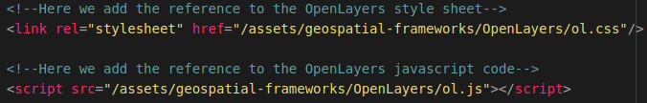
Now we will be able to use the geospatial framework OpenLayers in our application.
If you want to upgrade to a newer or older version of OpenLayers you can use the same technique as mentioned above but then with the desired version from the OpenLayers Github repository.

2. Creating the services
Now let’s start of with creating the services that contain the functions to retrieve data from our datastores. We need 3 services which are a map service in which we are going to add the functions that retrieve the Tilestache entries from our Tileserver and a Crane service which contains all the functions related to performing API calls to our Flask-API to obtain the Crane Tracker data from our MongoDB datastore.
NOTE: In the folder “POC” you can also find the service which is required to perform API calls to our Flask-API to obtain the GPS-Route (Trail) data from our MongoDB datastore. This is not described in this cookbook since it’s basically the same as the code for the Crane Trackers.

2.1 Creating the map service
To create the map service we first need to create a new TypeScript file called:”map.service.ts“. We do this by running the following command:
touch ~/Geostack/angular-apps/2d-map-viewer/src/app/services/map.service.ts
Now let’s open this file and import the basic Angular modules at the top of this file by adding the following code:

Now we want to create the class and it’s constructor for the Map service. This is done by adding the following code below the line: “@Injectable()”:

Now we want to add a function that is able to retrieve all the entries in our Tilestache Tileserver.
Now we want to add a function that is able to retrieve all the entries in our Tilestache Tileserver. So lets add the function called: "getTilestacheEntries()".
When the function is called in the MapComponent it will perform an HTTP GET request on the Flask-API, which will then activate the function which is bound to the URL: /api/get_tilestache_entries/. The function bound to this URL scrapes all the entries in our Tilestache configuration and returns them as a list. We need these entries to switch between WMS's (Web Map servers)
Adding the function is done by adding the following function in the class: “MapService ”below the constructor:
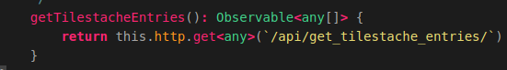
That’s all! Now we have created a function that can perform an API call to obtain all the WMS entries in our Tilestache configuration.

2.2 Creating the Crane service
Let’s create the Crane service to which contains all the functions required to retrieve data from our MongoDB datastore. To create the Crane service we first need to create a new TypeScript file called:”crane.service.ts“. We do this by running the following command:
touch ~/Geostack/angular-apps/2d-map-viewer/src/app/services/crane.service.ts
Now let’s open this file and import the basic Angular modules at the top of this file by adding the following code:

Now we want to create the class called: ”CraneService” and it’s constructor for this service. This is done by adding the following code below the module imports:
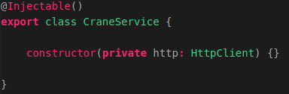
This class will be instantiated in the MapComponent which we will create later. This class will contain all the functions which are required to perform API requests to our Flask-API.
The class will contain functions related to requesting Crane data from our MongoDB datastore.
Now we want to add 6 functions to retrieve the Crane Tracker data from our MongoDB datastore, these functions are as follows:
- getTrackers() to obtain all the trackers in our database.
- getTracker() to obtain one tracker using the MongoID.
- getTransmissionsID to obtain all transmissions belonging to a tracker.
- getTransmissionsAmount to obtain a N amount of transmissions belonging to a tracker.
- getTransmissionsDTG() to obtain all the transmission in a given timeframe.
- getTransmissionsCountry() to obtain all the transmissions in a given polygone.
So let’s add a function called: “getTrackers()”, that is able to retrieve trackers in our MongoDB datastore. This is done by adding the following function in the class: “CraneService ” and below the constructor:
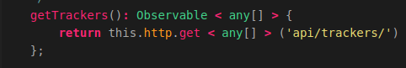
The function called: "getTrackers()", which is used to perform an HTTP GET request to our Flask-API. The function performs a request on the following URL:api/trackers/. This URL is bound to a function in our Flask-API. The function, bound to this URL, executes a query on our MongoDB datastore and retrieves all trackers from the MongoDB datastore. The function:"getTrackers()" then returns all the trackers to our MapComponent.
Now let’s add the function called: “getTracker()”, which is used to obtain a specific tracker using it’s MongoID, we do this by adding the following function below the function we created above:
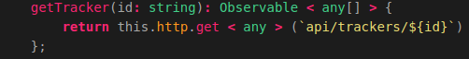
This function is used to perform an HTTP GET request to our Flask-API. The function performs a request on the following URL: api/trackers/{id}. This URL is bound to a function in our Flask-API. The function, bound to this URL, executes a query on our MongoDB datastore and retrieves a tracker which has the id passed in this function,from the MongoDB datastore. The function:"getTracker()" then returns the tracker to our MapComponent.
Now let’s add the function called:”getTransmissionID()” which obtains all the transmissions belonging to a tracker, we do this by adding the following code below the function we created above:
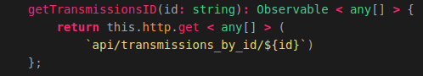
This function is used to perform an HTTP GET request to our Flask-API. The function performs a request on the following URL: api/transmissions_by_id/${id}. This URL is bound to a function in our Flask-API. The function which is bound to this URL executes a query on our MongoDB datastore and retrieves all transmissions belonging to a tracker that has the id passed in this function. The function:"getTransmissionsID()" then returns the transmissions to our MapComponent.
Now we want to create the function called: “getTransmissionsAmount()” that obtains a N amount of transmissions belonging to a specific tracker. We do this by adding the following code below the function we created above:
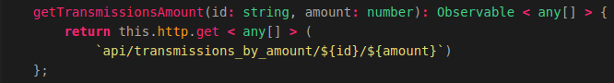
The function performs a request on the following URL: api/transmissions_by_amount/${id}/${amount}. This URL is bound to a function in our Flask-API. The function, bound to this URL, executes a query on our MongoDB datastore and retrieves all transmissions belonging to a tracker that has the id passed in this function. The amount of transmissions it returns is the amount passed in the function call. The function:"getTransmissionsAmount()" then returns the transmissions to our MapComponent.
Now let’s add the function which obtains all the transmissions belonging to a tracker in a given time frame, we do this by adding the following code below the function we created above:
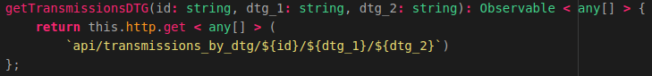
The function performs a request on the following URL: api/transmissions_by_dtg/${id}/${dtg_1}/${dtg_2}. This URL is bound to a function in our Flask-API. The function, bound to this URL, executes a query on our MongoDB datastore and retrieves an N amount of transmissions between the start date (dtg_1) and the end date (dtg_2) belonging to a tracker that has the id passed in this function.
Finally we want to add the function which obtains all the transmissions belonging to a tracker in a given polygon, we do this by adding the following code below the function we created above:
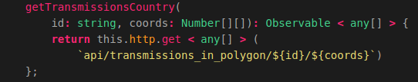
The function performs a request on the following URL: api/transmissions_in_polygon/${id}/${coords}. This URL is bound to a function in our Flask-API. The function, bound to this URL, executes a query on our MongoDB datastore and retrieves all transmissions of which the coordinates reside in the list of coordinates passed as parameter in the function, belonging to a tracker that has the id passed in this function.
That’s it! Now we have created the service that contains functions which can perform an API call to obtain data from our MongoDB datastore.

2.3 Creating the Port service
Let’s create the Port Service which is going to contain all the functions required to retrieve the World Port Index data from our PostgreSQL datastore. To create the Port Service we first need to create a new TypeScript file called:”port.service.ts“. We do this by running the following command:
touch ~/Geostack/angular-apps/2d-map-viewer/src/app/services/port.service.ts

Now let’s open this file and import the basic Angular modules at the top of this file by adding the following code:

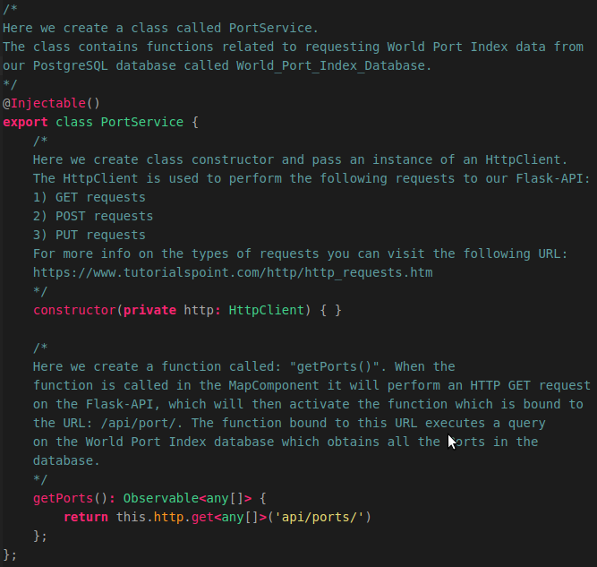
Now we want to create the class and it’s constructor for this service we also add the function which is used to perform the API request on the Flask-API. This is done by adding the following code below the module imports:

4. Creating the 2D Map page
The 2D Map page is going to be the page which contains all the code logic to actually display the data which is obtained from our datastore on a 2D Map from OpenLayers.
To create the map page we first have to add a new folder to our pages folder in our web application. We do this by running the following command:
mkdir ~/Geostack/angular-apps/2d-map-viewer/src/app/pages/map-page
In that folder we need to create 2 files which are a map.component.ts file and map.component.html file. We do this by running the following commands :
touch ~/Geostack/angular-apps/2d-map-viewer/src/app/pages/map-page/map.component.ts && touch ~/Geostack/angular-apps/2d-map-viewer/src/app/pages/map-page/map.component.html
Now that we have created the required files we can start creating the basic structure of our map page.

4.1 Creating the Map Component base
We want to start of with importing the Angular modules required to create the map component in the map.component.ts file, so let’s open this file and add the following code at the top:

Next we want to import the map service, crane service and port service we do this by adding the following code to the file:
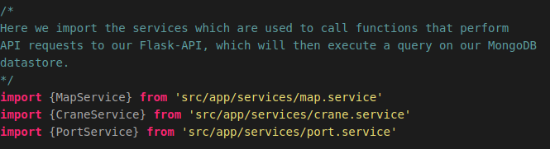
Now we want to create a global variable which is required to use the OpenLayers code throughout our map component. We do this by adding the following code:


Now we want to create the component metadata for our map component. We do this by adding the following code:
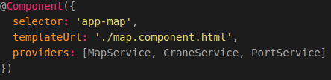
The following applies to this code:
- selector: If we want to use the map component, we add the code: <app-map/> to the HTML file in which we want to add the component.
- templateUrl: The HTML file in which we will define the layout of the component.
- providers: A list of providers (services) in which we have defined the functions required to perform API calls.
Now we want to create the base of our map component. We do this by adding the following code below the metadata:
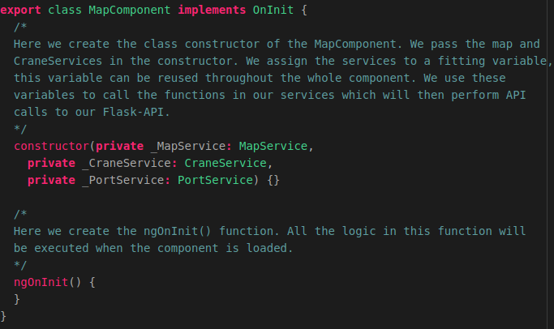
Now we want to add a div element to our map.component.html file. This div element is going to contain our OpenLayers map after we create it. So let’s open the html file and add the following code:

Now we want to make the map page available in our 2D map viewer application. We do this by adding the component to our app.module.ts file. So let’s open this file and import the map component by adding the following code below the last import:

Next we want to add the imported component to the declarations section in the app.module.ts file. The final declarations section will look the same as shown in the illustration below:

Now we need to add a new route to our app-routing.module.ts file. First we need to import the map component. We do this by adding the following code below the last import in that file:

Then we need to add the new route to our routes in this file. We do this by changing the current routes to the following:

Now we want to add a new entry to our sidebar. This is done in the file: sidebar.component.ts,
located in the folder: src/app/components/sidebar/. So let’s open this file and add a new route

to our route list. The final code will be the same as shown in the illustration below.

Now when we start our application we will be greeted with the the new page as shown in the illustration below:

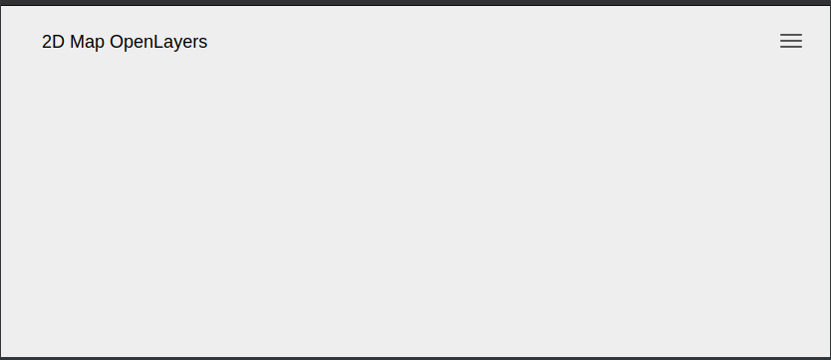
The page does not have any content yet so we are going to add this now.

4.1.1 Creating the base of the settings menu
We want to start of by adding the base of the settings menu to our map.component.html file. We do this by adding the following code, below the div element related to the map, to this file:

Now when we reload the application a drop down button will be displayed as shown in the illustration below:
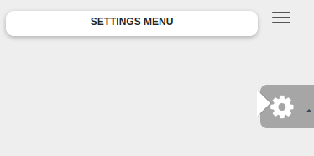
When we you click the button an empty drop down menu will pop up. Let’s add some extra functionalities to our application to make sure the drop-down menu will be filled with items. We are going to do this in the next section.

4.2 Creating the Map Component functionalities
In this section we are going to add all the code logic to our application. We want to start of by creating the OpenLayers map instance in which we are going to create all our layers later.

4.2.1 Creating the OpenLayers Map instance
We want to start off by creating the OpenLayers map, we do this in the file: “map.component.ts” First we need to define a global variable called map. We do this by adding the following code below the line where we defined the class name: MapComponent:
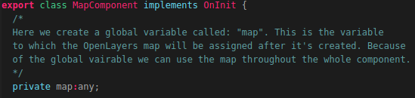
Note: In the illustration above the line where we defined the class name is also included (“export class MapComponent….”). You don’t need to add this line again.
Next we have to create a global JavaScriptMap which is going to be populated with all the entries from our Tileserver after the function is called related to retrieving the Tileserver entries. We do this by adding the following code below the code we added above:
We created a global variable called: "mapProviders". The variable is a JavaScriptMap which will contain key | values. The JavaScriptMap map will be populated with available map providers once the function:"getMapProviders()" is triggered. We will create this function later on
Next we need to create a global variable which is going to contain the base layer of the OpenLayers map. We do this by adding the following code below the code we added above:
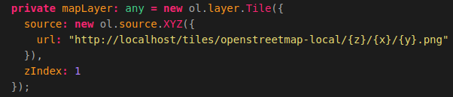
Above we created a global variable called: "mapLayer". This is the variable to which the base layer of the map will be assigned. We set the default map (The map that will be shown when the component is loaded) to the local OpenStreetMap map. We assign the URL on which the Local OpenSteetMap tiles are available served from the Tilestache Tileserver running behind the NGINX webserver.

Next we want to create a global variable which is going to contain the OpenSeaMap layer. We do this by adding the following code below the global variable: “mapLayer”:
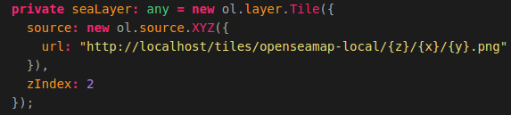
On the previous page we created a global variable called: "seaLayer" to which we assign a Tile layer to which we assign the URL on which the Local OpenSeaMap tiles are available served from the Tilestache Tileserver running behind the NGINX webserver.

Now we want to create a global variable called portLayer. The layer containing the World Port Index dataset will be assigned to this variable later on. We add this global variable by adding the following code below the global variable: “seaLayer”:

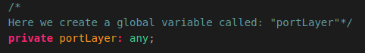

Next we want to create a function that calls the function: “getTilestacheEntries()” which we defined in our mapservice.ts file. We do this by adding the following code below the ngOnInit() function:
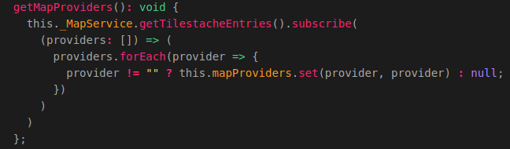
Above we created the function to retrieve all the WMS entries in our Tilestache configuration.This function triggers the function getTilestacheEntries() in the MapService. Then it populates the mapProviders JavaScriptMap with all the obtained entries. If an entry is empty ( equal to ""), the entry will not be added to the JavaScriptMap.

Now we want to create the function which actually creates an OpenLayers Map instance when it’s triggered. This function will be called:”createOpenLayersMap()”. In the function we create a new OpenLayers View (Map) and assign the base layer, which was created earlier, to the View. The map will be assigned to the HTML div element with the id: "map". This is the div element in the layout of the MapComponent (map.component.html).

The code required to create this function is shown on the next page.

So let’s add the createOpenLayersMap() function below the function: “getmapProviders()” by adding the following code:
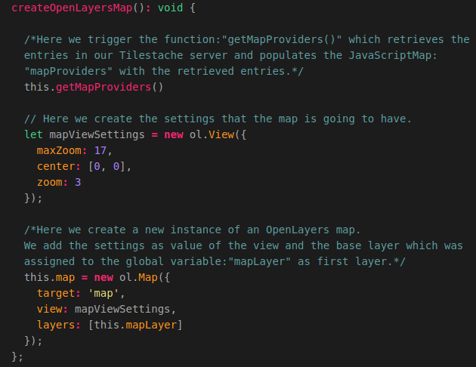
Now we want to add the function we just created to the ngOnInit() function so that it’s triggered when the map component is loaded. The function will look the same as shown in the illustration below after you added the function: “createOpenLayersMap()”.


Now when we start the Tileserver and Flask-API and reload the application you will be greeted with a map that shows the local OpenStreetMap map as baselayer in the OpenLayers View as shown in the illustration below:

4.2.2 Switching between map providers (WMS)
Now we want to add the functionality for us to be able to switch between map providers. For this we first need to create a new function in the map.component.ts file. We do this by adding the following code below the function: “createOpenLayersMap()”:
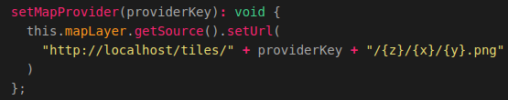
Above we created the function that changes the mapProvider. When the function is triggered a providerKey is passed. This providerKey is the key of the entry in the JavaScriptMap: "mapProviders". We then call: “getSource” on the mapLayer to obtain the source of the layer. Then we set the URL, on which the map (with the provider key which for example could the landscape-map) is available, using “setURL()”. This function is assigned to the WMSSelection settings menu which we are going to create now!
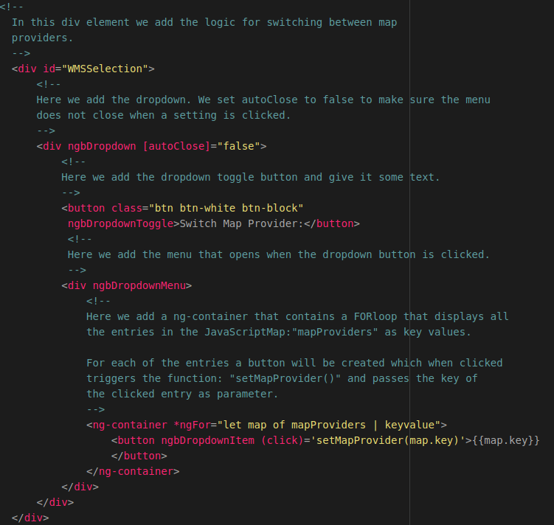
So let’s add some code to the settings menu in our map.component.html file. Open this file and add the following code in the div element with the id:”settings”:
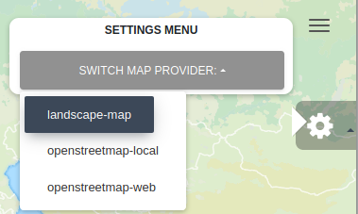
Now when we reload the page we get a new option in our settings menu which if we click shows all the entries in our Tileserver. If we click on an entry the map will change according to the entry (providerkey) that was selected.

In the next section we are going to add the functionality which is required to select and add items to our application. Each (Crane) Tracker and a GPS-Route (Trail) can be seen as one item.

4.2.3 Adding items from the datastore to our application
Now we want to create the functionality for adding items (Crane Trackers or GPS-Routes/Trails) which are obtained from our MongoDB datastore to the web application.
For this we are first going to create a class called:”Item” which serves as a template for each item that is added. This means that each item is going to contain a specific set of attributes. When loading the items we are going to create a new instance of the item class for each Tracker or Trail in our database.
We are going to add the class below the global constant: “ol” which we defined at the beginning of this document. To create this class we are going to add the following code:
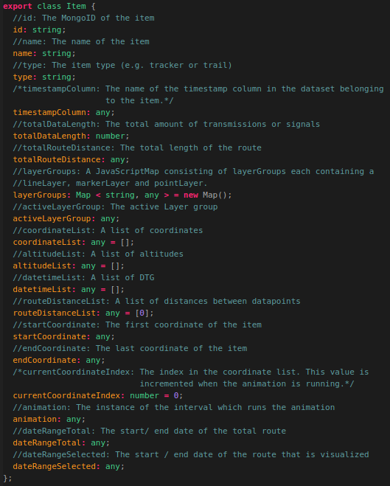
Now that we have created the Item class we need to add a global variable called: “Items” which starts of as an empty list of items.
We create this variable by adding the following code below the global variable: portLayer which we created earlier.
Above we created a global variable called: "items". The type of the variable is a list of Items. This list starts of empty, but when we call the function(s) that retrieve the Crane Trackers and GPS-Routes from the datastore, the empty list will be populated with these results.
We want to start of by creating a function called:”addItem()”. This function will create a new instance from the Item class, which we created earlier, for each item that is obtained from our MongoDB datastore. We add this function by adding the following code below the function “setMapProvider()”:
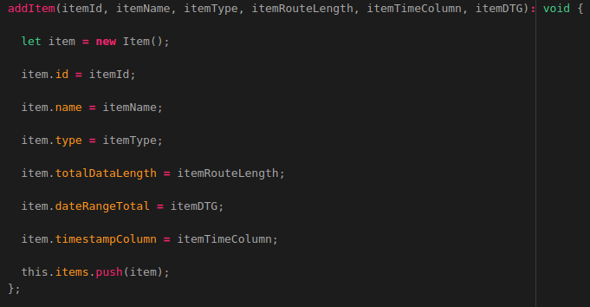
Above we created a function called: "addItem()". This function is called on each item retrieved in the getItems() function which we will be creating next.
The function: addItem() then creates a new item and assigns the parameters passed in the function to the newly created item. The parameters are as follows:
- itemId : The MongoID of the item that is added.
- itemName : The name of the item that is added.
- itemType : The itemType, this is necessary because we want to be able to visualize multiple types of datasets such as trackers and trails.
- itemRouteLength : The total amount of transmissions / signals belonging to the Tracker / Trail that is added.
- itemTimeColumn : The name of the timestamp column in the dataset. This is required since the column name representing the timestamp differs in each dataset.
- itemDTG : The TOTAL time frame of the route. This is NOT the time frame of the amount of transmissions / signals which are selected. This value is used to set a begin and end date in the calendar used to select a DTG (Date time group). The value passed as parameter is a line of the start and end date of the route.
When all the values are assigned to the item, the item is added to the global variable: items, which is a list of all items (trackers and trails) located in the MongoDB datastore. The global variable Items populates the list of items that can be selected in the application. We will be adding this list later on. Let’s first add the function: “getItems()” which triggers the function:”getTrackers()” which was defined in our CraneService.ts file. We do this by adding the following code below the addItem function:
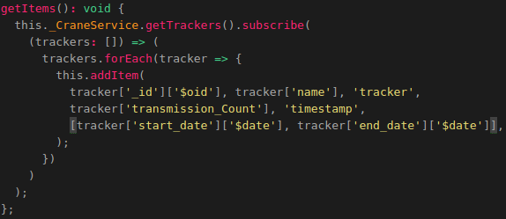
Above we ccreated the function called: "getItems()”.
This function triggers the function: "getTrackers()" in our CraneService file, which then returns all the trackers in our MongoDB datastore. After the trackers are obtained the function:”addItem()” is called on each tracker.
The syntax used in the function is as follows:
this.{service}.{function}.subscribe({elements} => {elements}.forEach({element} =>{ addItem(element values) }); );
The following applies to the syntax above:
- service = the service which contains the API call functions
- function = the function from the service you want to trigger. This function will then return the data retrieved from our datastore.
- elements = this name can be generic. This value stands for the list of data returned by the function. A foreach loop is performed on the list of data because we want to add all rows in the elements to the JavascriptMap it belongs to.
- element = this name can also be generic. This value stands for 1 row in the data returned by the function. For each element we trigger the function: "addItem()". We pass the required values as parameters in the function: "addItem()"

As mentioned before the function:”getItems” needs to be triggered when the MapComponent loads. So we need to add the function:”getItems()” to our ngOnInit() function so that the items are obtained from our datastore when the map component is loaded.
The final ngOnInit() function will look the same as shown in the image below:
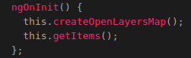
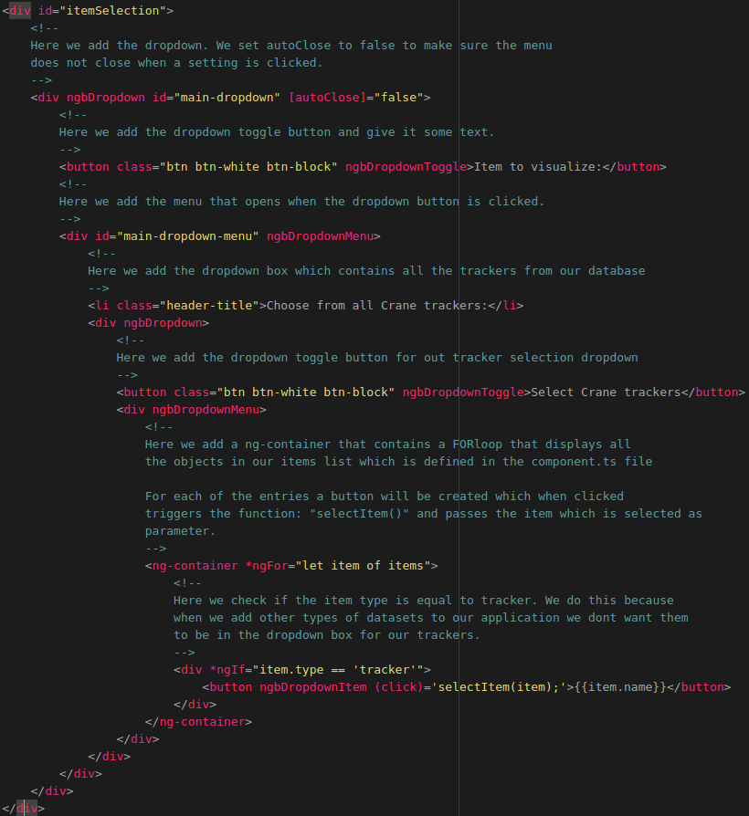
At this point we cannot select any items yet. To solve this we need to add another drop-down menu to our map.component.html file. We add this html code in the div element with the id:”settings” and below the div tag with the id: “WMSSelection”.
Now when we reload the web application click on the new drop-down menu in our settings menu we will see all the trackers in our MongoDB database, as shown in the illustration below.
NOTE: Make sure your Tileserver and Flask-API are running otherwise the items cannot be obtained form the datastore!
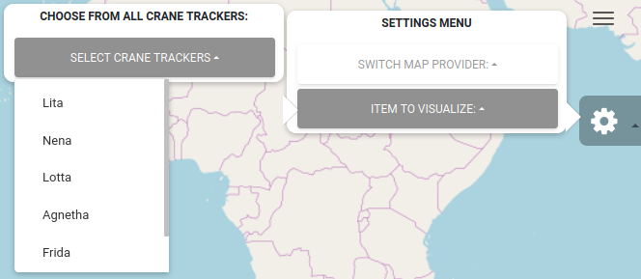
When we select an item from the drop-down list nothing will happen this is because we assigned a function called:”selectItem()” to each entry in the drop-down menu. To fix this we need to add some extra functionalities to the map.component.ts file.

4.2.4 Selecting items
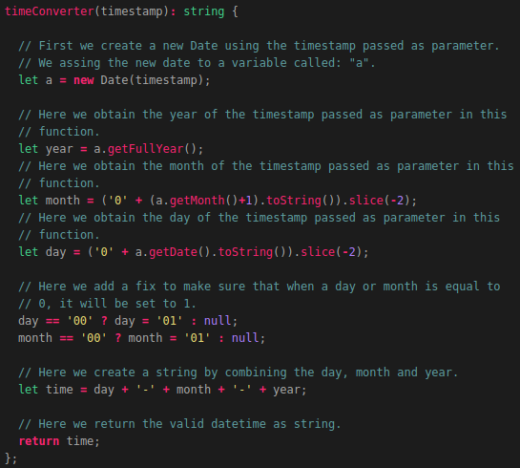
Before we are going to create the item selection functionality we first need to create a function which is used to convert timestamps to a valid and human readable format. We do this by adding the following code in the map.component.ts file below the getItems() function which we created earlier:
Now to be able to actually select items we first need to add a new global variable called: ‘selectedItems”. We do this by adding the following code below the global variable:”items” which we defined earlier:
Above we created a global variable called: "selectedItems". The type of the variable is a list of Items. This list starts of empty, but when we select an item from the drop-down menu in the application the function: "selectItem()" will be triggered which will then add the selected item to the selectedItems list. We are going to create the function “selectItem()” later. First we need to create a new global variabe called:”activeItem”. We do this by adding the following code below the selectedItems global variable:
Above we created a global variable called: "activeItem". When an item is selected using the function: "selectItem()" it will become the activeItem. So let now let’s create the function selectItem() which will be triggered when an item is selected from the drop-down list.
We do this by adding the following code below the function:”timeConverter()”:
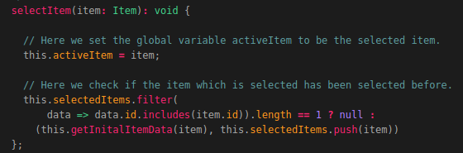
Above we created a function called: "selectItem".This function is triggered when one of the items in the ItemList is clicked using the drop-down menu in the application. The item that is clicked is then passed as parameter in this function.
When the function is triggered the follow steps are performed:
- The selected item becomes the activeItem.
- The function: ".filter()" is executed on the global JavascriptMap: "selectedItems".
This JavascriptMap contains all the items that are have been selected.The filter function is used to check whether the id (From the item that is being selected) is already in the list assigned to the global variable: "selectedItems". If this is the case nothing will happen since the Item was already selected.
If the itemId, of the item that is being selected, is not in the list of selectedItems the following will happen:
  - The function: "getInitalItemData()" will be triggered. In the function the item will be passed. This function will retrieve the first 100 transmissions / signals belonging to that item.
  - The item is added to the selectedItems list.
As you can see we used the function: “getInitialItemData()” which has not been defined yet. So let’s do this now by adding the following code below the function:”selectItem()”:
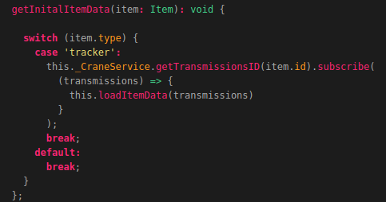
Above we created a function called: "getInitalItemData()" This function is called in the function: "selectItem()" IF the item that is being selected has not been selected yet (so is not in the selectedItems list). The item from which the data has to be retrieved is then passed as parameter in this function.
This function contains a switch/case. The switch case takes the itemType, which in our case can be a tracker or a trail, as input. Depending on the itemType the corresponding function is in the services is triggered.
The reason we add a switch/case in the function is because when we want other types of datasets we can easily create new cases and add the code, related to triggering a function in the service for performing API calls, to those cases.
The data obtained from the function which is triggered in the service, will then be passed as parameter in the function: "loadItemData()". The function loadItemData() will then assign the returned data to the item which was selected in the function: "selectItem()". We did not create the function: “loadItemData()” yet so let’s do this now.
The function loadItemData() has not been created yet, we are going to do this in the next chapter. But first we want to add another drop-down menu to our settings menu in the map.component.html file.
First we want to create a div element which is only shown in our web application when the amount of selected items is bigger than 0.

We do this by adding the following code below the div element with the id: “itemSelection”.
The rest of the settings we are going to add to our 2D map viewer will be added in this div element. In the div element we want to add a new drop-down box which will contain all the items that have been selected. We do this by adding the following code:
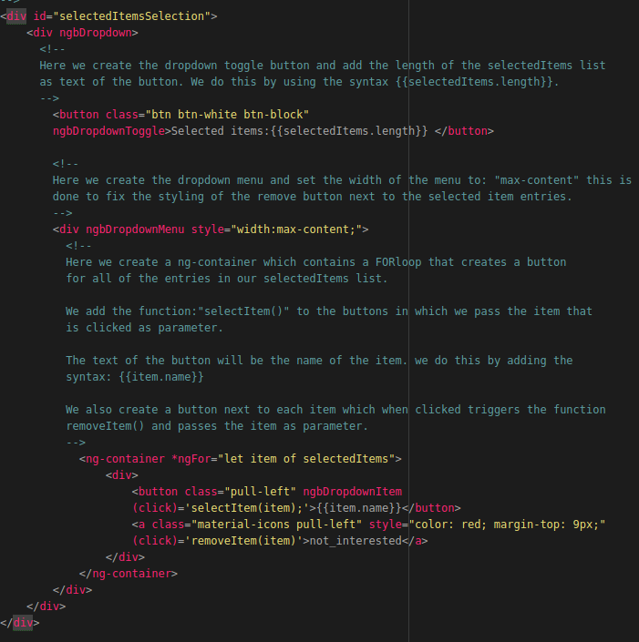
The function: “removeItem()” has not been created yet. We are going to do this later. First we want to create a function which loads the item data, which is retrieved from the MongoDB datastore, when an item is selected. We are going to do this in the next section.

4.2.5 Loading Item data
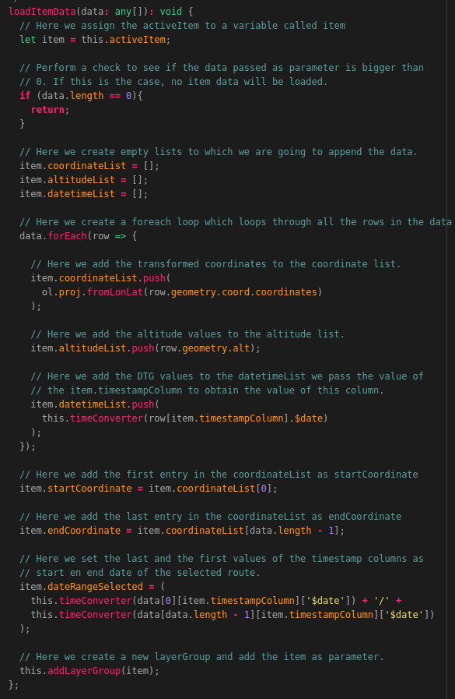
To load the item data we first need to create a function called: “loadItemData()”. We are going to create this function by adding the following code below the getInitialItemData() function:
Above we created the function called: "loadItemData()".This function is called in the following functions which we are going to add later:
- getInitalItemData()
- getItemDataByDTG()
- getItemDataByAmount()
- getItemDataByCountry()
Each of these functions obtain data from the MongoDB datastore and pass the returned data to the function "loadItemData()" as parameter.
The function then does the following:
- Assign the activeItem to a variable called: "item". This is done so we only need to use the variable item instead of code: "this.activeItem".
- Check whether the data passed as parameter is not empty. If the data is empty the function will return because there is no data to be loaded.
- Set the value of the coordinateList, belonging to the item, to an empty list.
- Set the value of the altitudeList, belonging to the item, to an empty list.
- Set the value of the datetimeList, belonging to the item, to an empty list.
- Execute a forEach loop on the ItemList, the foreach loop does the following for all the rows in the list of data:
  - Obtain the value of the coordinates and transform them to a format which can be used with OpenLayers. For this we use the the syntax: "ol.proj.fromLonLat()", in which we pass the value of the coordinate column as parameter. After the coordinate has been transformed it is added to the coordinateList belonging to the item.
  - Obtain the value of the altitude column and append it to the altitudeList belonging to the item.
  - Obtain the value of the timestamp column and append it to the datetimeList belonging to the item.
- Assign the first value of the coordinateList (the value at index 0) to the variable: "startCoordinate".
- Assign the last value of the coordinateList (the value on the index (length of the list of data passed as parameter – 1)) to the variable endCoordinate.
- Create a list containing the first item in the datetimeList and the last item of the datetimeList, created in step 5.3, and assign it to the variable: "dateRangeSelected".
- Trigger the function: "addLayerGroup()", and pass the activeItem as parameter. The function: "addLayerGroup()" wil then create the first layerGroup.
The function addLayerGroup() has not been defined yet. We are going to do this in the next section. First we want to create a new drop-down menu in our HTML page which is used to display info related to the selected route.

For this we going to add the following code below the div element with the id: “selectedItemsSelection”:
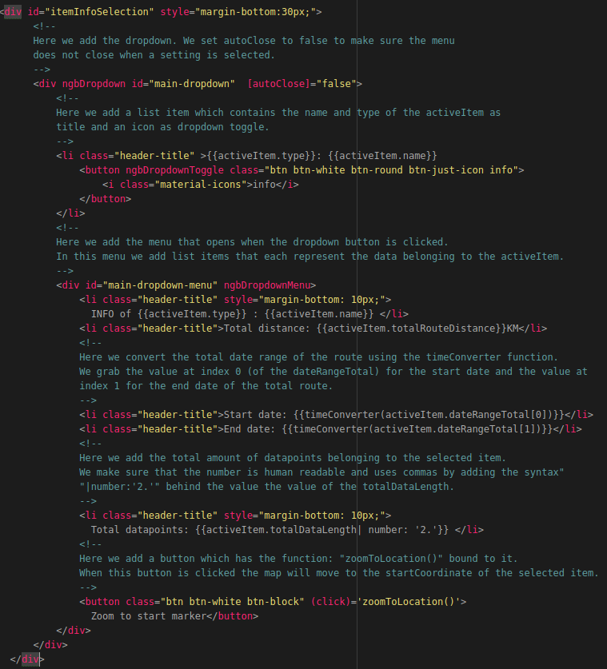

The function: “zoomToLocation()” has not been created yet. So let’s create this function by adding the following code below the function:”loadItemData()” in the map.component.ts file:
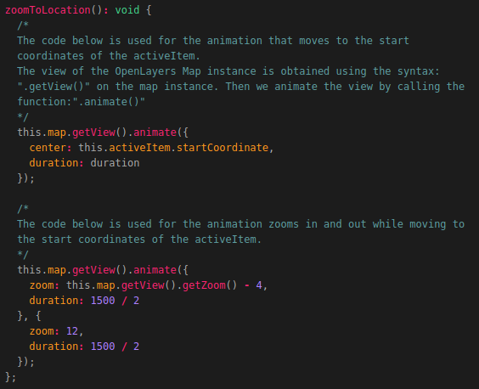
Above we created a function called: "zoomToLocation()". This function is assigned to the button: "Zoom to start", defined in the HTML file of the MapComponent. The function gets the current view and animates it to move to the start coordinates of the item on which the: "zoom to start" button is clicked. There are 2 animations which are executed, these are as follows:
- Move to the location of the startCoordinate;
- Zoom out and in again on the startCoordinate.
The value: "1500" defines the amount of time it takes for the animation to complete. You can increase or decrease it if you want. Now when we select a new item we can display information related to that item and zoom to the start location as shown in the illustration below.
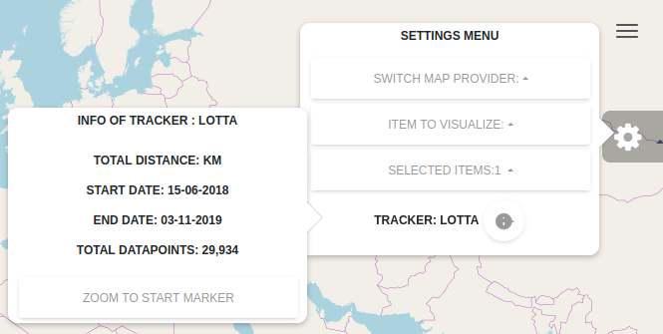
At this point no data is shown on the map yet. We are going to add this functionality in the next section.

4.2.6 Creating and setting Layer groups
In this section we are going to add the code which is used to actually visualize the selected data obtained from our MongoDB datastore. We are going to visualize the data by adding extra layers on the base layer which we defined earlier in this document. The layers we are going to be creating are as follows:
- A pointLayer: This is the layer which will contain the arrows that visualize the direction in which the item is going.
- A markerLayer: This layer contains the start and end marker of the visualized route.
- A lineLayer: This is the layer that creates the lines between the datapoints.
Before creating the function which is used to create the layers we need to create a global variable called:”layerStyles”. This variable is going to contain the default styling of the layers which we will be creating. To create this global variable we need to add the following code below the global variable called:”activeItem”:
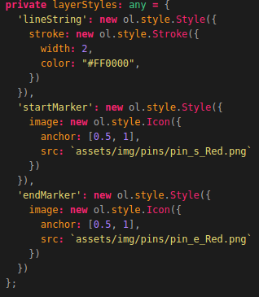
Above we created a global variable called: "layerStyles". The value of this variable is a dictionary that contains the default styling of the layers.
To create a line we use the OpenLayers style: "Stroke". We give the stroke a width and a color.
To create a marker we use the OpenLayers style: "Icon". We pass the location of our pins (located in the assets/img folder of our application) as data source of the icon. We also anchor the icon to be displayed above the data point.
Now we want to create the function: “addLayerGroup()’, which is triggered in the function: “loadItemData()”, which we created in the previous chapter. First an explanation related to the function we are going to add is given using the inline-comments found in the source code located in the POC folder.
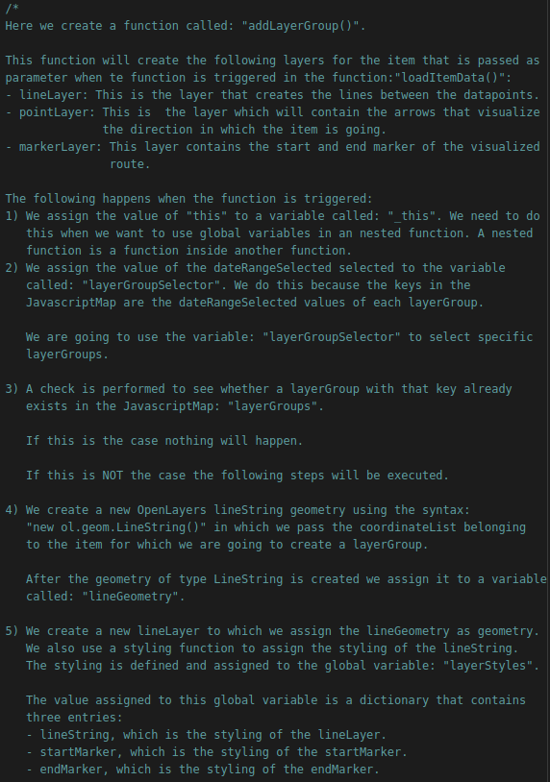

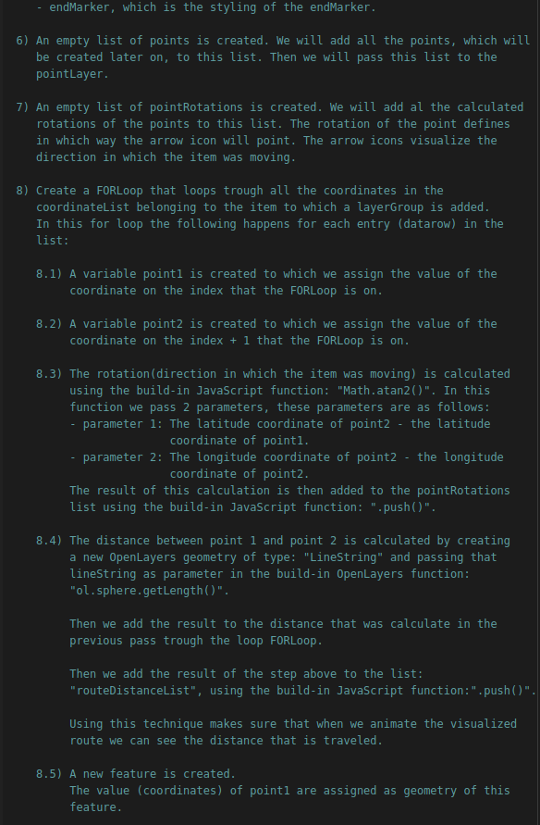

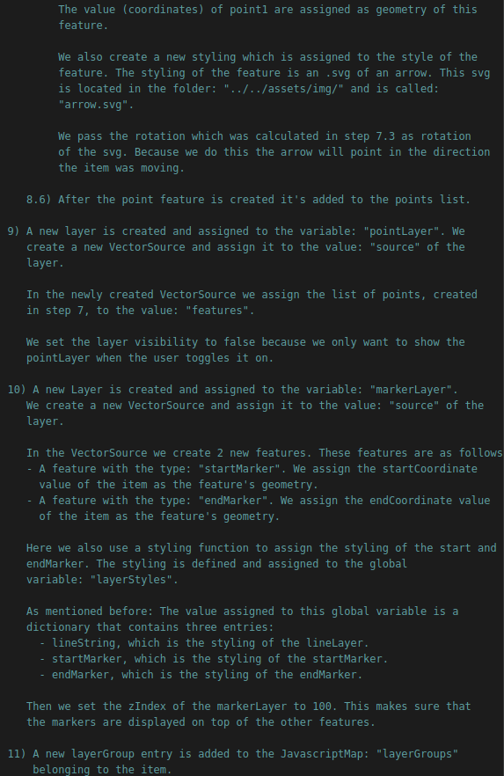

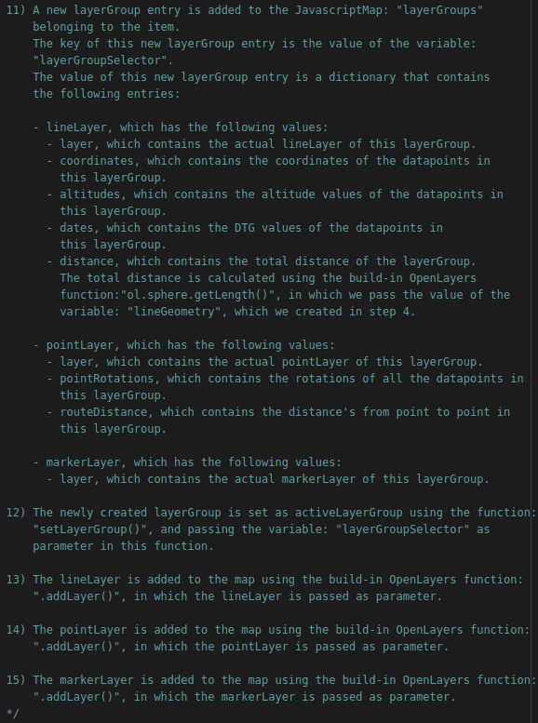
On the next pages the images will follow related to actually creating the function.

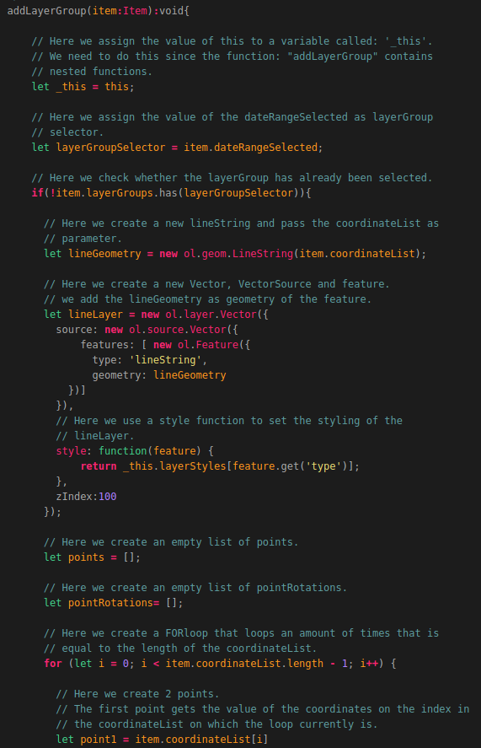

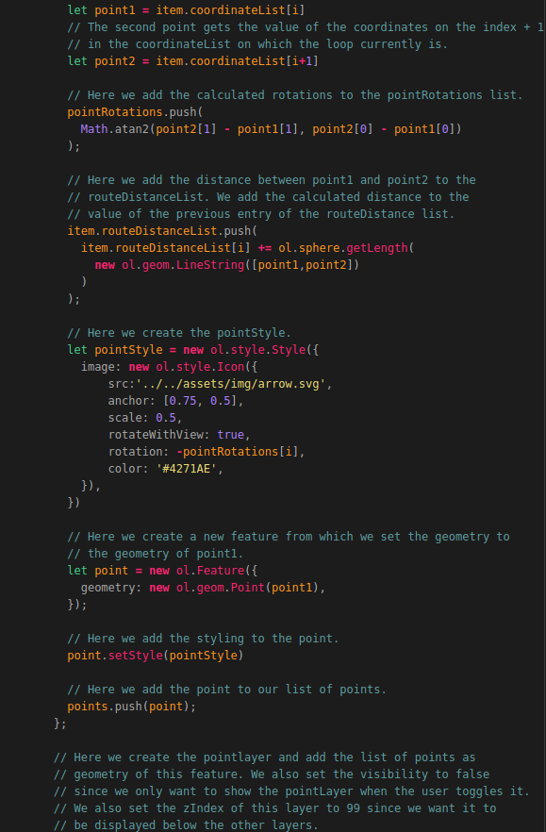

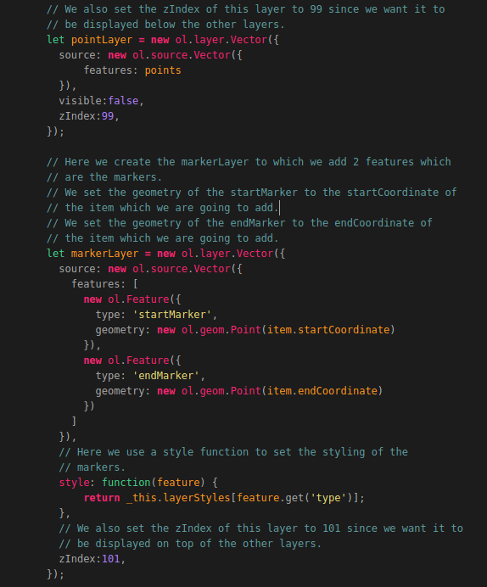

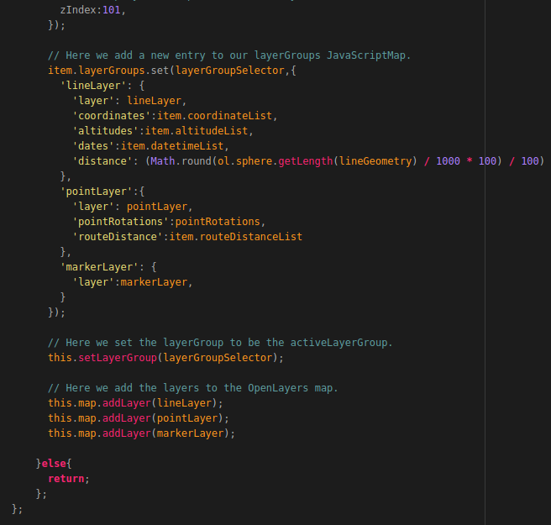
That’s it! Now we have created the function that creates all our layers and adds them to the map and the item’s layerGroups list.
The function: “setLayerGroup()” has not been created yet. So let’s create this function.
Create function setLayerGroups
add function addLayerGroup to function LoadItemData
Add HTML for DTG selection

4.2.7 Creating and setting Overlays
Adding overlay html divs to HTML file
Create function addOverlays()
add Adoverlays function in the CreateMap function()
add setDynamicOverLayes function()
add setStatiocOverlays function()
add setStaticOverlays function to selectItem function and to loaditemdata function and to setLayergroup function

4.2.8 Removing a selected Item
Add fcuntion removeItem

4.2.9 Removing a LayerGroup
Add function removeLayerGrooup

4.2.10 Adding DTG selection
Create function for getting DTG item data
Create DTG picker component folder
create HTML DTG Picker
Create TS DTG picker
Import and add datepicker to app.module.ts
add dateRange as global variable
add getDTGEvent function
add html to dtgSelection
add this.dateRange = this.activeItem.dateRangeTotal; to the selectItem function

4.2.11 Adding Amount selection
Now that we have most of our functionalities in place we want to be able to select a desired amount of transmissions or signals.
We do this by adding a function that triggers the function in our service that is related to performing an API call to obtain a certain amount of data.
We need to add the following code below the function: “getDTGEvent()”:
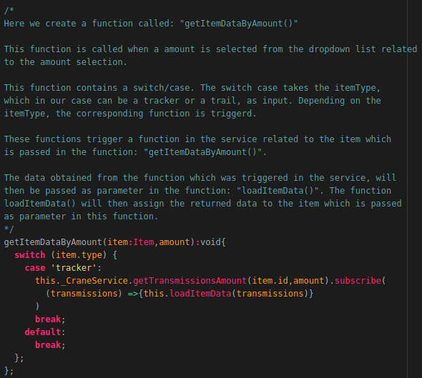
Now we need to add a drop-down box which is used to trigger this function.
How this is done is shown on the next page.

To create a dropdown box for the amount selection we need to add the following code to the map.component.html file below the div element with the id:”dateSelection”:
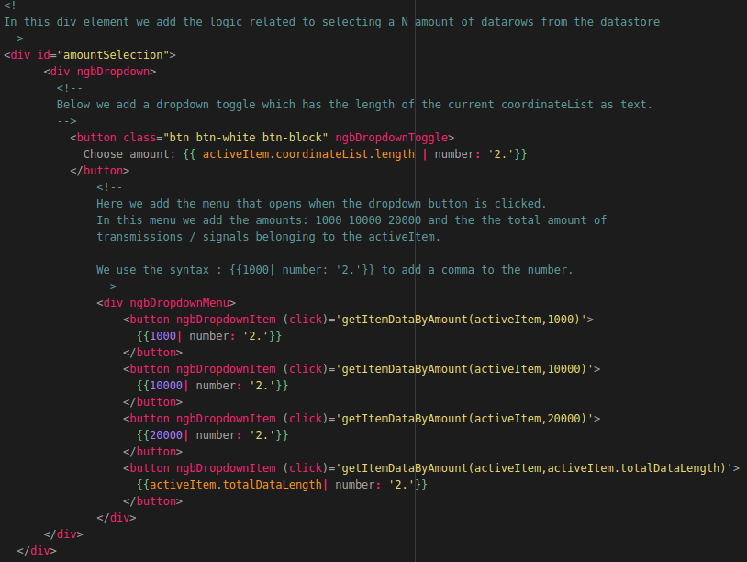
Now when we reload the application we get the option to select an amount of transmissions / signals from the dropdown box as shown in the illustration below.
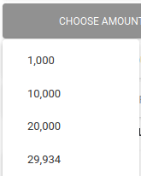

4.2.12 Adding Country selection
Add global variable country selection
Create function for getting selection by country
Add HTML for amount selection

4.2.13 Adding Layer and Overlay Toggling
Add toggleLayer function
add toggleOverlay function
add HTML

4.2.14 Changing layer styling
Add global colorlist, widthlist , linestylelist
Add global dictionary styleDict
Add function setLayerStyles()
Add HTML

4.2.15 Animating routes
Add animateRoute function
Add clea Animartion fucntion
add HMTL

4.2.16 Creating an elevation profile
Add globals private elevationProfile:any;
private elevationProfileOpen:boolean;
Add loadElevationData function
Add createLEevationProfile fucntion
add html

