
CREATING AN 2 DIMENSIONAL
MAP VIEWER
Programming Manual
Version : 1.0

Date :08-04-2020

Author :The GeoStack Project

Purpose of this document
This programming manual serves as an extension for the following documents:
- Cookbook: Creating the GeoStack Course VM:
The datastores, tools and libraries used during this programming manual are installed and created in the cookbook: Creating the GeoStack Course VM.
- Cookbook: Creating a basic web application:
The base application of this Dataset Dashboard has been created during the cookbook: Creating a basic web application.
- Cookbook: Data modeling in MongoDB using MongoEngine:
The data used during this cookbook, is modeled, indexed and imported in the cookbook: Data modeling in MongoDB using MongoEngine.
- Programming manual: Creating the Python-Flask web application:
The middleware that will be used during this programming manual is created in the programming manual: Creating the Python Flask web application.
If you have not read these documents yet, please do so before reading this document.
The purpose of this programming manual is to create an 2D map viewer application using the AngularJS JavaScript framework and OpenLayers 6. This application is an extension of our Angular base application.
The Angular apps will perform API calls to our Flask application and our Flask application will then retrieve the requested data via queries, performed on our datastores. The results are then returned to our Angular applications.
This programming manual serves as a guideline for the steps you have to perform to create a 2D Map Viewer using OpenLayers and visualize the data retrieved by the Flask-API.
During this programming manual the code is explained using the inline comments in the source code located in the folder: “POC”. It’s highly recommended to use the source code provided in this folder when creating the web application yourself.
NOTE: Sometimes you will notice that in the code which you have to create some functions do not exist yet. Don’t worry about this since they will be added later on during the programming manual!
Table of Contents
Purpose of this document 2
1.Introduction 4
1.1 Getting ready 4
1.2 Adding the Geospatial framework OpenLayers 5
2. Creating the services 5
2.1 The map service 5
2.2 The Crane service 6
4. Creating the 2D Map page 10
4.1 Creating the Map Component base 11
4.1.1 Creating the base of the settings menu 14
4.2 Creating the Map Component functionality 15
4.2.1 Creating the OpenLayers Map 15
4.2.2 Switching between map providers. 17
4.2.3 Adding items 19
4.2.4 Selecting items 24
4.2.5 Loading Item data 28
4.2.6 Creating and setting Layer groups 32
4.2.7 Creating and setting Overlays 33
4.2.8 Removing a selected Item 33
4.2.9 Removing a LayerGroup 33
4.2.10 Adding DTG selection 33
4.2.11 Adding Amount selection 35
4.2.12 Adding Country selection 37
4.2.13 Adding Layer and Overlay Toggling 37
4.2.14 Changing layer styling 37
4.2.15 Animating routes 37
4.2.16 Creating an elevation profile 37

1.Introduction
During this chapter we are going to convert the basic web application in such a way that we can start coding the 2D Map Viewer application. We do this because the base application contains the base structure of the 2D Map viewer application which we are going to create during this programming manual. As mention before; if you did not read the programming manual: “Creating a basic web application” you should read it before continuing this programming manual.

1.1 Getting ready
Since this application is an extension of the base-application we can copy this application and start creating the 2D map viewer from there. After we copied the base-application folder, we need to change some names and titles to make the new application the 2D map viewer. We start by changing the name of the folder we just copied from base-application to 2d-map-viewer, as shown in the image below.


We also need to edit the project name: “base-application” to “2d-map-viewer”. If you are using the code-editor Atom, this is done by performing the following steps:
- In the editor press the key combination Ctrl + shift + f on your keyboard.
- In the screen that pops up enter: “base-application” in the find section and “2d-map-viewer” in the replace section, as shown in the illustration below. Then click on find all.

- Click on replace all and on the save button in the screen that pops up.


- In the file called: “index.html” which is located in the folder 2d-map-viewer/src, replace the title from BaseApplication to 2D Map Viewer.
- In the file: sidebar.component.html located in the folder src/app/components/sidebar/, change the text: “Base Application” to “2D Map Viewer.”

1.2 Adding the geospatial framework OpenLayers
Adding a geospatial framework to our Angular application can be done in 2 ways which are as follows:
- Installing the NPM Package: “Ol”:
This is the first technique which you can use to install OpenLayers in your application. During this programming manual we will not be using this technique. If you want to read up on using this technique you should visit the following URL: https://www.npmjs.com/package/ol
- Downloading the OpenLayers source code:
During this programming manual we are going to use this technique. We do this because, from the version control point of view, this method is the best method since there are no files added to the Node_Modules folder of the application. Using this technique we are going to add the geospatial framework as static files in the assets folder of our application. This enables us to easily switch to a newer or older version of the geospatial framework.
First we want to download the OpenLayers source code from the OpenLayers Github repository which is located on the following URL:
https://github.com/openlayers/openlayers/releases/download/v6.2.1/v6.2.1-dist.zip
When the download is complete you want to extract the folder somewhere, after which you want to create a new folder in the assets folder of our 2d-map-vierwer.
We do this by running the following command:
mkdir ~/Geostack/angular-apps/2d-map-viewer/src/assets/geospatial-frameworks
Copy the extracted OpenLayers folder to the folder we just created.
Add the following lines inside the <head> element from the index.html file located in the folder 2d-map-viewer/src/app/.
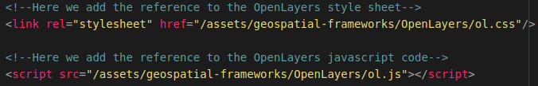
Now we will be able to use the geospatial framework OpenLayers in our application.
If you want to upgrade to a newer or older version of OpenLayers you can use the same technique as mentioned above but then with the desired version from the OpenLayers Github repository.

2. Creating the services
Now let’s start of with creating the services that contain the functions to retrieve data from our datastores. We need 3 services which are a map service in which we are going to add the functions that retrieve the Tilestache entries from our Tileserver and a Crane service which contains all the functions related to performing API calls to our Flask-API to obtain the Crane Tracker data from our MongoDB datastore.
NOTE: In the folder “POC” you can also find the service which is required to perform API calls to our Flask-API to obtain the GPS-Route (Trail) data from our MongoDB datastore. This is not described in this cookbook since it’s basically the same as the code for the Crane Trackers.

2.1 Creating the map service
To create the map service we first need to create a new TypeScript file called:”map.service.ts“. We do this by running the following command:
touch ~/Geostack/angular-apps/2d-map-viewer/src/app/services/map.service.ts
Now let’s open this file and import the basic Angular modules at the top of this file by adding the following code:

Now we want to create the class and it’s constructor for the Map service. This is done by adding the following code below the line: “@Injectable()”:

Now we want to add a function that is able to retrieve all the entries in our Tilestache Tileserver.
Now we want to add a function that is able to retrieve all the entries in our Tilestache Tileserver. This is done by adding the following function in the class: “MapService ”below the constructor:
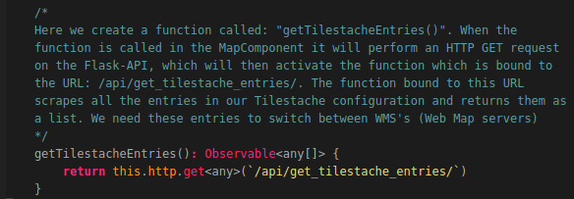
That’s all! Now we have created a function that can perform an API call to obtain all the WMS entries in our Tilestache configuration.

2.2 Creating the Crane service
Let’s create the Crane service to which contains all the functions required to retrieve data from our MongoDB datastore. To create the Crane service we first need to create a new TypeScript file called:”crane.service.ts“. We do this by running the following command:
touch ~/Geostack/angular-apps/2d-map-viewer/src/app/services/crane.service.ts

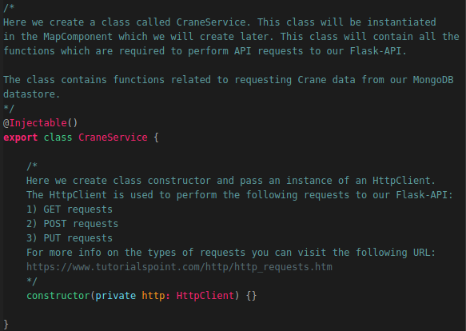
Now let’s open this file and import the basic Angular modules at the top of this file by adding the following code:
Now we want to create the class and it’s constructor for this service. This is done by adding the following code below the module imports:

Now we want to add 6 functions to retrieve data from our MongoDB datastore, these functions are as follows:
- getTrackers() to obtain all the trackers in our database.
- getTracker() to obtain one tracker using the MongoID.
- getTransmissionsID to obtain all transmissions belonging to a tracker.
- getTransmissionsAmount to obtain a N amount of transmissions belonging to a tracker.
- getTransmissionsDTG() to obtain all the transmission in a given timeframe.
- getTransmissionsCountry() to obtain all the transmissions in a given polygone.
So let’s add a function that is able to retrieve trackers in our MongoDB datastore. This is done by adding the following function in the class: “CraneService ” below the constructor:
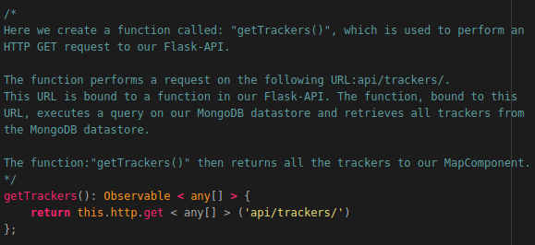
Now let’s add the function to obtain a specific tracker using it’s MongoID, we do this by adding the following function below the function we created above:

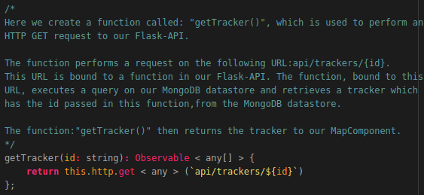

Now let’s add the function which obtains all the transmissions belonging to a tracker, we do this by adding the following code below the function we created above:
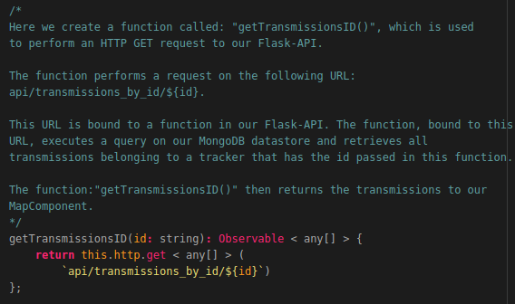
Now we want to create the function that obtains a N amount of transmissions belonging to a tracker. We do this by adding the following code below the function we created above:
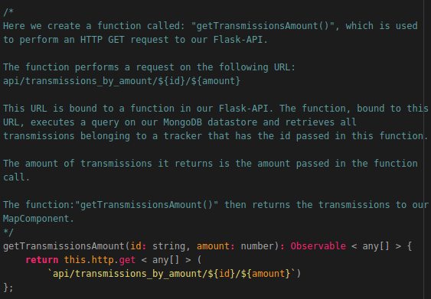

Now let’s add the function which obtains all the transmissions belonging to a tracker in a given time frame, we do this by adding the following code below the function we created above:

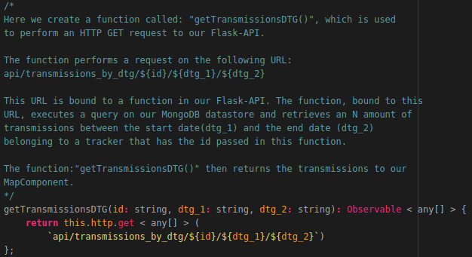
Finally we want to add the function which obtains all the transmissions belonging to a tracker in a given polygon, we do this by adding the following code below the function we created above:

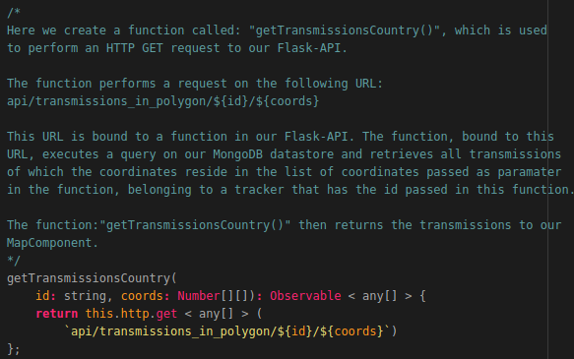
That’s it! Now we have created the service that contains functions which can perform an API call to obtain data from our MongoDB datastore.

2.3 Creating the Port service
Let’s create the Port service to which contains all the functions required to retrieve the World Port Index data from our PostgreSQL datastore. To create the Port Service we first need to create a new TypeScript file called:”port.service.ts“. We do this by running the following command:
touch ~/Geostack/angular-apps/2d-map-viewer/src/app/services/port.service.ts

Now let’s open this file and import the basic Angular modules at the top of this file by adding the following code:

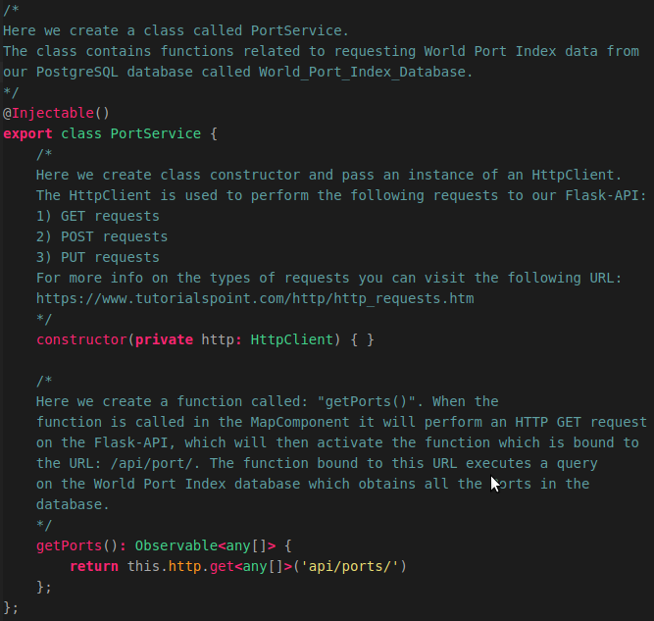
Now we want to create the class and it’s constructor for this service we also add the function which is used to perform the API request on the Flask-API. This is done by adding the following code below the module imports:

4. Creating the 2D Map page
To create the map page we first have to add a new folder to our pages folder in our web application. We do this by running the following command:
mkdir ~/Geostack/angular-apps/2d-map-viewer/src/app/pages/map-page
In that folder we need to create 2 files which are a map.component.ts and map.component.html. We do this by running the following commands :
touch ~/Geostack/angular-apps/2d-map-viewer/src/app/pages/map-page/map.component.ts && touch ~/Geostack/angular-apps/2d-map-viewer/src/app/pages/map-page/map.component.html
Now that we have created the required files we can start creating the basic structure of our map page.

4.1 Creating the Map Component base
We want to start of with importing the Angular modules required to create the map component in the map.component.ts file, so let’s open this file and add the following code:

Next we want to import the map service and the crane service, we do this by adding the following code to the file:
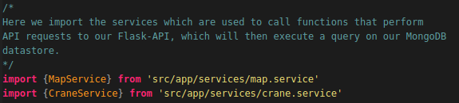
Now we want to create a global variable which is required to use the OpenLayers code throughout our map component. We do this by adding the following code:


Now we want to create the component metadata for our map component. We do this by adding the following code:
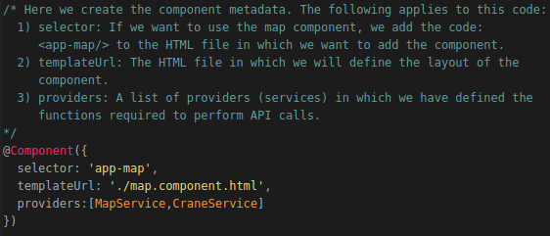
Now we want to create the base of our map component. We do this by adding the following code below the metadata:
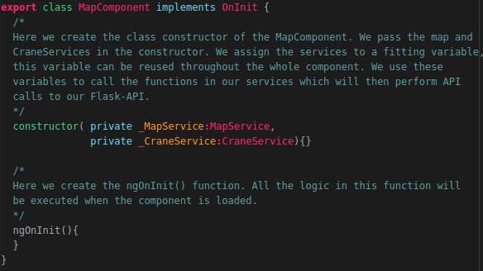
Now we want to add a div element to our map.component.html file. This div element is going to contain our OpenLayers map after we create it. So let’s open the html file and add the following code:

Now we want to make the map page available in our 2D map viewer application. We do this by adding the component to our app.module.ts file.
So let’s open this file and import the map component by adding the following code below the last import:

Next we want to add the imported component to the declarations section in the app.module.ts file. The final declarations section will look the same as shown in the illustration below:

Now we need to add a new route to our app-routing.module.ts file. First we need to import the map component. We do this by adding the following code below the last import in that file:

Then we need to add the new route to our routes in this file. We do this by changing the current routes to the following:

Now we want to add a new entry to our sidebar. This is done in the file: sidebar.component.ts,
located in the folder: src/app/components/sidebar/. So let’s open this file and add a new route

to our route list. The final code will be the same as shown in the illustration below.
Now when we start our application we will be greeted with the the new page. The page does not have any content yet so we are going to add this now.

4.1.1 Creating the base of the settings menu

We want to start of by adding the base of the settings menu to our map.component.html file. We do this by adding the following code to this file:
Now when we reload the application a drop down button will be displayed. When we you click the button an empty dropdown menu will pop up.

4.2 Creating the Map Component functionality
In this chapter we are going to add all the functionality to our OpenLayers Map. We want to start of by creating the OpenLayers map itself.

4.2.1 Creating the OpenLayers Map
We want to start off by creating the OpenLayers map. First we need to define a global variable called map. We do this by adding the following code below the line where we defined the class name: MapComponent:
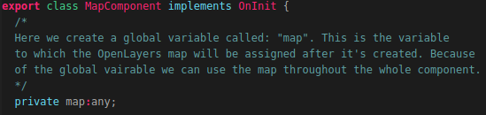
Note: In the illustration above the line where we defined the class name is also included. You don’t need to add this again.
Next we have to create an global JavaScriptMap which is going to be populated with all the entries from our Tileserver after the function is called related to retrieving the Tileserver entries. We do this by adding the following code below the code we added above:
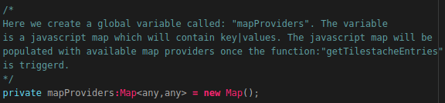
Next we need to create a global variable which is going to contain the base layer of the OpenLayers map. We do this by adding the following code below the code we added above:
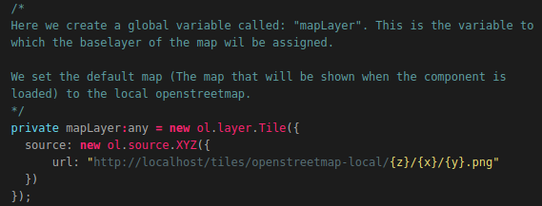

Next we want to create a function that calls the function: “getTilestacheEntries()” in our mapservice. We do this by adding the following code below the ngOnInit() function:

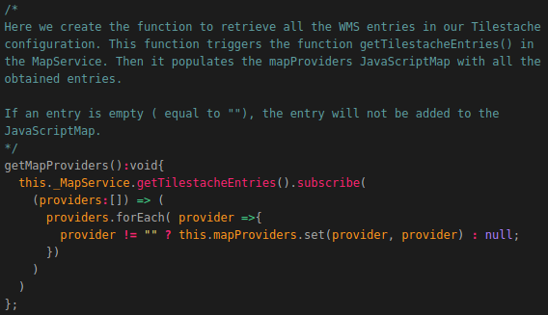
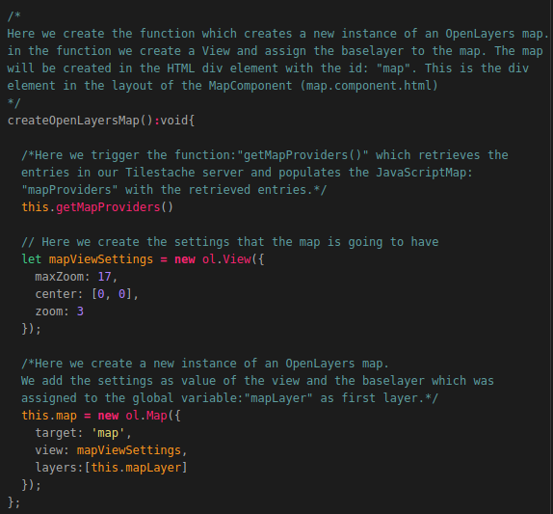
Next we want to create a function that actually creates the OpenLayers Map. We do this by adding the following code below the function we created above:
Now we want to add the function we just created to the ngOnInit() function so that it’s triggered when the map component is loaded. The function will look the same as shown in the illustration below after you added the function: “createOpenLayersMap()”.

Now when you start the Tileserver and reload the application you will be greeted with a map that shows the local OpenStreetMap map as base layer on the OpenLayers Map.


4.2.2 Switching between map providers.
Now we want to add the functionality for us to be able to switch between map providers. For this we first need to create a new function in the map.component.ts file. We do this by adding the following code below the function: “getMapProviders()”:
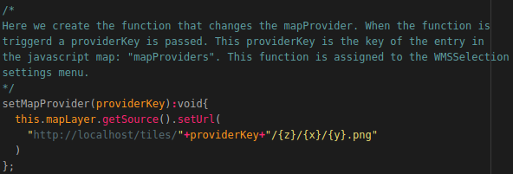

Now we need to add some code to the settings menu in our map.component.html file. So let’s open this file and add the following code in the div element with the id:”settings”:
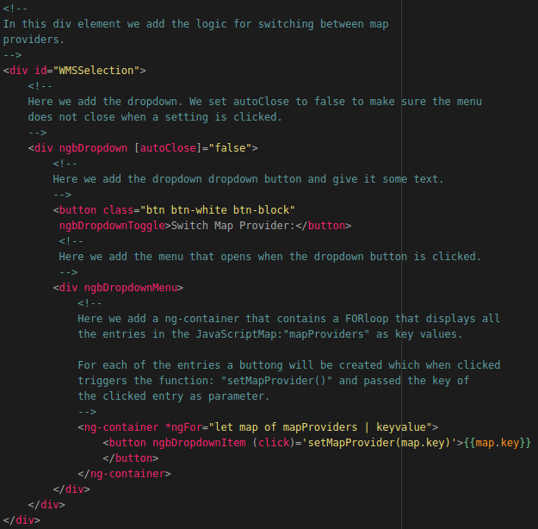
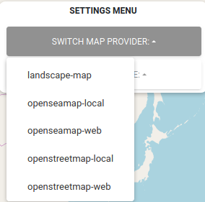
Now when we reload the page we get a new option in our settings menu which if we click shows all the entries in our Tileserver. If we click on an entry the map will change.

4.2.3 Adding items
Now we want to create the functionality for adding items (Trackers or trails) which are obtained from our MongoDB datastore to the web application. For this we are first going to create a class called:”Item” which serves as a template for each item that is added after being selected.
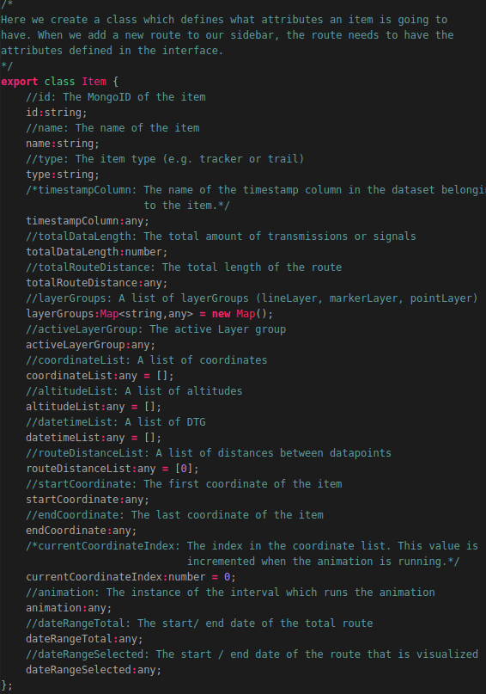
We are going to add the class below the global constant: “ol” which we defined at the beginning of this document. To create this class we are going to add the following code:
Now that we have created the Item class we need to add a global variable called: “Items”. The type of this global variable is a list of items. We create this variable by adding the following code below the code we created above:
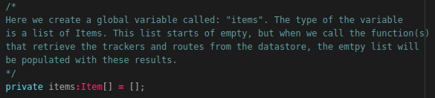
Now we need to create a function that triggers the function in our services related to retrieving the data from our datastore. We do this by adding the following code below the function:”createOpenLayersMap()”:
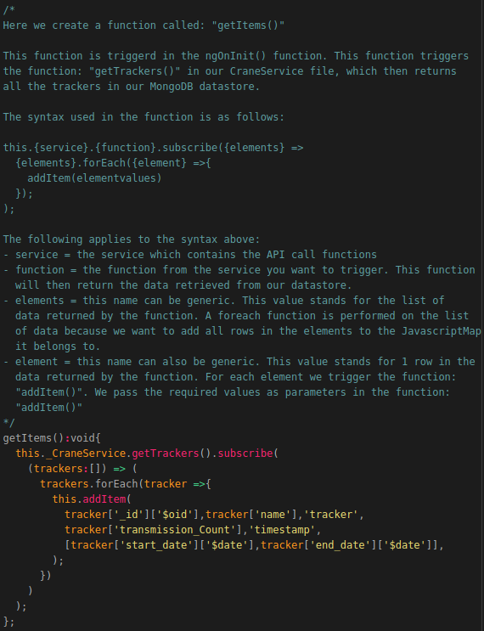
As you can see in the function we just created we use a function called: “addItem” which we have no defined yet, so let’s do this by adding the following code below the function:”getItems()”:
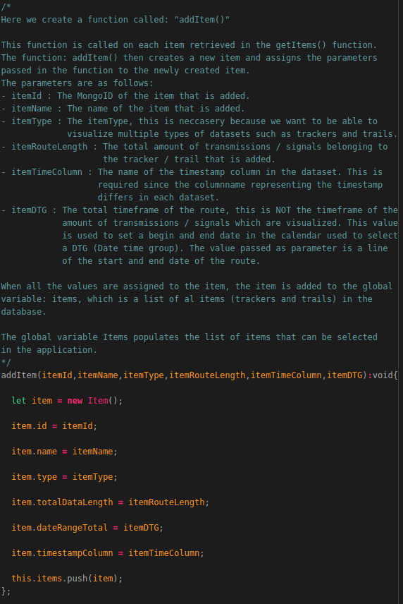
Now we need to add the function:”getItems()” to our ngOnInit() function so that the items are obtained from our datastore when the map component is loaded. The final ngOnInit() function will look the same as shown in the image below:
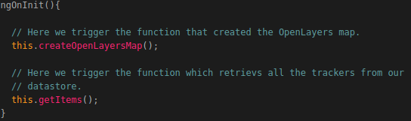
Now when you start your Flask-API and reload the web application the data will be available in our web application.
At this point we cannot select any items yet. To solve this we need to add another dropdown menu to our map.component.html file. We add this html code in the div element with the id:”settings” and below the div tag with the id: “WMSSelection”.
NOTE: The following image will consist of 2 images. The last line of the first image is the same as the first line of the second image.
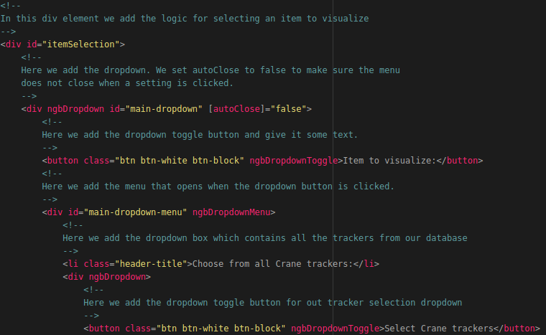
The second part of the HTML code that you have to add is shown on the next page.

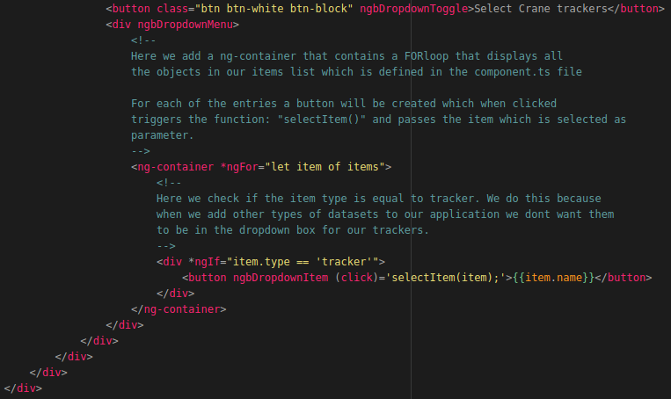
Now when we reload the web application click on the new dropdown box in our settings menu we will see all the trackers in our MongoDB database, as shown in the illustration below.
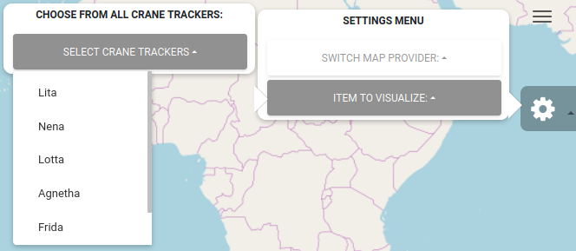
When we select an item from the drop-down list nothing will happen. To fix this we need to add some extra functionality to the map.component.ts file.
We are going to do this in the next chapter.

4.2.4 Selecting items
To be able to actually select items we first need to add a new global variable called: ‘selectedItems”. We do this by adding the following code below the global variable:”items”:
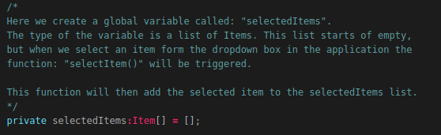
We also want to create a global variable called:”activeItem”. We do this by adding the following code below the selectedItems variable:
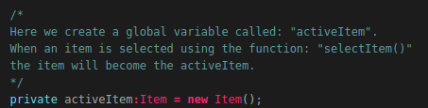
Next we want to create the function which is triggered when a item is selected from the item Selection drop down box in the application.
NOTE: The image below consists of 2 parts. The last line of the first image is the same as the first line of the second image.
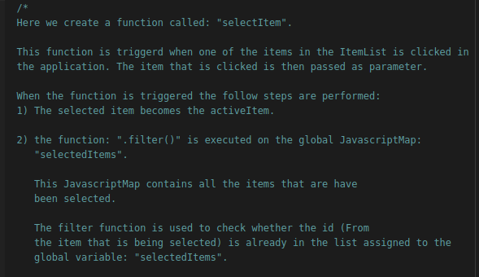

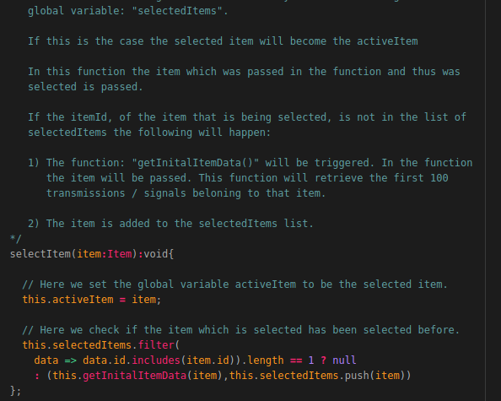
The function: “getInitialItemData()” has not been defined yet. We are going to create this function on the next page.

So now we need to create a function which when triggered triggers a function in the service related to the itemType which was selected. To be able to do this we add the following code below the selectItem() function:
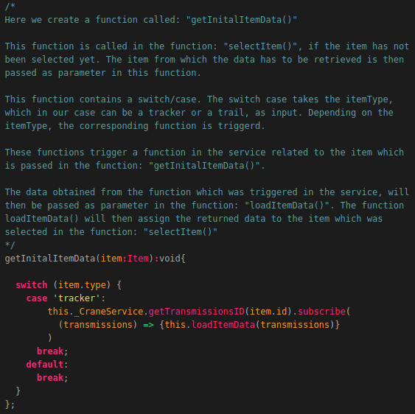
The reason we add a switch/case in the function is because when we want other types of datasets we can easily create new cases and add the code, related to triggering a function in the service for performing API calls, to those cases.
The function loadItemData() has not been created yet, we are going to do this in the next chapter. But first we want to add another dropdown box to our settings menu in the map.component.html file.
How this is done is shown on the next page.

First we want to create a div element which is only shown in our web application when the amount of selected items is bigger than 0.
We do this by adding the following code below the div element with the id: “itemSelection”.

The rest of the settings we are going to add to our 2D map viewer will be added in this div element. In the div element we want to add a new dropdown box which will contain all the items that have been selected. We do this by adding the following code:
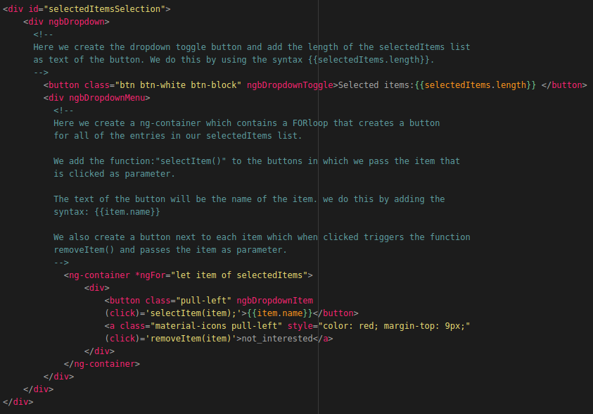
The function: “removeItem()” has not been created yet. We are going to do this later. First we want to create a function which loads the item data, which is retrieved from the MongoDB datastore, when an item is selected. We are going to do this in the next chapter.

4.2.5 Loading Item data
To load the item data we first need to create a function called: “loadItemData()”. We are going to create this function by adding the following code below the getInitialData() function:
NOTE: The image below consists of 3 parts. The last line of the first image is the same as the first line of the second image and the last line of the second image is the same as the first line of the third image.
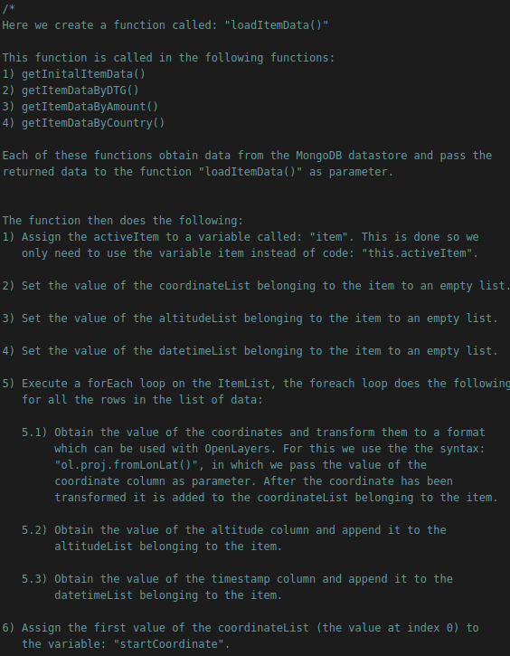

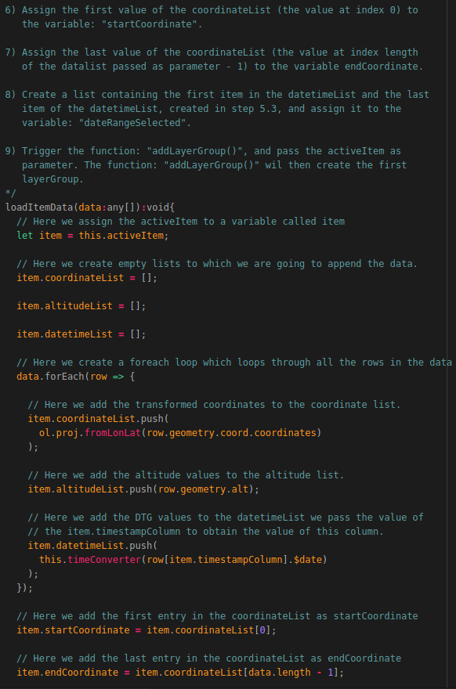

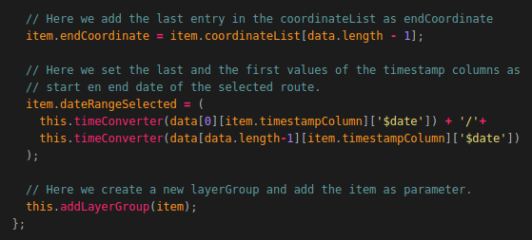
The function addLayerGroup() has not been defined yet. We are going to do this in the next chapter. First we want to create a new dropdown box in our HTML page which is used to display info related to the selected route. For this we going to add the following code below the div element with the id: “selectedItemsSelection”:
NOTE: The image below consists of 2 parts. The last line of the first image is the same as the first line of the second image.
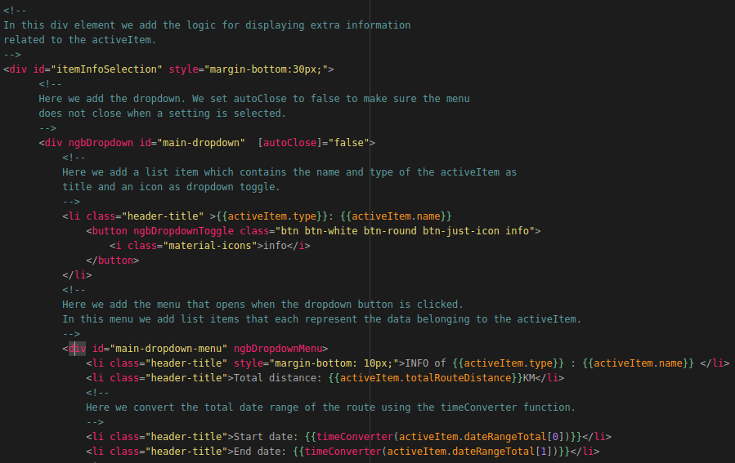

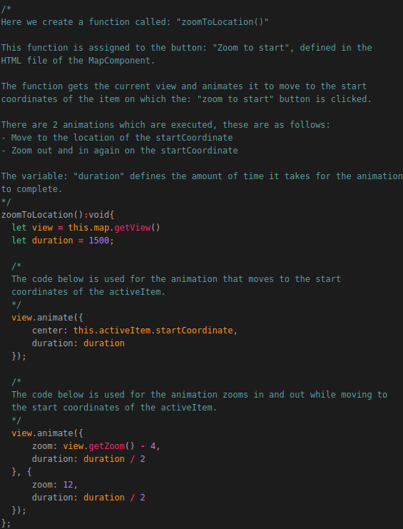
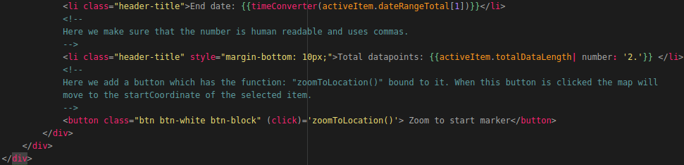
The function: “zoomToLocation()” has not been created yet. So let’s create this function by adding the following code below the function:”createOpenLayersMap()”:
Now when we select a new item we can display information related to that item as shown in the illustration below. We can also zoom in to the start Coordinate of the selected route. At this point no data is shown on the map yet. We are going to add this functionality in the next chapter.
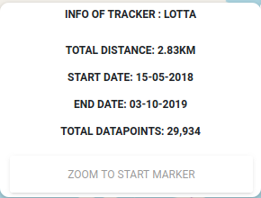

4.2.6 Creating and setting Layer groups
Now we are going to add the functionality to actually visualize the selected data obtained from our MongoDB datastore by creating layers.
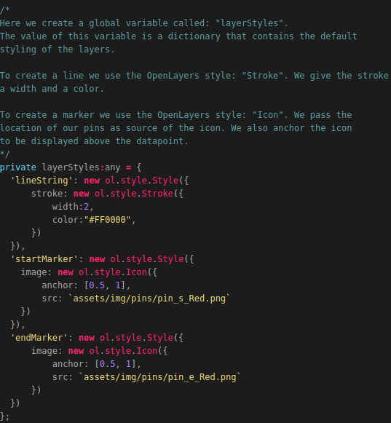
First we need to create a global variable called:”layerStyles”. This variable is going to contain the default styling of the layers we are going to create. To create this global variable we need to add the following code below the global variable called:”activeItem”:
Now we want to create the function: “addLayerGroup()’, which is triggered in the function: “loadItemData()”, which we created in the previous chapter. First an explanation related to the function we are going to add is given using the inline-comments found in the source code located in the POC folder.
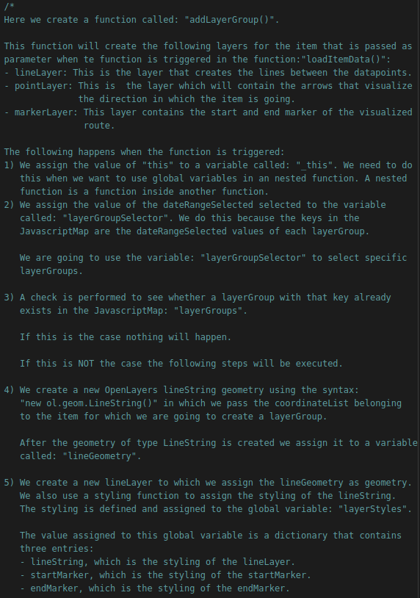

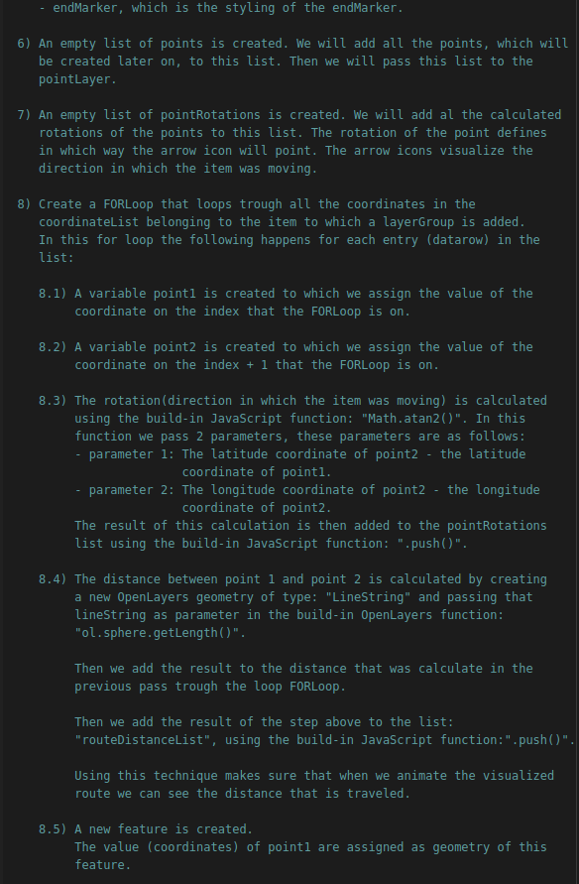

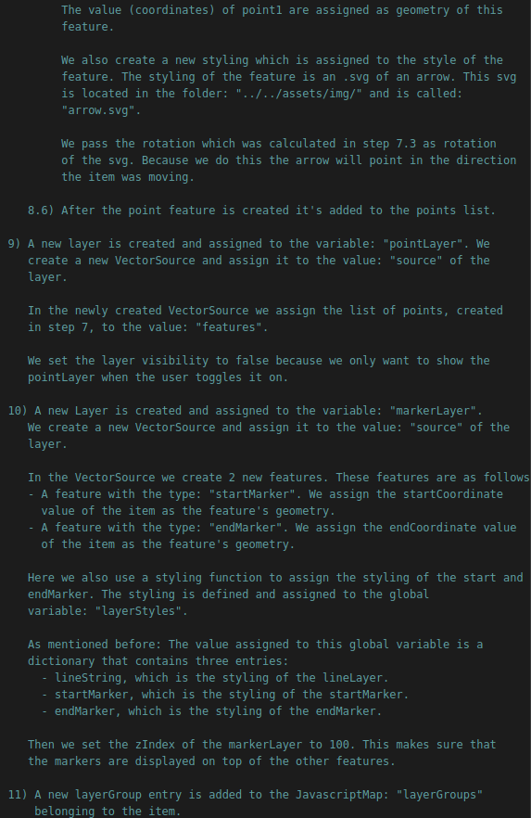

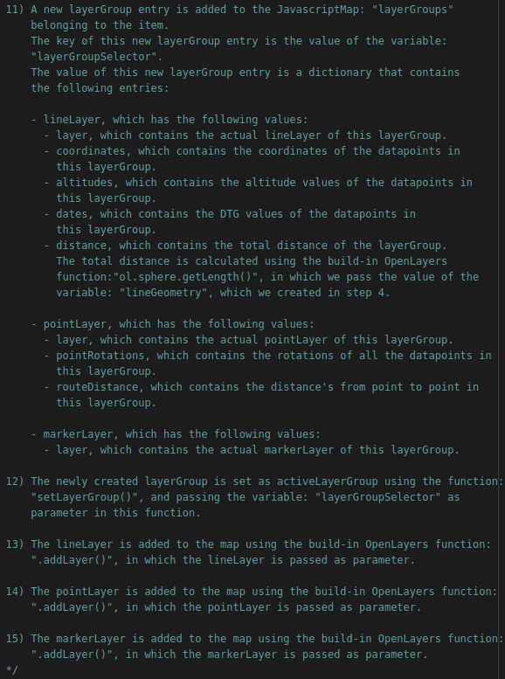
On the next pages the images will follow related to actually creating the function.

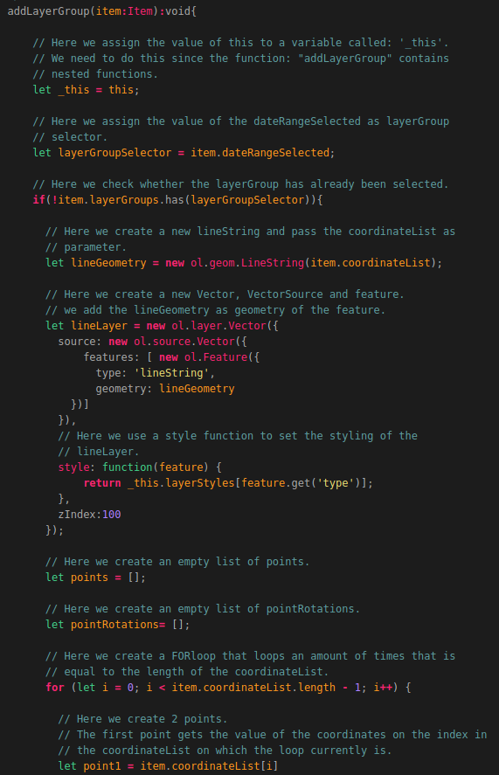

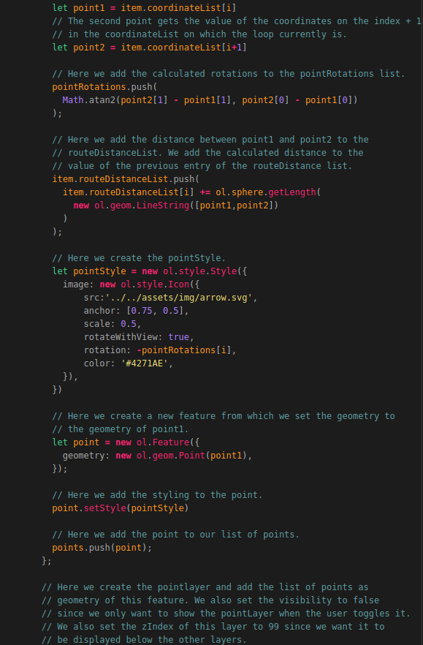

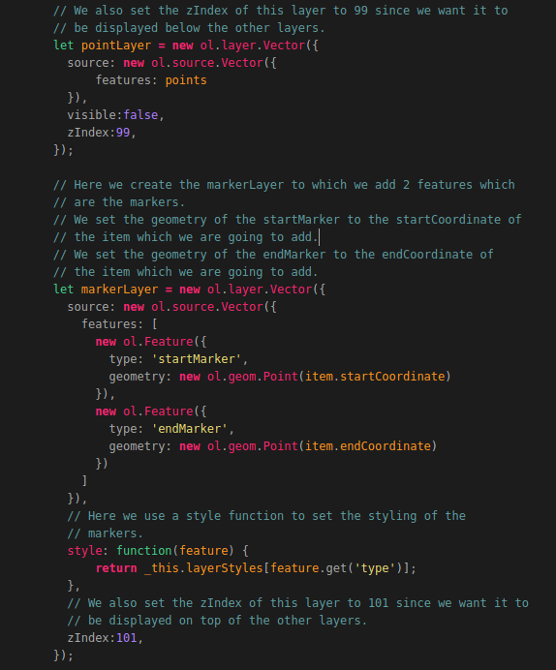

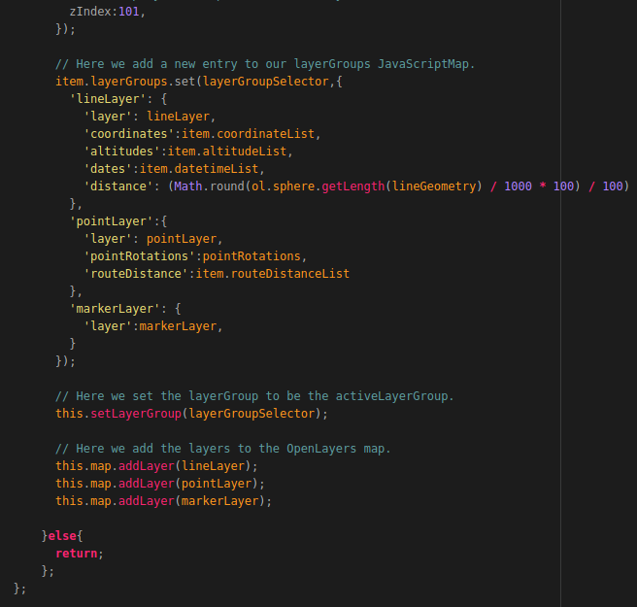
That’s it! Now we have created the function that creates all our layers and adds them to the map and the item’s layerGroups list.
The function: “setLayerGroup()” has not been created yet. So let’s create this function.
Create function setLayerGroups
add function addLayerGroup to function LoadItemData
Add HTML for DTG selection

4.2.7 Creating and setting Overlays
Adding overlay html divs to HTML file
Create function addOverlays()
add Adoverlays function in the CreateMap function()
add setDynamicOverLayes function()
add setStatiocOverlays function()
add setStaticOverlays function to selectItem function and to loaditemdata function and to setLayergroup function

4.2.8 Removing a selected Item
Add fcuntion removeItem

4.2.9 Removing a LayerGroup
Add function removeLayerGrooup

4.2.10 Adding DTG selection
Create function for getting DTG item data
Create DTG picker component folder
create HTML DTG Picker
Create TS DTG picker
Import and add datepicker to app.module.ts
add dateRange as global variable
add getDTGEvent function
add html to dtgSelection
add this.dateRange = this.activeItem.dateRangeTotal; to the selectItem function

4.2.11 Adding Amount selection
Now that we have most of our functionalities in place we want to be able to select a desired amount of transmissions or signals.
We do this by adding a function that triggers the function in our service that is related to performing an API call to obtain a certain amount of data.
We need to add the following code below the function: “getDTGEvent()”:
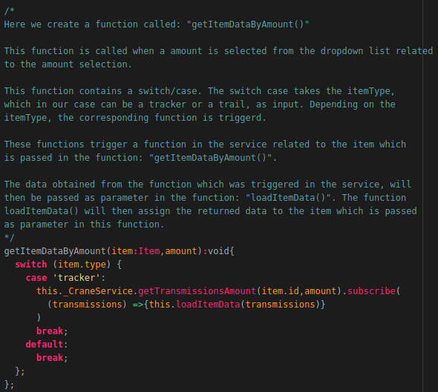
Now we need to add a drop-down box which is used to trigger this function.
How this is done is shown on the next page.

To create a dropdown box for the amount selection we need to add the following code to the map.component.html file below the div element with the id:”dateSelection”:
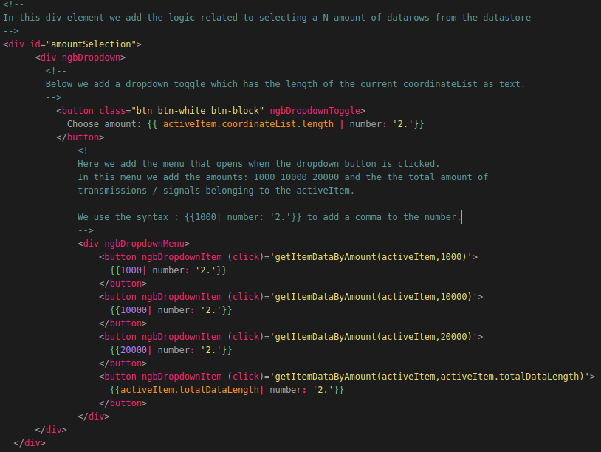
Now when we reload the application we get the option to select an amount of transmissions / signals from the dropdown box as shown in the illustration below.
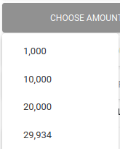

4.2.12 Adding Country selection
Add global variable country selection
Create function for getting selection by country
Add HTML for amount selection

4.2.13 Adding Layer and Overlay Toggling
Add toggleLayer function
add toggleOverlay function
add HTML

4.2.14 Changing layer styling
Add global colorlist, widthlist , linestylelist
Add global dictionary styleDict
Add function setLayerStyles()
Add HTML

4.2.15 Animating routes
Add animateRoute function
Add clea Animartion fucntion
add HMTL

4.2.16 Creating an elevation profile
Add globals private elevationProfile:any;
private elevationProfileOpen:boolean;
Add loadElevationData function
Add createLEevationProfile fucntion
add html

