
k

Cookbook

Creating the GeoStack
Course VM

Version : 1.0

Date :29-07-2020

Author :The GeoStack Project

License :CC BY 4.0

Purpose of this document
This cookbook serves as manual for installing all the software, tools, modules and libraries required to create a fully functional Open Source Geographical software stack which does not need an active network-connection to visualize Geospatial datasets on 2D maps and 3D maps.
During this cookbook references are made to other cookbooks and programming manuals. When such a reference is made the cookbook and / or programming manual in question should be read before continuing to read this cookbook.
First there will be an introduction to the tools and software products used in the GeoStack. During this introduction a global description regarding the functioning of the GeoStack and what task each component fulfills in relation to the complete Geographical software stack. These descriptions will be given using a diagram which shows the data flow between the GeoStack components.
After discussing the software, tools and data sets used during the Beginner Course Open Source Geospatial Programming for Data Scientists, a description will be given regarding the 2 ways you can go about installing the GeoStack components and creating the web applications.
As mentioned before; this document will give a global description regarding each of the components in the GeoStack. For an in depth explanation regarding the components you should read the cookbook or programming manual related to the component in question.
If you decide to install the GeoStack software using the automatic installation scripts you will have the complete software stack up and running in no time. If you decide to install the GeoStack software manually, using the programming manuals you will build each component from scratch.
Prerequisite for the Workshop are as follows:

- A laptop with an active network-connection.

- 60GB of free space on you hard drive.

During the GeoStack workshop you installed VirtualBox on your host system. If you have not conducted this workshop yet, you should start by doing so. If you have VirtualBox installed we are going to create a new Ubuntu Virtual machine in which we are going to install the software and tools required for the GeoStack.
You can decide whether you want to install the GeoStack using the installation scripts provided in the folder: ”Building-the-VM-using-the-installation-scripts” or to install the Complete GeoStack from scratch using the cookbooks, Jupyter Notebooks, programming manuals and presentations provided in the folder: “Building-the-VM-from-scratch-using-the-manuals”. Both folders are located in the GeoStack-Course Github Repository which we will be cloning later on!
But more on that later! Let’s start of with an introduction to the GeoStack’s goal, components and software products.
Table of Contents
Purpose of this document 2
1. Introduction to the GeoStack 5
1.1 The GeoStack work environment 7
1.1.1 The Virtualization software 8
1.1.2 The Backend software 9
1.1.3 The Middleware software 10
1.1.4 The Frontend software 11
1.2 The GeoStack components 12
1.2.1 The PostgreSQL datastore 13
1.2.2 The MongoDB datastore 13
1.2.3 The Tilestache Tileserver 14
1.2.4 The Flask-API 16
1.2.5 The NGINX Webserver 18
1.2.6 The Dataset Dashboard 19
1.2.7 The 2D Map Viewer 21
1.2.8 The 3D Map Viewer 23
2. Installing VirtualBox 25
3. Installing the GeoStack 26
3.1 Creating the Virtual Machine in VirtualBox 27
3.2 Installing Ubuntu in the Virtual Machine 30
3.3 Cloning the GeoStack Course Github Repository 30
3.4 Downloading the Course Datasets 31
3.4.1 The Crane (Tracker) Datasets 32
3.4.2 The World Port Index Dataset 36
3.4.3 The OpenStreetMap data 37
3.4.4 Cesium Elevation Map data (DEM Files) 38
4. Installing GeoStack components AUTOMATICALLY 40
4.1 Pre-installation Information 40
5. Installing GeoStack components MANUALLY 47
5.1 Installing Docker virtualization software 48
5.2 Installing the general software 49
5.3 Installing data-analyses software 51
5.4 Installing backend software 52
5.4.1 Installing PostgreSQL 53
5.4.1.1 Dockerizing PostgreSQL and PostGIS 54
5.4.1.2 Importing data in the PostgreSQL Docker datastores 56
5.4.1.3 Exporting the PostgreSQL Docker data volume 56
5.4.1.4 Managing the PostgreSQL Databases 56
5.4.1.5 Setup PGAdmin4 58
5.4.2 Installing MongoDB 60
5.4.2.1 Dockerizing MongoDB 61
5.4.2.2 Importing data in the MongoDB Docker datastore 61
5.4.2.3 Exporting the MongoDB Docker data volume 62
5.4.2.4 Managing the MongoDB Databases 62
5.4.2.5 Automating the dataset import process 70
5.5 Installing middleware software 85
5.5.1 Installing the NGINX Webserver with ModSecurity Locally 88
5.5.2 Installing Python-Flask Locally 94
5.5.3 Installing the Tilestache Tileserver 95
5.5.3.1 OpenStreetMap explained 100
5.5.3.2 Downloading and importing OpenStreetMap data in PostgreSQL 103
5.5.3.3 OpenSeaMap explained 109
5.5.3.4 Downloading and Rendering OpenSeaMap Data 111
5.5.3.5 Creating the Tilestache configuration 116
5.5.3.6 Dockerizing the Tilestache Tileserver 120
5.5.3.7 Importing OSM data in the PostgreSQL Docker container 123
5.5.3.8 Automating the OSM data import and generation process 123
5.5.4 Installing the Cesium Terrain Server 128
5.5.4.1 Downloading DSM or DTM files 128
5.5.4.2 Rendering Digital Terrain Models for Cesium 130
5.5.4.3 Caching the Terrain files with Memcached 132
5.5.4.4 Automating the Cesium Terrain file generation process 134
5.5.4.5 Adding the Cesium Terrain server to our NGINX configuration 135
5.5.4.6 Dockerizing the Cesium Terrain Server 136
5.6 Installing the frontend software 137
5.6.1 Installing and updating an Angular Project 139
5.6.2 Serving an Angular app on the NGINX Webserver 140
6. Running the GeoStack as Docker containers 142
6.1 Exporting Docker images and volumes 146
7. Useful tips and tricks 149
7.1 Creating desktop shortcuts 149
7.2 Removing DEFAULT folders from Nautilus 151
7.3 Editing Atom theme settings 152
7.4 Useful Docker commands 153
7.5 3D Acceleration in your Virtual Machine 154
7.6 VirtualBox Graphics Adapters 156
7.7 Recording your Virtual Machine screen 157
7.7.1 Installing SimpleScreenRecorder 157
7.7.2 Increasing the cursor size 157
7.7.3 Using SimpleScreenRecorder 158
7.8 Allow Cross-Origin Resource Sharing (CORS) 161
8. Bibliography 162
8.1 Data analyses links and tools 162
8.2 MongoDB Links 162
8.3 PostgreSQL / PostGIS and GeoServer Links 162
8.4 NGINX ModSecurity Links 163
8.5 Python-Flask Links 163
8.6 Tilestache Tileserver Links 164
8.7 Cesium Terrain Server Links 164
8.8 Angular Links 164
8.9 OpenLayers Links 164
8.10 Cesium Links 165
8.11 Leaflet Links 165
8.12 Remaining Links 165

1. Introduction to the GeoStack
The purpose of the GeoStack is to provide a free, open source, light-weight solution for visualizing data on digital maps. The GeoStack is a light-weight software stack and can run without an active network connection.
The official website of The GeoStack Project (https://the-geostack-project.github.io/) contains a global description of what you will learn during this course and the functionalities which the Geographical software stack has.
The geographical software stack can be divided in 6 parts which are as follows:
- Virtualization software:
Each GeoStack component is Dockerized and thus can run separately from the other components. The components are also installed in one Virtual Machine so everything can run locally on one machine.
- General software:
To create the code and documentation, tools such as Atom and LibreOffice are used. These kind of software products are covered in the general software section.
- Data analyses and processing software:
During the cookbooks we are going to work with multiple types of data formats. These data formats have to be transformed and then stored in the corresponding data store. To be able to do this we need the data-analyses and processing software.
- Backend software:
The backend consists of 2 datastores that each serve their own purpose and store a different type of dataset.
- Middleware software:
The Middleware consists of multiple webservers and an API. The middleware contains the Tilestache Tileserver, Cesium Terrain Server, Flask-API and the NGINX-Webserver. The middleware is where all the “magic” happens.
- Frontend software:
The frontend consists of 3 web applications, each serving their own purpose. These web applications are as follows:
  - Dataset dashboard: An application which displays all the datasets used in the GeoStack using interactive graphs and tables.
  - 2D Map Viewer: An application which displays all the datasets in 2D on a 2D map using the Geospatial Framework OpenLayers.
  - 3D Map Viewer: An application which displays all the datasets in 3D on a 3D map using the Geospatial Framework Cesium.
We are going to install the software in the order of the parts mentioned above.
In the table on the next page you can find an overview of existing Geographical software stacks and geospatial software products.

Categorie | Products and Providers
Open Source | - OSGeo.org: Publishes the OSGeo live DVD with well-known Open Source Geoproducts.  - OpenGeospatial.org: An international consortium of 530 companies around the world for Open Standards in geospatial.  - Geonovum: An advice foundation and knowledge center from and for the Dutch Government.  - Foss4G.org: An annual conference for Open Source geographic software products. Also called Foss4G.
Comercial | - ArcGIS Suite from ESRI: The leading standard in the world of commercial geographic software stacks.  - HexagonSpatial Suite: Contains the Luciad Suite, which is now the new competitor to the ArcGIS Suite.  - Planet.com: a spatial cloud service which includes the former Open Source suite from Boundless.
Mobile | - National Geospatial-Intelligence Agency has 3 SDKs:  - AG NGAGeoINT IOS: A Github package for programming geographic applications for IOS.  - AG NGAGeoINT Android: A Github package for programming geographic applications for Android.  - AG NGAGeoINT Javascript: A Github package for programming geographic applications using Javascript.  - Ionic with Cordova: A development environment consisting of TypeScript and Angular.
Geospatial Datastores | - Postgres + PostGIS: An Open Source geographic extension for a PostgreSQL database.  - SQLite + SpatiaLite: SQLite is a single file datastore. SpatiaLite is the geographical extension of this database.  - MariaDB + Microsoft MySQL spatial: A geographical extension of a MariaDB database.  - Oracle Spatial DB: A commercial geographic extension of the Oracle SQL commercial relational database.  - Microsoft SQL Server: A commercial geographic extension for a MySQL database.
Geospatial SearchEngines | - Lucene: This is Apache's Open Source Core Search Engine with spatial search functions.  - Solar: This is the Open Source search engine of the Apache foundation used by Lucene.  - ElasticSearch: An Open Source geographic search engine.

1.1 The GeoStack work environment

During the Beginner Course Open Source Geospatial Programming you will be working with lots of different tools and software products. The most important tools and software products are shown in the illustration below. A small introduction to each of the tools and software products is given on the next pages.

1.1.1 The Virtualization software


1.1.2 The Backend software


1.1.3 The Middleware software
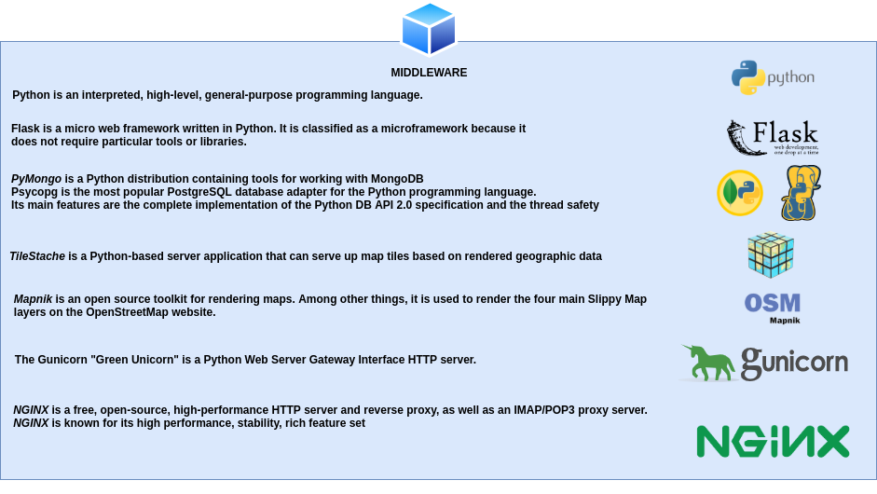


1.1.4 The Frontend software

1.2 The GeoStack components
The diagram below shows the positioning of each component in the GeoStack. An explanation concerning the diagram and the components shown in the diagram is given during this section. A video is also available which gives a global introduction related to the GeoStack components and the web applications which are created during the GeoStack Course. These videos can be found on The GeoStack Project Youtube Channel (https://www.youtube.com/channel/UCiZEImhO8r-LMAWh-KQiH6g) For a better understanding of what your about to create during this course you should watch these video’s.


Below you can find a textual description, per component, of what you learned in the GeoStack Demo video’s.

1.2.1 The PostgreSQL datastore
The SQL relational database called: “PostgreSQL” is going to contain the following data:
- OpenStreetMap data
OpenStreetMap is an open source map provider. The RAW data shown on the map has to be stored in an SQL database. The dataset contains data related to streets, mountains etc. This data is stored as RAW data in the PostgreSQL datastore. This data combined with a style sheet is going to be used to generate OSM (OpenStreet and OpenSeaMap) Tiles (PNG images that make up a base map). This process is done by our Tileserver.

- OpenSeaMap data
OpenSeaMap is also an open source map provider. The data shown on the map also has to be stored in an SQL database. The dataset contains data related to waterways, anchorages buoys etc. This dataset is especially useful for maritime related visualizations.

- World Port Index data
The World port index dataset contains data related to ports around the world. The dataset contains data related to the type of port or how big a port is and much more.


1.2.2 The MongoDB datastore
The NoSQL JSON document store called: “MongoDB” is going to contain the following data:
- Crane datasets (Crane tracker datasets)
These datasets contain data related to multiple Cranes. They are a good representation of objects that contain coordinates and altitude data.

- GPS-Route datasets (Trail datasets)
These datasets contain GPS data related to routes traveled throughout the Netherlands. The routes are a good representation of how land or water vehicles can be visualized.



1.2.3 The Tilestache Tileserver
A tile server is the server that generates rendered images (tiles) from a database. There are multiple services online that provide a Tileserver. The problem with using online services is that the Tileserver will not work when you don’t have a n active network-connection. This is also the reason why we are going to create our own Tileserver for generating base maps.
There are multiple ways in which you can create a Tileserver. One of these is using an Apache webserver in combination with Mod_Tile and Mapnik. We are not going to use Apache since we want a lightweight Tileserver which serves our needs for generating, caching and serving base maps using the RAW OpenStreetMap data from our PostgreSQL datastore.
If you want to create a Tileserver using Apache and Mod_Tile, you should follow the guide on the following website: https://switch2osm.org/serving-tiles/building-a-tile-server-from-packages/.
We are going to create a Tileserver using the lightweight webserver: “NGINX” in combination with Tilestache (for caching the generated tiles) and Mapnik (For generating the tiles using the RAW OpenStreetMap data in our PostgreSQL datastore).
In the diagram below you find the structure and dataflow of the Tileserver in our GeoStack.

The way the Tilestache Tileserver works is as follows:
- The frontend sends a so called “{Z}{X}{Y}” request to our Tileserver. This request consists of the following values:
  - The name of the entry in the Tilestache configuration file concerning the map that is requested. Such an entry contains information related to where the map data is stored.
  - An Z value, which represents the Zoom Level of the map that is being requested.
  - An X value, which represents for the X-axis of the map that is being requested.
  - An Y value, which represents for the Y-axis of the map that is being requested.

These values are then used to only return the tiles than need to be displayed in the web application instead of the complete map.


- The Tileserver then checks in the cache, belonging to the map that is being requested, to see if the requested tiles have already been generated before.


- If the tiles have been generated before the Tileserver will extract these tiles from the cache and send them back to the frontend (Our web applications).

- If the tiles have NOT been generated before the Tileserver will request the RAW OSM data from the PostgreSQL datastore after which Mapnik will generate the requested Tiles using the OpenStreetMap-Carto style sheet.
The way Mapnik works is as follows:
- The raw OSM data consists of nodes which contain a set of coordinates and a tag (e.g. a water tag).
- The tag: “water”, is then linked to the styling of water in the stylesheet. The style sheet will then for example give all the nodes containing the tag:”water” the color blue.

- After the requested tiles have been generated they will be stored in the cache belonging to the requested map after which they are send to the frontend. When the tiles are requested a second time they don’t have to be generated anymore. This makes the loading of a map a lot faster.

1.2.4 The Flask-API
Flask is a light-weight Python WSGI web application framework. It’s also known as an micro framework since it’s so small and doesn’t need a lot of configuration to get it up and running. It is especially design to get started quick and easy, with the ability to scale up to a complex application.
The Flask-API can be seen as the beating heart of the GeoStack. This is where all the “magic” happens. The Flask-API contains the Source code related to the processing of the datasets from both the PostgreSQL datastore and the MongoDB datastore.

The Flask-API contains functions that contain queries. A function is bound to a “route” which can be seen as an URL. An example of such a function can be found in the illustration below.

The name of the function in the illustration above is: “get_one_tracker()” and takes an ID as input parameter. The function is bound to the URL: /api/trackers/<id>.
If an request is send to this URL the function: “get_one_tracker()” is triggered and a query is executed on the MongoDB datastore. This query than returns the tracker data belonging to the tracker with the ID passed as parameter in the function.
The API then sends the requested and obtained tracker data back to the frontend.

The way the Flask-API works is as follows:
- The Flask-API receives a request from the frontend. Such a request consists of an URL and values which are used to query on specific items in the datastores.


- The Flask-API then triggers the function, bound to the URL from the request after which it performs a query on the MongoDB or PostgreSQL datastore.

- The datastore then returns the data to the Flask-API which then performs the necessary transformations.


- The API then sends the transformed data back to the frontend.

1.2.5 The NGINX Webserver
NGINX, pronounced "engine X", is a fast and lightweight web server, that can be used to serve static files, but is often used as a reverse proxy. It has some very nice features like load balancing and rate limiting.
NGINX is commonly used if you need a lightweight web server with:
- A reverse proxy:
A reverse proloxy is useful if you have multiple web services listening on various ports and you need to reroute requests internally. This allows you to run multiple domain names on port 80 which is the port the web server is running on.
- Load balancing:
Load balancing is a technique used to distribute workload across multiple machines. Load balancing could be division of processes, hard drives and other resources.
- Rate limiting:
Rate limiting is kind of the same as load balancing, but in the case of rate limiting the work load is divided among users of the web server.
The three web applications of the Geostack are hosted as static files on the NGINX webserver.


The NGINX webserver works as follows:

- The webserver receives request from the client (User). A request could be the following:
  - The location of a Crane.
  - All GPS-Routes in the MongoDB datastore.
  - All Ports in the PostgreSQL datastore.

  - A map from our Tileserver.

- The webserver then relays the request to the corresponding component in the Geostack. A corresponding component could be:
  - The Tileserver for generating a base map.
  - The MongoDB datastore for the location of a Crane.
  - The PostgreSQL datastore for all the Ports in the database.

- The webserver than receives the requested data from the corresponding component and sends it back to the client in combination with the static files from the web application which the user is currently using.


1.2.6 The Dataset Dashboard
The Dataset Dashboard is the first in a set of three applications created during the Beginner Course in Open Source Geospatial Programming for Data Scientists. It shows all the datasets in our MongoDB datastore. The dashboard contains interactive graphs and tables. In the table below you can find an overview of the functionalities of the dataset dashboard.

# | Functionality | Description
1) | Overview of the Crane datasets | The dataset dashboard shows information related to the total amount of Crane trackers and transmissions in the MongoDB datastore.
2) | Overview of the GPS-Route datasets | The dataset dashboard shows information related to the total amount of GPS-Routes and signals in the MongoDB datastore.
3) | Overview of improvised AIS data | The dataset dashboard shows information related to the total amount of Ships and transmissions in the MongoDB datastore.
4) | Overview of World Ports Index dataset | The dataset dashboard shows information related to the amount of ports in the database.
5) | Interactive graphs related to the data in the datastore. | The dataset dashboard contains interactive graphs related to the data in the MongoDB datastore.
6) | Interactive tables with more information related to the datasets | Each of the datasets have their own table which shows in detail information related to the dataset in questions.
7) | Generate dataset profiles using Pandas-Profiling | The dataset dashboard offers possibility to create a dataset profile for each of the datasets in the dataset dashboard. These profiles show information related to the dataset.

Below you find an image of the Dataset Dashboard created using the JavaScript framework: “Angular” in combination with TypeScript.



1.2.7 The 2D Map Viewer
The 2D Map Viewer is the second in a set of three applications created during the Beginner Course in Open Source Geospatial Programming for Data Scientists. This application is used to visualize the datasets stored in the MongoDB and PostgreSQL datastore in 2D on a 2 Dimensional map using the JavaScript framework OpenLayers in combination with base maps of OpenStreetMap and OpenSeaMap.
All the data shown in the 2D Map Viewer is “live” which means that when we add data to our datastores the data will automatically be updated.
The functionality of this application can be found in the table below.
# | Functionality | Description
1) | Switch between WMS’s (Web Map Server) | The application offers the possibility to switch between the Web Map Servers defined in the Tilestache Tileserver.
2) | Select items | The application offers the possibility to select Crane data, GPS Route data and improvised AIS data.
3) | Select multiple items | The application offers the possibility to select multiple items and put them next to each other.
4) | Request detailed information related to an item. | The application offers the possibility to request detailed information related to an item.
5) | Select a given amount of datapoints | The application offers the possibility to choose the amount of datapoints you want to visualize.
6) | Select datapoints in a certain area | The application offers the possibility to select datapoints in a given polygon
7) | Select one or more timeframes | The application offers the possibility to select data in a given timeframe (DTG) there is also an option to choose multiple timeframes from one item.
8) | Change styling of features | The application offers the possibility to change the styling of features such as lines, arrows and markers.
9) | Animate, pause and continue routes. | The application offers the possibility to animate the selected routes. You can also pause and continue the route. The animation speed can also be changed.
10) | Live information. | While animating a route the information is updated. The information includes the current DTG, coordinates and distance travelled.
11) | Request information related to the start and end points of the route. | The application offers the possibility to request information related to the start and end points of the selected items. This information contains the coordinates, date and total distance of the visualized route.
12) | Elevation profile | The application offers the possibility to generate an elevation profile of the visualized routes. This profile contains an interactive graph in which you can move your cursor on the line to view the specific height at a certain point in the route.
13) | Toggle layers on and off. | The application offers the possibility to toggle layers such as an OpenSeaMap layer, World Port Index layer, lines, points and markers.

An illustration of the 2D Map Viewer application can be found on the next page.
A Video of the 2D Map Viewer is also available in the folder: “GeoStack-Demo-Videos”. This folder can be found in the root folder of The GeoStack Project.

In the illustration below you can see a multiple visualized Crane tracker routes using the 2D Map viewer created with the Geospatial Framework: “OpenLayers”.


1.2.8 The 3D Map Viewer
The GeoStack also contains an 3D Map Viewer using the geospatial framework Cesium.
This is the third in a set of three applications created during the Beginner Course in Open Source Geospatial Programming for Data Scientists.
This application is used to visualize the datasets stored in the MongoDB datastore in 3D on a 3 Dimensional map using the JavaScript framework Cesium in combination with a base map of OpenStreetMap.
All the data shown in the 3D Map Viewer is “live” which means that when we add data to our datastores the data will automatically be updated.
This application is used to visualize data in 3D and displaying height maps. The functionalities of this application are similar to the ones of the 2D application.

# | Functionaliteit | Omschrijving
1) | Switch between WMS’s (Web Map Server) | The application offers the possibility to switch between the Web Map Servers defined in the Tilestache Tileserver.
2) | Select items | The application offers the possibility to select Crane data, GPS Route data and improvised AIS data.
3) | Select multiple items | The application offers the possibility to select multiple items and put them next to each other.
4) | Request detailed information related to an item. | The application offers the possibility to request detailed information related to an item.
5) | Select a given amount of datapoints | The application offers the possibility to choose the amount of datapoints you want to visualize.
6) | Select datapoints in a certain area | The application offers the possibility to select datapoints in a given polygon
7) | Select one or more timeframes | The application offers the possibility to select data in a given timeframe (DTG) there is also an option to choose multiple timeframes from one item.
8) | Displaying elevation maps. | The application offers the possibility to display elevation maps served by the Cesium-Terrain Server.
9) | Animating a route. | The application offers the positbilty to visualize the visualized routes in 3D. The animation speed can be increased or decreased. The route can also be animate using a dateslider.

An illustration of the 3D Map Viewer application can be found on the next page. A Video of the 3D Map Viewer is also available in the folder: “GeoStack-Demo-Videos”. This folder can be found in the root folder of The GeoStack Project.
In the illustration below you can see a visualized Crane tracker Route flying over the Alps using the 3D Map viewer created with the Geospatial Framework: “Cesium”.


2. Installing VirtualBox
To be able to create the GeoStack Course VM you will need to have VirtualBox installed on your system. How this is done is described in chapter 1 of the cookbook: “Creating the GeoStack Workshop VM”.

If you started with the workshop you should have VirtualBox installed on your system. If you skipped the workshop you should start with the workshop before continuing this cookbook.

It’s highly recommend you to start with the workshop first since the GeoStack workshop provides fast situational awareness relating to the complete Beginner Course in Open Source Geospatial Programming for Data Scientists.

The 1-day Workshop focuses on building a Client / Server infrastructure in a VM to get familiar with the server side software architecture of the entire software stack.



3. Installing the GeoStack
Before we can start with the installation process of the GeoStack software, tools and applications we first have to create a new Virtual Machine and install an Ubuntu Operating System. This will be done in the next section.
After you have created a new Ubuntu Virtual machine, you can decide which technique you want to use to install the GeoStack software and applications.
As mentioned in the introduction of this document; there are 2 techniques to install the complete GeoStack. These techniques are as follows:
- Creating a new Virtual Machine and using the installation scripts to install all the software and applications (Chapter 4):
If you choose to install the GeoStack using this technique you will have a fully functional geographical software stack in no time.
In the GeoStack-Course Github repository you will find a folder called: “Building-the-VM-using-installation-scripts”. This folder contains everything you need to install the GeoStack software using the automated scripts.
If you choose to install the Geographical software stack using this technique you have to read this chapter (3) and chapter 4.
- Build the Geostack from scratch using this document, the Jupyter Notebooks, the cookbooks, the programming manuals and the presentations (Chapter 5 +):
If you choose to install the GeoStack using this technique you will learn a lot about the tools, software and data types discussed at the beginning of this cookbook.
In the GeoStack-Course Github repository you will find a folder called: “Building-the-VM-from-scratch-using-the-manuals”. This folder contains all the cookbooks and manuals required to do the following and a lot more.
The contents of this folder is shown in the illustration below.

If you choose to install the Geographical software stack using this technique you can skip chapter 4.

In section 3.1 is described how you should create a new Virtual Machine and in section 3.2 references are shown to the GeoStack Workshop cookbook which describes the steps you have to perform to get the Virtual Machine ready.
As mentioned above if you choose to install the GeoStack using the installation scripts you should read chapter 4 and If you choose to install the GeoStack manually, you should skip chapter 4 and read from there on.

3.1 Creating the Virtual Machine in VirtualBox
At this point you have VirtualBox on your system. Now we need to install the GeoStack Course Virtual Machine. To be able to install the GeoStack Course VM we first need to create a new Virtual Machine. After we have created the Virtual Machine we are going to install an Ubuntu ISO file.
Creating a Virtual Machine is done by performing the following steps:
- Click on the button: “new” in the VirtualBox start screen.


- Give the Virtual Machine a suitable name in this case we give it the name: “Geostack-Course-VM”.

- Assign the amount of RAM you want the machine to use. the minimal amount of RAM is 1 GB (1024MB) for a VM. If your PC has enough RAM the advice is to assign 3 GB (3072 MB) or 4 GB (4096 MB) RAM because Ubuntu will use up to 2 GB (2048 MB) already for itself.


- Select create a virtual hard disk.


- Set hard disk file type to VDI (Virtual Disk Image).


- Select allocate disk space dynamically (Dynamically allocated). Tip: choose fixed disk size if performance matters to you.


- Select the location where you want to store the Virtual Disk Image file (.vdi file). In the perspective of managing your Virtual Machines, it’s useful to create a centralized folder on your host system in which you create your VM’s. The folder name could for example be called: “ VirtualBox_Vms”. This folder can also be used to store files such as ISO’s and VBox extension packs. Then set the size of the hard disk to a minimum of 50 GB. The reason we are choosing to set the disk size to 50GB is because increasing the disk size of an VDI file can be a tricky process.

- Click on the green “start” arrow while the Virtual Machine is highlighted (This is done by clicking on the VM) to start the VM.


- Select a startup disk which is the Ubuntu ISO that you have downloaded in the previous cookbook. Click on the yellow folder icon on the right to browse and select the ISO file.

3.2 Installing Ubuntu in the Virtual Machine
As mentioned before; If you skipped the workshop it’s highly recommend you to start with the workshop first. In the cookbook related to the workshop you can find information related to setting up and finalizing a Virtual Machine installation. The following chapters should be read:

- Section 2.2: Installing the Ubuntu ISO

To install an Ubuntu ISO in the new Virtual Machine, which was created in the previous section, you should read chapter 2.2 of the cookbook: ‘Creating the GeoStack Workshop VM’.

- Section 2.3: Connecting the Virtual Machine to the network
To connect your newly create Ubuntu system to a network you should read section 2.3 from the cookbook: “Creating the GeoStack Workshop VM”.

- Section 2.4: Creating a shared folder
To create a shared folder between your host system and the GeoStack Course Virtual Machine, you should read section 2.4 from the cookbook: “Creating the GeoStack Workshop VM”. After reading section 2.4 you should come back to this cookbook to finalize the GeoStack Course VM Installation.

Now that you have a new Virtual Machine up and running you can choose whether you want to install the GeoStack using the installation scripts or to create it from scratch using the cookbooks, programming manuals and Jupyter Notebooks.

3.3 Cloning the GeoStack Course Github Repository
Whether you choose to install the GeoStack Automatically or Manually, in both cases we first need to clone the GeoStack-Course Github repository to our newly created Virtual Machine.
We are to clone the Github repository, which contains the GeoStack Course files, by performing the following steps:
- Open a terminal by pressing the Ctrl + alt + t on your keyboard.
- Install GIT by using the following command: sudo apt install git
- Clone The GeoStack-Course Github repository by running the following command:
git clone https://github.com/The-GeoStack-Project/GeoStack-Course.git
The download process will take around 4 minutes depending on your network speed. After the download process is completed the terminal output should be similar to the one shown in the illustration below:
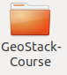
If everything works accordingly you should end up with a folder called: “GeoStack-Course” in your home directory of your Virtual Machine.

3.4 Downloading the Course Datasets
As previously mentioned; you will be using multiple types of datasets and data formats during the GeoStack Course. These types and formats are as follows:
- GPS Route (Trail) Datasets:
The Trail datasets are provided in the folder “GeoStack-Course/Course-Datasets/GPX”. These datasets are obtained from a GARMIN GPS-Device.
- Crane (Tracker) Datasets:
The Crane (Tracker) datasets are provided by an organization called MoveBank. The Movebank Data Repository contains published data sets of animal movement data in the Movebank format. This is distinct from the main Movebank tracking database, in which users control access and are responsible for their data quality, and where most data are stored. To be published in the Movebank Data Repository, a data set in Movebank undergoes an official review process and, when accepted, is granted a unique identifier (DOI) and license and is made publicly available.
- The World Port Index Dataset:
The World Port Index shows locations, physical characteristics, facilities, and services offered by major ports around the world. This dataset is created by the Maritime Security Office of the National Geospatial-Intelligence Agency (NGA) to document the locations and features of major ports around the world.
- OpenStreetMap Datasets:
OpenStreetMap (OSM) is aimed at creating and providing free geographic data such as street maps to anyone who wants them. The project was started because most maps you think of as free actually have legal or technical restrictions on their use, holding back people from using them in creative, productive or unexpected ways.
- DEM (Digital Elevation Model) files:
DEMs are files that contain either points (vector) or pixels (raster), with each point or pixel having an elevation value. They come in a variety of file formats, from . csv to . dem to . txt, and you can derive lots of other information - like contours or 3D surface models - from them. We are going to download the DEM files from a Dutch data provider called “PDOK” (Publieke Dienstverlening op de Kaart in Dutch). Public Services On the Map (PDOK) is a central facility for opening up geo data sets of national importance. These are current and reliable data for both the public and private sector. PDOK makes digital geo-information available as data services and files. Most PDOK services are based on open data and are therefore freely available to everyone.
The Crane (Tracker) Datasets, World Port Index Dataset, OpenStreetMap Datasets and DEM Files have to be downloaded separately since The GeoStack Project does not own the right’s of these datasets. However The GeoStack Project is the owner of the GPS Route datasets so they are already provided in the GeoStack-Course folder which you downloaded in the previous chapter. The GeoStack-Course folder contains a sub-folder called: “Course-Datasets” which contains a sub-folder called: “GPX” in which you can find the GPS Route datasets in the file format: “GPX”.
The CSV, JSON, SHP, OSM and DEM folders are empty at first since we are going to download these datasets ourselves in this chapter.

3.4.1 The Crane (Tracker) Datasets
The way we are going to download the Crane Tracker datasets is by navigating to the Movebank website and downloading the complete datasets. This procedure is described in the steps below:

- Navigate to the Movebank downloading page: https://www.movebank.org/panel_embedded_movebank_webapp

- In the search field type: “grus grus” and click on Search as shown in the illustration below:


- Scroll down till you find the entry : GPS telemetry of Common Cranes, Sweden (n=19) as shown in the illustration below:

- Click on the plus sign to expand the search results.
- Select the box with the ID-number : 9381

- Click on the information icon and then click on Download Search result:

- Click on I agree in the screen that pops up:


- Click on Download in the screen that pops up:

- A Screen will pop up asking you to save the file. Select Save File and click on OK as shown in the illustration below:

- Now that you know how to download a Crane Tracker dataset you should repeat step 5, 6, 7, 8 and 9 on the Crane Tracker datasets with the id’s 9407 and 9472 as shown in the illustration below:

- Next up we have to do the same for a Lithuanian Crane dataset. This is done by scrolling till you find the search result: “Common Crane 2016 Lithuania 2016” as shown in the illustration below. Download the dataset with Tracker ID: “16121” by clicking on the information button next to the entry and selecting: “Download search result”:
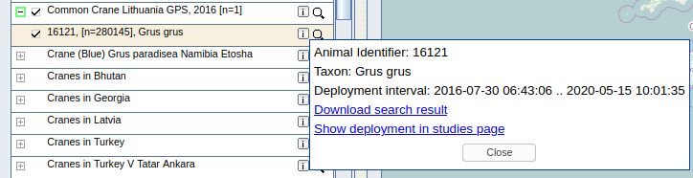
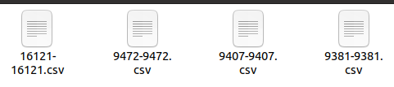
- After you have downloaded the 4 datasets you will end up with 4 CSV files in your system’s downloads folder as shown in the illustration below:
- The last thing we need to do is renaming the files to something logical and copy them to the correct place on our system. Currently the names of downloaded files represent the Tracker ID’s of the Cranes. Since we want to know which Crane dataset is which, we are going to give the datasets a more descriptive name.
For example: We are going to give the Crane Tracker with the ID: “9381” the name: “Frida”. We also know that it’s a Swedish Crane so we want to add that to the name. We also want the date from when the dataset was uploaded on the MoveBank website (10-03-2018). We also want to add the Ring color code to the name which is RRW_BuGBk(Red Red White - Blue Green Black). So the final name of the Crane (Tracker) Dataset with the Tracker ID: “9381” will be as follows: “20181003_Dataset_SV_GPS_Crane_9381_Crane_RRW-BuGBk_Frida.csv”.
To rename and copy all the datasets to the correct place we should run following commands from a terminal:
For the Swedish Crane with the Tracker ID: “9381”:
cp ~/Downloads/9381-9381.csv \ ~/GeoStack-Course/Course-Datasets/CSV/20181003_Dataset_SV_GPS_Crane_9381_Cran\e_RRW-BuGBk_Frida.csv
For the Swedish Crane with the Tracker ID: “9407”:
cp ~/Downloads/9407-9407.csv \ ~/GeoStack-Course/Course-Datasets/CSV/20181003_Dataset_SV_GPS_Crane_9407_Cran\e_RRW-BuGBk_Agnetha.csv
For the Swedish Crane with the Tracker ID: “9472”:
cp ~/Downloads/9472-9472.csv \ ~/GeoStack-Course/Course-Datasets/CSV/20181003_Dataset_SV_GPS_Crane_9472_Cran\e_RRW-BuGR_Cajsa.csv
For the Lithuanian Crane with the Tracker ID: “16121”:
cp ~/Downloads/16121-16121.csv \
~/GeoStack-Course/Course-Datasets/CSV/20200103_Movebank_Common_Crane_Lithua\nia_GPS_2016_Dataset.csv
If everything is done accordingly you should end up with the following datasets in the folder “/GeoStack-Course/Course-Datasets/CSV/”.
NOTE: Before continuing please check whether the names of the datasets match the ones in the illustration below.
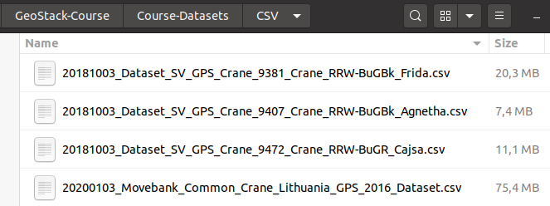

3.4.2 The World Port Index Dataset
Downloading the World Port Index dataset is done by performing the following steps:
- Navigate to the website from where you can download the dataset by clicking on the following URL: https://msi.nga.mil/Publications/WPI
- Scroll down till you see the table as shown in the illustration below and then click on World Port Index Shapefile entry as shown in the illustration below.
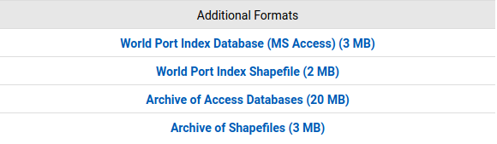
- A window will pop up asking you to open or save the file. Select “Save file” and click on OK as shown in the illustration below.
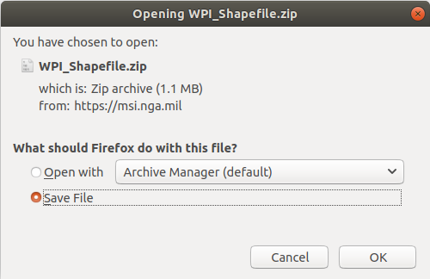
- Open a terminal (Ctrl + alt + t on your keyboard) and unzip the downloaded file to the Course-Datasets folder by running the following command in the terminal:
unzip ~/Downloads/WPI_Shapefile.zip -d \ ~/GeoStack-Course/Course-Datasets/SHP/World-Port-Index
- That’s it! Now you have the World Port Index dataset in the Course-Datasets Shapefiles folder located at “~/GeoStack-Course/Course-Datasets/SHP/World-Port-Index” as shown in the illustration below.
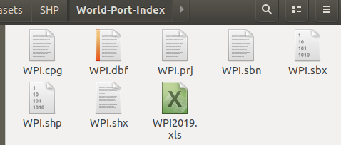

3.4.3 The OpenStreetMap data
Downloading the OpenStreetMap data of the Dutch province: “Limburg” is done by performing the following steps:
- Navigate to the website from where you can download the dataset by clicking on the following URL: http://download.geofabrik.de/
- Select Europe in the table shown on the web page as shown in the illustration below:
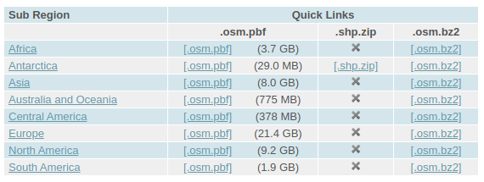
- Scroll down till you find The Netherlands and click on it as shown in the illustration below:
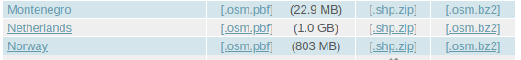
- Find Limburg and click on the .osm.pbf button as shown in the illustration below:
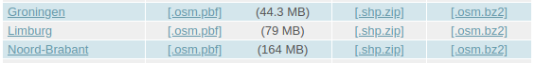
- A window will pop up asking you to save the file. Click on Save File as shown in the illustration below (Note: sometimes this pop-up will not be shown and the file is downloaded instantly) :
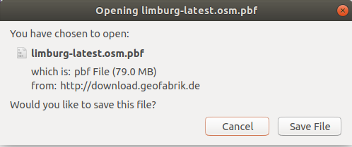
- Open a terminal (Ctrl + alt + t on your keyboard) and copy the downloaded file to the Course-Datasets folder by running the following command in the terminal:
cp ~/Downloads/limburg-latest.osm.pbf ~/GeoStack-Course/Course-Datasets/OSM

3.4.4 Cesium Elevation Map data (DEM Files)
Downloading the Elevation Map data of a section of the Dutch province: “Limburg” is done by performing the following steps:
- Navigate to the website from where you can download the dataset by clicking on the following URL: https://downloads.pdok.nl/ahn3-downloadpage/
- Zoom in on the location encircled in red in the illustration below:

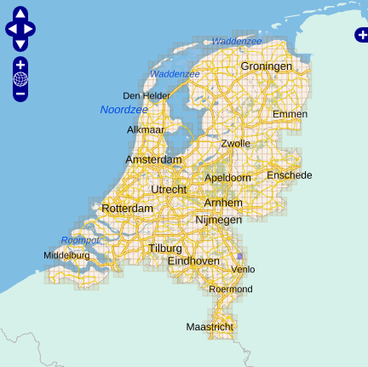
- Click on the box noted with 52ez2 as shown in the illustration below :
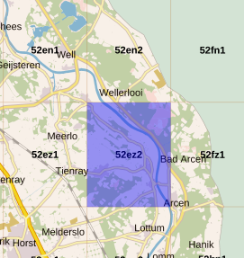
- In the table below the map you will now get the option to download the data. Click on the download button encircled in red in the illustration below:
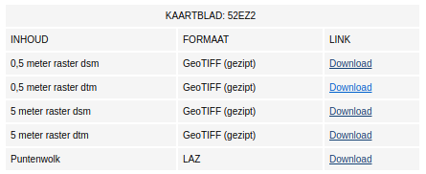
- A pop up dialog will open asking you to open or save the file. Select Save File as shown in the illustration below (Note: this file is about 350MB in size so the download process takes about 1 to 2 minutes depending on your network speed):
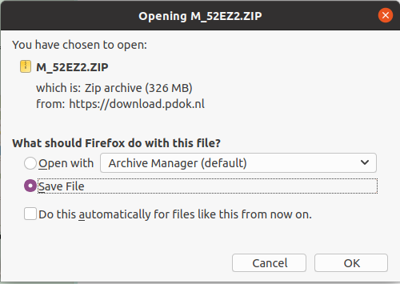
- The last thing we need to do is to copy the downloaded dataset to the correct place in our system. This is done by opening a terminal (Ctrl + alt + t on your keyboard) and running the following command:

cp ~/Downloads/M_52EZ2.ZIP ~/GeoStack-Course/Course-Datasets/DEM/

That’s it! Now you have the DEM dataset in the correct place in your system located at
~/GeoStack-Course/Course-Datasets/DEM/ as shown in the illustration below.
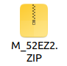

Don’t worry about unzipping the file, this will be done later!

Now that we have all the datasets in place we can start creating the Open-Source Geographical Software stack. As mentioned before; you can choose whether you want to install the GeoStack using the installation scripts (Chapter 4) or to install it using the cookbooks, programming manuals and notebooks (Chapter 5+).

4. Installing GeoStack components AUTOMATICALLY
So you chose to install the GeoStack automatically? That’s a good choice! If everything goes accordingly you will have a fully working Geographical software stack in less than 3 hours.

In the GeoStack-Course folder, which was downloaded in the previous section, you will find a folder called:”Building-the-VM-using-the-installation-scripts”. This folder contains the following sub-folders:

- a folder called: “Geostack”:
In this folder you will find all the source code of the GeoStack components and web applications.

- a folder called: “Installation-scripts”:
In this folder you will find all the installation scripts to install the GeoStack components and web applications.

Let’s copy these two folders to our home directory by entering the GeoStack-Course directory and then copying the 2 folders to our home directory as shown in the illustration below.

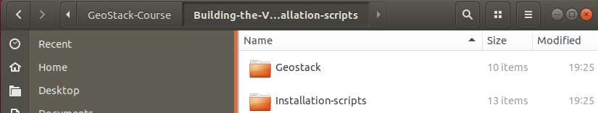

4.1 Pre-installation Information
Now that we have the required files in our Virtual Machine we can start the installation process. First we need to clear some things up.
NOTE: INSTALLING THE SOFTWARE AUTOMATICALLY, USING THE INSTALLATION SCRIPTS, DOES NOT MEAN YOU DON’T HAVE TO PAY ATTENTION.
Once in a while you are asked for some input such as changing default passwords, accepting updates and adding package sources to our sources-list. the following should be done in those cases:
- Password prompt enter the password: geostack
- Accepting updates enter: y
- Adding packages to source list: press ENTER

The folder: “Installation-scripts” contains 12 scripts. The backend, middleware, frontend and virtualization software products each have their own installation script.
Now let’s start with the execution of the installation scripts:
- Close all windows and open a new terminal by pressing the keys Ctrl + Alt + t on your keyboard. Note: You can copy/paste the commands mentioned below to increase your workflow, but make sure that you understand what is happening.

- Run the first script by entering the command:bash ~/Installation-scripts/1-pre-reboot.sh

This script will do the following:
  - Update the system.
  - Install open-vm-tools.
  - Install Bleachbit.
  - Install net-tools.
  - Install LibreOffice Writer.
  - Install Python3 and Python3-pip.
  - Install Curl.
  - Install GIT.
  - Install Docker.
  - Install Docker-compose.
  - Install NodeJS.
  - Install Atom.
  - Add new sidebar shortcuts for the newly installed software and tools.

After the completion of this script the system will reboot for the updates to take effect. This script takes around 10 minutes to complete depending on the speed of you network-connection. After the script is complete 2GB of additional disk space is used.

- After the reboot open a new terminal and enter the command:
bash ~/Installation-scripts/2-post-reboot.sh
This script will do the following:
  - Copy the desktop shortcuts and to the correct place.
  - Create file links on the desktop so you can easily access the component folders.
  - Clean the unused files.

This script will make sure all the folders and shortcuts are placed in the correct place and takes about 10 seconds to complete. After the script is complete no additional disk space is used.

- Now when that script is done and no errors were encountered we can move on to the script for installing the data-analyses software required for performing the data analyses. This is done by running the following command:
bash ~/Installation-scripts/3-data-analyses-software.sh
This script will do the following:
  - Install Jupyter Lab.
  - Install Pandas and GeoPandas.
  - Install Pandas Profiling.
  - Install Cartopy and MathPlotLib.
  - Install GPXPy.

This scripts takes about 10 minutes to complete depending on the speed of your network-connection. After the script is complete 2GB of additional disk space is used.

- Now when that script is done and no errors were encountered we can move on to the next script for installing the backend software required to store all the data. This is done by running the command: bash ~/Installation-scripts/4-backend-software.sh
This script will do the following:
  - Install PostgreSQL.
  - Install PostGIS.
  - Install PGAdmin4.
  - Install PsycoPG2.
  - Install MongoDB.
  - Install MongoCompass.
  - Install MongoEngine.
  - Add the new sidebar shortcuts.

This scripts takes about 10 minutes to complete depending on the speed of your network-connection. After the script is complete 1GB of additional disk space is used.

- Now when that script is done and no errors were encountered we can move on to the next script for importing all the datasets in the correct datastores. This is done by running the command: bash ~/Installation-scripts/5-dataset-import.sh
This script will do the following:
  - Import, model and index the Crane(Tracker) datasets in MongoDB.
  - Run the dataset-convert.py script to transform and copy the datasets.
  - Import, model and index the GPS-Route (Trail) datasets in MongoDB.
  - Create a World Port Index database and import the WPI (World Port Index) dataset in the PostgreSQL datastore.
The above is done by calling the import scripts located in the folder: “~/Geostack/import- utilities”.
These scripts will transform and import the Crane (Trail) datasets, GPS Route (Trail) datasets and the World Port Index dataset. The script takes about 15 minutes to complete and 3GB of additional disk space is used.

NOTE: During the import process the VM can become slow. Don’t worry about this!
The reason for this is because the MongoDB import scripts use a feature called: “bulk import”. This feature adds all the data at once. This makes the import process a lot faster but can take up a lot of RAM which results in a slower VM (temporarily).

- Now when that script is done and no errors were encountered we can move on to the next script for installing the Flask-API software. This is done by running the command: bash ~/Installation-scripts/6-middleware-software-Flask.sh
This script will do the following:
  - Install Python-Flask.
  - Install Flask-Pymongo.
  - Install Gunicorn3.
  - Install BeautifullSoup 4.

This scripts takes about 3 minutes to complete depending on the speed of your network-connection. After the script is complete 300MB of additional disk space is used.

- Now when that script is done and no errors were encountered we can move on to the next script for installing the Tileserver software. This is done by running the command:
bash ~/Installation-scripts/7-middleware-software-Tileserver.sh
This script will do the following:
  - Install Gunicorn.
  - Install Tilestache and Pillow.
  - Install Mapnik.
  - Install OpenStreetMap-Carto.
  - Install OSM2PGSQL.
  - Install OpenSeaMap Renderer.
  - Create the OSM PostgreSQL database: “gis” and add the PostGIS extensions.
  - Download and import the OpenStreetMap-Carto base shapefiles in the OSM PostgreSQL database: ‘gis’.
  - Import the OSM data of the dutch province: “Limburg”.

This scripts takes about 15 minutes to complete depending on the speed of your network-connection. After the script is complete 1.2GB of additional disk space is used.

- Now when that script is done and no errors were encountered we can move on to the next script for installing the Cesium Terrain server. This is done by running:
bash ~/Installation-scripts/8-middleware-software-Cesiumserver.sh
This script will do the following:
  - Download and install Cesium Terrain Server.
  - Download and install GDALWarp.
  - Download and install ctb-quantized-mesh which is used to generate Cesium terrain files.
  - Generate the Hamert DTM terrain files.
  - Generate the Hamert DSM terrain files.

This scripts takes about 20 minutes to complete depending on the speed of your network-connection. The reason the script takes a longer than the other scripts Is because generating terrain files is a lengthy process. After the script is done executing 1.2GB of additional disk space is used.

- Now when that script is done and no errors were encountered we can move on to the next script for installing the NGINX webserver. This is done by running:
bash ~/Installation-scripts/9-middleware-software-NGINX.sh
This script will do the following:
  - Remove older NGINX version(s) and install the latest NGINX version.
  - Install ModSecurity and the NGINX ModSecurity connector modules.
  - Install the ModSecurity Core Rule Set (CRS).

This scripts takes about 20 minutes to complete depending on the speed of your network-connection. The reason this script takes a bit longer than the other scripts is because the process of compiling the NGINX ModSecurity modules takes a while. After the script is done executing 100MB of additional disk space is used.

- Now when that script is done and no errors were encountered we can move on to the next script for installing the frontend software required for the web applications. This is done running the command:
bash ~/Installation-scripts/10-frontend-software.sh
This script will do the following:
  - Install the Angular CLI (Command Line Interface) Tool.
  - Install the Dataset Dashboard Node Modules.
  - Install the 2D Map Viewer Node Modules.
  - Install the 3D Map Viewer Node Modules.

NOTE: During the execution of this script you are asked to share anonymous usage data with the Angular Team at Google under Google’s Privacy Policy. Select No and press enter in all cases. During the script you will also see some NPM warnings. Don’t worry about these warnings. These security / update warnings are normal when installing Angular Node modules. If you want to find more information related to updating Angular modules, you should read section 5.6.1 from this cookbook.

This scripts takes about 3 minutes to complete depending on the speed of your network-connection. After the script is complete 500MB of additional disk space is used.

- Now when that script is done and no errors were encountered we can move on to the script that builds the Docker containers. This script is optional so if you don’t feel like using the Docker containers you don’t have to run this script.
To run the script enter the command: bash ~/Installation-scripts/11-docker-containers.sh
This script will do the following:
  - Install Xterm Terminal
  - Build all the Docker containers.
  - Stop the local instances of the datastores and NGINX.
  - Start the Docker containers
  - Import the corresponding datasets in a MongoDB data volume.
  - Import the corresponding datasets in a PostgreSQL data volume.

NOTE: This script will take a while to complete since it builds all the GeoStack components in Docker containers and imports the required data!

- Now when that script is done and no errors were encountered we can move on to the last script which removes all the unused packages and clears the temporary files. This is done by running the application: “Bleachbit”.
bash ~/Installation-scripts/12-post-installation-cleanup.sh
This script takes about 3 minutes to complete and clears about 1.7GB of disk space.
- If you are on Ubuntu 19.10 or 20.04 you need to allow the desktops shortcuts to be executable. This is done by right-clicking a desktop shortcut and the selecting Allow Launching in the menu that pops up as shown in the illustration below:
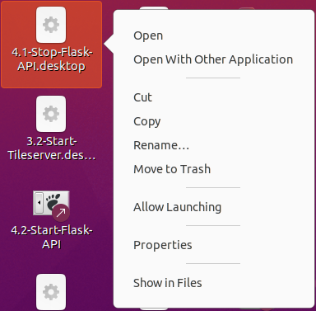
When the last script is done executing you will end up with a lot of shortcuts on you desktop. These shortcuts have to be organized. The illustration below shows the recommended way to order the shortcuts. You can change it where you see fit.
NOTE: This screenshot was created using Ubuntu 20.04.
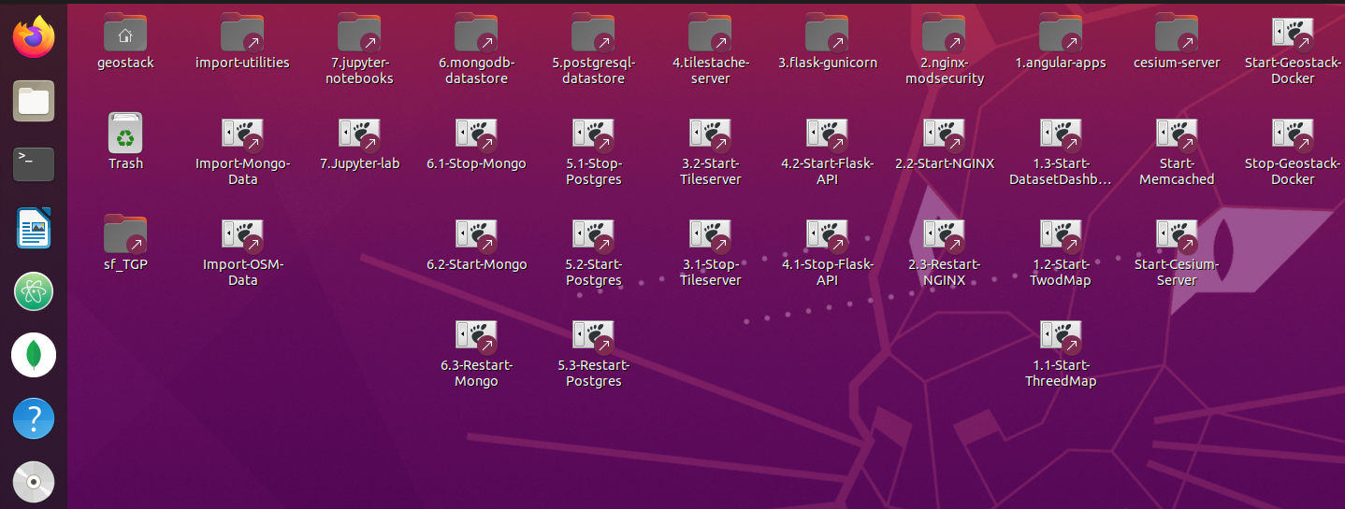

5. Installing GeoStack components MANUALLY
So you chose to install the GeoStack manually? That’s a good choice! It’s highly recommend you to clear some time in your schedule because his will be a lengthy but fun processes which will result in a lot of knowledge on subjects reaching from data analyses up to and including data visualizations using web applications.
In the folder: “~/GeoStack-Course/Building-the-VM-using-the-installation-scripts/Geostack” you can find all the files which we are going to create in the following chapters. These files can be used in case you get stuck during the creation of one or more of the components.

Have fun and Best of luck!

We are going to start of by creating the folder in which we are going to create and add all the GeoStack related files and folder. We create this folder by opening a terminal (Ctrl + alt + t on your keyboard) and running the command: mkdir ~/Geostack

This folder is going to serve as the root folder for all the GeoStack components and utility scrips. Each component will be created in it’s corresponding folder. The final Geostack root folder structure will look the same as shown in illustration below:


5.1 Installing Docker virtualization software
The illustration below shows all the GeoStack components encircled in red. Each GeoStack component is Dockerized and thus can run separately from the other components. Because of this compartmentalization you can for example run the PostgreSQL database on a system at home and the Tilestache Tileserver on a system located at work. The components are also installed in one Virtual Machine so everything can run locally on one machine. This is all possible by making use of Virtualization software. In this chapter we are going to install the tools required for the virtualization.
So let’s install the Docker virtualization software.

Install Docker by performing the following steps:
- Update the local database by running the following commands: sudo apt-get update
- Install the required dependencies for Docker.
sudo apt-get install apt-transport-https ca-certificates curl software-properties-common
- Install Docker by using the command: sudo apt install docker.io
- Validate whether Docker has been correctly installed. The output should be the docker version. We do this by running the command: docker --version
Install Docker-compose by performing the following steps:
- Enter the directory: “/usr/local/bin” by running the following command: cd /usr/local/bin
- Download the required binary's and executable for Docker-compose by running the following command:
sudo curl -L "https://github.com/docker/compose/releases/download/1.25.0-rc2/docker-\compose-$(uname -s)-$(uname -m)" -o /usr/local/bin/docker-compose
- Change the file permissions of the executable by running the following command:
sudo chmod +x /usr/local/bin/docker-compose
- Validate whether Docker-compose has been correctly installed by running the following command: docker-compose --version
- Add docker to the current user and reboot the system for the changes to take effect by running the following command: sudo usermod -a -G docker $USER && reboot
In the GeoStack folder, located in the Home folder of the VM, we are going to create a file called: ‘docker-compose.yml’. This is done by opening a terminal and running the command:
touch ~/Geostack/docker-compose.yml
In this file we are going to add all the GeoStack components as services after creating them. This file is used to run all the docker containers / components at once by running the command: “docker-compose up” from the directory “Geostack” which is the root directory of the Geographical software stack.
In chapter 6 of this cookbook we are going to run all the GeoStack components as docker containers using the docker-compose.yml file. But more on this later, let’s first install some general software and tools which are used to increase our workflow during the Beginner Course Open Source Geospatial Programming for Data Scientists.

5.2 Installing the general software
Install Bleachbit, which is a tool for keeping you system clean, by running the following command: sudo apt install bleachbit
Install Curl (A package for downloading files using the CMI): sudo apt install curl
Install Net Tools (A package for analyzing network statistics) : sudo apt install net-tools
Install LibreOffice Writer : sudo apt install libreoffice-writer
Install Python2 and Python2-pip by performing following steps (this step is not required but could be useful when in need for tools which require Python 2):
- Install Python 2 by running the following command: sudo apt install python
- Download the Python-pip install script by running the following command:
curl -O -L https://bootstrap.pypa.io/get-pip.py
- Install python-pip by running the following command: sudo python get-pip.py
- Remove the install script by running the following command: rm get-pip.py
Install Python3 and Python3-pip: sudo apt install python3-pip
Install GDAL for Geographical tools: sudo apt install gdal-bin
Install Atom, which is the code editor used during the cookbooks, by performing the following steps:
- Add the Atom signing key to the system by running the following command:
wget -qO - https://packagecloud.io/AtomEditor/atom/gpgkey | sudo apt-key add -
- Add the Atom repository to the system’s repositories list, using the following command:
sudo sh -c 'echo "deb [arch=amd64] https://packagecloud.io/AtomEditor/atom/any/ any\ main" > /etc/apt/sources.list.d/atom.list'
- Update the local database and install Atom by running the following command:
sudo apt update && sudo apt-get install atom
Install NodeJS & NPM, which are used for the Tileserver and the Angular applications, by performing the following steps::
- Temporarily download the NodeJS installation script using the following command:
curl -sL https://deb.nodesource.com/setup_12.x | sudo -E bash -
- Install the required packages for NodeJS by using the following command:
sudo apt install build-essential
- Install NodeJS by using the following command: sudo apt install nodejs
- Validate whether NodeJS has been correctly installed the output should be a version of NodeJS. We do this by running the following command: node -v
- Validate whether NPM has been correctly installed the output of this command should display the version of NPM. We do this by running the following command: npm -v

5.3 Installing data-analyses software
Now let’s install the tools required for the analyses of the datasets used during the Beginners Course Open Source Geospatial Programming for Data Scientists.
Installing Jupyter Lab is done by performing the following steps:
- Install the Jupyter package by running the following command:
sudo -H pip3 install jupyterlab
- Create a Desktop shortcut to start Jupyter Lab by running the following command:
touch ~/Desktop/Jupyter-lab.desktop
NOTE: During this course we are going to create a lot of desktop shortcuts which will be used to start and stop the GeoStack components. For more information related to creating desktop shortcuts you should read section 7.1 of this cookbook. The process of adding shortcuts in Ubuntu 19.04 and 20.04 differs from the process described below. See section 7.1 for more information.
- Add the following code to the file that was created on the desktop:
#!/usr/bin/env xdg-open

[Desktop Entry]
Version=1.0
Type=Application
Terminal=true
Exec=sh -c "fuser -k 8888/tcp; jupyter lab"
Icon=gnome-panel-launcher
Name[en_US]=jupyter-lab

- Make sure the shortcut is trusted by running the following command:

for i in ~/Desktop/*.desktop; do gio set "$i" "metadata::trusted" yes ;done

- Make sure the shortcut is launch-able by running the following command:

sudo chmod +x ~/Desktop/Jupyter-lab.desktop

Install Pandas and GeoPandas : pip3 install pandas geopandas
Install Ubuntu libraries required for Cartopy:
sudo apt install libproj-dev proj-data proj-bin libgeos-dev
Install Python packages required for Cartopy: pip3 install cython
Install MatPlotLib and Scipy: pip3 install cartopy matplotlib scipy
Install Cartopy: pip3 install git+https://github.com/SciTools/cartopy.git --no-binary cartopy
Install Python packages required for the GPX file format: pip3 install gpxpy geopy numpy
Install Pandas-Profiling: pip3 install pandas-profiling

5.4 Installing backend software
During the cookbooks we are going to work with multiple types of data formats. These data formats have to be transformed and then stored in the corresponding data store. During this section we are going to install all the tools and software required to perform this process. First some information is discussed on how to perform certain actions which can come in useful later on in the course. Afterwards we are going to put this software and information to use in the cookbooks:”ETL-Process-with-datasets” and “Data-modeling-in-MongoDB-using-MongoEngine”. Note: The things you will learn during the beginning of the section (Dockerizing, managing and importing in the datastores) will become more clear after reading the cookbooks mentioned above. This information is added in this section because it will be useful later on during the Course.

5.4.1 Installing PostgreSQL
Install PostgreSQL by performing the following steps:
- Add the official PostgreSQL repository key to the system.
wget -O - https://www.postgresql.org/media/keys/ACCC4CF8.asc | sudo apt-key add -
- Add the PostgreSQL repository to the system’s repository list.
sudo sh -c 'echo "deb [arch=amd64] http://apt.postgresql.org/pub/repos/apt/\ `lsb_release -cs`-pgdg main" >> /etc/apt/sources.list.d/pgdg.list'
- Update the package database, using the following command: sudo apt update
- Depending on the Ubuntu version install PostgreSQL:
Install PostgreSQL 11 if you are using Ubuntu 18.04 or lower by the following command:
sudo apt install postgresql-11
Install PostgreSQL 12 if you are using Ubuntu 19.10 or higher by the following command:
sudo apt install postgresql-12
- Validate whether PostgreSQL has been correctly installed by running the following command: sudo service postgresql status
- Login to the PostgreSQL user and the PostgreSQL CLI (Command line interface), using the following command: sudo -u postgres psql

- Change default PostgreSQL password by running the following: \password postgres
Then enter the password: geostack
- Exit the PostgreSQL CLI by using the following command: \q
- Create a desktop shortcut, which is used to start the PostgreSQL service, by running the following command: touch ~/Desktop/Start-Postgres.desktop
- Add the following code to the file that is created on the desktop and save the file.
#!/usr/bin/env xdg-open
[Desktop Entry]
Version=1.0
Type=Application
Terminal=false
Exec=sh -c "service postgresql start"
Icon=gnome-panel-launcher
Name[en_US]=Start-Postgres

- Create a desktop shortcut, which is used to stop the PostgreSQL service, by using the following command: touch ~/Desktop/Stop-Postgres.desktop
- Add the following code to the file that is created on the desktop and save the file.
#!/usr/bin/env xdg-open
[Desktop Entry]
Version=1.0
Type=Application
Terminal=false
Exec=sh -c "service postgresql stop"
Icon=gnome-panel-launcher
Name[en_US]=Stop-Postgres

- Make sure the shortcuts are trusted by running the following command:

for i in ~/Desktop/*.desktop; do gio set "$i" "metadata::trusted" yes ;done

- Make sure the shortcuts are launch-able by running the following command:

sudo chmod +x ~/Desktop/Stop-Postgres.desktop && sudo chmod +x ~/Desktop/Start-\Postgres.desktop

Now depending on the Ubuntu version install PostGIS:
installing PostGIS on Ubuntu 18.04 or lower : sudo apt install postgis postgresql-11-postgis-2.5
installing PostGIS on Ubuntu 19.1 or higher : sudo apt install postgis postgresql-12-postgis-2.5
install PGMyAdmin: sudo apt install pgadmin4
install packages required for PsycoPG2:
sudo apt-get install libpcap-dev libpq-dev python-dev python3-dev
Install PsycoPG2: pip3 install psycopg2

5.4.1.1 Dockerizing PostgreSQL and PostGIS
Dockerizing the PostgreSQL datastore can be done by performing the steps below. As mentioned in the beginning of the section; Some steps may seem unclear at this point but don’t worry about this. They will become more clear during the Course!.
- In the GeoStack folder, create a folder called: “postgresql-datastore” by running the following command: mkdir ~/Geostack/postgresql-datastore
- Create a folder called: “data” which is going to contain all our data from the PostgreSQL Docker container. We do this by running the following command:
mkdir ~/Geostack/postgresql-datastore/data
- Next we are going to create a script which will run when the container is started for the first time. We are going to call this script: “initdb.-postgis.sh”. We do this by running the following command: touch ~/Geostack/postgresql-datastore/initdb-postgis.sh
- Open the file, add the following code to the file and save the file afterwards:
#!/bin/bash

# Create the user geostack and set the password to geostack
createuser geostack
psql -c "ALTER USER geostack WITH PASSWORD 'geostack';"

# Create the gis database with user: "gis" and add the required
# extensions to the database
createdb -E UTF8 -O geostack gis
psql -c "CREATE EXTENSION IF NOT EXISTS postgis;" gis
psql -c "CREATE EXTENSION IF NOT EXISTS postgis_topology;" gis
psql -c "CREATE EXTENSION hstore;" gis
The script above is going to run when the Docker container is being build for the first time. The script makes sure a database called: “gis” is created in which the required PostGIS extensions are loaded.
- Create a file called: “Dockerfile” in the folder postgresql-datastore. This file is going to contain all the logic required to build the PostgreSQL Docker container. We do this by running the following command: touch ~/Geostack/postgresql-datastore/Dockerfile
- Now open the newly created Docker file which is located in the folder: “~/Geostack/postgresql-datastore/” and add the following to this file and save it afterwards:
# The line below creates a layer from the PostgreSQL V. 11 Docker image.
FROM postgres:11

# Set build environment to the versions required for our PostgreSQL installation.
ENV POSTGIS_MAJOR 2.5
ENV POSTGISV 2.5

# Download the required packages, software and modules using the environment
# variables which we set above. After the modules are downloaded, they are
# unziped and compiled.
RUN apt-get update \
&& apt-get install -y --no-install-recommends \
postgresql-$PG_MAJOR-postgis-$POSTGISV \
postgresql-$PG_MAJOR-postgis-$POSTGISV-scripts \
postgresql-$PG_MAJOR-pgrouting \
postgresql-$PG_MAJOR-pgrouting-scripts \
postgresql-server-dev-$PG_MAJOR \
unzip \
make \
&& apt-get purge -y --auto-remove postgresql-server-dev-$PG_MAJOR make unzip

# Create a directory in which we will copy the script that creates the database.
RUN mkdir -p /docker-entrypoint-initdb.d

# Copy the script which will run when the container is started for the first time
COPY ./initdb-postgis.sh /docker-entrypoint-initdb.d/postgis.sh

# Set the permissions of the postgis.sh init script.
RUN chmod +x /docker-entrypoint-initdb.d/postgis.sh
- Add the following to the docker-compose.yml, which is located in the folder: “~/Geostack”, and save it afterwards.
#Define the docker compose version
version: '3.7'

#Defining the GeoStack services (components) is done below
services:
# Here we define the name of the PostgreSQL datastore Docker service
postgresql-datastore:
container_name: postgresql-datastore
# Set the directory in which the dockerfile is located
build: ./postgresql-datastore
# Add the data volume of the docker container
volumes:
- ./postgresql-datastore/data:/var/lib/postgresql/data
# Set the port on which the docker container is available to port 5432
# Since we set it to port 5432:5432, the docker container will also be accessible on
# our host system via localhost:5432
ports:
- '5432:5432'
# Here we add the environment variable which allows connections without a pass.
environment:
POSTGRES_HOST_AUTH_METHOD: "trust"

5.4.1.2 Importing data in the PostgreSQL Docker datastores
The process of importing data in a Dockerized PostgreSQL database is similar to importing data in a Local PostgreSQL database instance. Before starting the import process you have to make sure that the Local PostgreSQL instance is not running and the Docker PostgreSQL instance (container) is running with a port that is exposed to our local system (Localhost).
Making sure the docker container is exposed to the Localhost is done by setting the ports of the postgresql-datastore service in the docker-compose.yml file to: ‘5432:5432’. As you can see in the code above we set the container to also be available on our localhost.
This means that the PostgreSQL database is available locally and in the docker container on port: 5432. If you set it to just 5432 the docker container will not be exposed to the LOCALHOST. Doing this comes in handy if you want to run a Local and a Dockerized database simultaneously.

5.4.1.3 Exporting the PostgreSQL Docker data volume
Exporting a PostgreSQL Docker data volume can be done by performing the following steps:
- Change the permissions of the PostgreSQL Data volume to the permissions of our current user by running the following command:
sudo chown -R $USER ~/Geostack/postgresql-datastore/data
- Zip the data folder so that the size is decreased which is useful when distributing the PostgreSQL Docker data volume to other systems.
NOTE: When rebuilding a Docker container with a large data volume attached to it the rebuilding process will take longer depending on the size of the data volume!

5.4.1.4 Managing the PostgreSQL Databases
To manage the PostgreSQL databases you can perform the following steps:
- Open a terminal by pressing the key combination Ctrl + Alt + t on you keyboard.
- Login to the PostgreSQL user and the PostgreSQL CLI by running the following command and entering the password: “geostack”: sudo -u postgres psql
This will log you in to the PostgreSQL user and open the PostgreSQL CLI. You can type the command \h to see all available commands for the PostgreSQL CLI.

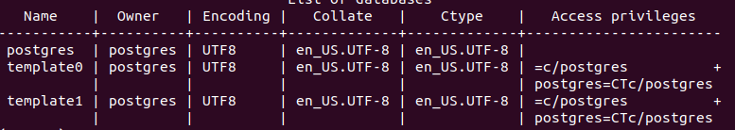
- List the current databases by entering the command: \l
This will show an output similar to the one shown in the illustration below.
- You can create databases by running the command: CREATE DATABASE {DB_NAME};

- You can delete databases by running the command: DROP DATABASE {DB_NAME};


- Select a database by running the command: \c {name of the database}. This will connect you to the selected PostgreSQL database as shown in the illustration below. NOTE: You will not have a database called: “gis” yet. We will be creating this database later during the course!


- You can list all the tables in the database by running the command: \dt
The output should be similar to the one shown in the illustration below.

This illustration shows all the tables in our gis database which is used to store our raw OpenStreetMap data. We are going to create this database when creating the Tilestache Tileserver so don’t worry about not having the database yet!

- To show the contents of a table you can run the command: SELECT * FROM {table name};

- To remove an entry from a table you can run the command:
DELETE FROM {table name} WHERE {table name}.{column name} = ‘{value}’;

- You can create tables by running the command: CREATE TABLE TEST ( test Int );

- You can delete tables by running the command: DROP TABLE TEST;

- To exit the PostgreSQL CLI you can type the command : exit

For more information related to the PostgreSQL CLI commands, you should read the documentation which can be found on the following URL: https://www.postgresql.org/docs/

You can also use the GUI version called: “PGAdmin 4”. We already installed this application which can be started by clicking on the shortcut shown in the illustration below.

5.4.1.5 Setup PGAdmin4


To easily manage PostgreSQL database you can also use the GUI version called: “PGAdmin4”. We already installed this software product which can be started by clicking on the shortcut shown in the illustration below. Which can be found by searching for: “PGAdmin” in the systems applications.
Loading PGAdmin4 for the first time can take a while but after a few seconds the screen shown in the illustration below will show up as an Tab in your Firefox browser:
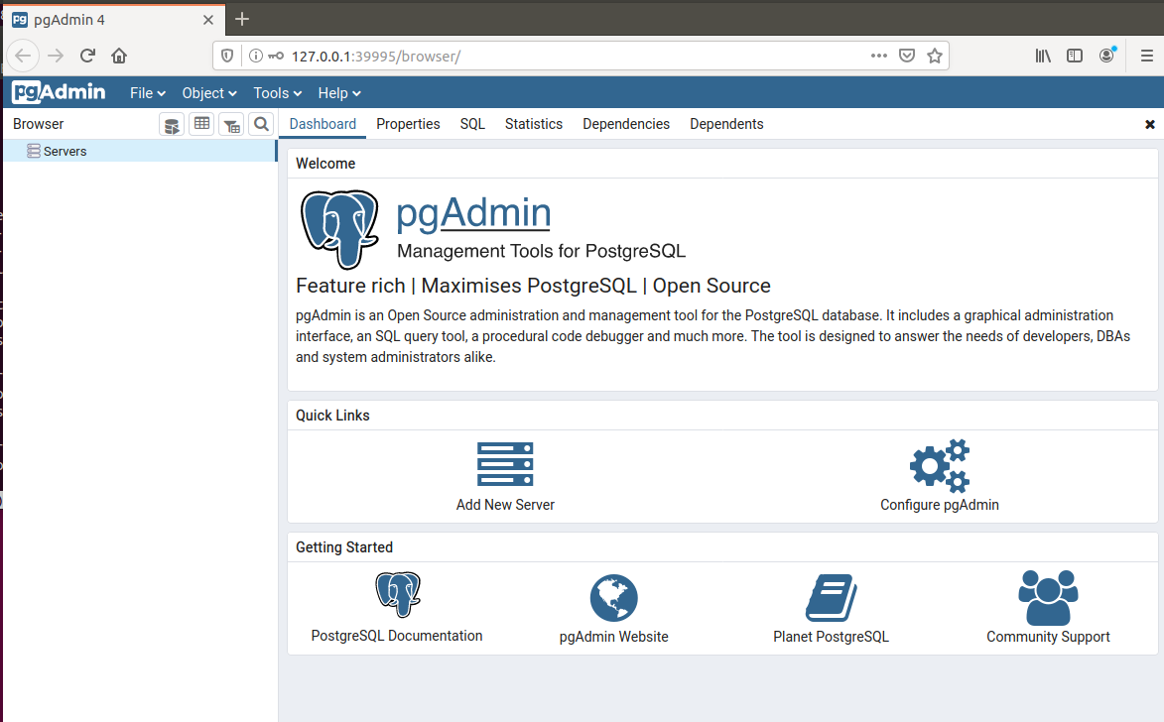
Right click on the servers entry in the left menu then select Create → Server as shown in the illustration below:
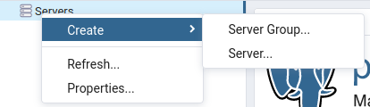
The set the Name (Red) and Host name / Address (Blue) to localhost, the username (Orange) to postgres and the password (Green) to geostack and select Save as shown in the illustrations below:
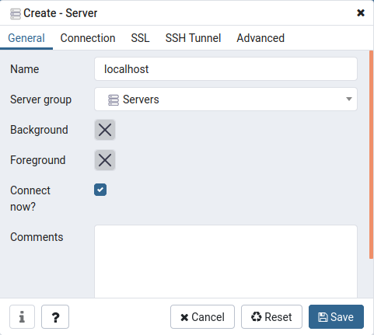
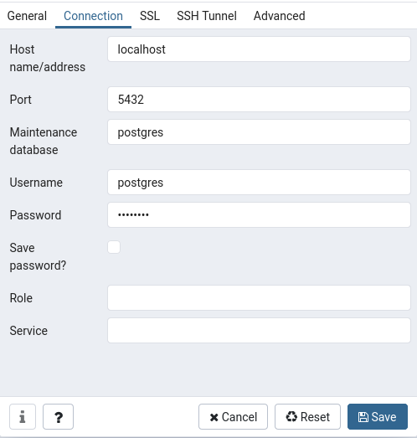

As you can see we now have a new server called: “localhost” as shown in the illustration below:

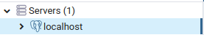

When you click on localhost → databases you will get a list of all the database currently running on our local PostgreSQL instance as shown in the illustration below.

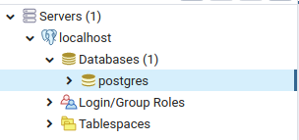

You can manage database by right-clicking on the desired database an choosing one of the options shown in the menu that pops up as shown in the illustration below:

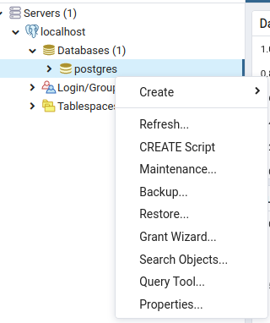
For more in depth instructions related to PGAdmin4 you should visit the following URL:
https://www.pgadmin.org/

5.4.2 Installing MongoDB
Install the libraries which are required for MongoDB: sudo apt install libgconf-2-4
Install MongoDB by performing the following steps:
- Install the MongoDB package by running the following command:
sudo apt install mongodb
- Validate if MongoDB is correctly installed by running the following command: mongo
- Create a desktop shortcut to start the MongDB service, using the following command:
touch ~/Desktop/Start-Mongo.desktop
- Add the following code to the file that is created on the desktop and save the file:
#!/usr/bin/env xdg-open
[Desktop Entry]
Version=1.0
Type=Application
Terminal=false
Exec=sh -c "service mongodb start"
Icon=gnome-panel-launcher
Name[en_US]=Start-Mongo
- Create a desktop shortcut to stop the MongoDB service by running the following command: touch ~/Desktop/Stop-Mongo.desktop
- Add the code below to the file that is created on the desktop and save it afterwards:
- Make sure the shortcut is trusted by running the following command:
#!/usr/bin/env xdg-open
[Desktop Entry]
Version=1.0
Type=Application
Terminal=false
Exec=sh -c "service mongodb stop"
Icon=gnome-panel-launcher
Name[en_US]=Stop-Mongo

for i in ~/Desktop/*.desktop; do gio set "$i" "metadata::trusted" yes ;done

- Make sure the shortcuts are launch-able by running the following command:

sudo chmod +x ~/Desktop/Stop-Mongo.desktop && sudo chmod +x ~/Desktop/Start-\Mongo.desktop

Installing MongoCompass is done by performing the following steps:
- Download the MongoCompass package by running the following command:
wget https://downloads.mongodb.com/compass/mongodb-compass_1.20.4_amd64.deb
- Install the MongoCompass package by running the following command:
sudo dpkg -i mongodb-compass_1.20.4_amd64.deb
- Remove the MongoCompass package by running the following command:
sudo rm mongodb-compass_1.20.4_amd64.deb
Install MongoEngine: pip3 install mongoengine

5.4.2.1 Dockerizing MongoDB
To Dockerize the MongoDB datastore you have to perform the following steps:
- Create a folder called: “mongodb-datastore” in the Geostack folder by running the following command: mkdir ~/Geostack/mongodb-datastore
- Create a folder called: “data”. This folder is going to contain all our data from the MongoDB Docker container.
mkdir ~/Geostack/mongodb-datastore/data
- Add the following to the docker-compose.yml file which is located in the Geostack folder:
# Here we define the name of the MongoDB datastore Docker service
mongodb-datastore:
# Here we define the name which the MongoDB container is going to have
container_name: mongodb-datastore
# Here we define the image that is used for this container
image: mongo:latest
# Add the data volume of the docker container
volumes:
- ./mongodb-datastore/data:/data/db
# Set the port on which the docker container is available to port 27017
# Since we set it to port 27017:27017, the docker container will also be # accessible on our host system via localhost:27017
ports:
- '27017:27017'

NOTE: In the case of Dockerizing the MongoDB datastore, we do not have to create a Dockerfile because we don’t have to add any extra logic when creating the MongoDB Docker container.

- Build the new service we just added in the docker-compose.yml file.
cd ~/Geostack && docker-compose build
The command above will build the PostgreSQL and MongoDB images which we added in this section and the previous section.

5.4.2.2 Importing data in the MongoDB Docker datastore
The process of importing data in a Dockerized MongoDB database is similar to importing data in a Local MongoDB database instance. Before starting the import process you have to make sure that the Local MongoDB instance is not running and the Docker MongoDB instance (container) is running with a port that is exposed to our local system (Localhost).
Making sure the Docker container is exposed to the Localhost is done by setting the ports of the mongodb-datastore service in the docker-compose.yml file to: ‘27017:27017’. As you can see in the code above we set the container to also be available on our localhost.
This means that the MongoDB database is available locally and in the docker container on port: 27017. If you set it to just 27017 the docker container will not be exposed to the Localhost. Doing this comes in handy if you want to run a Local and a Dockerized database simultaneously.

5.4.2.3 Exporting the MongoDB Docker data volume
Exporting a MongoDB Docker data volume can be done by performing the following steps:
- Change the permissions of the MongoDB Data volume to the permissions of our current user by running the following command:
sudo chown -R $USER ~/Geostack/mongodb-datastore/data
- Zip the data folder so that the size is decreased which is useful when distributing the MongoDB Docker data volume to other systems.

5.4.2.4 Managing the MongoDB Databases
If you want to remove a database from you MongoDB instance you should perform the following steps:
- Open a terminal and enter the command: mongo. This will open a MongoDB CLI as shown in the illustration below.

- Then we want a list of all the databases on our system. This is done by entering the command: show dbs

Note: You will not have the Crane and Trail Databases yet. We will be creating these later in the course.

- Then look for the name of the database which you want to remove and enter the command: use {name of the database}
- You can display the collections in a database by running the command: show collections

- Then enter the command: db.dropDatabase() which will then remove the database.
If you want to clean (remove everything from) your local instance of MongoDB you should run the command:
mongo --quiet --eval 'db.getMongo().getDBNames().forEach(function(i)\{db.getSiblingDB(i).dropDatabase()})'

WARNING: This will remove all the content and data from you MongoDB which is as follows:
- All databases
- All indexes
- All documents
Now that we have all the tools, libraries and software products required for our data-analyses we can start performing the data-analyses on the datasets.
The cookbook: “ETL-Process with datasets” gives information related to performing the ETL-Process using one Crane (Tracker) dataset as example. The data analyses steps which we are going to perform are the first 2 steps of the so called: “ETL-Process”.
We are going to use Jupyter Lab in which we are going to create a Jupyter Notebook. In this Jupyter Notebook we are going to create the code which is required to analyze the datasets.
To start Jupyter Lab you can click on the desktop shortcut (that was created earlier) as shown in the illustration below:
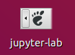
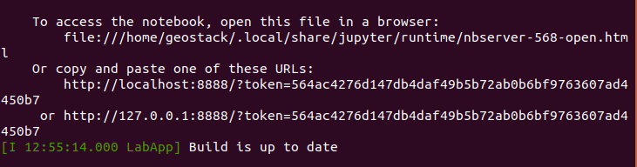
This will open a terminal telling you the Jupyter Lab server has been started on port 8888 as shown in the illustration below:

A Firefox window with the Jupyter Lab instance will also be opened as shown in the illustration below:
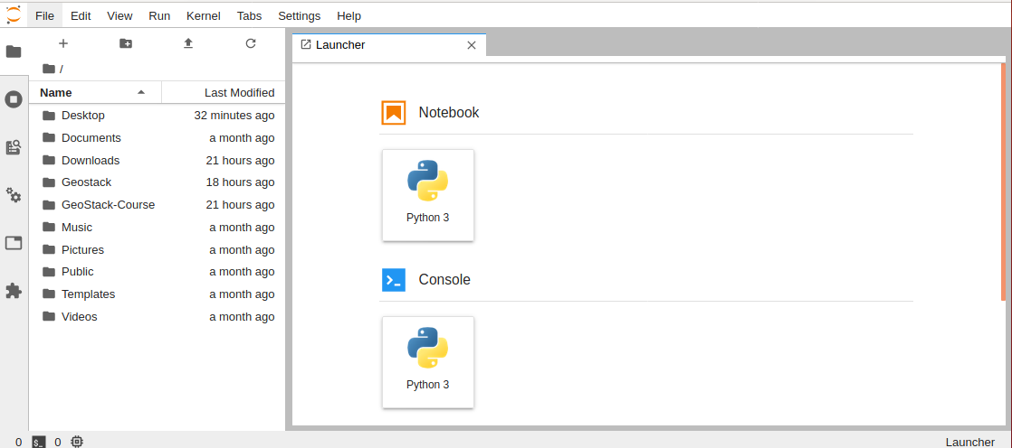
Before we can start reading the cookbook: “ETL-Process with datasets” we should create a ne Jupyter Notebook in which we are going to create the code. We should create this Jupyter Notebook in the same folder as the notebook called: “Notebook-Created-Druing-Cookbook” which can be found in the folder: “~/GeoStack-Course/Building-the-VM-from-scratch-using-the-manuals/1.Cookbook-ETL-Process-With-Datasets/Cookbook-Notebook/”. So let’s navigate to this folder using the sidebar which is encircled in red in the illustration above.
Now when you are navigated to the folder: “~/GeoStack-Course/Building-the-VM-from-scratch-using-the-manuals/1.Cookbook-ETL-Process-With-Datasets/Cookbook-Notebook/” (encircled in red in the illustration below) you should click on the Python 3 button below the Notebook entry (encircled in blue in the illustration below):
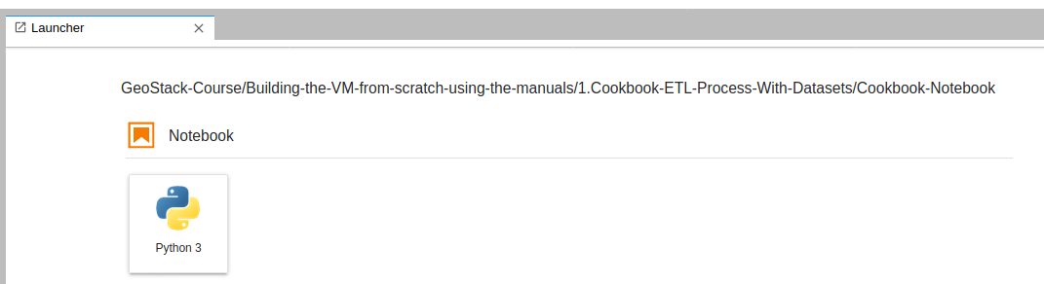
This will open a new notebook as shown in the illustration below:
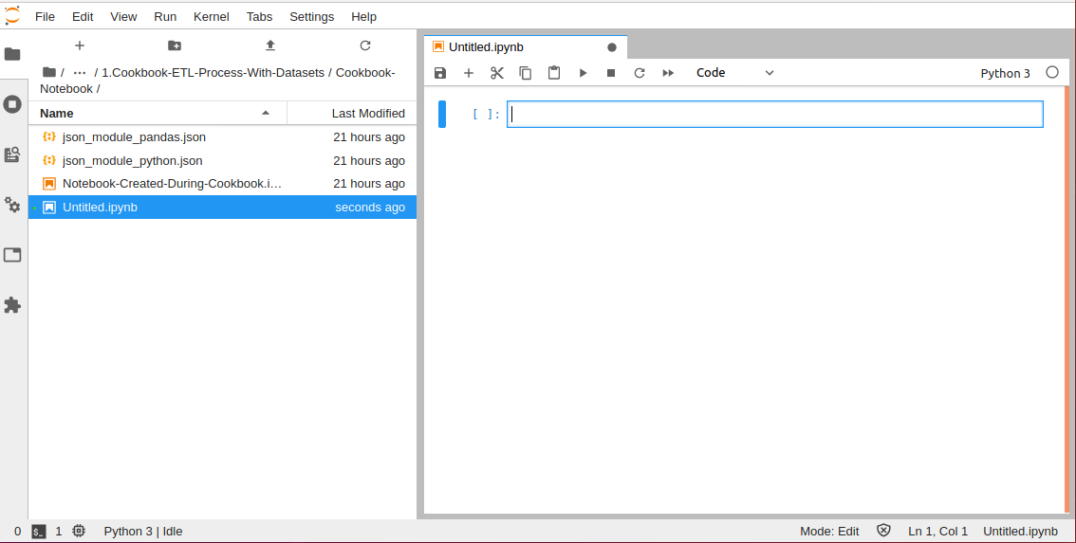
In this notebook we are going to create all the code which is described in the cookbook:“ETL-Process with Datasets”. So let’s keep this window open and start reading the cookbook: “ETL-Process with Datasets” which can be found in the folder: ‘~/GeoStack-Course/Building-the-VM-from-scratch-using-the-manuals/1.Cookbook-ETL-Process-With-Datasets’.
In this cookbook you will learn about the following subjects and many more:
- How to extract data from a data source;
- How to filter data for the application goals;
- How to transform data to the file formats JSON and GeoJSON.
As mentioned before; this cookbook uses ONE Crane dataset as an example. The notebook used during this cookbook can be found in the folder: “Cookbook-Notebook” which is located in the same folder as the cookbook: “ETL-Process with datasets”.
In the folder of the cookbook you will also find a folder called: “Remaining-Analyses-Notebooks”. This folder contains the Jupyter notebooks related to the data-analyses of the following datasets:
- The remaining Crane (Tracker) datasets;
- GPS Route (Trails) datasets;
- World Port Index dataset.
As you will see in the notebooks; the process of performing a data-analyses on the datasets, which are not described in the cookbook: “ETL-Process with datasets” is similar to the one described in the cookbook. You should run all the cells in the remaining notebooks since we need to have these datasets transformed to reach the end-goals in our applications. But let’s first read the cookbook: “ETL-Process with Datasets” as shown in the illustration below:

After you have finished reading this cookbook and the remaining Jupyter notebooks that come with it, you should continue reading this cookbook.

At this point you should have read the cookbook: “ETL-Process with datasets” and the notebooks in the folder: “Remaining-Analyses-Notebooks”. If you did everything accordingly you should end up with the following files in the following folders:

- The folder: “~/GeoStack-Course/Course-Datasets/JSON/Crane_GeoJSON” should contain the following files:
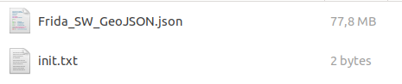

- The folder: “~/GeoStack-Course/Course-Datasets/JSON/Crane_JSON” should contain the following files:
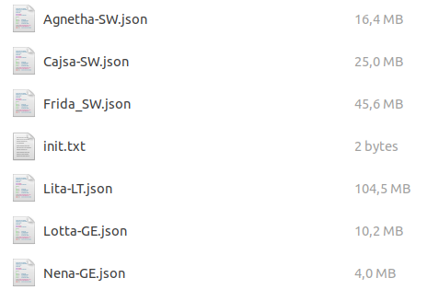
- The folder: “~/GeoStack-Course/Course-Datasets/JSON/Trail_JSON” should contain the following files:
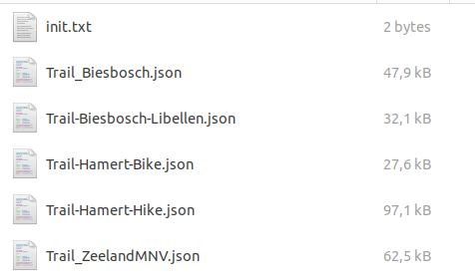

Now that we have analyzed and transformed the datasets, you should start reading the cookbook: “Data-Modeling-in-MongoDB-using-MongoEngine” in which you will learn how to create a data model for the Crane datasets.

The cookbook can be found in the folder: ‘~/GeoStack-Course/Building-the-VM-from-scratch-using-the-manuals/2.Data-Modeling-in-MongoDB ’. In this cookbook you will learn the following and much more:

- How to create data models using MongoEngine.
- How to import the data in a MongoDB datastore using the model.
- How to create indexes on databases.
This cookbook uses the Crane dataset, which was used in the cookbook: “ETL-Process-with-datasets”, as example. The notebook containing the final code created during this cookbook can be found in the folder: “Cookbook-Notebook” which is located in the same folder as the cookbook: “Data-Modeling-in-MongoDB-using-MongoEngine”
In the folder of the cookbook you will also find a folder called: “Remaining-Data-Modeling-Notebooks”. This folder contains the Jupyter notebooks related to the data importing of the following datasets:
- The remaining Crane (Tracker) datasets;
- GPS Route (Trails) datasets;
- World Port Index dataset.
As you will see in the notebooks; the process of modeling the datasets, which are not described in the cookbook: “Data-Modeling-in-MongoDB-using-MongoEngine” is similar to the one described in the cookbook. You should run all the cells in the remaining notebooks since we need to have these datasets modeled, imported and indexed in our MongoDB datastores and PostgreSQL datastore to reach the end-goals in our applications.
Let’s first create a new empty notebook in which we are going to add all the code which is described in the cookbook: “Data-Modeling-in-MongoDB-using-MongoEngine”. We do this by clicking on the Jupyter-Lab shortcut which can be found on the desktop as shown in the illustration below:
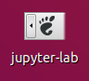
Once Jupyter lab is started you should navigate to the folder: “~/GeoStack-Course/Building-the-VM-from-scratch-using-the-manuals/2.Cookbook-Data-Modeling-in-MongoDB/Cookbook-Notebook/” (encircled in red in the illustration below) You should click on the Python3 button below the Notebook entry (encircled in blue in the illustration below):
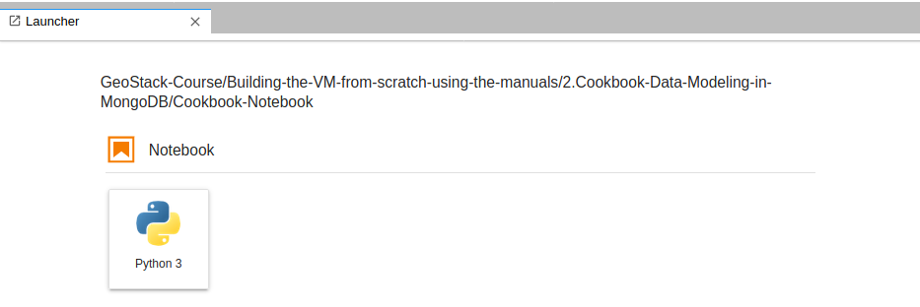
Which will open a new notebook as shown in the illustration below:
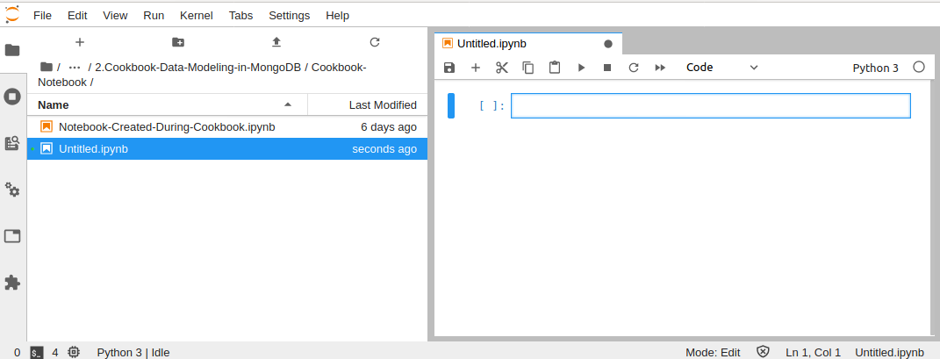
Now you can start reading the cookbook: “Data-Modeling-in-MongoDB-using-MongoEngine” as shown in the illustration below. You should add all the code, described in the cookbook, in the notebook which we created above.

After you have finished reading this cookbook and the Remaining Jupyter notebooks that come with it you should continue to read this cookbook.
Now let’s confirm if everything up till now has been done correctly. We start of by confirming if the Crane (Tracker) datasets and the GPS Route (Trail) Datasets have been correctly imported. This is done by performing the following steps:
- Start MongoDB Compass by clicking on the sidebar shortcut icon which is shown in the illustration below:

- The following database should be available in the left sidebar of the of the MongDB Compass start screen:
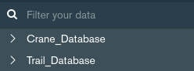
- The following should be shown in the main screen of the MongoDB Compass start screen:
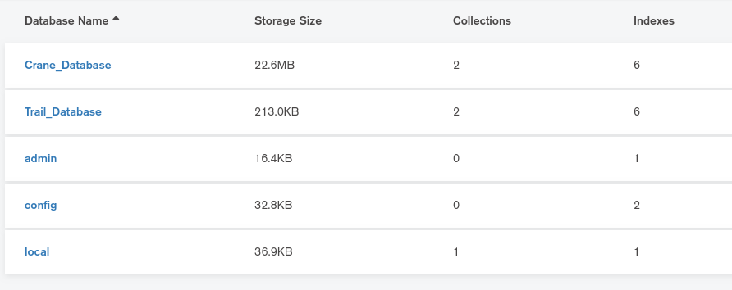
- When clicking on the

5.4.2.5 Automating the dataset import process
Now that you know how to manually model, index and import datasets in a MongoDB datastore, it’s time to make a Python script which automates this process. This script will do the following:
- Give you the option to select and import a dataset in either CSV, JSON or GPX format. This is done using a simple GUI as shown in the illustration below.
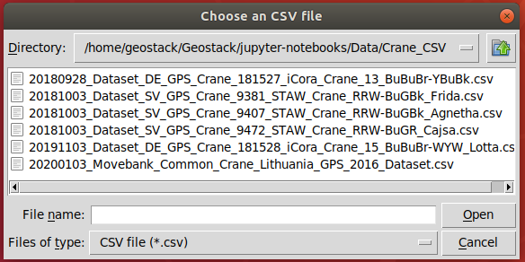
- Create a data model for the datasets and filter the datasets;
- Import the data in a database, which you can chose yourself, according to the data model.
- Create indexes on the newly imported dataset.
In some datasets the names of the longitude, latitude, altitude and timestamp columns differ. This script will ask you to enter the names of those columns to make sure that every type of dataset can be imported using the script. The script also employs multiple checks before the actual import process starts. This is useful to prevent the loading of incorrect data in the database.
First we need to install a Python package which is used for the simple GUI to select files. This package is called Tkinter and can be installed using the following command:
sudo apt-get install python3-tk
Now we are going to create a new folder in the Geostack folder. This folder is called: “import-utilities” and is going to contain all our scripts related to automating import processes. This is done by entering the following command in a terminal: mkdir ~/Geostack/import-utilities
Now we need to create a new Python file called: “mongo-data-import.py”. We do this by running the following command: touch ~/Geostack/import-utilities/mongo-data-import.py

Now let’s open this file in the Atom code editor. We start of by adding the modules which are required in the script. This is done by adding the following code at the top of the file:
Next we are need to let the script know it needs to create a Tkinter GUI in the background. We do this by adding the following code below the module imports.

Next we are going to create 3 functions which each represent a different type of data format. These formats are CSV, JSON and GPX. We start of with creating the function for the CSV import. We do this by adding the following code below the lines where we created the Tkinter GUI.


Now we need to create the function which is used to import JSON datasets. We do this by adding the following code below the csv_import function:
Before we are going to create the function which is used to import GPX datasets, we first need to create a function which creates a dataframe using raw GPX data. This is done by adding the following code below the json_import() function:
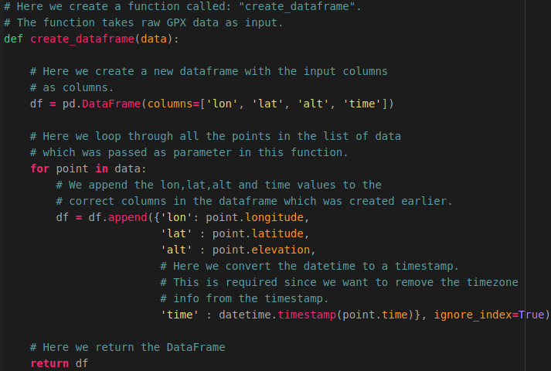

Now let’s create the function which is used to import GPX data. This is done by adding the following code below the create_dataframe function.


As you can see in the illustrations above, we used the function: “transform_data()”. This function has not been created yet. We are first going to create a function which is used to check whether an input dataframe is valid or not. We call this function: “check_dataframe()”. We do this by adding the following code below the csv_json() function.

Next, we are going to create a function called:”column_selection()”. This function is used to ask the user what the names are of the longitude, latitude, altitude and timestamp columns. This is required since not all datasets have the same columns names. This function makes sure that the import script can be used for every type of dataset.
Now we want to create a function called: “check_columns”. This function is used to check whether the columns, selected by the user in the function:”column_selection”, are valid.

Now let’s add the function: “transform_data()”. This function is used to perform checks on the dataframe and the selected columns. If everything is correct this function will trigger the data loading function which we will create later. So let’s add the following code below the function: “check_columns()”.

NOTE: The following illustration is divided in 2 parts. The last line of the first illustration is the same as the first line of the second illustration. You don’t need to add this line twice.

NOTE: The functions for loading the Crane (“load_crane_data()”) and Trail (“load_trail_data()”) data have not been created yet. This will be done later. Next we need to create the main function which is triggered when running the Python script. This function can be seen as the “main” function that let’s you choose between an CSV, JSON or GPX dataset. This function is called: “import_tool()”.
To add the main function we need to add the following function below the transform_data function.

NOTE: The following code is explained using inline comments. You can find the complete script in the folder: ”Building-the-VM-using-the-installation-script/Geostack/import-utilities” which can be found in the same folder as this cookbook.
Now we want to create the import function for the Crane datasets. Before we can do this we need to create a new Python file which is going to contain the Crane data model. We are going to call this file: “CraneModel.py”. We create this file by running the following command:
touch ~/Geostack/import-utilities/CraneModel.py
Open this file and add the following module import at the top of the file:

Now let’s add the Crane data model to this Python script. We have already created the data model in the cookbook: “Data-modeling-in-MongoDB”. You can copy this data model to the file. The illustrations on the next pages contain the code that should be copied to the Python script.

First, copy the model of the Transmission Metadata embedded document:

Next, copy the model of the Geometry Embedded document:



Next, copy the model of the Speed Embedded document:
Then copy the Transmission Document:

Finally copy the model of the Tracker document:

Now that we have to model we need to go back to the mongo-data-import script and import the CraneModel in this script. This is done by adding the following line below the import_tool function:

Now let’s create the function which is used to import the Crane datasets. This function is called: “load_crane_data” and takes a dataframe, a list of columns and the database name as input. This function is basically the same as the one which we created in the cookbook:”Data-modeling-in-MongoDB-using-MongoEngine”. There are a few minor differences which are crucial to automating the import the import process. So let’s create this function by adding the following code below the line where we imported the CraneModel.

NOTE: The following illustration is divided in 2 parts. The last line of the first illustration is the same as the first line of the second illustration. You don’t need to add this line twice.

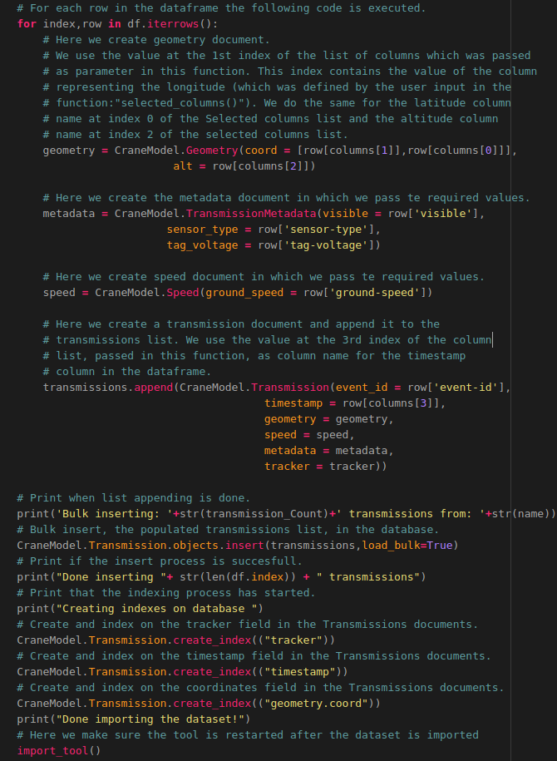
That’s it! The code required to automatically import Crane datasets is finished. Now we want to do the same for the GPS Route (Trail) datasets. How this is done is shown on the next pages.

Now we want to create the import function for the GPS Route (Trail) datasets. Before we can do this we need to create a new Python file which is going to contain the Trail data model. We are going to call this file: “TrailModel.py”. We create this file by running the following command:
touch ~/Geostack/import-utilities/TrailModel.py
Open this file and add the following module import at the top of the file:
Now let’s add the Trail data model to this Python script. We have already created the data model in the Jupyter Notebook related to the GPS Routes (Trail). You can copy this data model to the script. The illustrations below contain the code that should be copied to the Python script.
We start of by copying the Trail document:


Next we want to copy the Signal document:
Finally we want to copy the Geometry document:


Now that we have to model we need to go back to the mongo-data-import script and import the TrailModel in this script. This is done by adding the following line below the load_crane_data function:
Now let’s create the function which is used to import the Trail datasets. This function is called: “load_trail_data” and takes a dataframe, a list of columns and the database name as input. This function is basically the same as the one which we created in Jupyter notebook related to the GPS Routes.
So let’s create this function by adding the following code below the line where we imported the TrailModel.

NOTE: The following illustration is divided in 3 parts. The last line of the first illustration is the same as the first line of the second illustration. You don’t need to add this line twice.


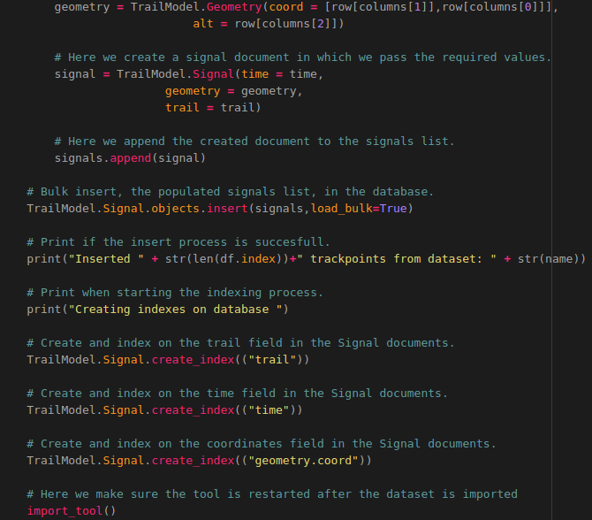
The last thing we need to do is adding a line of code which makes sure that when the Python script is executed the import_tool function is triggered. We do this by adding the following at the bottom of the script.

Now let’s create a desktop shortcut which runs the Python script when it’s clicked. We do this by performing the following steps:
- Create a desktop shortcut to start the Python script, using the following command:
touch ~/Desktop/Import-Mongo-Data.desktop
- Add the following code to the file that is created on the desktop and save the file:
- Make sure the shortcut is launch-able by running the following command:
#!/usr/bin/env xdg-open
[Desktop Entry]
Version=1.0
Type=Application
Terminal=true
Exec=sh -c 'python3 ~/Geostack/import-utilities/mongo-data-import.py'
Icon=gnome-panel-launcher
Name[en_US]=Import-Mongo-Data
for i in ~/Desktop/*.desktop; do gio set "$i" "metadata::trusted" yes ;done && sudo \ chmod +x ~/Desktop/Import-Mongo-Data.desktop

5.5 Installing middleware software
The Middleware consists of multiple webservers and an API. It contains the Tilestache Tileserver, the Cesium Terrain Server, the Flask-API and the NGINX-Webserver. The middleware is where all the “magic” happens. During this section we are going to install everything we need to create the middleware of the GeoStack.
Before we start installing the software required for the middleware of our GeoStack, you should start reading the cookbook: “A secure NGINX webserver with ModSecurity”. This is because you will learn more about the basics of Docker, how you should create separate Docker containers, how to run these containers and how to let containers communicate with each other.
In this cookbook you will first learn how to create the base Python Flask application and the NGINX-Webserver as Docker containers.
In this cookbook you will also learn about the following and much more:
- How to work with Docker containers.
- Create a basic Flask application and Dockerize it.
- Creating the secure NGINX webserver with ModSecurity and Dockerize it.
- Running the Docker containers separately.
- Linking and running the Docker containers together using Docker-Compose.
After you have finished reading the cookbook: “A secure NGINX webserver with ModSecurity” you should come back to this cookbook (Creating the GeoStack Course VM).



Now that you have finished the cookbook:”A secure NGINX webserver with ModSecurity” you end up with a folder which contains the base of the Flask-API and the NGINX webserver, The file structure of this folder is the same as shown in the image on the right.
We need to perform some transformations to make sure these files serve the needs of our GeoStack. Let’s first copy the nginx-modesecurity folder to the Geostack root folder in which we have all our other components.
Press Ctrl + alt + t to open a terminal and then enter the command:
cp -r {path to nginx-modsecurity folder} ~/Geostack/
In my case it would be:
cp -r ~/20200612_Secure_Webserver_NGINX/nginx-modescurity ~/Geostack/
Now we need to change the name of the file: “nginx.conf” to “nginx-docker.conf”since we want to keep this configuration for out GeoStack Docker containers. We do this by running the following command:
mv ~/Geostack/nginx-modsecurity/nginx.conf ~/Geostack/nginx-modsecurity/nginx-docker.conf
Now we want to change the content of the nginx-docker.conf file to the following:
# Load the modsecurity connector module.
load_module modules/ngx_http_modsecurity_module.so;

# Set the user to root
user root;

# Set the amount of processes
# A worker process is a single-threaded process.
# If Nginx is doing CPU-intensive work such as SSL or
# gzipping and you have 2 or more CPUs/cores
# then you may set worker_processes to be equal to the
# number of CPUs or cores.
worker_processes 1;

events {
# The worker_connections and worker_processes from the main section
# allows you to calculate max clients you can handle:
# max clients = worker_processes * worker_connection
worker_connections 1024;
}

http {
# Toggle Modsecurity on
modsecurity on;

# Set the location of the modsecurity rules configuration file.
modsecurity_rules_file /etc/modsecurity.d/include.conf;

server {
# Here we define the port on which the NGINX webserver has to listen for incoming traffic.
Listen 80;
# Here we set the location of the landing page which is the default NGINX index.html.
location / {
root /usr/share/nginx/html;
index index.html index.htm;
}
}
}
Save the Now we need to add the NGINX Webserver to our GeoStack docker-compose.yml file which is located in the GeoStack root folder. So let’s open this file and add the following service below the mongodb-datastore service:

# Below we define the service for the Middleware components in Geostack
nginx-webserver:
# Below we define the name of the NGINX docker container.
container_name: nginx-webserver
# Set the directory in which the docker file is located.
build: ./nginx-modsecurity
# The line below makes sure the NGINX container restarts when stopping # accidentally.
restart: always
# Set the port on which the docker container is available to port 80
# Since we set it to port 80:80 the docker container will also be accessible # on our host system via localhost:80 or just localhost
ports:
- "80:80"
# Below we define the services on which the NGINX webserver depends.
# These services have not been defined yet at this point.
depends_on:
- flask-api
- tilestache-server
- cesium-terrain-server

As you can see we have defined services on which the NGINX webserver depends (using the depends_on entry). These services have not been created yet. We are going to create these later on in the course. Because of this the Docker-compose up and docker-compose build commands will not work. First we are going to install NGINX with ModSecurity locally before we are going to create the flask-API, Tilestache Tileserver, the Cesium Terrain Server and their Docker services.

NOTE: When running the local version of the NGINX webserver, the Dockerized version of the NGINX webserver will not work. This is because both the Local as the Docker version will be running on port 80. To stop the local version of NGINX we will create a desktop shortcut in the next chapter. Use this shortcut to stop the local version of the NGINX webserver when starting the Dockerized version!
So let’s install the Local instance of the NGINX webserver, ModSecurity and the ModSecurity Core Rule set. How this is done is shown in the next section.

5.5.1 Installing the NGINX Webserver with ModSecurity Locally
Installing NGINX locally is done by performing the following steps:
- Download and add the official NGINX signing key.
wget -qO - wget http://nginx.org/keys/nginx_signing.key | sudo apt-key add -
- Add the official NGINX repository to the system’s repository list.
echo 'deb [arch=amd64] http://nginx.org/packages/mainline/ubuntu/ bionic nginx' |\ sudo tee --append /etc/apt/sources.list.d/nginx.list
echo 'deb-src http://nginx.org/packages/mainline/ubuntu/ bionic nginx'| sudo tee --\append /etc/apt/sources.list.d/nginx.list
- Update the packages database by running the following command: sudo apt update
- Remove any old NGINX installation by running the following command:
sudo apt remove nginx nginx-common nginx-full nginx-core
- Install the latest NGINX package by running the following command:sudo apt install nginx
- Validate whether NGINX has been installed correctly by running the following command:
sudo nginx -t
The output of this command should return that everything is OK.
- Create a desktop shortcut which is going to be used to start the NGINX service. We do this by running the following command:
touch ~/Desktop/Start-NGINX.desktop
- Add the following code to the file that is created on the desktop and save the file.
#!/usr/bin/env xdg-open

[Desktop Entry]
Version=1.0
Type=Application
Terminal=false
Exec=sh -c "service nginx start"
Icon=gnome-panel-launcher
Name[en_US]=Start-NGINX
- Create a desktop shortcut which is going to be used to stop the NGINX service.
touch ~/Desktop/Stop-NGINX.desktop
- Add the following code to the file that is created on the desktop and save it afterwards
#!/usr/bin/env xdg-open

[Desktop Entry]
Version=1.0
Type=Application
Terminal=false
Exec=sh -c "service nginx stop"
Icon=gnome-panel-launcher
Name[en_US]=Stop-NGINX
- Make sure the shortcuts are trusted by running the following command:

for i in ~/Desktop/*.desktop; do gio set "$i" "metadata::trusted" yes ;done

- Make sure the shortcuts are launch-able by running the following command:

sudo chmod +x ~/Desktop/Stop-NGINX.desktop && sudo chmod +x ~/Desktop/Start-\NGINX.desktop

Installing ModSecurity for NGINX is done by performing the following steps:
- Install the required packages for ModSecurity using the following command:
sudo apt-get install -y apt-utils autoconf automake build-essential git \
libcurl4-openssl-dev libgeoip-dev liblmdb-dev libpcre++-dev libtool libxml2-dev \
libyajl-dev pkgconf wget zlib1g-dev
- Login as superuser using the following command: sudo -i
- Enter directory: “/opt/”, clone the ModSecurity Github repository and enter the cloned directory called: “Modsecurity” by using the following command:
cd /opt/ && sudo git clone https://github.com/SpiderLabs/ModSecurity && cd \ ModSecurity
- Checkout the master branch of the repository that was cloned in the step above by using the following command: sudo git checkout v3/master
- Initialize a new git sub-module using the following command: sudo git submodule init
- Update the sub-module initialized in the previous step by using the following command:
sudo git submodule update
- Run the build script by using the following command: sh build.sh
- Run the configuration script by using the following command: ./configure
- Compile the binary's by running the following command: make
- Install the binary's, compiled in the previous step by using the following command:
make install
- Enter the directory: “/opt/” and clone the Modsecurity-NGINX connector repository
cd /opt/ && git clone --depth 1 https://github.com/SpiderLabs/ModSecurity-nginx.git
- Find your current NGINX version, this is required for the next steps so write it down somewhere. You can find the NGINX version by running the following command: nginx -v
- Download the binary's of your nginx version, where {version} should be the numbers from the output of the command executed above.
wget http://nginx.org/download/nginx-{You NGINX Version}.tar.gz
- Extract the binary's which were downloaded in the previous step, then enter the Directory of the folder that is extracted, again where {version} is your NGINX version.
tar zxvf nginx-{version}.tar.gz && cd nginx-{You NGINX Version}
- Run the configuration script and add the Modsecurity-NGINX connector modules
./configure --with-compat --add-dynamic-module=../ModSecurity-nginx
- Compile the modules by running the following command: make modules
- Copy the compiled modules to the modules directory of the NGINX installation
sudo cp objs/ngx_http_modsecurity_module.so /etc/nginx/modules/
- Logout of the superuser account by using the following command: exit

Installing ModSecurity CRS (Core Rule set) is done by performing the following steps:
- Create a new directory in our NGINX directory using the command:

sudo mkdir /etc/nginx/modsec && cd /etc/nginx/modsec

- Copy the NGINX ModSecurity unicode mapping (used to process files types) to the ModSecurity folder by running the following command:

sudo cp /opt/ModSecurity/unicode.mapping /etc/nginx/modsec/unicode.mapping

- Clone the ModSecurity CRS Github repository by running the following command:

sudo git clone https://github.com/SpiderLabs/owasp-modsecurity-crs.git

- Rename the example core rule set configuration file, located in the repository, to : “crs-setup.conf” by running the following command:

sudo mv /etc/nginx/modsec/owasp-modsecurity-crs/crs-setup.conf.example \
/etc/nginx/modsec/owasp-modsecurity-crs/crs-setup.conf

- Copy the recommend ModSecurity configuration, located in the cloned ModSecurity repository, to our NGINX ModSecurity folder and rename it to: “modsecurity.conf” by running the following command:

sudo cp /opt/ModSecurity/modsecurity.conf-recommended \ /etc/nginx/modsec/modsecurity.conf

- Open the main ModSecurity configuration file by running the following command:

sudo nano /etc/nginx/modsec/main.conf

- Open the main.conf file and add the following lines to that file.
# Make sure the ModSecurity Configuration is used.
Include /etc/nginx/modsec/modsecurity.conf
# Make sure the (default) Core Rule Set Configuration in used.
Include /etc/nginx/modsec/owasp-modsecurity-crs/crs-setup.conf
# Pass the list of rules we want to use. If you want to remove or add
# rules you can do this in the folder /etc/nginx/modsec/owasp-modsecurity-crs/rules/
Include /etc/nginx/modsec/owasp-modsecurity-crs/rules/*.conf

- Save the file by pressing the Ctrl + s keys on your keyboard.

- Close the file by pressing the Ctrl + x keys on your keyboard

At this point we have all the software in place to run our LOCAL instance of the NGINX webserver with ModSecurity. The only thing that’s missing is an NGINX configuration file for our Local NGINX instance. How to create the configuration for our Local instance is shown on the next page.
Creating the LOCAL NGINX Configuration is done by performing the following steps:

- Create a new NGINX configuration file which is going to contain the configuration of our local NGINX Webserver instance by running the following command:
nano ~/Geostack/nginx-modsecurity/nginx-local.conf
- Add the following to this file:
# Load the modsecurity connector module.
load_module modules/ngx_http_modsecurity_module.so;

# Set the user to root
user root;

# Set the amount of processes
# A worker process is a single-threaded process.
# If Nginx is doing CPU-intensive work such as SSL or
# gzipping and you have 2 or more CPUs/cores
# then you may set worker_processes to be equal to the
# number of CPUs or cores.
worker_processes 1;

events {
# The worker_connections and worker_processes from the main section
# allows you to calculate max clients you can handle:
# max clients = worker_processes * worker_connection
worker_connections 1024;
}

http {
# Toggle Modsecurity on
modsecurity on;

# Set the location of the modsecurity rules configuration file.
modsecurity_rules_file /etc/nginx/modsec/main.conf;

server {
# Here we define the port on which the NGINX webserver has to listen for
# incoming traffic.
listen 80;
# Here we set the location of the landing page which is the default index.html.
location / {
root /usr/share/nginx/html;
index index.html index.htm;
}
}
}
- Save the configuration files by pressing the Ctrl + s keys on your keyboard.

- Copy the nginx configuration to the correct folder in the system.
sudo cp ~/Geostack/nginx-modsecurity/nginx-local.conf /etc/nginx/nginx.conf

- Restart the NGINX service, for the changes to take effect, by running the following command: sudo service nginx restart

To validate whether everything is correctly installed, you can perform the following steps:

- Perform a dot dot slash attack in your browser, to check if the attack will be logged, by navigating to the following URL in your browser: http://localhost/?abc=../../
- Check the contents of the ModSecurity audit log to see if the attack was logged. We do this by running the following command: cat /var/log/modsec_audit.log
- Check if a malicious request is logged, it should look like something similar to the output shown in the illustration below:


- Now we need to make sure ModSecurity does not only log the attacks, but also blocks malicious requests by returning a “49503 Forbidden error”. We do this by opening the ModSecurity configuration file with the following command:

sudo nano /etc/nginx/modsec/modsecurity.conf

- Change the line “SecRuleEngine DetectiononOnly” to SecRuleEngine On

- Restart the NGINX service for the changes to take effect by running the following command: service NGINX restart

- Perform the dot dot slash attack again by entering following URL in your browser: http://localhost/?abc=../../

It should display the screen shown in the illustration below:



5.5.2 Installing Python-Flask Locally
Now that we have our Local NGINX webserver up and running we want to transform the base Python Flask application in such a way that it’s going to serve the needs of our GeoStack. We first need to install the Flask software locally.
Install Gunicorn3 by running the following command: sudo apt install gunicorn
Install Flask-PyMongo by running the following command : pip3 install flask-pymongo
Install Flask by running the following command: pip3 install Flask
Install BeautifullSoup4 by running the following command: pip3 install bs4
In the cookbook:”A secure NGINX Webserver with ModSecurity” we have created a basic Flask application. Now we want to extend the Flask-Application to serve the needs of our GeoStack.
To extend the base Python-Flask application you should now read the programming manual: “Creating-the-Python-Flask-Webapplication”.
In this manual we are going to transform the Flask application into a Flask-API which does the following:
- Connect to our MongoDB datastores and PostgreSQL datastore;
- Perform queries on the datastores;
- Create data profiles using Pandas-Profiling;
- Retrieve the WMS (Web map server) entries from our Tileserver to be able to switch between map providers in our web applications later on after creating the Tileserver.
The functionality of retrieving the Tileserver entries will not work yet since we have not created a Tileserver yet. This will be done in the next chapter, but more on that later! Let’s first transform the base Python Flask application to our Flask-API by reading the programming manual for the Flask-API. After you are done reading this document you should come back to this cookbook and continue reading from here.


5.5.3 Installing the Tilestache Tileserver
Now that we have a working Flask-API we want to create the TileStache Tileserver. We start by creating a new folder in the GeoStack root folder in which we are going to create the Tilestache Tileserver code and configuration files. We do this by running the following command:
mkdir ~/Geostack/tilestache-server
Installing Tilestache & Pillow & Gunicorn Python packages by running the following command: pip3 install tilestache pillow gunicorn

Installing Mapnik which is used for rendering tiles using the RAW OSM data in the PostgreSQL database: sudo apt install libmapnik-dev mapnik-utils python3-mapnik

Installing the fonts which are used to generate the names on the OpenStreetMap map.
sudo apt-get install fonts-noto-cjk fonts-noto-hinted fonts-noto-unhinted ttf-unifont

Now we want to create the PostgreSQL Database which is going to contain all our RAW OpenStreetMap data. We do this by performing the steps described below:
- Login as the PostgreSQL user by using the command: sudo -u postgres -i
- Create a new PostgreSQL user by using the command: createuser geostack
- Create a new database and start the PostgreSQL CLI by using the command:

createdb -E UTF8 -O geostack gis && psql
- Log in to the database:“gis” by using the command: \c gis
- Add the PostGIS extensions to the newly created gis database by using the commands:

CREATE EXTENSION postgis;
CREATE EXTENSION hstore;

- Set the permissions of the database to our newly created user by using the commands:

ALTER TABLE geometry_columns OWNER TO geostack;
ALTER TABLE spatial_ref_sys OWNER TO geostack;

- Change the password of the newly created user to ‘geostack’ by using the command:
ALTER USER geostack WITH PASSWORD 'geostack';

- Close the database and logout of the PostgreSQL user using the command: \q
- Logout of the PostgreSQL user using the command: exit

Installing Openstreetmap-Carto, which provides our OpenStreetMap tile styling, is done by performing the following steps:
- Enter the Tilestache directory by running the following command:
cd ~/Geostack/tilestache-server
- Clone the openstreetmap-carto Github repository by running the following command:
git clone git://github.com/gravitystorm/openstreetmap-carto.git
- Enter the openstreetmap-carto directory by running the following command:
cd openstreetmap-carto
- Install OpenStreetMap-carto by running the following command:
sudo npm install -g carto
- Run the get-external-data.py script which will download the base OpenStreetMap map and import it in the PostGIS datastore. The download process can take a while since the script will download 4 shapefiles. These files are as follows:
- simplified_water_polygons.shp, which has a size of 22.7MB: This shapefile contains all the waterway polygons of the base map.
- ne_110m_admin_0_boundary_lines_land.shp, which has a size of 56.3MB : This shapefile contains the land borders of the base map.
- water-polygons-split-3857.shp, which has a size of 609MB: This shapefile contains all the ocean water polygons of the base map.
- Antarctica-icesheet-polygons-3857.shp, which has a size of 50.8MB: This shapefile contains all the icesheet polygons of the base map.
- Antarctica-icesheet-outlines-3857.shp, which has a size of 51.4BM: This shapefile contains all the icesheet borders of the base map.
These shapefiles combined will serve as a base map as shown in the illustration below:
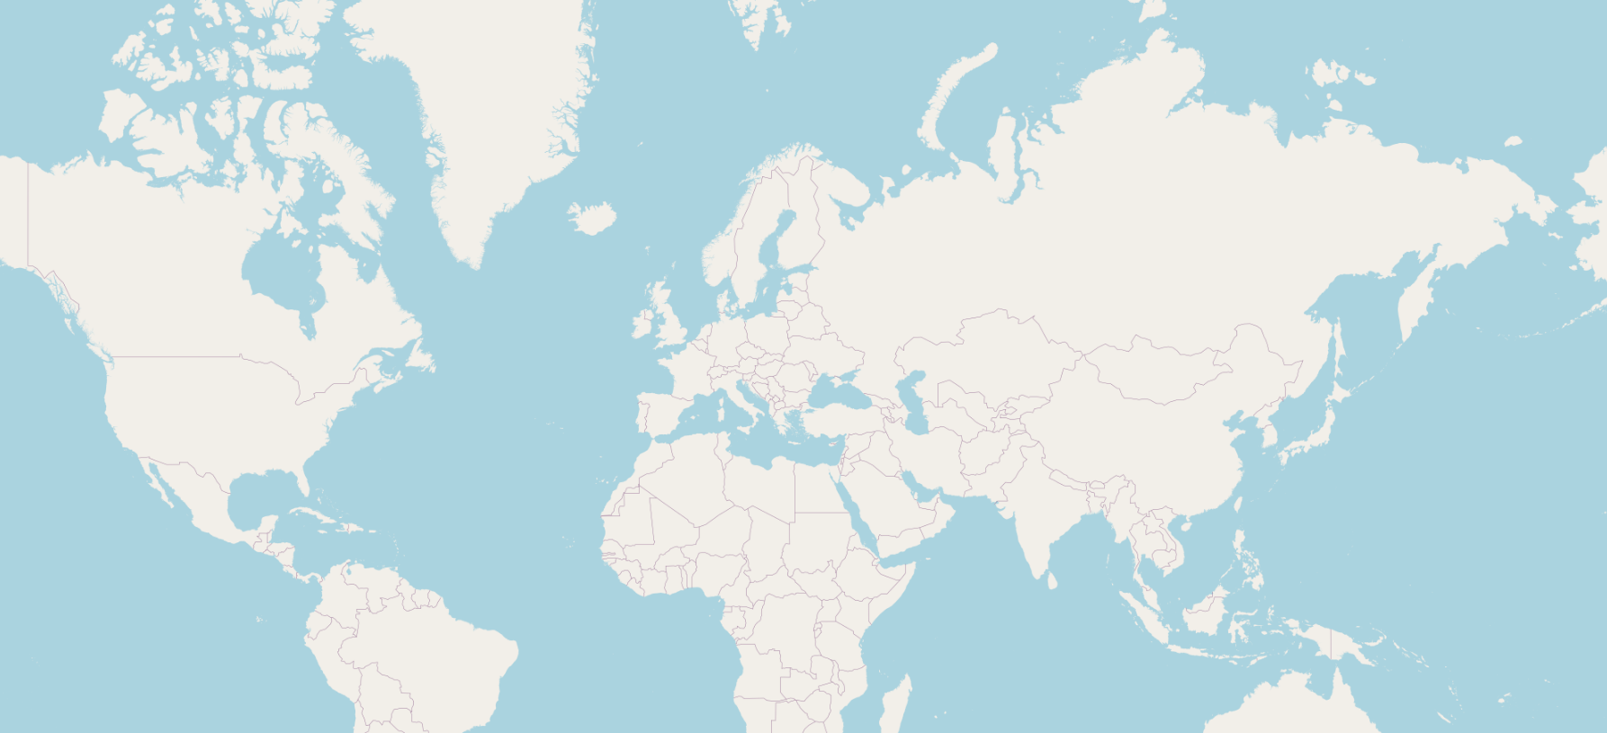
As you can see in the illustration above, this map is empty and does not contain any countries, cities, roads etc. This data will be added later when we are going to import RAW OpenStreetMap data in our PostgreSQL database called: “gis”.

To execute the script, which downloads the shapefiles required for the base map we run the following command from a terminal (Make sure you run this command from the directory “/Geostack/tilestache-server/openstreetmap-carto/”):
scripts/get-external-data.py
After the script is done executing the following should be displayed in the terminal:

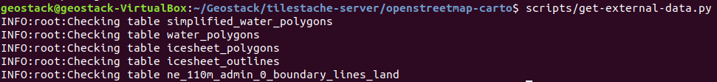
Installing OSM2PGSQL, which is used to import the RAW OpenstreetMap data in the PostgreSQL database, by performing the following steps:
- Enter the tilestache-server directory by running the following command:
cd ~/Geostack/tilestache-server
- Clone the osm2pgsql repository and enter the osm2pgsql directory
git clone git://github.com/openstreetmap/osm2pgsql.git && cd osm2pgsql
- Install the required packages for osm2pgsql

sudo apt install make cmake g++ libboost-dev libboost-system-dev \
libboost-filesystem-dev libexpat1-dev zlib1g-dev libbz2-dev libpq-dev \
libgeos-dev libgeos++-dev libproj-dev lua5.2 liblua5.2-dev

- Create a directory called: “build” and enter that directory by running the following command: mkdir build && cd build

- Create and run the code compiler by running the following command: cmake .. && make

- Install the code that was compiled in the previous step by running the following command: sudo make install

Install OpenSeaMap Renderer, which is used to generating OpenSeaMap Tiles, by performing the following steps:
- Add the OpenJDK PPA repository to the repository list by running the following command: sudo add-apt-repository ppa:openjdk-r/ppa

- Update the local package database by running the following command: sudo apt update

- Install openjdk-8-jdk package using the following command:sudo apt install openjdk-8-jdk

- Install the remaining packages by running the following command:

sudo apt install libbatik-java ant

- Enter the directory: “tilestache-server”, Clone the SeaRenderer repository and enter the searenderer directory by running the following command:

cd ~/Geostack/tilestache-server && git clone \ https://github.com/OpenSeaMap/renderer.git && cd renderer/searender

- Compile the code by running the following command: make -f Makefile.linux

- Enter directory: “jsearch” and build the .jar file by running the following command:

cd ../jsearch && ant

- Move the newly build .jar file to the work directory by running the following command:

sudo mv jsearch.jar ../work/

- Enter directory: “jtile” and download the newest version of batik.

cd ../jtile && wget https://www.apache.org/dist/xmlgraphics/batik/binaries/batik-1.7.zip

- Unzip the newest batik version by running the following command: unzip batik-1.7.zip

- Open the build.xml file and change the following line:

<property name="batik.dir" value="/usr/local/batik-1.7/"/>

to the line shown below:
<property name="batik.dir" value="./batik-1.7/">

- Build the .jar file by using the following command: ant
- Move the newly build .jar file to the work directory and Enter the work directory by running the following command: sudo mv jtile.jar ../work/ && cd ../work
- Create a directory called: “tmp” and a directory called: “tiles” by running the following command: mkdir tmp && mkdir tiles

- Cleanup by removing unnecessary files and folders using the following command. Note: This is a very big command but is meant to be written as one line in the terminal.

rm ~/Geostack/tilestache-server/renderer/README.md && \
rm -r ~/Geostack/tilestache-server/renderer/jharbour && \
rm -r ~/Geostack/tilestache-server/renderer/jsearch && \
rm -r ~/Geostack/tilestache-server/renderer/jtile && \
rm ~/Geostack/tilestache-server/renderer/work/sync && \
rm ~/Geostack/tilestache-server/renderer/work/upload && \
rm ~/Geostack/tilestache-server/renderer/work/tiler && \
rm ~/Geostack/tilestache-server/renderer/work/getworld
- Create a file called: “world.osm” by running the following command: touch world.osm

- Open the render script,remove all the code and add the following code:
#!/bin/bash
echo "Started rendering of OSM file please be patient…"

# This greps the differences between the OpenSeaMap data which already has
# been rendered and the new OpenSeaMap data. This makes sure no data is
# rendered twice. If the world.osm file is empty the scripts will render al the tiles
diff world.osm next.osm | grep id= | grep -v "<tag" > diffs

# This starts the jsearch java application. This application cuts the next.osm
# file in smaller osm files that each represent a tile.
java -jar jsearch.jar ./

# This renames the next.osm file to world.osm so that when you render a new
# osm file no data will be rendered twice.
mv next.osm world.osm

# if the content of the diffs text file is not empty (this means that new data
# will be rendered), the script will then print:"found files to render". If the text file is
# empty there is no new data to be added, the script will then print:
#"Found no tiles to render".
if [ -s diffs ]; then
echo "Found files to render"
else
echo "Found no files to render"
fi

- Save the render script by pressing Ctrl + s on your keyboard.

- Open the tilegen script, remove all the code and the following code:

#!/bin/bash
while true; do
# Check whether there is an OSM file in the tmp folder.
# If this is not the case the generating process is done
if [ $(ls tmp | grep -c "\.osm") -eq 0 ]; then
# When done generating the tiles, notify the user and copy the generated files to
# the openseamap folder in the tilestache cache folder.
echo "Finished generating Tiles"
echo "Starting copying of tiles to Tilestache Cache folder located at:
~/Geostack/tilestache-server/cache/openseamap-local"
cp -a tiles/. ../../cache/openseamap-local
exit
else
# For each file in the temporarie folder execute the code below.
for file in $(ls tmp | grep "\.osm"); do
echo "Generating SVG's from OSM file: " $file
# The y , x and z (zoom level) of the tile is assigned to the variable it
# belongs to.
tx=$(echo $file | cut -f 1 -d'-')
ty=$(echo $file | cut -f 2 -d'-')
z=$(echo $file | cut -f 3 -d'-')
z=$(echo $z | cut -f 1 -d'.')

# If the zoom level is equal to 12 execute the code below. This is because
# openseamap data is not shown below zoom level 12.
# NOTE: The higher the zoomlevel the more zoomed in you are in the map.
# So if the zoomlevel is equal to 18 you are zoomed in far.
if [ $z = 12 ]; then
# for every number between 12 and 18 (zoomlevels) execute the code below.
for k in {12..18}; do
# The line below assigns the correct OpenSeamap symbol to the correct
# svg icon
../searender/searender ../searender/symbols/symbols.defs $k \
>tmp/$tx-$ty-$k.svg <tmp/$file
done;

# If the zoom level is equal to 12 execute the code below. This is because
# openseamap data is not shown below zoom level 12.
else
# The line below assigns the correct OpenSeamap symbol to the correct
# svg icon.
../searender/searender ../searender/symbols/symbols.defs $z \
>tmp/$tx-$ty-$z.svg <tmp/$file
fi
# The code below is always executed no matter what the zoom level is.
# The line below makes sure the file is removed from the tmp folder after
# the tiles have been generated.
rm tmp/$file

# the Jtile application is started to generated the png's using the svg's
# generated by the jsearch application.
java -jar jtile.jar tmp/ tiles/ $z $tx $ty
done
fi
done

Before we are going to put the software to use we first need to understand some of the basics of the datasets (OpenStreetMap and OpenSeaMap) which we are going to process using our TileStache tile server.

5.5.3.1 OpenStreetMap explained
Before we are going to use the tools, which we set up in the previous section, it’s important to understand the background of the datasets which are going to be processed using these tools.
The raw OpenStreetMap data, which was downloaded in section 3.4.3, was downloaded in the file format .osm.pbf (“OpenStreetMap Protocol buffer Binary Format”). The .osm file format is specific to OpenStreetMap. You won’t come across it elsewhere.
The Protocol buffer Binary Format is intended as an alternative to the XML format which is shown in the illustration below:
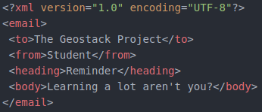
An .osm file consists of thousands of so called “nodes”. In the illustration below you can see a sample representation of an .osm file which contains 2 nodes:
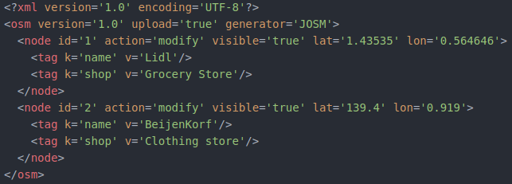
Each node contains one or more tags which define specifications (e.g. names or types) of the node. In the illustration above you can see a a node which is located on the coordinates (lat='1.43535' lon='0.564646'). This node represents a grocery store called “Lidl”. The file also contains a second node (located on the coordinates lat='139.4' lon='0.919') which represents a clothing store called “Beijenkorf”.
This RAW OpenStreetMap data will be imported in the PostgreSQL database called: “gis”. The TileStache tile server will then generate the map using the RAW data from the datastore.
To visualize any of these nodes on a map we need a style sheet. This style sheet contains the links between the tag types (e.g. a certain color, shape and size).
Let’s say that each node with the tag:”shop” should be shaped as an circle, be colored red and have a radius of 2 pixels. After the generation process is finished we will then end up with an empty map with 2 red dots with a size of 2 pixels.
The first dot represents the grocery store: “Lidle” located on the coordinates: lat='1.43535' lon='0.564646' and the second dot represents the clothing store: “BeijenKorf” located on the coordinates: lat='139.4' lon='0.919'.
Below the OpenStreetMap tile generation process is described using a pseudo representation.
Say we download the map extract shown in the illustration below in the file format osm.pbf. The map contains 3 main objects which are 2 diners and one shop.
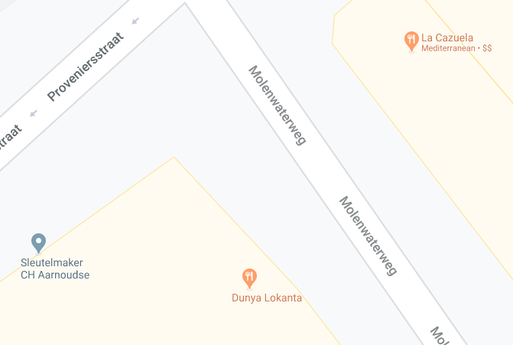
1
3
2
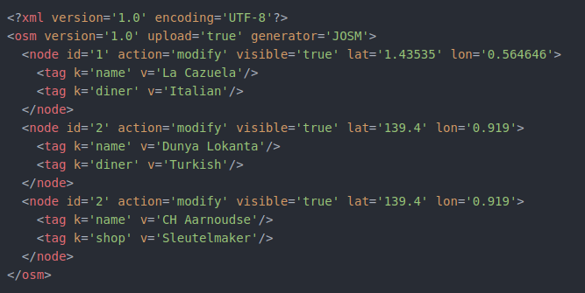
We know that the .osm file will contain at least 3 nodes which are shown in the illustration below:
1
2
3
After downloading an .osm.pbf file we want to import the Raw OSM data in our PostgreSQL datastore “gis”. This process is done by using a tool called OSM2PGSQL which is a command-line based program that converts OpenStreetMap data to postGIS-enabled PostgreSQL databases.
Later on you will learn how to use this tool to import newly downloaded data in the PostgreSQL database, but for now it’s useful to understand when this tool comes in play during the process of converting RAW OpenStreetMap data to tiles.
After the import process is done the data will end up looking something similar to the illustration shown on the next page.

NOTE: The data in the illustration below does not represent the data in the illustration above (containing the data in XML format). The data in the illustration below is obtained from the RAW OpenStreetMap data which we are going to import in the next section.
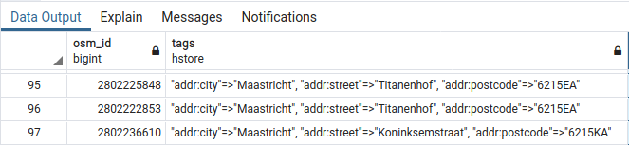
The data in the illustration above was obtained by running the following query in the PostgreSQL database: “gis”. This was done using the PostgreSQL database management tool called: “PGAdmin4” .
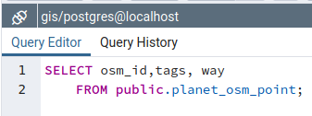
Now let’s say we zoom in on the location (in our web application which we will be building later) shown in the first image. The TileStache tile server will generate the image using the RAW OpenStreetMap data in our PostgreSQL database: ”gis”.
First the TileStache server will request a certain amount of data from the PostgreSQL datastore. The data which is requested depends on what part of the map the user is currently viewing.
Then the OpenStreetMap tile generation process will start depending on the data which is being requested by the TileStache tile server.
This generation process is done by linking the nodes and their tags to their corresponding styling which can be found in the OpenStreetMap-Carto. The linking process is done by using a tool called Mapnik.
We combine Mapnik and the PostgreSQL since PostgreSQL is one of the most efficient and flexible formats Mapnik can use for querying large amounts of data. For more information on using osm2pgsql to render OpenStreetMap data with Mapnik you should visit the following URL:
https://wiki.openstreetmap.org/wiki/Mapnik
Now let’s say that a style defined by OpenStreetMap-Carto says nodes with the tag: “diner” need to be colored orange and the nodes with the tag: “shop” need to be colored light blue. When the generation process is finished we will end up with the map as shown in the illustration below:

5.5.3.2 Downloading and importing OpenStreetMap data in PostgreSQL

Before importing RAW OpenStreetMap data, we have a base map but it’s still very empty. In the illustration on the right you see what the map looks like without any OpenStreetMap data.
This “base” map is generated using the shapefiles downloaded
when installing OpenStreetMap-Carto.
First we are going to create a folder which will contain all our downloaded OpenStreetMap data. We do this by running the command: mkdir ~/Geostack/tilestache-server/osm-data
Now we need to download the RAW OpenStreetMap data. This data will be imported in the “gis” database using the import tool: ”osm2pgsql”.
There are 3 locations from which you can download the RAW OpenStreetMap data. These locations are as follows:
- If you want to download the RAW OpenStreetMap data of the whole planet, you should use this website: https://planet.openstreetmap.org/
- If you want to download pre-selected regions such as a continent, a country or a specific region in a country, you should use this website: http://download.geofabrik.de/
- If you want to download small sections of the map (e.g. for test purposes) you should use this website: https://extract.bbbike.org/
NOTE: When downloading and importing RAW OpenStreetMap data you have to make sure you download an OSM.PBF (OpenStreetMap Protocolbuffer) file! This is the only file format that will work with the osm2pgsql OpenStreetMap data import tool.
The RAW OpenStreetMap data will make sure that countries, cities, roads etc. will be displayed on the base map which is created using the shapefiles that were downloaded at the beginning of section 5.5.3. In this course we are going to download, import and generate the OpenStreetMap data of the Dutch province: “Limburg”. The illustration below shows what it will look like before and after the RAW OpenStreetMap data is imported (in the gis database) and is generated by the TileStache tile server.
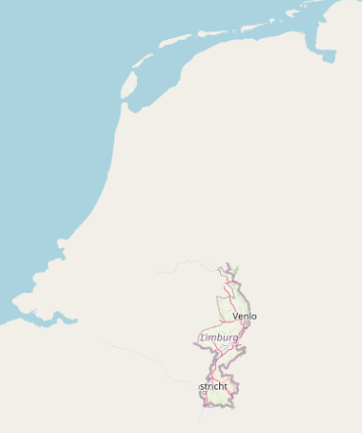

To generate the OpenStreetMap tiles (and achieve the goal shown in the illustration on the previous page) we need to create a style.xml file which contains the rules for the styling of the nodes / tags in the RAW OpenStreetMap data obtained from the PostgreSQL database: “gis” by using queries (which are also defined in the project.mml file using the database connection information). Generating the style.xml file is done by performing the following steps:
- Open and edit the project.mml file located in the folder: ”~/Geostack/tilestache-server/openstreetmap-carto/” so that it contains the following database login information:
osm2pgsql: &osm2pgsql
# This line defines the type of Geospatial extension added to the database
type: "postgis"
# This line defines the name of the database containing the RAW OSM data.
dbname: "gis"
# This line defines the server on which the OSM database is running.
host: "localhost"
# This line defines the name of the owner of the OSM database.
user: "geostack"
# This line defines the password of the OSM database.
password: "geostack"
# This line defines any key fields in the database. (Not necessary in our case)
key_field: ""
# This line defines the name of the field that contains the geometry of the datarow.
geometry_field: "way"
# This line defines the extend of the map.
extent: "-20037508,-20037508,20037508,20037508"

The project.mml file contains the connection to our PostgreSQL database and the queries that are executed on the database to retrieve the RAW OpenStreetMap data. The project.mml file will make sure that the style.xml file is updated with the correct database connection information.

- Create and generate the style.xml file using the database settings defined in our project.mml file by running the following commands:
touch ~/Geostack/tilestache-server/openstreetmap-carto/style.xml
carto ~/Geostack/tilestache-server/openstreetmap-carto/project.mml > \ ~/Geostack/tilestache-server/openstreetmap-carto/style.xml

NOTE: If you change database settings (location, name, password etc.) of the PostgreSQL database you need to redo step 1 and 2 to edit the project.mml file according to the new settings and then generate a new style.xml file with the new database settings.

- Importing the downloaded OSM data in the gis database using osm2pgsql:
The following command will insert the OpenStreetMap data you downloaded earlier into the database. This step is very disk I/O intensive; importing the full planet might take many hours, days or weeks depending on the hardware. For smaller extracts the import time is much faster accordingly, and you may need to experiment with different -C values to fit within your machine’s available memory.
osm2pgsql -d gis -H localhost -P 5432 -U geostack -W --create --slim -G --hstore --tag-transform-script ~/Geostack/tilestache-server/openstreetmap-carto/openstreetmap-carto.lua -C 2500 --number-processes 4 -S ~/Geostack/tilestache-server/openstreetmap-carto/openstreetmap-carto.style {The path to the downloaded osm.pbf file}

NOTE: In section 5.5.3.8 is described how you can create a Python script which automates the OpenStreetMap data import process.
Some explanation related to the command above is as follows:

- The -d flag is used to specify in which database you want to import the OpenStreetMap data (The database called: “gis” in our case).

- The -H flag is used to specify on which server the database is running (localhost in our case).

- The -P flag is used to specify on which port the database is running (5432 in this case).

- The -U flag is used to specify which user is the owner of the database (geostack).

- The -W flag is used to specify that a password is required to import the OSM data.

- The --create flag is used to specify that the data is loaded into an empty database rather than trying to append to an existing one.

NOTE: If do not have any OpenStreetMap data in the database yet, you should add this flag to the command. If you have already imported data in the gis database you should add the flag: “--append” instead of the: “--create” flag which make sure the existing data is not overwritten.

- The –slim flag is used to specify the table layout which need to be created. The “slim” tables works for rendering. If you plan on updating the database, you should add this flag.

- The -G flag determines how multi-polygons are processed.

- The –hstore flag allows tags for which there are no explicit database columns to be used for rendering.

- The –tag-transform-script flag defines the lua script used for tag processing. This an easy is a way to process OSM tags before the style itself processes them, making the style logic potentially much simpler.

- The -C flag specifies the amount of memory that is allocated to the osm2pgsql process. If you have less memory you could try a smaller number, and if the import process is killed because it runs out of memory you’ll need to try a smaller number or a smaller OSM extract.

- The --number-processes flag specifies the amount of CPU cores which are used in the import process. If you have more cores available you set this amount higher.

NOTE: An osm.pbf file with a size of 33.6MB, takes around 100 seconds to import. The OSM data of the Netherlands is around 1GB when downloaded, will around 50 minutes to process and will take up 25GB of disk space after the processing is finished.

- Then enter the password: “geostack” when prompted.

NOTE: After each import you should clear the folder containing the local OpenStreetMap cache. If you do not do this the newly generated files will not be shown because the TileStache server thinks they already exist because of the base OpenStreetMap tiles which were created using the OpenStreetMap-Carto shapefiles. Removing the existing cache can be done by running the following command in a terminal:

rm -r ~/Geostack/tilestache-server/cache/openstreetmap-local/*
Now to confirm you imported the data correctly you can perform the following steps:
- Open the PostgreSQL database management tool by clicking on the shortcut shown in the illustration below:

- When the prompt, shown in the illustration below, pops-up you should enter the password: “geostack”:
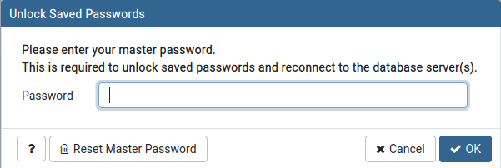

- Now click on the “Servers” entry in the left sidebar of the screen that pops-up and enter the password: “geostack”as shown in the illustration below:
NOTE: If you do not have the localhost server, it means that you have not created it yet. This was done in section 5.4.1.5. So you should go back to that section and perform the steps described in that section.
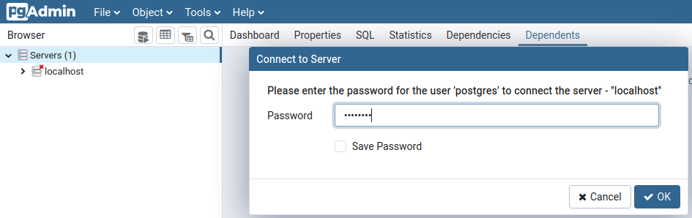
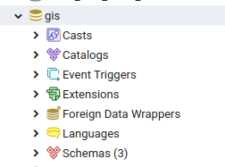
- Once connected to the localhost server you should click on the databases entry and then on the gis database as shown in the illustration below:

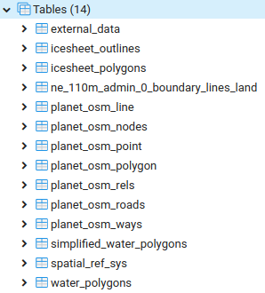
- Now click on Schemas → public → Tables and you will be greeted with all the tables in the gis database as shown in the illustration on the right.
Some explanation related to illustration on the right is as follows:
The table encircled in blue contains the spatial reference data which is required by the PostGIS and PostGIS topology extensions which are installed in the “gis” database.
All the tables encircled in red contain the data of the “base map” (the empty map without any OpenStreetMap data which can be found at the beginning of section 5.5.3.2) which was obtained in step 5 of section 5.5.3 when obtaining the external shapefiles from OpenStreetMap-Carto.
All the tables encircled in green contain the OpenStreetMap data which we imported at the beginning of this section. The table called: “planet_osm_nodes” can be seen as the main table in the database. This table contains three columns. Let’s see this columns by right clicking on the table name then go to scripts and the select: ‘SELECT Script’ as shown in the illustration below:
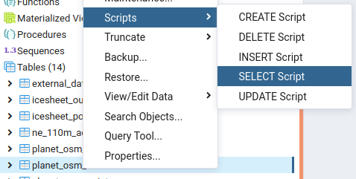
The query which will be created is shown in the illustration below:

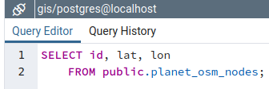
And the result of the query is as follows (only 4 rows are shown in the illustration below):
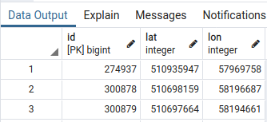
The planet_osm_nodes table can be seen as the main table which specifies the location on which the nodes have to appear on the map. The remaining information related to the nodes (so the tag’s) can be found in the remaining tables in the “gis” database.
For example let’s perform a select query on the table: “planet_osm_point” by right-clicking on the table name then go to scripts and the select: ‘SELECT Script’ as shown in the illustration below:
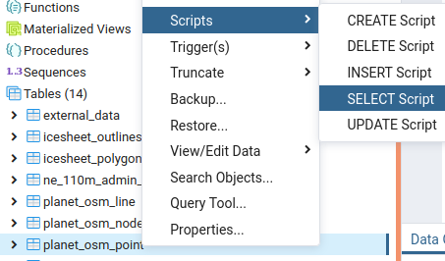
Then remove all the select statements excepts for osm_id and tags so that the query looks the same as shown in the illustration below:
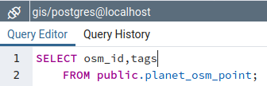
The result of the query will look similar to the one shown in the illustration below:
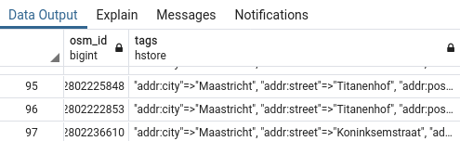
The osm_id in the table: “planet_osm_point” is the foreign key to the id in the table: osm_planet_nodes“. So the data of these two tables combined specify what type of object (obtained from the table: “osm_planet_points” should be displayed where on the map (obtained from the table: “osm_planet_nodes”) during the map generation process.

5.5.3.3 OpenSeaMap explained
Now that you know how to download, process and generate OpenStreetMap data, it’s time to learn how to do this with OpenSeaMap data. First of all; OpenStreetMap data is basically the same as OpenStreetMap data. This is because the OpenSeaMap data is also contained in the OpenStreetMap data.
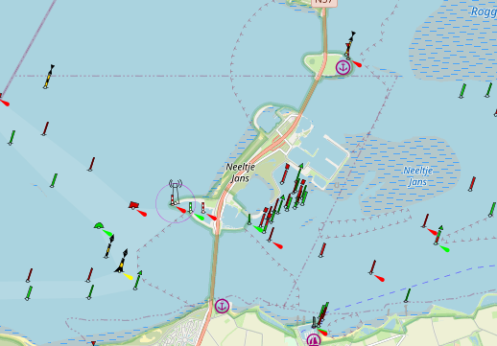
OpenSeaMap data is used to display nautical data on the map. This nautical data contains locations of lighthouses, buoys, sailing routes etc.
A quick view of what the nautical data looks like on an OpenStreetMap base map is shown in the illustration on the right:
For a full view of what nautical data looks like on the map you can visit the following URL:
https://map.openseamap.org/
You may have noticed in the previous section that the OpenStreetMap data also contained tags which contained the type: “Seamark”. These tags represent nautical data. The problem is that the OpenStreetMap-Carto style sheet does not contain the styling rules related to the Seamark tags so when generating the OpenStreetMap tiles, objects such as buoys and lighthouses are not generated.
If you have not noticed the tags of the type: “Seamark” you can perform the following steps to see them:
- Perform a select query on the table: “planet_osm_point” by right-clicking on the table name then go to scripts and the select: ‘SELECT Script’ as shown in the illustration below:

- Then remove all the select statements excepts for osm_id and tags so that the query looks the same as shown in the illustration below:
In the result of the query you will see a lot of tags containing seamarks as shown in the illustration below:
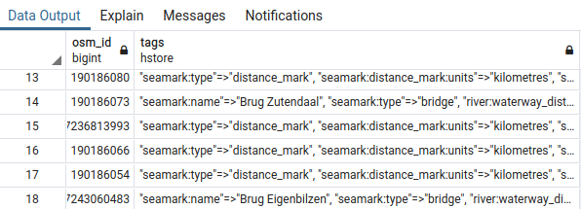

In order to generate the OpenSeaMap tiles we are going to require a tool which basically does the same as Mapnik in combination with OpenStreetMap-Carto but then for the nodes with the seamark tags.
The tool which we are going to use to create the OpenSeaMap tiles is called: “Searenderer”. In section 5.5.3 we already installed and transformed the tool in order to achieve our end-goals.
The goal of this tool is to generate tiles containing the nautical objects (such as buoys, lighthouses and waterways) in the file format PNG with the alpha layer turned on.
Turning on the alpha layer will result in a transparent tile (PNG image) which can be used as an overlay on the OpenStreetMap map. Using this method we can later toggle the OpenSeaMap layer on or off.
In the illustration below you can see the result of one generated nautical data tile:


5.5.3.4 Downloading and Rendering OpenSeaMap Data
To understand how the process of rendering OpenSeaMap tiles works, it’s important to know the file structure of the OpenSeaMap renderer folder.
An illustration of the renderer folder structure is as follows:
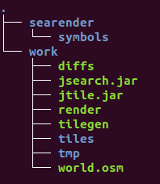
A textual representation of the file structure is as follows:
- The searender folder contains everything related to the styling of the OpenSeaMap tiles:
  - The symbols folder contains the symbols which need to be linked to nodes in the RAW OSM data (e.g. a buoy symbol or a lighthouse symbol).
- The work folder contains the scripts and files related to generating the OpenSeaMap tiles:
  - The tiles folder is going to contain the tiles after they have been generated.
  - The tmp (temporary) folder is going to contain the files which are generated during the rendering process. These files include the smaller (cut) .osm files and SVG’s.
  - The world.osm file is going to contain all the OSM data that has been rendered before. This file will be compared to the OSM file that contains the data from which we are going to generate the OpenSeaMap Tiles. If there is a difference between these files they will be written to the diffs.txt file.
NOTE: When you want to render a new part of the world and the new part overlaps with the data that already has been rendered, the data will not be rendered again. If you want to start from scratch you have to clear the contents of the world.osm file (see step 1 on the page below).
  - The diffs.txt text file is going to contain the differences between the OpenSeaMap tiles that have been generated before and the OpenSeaMap tiles that need to be rendered. If there is no difference in the data that has already been generated and the data that needs to be generated, the content of the diffs.txt file will be empty and no rendering will take place.
  - The jsearch.jar application splits the OSM file (next.osm) that contains the data which needs to be rendered, into smaller OSM files. These smaller OSM files each represent a tile using the X, Y, Z values of a tile.
  - The render script checks if there is a difference between the data to add and the data that has already been rendered. This script also executes the jsearch.jar application.

  - The tilegen script links the OSM data, that has to be rendered, to the correct symbol using the value of the <tag> data column in a node in the OSM data. An OSM file consists of a lot of nodes. In the illustration below you can find a part of the content of an OSM file. This illustration shows 2 nodes in the dataset.


So if a tag value in a node contains the value "buoy" the symbol of the buoy, located in the “searenderer/symbols” folder, will be linked to this node. The tilegen script also calls the jtile.jar application to generate the actual tiles using the SVG’s which are generated in the jsearch.jar application. After the tiles are generated, this script will copy the content of the tiles folder to the OpenSeaMap cache folder in our TileStache cache.

  - The jtile.jar application generates the actual tiles using the SVG's generated by the jsearch.jar application.

  - The next.osm file is not included in the file structure after installing the OpenSeaMap renderer. This file is going to represent the OSM data that you want to render. First you will have to download a new OSM file and then rename it to next.osm. After you have renamed the file, you need to place it in the work folder of the OpenSeaMap renderer.

To generate OpenSeaMap tiles you have to perform the following steps:

- If you have rendered tiles before and want to reset all the current tiles you should perform the next steps in the renderer/work directory which is located in the tilestache-server folder:
  - Clear the contents of the tiles and tmp folders.

rm -rfv ~/Geostack/tilestache-server/renderer/work/tiles/* && rm -rfv \ ~/Geostack/tilestache-server/renderer/work/tmp/*

  - Remove all contents of the diffs.txt file.

> ~/Geostack/tilestache-server/renderer/work/diffs

  - Remove all contents of the world.osm file.

> ~/Geostack/tilestache-server/renderer/work/world.osm

- Download a new map extract IN .OSM format NOT OSM.PBF from one of the sources from which you also downloaded the OSM data (See section 5.5.3.2).

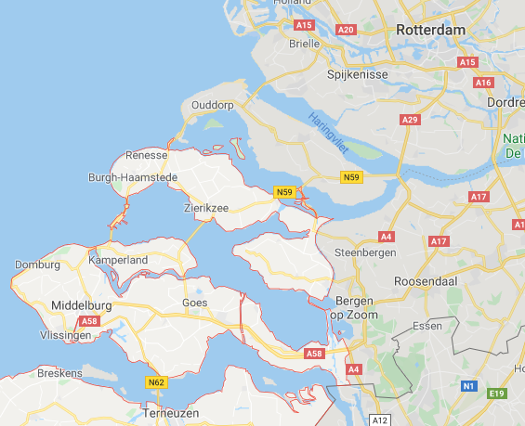
For testing purposes it’s recommend to download a map extract from the website: https://extract.bbbike.org/ since you can select a small portion of a map as shown in the illustration below. The map portion which is downloaded in the illustration below is called: “Neeltje Jans” which is a Dutch delta that was constructed to facilitate the construction of the Oosterscheldedam.


Also notice the red box in the illustration above. This is where you select the .OSM XML 7Z format in which you want to download the OpenSeaMap data.

After the download is completed you have to extract the file and copy it to the folder:
~/Geostack/tilestache-server/renderer/work/.

- Rename the downloaded .osm file in the folder: “ ~/Geostack/tilestache-server/renderer/work/” to next.osm.

- Enter the OpenSeaMap renderer folder by running the following command:

cd ~/Geostack/tilestache-server/renderer/work/

- Run the render and tilegen scripts by entering the command: ./render && ./tilegen
The process will look the same as shown in the illustration below. NOTE: The OpenSeaMap Tile rendering process can take a long time depending on the size of the OSM file from which the tiles need to be rendered!



After the scripts are finished rendering you will see the generated OpenSeaMap tiles in the folder: “~/Geostack/tilestache-server/cache/openseamap-local”. In the illustrations below you can see an example of one of the generated OpenSeaMap Tiles (PNG) and how it will look in the 2D Map Viewer as overlay on the OpenStreetMap map.


After setting up the TileStache tile server (which we will do in the next chapter) the OpenSeaMap tiles will become available via the following URL: http://localhost:8081/openseamap-local/ or if the tile server is running behind the NGINX webserver via the URL: http://localhost/tiles/openseamap-local.

NOTE: In section 5.5.3.8 is described how you can create a Python script which automates the OpenSeaMap tiles generation process.

5.5.3.5 Creating the Tilestache configuration
- Create a file called tilestache-configuration.cfg in the tilestache-server directory.
touch ~/Geostack/tilestache-server/tilestache-configuration.cfg
- Open the newly created file and add the following code to that file:
{
"index":"entries.html",
"cache":{
"name":"Disk",
"path":"cache",
"umask":"0000"
},
"layers":{
"openstreetmap-local":{
"provider":{
"name":"mapnik",
"mapfile":"openstreetmap-carto/style.xml"
},
"projection":"spherical mercator"
},
"openstreetmap-web":{
"allowed origin":"*",
"provider":{
"name":"proxy",
"url":"http://tile.openstreetmap.de/{Z}/{X}/{Y}.png"
}
},
"openseamap-local":{
"allowed origin":"*",
"provider":{
"name":"proxy",
"url": "file:////home/geostack/Geostack/tilestache-server/cache/openseamap-local/{Z}/{X}/{Y}.png"
}
},
"openseamap-web":{
"allowed origin":"*",
"provider":{
"name":"proxy",
"url": "http://tiles.openseamap.org/seamark/{Z}/{X}/{Y}.png"
}
},
"landscape-map":{
"allowed origin":"*",
"provider":{
"name":"proxy",
"url":"https://b.tile.thunderforest.com/landscape/{Z}/{X}/{Y}.png?apikey=YourAPIKey"
}
}
}
}
It’s not possible to add any comments to this file since it will throw error’s when adding comments to a configuration file. The configuration file above contains 5 different Tilestache entries which are as follows: A local OpenStreetMap version which uses the RAW OSM data in the PostgreSQL database, A web version of OpenStreetMap which proxies the WMS from OSM, A local version of OpenSeaMap which uses the generated tiles in the Tilestache cache, A web version of OpenSeaMap which proxies the WMS from OpenSeaMap and a WMS from Thunderforest. Some explanation related to the Tilestache configuration is given below.

The first part of the TileStache configuration is related to the settings of our Tilestache Tileserver tile caching. These settings are as follows:

The entry which is used to provide our local OpenStreetMap Tiles is as follows:
{
# Below we define the location and name of the landing page of our Tilestache server.
# This file is going to contain all the entries between which we want to switch in our Angular applications.
# In the Flask API we are going to scrape the contents of this.
"index":"entries.html",
# Below we define the settings related to the cache
"cache":{
# Below we define the name of the cache
"name":"Disk",
# Below we define the path location of the cache
"path":"cache",
# Below we define the permissions that the items in the cache will have.
# “0000” means that the files have full permissions
"umask":"0000"
},
An example of an entry in our Tilestache configuration using an external WMS (Web map server) is shown in the illustration below. This entry is related to the thunderforest WMS,
# Below we set the name of the Tilestache entry
"openstreetmap-local":{
# Below we set the type of provider to Mapnik.
# Mapnik is a tool for generating Tiles using a stylesheet
"provider":{
"name":"mapnik",
# Here we set the location of the style.xml which contains our database information and
# the query’s related to the styling of the OpenStreetMap Tiles
"mapfile":"openstreetmap-carto/style.xml"
},
# Below we define the projection of the Tiles
"projection":"spherical mercator"
},

The following is required to create a PROXY layer entry:
- The name of the Tilestache entry. You can decide yourself what you want the name of the entry is going to be, just make sure it’s related to the WMS. (Red)
- The allowed Origin Type (Blue): This is related to the HTML-headers in the HTTP requests. (* means every type of HTTP request is allowed)
- The provider (Green): This is where you declare the configuration of entry you are adding.
- The provide name (Purple): This is where you declare the entry type which is proxy in this case.
- The URL (Orange): Since the type of this entry is a proxy (name substitution) for a WMS located on a web link, we need to declare the URL on which the digital topographical map is located.
- In the URL we also declare the {Z}{X}{Y} notation for the requested tiles. (Yellow)

NOTE: For the Thunderforest WMS to work you need to register a free account and obtain an API key. This can be done at the following URL: https://www.thunderforest.com/pricing/
Once you have obtained an API key you should paste it where it say’s “YourAPIKey” in the TileStache configuration file.
- Create an HTML file in which we will place the layer names of our tilestache entries:
touch ~/Geostack/tilestache-server/entries.html
- Add the names of the entries in the Tilestache Configuration to the HTML file, by adding following lines:
<p>openstreetmap-local</p>
<p>openstreetmap-web</p>
<p>landscape-map</p>

The Flask-API will scrape this HTML file and return all the items between the <p> tags to the 2D and 3D map viewers (Our Angular applications).
NOTE: If you add more entries to the TileStache configuration file (and you also want them to be accessible in the Angular applications) you should also add it to the entries.html file.
- To validate whether the configuration is working correctly we run the following command. We set the amount of CPU workers to 4 and set the timeout to 100. This means that after 100 seconds of working (rendering) the worker will fail en restart. Set the timeout value higher if you want to render bigger maps.
gunicorn3 --workers 4 --timeout 100 -b :8081 \ "TileStache:WSGITileServer('/home/geostack/Geostack/tilestache-server/\
tilestache-configuration.cfg')"

- Create a desktop shortcut which is used to start the tile server service.
touch ~/Desktop/Start-Tileserver.desktop
- Add the following code to the file that is created on the desktop and save it afterwards:
- Create a desktop shortcut which is used to stop the tile server service.
#!/usr/bin/env xdg-open
[Desktop Entry]
Version=1.0
Type=Application
Terminal=true
Exec=gunicorn3 --workers 4 --timeout 100 -b :8081 "TileStache:WSGITileServer('/home/geostack/Geostack/tilestache-server/tilestache-configuration.cfg')"
Icon=gnome-panel-launcher
Name[en_US]=Start-Tileserver
touch ~/Desktop/Stop-Tileserver.desktop
- Add the following code to the file that is created on the desktop:
#!/usr/bin/env xdg-open
[Desktop Entry]
Version=1.0
Type=Application
Terminal=true
Exec=sh -c "fuser -k 8081/tcp"
Icon=gnome-panel-launcher
Name[en_US]=Stop-Tileserver

- Add the tile server to our local NGINX webserver configuration by editing the configuration file of our LOCAL NGINX webserver instance.
nano ~/Geostack/nginx-modsecurity/nginx-local.conf
- Add the following below the upstream server for the Flask-API:

# Creating the upstream server for the tilestache server
upstream tilestache-server{
server localhost:8081;
}
- Add the following below the location of the Flask-API:
# The location of the entries.html file which is used to scrape the entries in
# our TileStache configuration file.
location /tiles/ {
proxy_pass http://tilestache-server/;
}

# The location of the local OpenStreetMap TileStache entry.
location /tiles/openstreetmap-local/ {
proxy_pass http://tilestache-server/openstreetmap-local/;
}

# The location of the web version of the OpenStreetMap TileStache entry.
location /tiles/openstreetmap-web/ {
proxy_pass http://tilestache-server/openstreetmap-web/;
}

# The location of the local version of the OpenSeaMap TileStache entry.
location /tiles/openseamap-local/{
proxy_pass http://tilestache-server/openseamap-local/;
}

# The location of the web version of the OpenSeaMap TileStache entry.
location /tiles/openseamap-web/{
proxy_pass http://tilestache-server/openseamap-web/;
}

# The location of the landscape map TileStache entry.
location /tiles/landscape-map/ {
proxy_pass http://tilestache-server/landscape-map/;
}

- Save the configuration files by pressing the following keys on your keyboard: Ctrl + s

- Copy and rename the NGINX configuration to the correct folder in the system.

sudo cp ~/Geostack/nginx-modsecurity/nginx-local.conf /etc/nginx/nginx.conf

- Restart the NGINX service for the changes to take effect by running the following command: sudo service nginx restart

That’s it! Now when you navigate to one of the locations specified in the NGINX Configuration (e.g. http://localhost/tiles/openstreetmap-web/0/0/0.png), you should be greeted with a map served by the tile server which is running behind the NGINX webserver. Remember to first start the tile server using the desktop shortcut!

5.5.3.6 Dockerizing the Tilestache Tileserver
Dockerizing the TileStache Tileserver is done by performing the following steps:
- Create a file called: “Dockerfile” in the folder ~/Geostack/tilestache-tileserver/ by running the following command: touch ~/Geostack/tilestache-server/Dockerfile
- Open this file and add the following to the file and save it:
## Use ubuntu 18.04 as base image
FROM ubuntu:18.04

## Install git pip npm NodeJS Mapnik and other required packeges.
RUN apt-get update \
&& DEBIAN_FRONTEND="noninteractive" apt-get install -y -f git nodejs npm mapnik-utils python3-mapnik python3-pip mapnik-utils python3 gdal-bin \
&& rm -rf /var/lib/apt/lists/*

## Create folder structure
RUN mkdir tilestache && mkdir tilestache/cache

# Install the required python modules and libraries
COPY requirements.txt /
RUN pip3 install -r requirements.txt

# Clone the Openstreetmap carto github repo
RUN cd tilestache && git clone git://github.com/gravitystorm/openstreetmap-carto.git

# Install openstreetmap carto in the container
RUN cd /tilestache/openstreetmap-carto && npm install -g carto

# Copy the project.mml file to the correct location in the container.
COPY project-docker.mml /tilestache/openstreetmap-carto/project.mml

# RUN carto to create our OSM style file used to style the generated Tiles.
RUN carto /tilestache/openstreetmap-carto/project.mml > /tilestache/openstreetmap-carto/style.xml

# Copy tilestache configuration file to the correct location in the container
COPY tilestache-configuration.cfg /tilestache/

# Copy the index.html to the correct location in the container
COPY entries.html /tilestache/

- Copy and rename the project.mml file from the OpenStreetMap-Carto folder to the tilestache-tileserver folder by using the following command:
cp ~/Geostack/tilestache-server/openstreetmap-carto/project.mml \ ~/Geostack/tilestache-server/project-docker.mml

- Change the following section in the project-docker.mml file:
osm2pgsql: &osm2pgsql
# This line defines the type of Geospatial extension added to the database
type: "postgis"
# This line defines the name of the database containing the RAW OSM data.
dbname: "gis"
# This line defines the server on which the OSM database is running.
host: "localhost"
# This line defines the name of the owner of the OSM database.
user: "geostack"
# This line defines the password of the OSM database.
password: "geostack"
# This line defines any key fields in the database. (Not necessary in our case)
key_field: ""
# This line defines the name of the field that contains the geometry of the datarow.
geometry_field: "way"
# This line defines the extend of the map.
extent: "-20037508,-20037508,20037508,20037508"
To the following:
osm2pgsql: &osm2pgsql
type: "postgis"
dbname: "gis"
# We pass the name of the PostgreSQL datastore service, from the docker-compose.yml file, as host.
host: "postgresql-datastore"
user: "geostack"
password: "geostack"
key_field: ""
geometry_field: "way"
extent: "-20037508,-20037508,20037508,20037508"
This makes sure our PostgreSQL docker container is used instead of our local PostgreSQL Database instance.

- Create a requirements.txt file which is going contain the Python packages which need to be installed in the Tilestache Tileserver Docker container.
touch ~/Geostack/tilestache-server/requirements.txt
- Add the following to the requirements.txt file and save it:
gunicorn
TileStache
Pillow
pyyaml
requests
psycopg2-binary

Add the following service to the docker-compose.yml below the flask-API service:
# Here we define the name of the tilestache-server
tilestache-server:
# Here we define the name of the tilestache-server
container_name: tilestache-server
# The line below makes sure the Tileserver container restarts when stopping accidentally
restart: always
# Here we set the directory in which the Dockerfile is located
build: ./tilestache-server
# Here we add the cache as volume so the local cache is shared with the docker cache
volumes:
- ./tilestache-server/cache:/tilestache/cache
# Here we set the port on which the Tileserver will be running
ports:
- '8081'
# Here we define the command that will run when the docker container is started
command: gunicorn --workers 4 -b :8081 --timeout 100 "TileStache:WSGITileServer('/tilestache/tilestache-configuration.cfg')"
- Build the new service we just added in the docker-compose.yml file, using the following command: cd ~/Geostack && docker-compose build tilestache-server
- Add the following, below the line where we defined the flask-api upstream server, to the nginx-docker.conf file located in the folder: “~/Geostack/nginx-modsecurity”.
# Creating the upstream server for the tilestache server
upstream tilestache-server{
server tilestache-server:8081;
}
- Add the following to the nginx-docker.conf file located in the folder: “~/Geostack/nginx-modsecurity”. Do this below the line where we defined the flask-api location.
# The location of the entries.html file
location /tiles/ {
proxy_pass http://tilestache-server/;
}

# The location of the local openstreetmap .
location /tiles/openstreetmap-local/ {
proxy_pass http://tilestache-server/openstreetmap-local/;
}

# The location of the web version of openstreetmap.
location /tiles/openstreetmap-web/ {
proxy_pass http://tilestache-server/openstreetmap-web/;
}

# The location of the local openseamap.
location /tiles/openseamap-local/{
proxy_pass http://tilestache-server/openseamap-local/;
}

# The location of the web version of openseamap
location /tiles/openseamap-web/{
proxy_pass http://tilestache-server/openseamap-web/;
}

# The location of the landscape map.
location /tiles/landscape-map/ {
proxy_pass http://tilestache-server/landscape-map/;
}

- Rebuild the nginx-webserver service by running the following command:
cd ~/Geostack && docker-compose build nginx-webserver

5.5.3.7 Importing OSM data in the PostgreSQL Docker container
To import RAW OSM data in the ‘gis’ database running in the PostgreSQL docker container, you have to perform the following steps:
- Retrieve the Docker IP of the PostgreSQL Docker container by running the command:
docker inspect -f '{{range .NetworkSettings.Networks}}{{.IPAddress}}{{end}}' \
postgresql-datastore
- Run osm2pgsql using the IP address obtained in the previous step:
osm2pgsql -d gis -H {the IP adress} -P 5432 -U postgres -W --create --slim -G --hstore --tag-transform-script ~/Geostack/tilestache-server/openstreetmap-carto/openstreetmap-carto.lua -C 2500 --number-processes 1 -S ~/Geostack/tilestache-server/openstreetmap-carto/openstreetmap-carto.style {path to osm.pbf}
Where {The IP address} is the IP address obtained in step 2 and {Path to osm.pbf} is the location where the file osm.pbf is located which you want to import in the gis database.
- Then enter the password: “geostack” and let the import process finish.
You can also import OSM data in the docker instance of the PostgreSQL database by simply shutting down the local instance of the PostgreSQL database and then make the Dockerized version of the PostgreSQL database available to the LOCALHOST by editing the docker-compose.yml file ( see chapter 5.4.1.2).

5.5.3.8 Automating the OSM data import and generation process
Now that you know how to manually import OpenStreetMap data in a PostgreSQL Database and how to manually generate OpenSeaMap tiles, it’s time to make a Python script which automates these processes. This script will do the following:
- Select .osm.pbf and .osm files using a simple GUI;
- Give the user the option to import OpenStreetMap data in the ‘gis’ database;
- Give the user the option to generate OpenSeaMap tiles and place them in the Tilestache Cache.
So let’s start with creating a Python script called: “osm-data-import.py” in the folder: “~/Geostack/import-utilities/” by running the following command:
touch ~/Geostack/import-utilities/osm-data-import.py
NOTE: The following code is explained using inline comments. You can find the complete script, which is called: “osm-data-import-v-course.py”, in the folder: ”Building-the-VM-using-the-installation-script/Geostack/import-utilities” which can be found in the same folder as this cookbook.

Open the file and add the following module imports at the top of the script:
Next we need to create the main function which is triggered when running the Python script. This function can be seen as the “main” function that let’s you choose between an OpenStreetMap data import or the OpenSeaMap tile renderer. This function is called: “import_tool()”. To add the main function we need to add the following function below the transform_data function.

NOTE: The following illustration is divided in 2 parts. The last line of the first illustration is the same as the first line of the second illustration. You don’t need to add this line twice.



As you can see in the illustrations above we used 2 functions (“import_ostreetm()” and “import_oseam()”) which have not been created yet. So let’s create these functions. We start of by creating the function which will be triggered when the user chooses to import RAW OpenStreetMap data in the PostgreSQL database.
How this is done is shown on the next page.

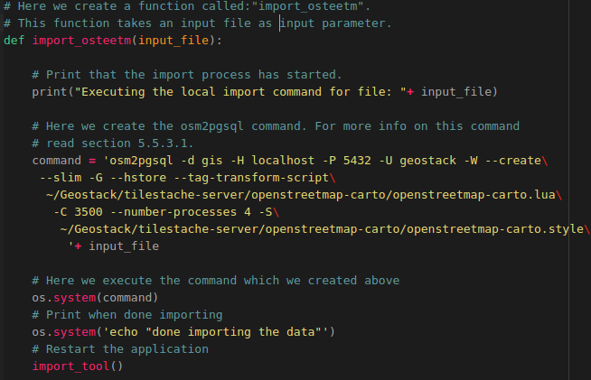
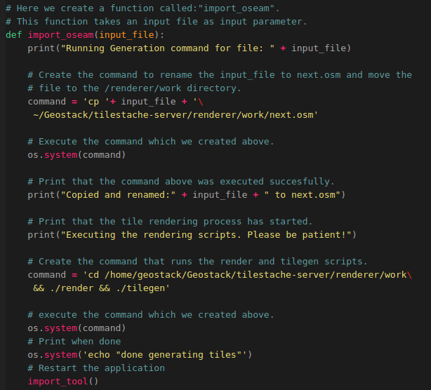
Now let’s create the function which is used to generate the OpenSeaMap tiles. How this is done is shown in the illustration below:
The last thing we need to do is adding the code which makes sure the Python script is executed and the import_tool function is triggered. We do this by adding the following at the bottom of the script:
Now let’s create a desktop shortcut which runs the Python script when it’s clicked. We do this by performing the following steps:
- Create a desktop shortcut to start the Python script, using the following command:
touch ~/Desktop/Import-OSM-Data.desktop
- Add the following code to the file that is created on the desktop:
#!/usr/bin/env xdg-open
[Desktop Entry]
Version=1.0
Type=Application
Terminal=true
Exec=sh -c 'python3 ~/Geostack/import-utilities/osm-data-import.py'
Icon=gnome-panel-launcher
Name[en_US]=Import-OSM-Data
- Make sure the shortcut is trusted by running the following command:

for i in ~/Desktop/*.desktop; do gio set "$i" "metadata::trusted" yes ;done

- Make sure the shortcut is launch-able by running the following command:

sudo chmod +x ~/Desktop/Import-OSM-Data.desktop

Now when you click the desktop icon, shown in the illustration below, you can easily import and render OpenStreetMap and OpenSeaMap tiles.



This will open a terminal as shown in the illustration below:



Now you are able to easily import OpenStreetMap Data and generate OpenSeaMap tiles.

5.5.4 Installing the Cesium Terrain Server
Now that we have most of the middleware components in place we should create the Cesium Terrain server which is used to generate and serve elevation maps to our 3D Map Viewer application. These terrain files contain information related to the height of the ground at a given point. Using the terrain files we can visualize local elevation maps in our web application.
A terrain file is created using a DEM file. A DEM can be represented as a raster (a grid of squares, also known as a height map when representing elevation) or as a vector-based triangular irregular network (TIN).
DEM files are commonly built using data collected using remote sensing techniques, but they may also be built from land surveying. A DTM, DTED, or DEM file resembles an image file, where pixels are mapped to specific geodetic coordinates.

Digital Terrain Models (DTM) sometimes called Digital Elevation Models (DEM) is a topographic model of the bare Earth that can be manipulated by computer programs. The data files contain the elevation data of the terrain in a digital format which relates to a rectangular grid.

Digital Surface Model (DSM) are files created using Airborne Light Detection and Ranging (LiDAR) In a LiDAR systems which use pulses of light traveled to the ground. When the pulse of light bounces off its target and returns to the sensor, it gives the range (a variable distance) to the Earth.
For more information related to DTM and DSM files you should visit the following URL:
https://gisgeography.com/dem-dsm-dtm-differences/

5.5.4.1 Downloading DSM or DTM files
To download the DSM or DTM files you should visit the following URL:
https://downloads.pdok.nl/ahn3-downloadpage/
You will then be greeted with a map as shown in the illustration below. On the map you can see a lot of small boxes which each represent a downloadable area.

When you zoom in on the location, from which you want to download the DEM file, you can click
on the box representing the location which you want to download, as shown in the illustration below.

You can choose from the following options:
- 0.5M Raster DSM which is a very precise (up to 0.5m) dataset which also includes the data of tree’s and houses etc.
- 0.5M Raster DTM which is a very precise (up to 0.5m) dataset which does NOT include the height data of tree’s and houses etc.
- 5M Raster DSM which is a is less precise (up to 5m) dataset which also includes the data of tree’s and houses etc.
5M Raster DTM which is a less precise (up to 5m) dataset which does NOT include the height data of tree’s and houses etc.
- A Point Cloud file which is the most precise. We are not going to use this types of datasets in the GeoStack.

When you have decided what type of DEM file you want to download, you should click on the Download link next to the file you want to download. (RED in the illustration above). This will download a ZIP file which will, if extracted, give you a .TIF file containing elevation data.

5.5.4.2 Rendering Digital Terrain Models for Cesium
To render terrain files, used in the 3D Map Viewer, you should perform the following steps:
- Create a new cesium server directory and its sub-folders in the Geostack folder:
mkdir -p ~/Geostack/cesium-server/data/tilesets/terrain
- Place the downloaded .TIF file in the ~/Geostack/cesium-server/data/ directory
- Transform the projection of the .tiff file to WGS84 by using the GDALWarp Docker container.
docker run -v ~/Geostack/cesium-server/data:/data geodata/gdal gdalwarp -t_srs \ EPSG:3857 /data/M_52EZ2.TIF /data/M_52EZ23857.TIF

The command above will first download the GDAL docker image after which it will transform the projection of the downloaded .TIF file. This process takes about 1 minute an should look similar to the illustration below.

- Create a new directory in the folder ~/Geostack/cesium-server/data/tilesets/terrain which is going to contain the rendered .terrain files. It’s recommend to give this folder the same name as the .tiff file. Once you have created the folder you need to move the rendered terrain files to this folder.
For example: the downloaded .tiff file, which is used in this example, has the name: “M_52EZ2” so it’s recommended to use the same name for the folder. The terrain files will then be available via the URL: http://localhost:8080/tilesets/M_52EZ2 or the URL: http://localhost/terrain/M_52EZ2 in case the cesium server is running behind the NGINX webserver.
We can create a new directory by running the following command:
mkdir -p ~/Geostack/cesium-server/data/tilesets/terrain/M_52EZ2
In the 3D Map viewer we are going to add a layer which uses the terrain data served by the cesium-terrain-server. This will be done by using the URL: http://localhost:8080/tilesets/{name of the folder} or the URL: http://localhost/terrain/{name of the folder} in case the cesium server is running behind the NGINX webserver.
- Navigate to the cesium-server directory by using the following command:
cd ~/Geostack/cesium-server
- Run the .terrain file generator using the folder created in the previous step as output directory
docker run -it -v ~/Geostack/cesium-server/data:/data tumgis/ctb-quantized-mesh \
ctb-tile -f Mesh -C -o /data/tilesets/terrain/M_52EZ2 /data/M_52EZ23857.TIF

The command above will first download the quantized-mesh docker container after witch it will start the terrain file generation process. The generation process of this file (500MB) takes around 10 minutes to complete.
- Create a TileJSON file which is used for representing map metadata. This file will be called layer.json. The CesiumTerrainProvider Class in Cesium requires that a layer.json resource is present describing the terrain tileset. The ctb-tile utility does not create this file. If a layer.json file is present in the root directory of the tileset then this file will be returned by the server when the client requests it. If the file is not found the server will return a default resource. Since we don’t want a default resource we are going to create the layer.json using the following command:

docker run -it -v ~/Geostack/cesium-server/data:/data tumgis/ctb-quantized-mesh \
ctb-tile -l -f Mesh -C -o /data/tilesets/terrain/M_52EZ2 /data/M_52EZ23857.TIF

This process takes about 5 seconds to complete and should look similar to the illustration below.

- Run the Cesium terrain server by running the following command:

cd ~/Geostack/cesium-server && docker run -p 8080:8000 -e 'SERVE_STATIC=0' -v \ /home/geostack/Geostack/cesium-server/data/tilesets/terrain:/data/tilesets/terrain \
geodata/cesium-terrain-server

The environment variable: “SERVE_STATIC=0” makes sure that the Cesium application, created by the Cesium Server, is not served by the Cesium-Terrain server. This will speed up the serving process of the .terrain files.

NOTE: The first time you run this command the cesium-terrain-server docker image will be downloaded so the startup process takes about 2 minutes to complete depending on your network speed.
Now when you navigate to the URL: http://localhost:8080/tilesets/M_52EZ2/layer.json you will be greeted with the layer metadata of the newly generated terrain files as shown in the illustration below.


NOTE: If you get a permission denied error, you should create the terrain folder again and copy the contents of the old folder to the new terrain folder.

5.5.4.3 Caching the Terrain files with Memcached
To be able to cache the generated .terrain files, we are going to use a software product called Memcached which serves as a temporary in-memory data cache. We are going to use a Memcached Docker container. This is done by running the following command:
docker run --rm --name cesium-memcache -p 11211:11211 memcached -m 200

This command will first download the MemCached Docker image after which it creates a new container called: “cesium-memcache” which is available on port 11211. The -m parameter indicates how much memory can be used by the memcache container.

To use Memcached with the Cesium Terrain Server we need to link the memcached container to our Cesium Terrain Server container. This is done by running the following command:

cd ~/Geostack/cesium-server && docker run -p 8080:8000 -v \
/home/geostack/Geostack/cesium-server/data/tilesets/terrain:/data/tilesets/terrain \
--link cesium-memcache:memcached geodata/cesium-terrain-server

As you can see we use the syntax: “- -link cesium-memcache:memcached ”. This syntax links the running memcached container to our Cesium Terrain Server.

To check whether the memcached container is working you can perform the following steps:

- Start the memcached Docker container (If it’s not running already) by running the following command:

docker run --rm --name cesium-memcache -p 11211:11211 memcached -m 200

- Start the Cesium terrain server with the memcached docker container by running the following command in a new terminal:

cd ~/Geostack/cesium-server && docker run -p 8080:8000 -v \ /home/geostack/Geostack/cesium-server/data/tilesets/terrain:/data/tilesets/terrain \
--link cesium-memcache:memcached geodata/cesium-terrain-server

- Load the Terrain Layer metadata file by navigating to the following URL:

http://localhost:8080/tilesets/M_52EZ2/layer.json

- List the current items in the memcached storage by connecting to the container using telnet. This is done by running the following command in a new terminal:

echo "stats items" | nc 127.0.0.1 11211

The output should be similar to the output shown in the illustration below:

If the result is similar to the one shown in the output above the Memcached cache is working correctly.
Now let’s create a desktop shortcut which can be used to start the Memcached docker container. This is done by performing the following steps:

- Create a new desktop shortcut, used to start the Memcached docker container, by running the following command: touch ~/Desktop/Start-Memcached.desktop

- Add the following code to the file that is created on the desktop.

#!/usr/bin/env xdg-open

[Desktop Entry]
Version=1.0
Type=Application
Terminal=true
Exec=sh -c "docker run --rm --name cesium-memcache -p 11211:11211 memcached -m 200"
Icon=gnome-panel-launcher
Name[en_US]=Start-Memcached
Now let’s create a desktop shortcut which can be used to start the Cesium Terrain Server. This is done by performing the following steps:

- Create a new desktop shortcut, used to start the Cesium Terrain Server, by running the following command: touch ~/Desktop/Start-Cesium-Server.desktop

- Add the following code to the file that is created on the desktop and save it afterwards:
#!/usr/bin/env xdg-open

[Desktop Entry]
Version=1.0
Type=Application
Terminal=true
Exec=sh -c "cd ~/Geostack/cesium-server && docker run -p 8080:8000 -v /home/geostack/Geostack/cesium-server/data/tilesets/terrain:/data/tilesets/terrain --link cesium-memcache:memcached geodata/cesium-terrain-server"
Icon=gnome-panel-launcher
Name[en_US]=Start-Cesium-Server
- Make sure the desktop shortcuts are set to trusted by running the following command:

for i in ~/Desktop/*.desktop; do gio set "$i" "metadata::trusted" yes ;done

- Make the shortcuts launch-able by running the following command:

sudo chmod +x ~/Desktop/Start-Memcached.desktop && sudo chmod +x \
~/Desktop/Start-Cesium-Server.desktop

Now we have 2 new desktop icons which can be used to start the Memcached cache and the Cesium-Terrain Server as shown in the illustrations below:


NOTE: When running the Cesium Terrain Server remember to first start the Memcached cache using the shortcut which we created above!

5.5.4.4 Automating the Cesium Terrain file generation process
To be able to quickly render new Terrain files, you can create a script by performing the following steps:

- In the folder: ”~/Geostack/import-utilities/” add a new file called: cesium-terrain-import.sh by running the command:

touch ~/Geostack/import-utilities/cesium-terrain-import.sh

- Then add the following code to this script:
#!/bin/sh

# Ask for user input.
echo -n "Please enter the name of the file (WITHOUT THE .TIF extension) that you want to import: "
# Read the user input.
read VAR

# Check if the user input is not empty
if [[ $VAR != '' ]]
then
# Create a new directory for the Terrain files.
echo "Creating a new directory"
mkdir -p ~/Geostack/cesium-server/data/tilesets/terrain/$VAR

# Tranform the file to WGS84 projection.
echo "Transforming tif file to WGS84"
docker run -v ~/Geostack/cesium-server/data:/data geodata/gdal gdalwarp -t_srs EPSG:3857\
/data/$VAR.TIF /data/$VAR+3857.TIF

# Generate the terrain files using the CTB-Quantized-Mesh tool.
echo " Running ‘tumgis/ctb-quantized-mesh’, to generate the terrain files"
docker run -it -v ~/Geostack/cesium-server/data:/data tumgis/ctb-quantized-mesh\
ctb-tile -f Mesh -C -o /data/tilesets/terrain/$VAR /data/$VAR+3857.TIF

# Generate the terrain files metadata using the -l parameter.
echo "Creating the layer.json file for Cesium"
docker run -it -v ~/Geostack/cesium-server/data:/data tumgis/ctb-quantized-mesh\
ctb-tile -l -f Mesh -C -o /data/tilesets/terrain/$VAR /data/$VAR+3857.TIF

# Print when process is done
echo "Done, you can now access the new terrain files via the URL:
http://localhost/terrain/$VAR/0/0/0.terrain or http://localhost/tilesets/terrain/$VAR/0/0/0.terrain "
echo "NOTE: The cesium server should be running when trying to access the terrain files"
fi
- Start the script by running the following command:

cd ~/Geostack/import-utilities/ && bash ./cesium-terrain-import.sh

- Then make sure the .TIF file, from which you want to generate the .terrain files, is located in the folder: “~/Geostack/cesium-server/data/” and enter the name of the file in the terminal. NOTE: Enter the name without the .TIF extension as shown in the illustration below.



5.5.4.5 Adding the Cesium Terrain server to our NGINX configuration
To make sure the Cesium Terrain Server is accessible via the NGINX webserver you have to perform the following steps:
- Open the LOCAL NGINX configuration file called: “nginx-local.conf” located in the folder: “/Geostack/nginx-modsecurity/”.

- Add the following upstream server below the part where we specified the upstream server for the Tilestache server:
# Here the upstream server for our Cesium terrain server is created
upstream cesium-terrain-server{
server localhost:8080;
}
- Add the following below the part where we specified the location of the Flask-API:
# Location of our Cessium .terrain files.
location /terrain/ {
proxy_pass http://cesium-terrain-server/tilesets/;
}

- Save the configuration files by pressing the following keys on your keyboard: ctrl + s

- Copy and rename the NGINX configuration to the correct folder in the system by running the following command:

sudo cp ~/Geostack/nginx-modsecurity/nginx-local.conf /etc/nginx/nginx.conf

- Restart the NGINX service for the changes to take effect by running the following command: sudo service nginx restart

That’s it! Now when you navigate to http://localhost/terrain/M_52EZ2/layer.json, you should be greeted with the terrain files metadata served by the Cesium Terrain Server which is running behind the NGINX webserver.

Remember to first start the Memcached cache and the Cesium Terrain Server using the desktop shortcuts shown in the illustration below.

5.5.4.6 Dockerizing the Cesium Terrain Server
Now that we have finished setting up the local version of the Cesium Terrain Server we should Dockerize it. This is done by performing the following steps:
- Add the cesium-terrain-server service to the docker-compose.yml file located in the GeoStack root folder.
memcached-cache:
# Here we set the name of the memcached container
container_name: memcached-cache
# Here we define the image that is used for this container
image: memcached:latest
# The line below makes sure the container restarts when stopping accidentally
restart: always
# Here we define the ports on which the container is available
ports:
- “11211"
cesium-terrain-server:
# Here we set the name of the container
container_name: cesium-terrain-server
# Here we define the image that is used for this container
image: geodata/cesium-terrain-server
# The line below makes sure the container restarts when stopping accidentally
restart: always
# Here we define the ports on which the container is available
ports:
- "8080:8000"
#- "8080"
volumes:
# Here we add the terrain folder as volume used in the container.
- ./cesium-server/data/tilesets/terrain:/data/tilesets/terrain
# Here we create a container link to the memcached container
links:
- memcached-cache:memcached
# Below we define the services on which the Cesium Server depends.
# These services will be started before the Cesium Server starts.
depends_on:
- memcached-cache
- Add the following upstream server below the upstream server for the Tilestache server:

# Here the upstream server for our Cesium terrain server is created
upstream cesium-terrain-server{
server cesium-terrain-server:8000;
}
- Add the following below the line where we specified the location of the last WMS from the tileserver. (The landscape map WMS location):
# Location of our Cessium .terrain files.
location /terrain/ {
proxy_pass http://cesium-terrain-server/tilesets/;
}
- Save the configuration files by pressing the keys on your keyboard: ctrl + s

- Rebuild the NGINX service for the changes to take effect:
cd ~/Geostack && docker-compose build nginx-webserver

That’s it! Now we have Dockerized our Cesium Terrain Server. In Chapter 6 we will be running the GeoStack as Docker containers and you will be able to see the end result but let’s first create the frontend of our GeoStack.

5.6 Installing the frontend software
At this point we have all the backend and middleware software in place. We have also modeled, indexed and imported the data in the corresponding datastores. This data now has to be visualized. We are going to do this by creating some web applications. First we need to install the software which is required to create the web applications.
Installing the Angular CLI is done by running the following command:
sudo npm install -g @angular/cli
Now we want to create a folder called: “angular-apps” in the root GeoStack folder. This folder is going to contain all the web applications which we are going to create. To create this folder we need to execute the following command from a terminal:
mkdir ~/Geostack/angular-apps

At this point you have the Angular CLI (command line interface) installed. This software product will be used to create the web applications. Each of the web applications has it’s own programming manual which can be found in the folder: “Building-the-VM-from-scratch-using-the-manuals” as shown in the illustration below.

These manuals are as follows:
- Manual Creating a basic web application:
In this manual you will learn how to create the base of all the applications in our GeoStack. The other programming manuals are an extension of this manual. This manual also contains some information related to the JavaScript framework Angular in combination with TypeScript.
- Manual Creating a Dataset Dashboard:
In this manual you will learn how to create a Dataset Dashboard which shows all the datasets in our MongoDB datastore. The dashboard contains interactive graphs and tables. You will also learn how to be able to generate data profiles using Pandas-Profiling.
- Manual Creating a 2D Map Viewer:
In this manual you will learn how to create a 2D Map Viewer using the geospatial framework OpenLayers. This application is used to visualize data in 2D. The functionality of this application can be found in the table related to the 2D Map Viewer found in chapter 1 of this document.
- Manual Creating a 3D Map Viewer:
In this manual you will learn how to create a 3D Map Viewer using the geospatial framework Cesium. This application is used to visualize data in 3D and displaying height maps. The functionality of this application can be found in the table related to the 3D Map Viewer found in chapter 1 of this document.
You should start by reading the manual related to creating the Basic web application. After you have finished creating this application you can choose which application you want to create next. All the code created during the programming manuals can be found in the POC folder which is located in the same folder as the Manual in question. It’s highly recommended to use this source code when creating the applications using the manuals. After you have finished creating the applications you can come back to this cookbook to start reading the next chapters.

5.6.1 Installing and updating an Angular Project
When you want to distribute an Angular project you should remove the Node_Modules folder which is located in the root folder of the Angular project which you want to distribute. This folder contains a lot of small files which will slow down the process of zipping or downloading the project significantly. During this section we will be installing and updating the base web application which we created during the programming manual: “Creating a basic web application”.
So let’s navigate to the root folder of the base application by running the following command:
cd ~/Geostack/angular-apps/base-application/
The Node Modules can be installed using the following command from the root folder of the Angular project: sudo npm install
The result of this command will look similar to the one shown in the illustration below:

As you can see the installer found some vulnerabilities which have to be fixed. When we run the following command to get an overview of the vulnerabilities which have to be fixed:
sudo npm audit fix
This will result in a long list of dependencies which have to be fixed. A part of the output is shown in the illustration below:

Now let’s fix these vulnerabilities by updating the Node Modules. Updating an Angular project / application can be a tricky process. This is because some dependencies only work together when certain versions of these dependencies are installed. Let’s first update the modules which won’t break the application. This is done by running the command: sudo npm audit fix
Now let the process finish. The output of this command is shown in the illustration below:

As you can see 62 of the 71 vulnerabilities which were found are now fixed and 6 of the vulnerabilities have to be reviewed manually since they could not be updated. One package update will break the application if it’s performed. If you are sure the update will not break the application you can run the command: sudo npm audit fix –force
It’s not recommended to run this command since it could break your Angular Project and thus your application. When running the command: sudo npm audit again you will be greeted with an list of dependencies which have to be reviewed manually. To update these packages you should inform the internet to see whats the best option.
To be sure your application is still working you should run the command: sudo npm start
When the output of the command is the same as shown in the illustration below you have successfully updated your Angular Project and thus your application.


5.6.2 Serving an Angular app on the NGINX Webserver
To serve an Angular application from behind an NGINX webserver we need to perform some steps. First step is to compile your Angular App into a set of plain HTML/Javascript/CSS files. For Angular application created using Angular-CLI (@angular/cli) this can be done with “ng build --prod” command. Since we created our applications using the Angular-CLI this will be the command which we will be using. Below we are going to run our 3 applications as static files behind our NGINX webserver.
For example: To serve the 2D Map Viewer application behind our NGINX webserver we have to perform the following steps:
- Enter the 2D Map Viewer application root directory by running the following command:
cd ~/Geostack/angular-apps/2d-map-viewer/
- Build the production version of our 2D Map Viewer by running the following command:
ng build --prod --base-href /2d-map-viewer/
The “base-href” flag is used to specify the location on which the 2D Map Viewer application will be accessible via the NGINX Webserver (http://localhost/2d-map-viewer).

- Now we need to specify a new location in our NGINX configuration file called: “nginx-local.conf” which is located in the folder “~/Geostack/nginx-modsecurity/”. So let’s open this file and add the following lines below the first specified location in the configuration file (the “/” location).
# Below we specify the location on which the 2D Map Viewer will
# be accessible
location /2d-map-viewer/ {

# Here we tell NGINX to include media types when handling request
# Media types are also known as a Multipurpose Internet Mail
# Extensions or MIME types (CSS, TXT, IMG).
include mime.types;

# Here we set the root folder to the location of the dist folder which
# was generated when running the command: ng prod --build.
root /home/geostack/Geostack/angular-apps/2d-map-viewer/dist/;

# Here we tell NGINX to search for an index.html file located in the
# dist folder from which the location was specified above.
try_files $uri /2d-map-viewer/index.html;
}
- Save the NGINX configuration file and click on the desktop shortcut called: “Restart-NGINX” which will first copy the updated NGINX configuration file to the correct location in the system (“/etc/nginx/nginx.conf”) and then reload the NGINX webserver for the changes to take effect. Enter the password: “geostack” when prompted as shown in the illustrations below:
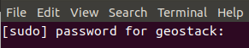
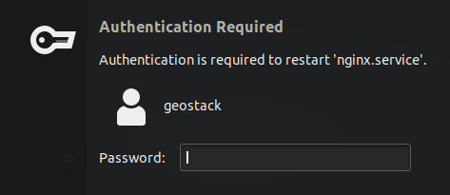
- Now when you navigate to the following URL: http://localhost/2d-map-viewer/ you will be greeted with the 2D Map Viewer which is served as static content via the NGINX Webserver. NOTE: Make sure the Flask-API and the TileStache Tileserver are running for the data and the OSM map to be able to load.
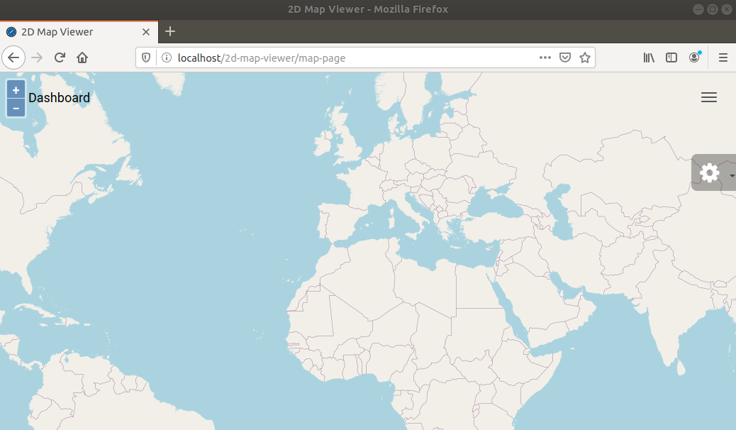
Since the process, of serving an Angular app via NGINX , is the same for all Angular Apps you can now do the same for the Base-Application, Dataset-Dashboard and 3D Map Viewer.

6. Running the GeoStack as Docker containers
If everything is correct you should end up with the following code in the docker-compose.yml file located in the folder: “~/Geostack”. The content should be the same as shown below:
NOTE: The code is split in 3 sections.

#Define the docker compose version
version: '3.7'
#Defining the services
services:
postgresql-datastore:
# Here we define the name which the PostgreSQL container is going to have.
container_name: postgresql-datastore
# Set the directory in which the dockerfile is located
build: ./postgresql-datastore
# Add the data volume of the docker container
volumes:
- ./postgresql-datastore/data:/var/lib/postgresql/data
# Set the port on which the docker container is available to port 5432
# Since we set it to port 5432:5432, the docker container will also be accessible on
# our host system via localhost:5432
ports:
- '5432:5432'
# Here we add the environment variable which allows connections without a pass.
environment:
POSTGRES_HOST_AUTH_METHOD: "trust"

# Here we define the name of the MongoDB datastore Docker service
mongodb-datastore:
# Here we define the name which the MongoDB container is going to have
container_name: mongodb-datastore
# Here we define the image that is used for this container
image: mongo:latest
# Add the data volume of the docker container
volumes:
- ./mongodb-datastore/data:/data/db
# Set the port on which the docker container is available to port 27017
# Since we set it to port 27017:27017, the docker container will also be
# accessible on our host system via localhost:27017
ports:
- '27017:27017'

# Below we define the service for the Middleware components in Geostack
nginx-webserver:
container_name: nginx-webserver
# Set the directory in which the dockerfile is located
build: ./nginx-modsecurity
# The line below makes sure the NGINX container restarts when stopping
# accidentally
restart: always
# Set the port on which the docker container is available to port 80
# Since we set it to port 80:80 the docker container will also be accessible
# on our host system via localhost:80 or just localhost
ports:
- "80:80"
# Below we define the services on which the NGINX webserver depends.
depends_on:
- flask-api
- tilestache-server
- cesium-terrain-server

flask-api:
# Here we set the name of the Flask-API / App container
container_name: flask-api
# The line below makes sure the Flask container restarts when stopping
# accidentally
restart: always
# Set the directory in which the dockerfile is located
build: ./flask-gunicorn
# Here we set the port on which the Tileserver will be running
ports:
- "5000"
# Here we set the command that will be executed when the Flask-API
# service starts.
command: gunicorn -b :5000 app:app
# Here we add the Downloads volume of the docker container
volumes:
- .:/downloads
# Below we define the services on which the Flask-API depends.
# These services will be started before the Flask-API starts.
depends_on:
- mongodb-datastore
- postgresql-datastore
- tilestache-server

# Here we define the name of the tilestache-server service
tilestache-server:
# Here we define the name of the tilestache-server container
container_name: tilestache-server
# The line below makes sure the Tileserver container restarts when stopping accidentally
restart: always
# Here we set the directory in which the Dockerfile is located
build: ./tilestache-server
# Here we add the cache as volume so the local cache is shared with the docker cache
volumes:
- ./tilestache-server/cache:/tilestache/cache
# Here we set the port on which the Tileserver will be running
ports:
- '8081'
# Here we define the command that will run when the docker container is started
command: gunicorn --workers 4 --timeout 100 -b :8081 "TileStache:WSGITileServer('/tilestache/tilestache-configuration.cfg')"

memcached-cache:
# Here we set the name of the memcached container
container_name: memcached-cache
# Here we define the image that is used for this container
image: memcached:latest
# The line below makes sure the container restarts when stopping accidentally
restart: always
# Here we define the ports on which the container is available
ports:
- "11211"
cesium-terrain-server:
# Here we set the name of the container
container_name: cesium-terrain-server
# Here we define the image that is used for this container
image: geodata/cesium-terrain-server
# The line below makes sure the container restarts when stopping accidentally
restart: always
# Here we define the ports on which the container is available
ports:
- "8080:8000"
#- "8080"
volumes:
# Here we add the terrain folder as volume used in the container.
- ./cesium-server/data/tilesets/terrain:/data/tilesets/terrain
# Here we create a container link to the memcached container
links:
- memcached-cache:memcached
# Below we define the services on which the Cesium Server depends.
# These services will be started before the Cesium Server starts.
depends_on:
- memcached-cache
Before running the Dockerized GeoStack you first have to make sure the Local NGINX webserver, TileStache Tileserver, Flask API, MongoDB datastore and PostgreSQL datastore are not running, otherwise the ports of the local instances of the GeoStack components will conflict with the ports of our running Docker containers. To stop the components listed above you can click on the desktop shortcuts that we have created.

Now you can run the following command to run all the docker containers in our docker compose file: cd ~/Geostack && docker-compose up

NOTE: If this is the first time the docker containers are build the process of starting the containers will take a while.

NOTE 2: Before the Dockerized TileServer will work you first need to download and import the OpenStreetMap-Carto Base Map Shapefiles in the Dockerized PostgreSQL ‘gis ’ database. This is done by running the following command in a terminal after all the Docker containers are started and running:

docker exec -it tilestache-server python3 tilestache/openstreetmap-carto/scripts/get-external-data.py -H postgresql-datastore -U geostack -c /tilestache/openstreetmap-carto/external-data.yml

This command makes sure the get-external-data.py script in the tilestache-server Docker container is executed. The -H flag is used to specify the Dockerized PostgreSQL instance, the -U flag is used to specify the PostgreSQL user and the -c flag is used to specify the external-data configuration file.

Now let’s create a new desktop shortcut which can be used to start the Dockerized GeoStack and stop the local instances of the GeoStack components. We do this by running the following command: touch ~/Desktop/Start-Geostack-Docker.desktop

Add the following to the new file which was created on the desktop:
#!/usr/bin/env xdg-open

[Desktop Entry]
Version=1.0
Type=Application
Terminal=true
Exec=sh -c "service mongodb stop && service postgresql stop && service nginx stop && cd ~/Geostack && docker-compose up"
Icon=gnome-panel-launcher
Name[en_US]=Start-Geostack-Docker
The command that is executed, when running this desktop shortcut, does the following:
- Stop the Local MongoDB instance, using the command: service mongodb stop;
- Stop the Local PostgreSQL instance, using the command: service postgresql stop;
- Stop the Local NGINX instance, using the command: service nginx stop;
- Navigate to the Geostack directory;
- Run the GeoStack Docker services, using the command: docker-compose up.

Create a new desktop shortcut, used to stop the GeoStack docker version and restart the local instances of the GeoStack components, by running the following command:

touch ~/Desktop/Stop-Geostack-Docker.desktop

Add the following to the new desktop file which was created:
The command that is executed, when running this desktop shortcut, does the following:
#!/usr/bin/env xdg-open

[Desktop Entry]
Version=1.0
Type=Application
Terminal=true
Exec=sh -c "cd ~/Geostack && docker-compose down && service mongodb start && service postgresql start && service nginx start"
Icon=gnome-panel-launcher
Name[en_US]=Stop-Geostack-Docker
- Navigate to the Geostack directory;
- Run docker-compose down to stop all the Docker services;
- Start the Local MongoDB instance, using the command: service mongodb start;
- Start the Local PostgreSQL instance, using the command: service postgresql start;
- Start the Local NGINX instance, using the command: service nginx start.

Now you can run the Dockerized GeoStack by clicking on the desktop shortcut shown in the illustration below.


When clicking on the desktop shortcut 3 screens will pop up asking you for a password. One of these screens is shown in the illustration below. Enter the password: “geostack”.



If everything is working correctly, the following output will be shown in the terminal.


6.1 Exporting Docker images and volumes
After all the GeoStack Docker containers are build we can run the following command to list all the current images which are located in our Docker system: docker images
The output of this command will be similar to the one shown in the illustration below:

Sometimes it’s useful to be able to distribute the Docker images / containers and their data volumes to other systems. So let’s pretend we have another system on which we want to run the PostgreSQL Datastore Docker container and the data volume containing the World Port Index dataset and the RAW OpenstreetMap data.
We can export an specific image to easily distribute it to other systems. For this we are going to use the command: docker save {image name} > {output directory name}.tar
Let’s export the PostgreSQL Docker image to a tar file. We do this by running the following command:
docker save geostack_postgresql-datastore > geostack_postgresql-datastore.tar
This will give us a .tar file as shown in the illustration below.

Now let’s export the data volume containing the World Port Index dataset and the RAW OpenstreetMap data as zip file. We do this by performing the following steps:
- Change the file permissions of the PostgreSQL Docker container data volume by running the following command:
sudo chown -R $USER ~/Geostack/postgresql-datastore/data
- Zip the data volume by running the following command:
zip -r postgresql-data-volume.zip ~/Geostack/postgresql-datastore/data

Let this zipping process finish which takes about 20 seconds.
After the zipping process is finished the output should look similar to the output shown in the illustration below:

Now we end up with a file containing the PostgreSQL Docker image and a file containing the PostgreSQL Docker data volume as shown in the illustration below:
Now let’s distribute these files to another system by placing it on a USB drive or something similar. Let’s imagine the system om which we want to run the PostgreSQL Docker container with data volume has a docker-compose.yml file containing the following code:
#Define the docker compose version
version: '3.7'
#Defining the services
services:
postgresql-datastore:
# Here we define the name which the PostgreSQL container is going to have.
container_name: postgresql-datastore
# Set the directory in which the dockerfile is located
build: ./postgresql-datastore
# Add the data volume of the docker container
volumes:
- ./postgresql-datastore/data:/var/lib/postgresql/data
# Set the port on which the docker container is available to port 5432
# Since we set it to port 5432:5432, the docker container will also be accessible on
# our host system via localhost:5432
ports:
- '5432:5432'
# Here we add the environment variable which allows connections without a pass.
environment:
POSTGRES_HOST_AUTH_METHOD: "trust"
This is the same PostgreSQL container setup as in our GeoStack. The docker-compose.yml file expects a folder called:”postgresql-datastore” inside the folder which contains the docker-compose.yml file (“~/GeoStack/” in our case).
When the files are on the new system you need to extract the postgresql-data-volume.zip file by running the following command: unzip postgresql-data-volume.zip
Now we will end up with a postgresql-datastore folder which contains the PostgreSQL data volume that was copied from our source system.

Now let’s load the PostgreSQL Docker container which we copied from our other system. We do this by running the following command:
docker load --input geostack_postgresql-datastore.tar
This will load the PostgreSQL Docker container from our other system in our new system. The output of the command which we used above should be similar to the one shown in the illustration below:

Now when we run the following command we can see the Docker container is correctly imported:
docker images
The output of this command should be similar to the one shown in the illustration below:
Now when we run the following command from the folder in which the docker-compose.yml file is located, we will have a working PostgreSQL Docker container copied from our GeoStack virtual machine:
docker compose up
You can perform the steps described in section 5.4.1.4 to check whether the data volume is working accordingly and the World Port Index database and the gis database are shown in the list of PostgreSQL databases as shown in the illustration below.

7. Useful tips and tricks
In this chapter some useful tips and tricks are discussed. These tips and tricks can increase the workflow during and after completing the GeoStack Course.

7.1 Creating desktop shortcuts
During this cookbook multiple desktop shortcuts are created. Creating Desktop shortcuts in Ubuntu 18.04 is a bit different from Ubuntu 19.10 and 20.04. The way a desktop shortcut is created (in Ubuntu 18.04) is as follows:
- First you created a new empty text file on your desktop. This file should have the file extension: “.desktop” and is can be created using the following command:
touch ~/Desktop/{shortcut name}.desktop
- Then you should open the file, add the following code and save it afterwards:
# The line below makes sure that the system knows that the text file is executable.
#!/usr/bin/env xdg-open

# The line below makes sure that the system knows that the file is a desktop shortcut.
[Desktop Entry]

# The Line below defines the version of the desktop shortcut.
Version=1.0

# The line below defines what type of shortcut the shortcut is. Set it to
# application if you want the shortcut to be an application launcher.
Type=Application

# The line below defines whether a terminal should be opened when the
# shortcut is launched. It’s recommended to set this value to True.
Terminal=true

# The line below defines the command that should be executed when the
# desktop shortcut is clicked. Using the syntax: “sh -c “command” ” tells the
# system that the command needs to be executed as root user.
Exec=sh -c "{your command}”

# The line below defines what type of icon should be displayed on the desktop. # This value can be set to another type of icon if you want it to.
Icon=gnome-panel-launcher

# The line below defines the name of the Desktop shortcut.
Name[en_US]={The shortcut name}

After you have saved the file we want to make sure the desktop shortcut is trusted. This is done by running the following command:
for i in ~/Desktop/*.desktop; do gio set "$i" "metadata::trusted" yes ;done
Finally we need to make sure the shortcut is launch-able. This is done by running the following command: sudo chmod +x ~/Desktop/{shortcut name}.desktop
Now if you are using Ubuntu 19.10 or higher you should perform one more step before a desktop shortcut can be used.
If you are on Ubuntu 19.10 or 20.04 you need to allow the desktops shortcuts to be executable. This is done by right-clicking a desktop shortcut and the selecting Allow Launching in the menu that pops up as shown in the illustration below:
That’s it! Now the shortcut should be executable and can be run by double clicking on the shortcut which you just created.

7.2 Removing DEFAULT folders from Nautilus
If you want to remove unused DEFAULT folders from the Nautilus folder viewer you should perform the following steps:
- Edit the user directory defaults file by opening it, using the following command:
sudo nano /etc/xdg/user-dirs.defaults
- Put a “#” in front of the folders that you want to remove, as shown in the illustration below.

- Save the file by pressing ctrl + s on you keyboard.
- Edit the user directory configuration file by opening it, using the following command:
sudo nano ~/.config/user-dirs.dirs
- Put a “#” in front of the folders that you want to remove, as shown in the illustration below.

- Save the file by pressing ctrl + s on you keyboard.
- Stop nautilus by running the following command: pkill nautilus
- Restart nautilus by running the following command:
nautilus-desktop > /dev/null 2>&1 & echo “Restarted”

Now the folder which you removed should be removed from the Nautilus folder viewer. If this is not the case you should restart you Virtual Machine.

7.3 Editing Atom theme settings
You can change the theme of your Atom editor by performing the following steps:
- At the top of the Atom window go to Edit → Preferences.
- Select Install in the left menu bar as shown in the illustration below.

- Select themes next to the search box, search for Atom Monokai and press install as shown in the illustration below.


- Select Themes in the left menu bar as shown in the illustration below.
- Set the syntax theme to Atom Monokai as shown in the illustration below.

- At the top of the Atom window go to Edit → Stylesheet.
- Add the following line to the stylesheet and save the file:
- Restart Atom for the changes to take effect.
This will change the color of the Inline comments to make them more readable.

7.4 Useful Docker commands
Some useful Docker commands are as follows:

# | Description | Command
1) | Find the IP address of a Docker container | docker inspect -f '{{range .NetworkSettings.Networks}}{{.IPAddress}}{{end}}' {container name or ID}
2) | List all docker images: | docker images
3) | List all running docker containers | docker ps
4) | Remove docker image: | docker image rm {container name or ID} -F
5) | List all docker containers: | docker container ls
6) | Kill a docker container: | docker stop {container ID}
7) | Clean docker system: | docker system prune
8) | Run docker-compose file: | docker-compose up
9) | Run a specific service in the docker-compose file | docker-compose up {service name}
10) | Build docker-compose file | docker-compose up
11) | Build a specific service in the docker-compose file | docker-compose build {service name}
12) | Open a terminal in a running docker container | docker exec -it {container name or ID} bash
13) | Show Memcached Docker data | echo "stats cachedump 15 4" | nc 127.0.0.1 11211
14) | Login to Docker PostgreSQL user | docker exec -it postgresql-datastore bash  su postgres  psql  \l

7.5 3D Acceleration in your Virtual Machine
On some platforms, and in some circumstances, the wrong renderers may be used by the guest OS which results in very slow 3d performance of the guest. To check whether you Virtual Machine is correctly configured you should perform the following steps:
- Install NUX Tools, which is used to perform some tests on your Guest system. This is done by running the following command: sudo apt install nux-tools
- Now run the following command to see whether your system is correctly configured:
/usr/lib/nux/unity_support_test -p
This command should print the following output:

If this is the case, your system is correctly configured. If this is not the case and you have something similar to the output shown in the illustration below, you should continue with the following steps.


- Install the required packages for building kernel module by running the following command:
sudo apt install dkms build-essential module-assistant

- Prepare your system to build kernel module by running the following command:
sudo m-a prepare

- In VirtualBox menu bar, select Devices → Insert Guest Additions CD image; at this point you'll be asked to run the software contained in it, click Run button:

- After the installation process is done you should rerun the command from step 2 and check if everything is set to yes. If this is not the case you should continue with the following step.
- Try installing xorg vmware drivers on your Ubuntu guest Virtual Machine by running the following command:
sudo apt-get install xserver-xorg-video-vmware-hwe-18.04

You can also install GL2MARK to see your systems 3D Performance. This is done by running the following command: sudo apt install glmark2

Then run GL2Mark by entering the command: gl2mark


After the application is done running you will get an score which represents the speed of your graphics adapter.

7.6 VirtualBox Graphics Adapters
VirtualBox offers a variety of Graphics Adapters. Depending on the Graphics card in your system you should chose the adapter which should be used. Below you can find some information related to the available graphics adapters.
1) VBoxVGA
This emulates a graphics adapter specific to VirtualBox, the same as in previous versions (<6.0.0).
- This is the default for images created for previous versions of VirtualBox (<6.0.0) and for Windows guests before Windows 7.
- It has some form of 3D pass through, but – if I remember correctly – uses an insecure approach that just lets the guest dump any and all commands to the host GPU.
- Using it on a Linux guest requires installing the guest additions because this adapter is not (yet) supported by the mainline Linux kernel.
- Only supports OpenGL 1.1 on 64bit Windows 10 and all Linux guests.
This option likely exists just to provide continuity – after upgrading to 6.0, all old VMs have this mode selected automatically so there's no unexpected change in behavior; you don't lose whatever acceleration you previously had.
2) VMSVGA
This emulates the VMware Workstation graphics adapter with the "VMware SVGA 3D" acceleration method.
- Contrary to what the manual says, this is currently the default for Linux guests.
- It is supposed to provide better performance and security than the old method.
- This is supported by the mainline Linux kernel using the SVGA drivers.
- Supports OpenGL 2.1 on all Windows and Linux guests.
- It might also have the advantage of supporting old operating systems which had VMware guest additions available but not VirtualBox guest additions.
3) VBoxSVGA
This provides a hybrid device that works like VMSVGA (including its new 3D acceleration capabilities), but reports the same old PCI VID:PID as VBoxVGA.
- This is the default for Windows guests.
- The advantage of this mode is that you can upgrade existing VMs (which previously used VBoxVGA and had the VirtualBox Video driver installed) and they don't lose their graphics in the process – they still see the same device, until you upgrade the "guest additions" at any later time to enable 3D acceleration.
- Also, because it's still VMware SVGA emulated by VirtualBox, choosing this option and using the VirtualBox driver may still have advantages over the VMware one, e.g. allow to make use of VirtualBox-specific additional features.
Source: https://superuser.com/questions/1403123/what-are-differences-between-vboxvga-vmsvga-and-vboxsvga-in-virtualbox

7.7 Recording your Virtual Machine screen
To record the screen of your Virtual Machine, you can use a simple tool called: “SimpleScreenRecorder”. First we need to install SimpleScreenRecorder. Then we are going to increase the size of the cursor which comes in handy when recording the screen. Afterwards as small description is given on how to use SimpleScreenRecorder.

7.7.1 Installing SimpleScreenRecorder
SimpleScreenRecorder is installed by performing the following steps:
- Add the SimpleScreenRecorder ppa to the systems repository list by running the following command:
sudo add-apt-repository ppa:maarten-baert/simplescreenrecorder

- Update the local package database by using the following command:
sudo apt update

- Install SimpleScreenRecorder using the following command:
sudo apt install simplescreenrecorder

7.7.2 Increasing the cursor size
Before recording the screen of you Virtual Machine, it’s recommended to increase the size of your cursor. This is done by performing the following steps:
- Open the settings menu in the top right of you Ubuntu Virtual Machine as shown in the illustration below.
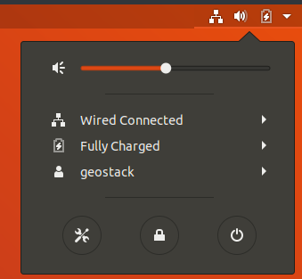
- Select Universal Access in the left menu of the screen that pops up. Then select Cursor Size as shown in the illustration below.
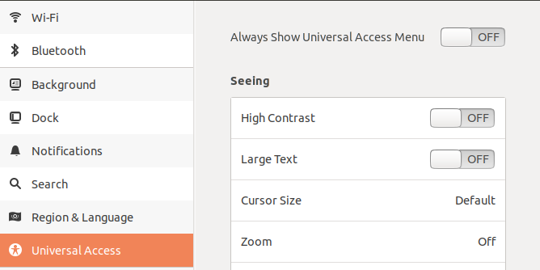
- Then select the size of the cursor which suits your needs as shown in the illustration below.


7.7.3 Using SimpleScreenRecorder
Opening the SimpleScreenRecorder application is done by performing the following steps:
- Open the show application menu on the bottom left of the desktop. The icon is shown in the illustration below.


- Then select All at the bottom of the screen that pops up, as shown in the illustration below.

- Enter “SimpleScreenRecorder” in the search bar and click on the icon that shows up, as shown in the illustration below.


To use the SimpleScreenRecorder application you should perform the following steps:
- When recording your Virtual Machine window it’s best to set your Virtual Machine window to full screen. This is done by clicking on View → Full-screen Mode in the VirtualBox window. How this is done is shown in the illustration below.

- Edit the settings as you see fit. It’s recommended to set the frame rate to 60 Frames Per Second. If you want to record with audio you should check the box: “Record Audio”. Select continue after editing the settings.



- In the next screen you also should edit the settings as you see fit. Here you can select where you want to save the video file after the recording process if finished. You can also set the extension type of the video. It’s recommended to set it to: “webm” since this is a small video format which can be played in a web browser.

- Next click on: “Start Recording” which will start the recording process. If you are done recording you can press on Pause recording and then on save recording to save the video.

When the screen is being recorded the icon shown in the illustration below will pop up in the top right of your screen.

7.8 Allow Cross-Origin Resource Sharing (CORS)
During the creation of a software stack there is a strong possibility you will encounter an error similar to the one shown in the illustration below:

These error’s occur when trying to obtain resources from multiple web servers at the same time. In the example above this error occurred when trying to obtain OpenStreetMap Tiles from the Tilestache tileserver (running on “localhost:8081”) in the 3D Map Viewer running on localhost:4200.
For more information related to the specifics of CORS you should read the following URL:
https://developer.mozilla.org/en-US/docs/Web/HTTP/CORS
To solve this problem we need to install a Firefox extension called: “Allow CORS”. This is done by performing the following steps:
- Navigate to the Addons website of Firefox by entering the following URL in your browser: https://addons.mozilla.org/en-US/firefox/
- Type: “Allow CORS” in the search bar in the top right of the page and click on the first option that pops up, as shown in the illustration below:

- On the next screen select: “Add to Firefox” as shown in the illustration below:

- Then select: “Add” in the popup window as shown in the illustration below:

- After the extension is add a new icon will pop up in the top right of your Firefox window (Blue), click it and Click on the allow CORS icon as shown in the illustration below (Red) :


8. Bibliography

8.1 Data analyses links and tools
Information related to the ETL-Process:
https://nl.wikipedia.org/wiki/Extraction,_Transformation_and_Load
Converting CSV to GeoJSON
http://www.convertcsv.com/csv-to-geojson.htm
Converting GPX to GeoJSON
https://mygeodata.cloud/converter/gpx-to-geojson
Converting JSON to GeoJSON
https://stackoverflow.com/questions/5620696/convert-lat-long-into-geojson-object

8.2 MongoDB Links
The MongoDB website:
https://www.mongodb.com/
The MongoDB documentation:
https://docs.mongodb.com/
An example of Python with MongoDB and MongoAtlas
https://www.youtube.com/watch?v=3ZS7LEH_XBg
An example of Python-Flask with MongoDB and Docker
https://www.youtube.com/watch?v=AAPOCB1U1kg

8.3 PostgreSQL / PostGIS and GeoServer Links
Installing PostgreSQL with Postgis and PGAdmin4 with GUI:
https://freegistutorial.com/how-to-install-postgis-on-ubuntu-18-04/
Installing PostgreSQL with Postgis and PGAdmin4 without GUI:
https://www.paulshapley.com/2018/11/how-to-install-postgresql-10-and.html?m=1
Installing GeoServer and running it as service:
https://github.com/jncc/web-mapper-core/wiki/Tips-for-installing-geoserver-on-Ubuntu-16.04
Installing GeoServer and running it as service, and managing the service:
https://gismentor.com/index.php/2019/05/08/installing-geoserver-in-linux-ubuntu-gismentor/
An example of Python-Flask with PostgreSQL and PostGIS
https://github.com/ryanj/flask-postGIS/tree/master/templates
An example of Python-Flask with PostgreSQL and Docker
http://fuzzytolerance.info/blog/2018/12/04/Postgres-PostGIS-in-Docker-for-production/

8.4 NGINX ModSecurity Links
Installing the latest version of NGINX:
https://www.linuxbabe.com/ubuntu/install-nginx-latest-version-ubuntu-18-04
Installing ModSecurity for NGINX:
https://www.linuxjournal.com/content/modsecurity-and-nginx
Installing the ModSecurity Core Rule Set

https://www.linuxjournal.com/content/modsecurity-and-nginx

The ModSecurity Github Repository:

https://github.com/SpiderLabs/ModSecurity

8.5 Python-Flask Links
An example of Python-Flask with PostgreSQL and Docker
http://fuzzytolerance.info/blog/2018/12/04/Postgres-PostGIS-in-Docker-for-production/
An example of Python with Folium, Leaflet and Pandas
https://www.youtube.com/watch?v=4RnU5qKTfYY
An example of Python-Flask with PostgreSQL and PostGIS
https://github.com/ryanj/flask-postGIS/tree/master/templates
An example of a Full-Stack Python Flask application with Docker and React:
https://medium.com/@riken.mehta/full-stack-tutorial-flask-react-docker-ee316a46e876
An example of Python with Leaflet and D3
http://adilmoujahid.com/posts/2016/08/interactive-data-visualization-geospatial-d3-dc-leaflet-python/
An example of Python Flask with Leaflet
https://github.com/adwhit/flask-leaflet-demo/tree/master/templates
An example of Python-Flask with MongoDB and PyMongo
https://devinpractice.com/2019/03/25/flask-mongodb-tutorial/
An example of Python with MongoDB, PyMongo and MongoEngine
https://pythonise.com/feed/python/mongodb-python-mongoengine-pt1
An example of Python with GeoJson, Folium and Leaflet
https://youtu.be/clP6W7W79MM
An example of Python-Flask with Leaflet:
https://www.freelancer.com/projects/javascript/flask-leaflet-application-that-displays/
2 websites with very useful information related to visualizations with Python:
https://pyviz.org/ and http://holoviz.org/

8.6 Tilestache Tileserver Links
The official Tilestache documentation:
http://tilestache.org/doc/
An example of Tilestache with Gunicorn and NGINX:
https://digital-geography.com/set-tileserver-using-tilestache-gunicorn-nginx/

8.7 Cesium Terrain Server Links
An example of creating a Cesium Terrain Server:
https://bertt.wordpress.com/2016/12/08/visualizing-terrains-with-cesium/
Installing Memcached for NGINX:
https://websiteforstudents.com/setup-memcached-on-ubuntu-18-04-16-04-with-nginx-and-php-7-2/
Creating an Cesium Terrain Server example:
https://www.aiwebnetwork.com/blog-detail/install-setup-cesium-terrain-server-on-ubuntu

8.8 Angular Links
Official AngularJS website:
https://angularjs.org/
Creating an Angular Application example:
https://angular.io/tutorial
Cleaning your Angular Project:
https://itnext.io/clean-code-checklist-in-angular-%EF%B8%8F-10d4db877f74

8.9 OpenLayers Links
Official OpenLayers website:
https://openlayers.org/
Official OpenLayers documentation:
https://openlayers.org/en/latest/doc/
Running OpenLayers Locally example:
https://wiki.openstreetmap.org/wiki/OpenLayers_Local_Tiles_Example
Running OpenLayers with OpenStreetMap and OpenSeaMap Locally:
https://openlayers.org/en/latest/examples/localized-openstreetmap.html
Example OpenLayers with Tileserver
https://switch2osm.org/using-tiles/getting-started-with-openlayers/
OpenLayers Cesium implementation:
https://openlayers.org/ol-cesium/

8.10 Cesium Links
Official Cesium website:
https://cesium.com/
Official Cesium documentation:
https://cesium.com/docs/cesiumjs-ref-doc/
Cesium coding examples:
https://sandcastle.cesium.com/

8.11 Leaflet Links
Creating a Leaflet application using a Tileserver:

https://switch2osm.org/using-tiles/getting-started-with-leaflet/

Creating a Leaflet slider example:

https://github.com/dwilhelm89/LeafletSlider

An example of Python with Leaflet and D3:
http://adilmoujahid.com/posts/2016/08/interactive-data-visualization-geospatial-d3-dc-leaflet-python/
An example of Python Flask with Leaflet:
https://github.com/adwhit/flask-leaflet-demo/tree/master/templates
An example of Python with GeoJson, Folium and Leaflet:
https://youtu.be/clP6W7W79MM
An example of Python-Flask with Leaflet:
https://www.freelancer.com/projects/javascript/flask-leaflet-application-that-displays/

8.12 Remaining Links

