
CREATING A DATASET
DASHBOARD
Programming Manual
Version : 1.0

Date :01-09-2020

Author :The GeoStack Project

License :CC BY 4.0
Open Content License
This work is licensed under the Creative Commons Attribution 4.0 International License.
To view a copy of this license, visit http://creativecommons.org/licenses/by/4.0/ or send a letter to Creative Commons, PO Box 1866, Mountain View, CA 94042, USA.
Purpose of this document
This programming manual serves as an extension for the following documents:
- Cookbook: Creating the Geostack Course VM:
The datastores, tools and libraries used during this programming manual are installed and created in the cookbook: Creating the Geostack Course VM.
- Cookbook: Creating a basic web application:
The base application of this Dataset Dashboard has been created during the cookbook: Creating a basic web application:.
- Cookbook: Data modeling in MongoDB using MongoEngine:
The data used during this cookbook, is modeled, indexed and imported in the cookbook: Data modeling in MongoDB using MongoEngine.
- Programming manual: Creating the Python-Flask web application:
The middleware that will be used during this programming manual is created in the programming manual: Creating the Python Flask web application.
If you have not read these documents yet, please do so before reading this document.
The purpose of this programming manual is to create a Dataset Dashboard web application with the Angular JavaScript framework as an extension of our Angular Base Application.
The Angular apps will perform API calls to the API of our Flask application and our Flask application will then retrieve the requested data via queries, performed on our datastores. The results are then returned to our Angular applications.
For more in depth information related to AngularJS see: https://angular.io/docs
Some code is explained using the inline comments in the source code. The source code can be found in the folder: “POC” which is located in the same folder as this document.
NOTE: it’s highly recommended you use the source code when creating the application yourself and learn from the inline comments!
A special thanks to the following people and organizations:
- The people and contributors from AngularJS for providing an awesome and easy to use JavaScript framework.
- The people from Creative Tim for providing some styled components which are used in the application.
- The people and contributors from all the extra packages used in the applications created during this programming manual.
Table of Contents
1 Getting ready 4
2 Creating the service.ts file 5
3 Creating the GPS Dashboard page 8
3.1 Retrieve the data from our MongoDB datastore 11
3.2 Displaying the first row of cards with data 14
3.3 Displaying interactive graphs in the dashboard 19
3.4 Creating an interactive table 25
3.5 Generating pandas data profile 32

Getting ready
This application is an extension of the base application so we can copy this application and start creating the Dataset Dashboard using this application as base.
After we copied the base-application folder, we need to change some names and titles to make the new application the dataset dashboard. We start by changing the name of the folder we just copied from base-application to dataset-dashboard, as shown in the image below.

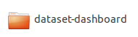
We also need to edit the project name: “base-application” to “dataset-dashboard”. If you are using the code-editor Atom, this is done by performing the following steps:
- In the editor press the keys Ctrl + shift + f

- In the screen that pops up enter: “base-application” in the find section and “dataset-dashboard” in the replace section, as shown in the illustration below.
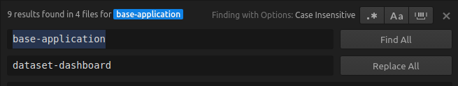

- Click on replace all and on the save button in the screens that pop up


- In the file: index.html located in the folder dataset-dashboard/src, rename the title from BaseApplication to Dataset Dashboard.

- In the file: sidebar.component.html located in the folder src/app/components/sidebar/, change the text: “Base Application” to “Dataset Dashboard”

Creating the service.ts file
In the folder dataset-dashboard/src/app/services, create a new service called: “gpsdashboard.service.ts” by running the following command:
touch ~/Geostack/dataset-dashboard/src/app/services/ gpsdashboard.service.ts
Now let’s open this file and import some basic modules by adding the following lines at the top of the file:
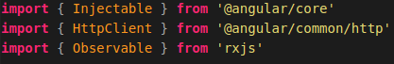
Next we need to create an inject able class called GPSDashboardService. How this is done is shown in the illustration below.
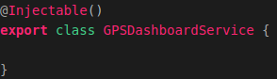
In this class we need to create a constructor in which we will pass an instance of the HTTPClient. This is required to perform HTTP requests to our Flask-API. How this is done is shown in the illustration below.
Now we are going to create some functions which will be used to perform API calls to our Flask-API. These functions will be called in our GPSDashboard.
The first function we are going to create is a function which retrieves all trackers from our datastore. The function is called:”getTrackers()” and is used to perform an HTTP GET request to our Flask-API.

The function performs a request on the following URL: http://localhost:4200/api/trackers/.

This URL will be transformed to: http://localhost/api/trackers/, which is our Flask-API, because of the proxy configuration which we added in the previous programming manual.

This URL is bound to a function in our Flask-API. The function bound to this URL executes the query on our MongoDB datastore which retrieves all trackers from the MongoDB datastore.
The code for creating this function is shown in the illustration below.
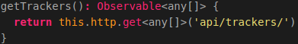

Now we need to create a function called: "getTracker()", which is used to perform an HTTP GET request to our Flask-API. The function performs a request on the following URL:api/trackers/{id}.

This URL is bound to a function in our Flask-API. The function, bound to this URL, executes a query on our MongoDB datastore and retrieves a tracker which has the id passed in this function, from the MongoDB datastore.

The function:"getTracker()" then returns the tracker to our GPSDashboard. The code for creating this function is shown in the illustration below.

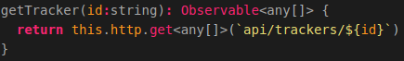
From here on the functions will be explained using the inline comments found in the source code, provided in the folder: “POC”.
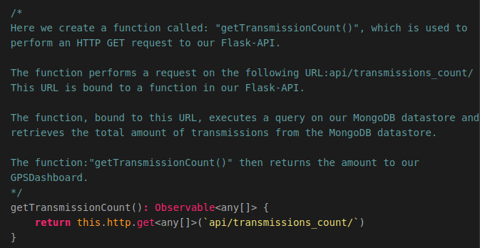
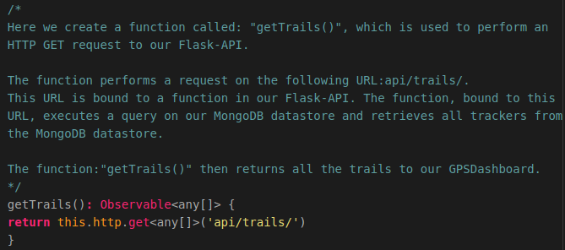
Now we need to create a function which returns all our GPS-Routes. The code for this is shown in the illustration below.
Now we need to create a function which returns a specific trail using the id passed in the function. The code for this is shown in the illustration below.
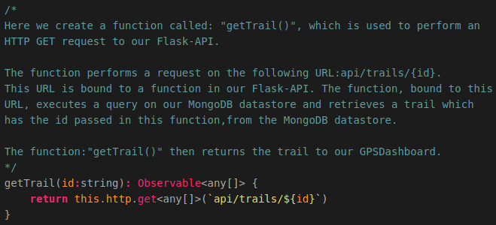
The last function which we are going to create is used to retrieve the total amount of signals from our datastore. The code for this function is shown in the illustration below.
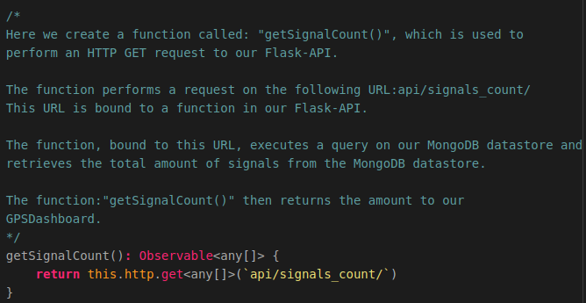

Creating the GPS Dashboard page
Now let’s create the GPS Dashboard page. For this we first need to create a folder in the folder “/dataset-dashboard/src/app/pages” called: “gpsdashboard”. We do this by running the following command:
mkdir ~/Geostack/angular-apps/dataset-dashboard/src/app/pages/gpsdashboard
In this folder create a file called: “gpsdashboard.component.ts” and a file called: “gpsdashboard.component.html”
We start of by importing the required modules in our gpsdashboard.component.ts file.
So let’s open this file and add the following code at the top of the file.
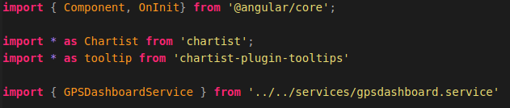
The imported modules are as follows:
- The base angular modules
- The module for creating the interactive charts
- The module for showing tool-tips in those charts
- The service we need to perform AP calls to retrieve data.
Now we need to define the metadata of the GPSDashboard component. How this is done is shown in the illustration below:
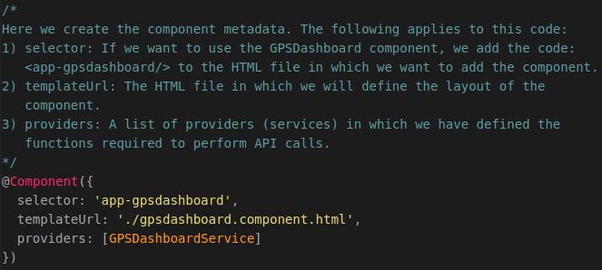
Now we need to create the basic class structure of the GPSDashboard component. We also create a global variable called currentDate which is used to show when the data displayed in the dashboard was last updated. The code for this is shown in the illustration below.
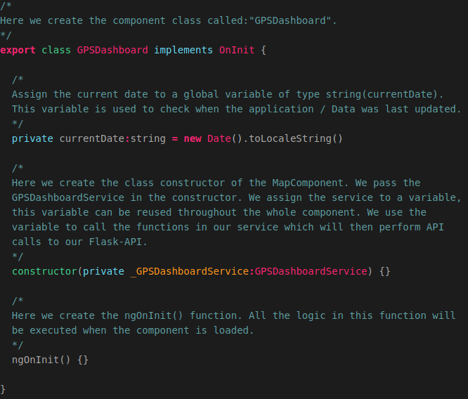
Now we need to add the GPSDashboard to our app.module.ts, so let’s open this file and add an import to the top of the file. The code for this is shown in the illustration below.
Then we need to add the GPSDashboard to the declarations section in the app.module.ts file. The final declarations section will look the same as shown in the illustration below.
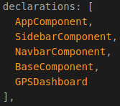

Now we need to add a new a new route to our app-routing.module.ts file. So let’s open this file.
First we need to import the GPSDashboard in this file. This is done by adding the following code to the top of that file.
Then we need to add a new route to our routelist. The code for this is shown in the illustration below.
If you want you can change the route which redirects us to the base-page, to redirect us to the gpsdashboard. If you choose to do this the final Route List will look the same as in the illustration below.
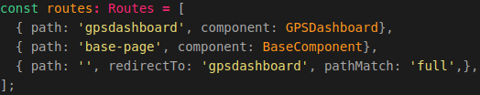
Now we want to add a new entry to our sidebar. This is done in the file: sidebar.component.ts, located in the folder : src/app/components/sidebar/. So let’s open this file and add a new route to our Routes List. The final code will be the same as shown in the illustration below.
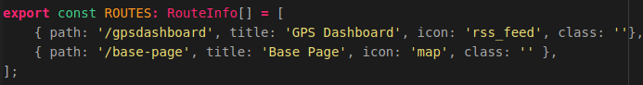
Now when we go to our application and open the sidebar we will have 2 entries as shown in the illustration below.
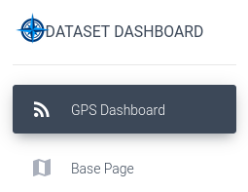
When clicking on the GPS Dashboard entry the page will still be empty. This is because we did not add anything to the layout of the GPS Dashboard. We are going to do this later on but let’s first make sure we can obtain data from our MongoDB datastore.

Retrieve the data from our MongoDB datastore
To retrieve, store and use data, from our MongoDB datastore, in our GPSDashboard we have to start of by defining some global variables. The global variables are going to contain the data retrieved by the functions in our GPSDashboard service. Because the variables are global variables, we can use them throughout the whole GPSDashboard component.
We are going to create a JavaScript map for the Crane trackers and for GPS-Route datasets (Trail). The code for creating the Crane map is shown below.
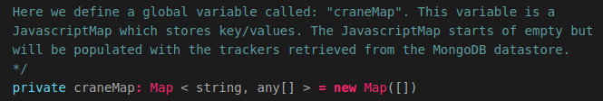
The code for creating the Trail map is shown below.
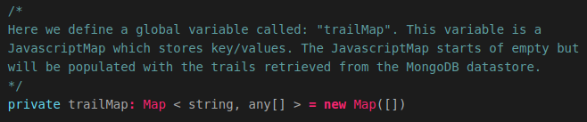
Now we also need to create 2 global variables to which we will assign the total amount of transmissions and signals in our datastore. The code for this is shown below.
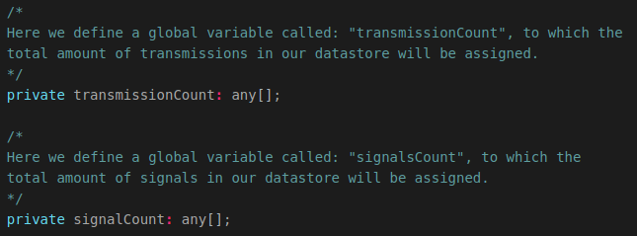
Next we need to create the functions which will trigger the API Call functions in our CraneService file which we created in chapter 2.

So we need to define the functions that retrieve all the data from our MongoD datastore. These functions are as follows:
- getTrackers() which is used to obtain all the (Crane) trackers from our datastore.
- getTotalTransmissions() which is used to obtain the total amount of transmissions.
- getTrails() which is used to obtain all trails (GPS Routes) from our datastore.
- getTotalSignals() which is used to obtain the total amount of singals.

The syntax used in these functions is as follows:
this.{service}.{function}.subscribe({elements} =>
{elements}.forEach({element} =>{
this.{JavascriptMap}.set(element['name'],element)
})
)
The following applies to the code block above:
- service = the service which contains the API call functions
- function = the function from the service you want to trigger. This function will then return the data retrieved from our datastore.
- elements = this name can be generic. This value stands for the list of data returned by the function. A foreach function is performed on the list of data because we want to add all rows in the elements to the JavascriptMap it belongs to.
- element = this name can also be generic. This value stands for 1 row in the data returned by the function. We want to add the element/item to the JavascriptMap using the name of the element as the key and the element itself as the value.

In the case of a Crane tracker, an entry in the JavascriptMap (craneMap) would be: {key = "Agnetha", value = [coordinates, study_name, etc..]}

The code for creating the getTrackers() function in shown in the illustration below:
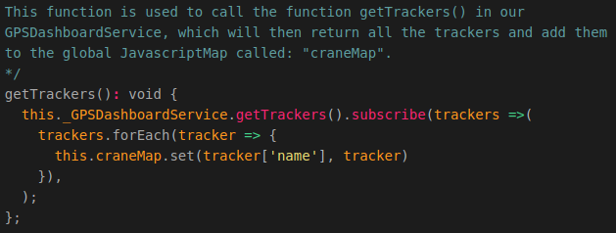

The code for creating the getTotalTransmissions() function in shown in the illustration below:

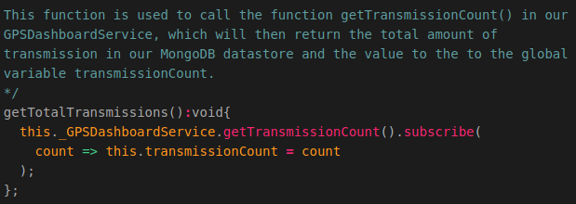

The code for creating the getTrails() function in shown in the illustration below:

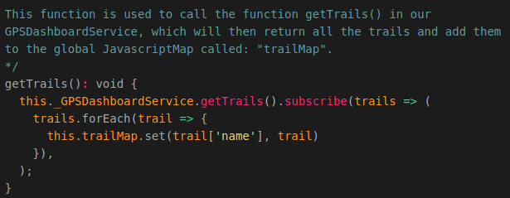

The code for creating the getSignals() function in shown in the illustration below:
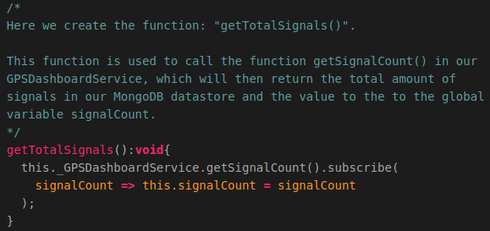

Now we need to add these functions to the ngOnInit() function to make sure that the functions get triggered when the component and thus the dashboard is loaded. The final ngOninit() function will look the same as shown in the illustration below.
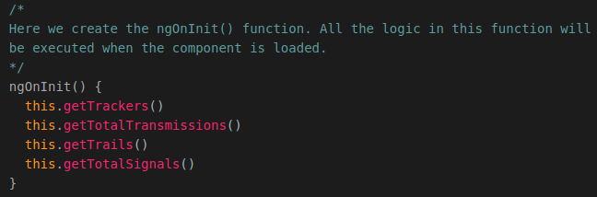
Now when you start the Flask-API and you load the web application the data will be obtained from our MongoDB datastore. You can confirm this by opening the Firefox element inspection and the inspect the network traffic. You will see something similair as shown in the illustration below:
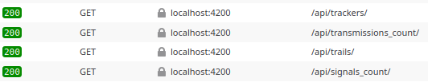
We did not add anything to the layout of our dashboard so we will not see anything yet so let’s do this in the next chapter.

Displaying the first row of cards with data
At this point we have a working dashboard that obtains the data from our MongoDB datastore. The problem is that we don’t have anything in our HTML layout file yet. So let’s add some cards that are going to contain the data that is retrieved by the functions we created in the previous chapter.
The final result will look the same as shown in the illustration below:

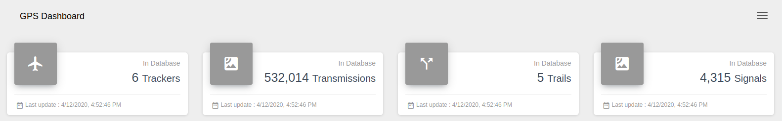

First we will add the basic layout of our dashboard page. This is done by adding the following code to our gpsdashboard.component.html file:
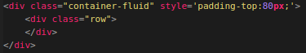
The div element with the class: “container-fluid”, makes sure that everything in the div element has a specific width. The div element with the class: “row”, makes sure that everything in that div is displayed next to each other.
All the cards we are going to create are created inside the div element with the class: “row”.
We are going to start of with the card that displays the amount of trackers in the database. The code for this is shown in the illustration below.
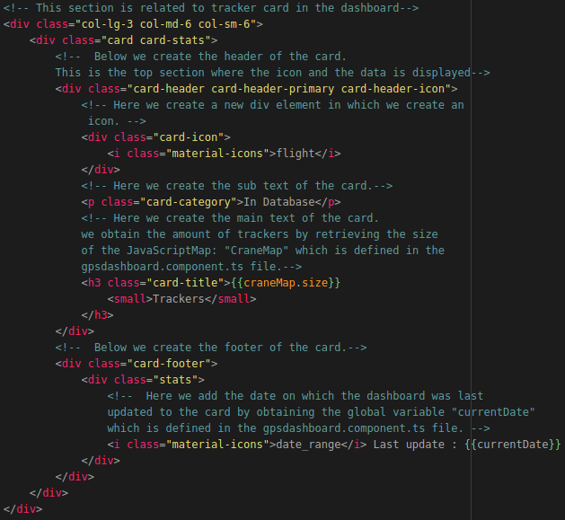
Now we are going to create the card that displays the amount of transmissions in the database. The code for this is shown in the illustration below, we add the code below the div element representing the card for the amount of trackers in the database.
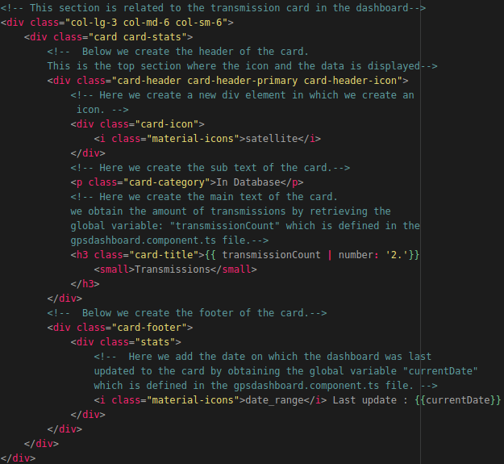

Now we are going to create the card that displays the amount of GPS-Routes (Trails) in the database. The code for this is shown in the illustration below, we add the code below the div element representing the card for the amount of transmissions in the database.
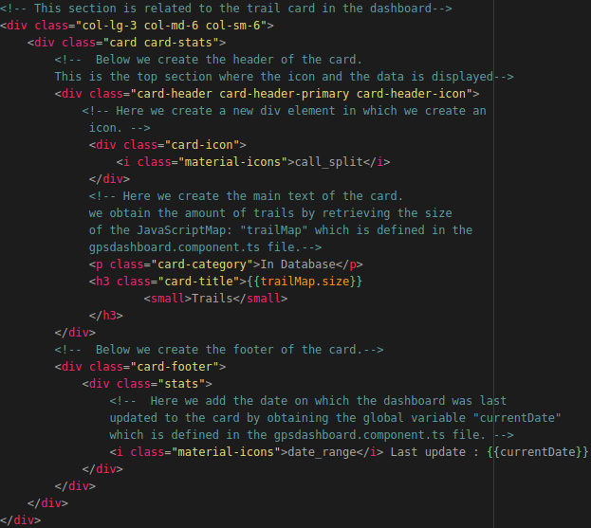

The last card we are going to create is the card that displays the total amount of signals in the database. The code for this is shown in the illustration below, we add the code below the div element representing the card for the amount of trails in the database.
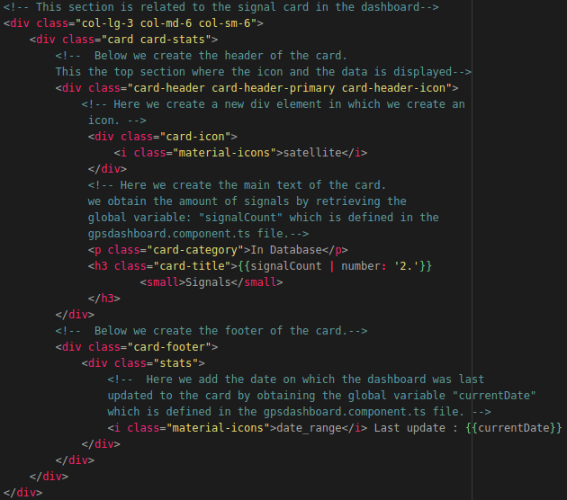
Now when we save the HTML file and reload the application we will be greeted by 4 cards displaying the data from our datastores.
NOTE: the Flask API and the MongoDB datastore have to be running for the application to show the data!

Displaying interactive graphs in the dashboard
At this point we have a working dashboard that contains the data from our MongoDB datastore and it displays a row of cards containing the amount of items in the database.
Now we want to create some interactive graphs that display the amount of transmissions per tracker and the amount of signals per trail.
The end result will look the same as shown in the illustration below.
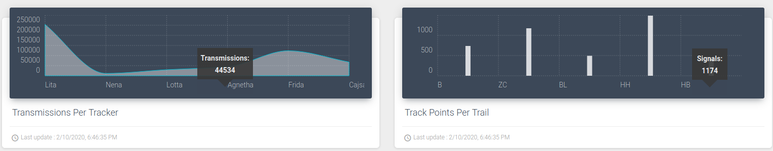
First we need to create a generic function which creates charts using the Chartist module we installed. We are going to create this function in the gpsdashboard.component.ts file.
We are going to call the function: createChart(). The creation of this function is going to be explained using the inline comments in the Source Code, which can be found in the folder POC located in the same folder as this programming manual.
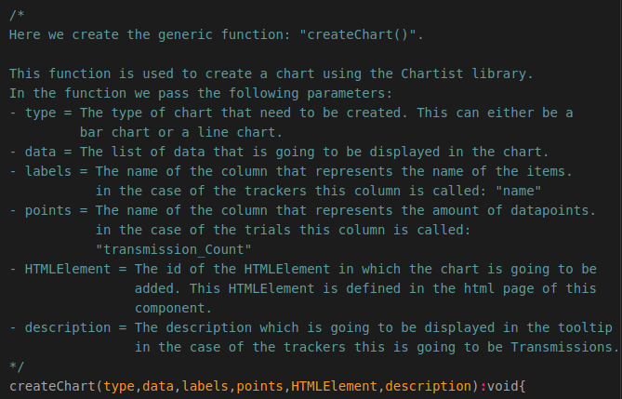

The code shown in the following illustration is located inside the createChart() function.
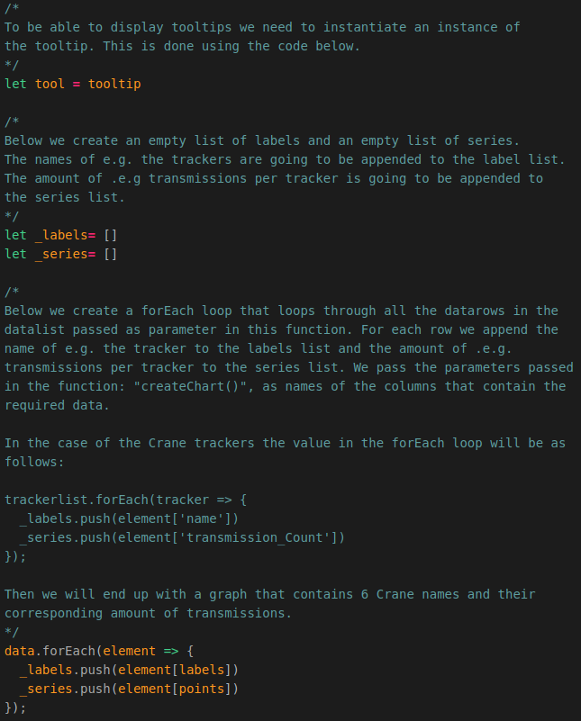

Now we need to assign the labels and points to a variable called chartData. The code for this is shown in the illustration below.
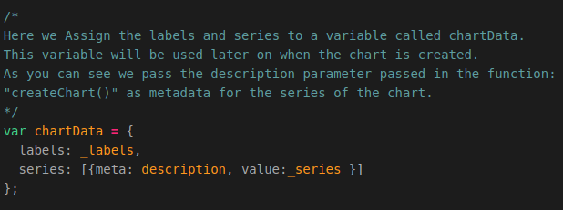
Now we need to create the properties the chart is going to have. The code for this is shown in the illustration below.
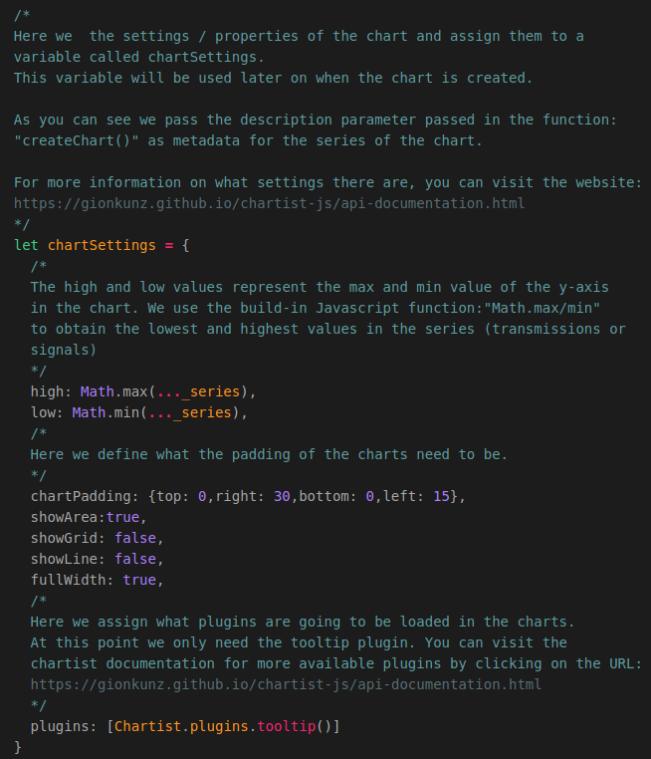
Now we have to make sure a line or bar chart is created when calling the function: “createChart()”. The code for this is shown in the illustration below.
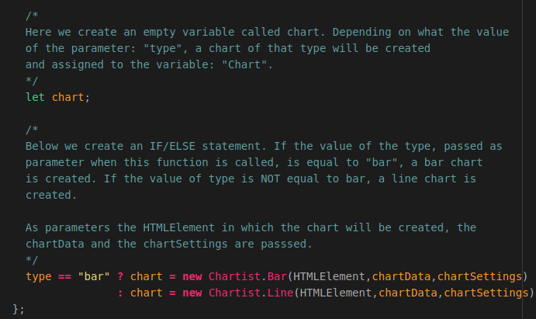
Finally we have to make sure the Charts are created and filled with data when the dataset dashboard is loaded. Since we are going to create a Line Chart for the trackers in the database, we are going to add some code to the function: “getTrackers()”.
The line we are going to add is show in the illustration below.

The following applies to the code shown above:
- The type of chart that will be created is a linechart.
- The list of data that is going to be passed is the list of trackers obtained from the datastore.
- The name of the column that represent the names of the trackers is called: “name”.
- The name of the column that represent the amount of transmissions belonging to a tracker is called: “transmission_Count”.
- The HTMLElement in which the chart will be created has the id: “#craneChart”.
- The description that will be shown in the tooltip is: “Transmissions:”

The final code of the getTrackers() function will be the same as shown in the illustration below:
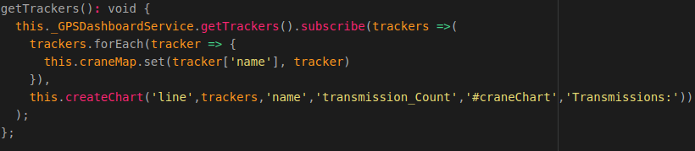
Now we need to do the same for the trails and the amount of signals belonging to a trail. To do this we need to add the following line of code to the function: “getTrails()”.
The following applies to the code shown above:
- The type of chart that will be created is a barchart.
- The list of data that is going to be passed is the list of trails obtained from the datastore.
- The name of the column that represent the names of the trails is called: “abr”.
- The name of the column that represent the amount of signals belonging to a trail is called: “t_points”.
- The HTMLElement in which the chart will be created has the id: “#trailChart”.
- The description that will be shown in the tooltip is: “Signals:”
The final code of the getTrails() function will be the same as shown in the illustration below:
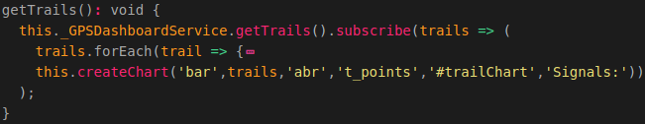
Now when we save the code and go to our web application we will not see any charts yet. For this to change we need to add the HTML code for the charts. So we need to add both charts to the layout of our dashboard which is specified in the file gpsdashboard.component.html.
First we want to add a new div element with the classname: “row”. In this div element we are going to add the 2 charts. We do this because we want the charts to be displayed next to each other (in a row).

The HTML code for the tracker Line Chart is shown in the illustration below.
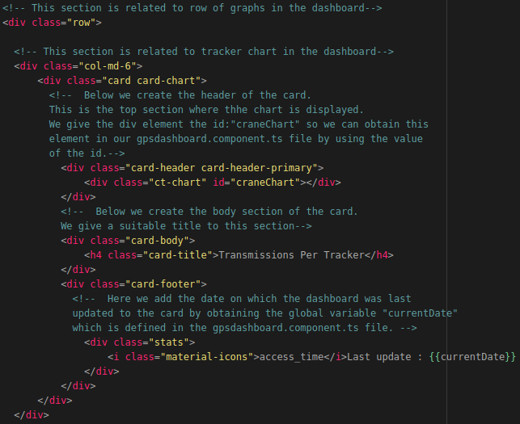
The HTML code for the trail barchart is shown in the illustration below.
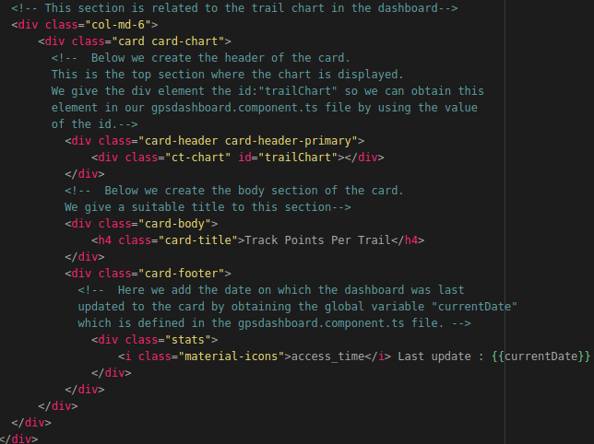
Now when we save the HTML file and reload the application we will be greeted by 2 charts displaying the data from our datastores.
NOTE: The Flask-API and the MongoDB datastore have to be running for the application to show the data.

Creating an interactive table
Now we want to create a table which shows detailed information related to the items and trackers. This table is going to be interactive and contains 2 tabs. One tab for the trackers in the datastore and one tab for the trails in the datastore.
The final result when the tracker tab is selected will look the same as shown in the illustration below.
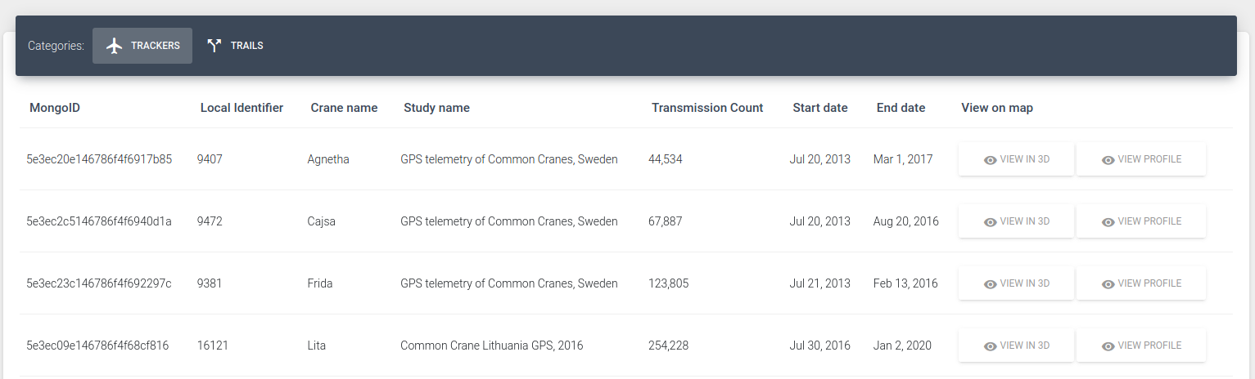
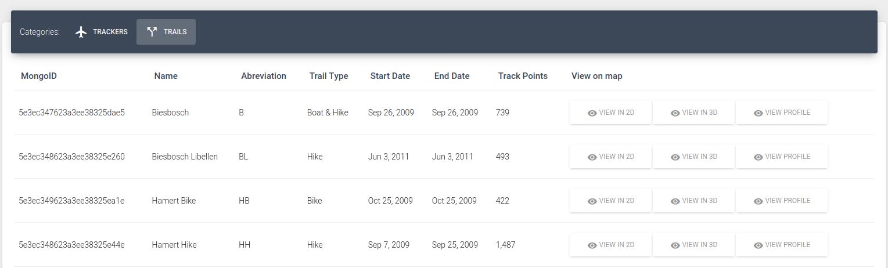
The final result when the trail tab is selected will look the same as shown in the illustration below.
First we want to create the header of the table (card) so we can switch between tabs. To create the header we need to add the following code to our gpsdashboard.component.html file.
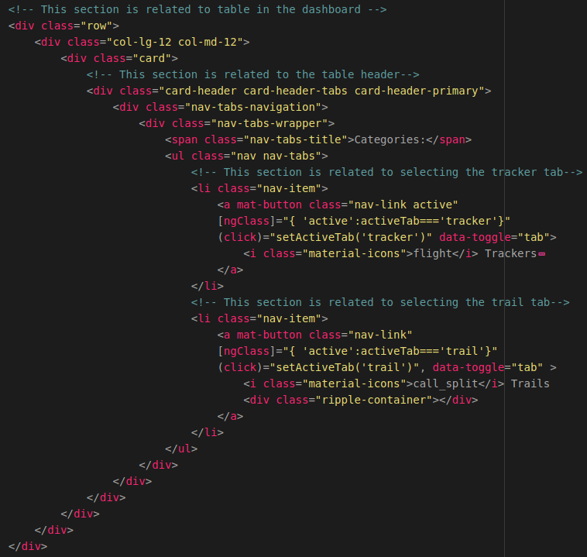

Now when we reload the application we are greated with the header of the table that contains 2 buttons. The problem is that we cannot click on these buttons yet. For this to be possible we need to add some code to our gpsdashboard.component.ts file.
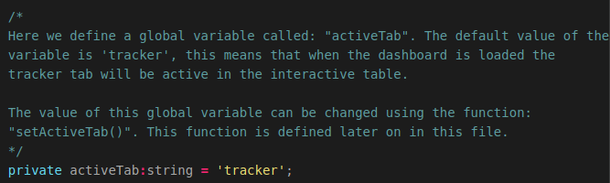
We need to create a global variable called activeTab. This global variable will have a default value of ‘tracker’, which means that the tracker tab is active when the dashboard is loaded. The code for defining this variable is shown in the illustration below.

Now we need to create a function which sets the value of the global variable: “activeTab” to the value passed in this function. The function we are going to create is called: “setActiveTab()”. In this function we pass the name of the tab that needs to be activated. The code required to create this function is shown in the illustration below.
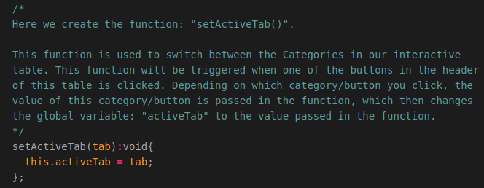
Now when we save the file an reload the application we can switch between the categories/tabs in the interactive table.
At this point we only have the header of our table. Now we want to fill the body of the table with the data obtained from our MongoDB datastore.
So let’s create the body of the table which will contain all the data related to the selected category/tab. For this we need to add some code to the gpsdashboard.component.html file.
First we want to add the column names of the tables by adding the following HTML code:
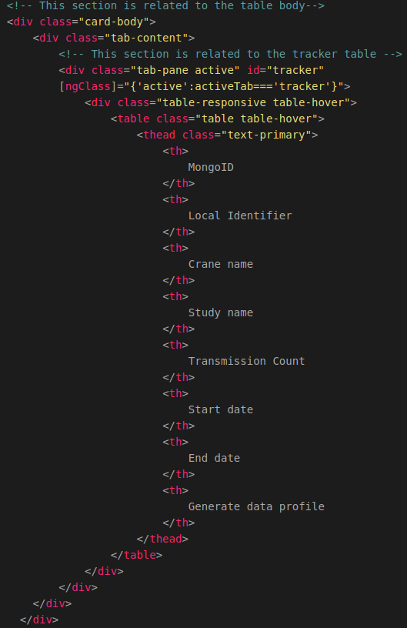

Now we want to add the data to these columns. For this we need to add the following code beneath the HTML tag </thead>. Note the </thead> tag is also included in this illustration, you do not add this tag again.
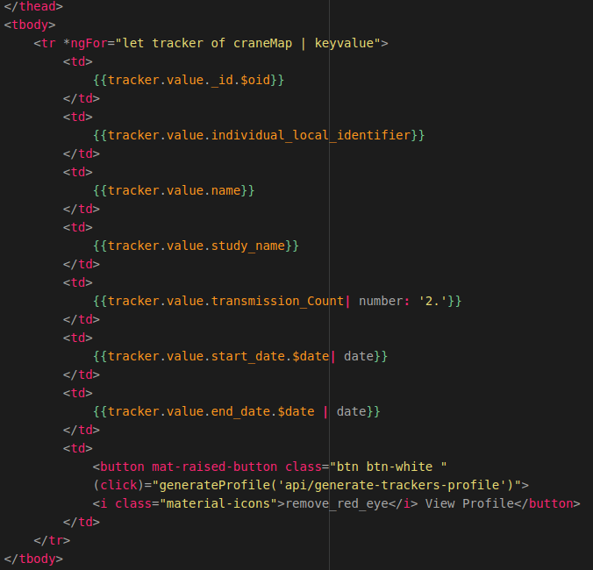
Now we have a table filled with data related to the trackers in the database.
Now we want to do the same for the trails.
Again, we first want to add the column names of the table for the trails. We do this by adding the following code to the HTML file.
We add the code below the closing div element representing the tab for the trackers.
The code for this is shown in the illustration below.
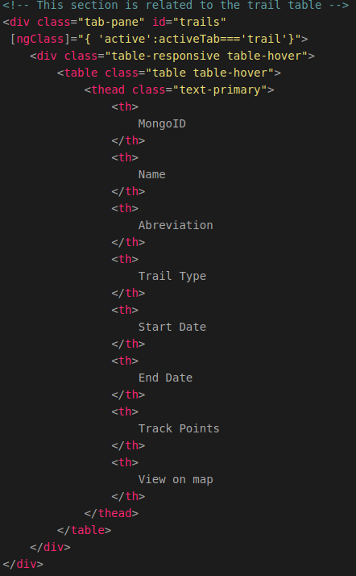

Again, we want to add the trail data to these columns. To be able to do this we add the following code below the </thead> tag in our HTML file.
NOTE: just like before, the </thead> tag is included in the illustration, so don’t add this tag again.
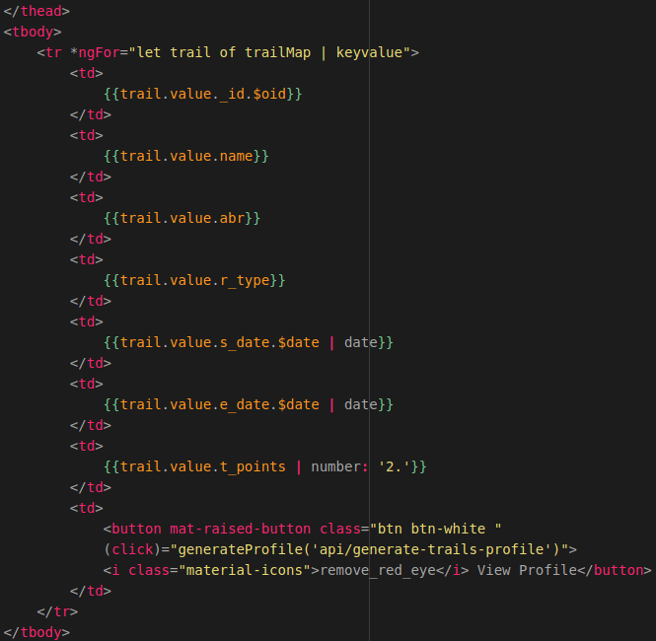

Generating pandas data profile
The last functionality we are going to add is the ability to generate data profile using Pandas Profiling. This function will be triggered when clicking on the button: “generate profile”, in the interactive table.
The function then performs an API request to the URL bound to the function in our Flask-API which creates a data profile. The code for creating this function is shown in the illustration below.
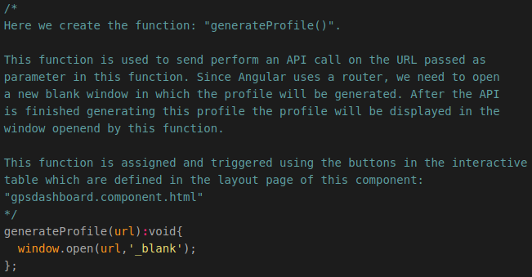
That’s it! When you click on the button generate profile in the interactive table, the Flask-API will generate a data profile belonging to the tracker from which you clicked the button as shown in the illustration below.
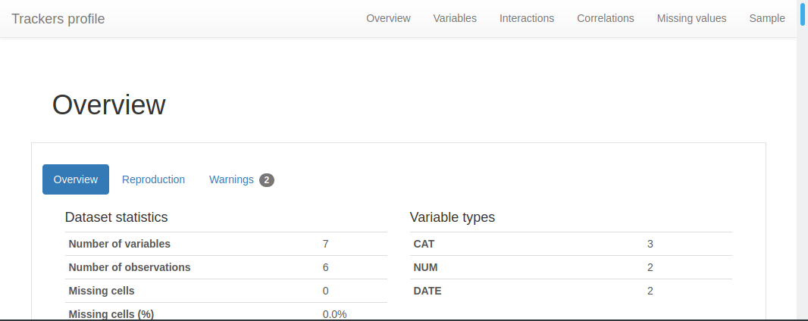
That’s it! You now have created your own Dataset Dashboard web application in Angular!
In the next programming manual you will learn how to create a 2D Map Viewer web application to visualize the data displayed in the dataset dashboard on 2D topographical base maps from OpenStreetMap using the geospatial framework: “OpenLayers”.

