

Cookbook

Creating the GeoStack
Workshop VM
Creating the GeoStack
Workshop VM

Version : 1.0

Date :24-09-2020

Author :The GeoStack Project

License :CC BY 4.0
Open Content License
This work is licensed under the Creative Commons Attribution 4.0 International License.
To view a copy of this license, visit http://creativecommons.org/licenses/by/4.0/ or send a letter to Creative Commons, PO Box 1866, Mountain View, CA 94042, USA.
Purpose of this document
This cookbook serves as manual for installing the GeoStack workshop Virtual Machine.
The GeoStack Workshop is the first study step of The GeoStack Project. In the workshop you will learn the basics about most of the components used in the full Geostack Course that follows.
At the end of this workshop you will have knowledge on the following subjects:
- Data analyses and processing of GPS datasets from GPS trackers and Navigation devices.
- Modeling and importing data in a MongoDB data store.
- Querying data using a Flask-API .
- Creating a Tileserver to generate topographical base maps using OpenStreetMap data.
- Creating a NGINX web server as the central hub to connect all the GeoStack components.
- Creating a web application for visualizing Geospatial data on a 2D map from OpenStreetMap using the Geospatial framework OpenLayers.
As mentioned before, the workshop is an introduction to this ‘Beginner Course in Open Source Geospatial Programming’. During the complete course you will learn much more about the subjects mentioned above and among other things subjects such as:
- Using a PostgreSQL data store to generate your own topographical maps.
- Creating a secure NGINX web server using ModSecurity for web apps to get the data.
- Creating a Dataset Dashboard to get a view on the datasets in the database.
- Creating a fully functional 2D Map Viewer using OpenLayers for ‘flat’ topographical maps.
- Creating a 3D Map Viewer using Cesium for topographical map projections with heights!
- Creating Docker-containers and volumes to virtualize each of the Geostack Components.

Prerequisite for the Workshop are as follows:
- A laptop with an Active Internet network-connection.
- 25GB of free space on you hard drive.

You are going to start of by installing VirtualBox on your host system and once you have VirtualBox installed you are going to create a new Virtual Machine running Ubuntu Linux.
- In that VM you are going to install the software and tools for the workshop using the installation scripts provided in the GitHub repository called: “GeoStack-Workshop”.
- You are going to clone this repository after the workshop’s Virtual Machine is created.
Table of Contents
1 Installing VirtualBox 4
1.1 Installing VirtualBox on Windows 4
1.2 Installing VirtualBox on Linux 7
1.2.1 Installing VirtualBox version 5.X 7
1.2.2 Installing VirtualBox version 6.X 8
1.3 Installing the VirtualBox Extension Pack 9
1.3.1 Using the terminal 9
1.3.2 Downloading from the website 10
1.4 Downloading an Ubuntu ISO file 11
2 Installing the GeoStack workshop Virtual Machine 12
2.1 Creating the Virtual Machine in VirtualBox 12
2.2 Installing the Ubuntu ISO 15
2.3 Connecting the Virtual Machine to the network 20
2.4 Creating a shared folder 21
2.4.1 Installing the required packages 21
2.4.2 Installing the VirtualBox Guest Additions 22
2.4.3 Adding a Shared Folder 25
2.5 Installing the GeoStack Workshop Software and Datasets 27
2.5.1 Cloning the Workshop GitHub Repository 27
2.5.2 Introduction to the Crane and Car Datasets 27
2.5.3 Downloading the Crane Datasets 28
2.5.4 How to run the Installation Scripts! 32
2.5.5 Running the Workshop Installation Scripts 32
3 Managing Virtual Machines in VirtualBox 36
3.1 Starting and Stopping a Virtual Machine 36
3.2 Exporting a Virtual Machine to an OVA file 38
3.3 Importing an OVA file 39
3.4 Increasing available RAM for the Virtual Machine 42
3.5 Increasing the Video Memory for the Virtual Machine 42
3.6 Creating and Using Snapshots of your Virtual Machine 43
4 Useful tips and tricks for Ubuntu Linux 46
4.1 Managing the Login Screen and Lock Screen 46
4.2 Manually updating Ubuntu using the CLI 47
4.3 Manually updating Ubuntu using the GUI 48
4.4 Cleaning the system 49
4.5 Adding shortcuts to the Favorites menu 49
4.6 Clipboard sharing between Host and Guest 50
4.7 Drag and Drop between Host and Guest 50
4.8 Installing the text editor LibreOffice Writer 51

Installing VirtualBox
VirtualBox can be installed on both Windows and Linux. This chapter describes how you should go about installing the VirtualBox software on both operating systems. Afterwards we will download and install the VirtualBox extension pack. The extension pack extends the functionality of VirtualBox base packages.

Installing VirtualBox on Windows
To be able to run VirtualBox on Windows you first have to make sure that:
- Virtualization technology VTx support is turned ON in the BIOS of your system. Read the manual of your BIOS to find this setting.
- Hyper-V support is turned OFF in the Windows Features settings of your Windows Host Operating System.
  - NOTE: Hyper-V is required for Docker to run on your HOST system!
If you have Docker already running on your system then VirtualBox will not work because Docker and VirtualBox can not run at the same time.
The reason is that Docker uses a Hyper-V VM to run on Windows and VirtualBox uses another VM sandbox system that both need the VTx functions from the hardware. Because these VTx functions can not be shared the user has to turn Windows Hyper-V support On or Off depending on which software needs to run.

To turn off Hyper-V in your Windows system you have to perform the following steps:

- Press the Windows key + X and select ‘Apps and Features‘:


- Scroll down to the bottom and click ‘Programs and Features’:


- Then click on ‘Turn Windows features on or off’ on the left

- Locate Hyper-V in the screen that pops up and uncheck it.


- Click on OK to save the changes and reboot the system.

NOTE 1: this option will not uninstall Hyper-V, but disable the feature temporarily.
NOTE 2: it will be enabled automatically after the installation of crucial Windows Updates!
- Source: https://ugetfix.com/ask/how-to-disable-hyper-v-in-windows-10/

Now that we have disabled Hyper-V we can start with the installation process of VirtualBox by performing the following steps:
- First we need to download the VirtualBox executable for the installation program. This is can be downloaded via the following link: https://www.virtualbox.org/wiki/Downloads
- Select Windows hosts under the section: “VirtualBox binaries”. This will open a download pop-up. Click on save file.

- When the executable is finished downloading you click on this .exe file to start this installation program. Then you get the screen on the right to click ‘Next >’ to continue.
 | 

- During the installation wizard, you’ll get a Network Interfaces warning. Click Yes to proceed.

- On the next screen, click Install to begin installing the program.

- When prompted with a message to install (Trust) Oracle Universal Serial Bus, click Install to continue and wait for the installation process to finish.

That's it! Now you first need to install the VirtualBox Extension Pack as explained in section 1.3 and then you can create a new Virtual Machine as explained in chapter 2.

Installing VirtualBox on Linux
The process for installing VirtualBox in Linux is a lot easier than on Windows. You can choose whether you want to use the version provided by the Ubuntu package repository. This is VirtualBox version 5.X. You can also install the latest version of VirtualBox which is version 6.X. This is done by adding a Personal Package Archive (PPA) repository from the VirtualBox Project to the systems software repository list. This enables the system to install the latest VirtualBox version and check for updates for this version.
Both installing VirtualBox V5 and V6 are described below.

Installing VirtualBox version 5.X
The installation of VirtualBox 5.X is done by opening a Terminal program (Ctrl + Alt + t) and running the following commands:
- Update the local package database.
sudo apt update
- Upgrade the local package database.
sudo apt upgrade
- Install the VirtualBox package
sudo apt install virtualbox
- Open VirtualBox by entering the command: virtualbox in the terminal or by simply clicking on the shortcut which was created.

That's it! Now you first need to install the VirtualBox Extension Pack as explained in section 1.3 and then you can create a new Virtual Machine as explained in chapter 2.

Installing VirtualBox version 6.X
The installation of VirtualBox 6.X is done by opening a Terminal program (Ctrl + Alt + T) and running the following commands:
- Update the local package database.
sudo apt update
- Upgrade the local package database.
sudo apt upgrade
- Add the signing keys from the VirtualBox website.
wget -q https://www.virtualbox.org/download/oracle_vbox_2016.asc -O- | sudo apt-key add -

wget -q https://www.virtualbox.org/download/oracle_vbox.asc -O- | sudo apt-key add -
- Add the repository to the repositories list.
sudo add-apt-repository "deb [arch=amd64] http://download.virtualbox.org/virtualbox/debian $(lsb_release -cs) contrib"

- Update the local database again.
sudo apt update
- Install the VirtualBox package
sudo apt install virtualbox-6.0
- Open VirtualBox by entering the command: virtualbox in the terminal or by simply clicking on the desktop shortcut which was created.

That's it! Now you first need to install the VirtualBox Extension Pack as explained in section
1.3 and then you can create a new Virtual Machine as explained in chapter 2.

Installing the VirtualBox Extension Pack
Installing the VirtualBox Extension Pack allows you to use advanced VirtualBox features.
The VirtualBox extension pack adds support for USB 2.0 and USB 3.0 devices, VirtualBox RDP, disk encryption, NVMe and PXE boot for Intel cards.
For more information related to the VirtualBox extension pack you should visit the URL: https://www.virtualbox.org/manual/ch01.html#intro-installing
Installing the VirtualBox Extension Pack can be done in 2 ways:
- The first way is by downloading and installing it via the terminal. If you have installed VirtualBox Version 5.X in Linux it’s recommended to install the extension pack in this way.
- The second way is by downloading the extension pack from the official VirtualBox website. If you installed Version 6.X in Linux it’s recommended to install the extension pack in this way.

Using the terminal
When installing VirtualBox 5.X in Linux you need to install 2 extra packages. These packages are as follows:
- The VirtualBox extension pack by using the command: sudo apt install virtualbox-ext-pack
- The VirtualBox Guest Additions ISO by using the command:
sudo apt install virtualbox-guest-additions-iso
If the installation process is finished you can go to File → Preferences → Extensions in your VirtualBox window and you should see something similar to the illustration below.


NOTE: the window in your version can look a little different so don’t worry about that!

Downloading from the website
First you need to download the VirtualBox extension pack. We do this by going to the following URL: https://www.virtualbox.org/wiki/Downloads.
Beware to download the version of the extension pack which is the same as the version of your VirtualBox software. Check the exact VirtualBox version number by starting the VirtualBox application and then in the Help menu click the menu option 'About VirtualBox'. Now let’s start the installation process of the VirtualBox extension pack by performing the following steps:

- In the VirtualBox start screen go to file → preferences.
- Go to extension and then click on the browse button to find the download for the extension pack.

- When prompted enter the password of the Linux account to authorize the software installation.
NOTE: After entering one character a screen can pop up showing the installation progress bar. You first have to minimize this pop up before entering the rest of the password.
That’s it! Now you have VirtualBox with the extension pack running on your system! Now we have to create a new Virtual Machine and install Ubuntu.

Downloading an Ubuntu ISO file
The Beginners Course Open Source GeoSpatial Programming for Data Scientists was created using Ubuntu 18.04. As of April 16, 2020 Ubuntu 20.04 LTS (Long Term Support) has been released. This version has been tested and can also be used during The Beginners Course Open Source GeoSpatial Programming for Data Scientists although the illustrations used in the documents are created using Ubuntu 18.04.
Before we can continue the installation process of the Virtual Machine we first need to download an Ubuntu ‘ISO’ file which is a file in the standard ISO 9660 CD image file format!
This can be done by clicking on the following URL: https://ubuntu.com/download/desktop
When on the website you should get the option to download the Long Term Support Ubuntu version which is version 20.04 as of April 16, 2020. This can be done by clicking the green Download button as shown in the illustration below.
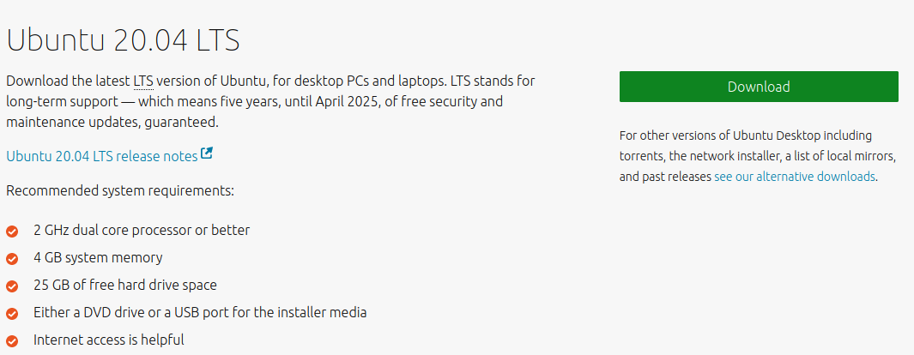
You also have the option to download the previous LTS version which is version 18.04. This can be done by navigating to the following URL:
https://ubuntu.com/download/alternative-downloads
Then scroll down until you see the screen as shown in the illustration below and then click on the button encircled in red in the illustration below:
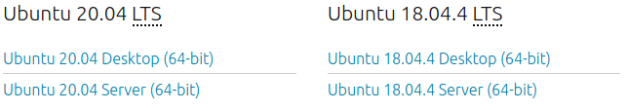
NOTE: During this cookbook we are going to use the Ubuntu 18.04 LTS version. You can also use Ubuntu 20.04 if you prefer this version. If you choose 20.04 some steps, described in this cookbook, are a bit different.

Installing the GeoStack workshop Virtual Machine
At this point you have VirtualBox on your system. Now we need to install the GeoStack workshop virtual machine. To be able to install the Workshop VM we first need to create a new Virtual machine. After we have created the Virtual Machine we are going to install an Ubuntu ISO file.

Creating the Virtual Machine in VirtualBox
Creating a Virtual Machine is done by performing the following steps:
- Click on the button: “New” in the VirtualBox start screen.

- Give the Virtual Machine a suitable name in this case we give it the name: “GeoStack-Workshop-VM”. Choose the folder to save the VM files and set the Type and Version!
Tip: create your own folder for VM files, like /home/vm/geostack

- Assign the amount of RAM you want the machine to use. The minimal amount of RAM is 1 GB (1024MB) for a VM. If your PC has enough RAM the advice is to assign 3 GB (3072 MB) or 4 GB (4096 MB) RAM because Ubuntu will use up to 2 GB (2048 MB) already for itself.


- Select: “Create a virtual hard disk now” and then click the Create button.


- Set hard disk file type to VDI (Virtual Disk Image).


- Select allocate disk space dynamically (Dynamically allocated). Tip: choose fixed disk size if performance matters to you.
- Select the location where you want to store the Virtual Disk Image file (.vdi file). In the perspective of managing your Virtual Machines, it’s useful to create a centralized folder on your host system in which you create your VM’s. The folder name could for example be called: “ VirtualBox_VMs”. This folder can also be used to store files such as an ISO file and the VirtualBox Extension Pack file. Then set the size of the hard disk to a minimum of 20 GB. The reason to set a large disk size of 20GB is because increasing the disk size of a VDI file later is a tricky process! Finally click the Create button to create the VDI file.



- Select the Virtual Machine 'GeoStack-Workshop-VM' by clicking on the VM's name so it highlights in blue if it is not already highlighted. Then click the icon with the green "Start" arrow to start the Virtual Machine in VirtualBox.



- Select the Ubuntu ISO file you have downloaded in section 1.3 as the start-up disk for the Virtual Machine by clicking on the yellow folder icon on the right to browse and select the ISO file and then click the Start button to load the ISO file into the Virtual Machine.



At this point you should read section 3.1: “Starting and stopping a Virtual Machine” in which you will learn how to correctly start and stop and Ubuntu Virtual Machine. After you have read section 3.1 you should come back to read from here on.

Installing the Ubuntu ISO
- Once the ISO file is loaded, click the button "Install Ubuntu".

- Select the keyboard layout. This depends on your preferences. For example choose US (English) - English (US, euro on 5). Then click the button Continue.

- Select “Minimal installation” which will only install the base software of the Ubuntu Installation. For more information related to a minimal Ubuntu installation you should visit the following URL: https://wiki.ubuntu.com/Minimal.

- Select ‘Erase disk and install Ubuntu’.
- IMPORTANT NOTE: ‘Erase disk’ will only erase the disk space of the Virtual Hard Drive that is present in the Virtual Disk Image file (.vdi file) of the Virtual Machine, the menu option will NOT erase the physical disk of your host operating system, so don't worry!

- Click the button Continue.

- Select a location for the timezone which will be used in your VM so it’s recommended to choose a city in the timezone of your current location. Then click the button Continue.


- Enter the same information as in the image below. The field: ‘’Your computer’s name” is automatically set to: “geostack-VirtualBox” instead of: “geostack-System”. If you want you can keep the default system’s name. The password of the VM has to be set to geostack. You can also choose one yourself but then you will have to use that password when you are asked to fill in the password: “geostack” during the workshop. When selecting login automatically, you will not have to login while starting the VM, however when the VM goes to the lock-screen you will still have to enter the password: “geostack”. If you choose to use another password you will have to change geostack with the password you chose.

- Wait until the installation is finished. The process takes about 5 minutes depending on your network connection speed and you will see informational screens as shown below.
After the installation process is completed 6GB of additional disk space is used.

- Press the button ‘Restart Now’ which will automatically reboot the Virtual Machine.

- When the system is rebooted the following screen will appear, asking you to remove the installation medium. Since this is a Virtual Machine we don’t need to remove any installation medium so we can Press the Enter key to continue the reboot process when prompted with the text 'Please remove the installation medium, then press ENTER:'

- After pressing enter you should wait for a few seconds after which you will automatically be logged in to the Ubuntu Virtual Machine. If you want to go back to controlling your host system you can press the Right Ctrl + the Host key on your keyboard. This will open the selection menu at the top of your VirtualBox window.
NOTE: It’s possible that the screen stay’s black after pressing ENTER on you’re keyboard. The reason for this is a bug in the snap server deamon in combination with the Linux kernel mostly in Ubuntu versions earlier than 19.10 as described here:
https://askubuntu.com/questions/1147756/a-start-job-is-running-for-wait-until-snapd-is-fully-seeded . There is a workaround for the Ubuntu 18.04 LTS version used in the workshop in 5 simple steps:

  - First wait for about 3 - 5 minutes until the blinking 'LED' in the blue disk icon stops blinking.

  - Then in the Machine menu click the menu option ACPI Shutdown. In a flash you see the warning message indicating the bug: A start job is running for wait until snapd is fully seeded.

  - After that restart the Virtual Machine again with the green Start icon.
Then install the software updates manually as described in section 4.2: “Manually updating Ubuntu using the CLI” and reboot again.

  - If the reboot gives a black screen again then simply shutdown via the menu option Machine / ACPI Shutdown for the second time and start the VM again.
Now all Power Offs, Shutdowns and Reboots should work normally.


- Some screens will pop up in the Virtual Machine. In these screens you are able to select settings related to telemetry services, automatic updates and privacy settings. These screens differ per Ubuntu version. When selecting the settings you have to make sure that you don’t send any system info.
In Ubuntu 19.10 and 20.04 you should perform the following steps. Click Skip to close the pop-up window Online accounts. Then check No, don't send system info in the next pop-up window Help improve Ubuntu and click Next. In the next screen Welcome to Ubuntu leave the Privacy slider switch for Location Services turned off and click Next. Finally close the pop-up window Ready to go by clicking Done.
- Sometimes after a little while an Ubuntu Installer screen pops up asking you to install software updates, click the button "Remind Me Later" to skip the installer update. Install the updates of the software packages in the usual way as described in the next step (14). The pop-up screen is shown in the illustration below.

- Now update the software packages in the usual manual way either from the command line in the Terminal application or with the Ubuntu Software Updater application.
- Now go to section 4.2: “Manually updating Ubuntu using the CLI” or section 4.3: “Manually updating Ubuntu using the GUI” to learn and run the update commands!
- This is important to learn because Ubuntu automatically checks and shows a notification message if manual software updates need to be run in order to keep the computer up-to-date and safe!

- OPTIONAL: in the following chapters you are asked multiple times to open a terminal by pressing the keyboard shortcut combination ‘Ctrl + Alt + T’ on your keyboard.
- You can also add the terminal shortcut to the favorites menu in your Ubuntu system, and open the terminal by clicking this shortcut instead.
- How to add the shortcut to your favorites menu is described in section 4.5 of this cookbook.

At this point we have a fully functional Ubuntu Virtual machine. In section 2.7 we are going to install the GeoStack Workshop software and content using the installation scripts provided in the Github Repository called: “GeoStack-Workshop”. We are going to clone this repository later!

At this point you should read section 4.1: “Managing the Login Screen and Lock Screen” in which you will learn what to do when your virtual machine screen automatically goes black after 5 minutes because the Ubuntu Lock Screen is activated as a security precaution.

The reason you should now disable the Ubuntu lock screen is that you will constantly encounter the lock screen while doing the workshop assignments because you often will need more reading time than the 5 minute lock time period which will result in a decreased workflow speed in the workshop.

After you have read section 4.1 and disabled the lock screen you should come back to this page and start reading from here on to continue with the workshop in the next section!

Connecting the Virtual Machine to the network
After you have started the GeoStack workshop virtual machine you should first check if the virtual machine has a network connection. This is done by performing the following steps:
- First check if the network connection in the HOST Operating System of your computer.
- Now check in your Guest OS of the Virtual Machine if your internet network connection is working by opening a terminal (ctrl + alt + t) and entering the command: ping 8.8.8.8. This command will send packets to the Google DNS server (8.8.8.8). This process will only work if you have an active network connection.
Let this command run for 3 seconds and then press ctrl + c to stop the pinging. The output should be similar to the one shown in the illustration below.

If the output is the same as the illustration below, we need to connect the Virtual machine to a network-connection.
I
Connecting a Virtual Machine to a network is done by performing the following steps:
- Open the Virtual machine settings at the top of the screen.
- Go to the network settings and check the box: Enable Network Adapter and at “Attached to” select NAT (Network Address Translation) in the drop down box, as shown in the illustration below.

- Redo the previous steps to check if your internet connection is working. If it is you can move on to step 3. If it doesn't work you should consult the internet.

Creating a shared folder
A shared folder is used to transfer files from your host system to your Virtual Machine. To be able to create a shared folder we first need to install some missing software required for creating a shared folder between our host system and our virtual machine (guest system). These packages are GCC, Perl, Make and DKMS. There is a possibility that one or more of these packages are already installed on your system. We run the following steps to make sure these packages are installed and up to date. After installing these packages we need to install the Guest Additions ISO. Then we need to create the shared folder by linking a folder from our Host system to our Guest system. After the folder had been created, we need to grant this folder permissions to be able to access the folder.

Installing the required packages
We start of by installing some packages which are required to install the VirtualBox Guest Additions. This is done by performing the following steps:
  - Open a Terminal windows by pressing the key combination: Ctrl + Alt + t on your keyboard.
  - Then run the command: sudo apt install gcc perl make dkms
  - Enter the password: “geostack”, when prompted.
  - Type y and press ENTER to let the install process finish. This process will take about 2 minutes to complete. If the packages are already installed you will see a message that the newest version is already installed.

  - When the installation process is finished you can close the terminal by entering the command: exit.

Installing the VirtualBox Guest Additions

Introduction
Now you are going to install the VirtualBox Guest Additions. These Guest Additions are required to create shared folders, enable full screen mode etc.
For more information related to the VirtualBox Guest Additions you should visit the URL:
https://www.virtualbox.org/manual/ch04.html

The Oracle VM VirtualBox Guest Additions for all supported guest operating systems are provided as a single ‘CD disk’ ISO image file which is called: VboxGuestAdditions.iso
This ISO image file is located in the installation directory of Oracle VM VirtualBox. To install the Guest Additions for a particular VM, you mount this ISO file in your VM as a virtual CD disk and install it from there.

Important Notices when installing the Guest Additions ISO file
IMPORTANT NOTICE 1: before installing the Guest Additions ISO file you first have to increase the video memory setting for the Virtual Machine!
- How you do this is explained in section 3.5 “Increasing the Video Memory for the Virtual Machine”.
- If you forget to do this now, then you will get a black screen in the VM window after installing the Guest Additions ISO file, after which you still have to increase the video memory as instructed in section 3.5!
- After increasing the video memory setting you of course will have to restart the VM for the new memory allocation settings to take effect.

IMPORTANT NOTICE 2: it’s possible if you did not follow this cookbook in the correct sequence that the Guest Additions ISO file has already been mounted during the installation process of the VM which results in an error when you try to install the Guest Additions ISO file again.
- If this is the case you will get an error in step 1 in the instructions below.
- This ‘already mounted’ error because the ISO image is seen as a ‘locked disk drive’, is as follows: Unable to insert the virtual optical disk /usr/share/virtualbox/VBoxGuestAdditions.iso into the machine GeoStack-Workshop-VM. Could not mount the media/drive '/usr/share/virtualbox/VBoxGuestAdditions.iso' (VERR_PDM_MEDIA_LOCKED).
- To solve this you open File / Virtual Media Manager / Optical Discs / Click Guest Additions ISO and Click Release icon to detach the ISO from the VM.

Installation Guidelines
So now install the VirtualBox Guest Additions ISO file in your Virtual Machine by performing the following 4 steps:

- At the top of the VirtualBox window, click the Devices menu and then click the last menu option 'Insert Guest Additions CD image.



- Click the button ‘Run’ when the pop-up window appears as shown in the image below.


- Enter the password: “geostack”.


- Wait until the installation process is finished and then close the terminal by clicking on the terminal window and pressing Enter.
- The installation process takes about 1 minute to complete.
- Ignore the message in the terminal window about restarting to load the new kernel module that was compiled for the Guest Additions CD image because we will reboot the VM in the next step.



Note: remember if you get a black screen in the VM window you have forgotten to increase the VM video memory first, as explained in section 3.5 “Increasing the Video Memory for the Virtual Machine”!

Adding a Shared Folder
Now let’s add a shared folder by performing the following steps:
- First create a folder on your HOST system. You can name the folder whatever you like but it’s useful to give it a name related to the project you are currently working on. In this example we are going to name the folder: “TGP” which stands for The GeoStack Project.

- After you have created the folder on your HOST system you should go to back to your Virtual Machine and select the following at the top of the Virtual Machine window: machine → settings → shared folders → press the Add button which will then open a popup screen.

- Select the path to where you created your folder (TGP in this case) on your host system as folder path:
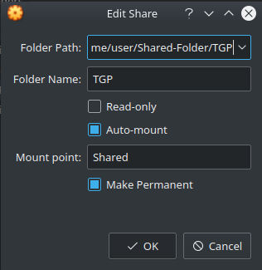
  - The folder name should be automatically filled in.
  - Select auto mount.
  - Depending on you VirtualBox version, you should get the option: Mount point. You only get this option when you are running VirtualBox version 6.X. Set the mount point to: “Shared” in case you are using Vbox V6.
  - Select make permanent. This option automatically mounts the folder when the system is rebooted.
  - Press OK twice to close the windows.

- To be able to use the shared folder without having to enter a password every time we want to open the folder. We do this by opening a terminal by pressing the keys Ctrl + Alt + t (This is a keyboard shortcut for opening the terminal) on your keyboard and entering the command: sudo usermod -aG vboxsf geostack

The command: “usermod” is used to add the geostack user to the VirtualBox user group for the shared folders (the vboxsf group) . This is done by adding the flag -aG ( -aG = add to Group) to the command.
- To load the new usermod setting, reboot the virtual machine by entering the command: reboot
NOTE: You can also reboot the system by clicking the pull-down menu arrow at the upper right on the Ubuntu taskbar at the top of the Ubuntu desktop and there click the Power button and finally click Restart in the pop-up window.

- Now the shared folder is available in the Ubuntu VM and can be accessed with the Nautilus file manager which can be started by clicking the file cabinet icon in the left Favorites menu. In Ubuntu 18.04 LTS the folder icon looks the same as shown in the illustration below.


- When clicking on this icon a screen will open from which you can access the shared folder by clicking on the sf_TGP entry in the left pane of the Nautilus file manager as shown in the illustration below. Note: The sf_ stands for Shared folder.



- Create a Desktop Shortcut for the Shared Folder in Ubuntu 19.10 and 20.04 can be done by running the following command: ln -s /media/sf_TGP ~/Desktop
The shared folder is /media/sf_TGP which is mounted on a different partition (/media) than the home folder for accounts (/Home/{account name}) so we don't get a 'Copy to...' menu option in the pop-up menu on a right mouse click on the shared folder in the Nautilus file manager. Therefore the desktop shortcut needs to be created from the terminal as a symbolic link (symlink).
Note: when placing a file in a shared folder from either the Guest OS or the Host OS first refresh the screen in the Nautilus file manager by pressing F5 or changing to another folder and then back if you don't see the file or if menu options like 'Move to trash...' are missing from the pop-up menu if you right-click a file with the mouse.
Note: also be aware that a shared folder does not have a Trash Can folder, so when you click on 'Move to trash...' for a selected file, this will result in a pop-up window with an error message 'Unable to find or create trash directory for /media/sf_TGP/filename.extension'. You can only permanently delete the selected file from the shared folder by clicking the red 'Delete' button in the pop-up window.

Installing the GeoStack Workshop Software and Datasets
In this section you are going to clone the GeoStack-Workshop repository from GitHub, download the crane datasets from Movebank and run the installation scripts for the GeoStack Workshop.

Cloning the Workshop GitHub Repository
You start by cloning the Github repository which contains the GeoStack Workshop files to our Virtual Machine. This is done by performing the following steps:
- Open a terminal by pressing the Ctrl + alt + t on your keyboard.
- Install GIT by using the following command: sudo apt install git
- Clone The GeoStack-Workshop Github repository by running the following command:
git clone https://github.com/The-GeoStack-Project/GeoStack-Workshop.git
The output of this command should be similar to the one shown in the illustration below:
The download process takes about 10 seconds to complete and uses around 60MB of disk space. If everything works accordingly you should end up with a folder called: “GeoStack-Workshop” in your home directory of your virtual machine.
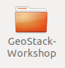

Introduction to the Crane and Car Datasets
In the workshop you will be using 2 types of datasets during the GeoStack workshop. Crane datasets in CSV files from a GPS Tracker on the legs of ringed crane birds (Grus grus) and Car route datasets (Trails) in GPX files from a GPS navigation device.
- The GeoStack Project is the owner of the GPS Car route datasets so they are already provided in the GeoStack-Workshop folder that you downloaded in the previous chapter.
- The GeoStack-Workshop folder contains a sub-folder called: “GeoStack-Workshop-Content” which in turn contains a sub-folder called: “Workshop-Datasets” in which you can find the GPS Car route datasets which are GPX files from a GPS navigation device.
- The CSV folder is empty since The GeoStack Project doesn't own the rights of the Crane (GPS Tracker) datasets. Therefore you need to download these crane datasets yourself and accept the content licenses of the dataset owners that come with them.

The crane datasets are hosted for the dataset owners by Movebank: https://www.movebank.org
- The Movebank Data Repository contains published data sets of animal movement data in the Movebank format. The datasets you download are in the CSV file format.
- This is distinct from the main Movebank tracking database, in which users control access and are responsible for their data quality and this is also where most data are stored.
- To be published in the Movebank Data Repository, a dataset in Movebank undergoes an official review process and, when accepted, is granted a unique identifier (DOI) and content license after which the dataset is made publicly available.

Downloading the Crane Datasets
The way you are going to download the Crane (GPS Tracker) datasets is by navigating to the Movebank website in your web browser and downloading the complete datasets.
The download procedure is described in the steps below.
- Navigate to the Movebank downloading page: https://www.movebank.org/panel_embedded_movebank_webapp

- In the search field type: “grus grus” as the scientific latin name for a crane as shown in the illustration below and then and click on the Search button to list the crane projects:

- Scroll down till you find the entry : “GPS telemetry of Common Cranes, Sweden” as shown in the illustration below:

- Click on the Plus sign in front of that crane project in the list to expand the search results.
- Select the check box of the crane with the ID-number : 9381

- Click on the information icon and then click on Download Search result:

- Click on I agree in the screen that pops up:


- Click on Download in the screen that pops up:

- A Screen will pop up asking you to save the file. Select Save File and click on OK as shown in the illustration below to save a crane GPS tracker dataset as a CSV file:

- Now that you know how to download a Crane Tracker dataset you should repeat step 5, 6, 7, 8 and 9 on the Crane Tracker datasets with the id’s 9407 and 9472 as shown in the illustration below:

- After you have downloaded the 3 datasets you will end up with 3 CSV files in your download folder as shown in the illustration below:
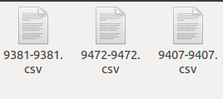
- The last thing you need to do is to rename the files to something logical that is human readable and copy them to the correct place in our system.
- Currently the file names of the downloaded files are the GPS Tracker ID’s which you will replace by a much longer descriptive file name so you know what the content is!
- Example: the file name for the crane dataset with the Tracker ID: “9381” will become:
“20181003_Dataset_SV_TrackerID_9381_ColorCode_RRW-BuGBk_Crane_Frida.csv”.
- The filename starts with the inverse date notation of when the dataset was uploaded on the MoveBank website, so the publication date of 10-03-2018 becomes 20180310.
- Then _Dataset_SV_ to know it’s a dataset file and the 2-character country code to know it’s a Swedish crane. Then the crane’s GPS Tracker ID, ring color code for the left and right legs and the name of the crane follow.
- The crane with Tracker ID “9381” was named “Frida” for the purpose of the workshop and the color code sequence of the rings on left and right legs the crane was ringed with is coded in a standard way as RRW-BuGBk for Red Red White - Blue Green Black.
- To rename and copy all the datasets to the correct place we should run following commands from a terminal:
  - Note: to continue typing a long command in the terminal type a ‘\’ (backslash) character at the end of the line, press Enter and continue typing on the next line so type the commands on 3 lines as shown below!

For the Crane with the Tracker ID: “9381”:
cp ~/Downloads/9381-9381.csv \ ~/GeoStack-Workshop/Geostack-Workshop-Content/Workshop-Datasets/CSV/\20181003_Dataset_SV_TrackerID_9381_ColorCode_RRW-BuGBk_Crane_Frida.csv
For the Crane with the Tracker ID: “9407”:
cp ~/Downloads/9407-9407.csv \ ~/GeoStack-Workshop/Geostack-Workshop-Content/Workshop-Datasets/CSV/\20181003_Dataset_SV_TrackerID_9407_ColorCode_RRW-BuGY_Crane_Agnetha.csv
For the Crane with the Tracker ID: “9472”:
cp ~/Downloads/9472-9472.csv \ ~/GeoStack-Workshop/Geostack-Workshop-Content/Workshop-Datasets/CSV/\20181003_Dataset_SV_TrackerID_9472_ColorCode_RRW-BuGR_Crane_Cajsa.csv

If everything is done as instructed above you should end up with the following 3 datasets in the folder “GeoStack-Workshop/GeoStack-Workshop-Content/Workshop-Datasets/CSV” as shown in the image below.
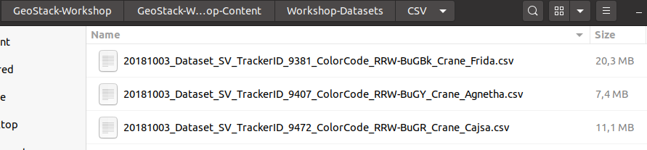

IMPORTANT NOTE: before continuing make sure the names of the files match the ones in the illustration above! Otherwise installation scripts you run later will fail!

How to run the Installation Scripts!
Now that you have the necessary files and datasets on our Virtual Machine you can start the installation process but first we need to clear some things up.
IMPORTANT NOTE: installing the software automatically, using the installation scripts, does not mean you don’t have to pay attention to what is happening!
Once in a while you are asked for some input such as changing default passwords, accepting updates and adding package sources to our system’s sources list. The following should be done in those cases:

- Password prompt enter the password: geostack
- Accepting updates by entering: y
- Adding packages to the source list of software repositories: press ENTER

Now that is cleared up we can start installing the software. The folder: “Installation-scripts”, contains 8 scripts. The backend, middleware and frontend software each has it’s own installation script.

Running the Workshop Installation Scripts
Now let’s start with the execution of the installation scripts:
- Close all windows and open a new terminal by pressing the keys Ctrl + Alt + T on your keyboard.

- Then run the first script by entering the command:
bash ~/GeoStack-Workshop/Installation-scripts/1-pre-reboot.sh
This script will do the following:
- Update Ubuntu Linux: always start by updating the operating system!
- Install Bleachbit: a cleaning application to remove obsolete files.
- Install net-tools: the base networking utilities for Linux; used to check the availability of network ports for the assignments.
- Install Python3 and Python3-pip: the Python shell and Python package installer.
- Install Atom: a programming editor.
- Add the sidebar shortcuts which we are going to need during the workshop.
After the completion of this script the system will reboot for the updates to take effect. This script takes around 10 minutes to complete depending on the speed of you network-connection. After the script is complete 2GB of additional disk space is used.

- After the reboot open the terminal again and enter the command:
bash ~/GeoStack-Workshop/Installation-scripts/2-post-reboot.sh
This script will do the following:
  - Copy the desktop shortcuts to the correct place.
  - Create file links on the desktop so you can easily access the workshop folders.
This script will make sure all the folders and shortcuts are placed in the correct place and takes about 2 minutes to c7omplete. After the script is complete no additional disk space is used.

- Now when that script is done and no errors were encountered we can move on to the script, for installing the data-analyses software required for performing the data analyses in part 1 of the workshop, by running the command:
bash ~/GeoStack-Workshop/Installation-scripts/3-data-analysis-software.sh
This script will do the following:
  - Install JupyterLab: a desktop app to run Python code from Jupyter Notebook files.
  - Install Pandas: a Python library for data analysis that uses tables and time lines.
  - Install Cartopy and MathPlotLib: Python libraries for simple maps, plots and graphs.
  - Install GPXPy: a Python library for GPX file parsing.
This scripts takes about 10 minutes to complete depending on the speed of your network-connection. After the script is complete 1.4GB of additional disk space is used.

- Now when that script is done and no errors were encountered we can move on to the next script, for installing the backend software required to store all the data in part 2 of the workshop, by running the command:
bash ~/GeoStack-Workshop/Installation-scripts/4-backend-software.sh
This script will do the following:
  - Install MongoDB: a schemaless No-SQL database server for JSON documents.
  - Install MongoCompass: a desktop app that is MongoDB’s database manager tool.
  - Add the new sidebar shortcuts.
  - Install MongoEngine: a third party Python library as an Object-Document Broker framework to access databases and JSON documents in MongoDB.
  - Clean up unnecessary files.
This scripts takes about 10 minutes to complete depending on the speed of your network-connection. After the script is complete 1GB of additional disk space is used.

- Now when that script is done and no errors were encountered we can move on to the next script, for importing all the datasets in the correct datastores, by running the command: bash ~/GeoStack-Workshop/Installation-scripts/5-dataset-import.sh
This script will do the following:
  - Import the Crane (Tracker) datasets in MongoDB.
  - Import the GPS-Route (Trail) datasets in MongoDB.
  - Copy the workshop Part 1 datasets to the correct location on the system.
  - Copy the workshop Part 2 datasets to the correct location on the system.
This script is used to import all the data which can be used in case something goes wrong during part 2 of the workshop. The script takes about 4 minutes to complete and an additional disk space of 200MB is used.

NOTE: During the import process the VM can become slow. Don’t worry about this!
The reason for this is because the MongoDB import scripts use a feature called: “bulk import”. This feature adds all the data at once. This makes the import process a lot faster but can take up a lot of RAM which results in a slower VM (temporarily).

- Now when that script is done and no errors were encountered we can move on to the next script , for installing the middleware software required for part 3 of the workshop, by running the command:
bash ~/GeoStack-Workshop/Installation-scripts/6-middleware-software.sh
This script will do the following:
  - Install Python-Flask: a Python framework to program Micro Web Services.
  - Install Flask-Pymongo: a Python wrapper for Flask apps to the Pymongo driver.
  - Install Gunicorn3: a Python web server to run Flask WSGI web applications.
  - Install TileStache and Pillow: a Python tile server for topographical map tiles and a Python Imaging Library.
  - Install NGINX: a web server for web apps and a proxy server for upstream servers.
This scripts takes about 10 minutes to complete depending on the speed of your network-connection. After the script is complete 1.2GB of additional disk space is used.

- Now when that script is done and no errors were encountered we can move on to the next script , for installing the frontend software required for part 4 of the workshop, by running the command:
bash ~/GeoStack-Workshop/Installation-scripts/7-frontend-software.sh
This script will do the following:
  - Install NodeJS: an application server for JavaScript and TypeScript applications.
  - Install the Angular CLI: the Command Line Interface (shell) for Angular commands.
  - Install the Node Modules for the web applications: JavaScript libaries for NodeJS.

NOTE: During the execution of this script you are asked to share anonymous usage data with the Angular Team at Google under Google’s Privacy Policy. Select No and press enter in all cases.
During the script you will also see some NPM warnings. Don’t worry about these warnings. These security / update warnings are normal when installing Angular Node modules. If you want to find more information related to updating Angular modules, you should follow the complete GeoStack course.

This scripts takes about 3 minutes to complete depending on the speed of your network-connection. After the script is complete 300MB of additional disk space is used.
- Now when the previous script is done and no errors were encountered we can move on to the last script which removes all the unused packages and clears the temporary files. We do this by running the command:
bash ~/GeoStack-Workshop/Installation-scripts/8-post-installation-cleanup.sh
This script takes about 3 minutes to complete and clears about 700MB of disk space. After this script is complete the total size of the Virtual disk will be around 8.7 GB
- If you are on Ubuntu 19.10 or 20.04 you need to allow the desktops shortcuts to be executable. This is done by right-clicking a desktop shortcut and then selecting the menu option ‘Allow Launching’ in the menu that pops up as shown in the illustration below:

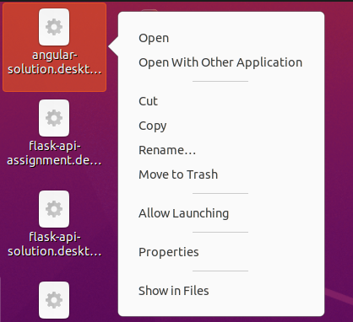

- After the last script is finished running you will end up with a lot of shortcuts on your desktop. You should organize the desktop icons in the same way as shown in the illustration below. This is done by dragging and dropping the shortcuts in the correct position and will result in a better workflow.
Note: This screenshot was created using Ubuntu 20.04.
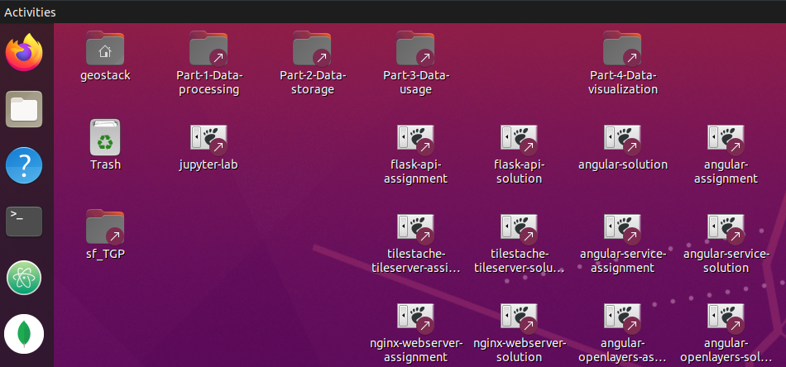
That’s it! When the last script is finished you can start the Workshop by reading the PDF called: “Cookbook-Workshop-Assignments.pdf”.
- This document contains all the instructions for the programming assignments which you have to complete during the GeoStack Workshop.
- The document can be found in the root folder of the GeoStack-Workshop folder which you downloaded at the beginning of section 2.5.

Managing Virtual Machines in VirtualBox
The easiest way to get a Virtual Machine up and running is by using .OVA files. The easiest way to backup and distribute your Virtual Machines as one (1) file for easy portability is to export your Virtual Machine with its Virtual Disk Image to what is called an OVA file (Open Virtualization Archive).
An OVA file is an Open Standard in the Open Virtualization Format (OVF) to package an entire VM into a single file. It can be used by virtualization applications such as Vmware Workstation and Oracle VM Virtualbox.
You also have the option to export a separate human readable Manifest companion file for the OVA file with its description and some meta data.
You can also include the ISO image files of the Operating System and the Guest Additions into the OVA file for easy backup or to let another person reuse the same ISO images.
Creating an OVA file is also done as a way to make a snapshot of a VM to freeze it's contents to preserve a state of installation or use.
NOTE: Make sure you have enough disk space!
It’s also possible to import and export .ova files in VMWare. The instructions on how to do this can be found by clicking on the following URL:
https://pubs.vmware.com/fusion-5/index.jsp?topic=%2Fcom.vmware.fusion.help.doc%2FGUID-275EF202-CF74-43BF-A9E9-351488E16030.html
Tip: when working in development teams, think about the password management of the Linux account of the Virtual Machine. If you distribute your Virtual Machine as an OVA file to someone else then depending on your security requirements either hand over the password of the user account of the VM in a secure way or if security is not an issue put the password in a README.txt file that you distribute with the OVA file or even make it very easy by making the password the same as the account name!

Starting and Stopping a Virtual Machine
Starting a Virtual Machine is a straight forward process. After you have created a new virtual machine you should highlight it by left clicking the Virtual Machine you want to start in the left sidebar menu of the VirtualBox start screen as shown in the illustration below:
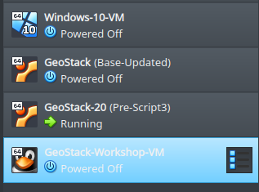
Then click on the green arrow in the top bar of the VirtualBox start screen as shown in the illustration below. This will start the selected Virtual Machine.
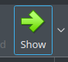
Stopping a Virtual Machine is a process that differs per operating system that is installed in the guest virtual machine. There are multiple ways in which you can shut down a virtual machine.
The best method to ensures no errors are encountered, is by always shutting down the guest operating system of the VM first (!), instead of closing down the VirtualBox window while the guest operating system is still running, which would be the virtual equivalent of pulling the plug from the power source!
In Ubuntu 20.4 you should shutdown the virtual machine by performing the following steps:
- Click on the small downward pointing arrow to the right of the battery icon at the top right side of the Ubuntu Virtual Machine window to get the pull-down menu.
Then click on the “Power Off / Log Out” menu option to open the “Power Off / Log Out” menu as shown in the illustration below in step 2:
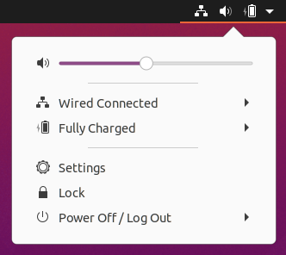
- Then click on “Power Off...” menu option in the drop down menu as shown in the illustration below:
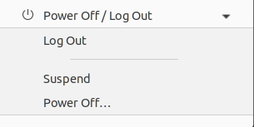
- Finally click the “Power Off” button in the pop-up as shown in the illustration below:
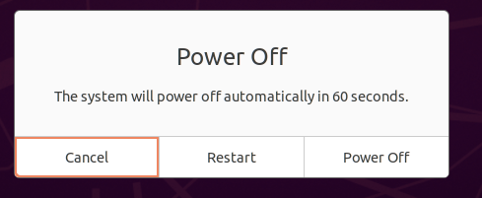
This will result in a clean shutdown of your Ubuntu guest operating system without encountering any errors.
Now you can also close the VirtualBox window without letting the VM crash!

Exporting a Virtual Machine to an OVA file
To export a Virtual Machine to a .OVA file you have to perform the following steps:
- In the VirtualBox window click on file → preferences → export appliance.
- Select the Virtual Machine which you want to export. In this case it’s the GeoStack workshop Virtual Machine.

- Set the settings to be the same as in the illustration below and click on next.

- Check if the Name of the Virtual Machine is correct and click on export.

- Let the export process finish. This process takes about 10 minutes.

- Now you will have an OVA file which can be easily distributed.



Importing an OVA file
To import a Virtual Machine using a .OVA file you have to perform the following steps:
- In the VirtualBox window click on file → preferences → import appliance.


- Click on the folder icon.


- Navigate to the folder in which you saved the .ova file which was exported in the previous section and click on open.


- Click on next.

- Change the settings where you find necessary and click on import.


- Wait till the import process is finished. This will take about 3 minutes to complete.

- That’s it, now you have the full Geostack as Virtual Machine on you system. You can start the Virtual Machine by selecting it and pressing the green arrow at the top of the VirtualBox screen.


Increasing available RAM for the Virtual Machine
If you have decent laptop you can always increase the amount of RAM that the Virtual Machine can use. By doing this the Virtual Machine will work faster en smoother.
To increase the amount of RAM that can be used by the Virtual Machine you have to perform the following steps:
- Shut down your Virtual Machine.
- In the VirtualBox start screen go to settings → system and increase the amount of RAM used by the VM.


Increasing the Video Memory for the Virtual Machine
Setting the Video Memory to the maximum amount of 128 MB will ensure smooth screen handling by VirtualBox and prevent black screens or slow screen redraws when resizing the window of the Virtual Machine. To fix this you need to perform the following steps:
- Shut down your Virtual Machine.
- In the VirtualBox start screen go to settings → display.
- Increase the Video Memory and toggle the Enable 3D and 2D acceleration boxes on.

You can also check the acceleration check boxes. For Linux as Host OS only check 'Enable 3D Acceleration'. For Windows as Host OS also check 'Enable 2D Video Acceleration'. If checked under Linux this 2D option will give the warning 'Invalid settings detected' as shown in the screen image below.

Creating and Using Snapshots of your Virtual Machine
Creating Snapshots: one very useful feature in VirtualBox is the ability to create snapshots of your Virtual Machines! As the name indicates, snapshots can be seen as backups or checkpoints of your current virtual machine’s state. See it as ‘Easy Freezing’ to save different VM versions!
Of course you need (lots of) disk space but it is ideal when experimenting because if something goes wrong you can easily revert your VM back to one of the previously made snapshots!
Snapshots can also very convenient in case you want to test new software in your virtual machine!
For example: if you want to know which tileserver fits your software stack best you can choose between the software products combination of NGINX with TileStache or Apache with mod-tile.
Before installing any of the software products you should create a snapshot of the current virtual machine’s state which you could name: “snapshot-pre-software-install”. Then you install NGINX in combination with TileStache after which you create a new snapshot of the system (now with NGINX and TileStache installed) which you could then name: “snapshot-post-nginx-tilestache”.
Then you can covert back to the snapshot named: “snapshot-pre-software-install” and install the software products Apache and mod-tile after which you create a new snapshot which you could name: “snapshot-post-apache-mod_tile”.
This will result in the following snapshot scheme:
snapshot-pre-software-install
snapshot-post-nginx-tilestache
snapshot-post-apache-mod_tile

You can switch back and forth between the created snapshots whenever you desire. This is very useful if you want to work with two system’s with a similar software base stack.
IMPORTANT NOTICE: Always shutdown your Virtual Machine before creating a snapshot!
Creating a snapshot after the VM shutdown is done by performing the following the following steps:
- Highlight the Virtual Machine from which you want to create a snapshot as shown in the illustration below:
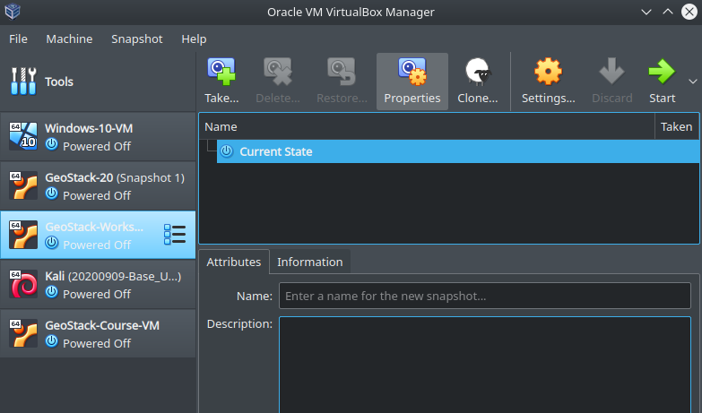
- Then select Snapshot --> ‘Take...’ at the top of the screen as shown in the illustration below:
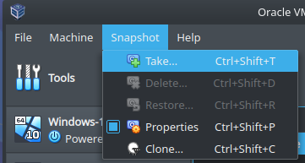
- Now enter the name of the Snapshot.
Tip: Give the snapshot a name which describes the current state of the virtual machine. For example: The VM which was highlighted while making the illustrations was a fresh and updated installation of the GeoStack-Workshop VM. We should also add the date of when the snapshot was taken to the name. So in this case the name was set to: “20201014-snapshot-fresh-and-updated-installation”. You can also add a description of the snapshot. After you have entered the name and description you should press on “OK” at the bottom of the pop-up screen as shown in the illustration below:
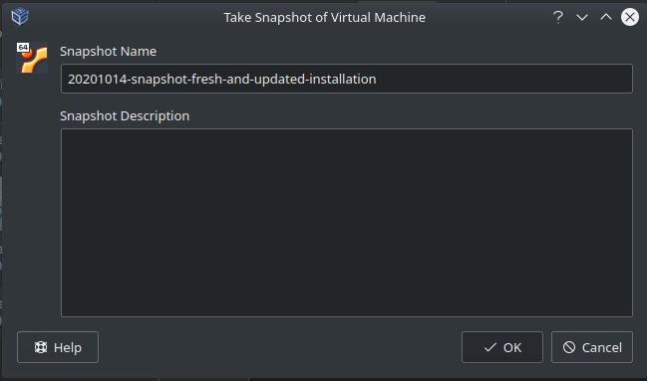
- As you can see in the illustration below (encircled in red) a snapshot has now been created:
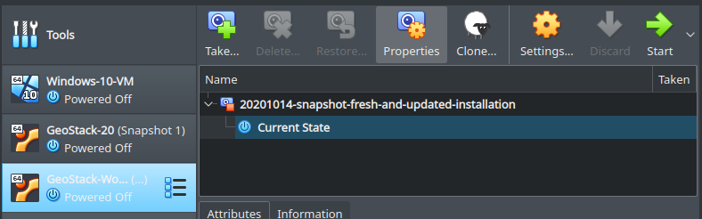
- Now you can start the Virtual Machine as usual by pressing the green arrow.

Using Snapshots: now let’s say that you did something in the Virtual Machine which resulted in a system crash or you want to get rid of software you tested. Then it is very easy to revert back to a previously created snapshot (= checkpoint) of your VM by performing the following steps:
- First shut down the virtual machine.
- Then select the previously taken snapshot to which you want to revert as shown below:
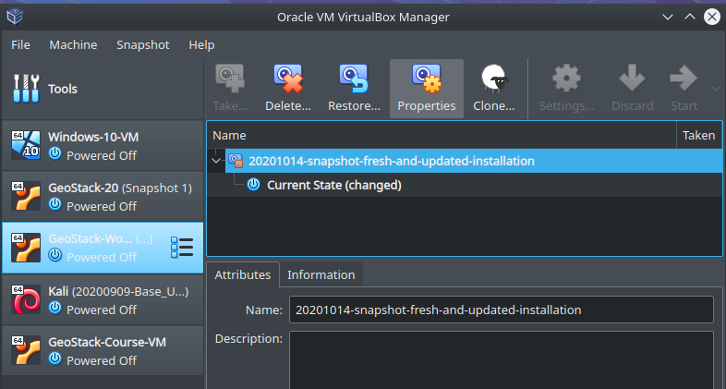
- Next click on Restore as shown in the illustration below:
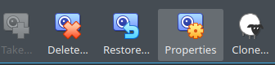
- Now you can choose to also create a new snapshot of the current system’s state from which your are now going to revert back to keep for later re-use!
This is done by clicking the check box: ‘Create a snapshot of the current machine state’.
If you have the scenario of a crashed VM or corrupted software then uncheck this box.
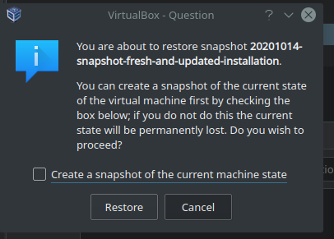
- Finally click the Restore button to finish reverting back to the selected previous snapshot.
That’s it! Now you have reverted back to a working snapshot you created earlier as a backup!

Useful tips and tricks for Ubuntu Linux
In this chapter some useful tips and tricks are discussed. These tips and tricks can increase the workflow during and after the workshop.

Managing the Login Screen and Lock Screen
While working with the operating system of Ubuntu Linux you will encounter the “problem” of your system automatically locking itself for security purposes to avoid unauthorized access when left unattended.
This happens when you are inactive for a certain amount of time which is the count down timer setting for the lock time period that is set by default to a value of 5 minutes of inactivity.
When the lock time period has passed your virtual machine screen will then turn black, also as a Power Saving option, after which you have to fill in the password of your account to be able to access the desktop again.
- This can be quite annoying when reading the workshop cookbooks and then having to login every time when you want to continue working on the VM.
How to login again when the screen turned black, how to get the lock screen to appear and how to disable the lock screen setting or set a longer lock time period is described below.
If your system locks itself take the following steps to re-access the desktop again:
- The Ubuntu lock screen in Ubuntu 20.04 looks similar to the one shown in the illustration:
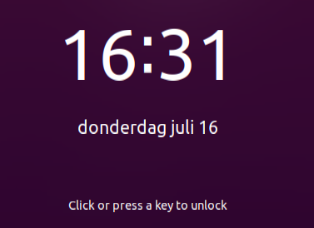
- When you see the lock screen, as shown in the illustration above, you should press a key on your keyboard or press the left / right button on your mouse. This will result in the following login screen on Ubuntu 20.04:
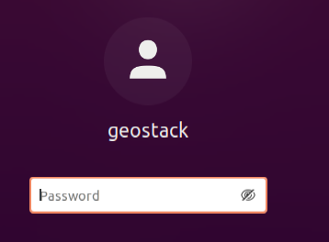
- Now enter the password: “geostack” to obtain access again to the desktop of your virtual machine’s operating system.
Disabling the lock screen can be done in the Ubuntu Settings menu in the Power Saving optioon by setting the lock time period for the Blank Screen by performing the following steps:

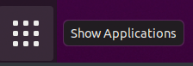
- Click the Show Applications icon in the Favorites menu on the bottom left of the desktop. The icon is shown in the illustration below.

- Enter: “Power” in the search box and select the Power setting as shown in the illustration.
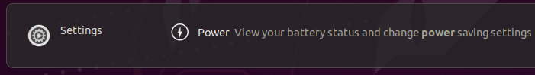

- Then select the drop down box next to: “Blank Screen” and set it to ‘Never’ as shown in the illustration below:

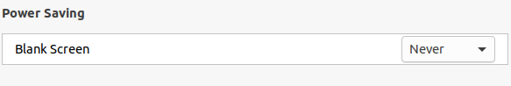

That’s it! Now you have disabled the Ubuntu lock-screen.
- Note: you could also choose to set a longer lock time period than 5 minutes if you want to keep the lock screen for security purposes.

Manually updating Ubuntu using the CLI
To manually update the Ubuntu system from the Command Line Interface (CLI) in a terminal using Linux commands in the Ubuntu bash shell. you should perform the following steps:

- Open a terminal by pressing the key combination: Ctrl + Alt + t on you keyboard.

- Retrieve the new packages and package updates by running the command: sudo apt update

- Update the system using the command: sudo apt upgrade

- Reboot the system for the updates to take effect by using the command: reboot

Manually updating Ubuntu using the GUI
To manually update the Ubuntu system from the Gnome Graphical User Interface (GUI) on the Ubuntu desktop. you should perform the following steps:


- Open the show application menu on the bottom left of the desktop. The icon is shown in the illustration below.

- Then select All at the bottom of the screen that pops up, as shown in the illustration below.

- Select the Software Update icon, as shown in the illustration below.

- Let the update search for updates as shown in the illustration below.

- Select: “Install Now” in the screen shown in the illustration below.


- Let the software updates finish as shown in the illustration below.


- When the screen in the illustration below is shown, the updates are successfully installed.



At this point you have a fully updated system and you can go back to what you were doing. Remember to redo this process once in a while to make sure your system is always up to date and the latest security patches have been installed.

Cleaning the system
If you want clean your system after installing updates, you can perform the following steps:
- Clean the unnecessary packages by running the command: sudo apt autoremove
- Clean the system’s memory and temporary files, using an application called: “Bleachbit”, by running the following command:
bleachbit --list | grep -E "[a-z0-9_\-]+\.[a-z0-9_\-]+" | grep -v system.free_disk_space | xargs sudo bleachbit --clean
This command first prints the available cleaning options, then it greps every option except for the free disk space option since this is unnecessary. Finally Bleachbit is executed using the selected options.

Adding shortcuts to the Favorites menu
During the installation scripts some shortcuts are added to the Favorites Menu on your Ubuntu system. If you want to do this manually you have to perform the following steps:
- Open the show application menu on the bottom left of the desktop. The icon is shown in the illustration below.
- Then select All at the bottom of the screen that pops up, as shown in the illustration below.
- Enter the name of the application, which you want to add to the menu, in the search bar as shown in the illustration below. In this example we are going to add the terminal to our Favorites menu.


- Right click on the terminal icon and select: “Add to Favorites” as shown in the illustration below.


Clipboard sharing between Host and Guest
If you want to copy/paste text between your Host and Guest system, you need to activate this option by going to Devices → Shared Clipboard at the top of the VirtualBox Window and selecting: “Bidirectional” as shown in the illustration below.


Drag and Drop between Host and Guest
If you want to drag and drop files between your Host and Guest system, you need to activate this option by going to Devices → Drag and Drop at the top of the VirtualBox Window and selecting: “Bidirectional” as shown in the illustration below.


Installing the text editor LibreOffice Writer
Because you installed the minimal version of the Ubuntu Linux distribution the office suite LibreOffice is not installed and it is required if you want to use the workshop's text editor and presentation files in their original file format to read or edit for your own purposes because that's why we included these source files along with their 'frozen content' versions in the PDF file format that you would normally use to follow the workshop.
The original source files are the ODT files (Open Document Text) from the text editor application LibreOffice Writer and the ODP files (Open Document Presentation) from the presentation application LibreOffice Impress.
To install the packages for the LibreOffice applications and help texts (this requires about 1 GB of disk space in total), open the Terminal application with the keyboard shortcut Ctrl + Alt + t and then use the following commands to install the basic version of LibreOffice (about 915 MB in disk size): sudo apt install libreoffice
To install the package with English help texts (about 32 MB in disk size) use either the command:
sudo apt install libreoffice-help-en-us (for help texts in English - American spelling)
or
sudo apt install libreoffice-help-en-gb (for help texts in Englis - Brittish spelling)
See the following weblink with instructions on how to install help text packages in other languages or other additional LibreOffice packages from the command line if you might need them:
https://wiki.ubuntu.com/LibreOffice
After the installation you will find the LibreOffice applications in the Show Applications menu (the nine-grey-squares icon at the bottom the Favourites menu at the left of the desktop screen) or double click an ODT or ODP file to open the corresponding Writer or Impress application respectively.

