**EGRE 364**

**Lab #8 Report**

**Date:**

12/5/2019

**Team Members:**

Dakota Bernacki

Jonathan O’Dell

## Introduction

Lab 8 is focused on creating a device that uses four digital IR reflectance sensors and an analog distance sensor to generate accurate readings and display their results on the STM32L4 Discovery board’s LCD. These sensors need to be calibrated to produce accurate readings and the LCD and ADC need to be properly setup to respectively receive and display the data.

## Design

The code associated with this project has been zipped and uploaded to Blackboard.

The file name is: Lab8_DakotaBernacki_JonathanO_Dell.zip

Primary files:

* main.c
* setupHeaders.h
* LCD_structures.h
* LCD_structures.c
* LCDinit.c
* ADCinit.c
* IRinit.c
* Sys_clk_init.c
* startup_stm32l476xx.s
* Pin_Connection.txt

See **Appendix A** for code snippets. [startup_stm32l476xx.s and Pin_Connection.txt excluded as they were provided as part of the project]

## Functionality and Correctness

**Correctness**

The STM32L4 Discovery board was correctly configured to receive data from four IR reflectance sensors and an analog distance sensor. These inputs were then displayed on the board’s LCD display for the user to read.

**Functionality**

**LCD:**

**KARA**

**IR Sensor:**

The QTR-1RC IR reflectance sensors communicate digitally with board. To determine their output the duration of their capacitor discharge must be measured and a threshold for said discharge determined. A single GPIO pin is used for each sensor; GPIOE 12-15 were used. At the beginning of each reading the pin is set as an output and asserted HI; this charges the sensor’s capacitor. After the capacitor is charged, < 10ms, the pin is changed to an input and the capacitor begins to discharge.

To ascertain the duration of this discharge a delay is implemented; the system will wait until the specified discharge duration threshold, in ms, is reached. At that time, the program reads each sensor’s input pin; if a sensor’s pin is high, then it is asserted that the reflectance being received is below the threshold range we set and therefore not reflecting. [B] Otherwise, it is above the reflectance range and is reflecting. [W]

**Distance Sensor:**

The Sharp GP2Y0A21YK0F distance sensor is analog, consequently the onboard ADC had to be utilized to read its output. The onboard ADC was setup on PA1 with a 10bit resolution, single conversion, using the 80MHz clock, with the conversion initiated via software.

Once the onboard ADC was properly initialized, several additional steps needed to be taken. First the value generated by the ADC needed to be converted from binary into a voltage. Then this value needed to be converted to a distance to be sent to the LCD. To accomplish the 1st step, the ADC output conversion formula from the textbook [pg????] was used:

Where is the number of result bits and is 3.0V when using the internal voltage reference.

This was then combined with the linear formula [see Plot #1] we generated based off the sensor’s datasheet. This resulted in the following equation:

Several linearizations of the sensor’s curve were experimented with but using the 30-80cm range to generate the equation got us the most accurate readings; once we tweaked it a little via experimentation.

Once the correct distance was calculated, it was then divided and modulus by 10 to separate it into its 10’s and 1’s place. Additionally, the distance was put into an if/else to determine what percentage of the sensor’s effective range was utilized and display it on the LCD’s bars. [100% = 0cm, 4bars lit: 0% = 80cm, 0 bars lit]

**Plot #1**

## Lab Demonstration

The aforementioned correct behavior was demonstrated to a TA, and he signed off on it at approximately 1320hrs 12/5/2019:

## Pre-lab assignment

Scanned pre-lab assignments:

Bernacki:

O’Dell:

## Post-lab assignment

1. Suppose the duty ratio of an LCD display is ¼ and has a total of 120 display segments. Howa many pins are required to drive this LCD:

**34pins are needed to drive the LCD**

1. For a 12bit ADC, the margin of error is found via:

Design and experiment to find an unknown Vref:

With this derived equation, a series of known voltages can be applied to the ADC input. For each of these voltages the returned ADC result can be plugged into the equation returning an approximation of the reference voltage.

At least five different voltages should be supplied the ADC and the resulting should be averaged to determine the actual .

1. What is the maximum distance your Distance Sensor can reliably detect an object:

This is HEAVLY dependent upon the size of the object and, to a lesser extent, said object’s reflectivity.

The sensor can reliably detect large objects up to distances around 90-100cm and, if the object is very reflective [bright white paper] sometimes beyond. However, a smaller object, like a finger, becomes hard for the sensor to pickup one it gets 60-70cm out. This is likely due, at least in part, to the difficulty of keeping said finger in front of the sensor’s aperture at such a range.

## Conclusions

All lab objectives were successfully achieved. The data from the IR reflectance sensors and the distance sensor was correctly calibrated and displayed on the STM32L4’s LCD.

Initially there was significant difficulty in getting the custom LCD bitmask to display the correct characters. After troubleshooting, it was discovered that the bitmask was written in reverse order and that the LCD RAM requires that all 32 bits, of a RRAM[x] section, to be written each time; we were only writing 4bit areas at a time.

There was also an error with the ADC initialization. Its resolution was mistakenly set to 12bits. This resulted in some very convoluted attempts to get the sensor reading accurately. Once the mistake was discovered, and the ADC set to use 10bits, our calculation to calibrate the sensor became much simpler and more accurate.

## Appendix A

**main.c:**

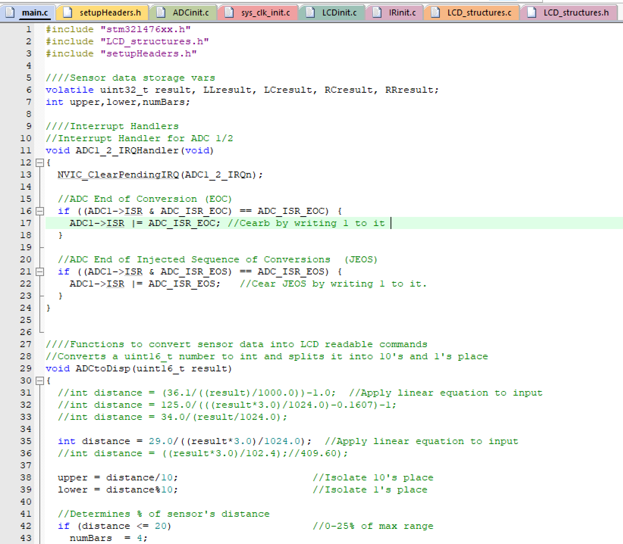

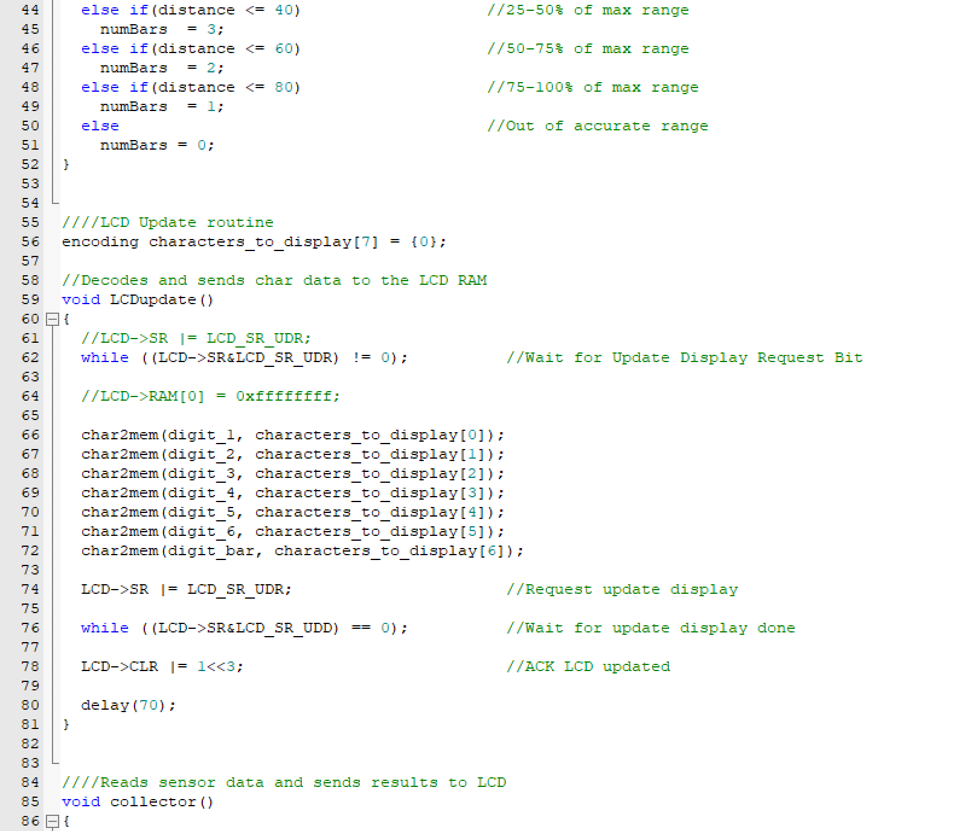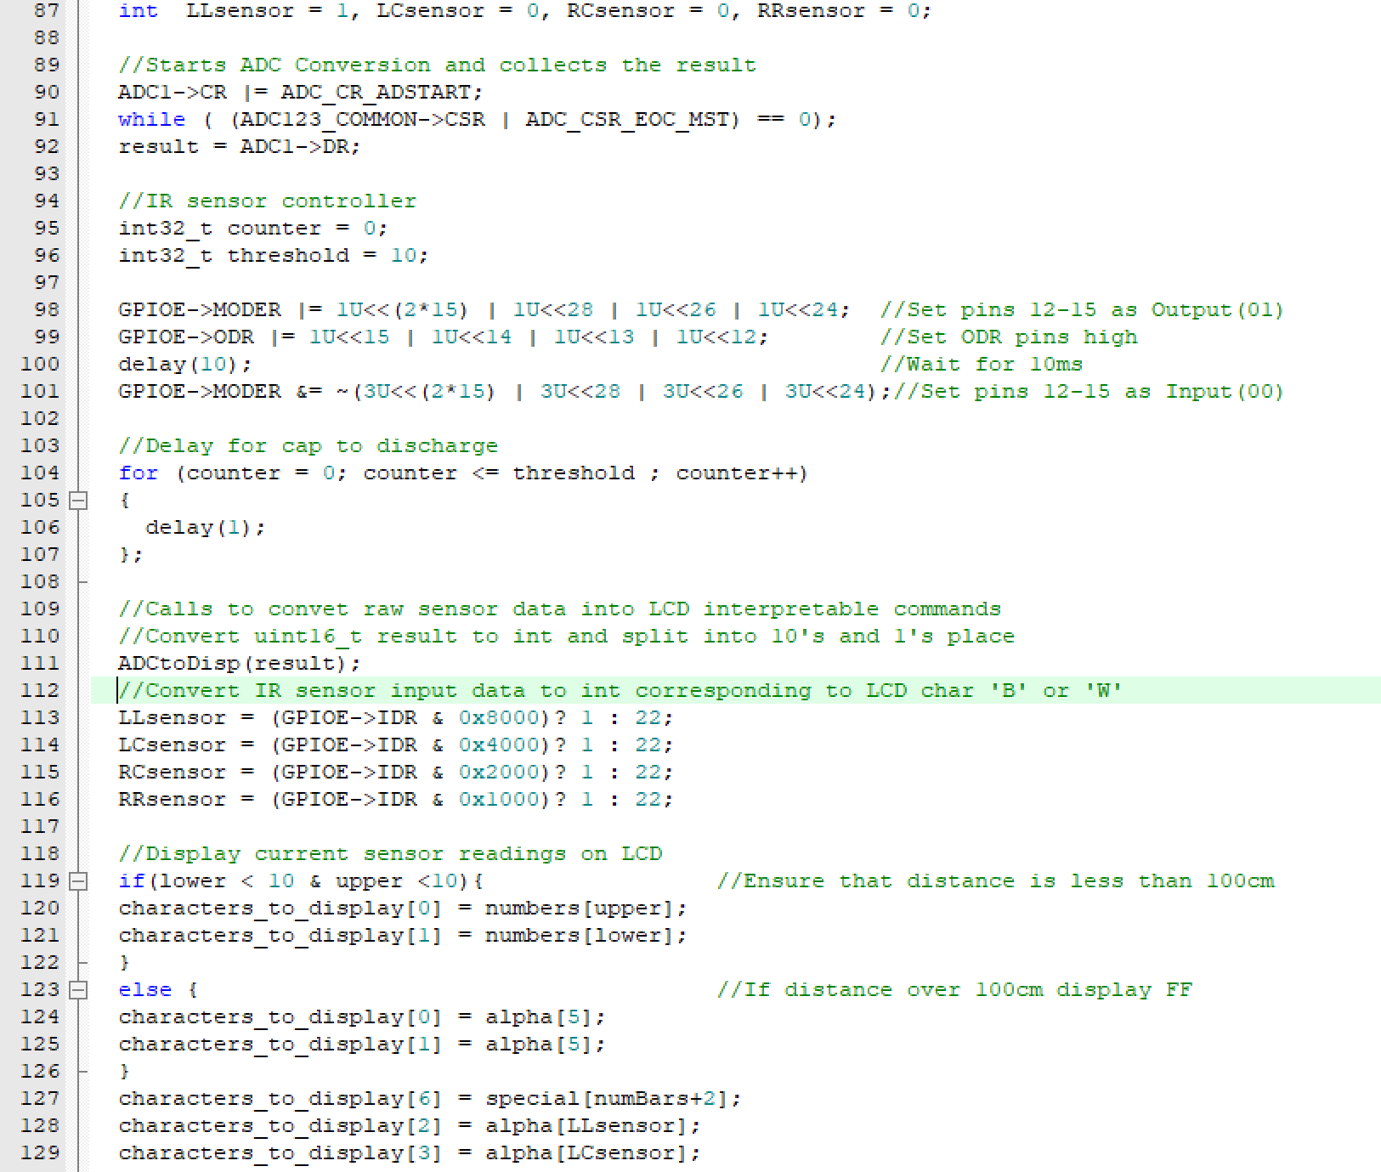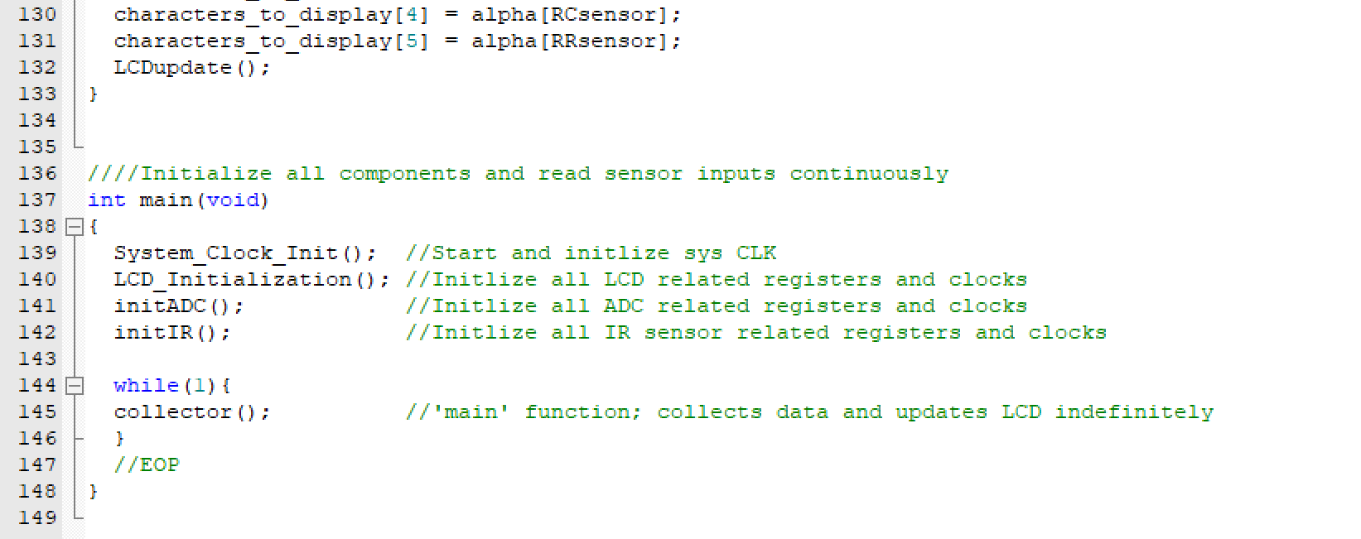

**setupHeaders.h:**

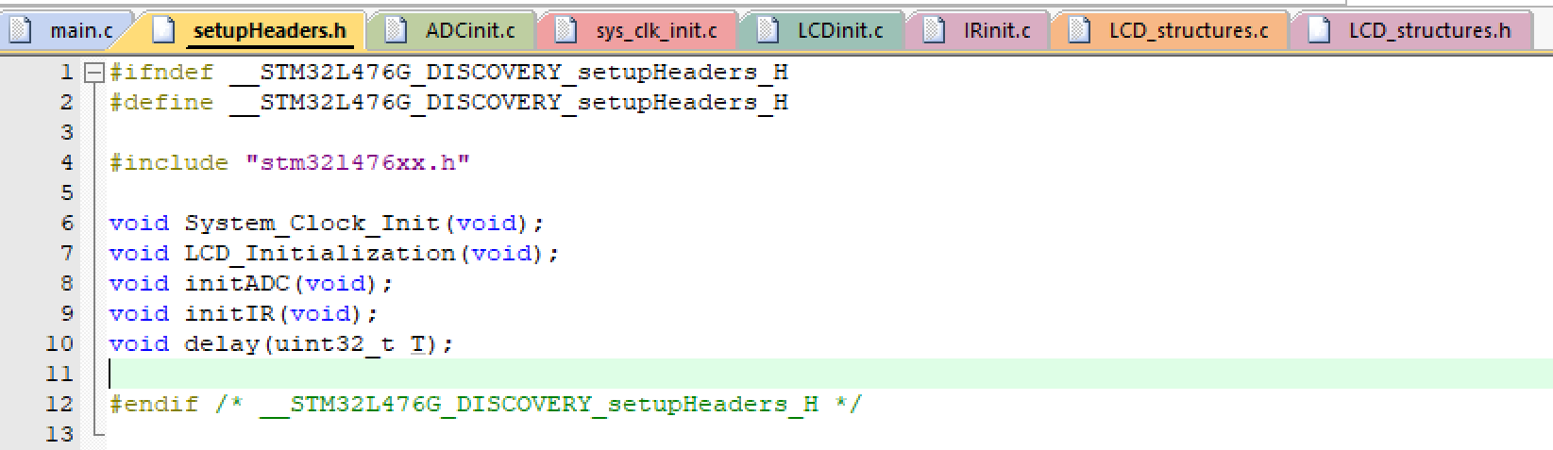

**Sys_clk_init.c:**

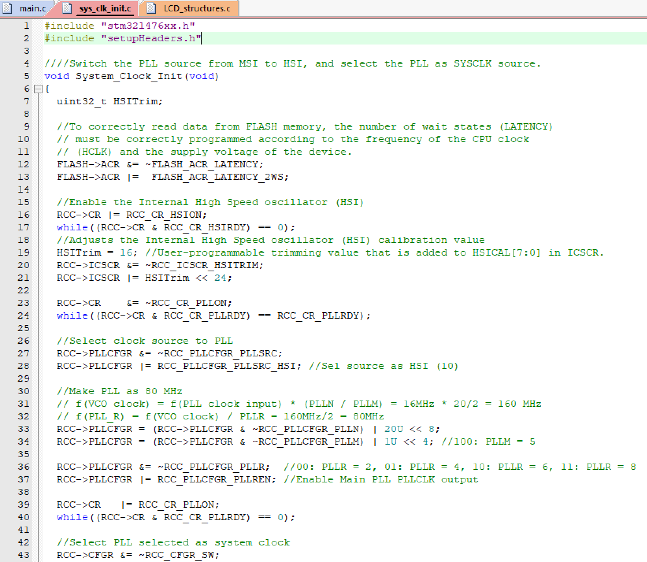 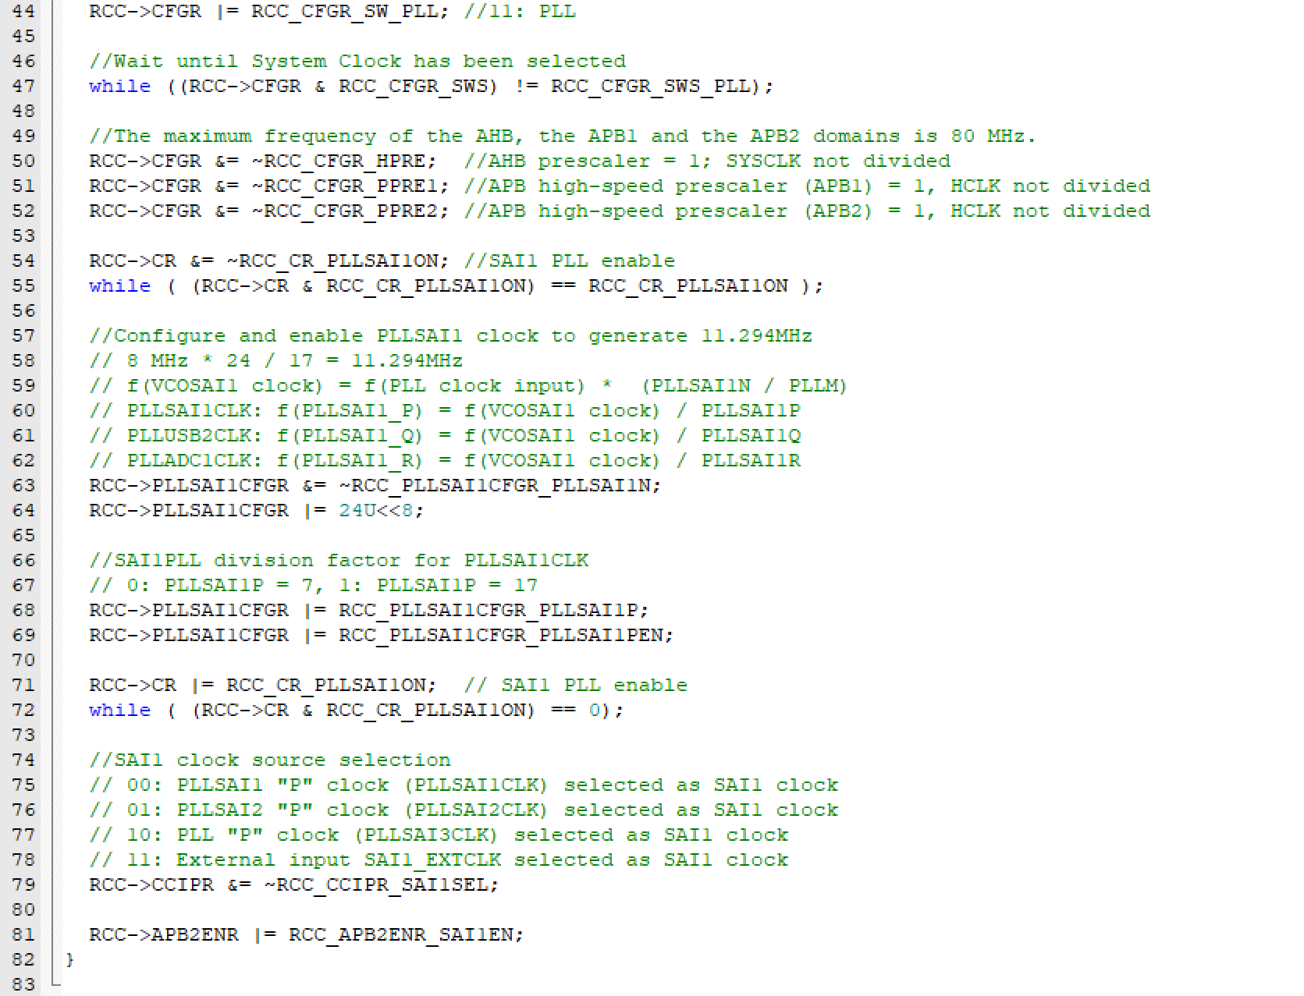

**LCD_structures.h:**

**KARA**

**LCD_structures.c:**

**KARA**

**LCDinit.c:**

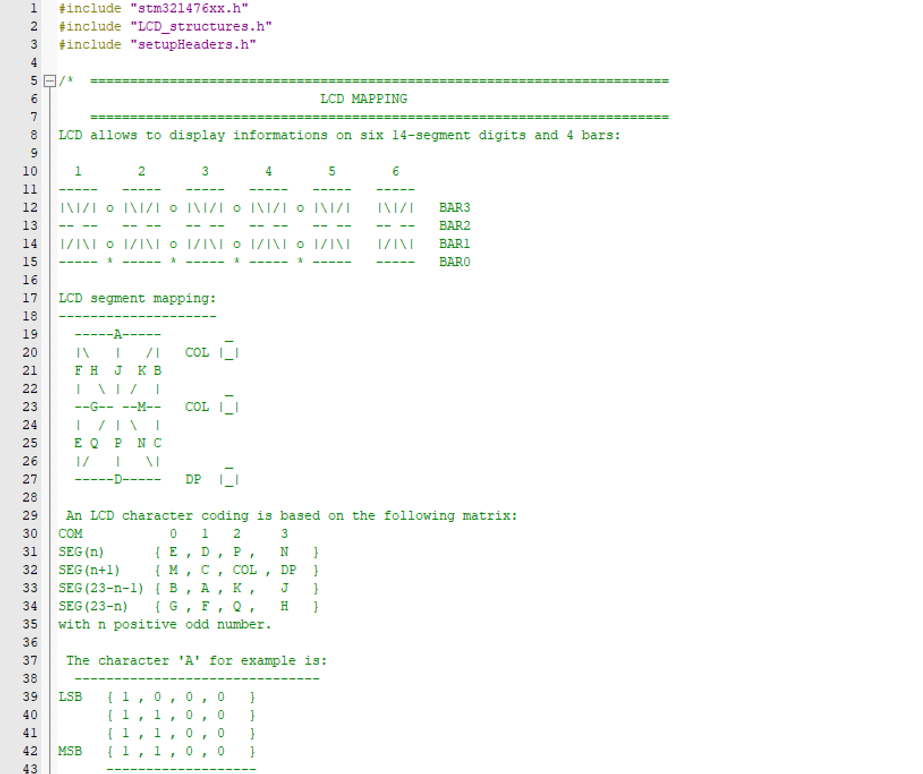

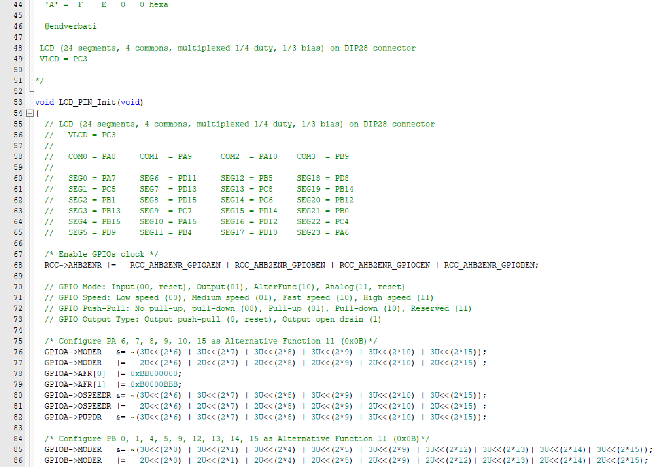 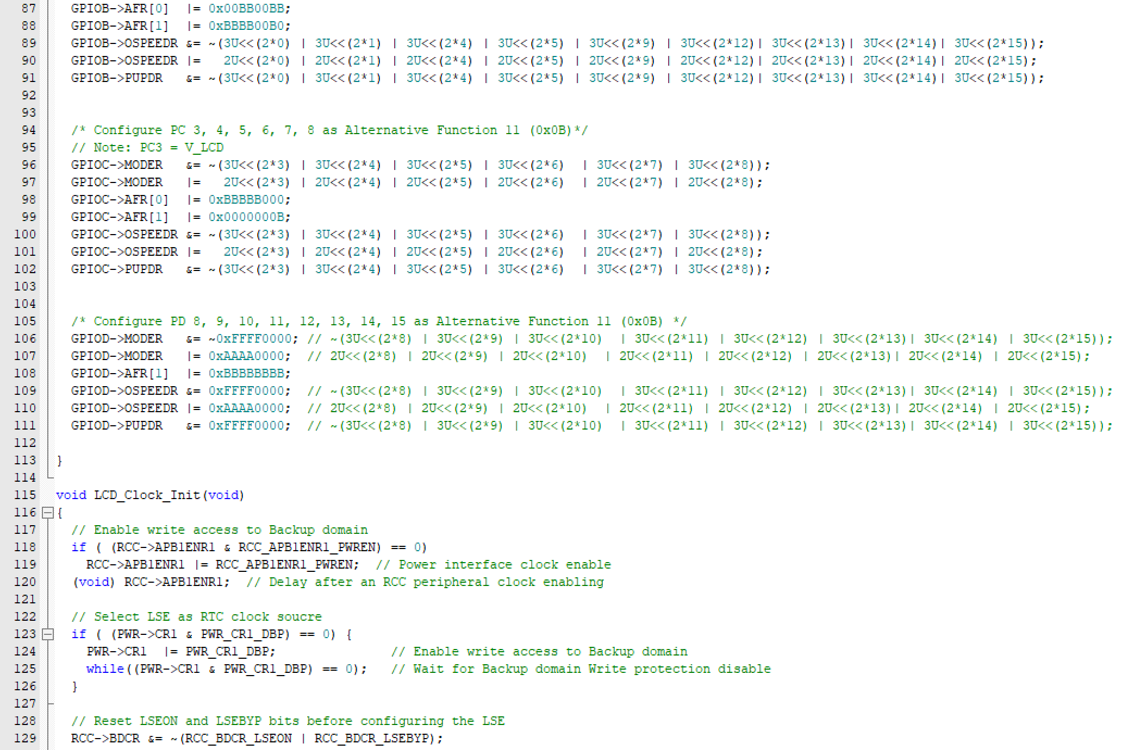 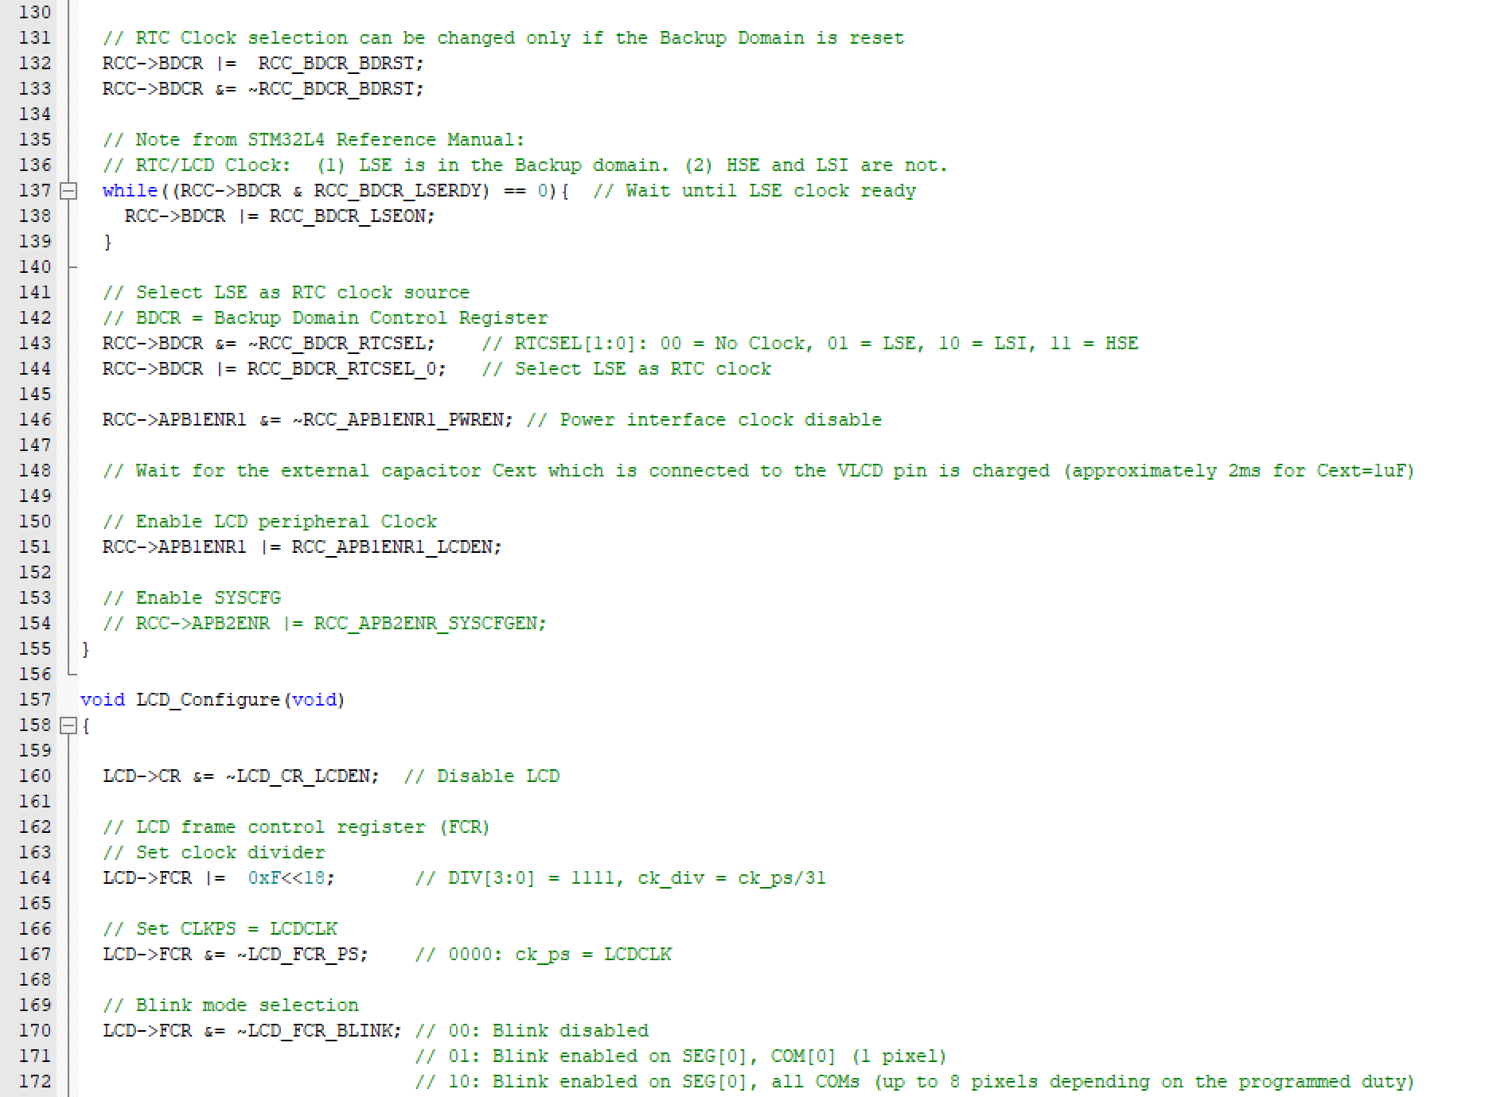 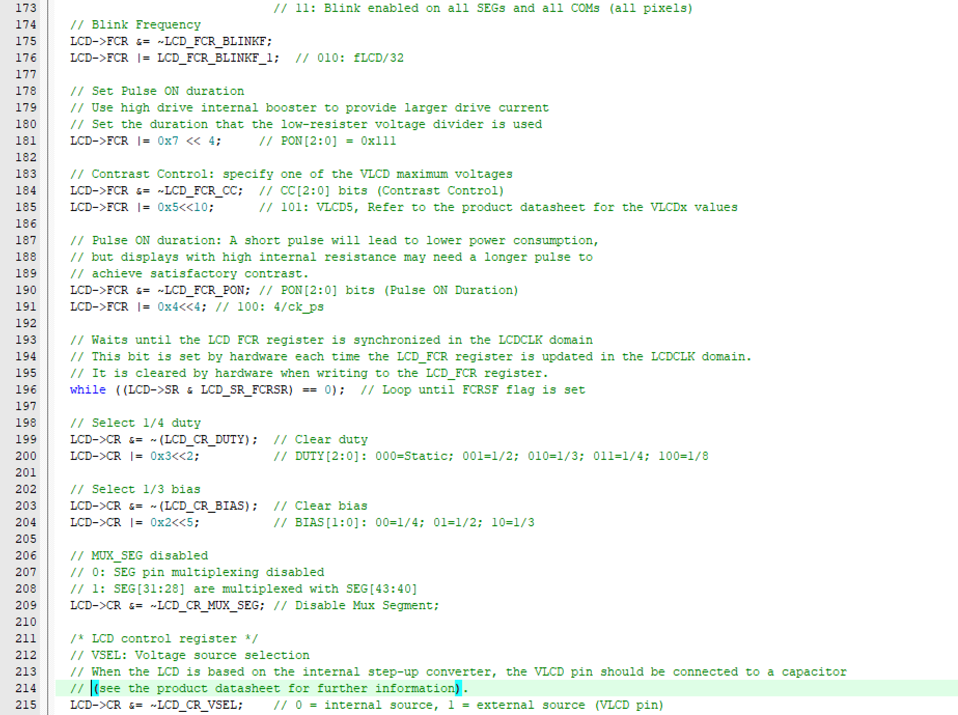 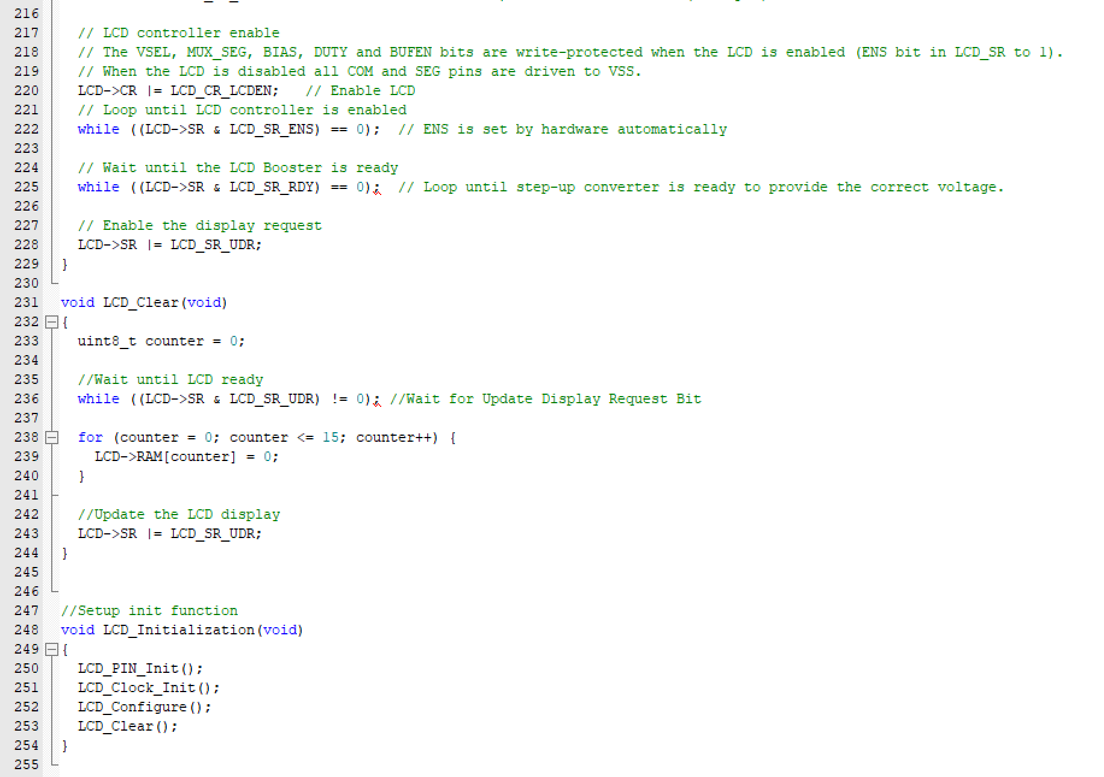

**ADCinit.c:**

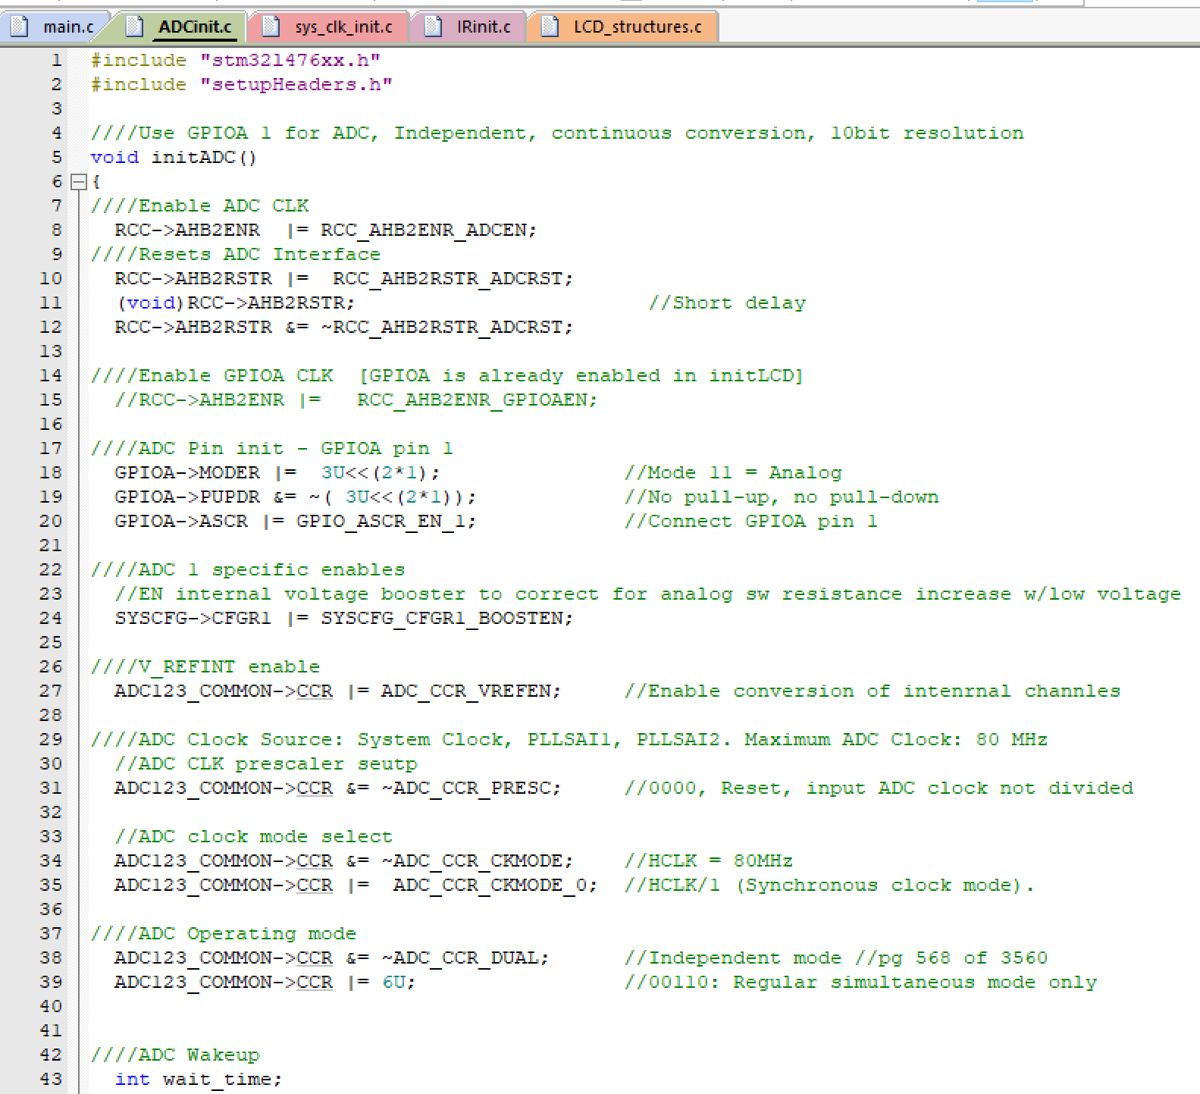 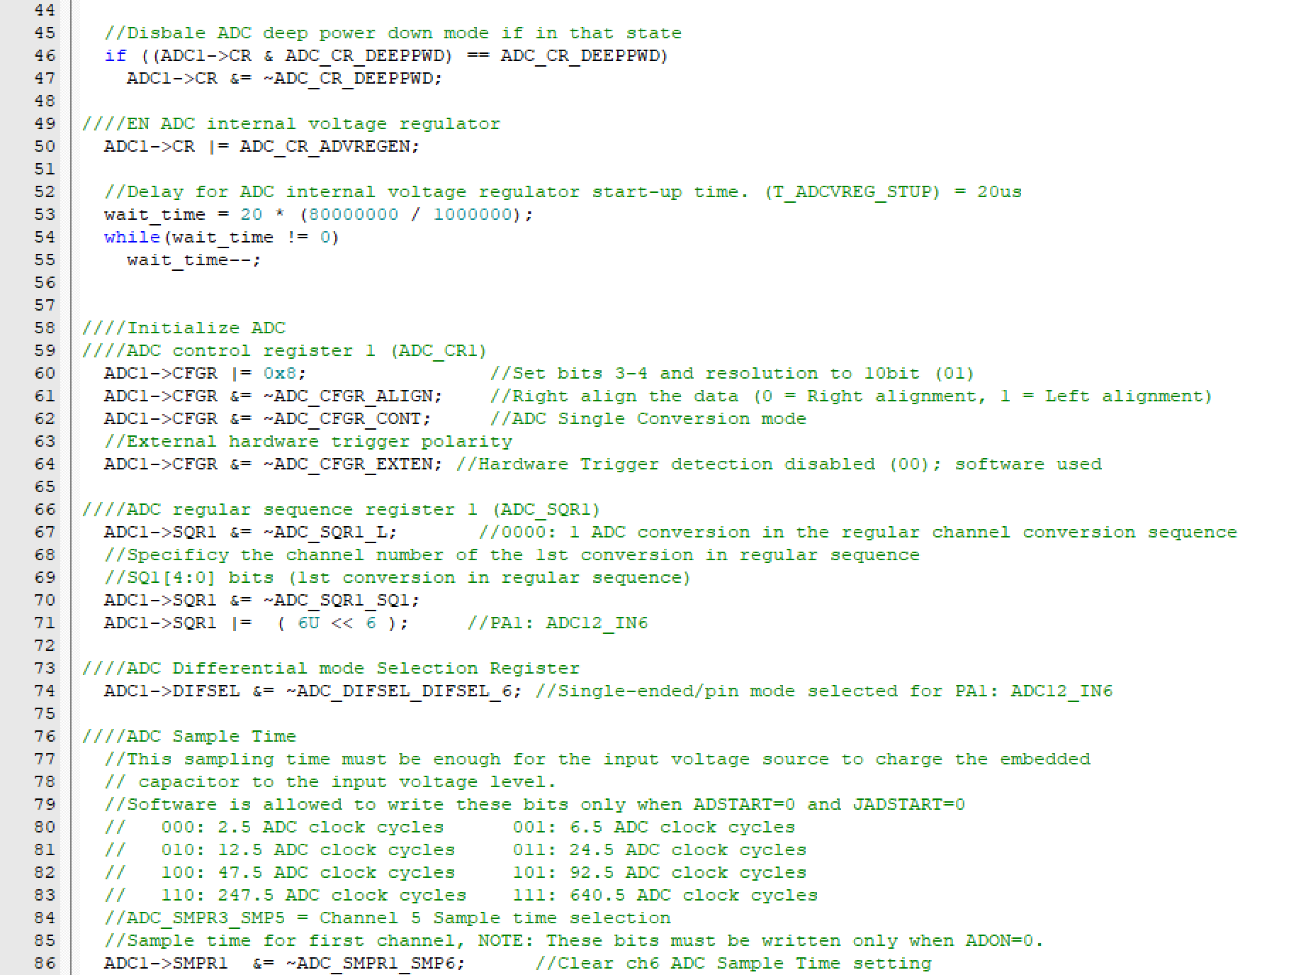 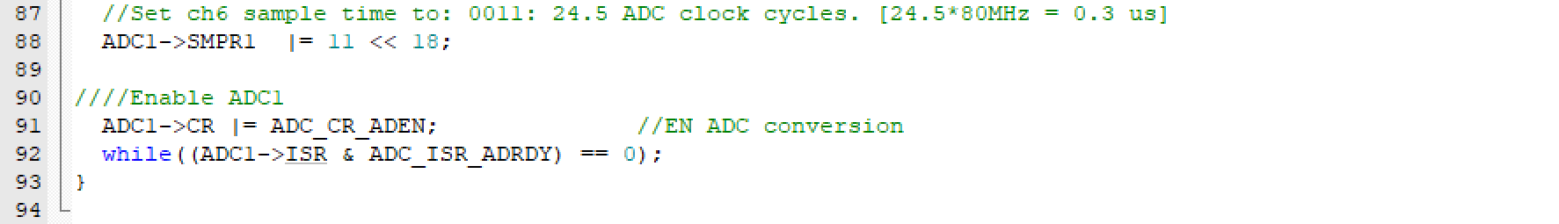

**IRinit.c:**

