CS-110: Fundamentals of Computer Programming

Assignment 1: Relief Supply Distribution System



[CLO-2] | Solve given real-world problem by applying appropriate programming concepts and techniques

Date: (11/10/2026)

Class: BESE-17 A

Submitted By:

Shaheer Ahmad Mirza (586378)

Hania Nauman (591944)

Rameen Arjmand (584654)

Submitted To: Dr. Momina Moetesum

School of Electrical Engineering and Computer Science (SEECS)

National University of Sciences & Technology (NUST)

Relief Supply Distribution System: Scoring Documentation
This program manages relief supply distribution in case of a natural disaster such as an earthquake. Starting stock: 5 trucks, 120 supply packs. This program uses the data about the disaster to assign a severity index and a need score. Then, the need score is used to allocate the relief supply.
GitHub Repository URL: https://github.com/The-Hacker-s-Den/FOCP-Assignment-1

1. Formula
Every relief request is converted into one Need Score from 0 to 100. Three sub-scores feed it.

1.1 People points (P), maximum 100
P = F + 25 × Medical + 30 × Trapped + 15 × Vulnerable + 10 × ClinicDown
Component | Points
Families affected (F): 10–50 / 51–100 / 101–150 / 151–200 | + 5 / 10 / 15 / 20
Medical need (yes) | +25
People trapped (yes) | +30
Vulnerable groups present: children, elderly, disabled (yes) | +15
Local clinic not working (no) | +10

1.2 Impact points (I), maximum 100
I = D + 40 × Aftershock
Component | Points
Infrastructure damage (D): Low / Medium / High | 12 / 36 / 60
Aftershock warning (yes) | 40

1.3 Complexity points (C), 0 or 100
- A = 100 if the road is damaged.
- A = 0 if the road is open.

1.4 Need Score (N)
N = (0.5 × People Points) + (0.4 × Impact Points) + (0.1 × Complexity Points)
If the area already received aid: N = N − 10.
Clamp N to the range 0–100. Round to 1 decimal place.
Category weights: People 50%, Impact 40%, Complexity 10%. Maximum N = 50 + 40 + 10 = 100.

1.5 Effective weight of each input in the final score
Category weights multiply the raw points. This table shows what each input is actually worth on the 0–100 scale.
Input | Raw points | Points in final score
People trapped | 30 (of People Points) | 15.0
Medical need | 25 (of People Points) | 12.5
Vulnerable groups present | 15 (of People Points) | 7.5
Local clinic not working | 10 (of People Points) | 5.0
Families affected (low to high bracket) | 5–20 (of People Points) | 2.5–10.0
Infrastructure damage (Low / Medium / High) | 12 / 36 / 60 (of Impact Points) | 4.8 / 14.4 / 24.0
Aftershock warning | 40 (of Impact Points) | 16.0
Road damaged | 100 (of Complexity Points) | 10.0
Prior aid received | −10 flat | −10.0
Totals: People inputs 15 + 12.5 + 7.5 + 5 + 10 = 50. Impact inputs 24 + 16 = 40. Complexity 10.

2. Rules

2.1 Input validation
- Families affected: integer from 10 to 200.
- Medical need, trapped people, vulnerable groups, clinic working, aftershock warning, road open, prior aid: yes or no.
- Damage level: High, Medium or Low.
- An invalid answer produces an error message and the same question is asked again. Scoring starts only when every answer is valid.

2.2 Package selection
Need Score | Package | Trucks | Supply packs
65 or more | Full Relief | 2 | 50
40 to 64.9 | Standard Relief | 1 | 30
20 to 39.9 | Emergency Kit | 1 | 10
Below 20 | Defer / Monitor | 0 | 0

2.3 Dispatch and fallback
- Score below 20: mark the request Defer / Monitor. Send nothing. Stock is not checked.
- Otherwise select the package the score earned.
- Dispatch test: the package is sent only if trucks in stock ≥ trucks required AND supply packs in stock ≥ packs required. Both conditions must hold.
- If the test fails, step down one package and repeat step 3. Order: Full Relief → Standard Relief → Emergency Kit.
- If the Emergency Kit test fails, mark the request Deferred: not enough stock. Send nothing.
- On a successful dispatch, subtract the trucks and packs used from stock. Stock changes only on a successful dispatch.
- Stepping only goes down. A request is never upgraded above the package its score earned.
Score band | Attempt order | Possible outcomes
65 or more | Full → Standard → Emergency | Full, Standard, Emergency, or Deferred: not enough stock
40 to 64.9 | Standard → Emergency | Standard, Emergency, or Deferred: not enough stock
20 to 39.9 | Emergency | Emergency, or Deferred: not enough stock
Below 20 | none | Defer / Monitor

2.4 Two kinds of deferral
- Defer / Monitor: the score is below 20. Deliberate decision. Happens regardless of stock.
- Deferred: not enough stock: the score earned a package but stock cannot fund even the smallest one (1 truck, 10 packs). Supply gap, not a need judgement. Signals that restocking is required.
Both count as deferred in the summary.

2.5 Request loop and reporting
- After each request the system shows the area, the action taken, trucks used, packs used and remaining stock.
- Requests are processed in the order received. Stock is not reserved for later requests.
- At the end of an earthquake the summary shows requests served, requests deferred, and trucks and packs remaining.

3. Sample Tests
The following sample tests were performed to test the program's processing of the requests and it's behavior when trucks and/or supply packs run out.

3.1 R1 – Riverside Village (Sufficient Resources)
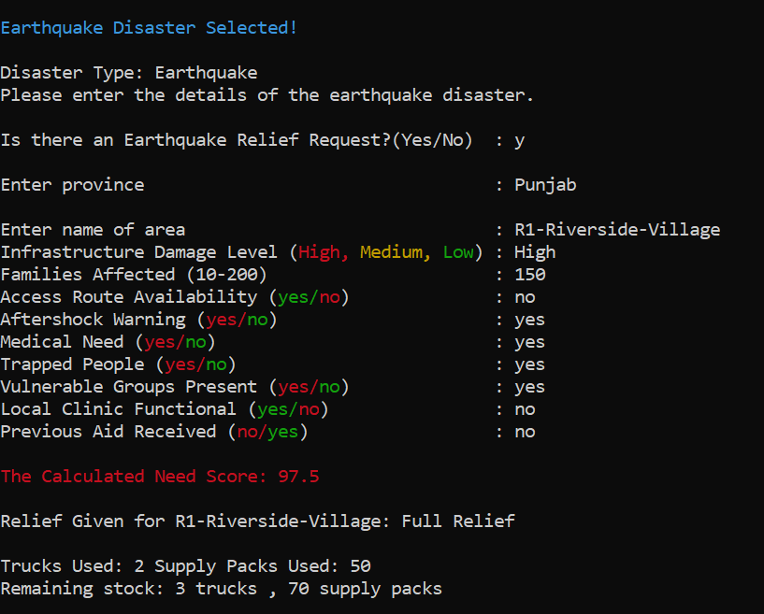
3.2 R2 – Hilltop Settlement (Sufficient Resources)
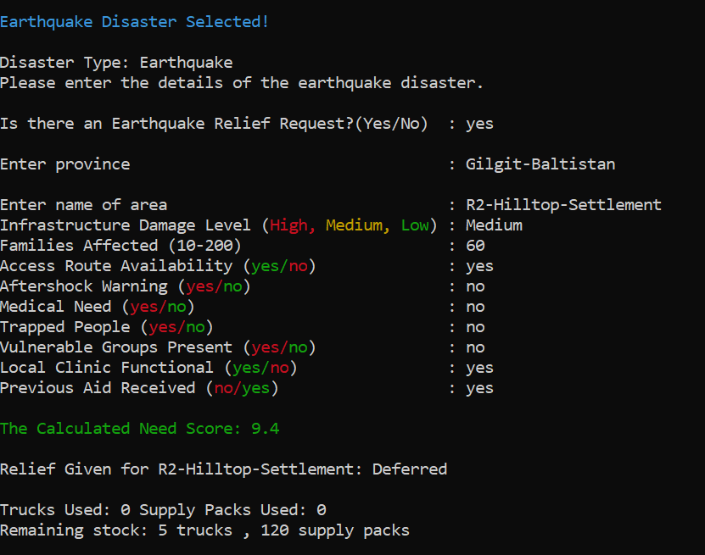

3.3 R3 – Lakeside Camp (Sufficient Resources)
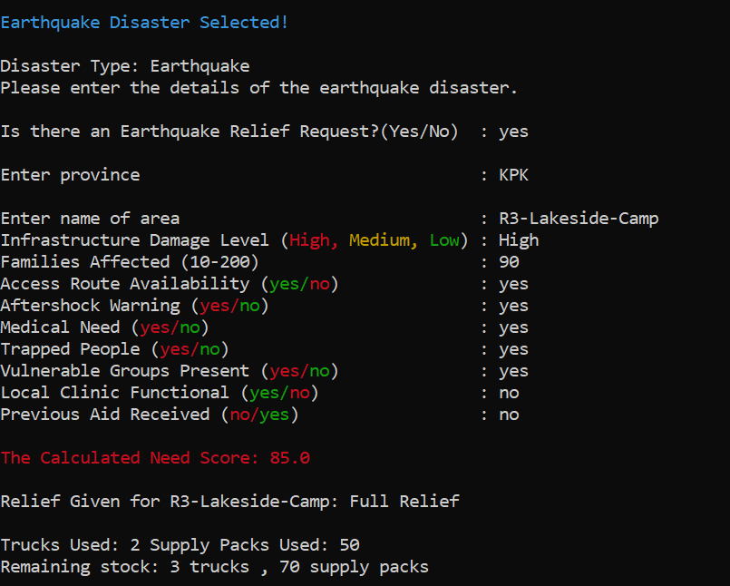

3.4 R2 – Market Town (Insufficient Resources)

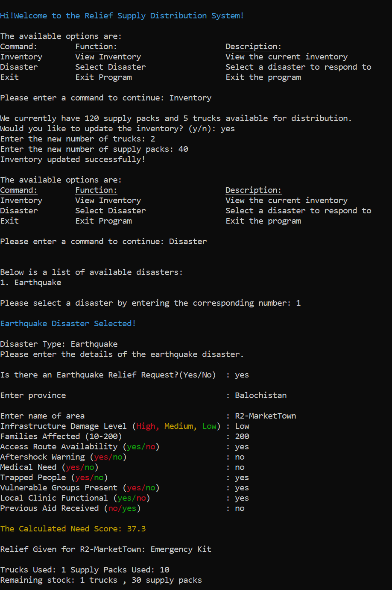

3.5 R5 Bridge Colony (Insufficient Resources)

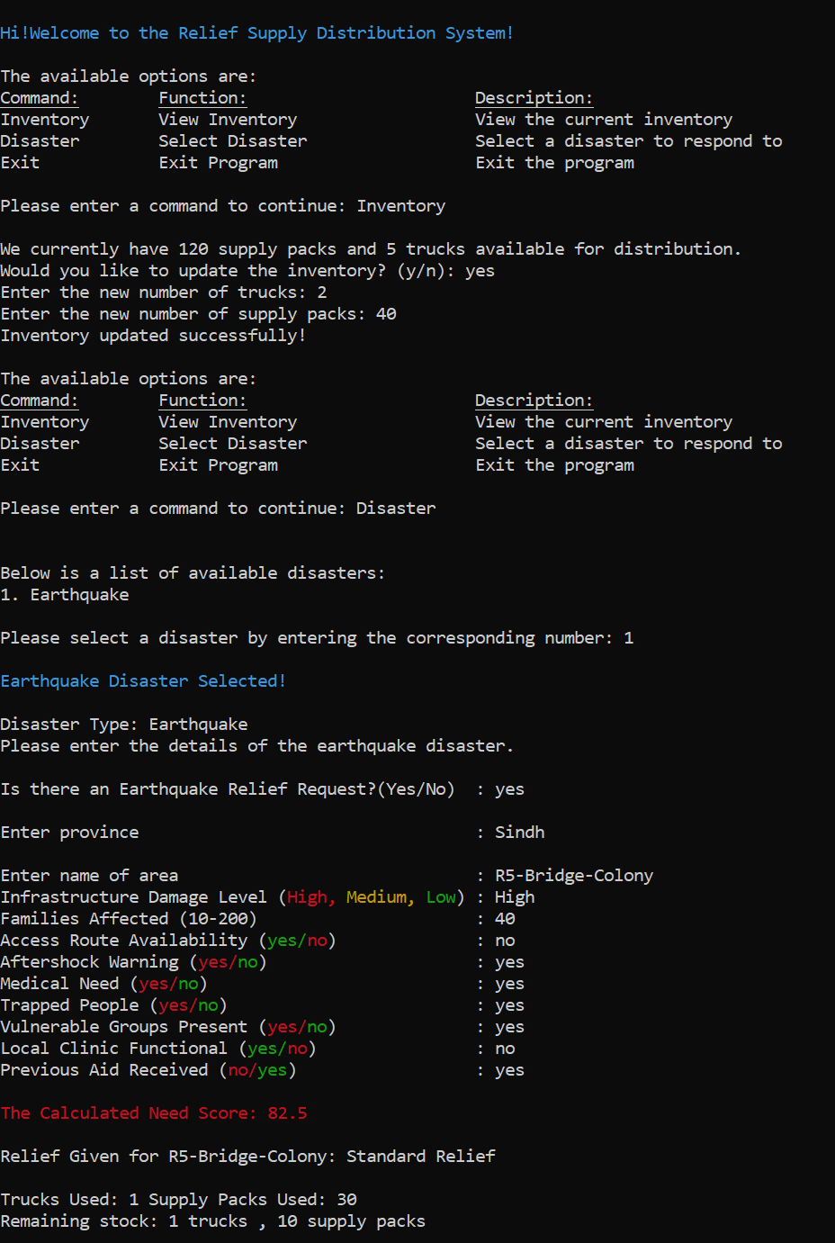

4. Rationale
The point values are design judgements by the project team. They are not statistically calibrated against historical disaster data. The reasons below justify why each input is in the model, its rank against the other inputs, and its size relative to the package thresholds.

4.1 Design principles
- People before logistics. Half of the score (50%) measures the condition of people.
- Condition before scale. A small area with entrapment must outrank a large area that is stable.
- Area-wide hazard is separate from person-level need. Hazards that affect everyone in the area, including responders, sit in Impact (40%).
- Delivery difficulty adjusts the response but does not measure suffering. Complexity carries the smallest weight (10%).
- Fairness across areas. An area that already received aid is deprioritized so stock reaches areas with nothing.
- Some help beats no help. When stock is short the system sends a smaller package instead of refusing.

4.2 Reason for every input weight
Trapped people: 30 raw, 15.0 final. Highest person-level weight. Survival of people trapped in collapsed structures falls steeply with time. Urban search and rescue operations are planned around the first 72 hours. A delay here is irreversible: a life lost cannot be recovered by later aid. Trapped people also indicate collapse and injury in the same area.
Medical need: 25 raw, 12.5 final. Untreated injuries such as bleeding, crush injuries, fractures and infection deteriorate within hours to days. A medical need turns delay into avoidable death and permanent disability. Ranked below entrapment because entrapment is the more time-critical of the two.
Vulnerable groups present: 15 raw, 7.5 final. Children, elderly people and people with disabilities have higher mortality in disasters and depend on others for evacuation, water, food and medication. They are often treated as priority groups. Weighted below trapped and medical because this input describes who is exposed, not an active life-threatening event.
Local clinic not working: 10 raw, 5.0 final. A working clinic absorbs part of the medical load locally. When it is down, the full load falls on external aid. Lowest of the four condition flags because it modifies the consequence of medical need and overlaps with it.
Families affected: 5 / 10 / 15 / 20 raw, 2.5 to 10.0 final. The number of families sets how much material is needed. Even the maximum bracket (20) is below every condition flag except clinic status and vulnerable groups, and below trapped (30) and medical (25), so a large stable area cannot outrank a small area with entrapment or injuries. Brackets are used instead of exact counts because early counts are estimates.
Infrastructure damage: 12 / 36 / 60 raw (ratio 1 : 3 : 5), 4.8 / 14.4 / 24.0 final. Damage drives shelter loss, loss of water and power, and the number of entrapments. Low damage means mostly habitable buildings. Medium means partial uninhabitability. High means collapse and mass displacement. The steps are not proportional: the jump from Low to Medium (24 raw) is larger than from Medium to High (24 raw) only in ratio terms (3× then 1.7×), reflecting that any real structural damage changes needs sharply. High damage is the largest single contribution to the final score (24.0) because it is the best area-wide proxy for severity when person-level facts are unknown.
Aftershock warning: 40 raw (40% of Impact), 16.0 final. Aftershocks can collapse already weakened buildings, injure survivors and endanger responders, and push people to stay outdoors, which raises shelter, water and warmth needs. It affects everyone in the area, so it sits in Impact and carries a high weight. An aftershock warning alone is enough to lift even a Low-damage, 10-family request out of Defer / Monitor (minimum score 23.3).
Road damaged: 100 raw, 10.0 final. A cut-off area cannot self-resupply, evacuate its injured or be reached by follow-up convoys, so relief must be sized for the delivery effort. The complexity weight is only 10% because road condition describes delivery difficulty, not human suffering. An accessible area with trapped people must outrank an unreachable area with no casualties. A damaged road alone, with no other risk factor, scores 17.3 and does not trigger relief.
Prior aid received: −10 flat. An area already served has had part of its initial need met. Limited stock should go first to areas with nothing. The deduction is a flat subtraction after the weighted sum, not a multiplier, so it lowers priority by roughly half a band without erasing severe need: any request with both trapped people and medical need still scores at least 24.8 after the penalty and receives at least an Emergency Kit when stock allows.

4.3 Reason for the package thresholds
- Below 20: only 83 of 1,536 possible input combinations (5.4%) fall here. The cut-off removes requests with almost no risk factors and nothing else.
- 20 to 39.9, Emergency Kit: the smallest dispatch. Every dispatch needs at least one truck, so the truck is the minimum unit of response. 26.4% of combinations.
- 40 to 64.9, Standard Relief: covers the broad middle of requests. 49.5% of combinations.
- 65 and above, Full Relief: the only package that commits two trucks. With default stock it uses 40% of trucks and about 42% of packs, so it is reserved for the top 18.8% of combinations, where several severe factors combine.

4.4 Reason for the fallback to a smaller package
- Stock is a hard limit. A request that earned Full Relief with stock for only Standard Relief still receives Standard Relief. Help arrives now instead of never.
- Both trucks and packs are tested at every step, so the system finds the largest package the remaining stock can support. Stock is not left idle while an area waits.
- Smaller packages stretch scarce stock over more areas.
- The system never steps up. A larger package than the score earned would take stock from areas that have not yet reported.
- The final failure is recorded as Deferred: not enough stock, separate from Defer / Monitor, so the operator can see a supply shortage as distinct from low need.
- Stock is deducted only after a package is confirmed, so a failed attempt never leaves stock partly consumed.

4.5 Reasoning behind the prediction or estimation of people trapped under rubble
This subprogram uses nested if-else ladder to estimate the trapped people.
- Every province has its unique average no. of family size which is multiplied by the families affected to find the total no. of people trapped.
- The total no. of people affected are than multiplied by 1 if the damage level is "High" or 0.5 if the damage level is "Medium" and 0 if its "Low". This is done so that no. of families affected doesn't change when there is "High" damage level so that people's lives aren't ignored. However, when the damage level is "Medium" the total no. of people affected is halved as it wasn't a full scale destructive earthquake but its still kept at half to estimate the farthest range or "worst case scenario".
- Finally, any reported rescued people/safe/unaffected people are subtracted for accuracy. If the answer goes below 0 ( < 0 ) it is set to 0 and ignored to stop the program from giving wrongful answers.
- NOTE: This program is in no way absolute or accurate, it is only a " Worst case estimation model " so that authorities have a rough idea of the severity of the situation and save as many hopeful human lives as possible.

5. Results

5.1 Capacity of the default stock
Package | Limited by trucks | Limited by packs | Maximum dispatches
Full Relief | 5 ÷ 2 = 2 | 120 ÷ 50 = 2 | 2
Standard Relief | 5 ÷ 1 = 5 | 120 ÷ 30 = 4 | 4 (Limited Packs)
Emergency Kit | 5 ÷ 1 = 5 | 120 ÷ 10 = 12 | 5 (Limited Trucks)
Trucks are the scarce resource for Emergency Kits. Packs are the scarce resource for Standard Relief.

5.2 Verified behaviors of the scoring model
- Trapped people, with no prior aid, score at least 22.3. The request always earns at least an Emergency Kit.
- Trapped people plus medical need score at least 34.8, or 24.8 with prior aid. The request always earns at least an Emergency Kit.
- An aftershock warning alone lifts a request to at least 23.3, above the Defer / Monitor line.
- A damaged road alone, with no other risk factor, scores 17.3. It does not trigger relief by itself.
- Limit: trapped people alone, combined with prior aid received, Low damage and 10 families, score 12.3 and are deferred as Defer / Monitor.

Assessment Rubric:
Each of the five criteria below is ranked on a scale of 1 to 4. The rank you receive is the number of marks for that criterion, so the maximum total is 5 × 4 = 20. Criteria 1–4 are marked for the group; Criterion 5 (Viva) is marked for each student individually.
How ranks are awarded:
- – Exemplary: every statement in the descriptor is met.
- – Proficient: the work is correct and complete overall, with minor gaps.
- – Developing: the work is partly correct but has significant gaps or errors.
- – Beginning: the work is attempted but mostly incorrect, unclear or incomplete.
0 – Nothing was submitted for that criterion.

Criterion | 4 – Exemplary | 3 – Proficient | 2 – Developing | 1 – Beginning
1. Problem Analysis, Need Score & Decision Logic | - Formula uses at least 4 of the 6 inputs.  - Every weight has a written reason linked to real-world impact.  - Rules cover all four actions and check available trucks and packs.  - Falls back to a smaller action when resources are short.  - Hand-tracing the test requests shows no contradictions. | - Formula uses at least 4 inputs.  - Reasons are given for most weights, but some are vague.  - Rules cover all four actions and check resources.  - At least one edge case is missed (e.g., enough trucks but not enough packs). | - Formula uses only 2–3 inputs, or copies the example without change.  - Thresholds are given without reasons.  - Some input combinations lead to no action or an illogical action. | - Formula or rules are missing, unexplained or illogical (e.g., low need gets Full Relief).  - Available resources are not considered in the decision.
2. C++ Implementation & Programming Concepts | - Compiles and runs with no errors.  - Uses appropriate decision control, logical and relational operators, arithmetic and assignment operators, a loop over requests  - well commented code  - meaningful names; consistent indentation. | - Compiles and gives correct output.  - All required concepts appear, but one is weak  - Naming or indentation is sometimes inconsistent.  - nominal commenting. | - Compiles, but a required concept is missing.  - Logic errors give wrong output for some  requests.  - Heavy code repetition.  - bare minimum commenting | - Does not compile or crashes.  - Most required concepts are absent, or output is hard-coded rather than calculated.  - No commenting.
3. Testing, Resource Handling & Output | - Both test sets are shown.  - Trucks and packs never go below zero or exceed what is available.  - Output shows all items: request info, score, action, units used, remaining units, and the summary.  - Insufficient set clearly shows a fallback or deferral with the reason printed.  - Summary counts are correct. | - Both test sets are shown and resources are never exceeded.  - Output has 5–6 of the required items, or the summary has a minor error.  - Insufficient case is shown, but the reason for the fallback is not stated. | - Only one test set truly works, or the insufficient set never runs out of resources.  - One or more required output items are missing.  - Remaining values are inconsistent with the actions taken. | - Resources can go negative or be exceeded.  - Most required output items are missing.  - No summary is shown.
4. Flowchart & Documentation | - Flowchart matches the actual code and shows the decision branches and resource update.  - README has every required item: formula, rules, rationale, results, member contributions, GitHub link, AI-use note.  - Clearly written and well organised. | - Flowchart is present and mostly matches the code.  - README has every required item, but one is thin (e.g., the rationale is one line). | - Flowchart is incomplete or does not match the code.  - README is missing one or two required items. | - No flowchart  - README is missing most required items or is not submitted.
5. Viva & Individual Contribution (per student) | - Explains any part of the code and the reasons behind the design without help.  - Correctly predicts the output for a changed input.  - Contribution is specific and matches the README and repository history. | - Explains own part clearly and the general flow of the rest.  - Traces a changed input with minor prompting.  - Contribution is stated and believable. | - Explains own part only partially.  - Needs significant prompting to trace a changed input.  - Contribution is vague. | - Cannot explain the code or own  contribution.  - Answers suggest the work is not the student's own.

Scoring sheet:

Criterion | Rank (1–4)
1. Problem Analysis, Need Score & Decision Logic
2. C++ Implementation & Programming Concepts
3. Testing, Resource Handling & Output
4. Flowchart / Pseudocode & Documentation
5. Viva & Individual Contribution
Total (out of 20)

Annexure A: C++ Source Code
#include<iostream>
#include<string>
#include <iomanip>
using namespace std;

/* Global resources and state variables
trucks/supply_packs = current availale stock
disaster = which disaster has the user picked from the menu
request_handled, deferred = running counters
The string variables hold the yes/n and cateogircal answers collected from the user*/

int trucks = 5, supply_packs = 120, disaster = 0, families_affected = 0, deferred = 0, request_handled = 0;
string damage_level, access_route, aftershocks, area, medical_need, trapped_ppl, vulnerable_grps, local_clinic, previous_aid_received, selected_package, earth_quake, disas_start, update_inventory, main_option, province;

//Prints the welcome banner when the program starts
int welcome() {
cout << "\033[36m"<<"\nHi!Welcome to the Relief Supply Distribution System!" << "\033[0m" << endl;
return 0;
}

int main_menu() {
cout << "\nThe available options are:" << endl;
cout << "\033[4mCommand:\tFunction:\t\t\tDescription:\033[0m" << endl;
cout << "Inventory\tView Inventory\t\t\tView the current inventory" << endl;
cout << "Disaster\tSelect Disaster\t\t\tSelect a disaster to respond to" << endl;
cout << "Exit\t\tExit Program\t\t\tExit the program" << endl;
cout << "\nPlease enter a command to continue: ";
cin >> main_option;
while (main_option != "Inventory" && main_option != "Disaster" && main_option != "Exit" && main_option != "inventory" && main_option != "disaster" && main_option != "exit" && main_option != "d" && main_option != "e" && main_option != "i" && main_option != "D" && main_option != "E" && main_option != "I") {
cout << "Invalid input. Please enter a valid option." << endl;
cout << "\nThe available options are:" << endl;
cout << "\033[4mCommand:\tFunction:\t\t\tDescription:\033[0m" << endl;
cout << "Inventory\tView Inventory\t\t\tView the current inventory" << endl;
cout << "Disaster\tSelect Disaster\t\t\tSelect a disaster to respond to" << endl;
cout << "Exit\t\tExit Program\t\t\tExit the program" << endl;
cout << "\nPlease enter a command to continue: ";
cin >> main_option;
}
return 0;
}

/*Shows the current stock and lets the admin optionally overwrite / update the
resources when the program restarts once over before processing any requests.*/
int inventory() {
cout << "\nWe currently have " << supply_packs << " supply packs and " << trucks << " trucks available for distribution." << endl;
cout << "Would you like to update the inventory? (y/n): ";
cin >> update_inventory;
if (update_inventory == "y" || update_inventory == "Y" || update_inventory == "yes" || update_inventory == "Yes") {
cout << "Enter the new number of trucks: ";
cin >> trucks;
cout << "Enter the new number of supply packs: ";
cin >> supply_packs;
cout << "Inventory updated successfully!" << endl;
}
else {
cout << "Inventory remains unchanged." << endl;
}
return 0;
}

/*Displays the disaster type menu and recors the user's choice
Currently only "Earthquake" is implemented */
int disasters() {
cout << "\n\nBelow is a list of available disasters:" << endl;
cout << "1. Earthquake" << endl;
cout << "\nPlease select a disaster by entering the corresponding number: ";
while (!(cin >> disaster)) {
cin.clear(); // Clear the error flag
cin.ignore(numeric_limits<streamsize>::max(), '\n'); // Ignore the invalid input
cout << "Invalid input. Please enter a valid disaster number." << endl;
cout << "\n\nBelow is a list of available disasters:" << endl;
cout << "1. Earthquake" << endl;
cout << "\nPlease select a disaster by entering the corresponding number: ";
}
return 0;
}

/* Handles the full earthquake relief overflow:
1. Collects request details
2. Validates input
3. Scores the request
4. Decides an action
5. Updates the stock
6. Prints a summary*/
int earthquake() {
cout << "\n\033[36m" << "Earthquake Disaster Selected!" << "\033[0m" << endl;
cout << "\nDisaster Type: Earthquake" << endl;
cout << "Please enter the details of the earthquake disaster." << endl;

cout << "\nIs there an Earthquake Relief Request?(Yes/No)\t: ";
cin >> earth_quake;

//Main loop: keep processing the relief requests until the user says no
while (earth_quake == "y" || earth_quake == "Y" || earth_quake == "yes" || earth_quake == "Yes") {

//Collect request details (each with input validation loops)
cout << "\nEnter province\t\t\t\t\t: ";
cin >> province;
cout << "\nEnter name of area\t\t\t\t: ";
cin >> area;

//Damage level: must be High/Medium/Low (various cases/abbreviations accepted
cout << "Infrastructure Damage Level (\033[31mHigh,\033[33m Medium,\033[32m Low\033[0m) : ";
cin >> damage_level;
while (damage_level != "High" && damage_level != "Medium" && damage_level != "Low" && damage_level != "high" && damage_level != "low" && damage_level != "medium" && damage_level != "h" && damage_level != "m" && damage_level != "l" && damage_level != "H" && damage_level != "M" && damage_level != "L") {
cout << "Invalid input. Please enter (\033[31mHigh,\033[33m Medium,\033[0m \033[32mLow\033[0m)\t:" << endl;
cout << "Infrastructure Damage Level\t\t\t: ";
cin >> damage_level;
}

//NUmber of families affect: must be within the allowed 10-200 range
cout << "Families Affected (10-200)\t\t\t: ";
cin >> families_affected;
while (families_affected < 10 || families_affected > 200) {
cout << "Invalid input. Please enter a value between 10 and 200." << endl;
cout << "Families Affected\t\t\t\t: ";
cin >> families_affected;
}

//Whether the access route into the area is open or damaged
cout << "Access Route Availability (\033[32myes/\033[31mno\033[0m)\t\t: ";
cin >> access_route;
while (access_route != "yes" && access_route != "Yes" && access_route != "no" && access_route != "No" && access_route != "y" && access_route != "n" && access_route != "Y" && access_route != "N") {
cout << "Invalid input. Please enter yes or no." << endl;
cout << "Access Route Availability\t\t\t: ";
cin >> access_route;
}

//Whether an aftershock warning is in effect for the area
cout << "Aftershock Warning (\033[31myes/\033[32mno\033[0m)\t\t\t: ";
cin >> aftershocks;
while (aftershocks != "yes" && aftershocks != "Yes" && aftershocks != "No" && aftershocks != "no" && aftershocks != "y" && aftershocks != "n" && aftershocks != "Y" && aftershocks != "N") {
cout << "Invalid input. Please enter yes or no." << endl;
cout << "Aftershock Warning\t\t\t\t: ";
cin >> aftershocks;
}

//Whether the area has an urgent medical need
cout << "Medical Need (\033[31myes/\033[32mno\033[0m)\t\t\t\t: ";
cin >> medical_need;
while (medical_need != "yes" && medical_need != "Yes" && medical_need != "No" && medical_need != "no" && medical_need != "y" && medical_need != "n" && medical_need != "Y" && medical_need != "N") {
cout << "Invalid input. Please enter yes or no." << endl;
cout << "Medical Need\t\t\t\t\t: ";
cin >> medical_need;
}

//Whether there are people trapped in the area/ the rubble
cout << "Trapped People (\033[31myes/\033[32mno\033[0m)\t\t\t\t: ";
cin >> trapped_ppl;
while (trapped_ppl != "yes" && trapped_ppl != "Yes" && trapped_ppl != "No" && trapped_ppl != "no" && trapped_ppl != "y" && trapped_ppl != "n" && trapped_ppl != "Y" && trapped_ppl != "N") {
cout << "Invalid input. Please enter yes or no." << endl;
cout << "Trapped People\t\t\t\t\t: ";
cin >> trapped_ppl;
}

//Whether the vulnerable groups (elderly, children, disable, etc.) are present
cout << "Vulnerable Groups Present (\033[31myes/\033[32mno\033[0m)\t\t: ";
cin >> vulnerable_grps;
while (vulnerable_grps != "yes" && vulnerable_grps != "Yes" && vulnerable_grps != "No" && vulnerable_grps != "no" && vulnerable_grps != "y" && vulnerable_grps != "n" && vulnerable_grps != "Y" && vulnerable_grps != "N") {
cout << "Invalid input. Please enter yes or no." << endl;
cout << "Vulnerable Groups Present\t\t\t: ";
cin >> vulnerable_grps;
}

//Whether the local clinic is still functional (affects how much medical support is needed
cout << "Local Clinic Functional (\033[32myes/\033[31mno\033[0m)\t\t: ";
cin >> local_clinic;
while (local_clinic != "yes" && local_clinic != "Yes" && local_clinic != "No" && local_clinic != "no" && local_clinic != "y" && local_clinic != "n" && local_clinic != "Y" && local_clinic != "N") {
cout << "Invalid input. Please enter yes or no." << endl;
cout << "Local Clinic Functional\t\t\t\t: ";
cin >> local_clinic;
}

//Whether the area has already received aid previously (reduces priority slightly)
cout << "Previous Aid Received (\033[31mno/\033[32myes\033[0m)\t\t\t: ";
cin >> previous_aid_received;
while (previous_aid_received != "yes" && previous_aid_received != "Yes" && previous_aid_received != "No" && previous_aid_received != "no" && previous_aid_received != "y" && previous_aid_received != "n" && previous_aid_received != "Y" && previous_aid_received != "N") {
cout << "Invalid input. Please enter yes or no." << endl;
cout << "Previous Aid Received\t\t\t\t: ";
cin >> previous_aid_received;
}

/* ---NEED SCORE CALCULATION--
The score is build from three sub-scores (people, impact and complexity)
Each of them is weighted differently, combined and then adjusted. */

//People points: how much people are affected due to the earthquake
int people_points = 0;
if (families_affected >= 10 && families_affected <= 50)
people_points = people_points + 5;
else if (families_affected >= 51 && families_affected <= 100)
people_points = people_points + 10;
else if (families_affected >= 101 && families_affected <= 150)
people_points = people_points + 15;
else if (families_affected >= 151 && families_affected <= 200)
people_points = people_points + 20;
if (medical_need == "yes" || medical_need == "Yes" || medical_need == "y" || medical_need == "Y")
people_points = people_points + 25;
if (trapped_ppl == "yes" || trapped_ppl == "Yes" || trapped_ppl == "y" || trapped_ppl == "Y")
people_points = people_points + 30;
if (vulnerable_grps == "yes" || vulnerable_grps == "Yes" || vulnerable_grps == "y" || vulnerable_grps == "Y")
people_points = people_points + 15;
if (local_clinic == "no" || local_clinic == "No" || local_clinic == "n" || local_clinic == "N")
people_points = people_points + 10;

//Impact points: severity of physical/ structural damage and ongoing risks
int impact_points = 0;
if (damage_level == "High" || damage_level == "high" || damage_level == "H" || damage_level == "h")
impact_points = impact_points + 60;
else if (damage_level == "medium" || damage_level == "Medium" || damage_level == "M" || damage_level == "m")
impact_points = impact_points + 36;
else if (damage_level == "Low" || damage_level == "low" || damage_level == "L" || damage_level == "l")
impact_points = impact_points + 12;
if (aftershocks == "yes" || aftershocks == "Yes" || aftershocks == "y" || aftershocks == "Y")
impact_points = impact_points + 40;

//Complexity points: how hard it is to physically deliver aid
int complexity_points = 0;
if (access_route == "no" || access_route == "No" || access_route == "n" || access_route == "N")
complexity_points = complexity_points + 100;

/*Total needscore is the weighted combination of three categories:
people (50%) + impact (40%) + complexity (10%) */
float needscore;
needscore = (0.5 * people_points) + (0.4 * impact_points) + (0.1 * complexity_points);
//Penalty if the area has already received aid before (lower relative priority)
if (previous_aid_received == "yes" || previous_aid_received == "Yes" || previous_aid_received == "y" || previous_aid_received == "Y")
needscore = needscore - 10;
//Clamp the score between the valid 0-100 range
if (needscore > 100)
needscore = 100;
if (needscore < 0)
needscore = 0;
cout << fixed << setprecision(1);

//Colorcode the printed score by severity band (just for readability in terminal)
if (needscore < 20)
cout << "\033[32m"; //Green Text
else if (needscore >= 20 && needscore < 40)
cout << "\033[33m"; //Yellow Text
else if (needscore >= 40 && needscore < 65)
cout << "\033[38;5;208m"; //Orange Text
else if (needscore >= 65)
cout << "\033[31m"; //Bright Red Text

cout << "\nThe Calculated Need Score: " << needscore;

//---Decision/Action Rules---
string action;
int level = 0, trucksused = 0, packsused = 0;

if (needscore < 20)
{
//Scores below 20 are not urgent enough to act on right now
action = "Deferred";
deferred++;

}
else
{
//Map the score band to a starting relief "level"
// (level 1 = largest relief package, level 3 = smallest)
if (needscore >= 20 && needscore < 40)
level = 3; //emergency first aid kit
else if (needscore >= 40 && needscore < 65)
level = 2; //standard aid
else if (needscore >= 65)
level = 1; //full aid

/*Try to fulfill at the assigned level.
If stock is insufficient, step down to a smaller relief level instead of
refusing outright */
bool sent = false;
while (!sent && level <= 3) {
int trucksneeded = 0, packsneeded = 0;
if (level == 1) {
trucksneeded = 2; packsneeded = 50;
}
else if (level == 2) {
trucksneeded = 1; packsneeded = 30;
}
else if (level == 3) {
trucksneeded = 1; packsneeded = 10;
}
//Only dispatch if enough trucks AND supply packs are available
if (trucks >= trucksneeded && supply_packs >= packsneeded) {
trucks = trucks - trucksneeded;
supply_packs = supply_packs - packsneeded;
packsused = packsneeded;
trucksused = trucksneeded;
sent = true;
request_handled++;

if (level == 1) action = "Full Relief";
else if (level == 2) action = "Standard Relief";
else if (level == 3) action = "Emergency Kit";
}
else
level++; // not enough stock at this level, try a smaller one
}
// If even the smallest relief level couldnt be met, defer the request
if (!sent) {
action = "Deferred - not enough stock";
deferred++;
}
}

cout << "\033[0m"; // Reset terminal color

//---Print result for this request---
cout << "\n\nRelief Given for "<<area<<": "<< action << endl;
cout << "\nTrucks Used: " << trucksused << " Supply Packs Used: " << packsused << endl;
cout << "Remaining stock: " << trucks << " trucks , " << supply_packs << " supply packs"<<endl;

//Ask whether the program should predict people under the rubble based on the number of families affected
cout << "\nWould you like to predict the number of people trapped under the rubble based on the number of families affected? (Yes/No)\t: ";
if (cin >> earth_quake && (earth_quake == "y" || earth_quake == "Y" || earth_quake == "yes" || earth_quake == "Yes")) {
if (province == "Sindh" || province == "sindh" || province == "SINDH") {
cout << "\nNote: In Sindh, the average family size is 5.6 people per family." << endl;
float predicted_trapped = families_affected * 5.6; //Assuming an average of 5.6 people per family in Sindh
int unaffected_people = 0;
if (damage_level == "High" || damage_level == "high" || damage_level == "H" || damage_level == "h") {
predicted_trapped = predicted_trapped * 1;
}
else if (damage_level == "medium" || damage_level == "Medium" || damage_level == "M" || damage_level == "m")
predicted_trapped = predicted_trapped * 0.5;
else if (damage_level == "Low" || damage_level == "low" || damage_level == "L" || damage_level == "l")
predicted_trapped = predicted_trapped * 0.0;
cout << "number of reported found people/ safe or unaffected people: ";
cin >> unaffected_people;
predicted_trapped = predicted_trapped - unaffected_people;
if (predicted_trapped < 0) {
predicted_trapped = 0; // Ensure predicted trapped people is not negative
}
cout << "\nPredicted number of people trapped under the rubble: " << predicted_trapped << endl;
}
else if (province == "Punjab" || province == "punjab" || province == "PUNJAB") {
cout << "\nNote: In Punjab, the average family size is 6.4 people per family." << endl;
float predicted_trapped = families_affected * 6.4; //Assuming an average of 6.4 people per family in Punjab
int unaffected_people = 0;
if (damage_level == "High" || damage_level == "high" || damage_level == "H" || damage_level == "h") {
predicted_trapped = predicted_trapped * 1;
}
else if (damage_level == "medium" || damage_level == "Medium" || damage_level == "M" || damage_level == "m")
predicted_trapped = predicted_trapped * 0.5;
else if (damage_level == "Low" || damage_level == "low" || damage_level == "L" || damage_level == "l")
predicted_trapped = predicted_trapped * 0.0;
cout << "number of reported found people/ safe or unaffected people: ";
cin >> unaffected_people;
predicted_trapped = predicted_trapped - unaffected_people;
if (predicted_trapped < 0) {
predicted_trapped = 0; // Ensure predicted trapped people is not negative
}
cout << "\nPredicted number of people trapped under the rubble: " << predicted_trapped << endl;
}
else if (province == "Balochistan" || province == "balochistan" || province == "BALOCHISTAN") {
cout << "\nNote: In Balochistan, the average family size is 6.4 people per family." << endl;
float predicted_trapped = families_affected * 6.4; //Assuming an average of 6.4 people per family in Balochistan
int unaffected_people = 0;
if (damage_level == "High" || damage_level == "high" || damage_level == "H" || damage_level == "h") {
predicted_trapped = predicted_trapped * 1;
}
else if (damage_level == "medium" || damage_level == "Medium" || damage_level == "M" || damage_level == "m")
predicted_trapped = predicted_trapped * 0.5;
else if (damage_level == "Low" || damage_level == "low" || damage_level == "L" || damage_level == "l")
predicted_trapped = predicted_trapped * 0.0;
cout << "number of reported found people/ safe or unaffected people: ";
cin >> unaffected_people;
predicted_trapped = predicted_trapped - unaffected_people;
if (predicted_trapped < 0) {
predicted_trapped = 0; // Ensure predicted trapped people is not negative
}
cout << "\nPredicted number of people trapped under the rubble: " << predicted_trapped << endl;
}
else if (province == "Khyber-Pakhtunkhwa" || province == "khyber-pakhtunkhwa" || province == "KPK" || province == "kpk") {
cout << "\nNote: In Khyber Pakhtunkhwa, the average family size is 6.9 people per family." << endl;
float predicted_trapped = families_affected * 6.9; //Assuming an average of 6.9 people per family in Khyber Pakhtunkhwa
int unaffected_people = 0;
if (damage_level == "High" || damage_level == "high" || damage_level == "H" || damage_level == "h") {
predicted_trapped = predicted_trapped * 1;
}
else if (damage_level == "medium" || damage_level == "Medium" || damage_level == "M" || damage_level == "m")
predicted_trapped = predicted_trapped * 0.5;
else if (damage_level == "Low" || damage_level == "low" || damage_level == "L" || damage_level == "l")
predicted_trapped = predicted_trapped * 0.0;
cout << "number of reported found people/ safe or unaffected people: ";
cin >> unaffected_people;
predicted_trapped = predicted_trapped - unaffected_people;
if (predicted_trapped < 0) {
predicted_trapped = 0; // Ensure predicted trapped people is not negative
}
cout << "\nPredicted number of people trapped under the rubble: " << predicted_trapped << endl;
}
else if (province == "Gilgit-Baltistan" || province == "gilgit-baltistan" || province == "GB" || province == "gb" || province == "Gilgit" || province == "Baltistan") {
cout << "\nNote: In Gilgit-Baltistan, the average family size is 7.3 people per family." << endl;
float predicted_trapped = families_affected * 7.3; //Assuming an average of 7.3 people per family in Gilgit-Baltistan
int unaffected_people = 0;
if (damage_level == "High" || damage_level == "high" || damage_level == "H" || damage_level == "h") {
predicted_trapped = predicted_trapped * 1;
}
else if (damage_level == "medium" || damage_level == "Medium" || damage_level == "M" || damage_level == "m")
predicted_trapped = predicted_trapped * 0.5;
else if (damage_level == "Low" || damage_level == "low" || damage_level == "L" || damage_level == "l")
predicted_trapped = predicted_trapped * 0.0;
cout << "number of reported found people/ safe or unaffected people: ";
cin >> unaffected_people;
predicted_trapped = predicted_trapped - unaffected_people;
if (predicted_trapped < 0) {
predicted_trapped = 0; // Ensure predicted trapped people is not negative
}
cout << "\nPredicted number of people trapped under the rubble: " << predicted_trapped << endl;
}
else if (province == "Azad Jammu and Kashmir" || province == "azad jammu and kashmir" || province == "AJK" || province == "ajk") {
cout << "\nNote: In Azad Jammu and Kashmir, the average family size is 6.7 people per family." << endl;
float predicted_trapped = families_affected * 6.7; //Assuming an average of 6.7 people per family in Azad Jammu and Kashmir
int unaffected_people = 0;
if (damage_level == "High" || damage_level == "high" || damage_level == "H" || damage_level == "h") {
predicted_trapped = predicted_trapped * 1;
}
else if (damage_level == "medium" || damage_level == "Medium" || damage_level == "M" || damage_level == "m")
predicted_trapped = predicted_trapped * 0.5;
else if (damage_level == "Low" || damage_level == "low" || damage_level == "L" || damage_level == "l")
predicted_trapped = predicted_trapped * 0.0;
cout << "number of reported found people/ safe or unaffected people: ";
cin >> unaffected_people;
predicted_trapped = predicted_trapped - unaffected_people;
if (predicted_trapped < 0) {
predicted_trapped = 0; // Ensure predicted trapped people is not negative
}
cout << "\nPredicted number of people trapped under the rubble: " << predicted_trapped << endl;
}
else if (province == "Islamabad" || province == "islamabad" || province == "ISB" || province == "isb") {
cout << "\nNote: In Islamabad, the average family size is 5.1 people per family." << endl;
float predicted_trapped = families_affected * 5.1; //Assuming an average of 5.1 people per family in Islamabad
int unaffected_people = 0;
if (damage_level == "High" || damage_level == "high" || damage_level == "H" || damage_level == "h") {
predicted_trapped = predicted_trapped * 1;
}
else if (damage_level == "medium" || damage_level == "Medium" || damage_level == "M" || damage_level == "m")
predicted_trapped = predicted_trapped * 0.5;
else if (damage_level == "Low" || damage_level == "low" || damage_level == "L" || damage_level == "l")
predicted_trapped = predicted_trapped * 0.0;
cout << "number of reported found people/ safe or unaffected people: ";
cin >> unaffected_people;
predicted_trapped = predicted_trapped - unaffected_people;
if (predicted_trapped < 0) {
predicted_trapped = 0; // Ensure predicted trapped people is not negative
}
cout << "\nPredicted number of people trapped under the rubble: " << predicted_trapped << endl;
}
else {
cout << "\nProvince not recognized. Unable to predict the number of people trapped under the rubble." << endl;
}
}
else {
cout << "\nPrediction skipped." << endl;
}
//Ask whether to process another request, loop continues if yes
cout << "\nDo you have another relief request? (Yes/No)\t: ";
cin >> earth_quake;
}

//---END OF DISASTER SUMMARY--
cout << "\033[36m" << "\n--- SUMMARY OF THE EARTHQUAKE--- "<<"\033[0";
cout << "\033[32m" << "\nRequests served : " << request_handled << "\033[0m" << endl;
cout << "\033[31m" << "Requests deferred : " << deferred << "\033[0m" << endl;
cout << "Trucks remaining: " << trucks << endl;
cout << "Supply packs remaining: " << supply_packs << endl;

cout << endl;
return 0;
}

/*Program entry point:
1. shows welcome message
2. sets up inventory
3. loops over disasters until the user indicates there are no more to process */
int main() {
welcome();
main_menu();
while (main_option != "Exit" && main_option != "exit" && main_option != "e" && main_option != "E") {
if (main_option == "Exit" || main_option == "exit" || main_option == "e" || main_option == "E") {
cout << "\nThank you for using the Relief Supply Distribution System." << endl;
return 0;
}
else if (main_option == "Inventory" || main_option == "inventory" || main_option == "i" || main_option == "I") {
inventory();
main_menu();
}
else if (main_option == "Disaster" || main_option == "disaster" || main_option == "d" || main_option == "D") {
disasters();
}
if (disaster == 1) {
earthquake();
cout << "\nIs there another disaster?(yes/no) ";
cin >> disas_start;
}

if (disas_start == "yes" || disas_start == "Yes" || disas_start == "y" || disas_start == "Y") {
disasters();
}
else if (disas_start == "no" || disas_start == "No" || disas_start == "n" || disas_start == "N") {
cout << "\nThank you for using the Relief Supply Distribution System." << endl;
return 0;
}
}
cout << "\nThank you for using the Relief Supply Distribution System." << endl;
return 0;
}

