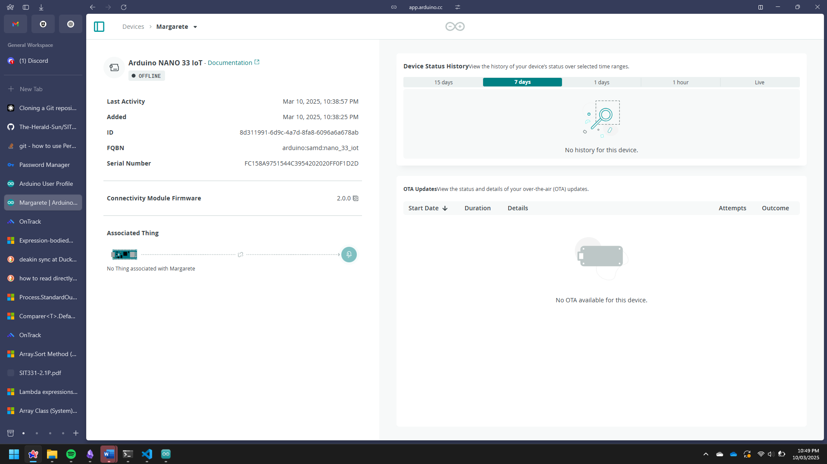  
Screenshot yeah

Repo link (Please drop your email in the ontrack feedback so I can add you to the repo)  
<https://github.com/The-Herald-Sun/SIT210>

Video:  
<https://deakin.au.panopto.com/Panopto/Pages/Viewer.aspx?id=c1eba196-26fd-4b11-9c5c-b29c00c6587f>