Submission

# Everyone keeps asking what is a webhook, but no one asks how the webhook is. (A little down but thanks for asking)

A webhook is a communication methodology that places the responsibility of communication onto the server rather than the client. This cuts down on polling seen with APIs wherein the client constantly “asks” the server it has the information yet. Webhooks cut down on this polling by allowing the server to just send information to the client when its available.

An example of a webhook could be an embedded system sending sensor data to a server that can then process and display said data.

Sources:

<https://docs.redhat.com/en/documentation/red_hat_3scale_api_management/2.10/html/creating_the_developer_portal/webhooks>  
<https://en.wikipedia.org/wiki/HTTP/2_Server_Push>

<https://www.techtarget.com/searchapparchitecture/tip/Webhooks-explained-simply-and-how-they-differ-from-an-API>

Images of the data

A delightful picture of the circuit used for this

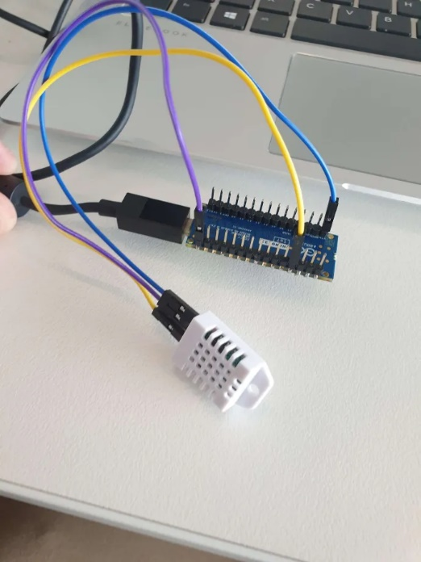

# But what about video evidence?

<https://deakin.au.panopto.com/Panopto/Pages/Viewer.aspx?id=5c0e95d5-9f3a-43cd-a8d6-b29e001fe8f4>