PBL PROJECT
MOVIE RECOMMENDATION SYSTEM

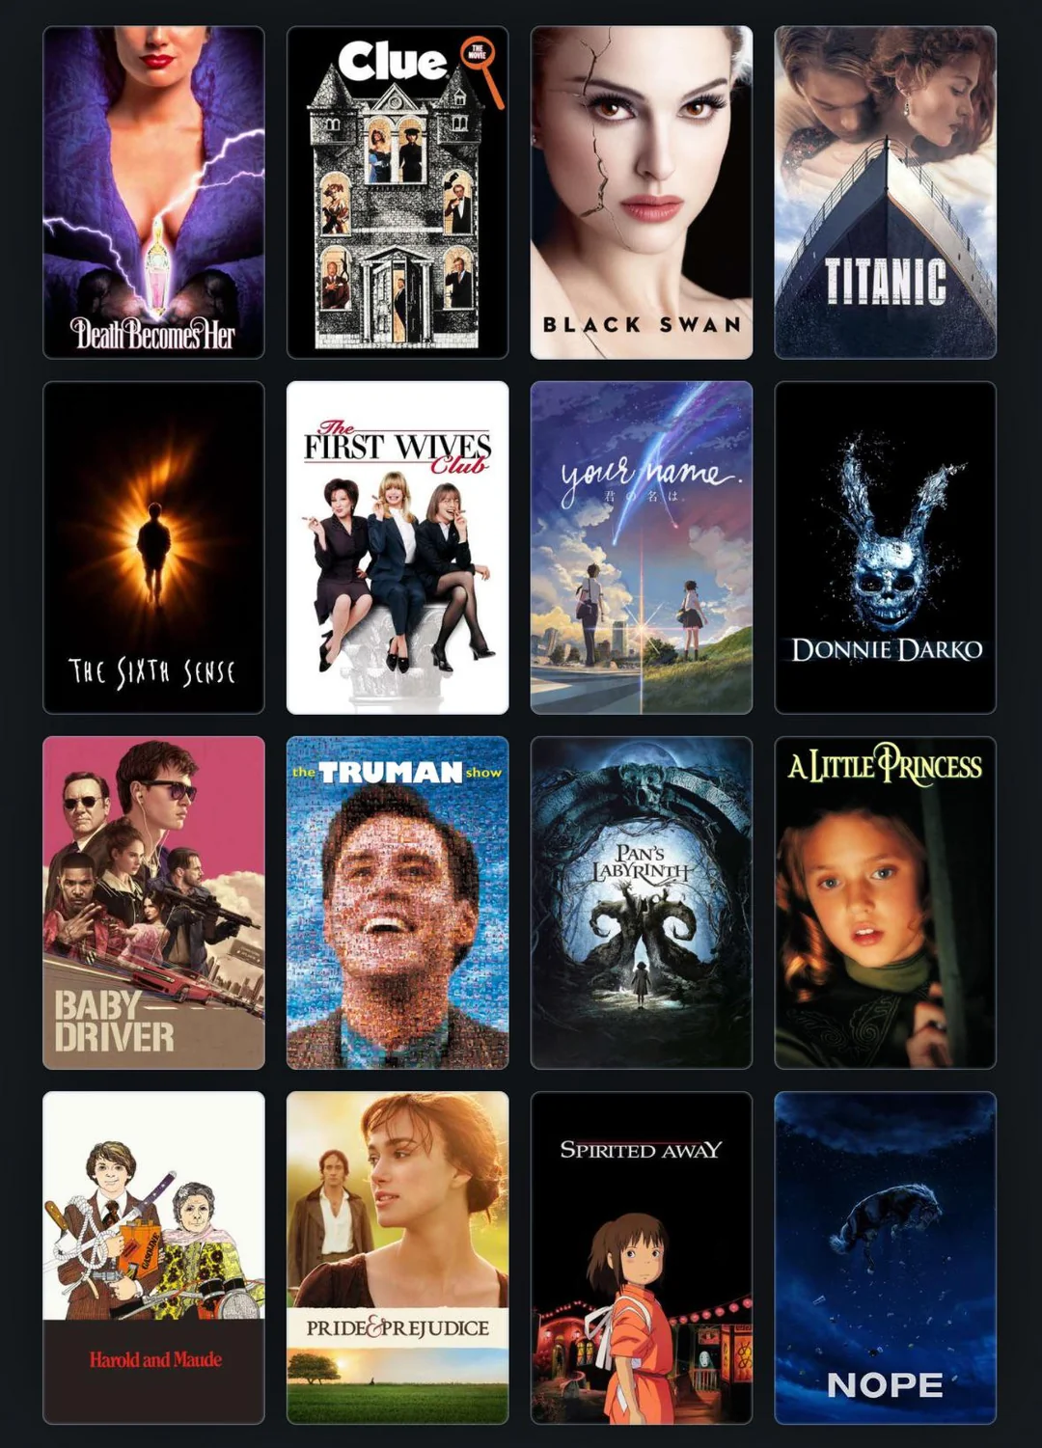

By,
Aditya Durve
Siddhi Wagh
Varun Chappedi
Vedang Joshi
INTRODUCTION

With the growing number of movies available across streaming platforms and online databases, choosing a movie that matches a user's interests can sometimes be difficult. A Movie Recommendation System helps solve this problem by suggesting movies based on factors such as a user's preferences, movie genres, ratings, popularity, and other movie-related information.
In this project, we develop a Machine Learning-based Movie Recommendation System that analyzes movie data and identifies similarities between movies to generate relevant recommendations. The system uses data preprocessing, feature selection, and similarity techniques to understand the characteristics of different movies and recommend titles that are likely to interest the user.
The main aim of this project is to demonstrate how Machine Learning and Data Science can be applied to a practical, real-world problem. It also provides hands-on experience with data cleaning, data analysis, feature engineering, and building a recommendation system using Python and libraries such as Pandas and NumPy. Ultimately, the project shows how ML can be used to make content discovery easier and provide users with more personalized movie suggestions.

Part 1: Data collection and data cleaning

For data collection we find an appropriate dataset for our purposes. We have selected a database which contains movie titles, genre, overview, taglines among other things.
Getting an overview:
We use the df.head(), df.column, df.shape() to get a general understanding of the dataset. Our dataset has 24 columns and consists of 45466 rows.
Removing Duplicates:
We use df.duplicated() to check whether there are any duplicate values. There are 13 duplicate values in this dataset so we use df.drop_duplicates().reset_index(drop=True)
function to remove duplicate values from the dataset.
Feature selection:
The first step here is deciding which columns are not required for our analysis.
We use the df.isnull().sum() to find the number of null values in the dataset. If a column has many null values, we cannot use it for prediction. For example, belongs_to_collection column had 40972 null values. Likewise, the adult column is not very helpful, as it is a Boolean value which gives us little insight.
Certain things like genre, overview and title help us ascertain similarities between movies. For example, a person who likes a certain action movie would be more likely to watch another action movie.
Title, genre, overview, tagline, vote_average, popularity columns are selected as suitable for our movie recommendation system.
Removing redundant values:
We have selected columns with lesser null values so that we can replace them. But, title is non-negotiable for recommending movies, therefore we use the df.dropna(subset=[’title’]) to remove those entries where the title is missing.
Replacing missing value:
We replace the NA values in the overview and tagline column with empty spaces.
Feature engineering:
We extract the genre names only from the genre column for our convenience. After that, we combine the overview, genres and tagline columns into a single column known as tags

Part 2: NLP Text Preprocessing

Definition:
NLP (Natural Language Processing) is a branch of AI that enables computers to understand, interpret, and generate human language. We must modify the text information we have in tags to be more suitable for NLP.
Preliminary steps:
Previously, we have created column tags that combined information from overview, genres and taglines. Now, our task is to remove all the
Removing punctuation and stopwords:
Characters like <. , - “” ! etc>, i.e, punctuating characters are of no use for prediction.
Stop words are words that frequently occur in a language, such as <and, this, at, for, in, to, a, etc>. These do not give any useful information for prediction.
Lemmatization in NLP:
Lemmatization is the process of converting a given word into its root form. For example: the word inviting becomes invite. We will import the nltk library for this purpose.

Part 3: Text Vectorization
TF-IDF Vectorization: TF-IDF Vectorizer is used to Vectorize a text block into a numerical array.
It is done by:
- Take all the unique words in all of the documents (rows)
- Build a term frequency matrix (TF matrix), that is, create a matrix such that each row of a matrix is populated by the number of times the word occurs in a given document.
Eg. If there are 3 unique words and only ‘the’ is repeating 2 times in the first document the matrix will be: [[2,0,0],[],[],…[]]
- Compute the Inverse Document Frequency for each word with formula:
$$IDF (t)=\frac{Total number of documents}{\begin{aligned}Total number of document \\ containing word 't'\end{aligned}}$$
It is used to calculate the rarity of the word.
- Build a TF-IDF Matrix by multiplying the TF matrix with the IDF of each word.
- This can be done using scikit-learn library using the inbuilt function “.TfidfVectorizer()”
- The only difference is that using sklearn the IDF formula changes to:
$$IDF\left(t\right)=\ln{(\frac{1+n}{1+df(t)} )}+1$$
Where,
df(t) = Word frequency in all documents
n = Total number of documents
Execution in Notebook:
After importing “.TfidfVectorizer()”, we used the following parameters:
- stop_words = ‘english’ : Removes all the stop words like punctuations in English vocabulary
- max_features = 50000 : Only 50000 unique words are selected ordered by term frequency across the corpus
- ngram_range= (1,2): Takes both unigrams and bigram words for vectorization.
Unigrams: Single words like “dog”, “cat”, etc.
Bigrams: Couple words like “I am”, etc.
I called the vectorizer using fit_transform() and stored the matrix in tfidf_mat. Which is stored in sparse matrix form.
Part 4: Cosine Similarity
Cosine similarity is used to find the similarity between the two sentences. Consider the following example:
- We have two sentences:
  - Action Adventure
  - Action
- Using the TF matrix, we will get:
[[1, 1, 0], [1,0, 0]]
- To evaluate the Cosine Similarity we use the following formula:
$$Cosine Similarity= \frac{\sum_{i=i}^{n}{A_{i} B_{i}}}{\sqrt{\sum_{i=1}^{n}{A_{i}^{2}}} \sqrt{\sum_{i=1}^{n}{B_{i}^{2}}}}$$
Here,
$A_{i}$ : Vector 1
$B_{i}$ : Vector 2

- Here the Cosine Similarity between the two is 0.71, means that they are very closely related, which makes sense as they both contain the word “Action”. Closer the number to 1, similar the sentences are.
Execution in Code:
I created a function called “recommendation()” with parameters “title” and “n=10”. We can call the function with any movie title which is available in the indexes and this function will give us ten recommendations of the movie.
NOTE: The full movie title with exact string as per the database needed. This is not a search engine but a recommendation function.

In the function, first we check if the given movie title has an exact match in the database or not, if not we print “No Movie title found”. If it exists, we then:
- Extract the index of the title
- Find the similarity score between the vector tag of a movie to all the other vector tags of the movies in the database using cosine similarity.
- Finally store the top 10 results in descending order so highest similarity score movie comes first and then return the movie title with it’s location (index).

Part 5: Importing Pickle Files
Pickle files are used to save and restore the exact state of Python objects. First we import the pickle library and then dump tfidf_mat (the TFIDF matrix), indices (the indexed movie titles) and tfidf (TFIDF function).

