Player | What it does | Privacy / data-handling claim | Link
OpenAI Operator | Cloud-hosted AI browser agent that performs real tasks (shopping, research) in an isolated cloud browser. | Cloud container isolates session; public-URL verification blocks malicious link exfiltration before fetching. | https://openai.com/index/introducing-operator/
Perplexity Comet | Browser agent integrated into Perplexity that browses, reads mail/calendar and fills forms on your behalf. | PII-Tracer (open-sourced, local 0.6B model) scans/redacts personal data before it leaves the device; local data storage by default. | https://www.perplexity.ai/hub/blog/pii-trace-detecting-personal-data-before-it-leaves-the-device
Brave Leo | Privacy-first AI assistant built into the Brave browser for chat, summarisation and local tasks. | Local-data-first: models hosted on own infra, no chat logs/training, reverse-proxy IP anonymisation, BYOM runs fully local, TEE 'Verifiable Privacy' proof. | https://brave.com/privacy/browser/
Microsoft Edge Copilot | AI assistant embedded in Edge for chat, summarisation and actions across files, mail and browser. | Settings-level transparency/control: manage + delete collected data, SmartScreen, Tracking Prevention, enterprise DLP, prompts not used for training. | https://learn.microsoft.com/en-us/legal/microsoft-edge/privacy
Google Gemini | Multi-modal AI assistant across Chrome, Workspace (Gmail, Docs, Meet) for chat and task completion. | Centralized My Activity/privacy dashboard; Workspace data access limited to user permissions; prompts/content not used for training. | https://policies.google.com/privacy
Cloudflare AI traffic classification | Edge-side system (not a browser agent) letting site owners classify AI bots as Search / Agent / Training. | Behavioral detection at network edge; default-block of Agent/Training bots on ad supported pages (from Sep 2026). | https://blog.cloudflare.com/content-independence-day-ai-options/
Browser-use (open source) | Open-source Python library to build browser agents (DOM-aware, Playwright-based). | Self-hostable - runs fully local so browsing data never leaves your infrastructure. | https://github.com/browser-use/browser-use
Skyvern (open source) | Open-source browser automation agent for workflows (form-filling, checkout) via LLM + computer vision. | Self-hosted option keeps data on your own infra; API-usage is the default hosted path. | https://github.com/Skyvern-AI/skyvern
Claude Computer Use / MCP (Anthropic, open source) | Open-source 'computer use' framework + Model Context Protocol letting models operate the browser/desktop. | Developer-controlled data boundaries via MCP; model has no memory by default; open-source so processing can be local. | https://www.anthropic.com/news/developing-computer-use
TRACK 1 - COMPETITIVE LANDSCAPE SUMMARY
Track-1: Compitetive Landscape
Player 1: AI Browser agent
PROBLEM:
- Allowing tools to collect browser history and open page text and active inputs
- Using personal prompts from our browser to train the models which automatically enables them
- Granted permission tools like co-pilot and other reading our history , login sessions ,context
- Exposing personal mails ,internal documents,financial data ,cloud servers.
SOLUTION:
- Cloudflare's solution is a new AI traffic classification and control system that lets website owners manage AI bots with far more precision than a simple block. Instead of treating all AI traffic the same, they introduced three categories: Search (for indexing, like search engines), Agent (for real-time user tasks), and Training (for model training). This allows site owners to allow beneficial search crawlers while blocking unwanted training or agent bots. The system is enforced at the network edge, using behavioral analysis to catch even bots that try to hide their identity. From September 15, 2026, new sites will default to blocking Agent and Training bots on ad-supported pages, while keeping Search bots allowed. https://blog.cloudflare.com/content-independence-day-ai-options/
- OpenAI's solution to prevent AI agents from leaking data through malicious links is a public-URL verification system. Before the agent automatically fetches a link, it checks if that exact URL already exists in an independent web crawler's index. If the URL is found, it is considered safe to load; if not, the agent avoids it and shows a warning, as the link likely contains unique tracking parameters that could exfiltrate private data. This approach avoids the pitfalls of simple domain allow-lists, which fail due to common web redirects. Crucially, this is a server-side verification step, which contrasts with your project's approach of client-side redaction to prevent sensitive data from being included in any outgoing request in the first place. https://openai.com/index/ai-agent-link-safety/

- The results of the tests were scored numerically and entered into a custom privacy scoring framework that the authors named “AgentWatch,” which enables systematic scoring and comparison of agents and provides a structured assessment approach for this emerging area of research. The testing was complemented by qualitative analysis of the agents’ behavior and their alignment with the policies set by their creators.
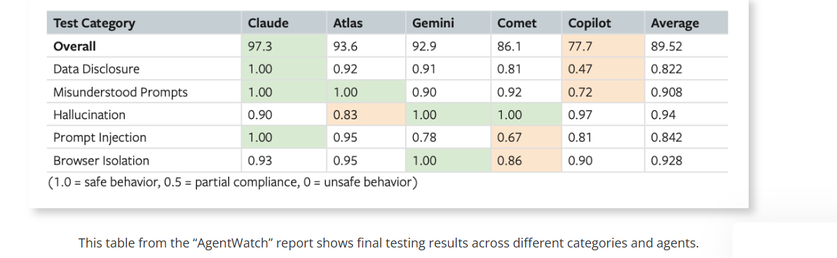

OTHER LINKS:
- https://witness.ai/blog/ai-browser-agent-security-risks/
- https://cltc.berkeley.edu/publication/agentwatch-report/

Player 2: Perplexity Comet
PROBLEM:
- Stores the browsing data by locally by default
- Comet accepts the invite or summarizes the email , it can thn read all the files from the computer and send them to attacker
- Unlocking passwords when kept open and then sends them to the attacker helping them to open login and also change the passwords sometimes
- Sometimes reading the mails and calendar and telling the otp’s read and then send them to the attacker, which might lead to account hijacks
- Attackers using different languages or places to hide their personal instructions
- The AI is designed to access your accounts on your behave without any prior instrusction
SOLUTION:
- Going incognite and browsing .
- Managing the permissions and deleting the data transferred to perplexity
- Restricting the deep tools like mails and calendar to minimise the data exposure risks.
- Adjusting account data settings via the main to manage data subject rights and training preferences.
- Perplexity's solution to this problem is a new, open-sourced AI model called PII-Tracer. This is a small 0.6 billion parameter model that runs locally on your device to scan every prompt and file upload for sensitive personal information before it's ever sent to the cloud . If it detects PII, it can either redact (mask) the data with placeholders, keep the entire task on your device, or ask for your permission before allowing the data to leave . This system ensures that sensitive content is never transmitted to external servers, and the company has also released a benchmark called PII-TRACE to help measure how well such detectors work . https://www.perplexity.ai/hub/blog/pii-trace-detecting-personal-data-before-it-leaves-the-device

Player 3: Brave Leo
PROBLEM:
- Attackers can hide malicious instructions in places you can't see on a website, like white text on a white background or hidden HTML elements. When you ask Leo to summarize that page, the AI reads and follows the attacker's hidden orders without you knowing.
- Sometimes when uploading a file 40% of workplace data and 20% personal data is being exposed to the attackers
- Attackers use hidden commands to login to the accounts without personal permission and access emails and company portals ,other files too.
- Some extensions that look like helpful AI tools are actually malicious and can steal passwords, monitor browsing, and read your clipboard
- It can make mistakes, misinterpret commands, and is still vulnerable to attacks like prompt injection
SOLUTION:
- Brave's primary solution is a comprehensive, multi-layered approach to keep your AI conversations completely private. All models are hosted on their own secure infrastructure, and they never store or log your chats after a response is generated, nor do they use them for training. They use technologies like a reverse proxy to ensure your request cannot be linked to your IP address and offer an "unlinkable subscription" for premium users so your purchase details cannot be connected to your usage. For advanced users, "Bring Your Own Model" (BYOM) lets you run AI models entirely locally on your own device, meaning your data never leaves your machine. They are also pioneering "Verifiable Privacy" using Trusted Execution Environments, which produce cryptographic proof that your conversation is private and using the expected model, moving beyond simply trusting their promises. https://brave.com/privacy/browser/
- Brave's solution ensures that any chat history saved by Leo is stored exclusively on your own device, not on their servers . This local data is encrypted, and you have full control to delete it anytime or disable the history feature entirely . For conversations that you don't want saved at all, you can use temporary chats which are deleted immediately when you close them . Even when using the chat history, Brave's core privacy protections remain: your IP address is anonymized, no identifiers are collected, and conversations are never used for model training https://community.brave.app/t/privacy-concerning-or-regarding-leo-remembering-previous-chats/653687
- Brave has introduced a groundbreaking feature called "Verifiable Privacy" using Trusted Execution Environments (TEEs) , which provides cryptographic proof that your conversation is truly private . This moves beyond just trusting Brave's privacy promises to a "trust but verify" model, where an attestation report confirms that your data is processed in a secure, isolated environment and that the expected AI model is being used . This technology is currently available for testing in Brave Nightly with the DeepSeek V3.1 model and is designed to prevent any scenario where a provider might silently switch to a cheaper, weaker model . This ensures users get absolute assurance that their data remains private and that they are getting the AI service they paid for https://www.pepper.inc/blog/brave-leo/
- 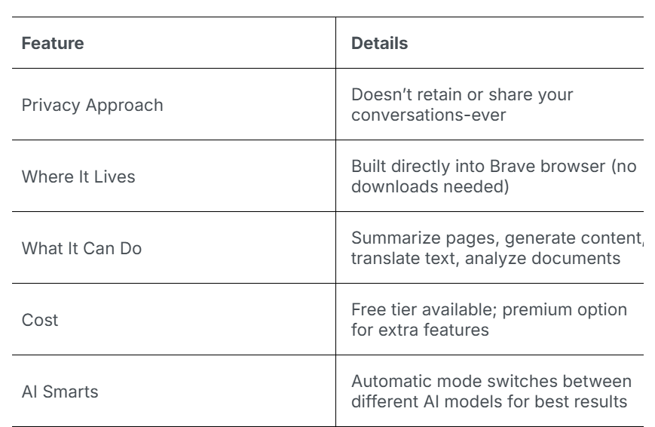
Player 4: Microsoft Edge Copilot:
PROBLEM:
- It can read sensitive data (like banking info) from background tabs without your permission, even when the feature is turned off .
- It can access everything you have access to (files, emails), so one compromise exposes everything
- Attackers can hide commands in web pages to steal your data, download malware, or log into your accounts without you knowing
- It relies on a chain of cloud services; a breach at any point can expose your data.
SOLUTION:
- Microsoft Edge's primary solution is giving you transparency and control over your data through detailed settings and clear explanations of how each feature works . You can manage what data is collected (like diagnostic data, browsing history, and typed searches) and choose to delete it locally or from Microsoft servers at any time . The browser also includes built-in protections like SmartScreen to block harmful sites and downloads, and Tracking Prevention to limit cross-site trackers . For enterprise users, additional tools like Data Loss Prevention (DLP) help organizations control sensitive data, while features like InPrivate and Guest modes ensure that browsing history, cookies, and form data are not saved after the session ends. https://learn.microsoft.com/en-us/legal/microsoft-edge/privacy.
- Microsoft Copilot provides enterprise-grade protections for work accounts, ensuring that prompts and responses are not used for model training and are safeguarded by strict compliance controls . For consumer accounts, you can manage personalization by controlling what Copilot remembers, viewing saved memories, and opting out of using conversation data for training models . You also have the ability to delete your conversation history, which is typically removed within 30 days . Additionally, administrators can configure data handling policies to meet their organization's specific privacy and security requirements https://support.microsoft.com/en-us/microsoft-copilot/microsoft-copilot-privacy-controls.
- The article argues that Microsoft's own tools (like Purview) are insufficient because they only enforce policies on data that is already correctly labeled, while most at-risk data is unlabeled or mislabeled. Concentric AI offers a third-party solution that uses advanced AI to autonomously discover, classify, and label sensitive data generated by Copilot without requiring any rules or end-user involvement. It then identifies risks from inappropriate permissions or sharing and can automatically remediate issues by adjusting access controls or preventing data from being shared . This approach addresses the root problem of overly broad permissions and inconsistent label inheritance, ensuring Copilot only accesses data that is properly secured and classified. https://concentric.ai/too-much-access-microsoft-copilot-data-risks-explained/.

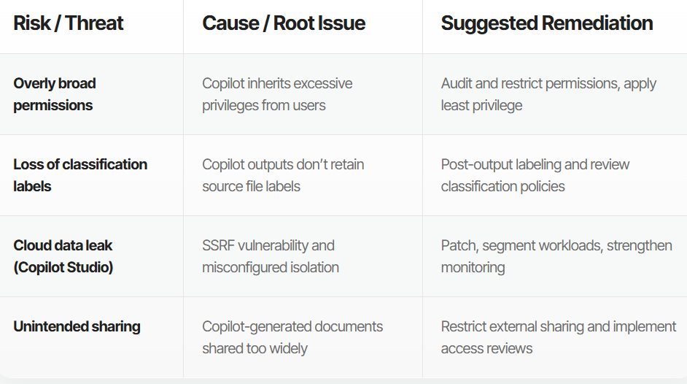

Player 5: Google Gemini:
PROBLEM:
- Google was sued for allegedly enabling Gemini tracking on Gmail, Chat, and Meet without user knowledge or consent
- Malicious instructions in notifications could hijack Gemini to open windows, impersonate contacts, or poison its memory
- Attackers could inject malicious commands through logs, search history, or web content to silently steal location data and saved memories
- A Chrome bug allowed a malicious extension to hijack Gemini and access your webcam, microphone, and local files.
- Gemini failed to distinguish between safe user input and attacker-supplied content, making it an unwitting attack vehicle
SOLUTION:
- Google's primary solution is giving you transparency and control over your data through a centralized privacy dashboard where you can manage what information is collected and how it's used . You can view, manage, and delete your activity data (like searches and location history) at any time through "My Activity," and you can choose to have it automatically deleted after a set time period . The policy also provides ad personalization controls, allowing you to opt out of personalized ads or modify your interests . Additionally, you can export a copy of your data or delete your entire Google account, and Google uses strong encryption to protect your data in transit and at rest https://policies.google.com/privacy
- Google Workspace provides enterprise-specific privacy controls through an AI control center that lets admins monitor usage, manage security settings, and enforce data protection rules. For Workspace customers, Gemini only accesses data the user already has permission to see and never uses your prompts, content, or responses to train its models. Admins can control data residency (where data is stored) and manage retention periods for Gemini conversations. Additionally, Google provides compliance support with resources like DPIA guides for public sector customers and maintains comprehensive security certifications (ISO, SOC, HIPAA) for Gemini in Workspace https://knowledge.workspace.google.com/admin/generative-ai/generative-ai-in-google-workspace-privacy-hub
- Gemini's biggest risk is inheriting overly broad Google Workspace permissions, which means it can surface sensitive files (like HR data) to employees who shouldn't have access, simply because sharing settings were too open. This exposure is amplified by Gemini Spark (agentic AI) and Personal Intelligence, which can autonomously act on or combine data from Gmail, Docs, and even financial services without constant user oversight, sometimes with human reviewers able to see your conversations. The article's solution is Concentric AI's Semantic Intelligence, which autonomously classifies data based on meaning and risk (not just labels) and automatically identifies and fixes risky sharing or permissions. This approach ensures that before Gemini even accesses data, it is properly secured and only available to authorized personnel, allowing organizations to safely deploy AI https://concentric.ai/google-gemini-security-risks/

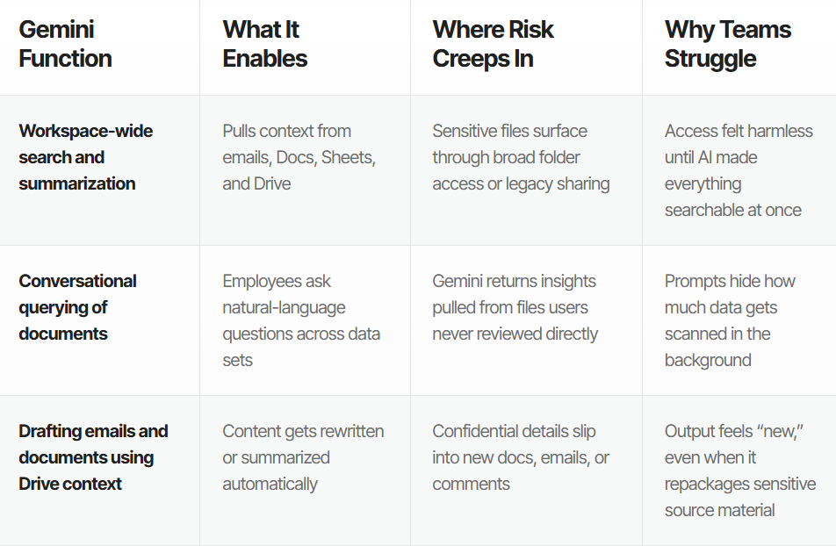
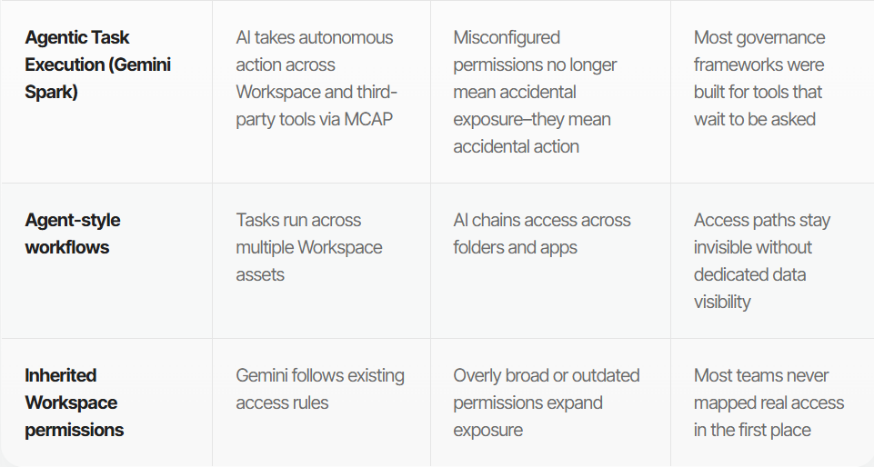
OPEN-SOURCE PROJECTS IN THIS SPACE

Alongside the commercial browser agents above, a significant and growing open-source ecosystem exists for browser agents. These are relevant to Track 1 because they position privacy very differently: since the code and models are self-hostable, the user can keep all browser data and prompts on their own infrastructure.

1) Browser-use (https://github.com/browser-use/browser-use)
One of the most popular open-source Python frameworks for building browser agents. It is DOM-aware and Playwright-based, and gives developers full control over what the agent reads and where data is processed. Because it is self-hostable, no browsing data or prompts have to leave the user's own machine, which is its core privacy/handling advantage versus cloud agents.

2) Skyvern (https://github.com/Skyvern-AI/skyvern)
An open-source browser automation agent that performs end-to-end workflows (form filling, checkout, procurement) using LLMs plus computer vision rather than fragile DOM selectors. It can be self-hosted so that all browsing and personal data stays within the organization's own infrastructure; the hosted API is the alternative path.

3) Anthropic Claude Computer Use + MCP (https://www.anthropic.com/news/developing-computer-use)
Open-source 'computer use' capability that lets a model operate the browser and desktop by taking screenshots and issuing mouse/keyboard actions, paired with the open Model Context Protocol (MCP) for connecting tools. Data boundaries are developer-controlled, the model has no memory by default, and the open-source design allows fully local deployment.

4) BrowserGym / WebArena (research)
Not products but the dominant open research testbeds for browser agents. BrowserGym (https://github.com/ServiceNow/BrowserGym) provides a gymnasium-style environment for training/evaluating agents; WebArena provides realistic web environments. They matter for the landscape because new privacy-aware agents (and the AgentWatch-style scoring referenced above) are benchmarked on these.

Why this matters for privacy positioning:
- Open-source agents can run entirely locally, so personal data, logins, history, and prompts never leave the user's device - the strongest privacy position on the market.
- The main tension in the cloud agents above (Perplexity, Copilot, Gemini, Operator) is data leaving the device to a provider's servers. Open-source self-hosting removes that trade-off entirely, at the cost of requiring the user to run and secure their own infrastructure.

