Lesson3_Sandbox

Jay Aher

2023-06-21

## Background for this activity

Welcome to the sandbox! This activity is going to provide you with the opportunity to preview some of the cool things you can do in R that you will be learning in this course. You will learn more about working with packages and data and try out some important functions.

In this activity, you are going to install and load R packages; practice using functions to view, clean, and visualize data; and learn more about using R markdown to document your analysis. R is a powerful tool that can do a lot of different things; this sandbox activity will help you get more comfortable using R while demonstrating some of its functions in action. In later activities, you will also get the opportunity to write your own R code!

## Step 1: Using R packages

Packages are a key part of working with R.They contain bundles of code called functions that allow you to perform a wide range of tasks in R. Some of them even contain datasets that you can use to practice the skills you have been learning throughout this course.

Some packages are installed by default, but many others can be downloaded from an external source such as the Comprehensive R Archive Network, or CRAN.

In this activity, you will be using a package called tidyverse. The tidyverse package is actually a collection individual packages that can help you perform a wide variety of analysis tasks.

To install the tidyverse package, execute the code in the code chunk below by clicking on the green arrow button in the top right corner. When you execute a code chunk in RMarkdown, the output will appear in the .rmd area and your console.

install.packages("tidyverse")

## Installing tidyverse [2.0.0] ...  
## OK [linked cache in 2.7 milliseconds]  
## * Installed 1 package in 3.1 seconds.

Once a package is installed, you can load it by running the library() function with the package name inside the parentheses, like this:

library(tidyverse)

## ── Attaching core tidyverse packages ──────────────────────── tidyverse 2.0.0 ──  
## ✔ dplyr 1.1.2 ✔ readr 2.1.4  
## ✔ forcats 1.0.0 ✔ stringr 1.5.0  
## ✔ ggplot2 3.4.2 ✔ tibble 3.2.1  
## ✔ lubridate 1.9.2 ✔ tidyr 1.3.0  
## ✔ purrr 1.0.1   
## ── Conflicts ────────────────────────────────────────── tidyverse_conflicts() ──  
## ✖ dplyr::filter() masks stats::filter()  
## ✖ dplyr::lag() masks stats::lag()  
## ℹ Use the conflicted package (<http://conflicted.r-lib.org/>) to force all conflicts to become errors

Installing and loading the tidyverse package may take a few minutes– be sure to wait for it to finish running before moving on to the next steps!

Once the chunk above has finished running, you will get a report that summarizes what packages were loaded because you ran the library() function. The report will also let you know you if there are any functions that have a conflict, but you don’t need to worry about that for now.

Now that you have loaded an R package, you can start exploring some data.

# Step 2: Viewing data

Many of the tidyverse packages contain sample datasets that you can use to practice your R skills. The diamonds dataset in the ggplot2 package is a great example for previewing R functions.

Because you already loaded this package in the last step, the diamonds dataset is ready for you to use.

One common function you can use to preview the data is the head() function, which displays the columns and the first several rows of data. You can test out how the head() function works by running the chunk below:

head(diamonds)

## # A tibble: 6 × 10  
## carat cut color clarity depth table price x y z  
## <dbl> <ord> <ord> <ord> <dbl> <dbl> <int> <dbl> <dbl> <dbl>  
## 1 0.23 Ideal E SI2 61.5 55 326 3.95 3.98 2.43  
## 2 0.21 Premium E SI1 59.8 61 326 3.89 3.84 2.31  
## 3 0.23 Good E VS1 56.9 65 327 4.05 4.07 2.31  
## 4 0.29 Premium I VS2 62.4 58 334 4.2 4.23 2.63  
## 5 0.31 Good J SI2 63.3 58 335 4.34 4.35 2.75  
## 6 0.24 Very Good J VVS2 62.8 57 336 3.94 3.96 2.48

In addition to head() there are a number of other useful functions you can use to summarize or preview the data. For example, the str() and glimpse() functions will both return summaries of each column in your data arranged horizontally. You can try out these two functions by running the code chunks below:

str(diamonds)

## tibble [53,940 × 10] (S3: tbl_df/tbl/data.frame)  
## $ carat : num [1:53940] 0.23 0.21 0.23 0.29 0.31 0.24 0.24 0.26 0.22 0.23 ...  
## $ cut : Ord.factor w/ 5 levels "Fair"<"Good"<..: 5 4 2 4 2 3 3 3 1 3 ...  
## $ color : Ord.factor w/ 7 levels "D"<"E"<"F"<"G"<..: 2 2 2 6 7 7 6 5 2 5 ...  
## $ clarity: Ord.factor w/ 8 levels "I1"<"SI2"<"SI1"<..: 2 3 5 4 2 6 7 3 4 5 ...  
## $ depth : num [1:53940] 61.5 59.8 56.9 62.4 63.3 62.8 62.3 61.9 65.1 59.4 ...  
## $ table : num [1:53940] 55 61 65 58 58 57 57 55 61 61 ...  
## $ price : int [1:53940] 326 326 327 334 335 336 336 337 337 338 ...  
## $ x : num [1:53940] 3.95 3.89 4.05 4.2 4.34 3.94 3.95 4.07 3.87 4 ...  
## $ y : num [1:53940] 3.98 3.84 4.07 4.23 4.35 3.96 3.98 4.11 3.78 4.05 ...  
## $ z : num [1:53940] 2.43 2.31 2.31 2.63 2.75 2.48 2.47 2.53 2.49 2.39 ...

glimpse(diamonds)

## Rows: 53,940  
## Columns: 10  
## $ carat <dbl> 0.23, 0.21, 0.23, 0.29, 0.31, 0.24, 0.24, 0.26, 0.22, 0.23, 0.…  
## $ cut <ord> Ideal, Premium, Good, Premium, Good, Very Good, Very Good, Ver…  
## $ color <ord> E, E, E, I, J, J, I, H, E, H, J, J, F, J, E, E, I, J, J, J, I,…  
## $ clarity <ord> SI2, SI1, VS1, VS2, SI2, VVS2, VVS1, SI1, VS2, VS1, SI1, VS1, …  
## $ depth <dbl> 61.5, 59.8, 56.9, 62.4, 63.3, 62.8, 62.3, 61.9, 65.1, 59.4, 64…  
## $ table <dbl> 55, 61, 65, 58, 58, 57, 57, 55, 61, 61, 55, 56, 61, 54, 62, 58…  
## $ price <int> 326, 326, 327, 334, 335, 336, 336, 337, 337, 338, 339, 340, 34…  
## $ x <dbl> 3.95, 3.89, 4.05, 4.20, 4.34, 3.94, 3.95, 4.07, 3.87, 4.00, 4.…  
## $ y <dbl> 3.98, 3.84, 4.07, 4.23, 4.35, 3.96, 3.98, 4.11, 3.78, 4.05, 4.…  
## $ z <dbl> 2.43, 2.31, 2.31, 2.63, 2.75, 2.48, 2.47, 2.53, 2.49, 2.39, 2.…

Another simple function that you may use regularly is the colnames() function. It returns a list of column names from your dataset. You can check out this function by running the code chunk below:

colnames(diamonds)

## [1] "carat" "cut" "color" "clarity" "depth" "table" "price"   
## [8] "x" "y" "z"

After running the code chunk, you may have noticed a number in brackets. This number helps you count the number of columns in your dataset. If you have data with lots of columns and colnames() prints the results on multiple lines, each line will have a number in brackets at the start of the line indicating what number column that is! So, for example, “carat” is the first column in the diamonds dataset. On the second line, there is the number seven in brackets; “price” is the seventh column.

## Step 3: Cleaning data

One of the most frequent tasks you will have to perform as an analyst is to clean and organize your data. R makes this easy! There are many functions you can use to help you perform important tasks easily and quickly.

For example, you might need to rename the columns, or variables, in your data. There is a function for that: rename(). You can check out how it works in the chunk below:

rename(diamonds, carat_new = carat)

## # A tibble: 53,940 × 10  
## carat_new cut color clarity depth table price x y z  
## <dbl> <ord> <ord> <ord> <dbl> <dbl> <int> <dbl> <dbl> <dbl>  
## 1 0.23 Ideal E SI2 61.5 55 326 3.95 3.98 2.43  
## 2 0.21 Premium E SI1 59.8 61 326 3.89 3.84 2.31  
## 3 0.23 Good E VS1 56.9 65 327 4.05 4.07 2.31  
## 4 0.29 Premium I VS2 62.4 58 334 4.2 4.23 2.63  
## 5 0.31 Good J SI2 63.3 58 335 4.34 4.35 2.75  
## 6 0.24 Very Good J VVS2 62.8 57 336 3.94 3.96 2.48  
## 7 0.24 Very Good I VVS1 62.3 57 336 3.95 3.98 2.47  
## 8 0.26 Very Good H SI1 61.9 55 337 4.07 4.11 2.53  
## 9 0.22 Fair E VS2 65.1 61 337 3.87 3.78 2.49  
## 10 0.23 Very Good H VS1 59.4 61 338 4 4.05 2.39  
## # ℹ 53,930 more rows

Here, the function is being used to change the name of carat to carat_new. This is a pretty basic change, but rename() has many options that can help you do more complex changes across all of the variables in your data.

For example, you can rename more than one variable in the same rename() code. The code below demonstrates how:

rename(diamonds, carat_new = carat, cut_new = cut)

## # A tibble: 53,940 × 10  
## carat_new cut_new color clarity depth table price x y z  
## <dbl> <ord> <ord> <ord> <dbl> <dbl> <int> <dbl> <dbl> <dbl>  
## 1 0.23 Ideal E SI2 61.5 55 326 3.95 3.98 2.43  
## 2 0.21 Premium E SI1 59.8 61 326 3.89 3.84 2.31  
## 3 0.23 Good E VS1 56.9 65 327 4.05 4.07 2.31  
## 4 0.29 Premium I VS2 62.4 58 334 4.2 4.23 2.63  
## 5 0.31 Good J SI2 63.3 58 335 4.34 4.35 2.75  
## 6 0.24 Very Good J VVS2 62.8 57 336 3.94 3.96 2.48  
## 7 0.24 Very Good I VVS1 62.3 57 336 3.95 3.98 2.47  
## 8 0.26 Very Good H SI1 61.9 55 337 4.07 4.11 2.53  
## 9 0.22 Fair E VS2 65.1 61 337 3.87 3.78 2.49  
## 10 0.23 Very Good H VS1 59.4 61 338 4 4.05 2.39  
## # ℹ 53,930 more rows

Another handy function for summarizing your data is summarize(). You can use it to generate a wide range of summary statistics for your data. For example, if you wanted to know what the mean for carat was in this dataset, you could run the code in the chunk below:

summarize(diamonds, mean_carat = mean(carat))

## # A tibble: 1 × 1  
## mean_carat  
## <dbl>  
## 1 0.798

These functions are a great way to get more familiar with your data and start making observations about it. But sometimes, previewing tables isn’t enough to understand a dataset. Luckily, R has visualization tools built in.

## Step 4: Visualizing data

With R, you can create data visualizations that are simple and easy to understand or complicated and beautiful just by changing a bit of code. R empowers you to present the same data in so many different ways, which can help you create new insights or highlight important data findings. One of the most commonly used visualization packages is the ggplot2 package, which is loaded automatically when you install and load tidyverse. The diamonds dataset that you have been using so far is a ggplot2 dataset.

To build a visualization with ggplot2 you layer plot elements together with a + symbol. You will learn a lot more about using ggplot2 later in the course, but here is a preview of how easy and flexible it is to make visuals using code:

ggplot(data = diamonds, aes(x = carat, y = price)) +  
 geom_point()

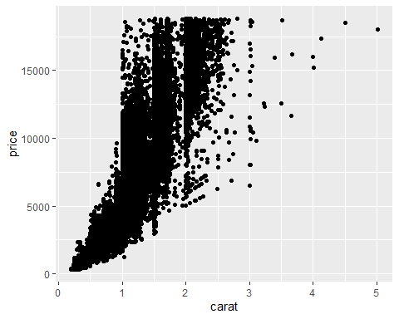

The code above takes the diamonds data, plots the carat column on the X-axis, the price column on the Y-axis, and represents the data as a scatter plot using the geom_point() command.

ggplot2 makes it easy to modify or improve your visuals. For example, if you wanted to change the color of each point so that it represented another variable, such as the cut of the diamond, you can change the code like this:

ggplot(data = diamonds, aes(x = carat, y = price, color = cut)) +  
 geom_point()

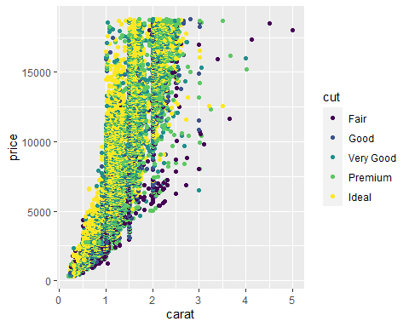

Wow, that’s a busy visual! Sometimes when you are trying to represent many different aspects of your data in a visual, it can help to separate out some of the components. For example, you could create a different plot for each type of cut. ggplot2 makes it easy to do this with the facet_wrap() function:

ggplot(data = diamonds, aes(x = carat, y = price, color = cut)) +  
 geom_point() +  
 facet_wrap(~cut)

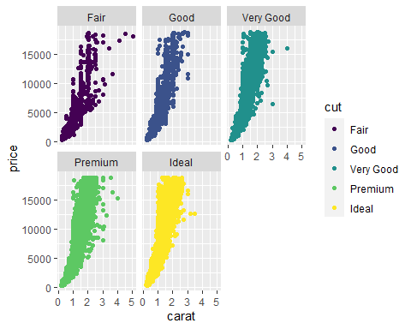

You will learn many other ways of working with ggplot2 to make functional and beautiful visuals later on. For now, hopefully you understand that it is both flexible and powerful!

## Step 5: Documentation

You have been working in an R markdown file, which allows you to put code and writing in the same place. Markdown is a simple language for adding formatting to text documents. For example, all of the section headers have been formatted by adding ## to the beginning of the line. Markdown can be used to format the text in other ways, such as creating bulleted lists:

* So if you have a list of things
* Or want to write bullets for another reason
* You can do that using markdown

When you have written, executed, and documented your code in an R markdown document like this, you can use the knit button in the menu bar at the top of the editing pane to export your work to a beautiful, readable document for others.

## Activity Wrap-up

You have had a chance to explore more R tools that you can start using on your own. You learned how to install and load R packages; functions for viewing, cleaning, and visualizing data; and using R markdownto export your work. Feel free to continue exploring these functions in the rmd file, or use this code in your own RStudio project space. As you practice on your own, consider how R is similar and different from the tools you have already learned in this program, and how you might start using it for your own data analysis projects. R provides a lot of flexibility and utility that can make it a key tool in a data analyst’s tool kit.

Make sure to mark this activity as complete in Coursera.