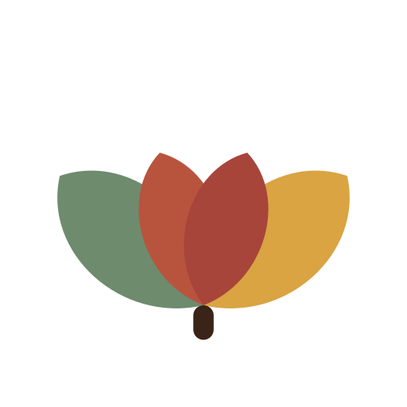
THE JOPETNAH FOUNDATION
How We Keep the People We Serve Safe
Many of the children and families in our programs are in vulnerable situations. Protecting them isn't an afterthought — it's a condition of everything we do, and everyone we work with.
What this means in practice:
✓ Every staff member, volunteer, and Trustee undergoes reference checks and background screening before working with beneficiaries.
✓ No staff member or volunteer is ever alone with a child without another adult present or documented parental consent.
✓ Every partner organization we fund must meet an equivalent safeguarding standard as a condition of receiving support.
✓ We have a named Safeguarding Focal Point and a clear, fast process for reporting and responding to any concern — within 24 hours.
✓ Anyone — staff, beneficiary, or community member — can raise a concern confidentially, without fear of retaliation, under our Whistleblower Policy.
✓ Serious concerns are referred to the appropriate child-protection or law-enforcement authorities, not handled quietly in-house.
✓ We photograph or share a beneficiary's story only with informed consent from them or their guardian.
✓ Our full Safeguarding Policy and Whistleblower Policy are reviewed by our Board at least annually.
Want the full policy?
We're glad to share our complete Safeguarding Policy, Whistleblower Policy, or Conflict of Interest Policy with any donor, partner, or funder conducting due diligence — just ask.
partnerships@jopetnahfoundation.org · The Jopetnah Foundation, Kampala, Uganda

