TheKidsBiostatsTemplate
  - A biostatistics report template
J Smith, Biostatistician
2024-12-12
Contents

Introduction

Project Summary
A blurb describing the project, which team or individual is conducting the research

Research Question
A succinct, specific research question to be answered in this report.
 Important
This must be confirmed with the researcher

Data Summary
Tables, explanatory plots, etc to examine the data prior to analysis.
mtcars %>%
ggplot(aes(x = mpg,
y = wt,
col = factor(cyl))) +
geom_point() +
labs(title = "Test Plot") +
thekids_theme(base_size = 20, base_family = "Orbitron")
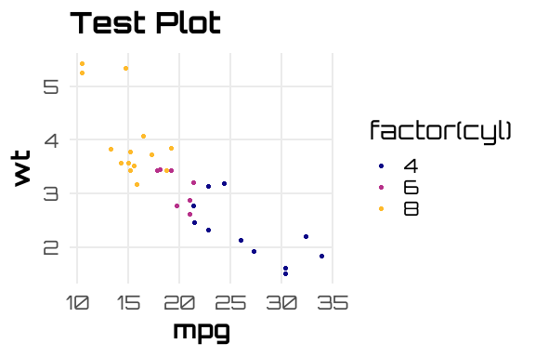

Analysis

Supplementary Material

