Calibration: population

Joyce Wu

09/06/2023

## Calibration of population size, population transition

1. Number of total population (Figure 1.)
2. Number of population size in community/prisons (Figure 2.)
3. Number of population size in each sub-population (Figure 3.)
4. Fraction of PWID/former PWID in community/prisons (Figure 4.)
5. Annual number of stop/relapse injection in community/prisons (Figure 5.)
6. Annual number of incarceration/release in PWID/former PWID (Figure 6.)
7. Incidence of stop injection in community/prisons (Figure 7. )
8. Incidence of relapse injection in community/prisons (Figure 8. )
9. Incidence of stopping injection in community/prisons (Figure 9. ) The blue lines are model outputs and black dots and lines represent the data points from in all figures.

## Figure1. number of population

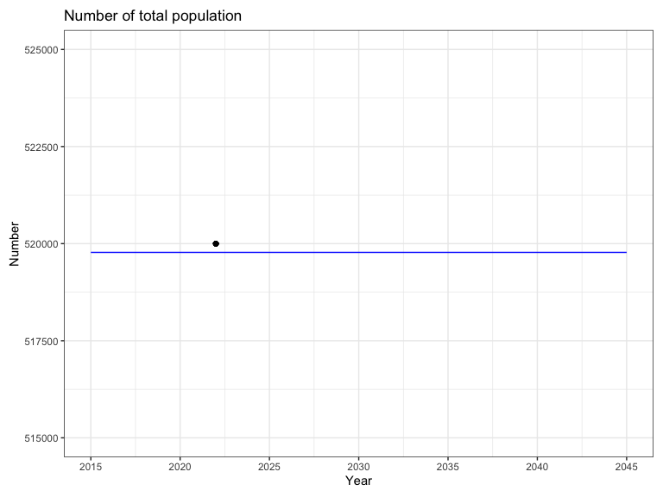

## Figure2. number of population size in community/prisons

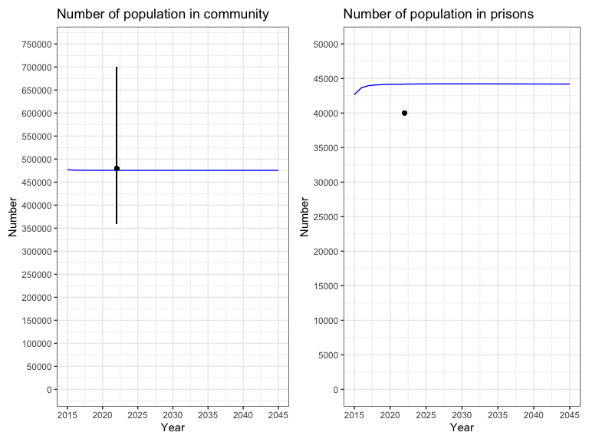

## Figure3. number of population size in each sup-population

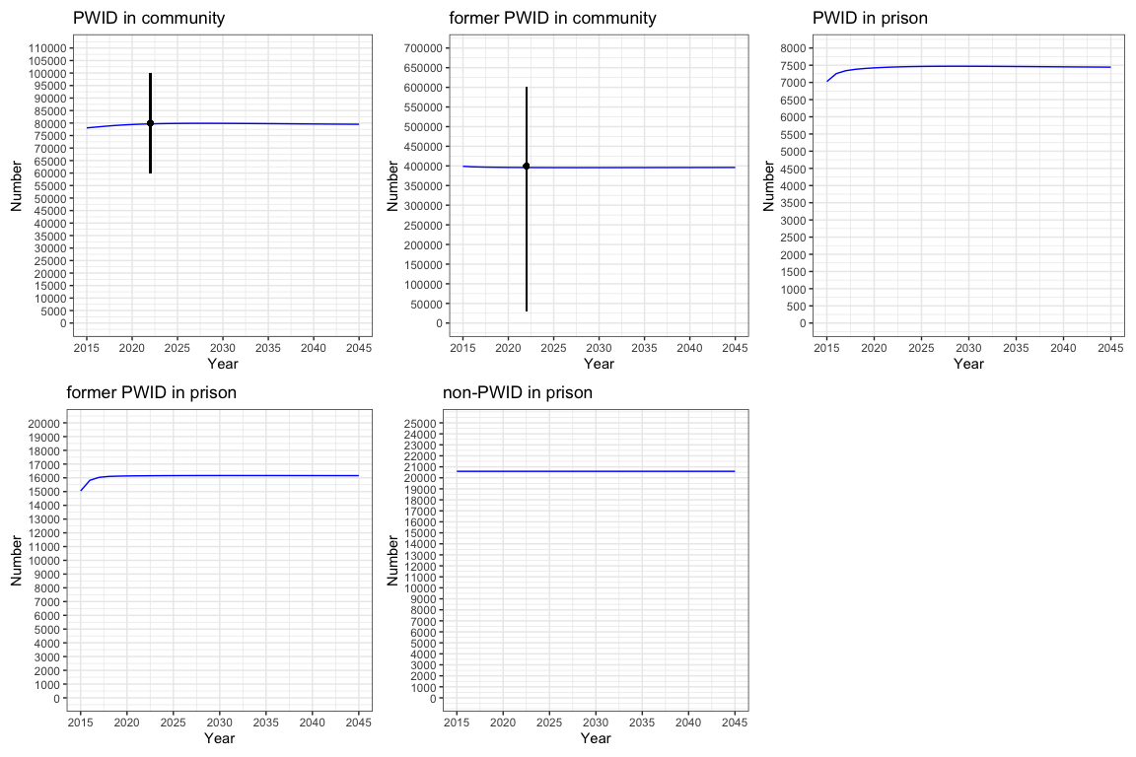

## Figure4. Fraction of PWID/former PWID in community/prisons

$$FractionofPWID_setting=\frac{PWID_setting}{N_setting}*100$$

$$FractionofformerPWID_prison=\frac{formerPWID_prison}{N_prison}*100$$

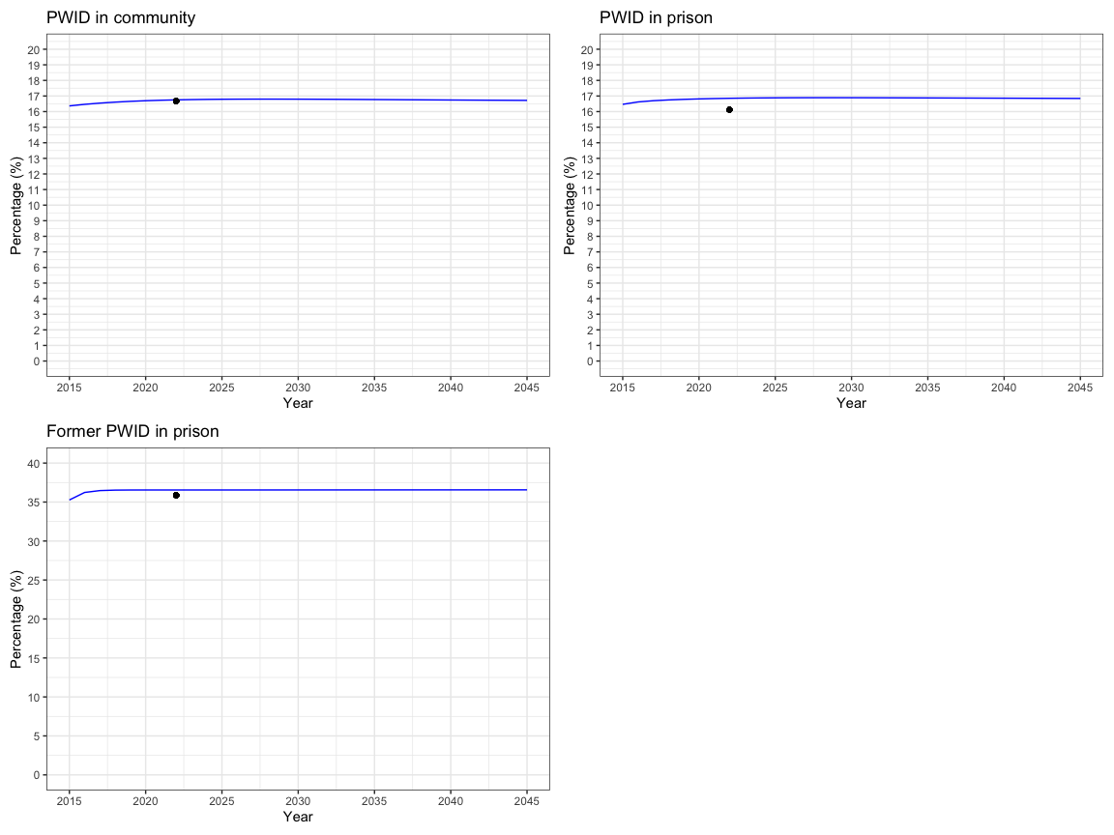

## Figure5. Annual number of stop/relapse injection in community/prisons

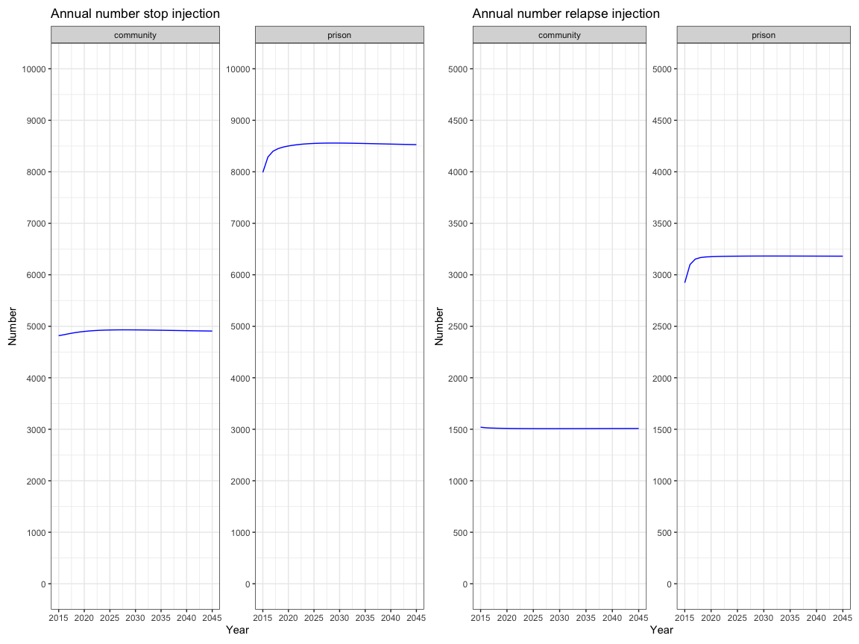

## Figure6. Annual number of incarceration/release in PWID and former PWID

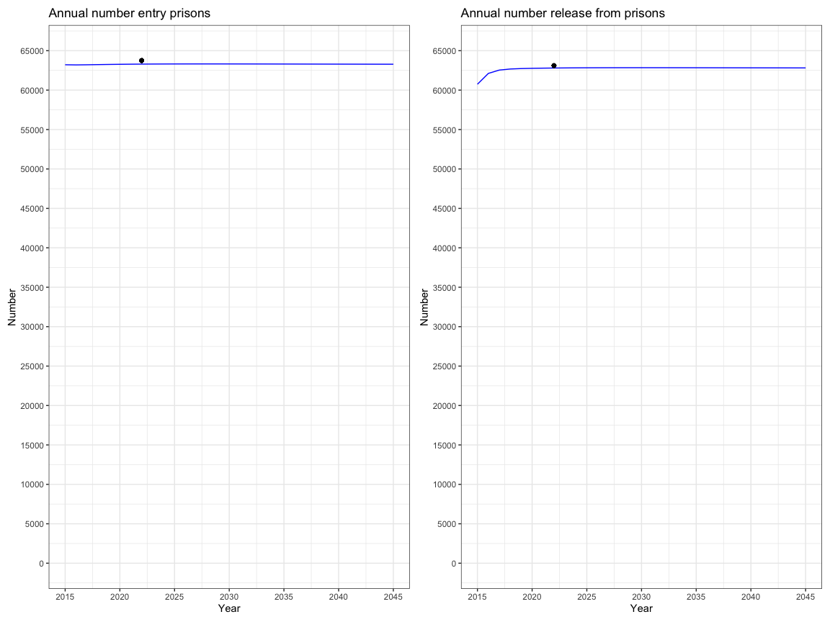

## Figure7. Incidence of stop injection in community/prisons

Incidence of stop injection in {setting} = annual number of stopping injection in {setting}/Number of PWID in {setting}*100 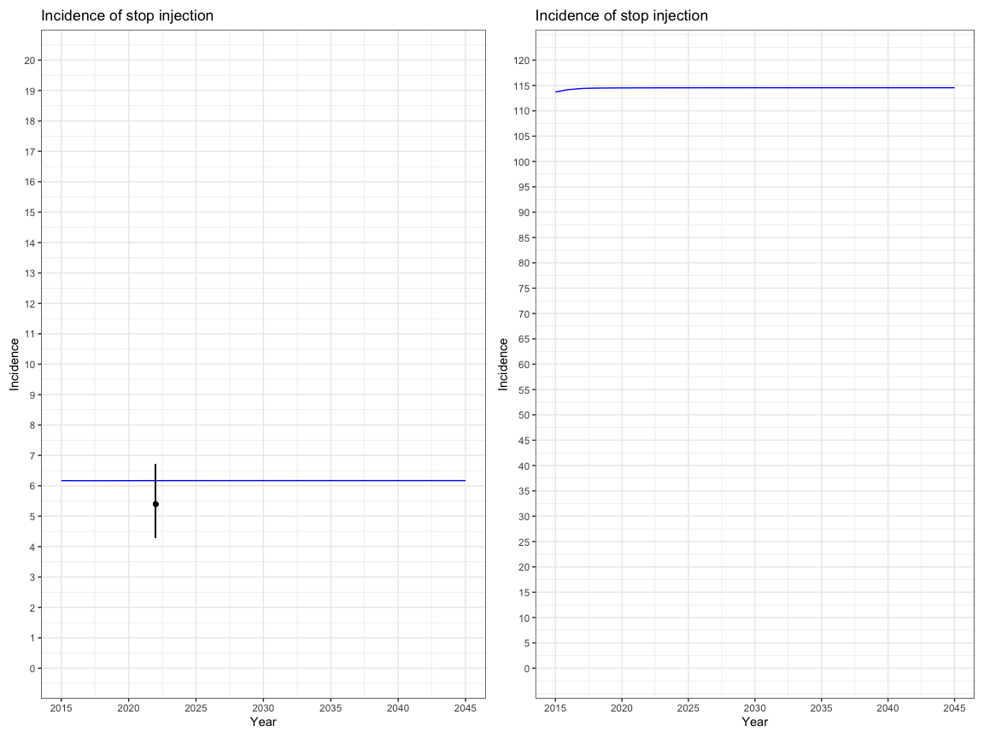

## Figure8. Incidence of relapse injection in community/prisons

Incidence of relapse injection in {setting} = annual number of relapse injection in {setting}/Number of former PWID in {setting}*100 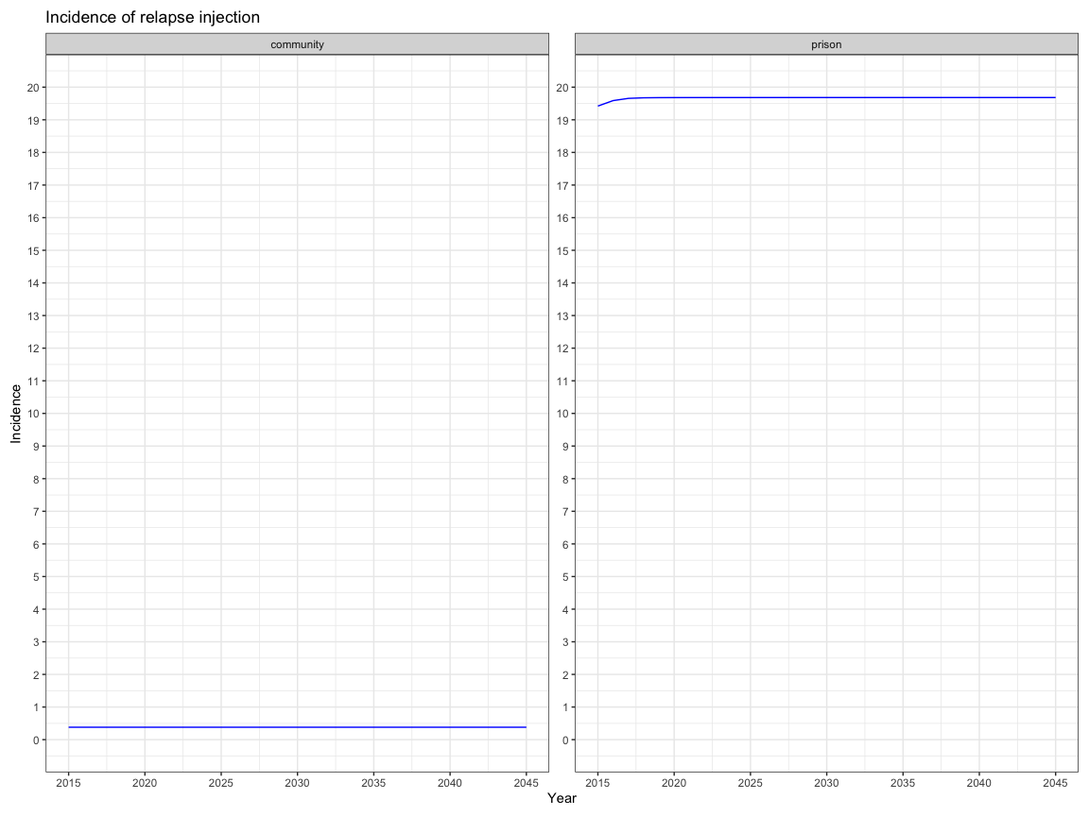

## Figure9. Incidence of incarceration/release in PWID and former PWID

Incidence of incarceration in {population} = annual number of incarceration in {population}/Number of {population} in community *100 Incidence of release in {population} = annual number of release in {population}/Number of {population} in prisons*100

