#TrendingInMedicine Notes and Information for HackTJ and the Future

Once we have a STATIC website (I’ll forward you guys the email Mr. White will send me, he’s providing me with some information about websites), I’m assuming you will code on the laptop, and just “throw” the results onto the website to present. Keep in mind that I may show this product to some real doctors for advice and future recommendations. Since I don’t know much about the coding side of this project, I’ll talk about the “results” that should be thrown onto the page.



This is what I prefer the top of the page to look like. The “Home” tab should, when clicked on, present you with a series of different colored hashtags (so people can differentiate between them). I will provide you with all the specific hashtags/keywords soon, after I talk to my brother this weekend.

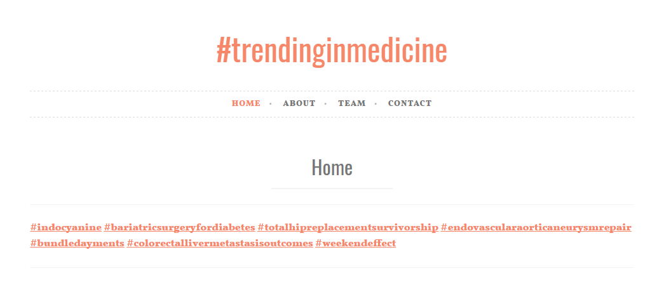

The “About” page should be a description of our website. I have it premade here, so you can copy the words in, and maybe make the images slightly more appealing if you wish? Or create your own images. I can work on the artsy stuff later eventually, and then you can implement it in. Read this too, it should help you understand the idea as well.

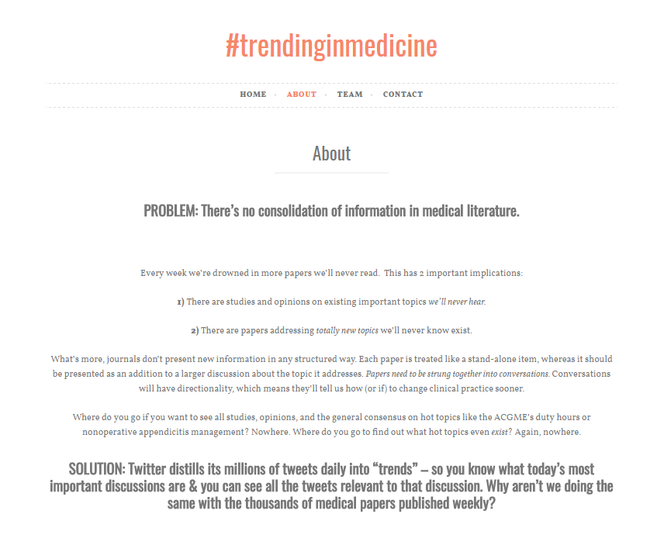

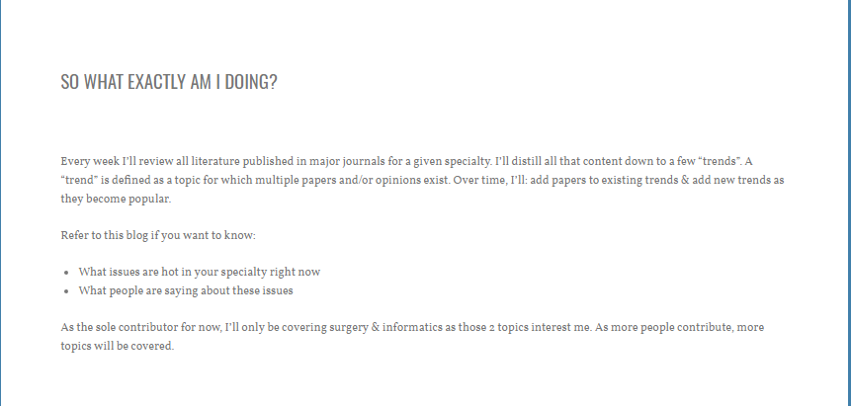

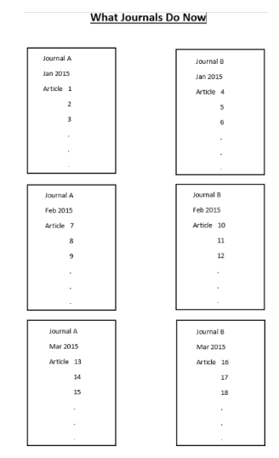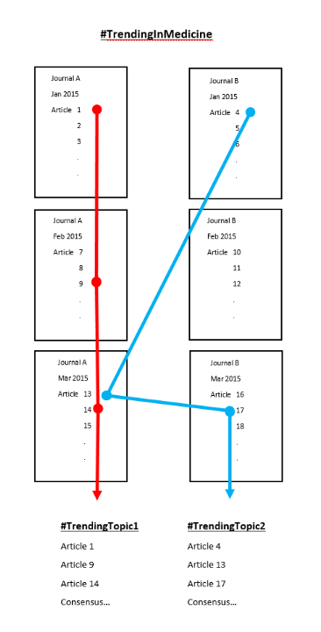

Here’s is a possible journal that we might use and collect articles from. Again, I’ll send you more once I talk to my brother, he’s more knowledgeable than I am. You’ll have to check if there are API’s on the journals, I have no idea and I don’t know how to check.

<http://jamanetwork.com/journals/jama>

The “Team” page will just consist of four faces, along with a small bio/description of each person (Alex, Ashwin, Anjam, Ankur). You can write whatever in there you want and find some pictures online of our faces.

Lastly, the “Contact” page, change it to whatever you want. I don’t necessarily need a 4th tab but if you feel like something important could go there, go for it.

**I have a lot more to send you**, I’ll spend time this weekend updating you and giving you more information. If your confused, or have something to add, or feel like something is missing, just ask/tell me. Things I need to send soon: Website information, keywords, list of journals… I will talk to my brother about a lot of things and I’ll be writing it down for you guys as well.

Also, I just want to make sure you guys know how to approach this. I don’t want you to show up at HackTJ and not know what to do. What I mean is that I want you guys to double-check that this is a feasible project for us. Mr. White said so himself that it was, so just plan ahead if you feel like you need to, like make a schedule ahead of time.

You guys can Facebook message me or text me (703.759.0462) if you guys have a question while you are at HackTJ. I’ll be in Maryland but I’ll have my phone on me.