**RESUME**

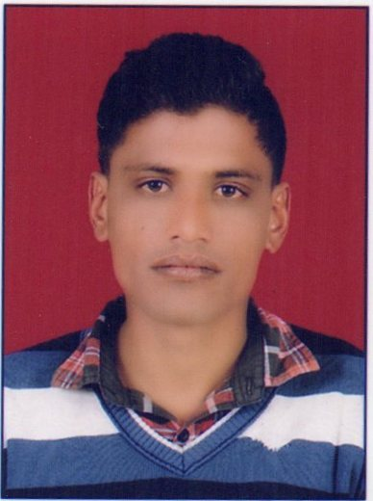

ASHOK SINGH

**Email:ashokchouhan1@gmail.com**

**Mob. No.** – 07976548510, 08890904951

**CARRIER OBJECTIVE :**

To perform to the best of the my skill and help the organization in which I am working to archive its objective. Work with highest priority and redefine best quality.

**Educational Qualification :-**

|  |  |  |  |  |
| --- | --- | --- | --- | --- |
| Class | Board/University | Year | Division | Percentage |
| 10th | Board Of Sec. Edu. Rajasthan | 2007 | I | 60.83 |
| 12tH | Board Of Sec. Edu. Rajasthan | 2009 | l | 67.23 |

**Additional Qualification :-**

|  |  |  |  |
| --- | --- | --- | --- |
| Diploma | Board/University | Year | Per. (%) |
| Mechanical(Auto Mobile) ENG. | Board Of Technical Education Rajasthan Jodhpur | 2014 | 60.85 |

**Computer Skills :-**

* Basic computer knowledge
* Diploma in advance basic of computer

**Vocational Training : -**

* Company Name : - Indian North Western Railway Ajmer

Period of Training : - 29/06/2011 to 26/07/2011.

Project Detail : - Basic loco engine and wagon wheel study

Position: -As a trainee

Duration :- Twenty Four Days

**Organization Experience: -**

**Current Employer :-**

* **Company :- Castamet Works Pvt. Ltd.  
  Designation :-** Asst. Mechanical Engineer   
  **Duration** :- 7 month  ( From July. 2016 to Till Date )  
  **Job Profile :-** All EOT crane Maintenance( gearbox, coupling, main hoist, hydraulic thruster Brakes ), Molding machine Maintenance, Hand molding machine Maintenance, Mixture plant maintenance, Heat treatment, Furness heating maintenance.

**Previous Employer :-**

* **Company :- Divyansh Automobile Pvt. Ltd ( Authorized by Man Tucks )**

**Designation :-**  Asst. Service Engineer

**Duration** :- 6 month  ( From June. 2014 to Dec. 2014 )

**Job Profile :-** General all service in man trucks, Engine service ( oil change , fuel 0oil and hydraulic filter, tappet valve check and adjust ), Transmission system ( gearbox works, clutch assembly, differential crown pinion works ), Pressure valve check and repair.

* **Company :- Dayco Vikas Engine System Pvt. Ltd.**

**Designation :-** CNC and VMC machine Operator

**Duration :-** ( From Dec. 2014 to Feb. 2015 )  
**Job Profile** :- Job work ( finishing, cutting, tool maintain )

* **Company :- Qh Talbros Ltd.**

**Designation :-** Diploma Apprentice Training holder

**Duration :-** ( From 10th Feb. 2015 to 9th Feb. 2016 )  
**Job Profile** :- Machine Shop Department ( cnc and vmc operating job work Exp.- job finishing , job cutting, job surface finishing and gear teeth cutting work ),

Assembly Shop Department ( steering and suspension parts assemble, tie rod assemble exp. Torque checking, load checking, sealing machine operate and manual work tie rod end. )

**Job responsibility**

* Line monitoring and supervising
* Planning about manpower as production plan and material availability
* Responsibility for smooth production and good quality

**HOBBIES**

* Visiting new place and photographing
* Playing cricket

**PERSONAL PROFILE :-**

Father’s Name - Mr. Prahlad Singh

Date of birth - 22/03/1992

Language Known - Hindi & English

Nationality - Indian

Marital Status - Unmarried

Permanent Address - Village-Ramgarh Sedothan,Post.- Sendra

Teh.- Raipur, Dist.-Pali

Rajasthan 306102

**Declaration**

If given an opportunity to serve I assure that my performance would be whole hearted, dedicated and always to the best of my capacity and the prestige of the firm.

Date ……………….

Place ………………

ASHOK SINGH